

Assessment Component 2

Written Essay

Student name: Erkan Paca
Student ID: 2010132

Module name: Children, Young People and Families
Module code: (BMHP5004_LON)
Lecturer name: Bianca Sanfilippo
Word count: 2500

Introduction

‘Childhood is a socially constructed’ concept.’
What is Childhood; as ‘the state of being a child’ on the other view according to Cambridge English Dictionary’s definition of a child ‘a boy or a girl from the time of birth until he or she is an adult’ whilst Oxford Dictionary’s definition as ‘ “a young human being below the age of puberty, or below the age of a legal majority”. In the modern UK and today’s society decides when childhood concludes, and maturity begins, and this has been adjusted at 18 when a person arrives at the age of ‘legal entitlement’. (Thompson, 2015).
‘Who is regarded as a child depends upon social, cultural and economic factors’
There is no such descriptive explanation universally available that defines a child or childhood.
Legal view; NCPCR describes a child as a person under 18.
Being a child is universal in any continence. The experience that influence children’s expectations vary from society; these factors are socioeconomic, family, culture, environment, and religion, and each element is different in each country as a social construction.
Every child goes through specific treatment based on the country’s socio-economic and cultural values as a factor. Underage labour, underage marriage, FGM (female genital mutilation), and underage prostitution. This explains the concept that childhood is a social construction. In Yemen, the most significant portion of the children works when they get the age between 5-9 years old, where they are subjected to work in an unsafe environment; compared to the UK, children must attend school till the age of 16, and all children must continue education and training till the age of 18 years old. (GOV.UK.,2021)
This indicates how these two countries differ regarding education and underage labour.
Whilst, child marriage is customary practice in England and Wales, the legal age for marriage is 16. (Children’s Commissioner, 2021).
Whereas, in Thailand, child prostitution is commonly experienced compared to the UK, which is a criminal offence that is considered sexual abuse. (CPS, 2019) Yinyinlah’s story from Burma to Thailand, where she was forced to work as a sex worker to provide for her family (Unknown Destination campaign, 2013).
Analysis
Family structure nuclear family is a dominant model discussed at the front of politicians’ minds when making relevant policies.
‘A family consisting of two parents and their children but not include aunts, uncles, grandparents, etc. (Cambridge Dictionary). Leading family standard in the west. (McDowall Clarke, 2013).
Changes in society over time changed the family. Thus, the construction of women’s roles reversed, and alterations included legal abortion, contraception, new divorce law, equality, career-minded women limiting pregnancies, and ceasing unhappy relationships due to their financial abilities. (McDowall Clark, 2013). In addition, common-law marriage, same-sex relationships, and changes in religious beliefs such as atheism made the family concept unimportant. Lone parents and children grow up without their mother or father. Thus, the family structure changed significantly. Additionally, early examinations and low-risk termination of pregnancies result in families having a choice about the decision to bear a child with a handicap into the world. (McDowall Clark, 2013).
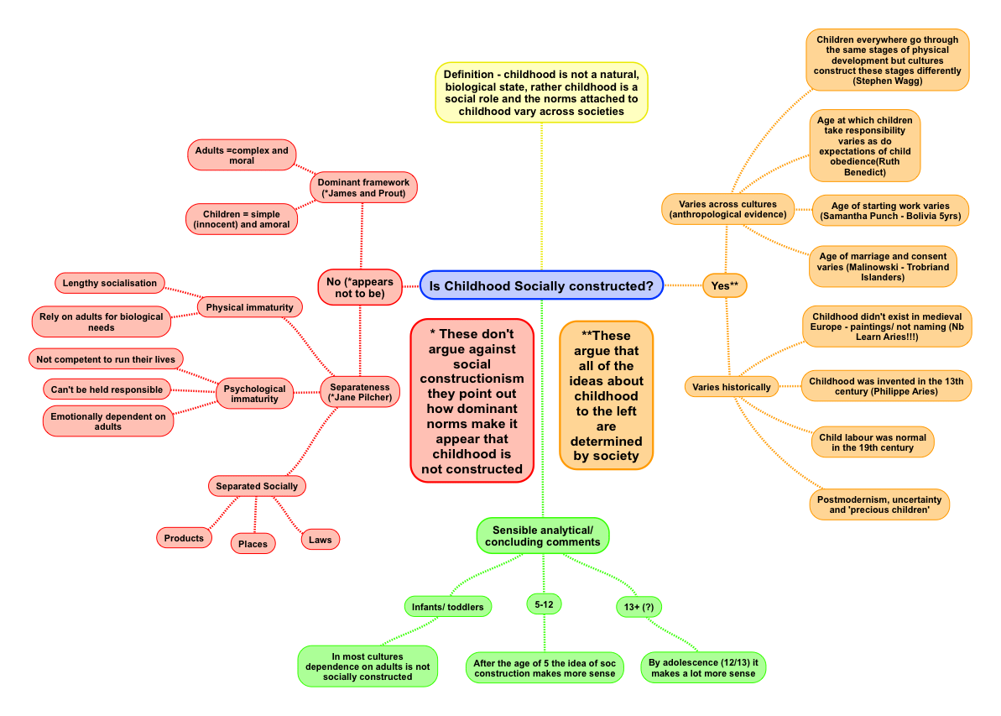
(Online Image, Thomson, 2015)
History of childhood had different views towards children in Europe. Thus, the lives of the children in the UK and Europe have changed historical periods and elaborated in three specific ways within Europe;
- Children were considered evil, the Christian perspective specifically connected with 16th and 17th Century Puritans.
- Locke’s view (1632-1704) that children are neither good nor evil are just formed due to education and the environment.
- Jean Jack Rousseau (1712-1778), children are good until adults do not manipulate them. (Kehily, 2013)
Industrial revolution (1760-1830) Children were employed using their little fingers as cheap labour and cleaning purposes. Children were forced to work long hours with little pay.
In Victorian Society (1837-1901), extreme poverty made children’s lives challenging to handle. At the only end of the period of 19thcentrury education was made compulsory. It was only in the 20th centuries developmental psychologists like Piaget, Erickson, and Freud, their theories, stated that early experiences that child suffers could affect them cognitively.
Piaget’s concept that children are active learners connecting with the world around them via play and discovery, and flourishing via a series of phases toward mature adult grasp, has been immensely influential. (Kehily, 2013). Piaget’s stage theory could determine children’s capability to understand and take the burden for their actions.
On the other hand, Erik Erikson gave the psychosocial theory of development. He proposed that humans are inspired to attain competency in many areas of life. According to Erikson, the human life span stages are distinguished by eight specific phases influenced by a crisis between two opposite forces/tendencies. One tendency is negative, and the other is positive. Each step is characterised by the conflict between these two opposing forces.
According to Erikson’s theory, the child/adolescent/person needs to successfully overcome the crisis to move to the next stage without impacting future development. On the contrary, if the problem is not overcome, this will have a negative long-term effect and influence the possibility of moving to the next stage. (Orenstein, 2020). 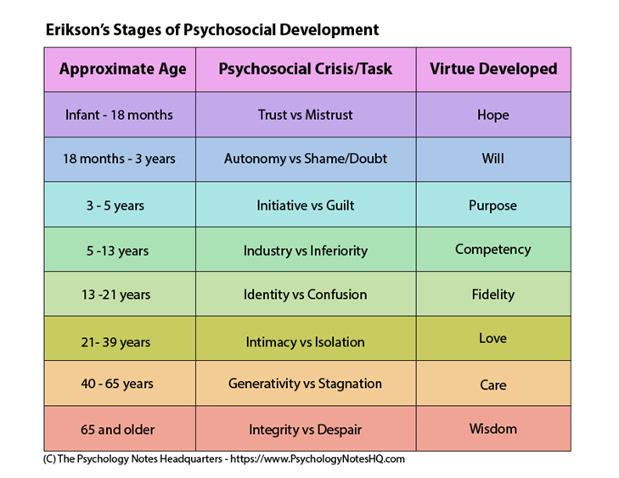(
(Simple Psychology, 2018)

Philippe Aries (1914-1984) was a person who contributed as a theorist of childhood initially after wartime. Utilising tasks of art, letters, and many other documents, he examined how the concept of childhood developed from middle age times advancing to the present.

Aries and Postman, cited in Clark (2010), discuss that the young were not recognised as children in the way we currently acknowledge them back in the old times.

As a result of higher mortality levels, families did not peril the psychological harm that occurred due to children and babies dying, so it was psychologically neutral.

In the Middle age society, the concept of childhood did not evolve yet; children lived and worked with adults, dressing in the same clothes and being responsible for the same activeness. A broader view of children considered evil impacted parents’ overprotective, and the babies became stubborn. (James et al. 1998:12)
In the Greek and Roman times, the fatality level was excessive and right after they were born, the names were not given accordingly. Unwanted babies were left to be dead. Physical appearance was valued, and if a baby had any abnormalities, they were thrown out of the cliff.
Children under seven were persuaded to stay home with their mothers and look after their younger ones. (mainly girls)
Girls stay home till they are 15, then they get married.
Boys were inspired to learn a trade.
Only wealthy boys who were seven years old and onwards were educated. That is gender inequality. (Wright 2015: 35-36).

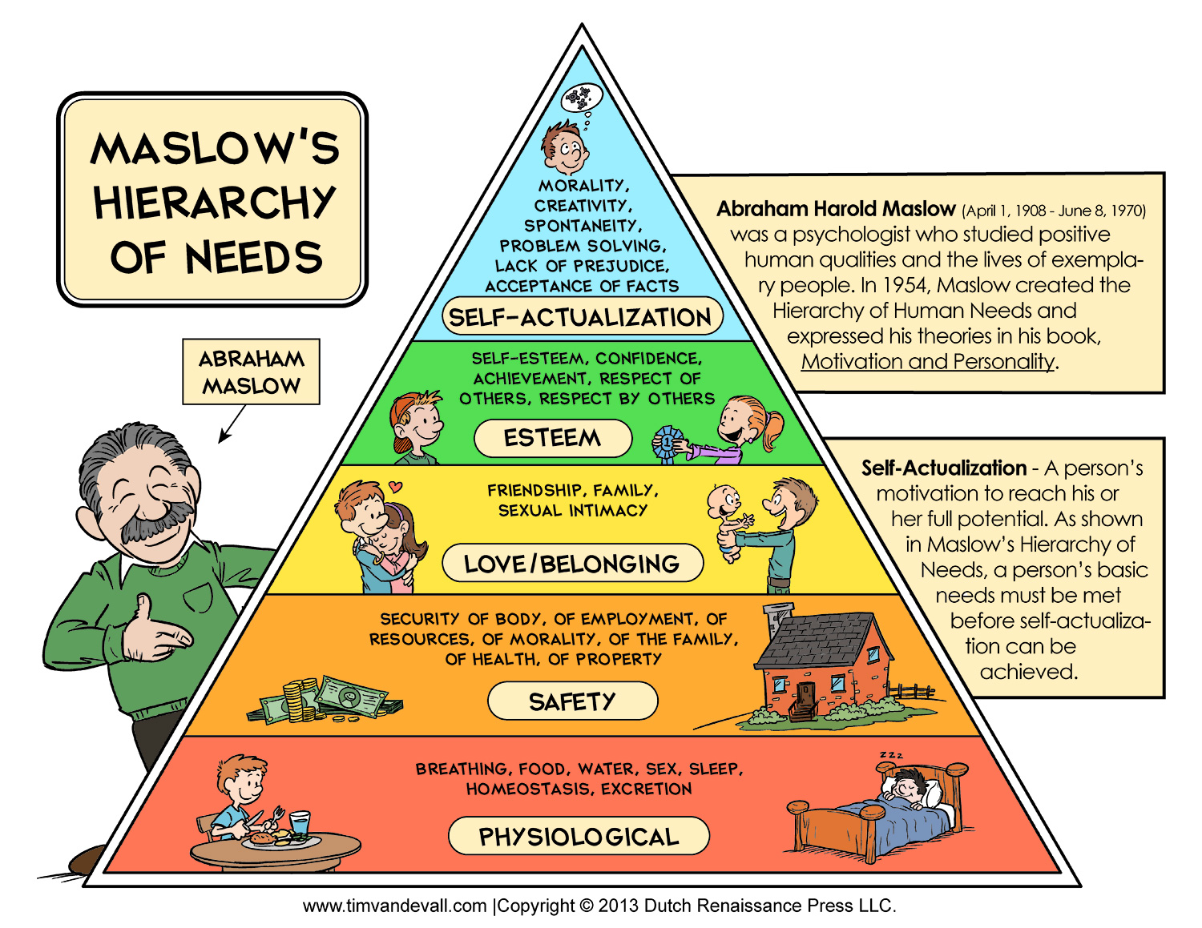
According to Maslow’s hierarchy, for a human being to achieve self-actualisation means that full potentials need to obtain other previous needs met in hierarchical order. Physiological necessities such as food, water, toilet, safety, housing and protection, connecting relationships that make us feel secure, love and belonging need to make a social connection can build self-esteem, confidence and respect for others resulting in an achievement called self-actualisation.

Policy and Legislation

The alterations that contributed to improving and progressing the lives of the children from Victorian to current times include changes in legislation and the policies, sociological factors and the emergence of child development and Neuroscience. There were several ‘factory acts’ throughout the 19th century, which gradually improved the rights of (male) workers by limiting working hours. Many of these acts prohibited factories from employing individuals of particular ages.
- The ‘1833 Factories Act’ was fundamental legislation to control child labour and was initially designed for illegal textile manufactories to employ children under 9. Required factories to supply children aged 9-13 with at least 12 hours of education a weekly.
- The 1867 Factories Act’ expanded this concept to every factory. This act made it illegal for any factors to employ children under eight and supply children aged 8-13 with at least 10 hours of education a week.
- The ‘1878 Factories Act placed a total ban on the work of children under the age of 10, implementing it with the addition of education policies. Today, ‘children can only work full-time from 16’; they must do training for that employment. Adults are working-age 18.
Children aged 13-15 can be employed, but there are limitations on the hours and the category of ‘industry’. Babysitting is the ideal one.
One of the most influential legislation was in 1880. The Education Act contributed to changing the lives of children. They initiated mandatory education for all children from the age of 5-to 11 years old. In the UK, all children must meet the required guidelines till they are 16 years old and be involved in the employability courses till they are 18. (GOV.UK., 2021).
As a result, Children now possess more time and money for themselves. Parents can have quality time with their children.
The Victorian time was difficult for children because many children suffered from higher fatality ratios. However, now, NHS supplies extensive ante-natal and post-natal care to mothers and children.
England’s policies and regulations have been administered legislation related to work, education, children’s health and safety, the United Nations Convention on the Child’s Rights (UNICEF UK, ND).
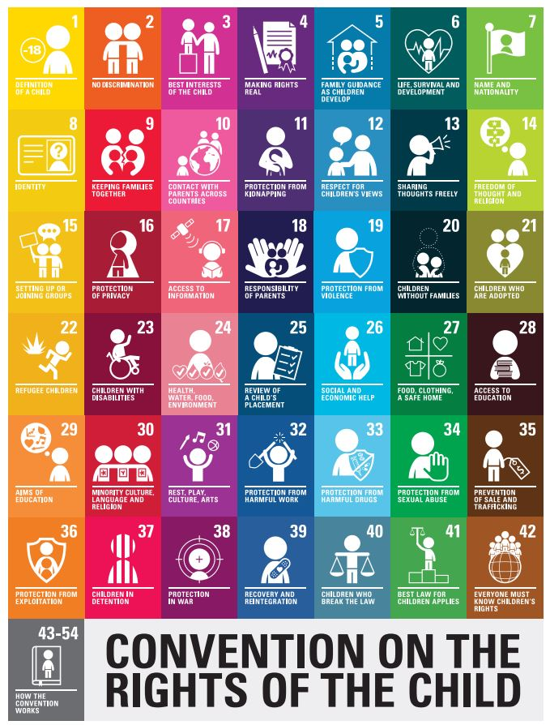

Legislation that guards children against harm and abuse, such as the sexual consent age from 16 years old and alcohol control under the age of 18 years old. This legislation has made a significant improvement in the lives of children. (NHS, 2021)
Alcohol consumption in the teenage years can be harmful and influence children’s cognitive development. (Childline, 2021)
The legislation assures to guard children against sexual abuse as sex with a child under the age of 16, which is against the law as the child under this age does not have the aptitude for giving permission.
The impact of the United Nations Conventions on the Rights of the Child (UNCRC, 1991). The essential of this convention is to make sure that every child has the right to life, education, non-discrimination, protection from harm and abuse for health progression. (Save the Children, 2021)

Legislation related to safeguarding children;

Children Act 1989, The United Nations Convention on the Rights of the Child 1992
The Human Rights Act 1998, The Education Act 2002, Every Child Matters (2003)
Designated Safeguard Lead (2004), Equality Act 2010, Children and Families Act 2014
Working Together to Safeguard Children 2018, The Children and Social Work Act 2017
Keeping Children Safe in Education 2019.
The rise of child development as a discipline of study has promoted the importance of supplying a wonderful childhood to all children, highlighting the impact of adverse outcomes on the children’s future progression. Neuroscience contributes evidence of the adverse effects on the children’s brains caused by negative experiences in the first five years of life.
This positively impacts societal factors as more families spend more time with their children. Thus, NHS supplies free healthcare to all.

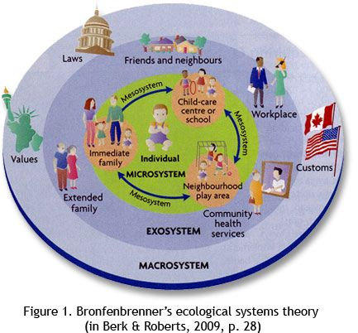Bronfenbrenner (1977) suggested that the child’s environment is an embedded formation adjustment, each accommodated within the next. He organised them to how much impact they have on a child. The idea is based on five systematic stages; the microsystem is the child that connects with family, the nursery, teachers, the playground and the relationship. The ecosystem comprises medical services, individuals in the local areas, and extended family or friends. Microsystem that is law, policy, and the values of the society.
Because the five systems are interconnected, the impact of one system on a child’s development relies on its connection with the others. Many elements influence the children's progression and psychological health, such as where they grow up, the relationship they restore, and their involvement. (NSPCC, 2022)

Conclusion
Childhood is a social construction, many changes improved the lives of children, and for that respect, good progress has been made to reduce adversities and inequalities. In the UK, many children still live in poverty to survive despite all the efforts that have been created.
According to the Rowntree Foundation (2021), there are 2.8 million children still in poverty. Prior to Covid-19, 4.3 million children lived in destitution within the UK. They are resulting in 9 per classroom of 30.
2.5 million children food instability in February and July 2021.
One million children in the UK suffer from deprivation and are not entitled to Free School Meals. (End Child Food Poverty, 2020).

Recommendation
Providing free school meals to the families is essential as primary care for their children will at least help them to have proper nutrition. (Sustain, 2021).
Reforming the current Universal support is essential.
Parents will have difficulties for caring their children in the summer as two-thirds of mothers have the same problems facing adversities due to holidays clubs are no longer available for them. (The Guardian, 2021)
A free school meal is an essential support for all children to have basic needs such as food.
Proper nutrition will assist and support children to have a better life with holistic developmental needs such as physical, cognitive, emotional and societal as per Maslow’s hierarchy of needs. Particular provision of adoption is necessary for children’s development.
Reform to Universal credit will support families prospectively. The extra financial support of £ 20 weekly given to the communities during the Covid-19 has been abolished and impacted their finances for basic daily living to provide essential care for their families. Therefore, families still suffer significantly. Despite all the efforts that anti-poverty campaigners and MP’s warning made. (The Big Issue, 2021) 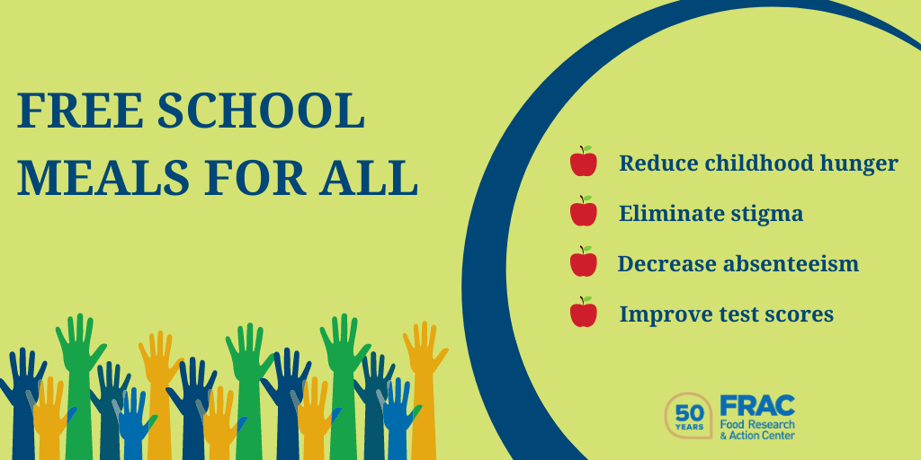
(Perez, 2021)

REFERENCES

Bronfenbrenner, U. (2005) Making human beings human: Bioecological perspectives on human development. Thousand Oaks, CA: Sage.
Childline (2021) Alcohol. [online] Available at: https://www.childline.org.uk/info-advice/you-your-body/drugs-alcohol-smoking/alcohol/ (Accessed: 26/04/2022)
Crown Prosecution Service (2019) Prostitution and Exploitation of Prostitution. [online]. Available at: https://www.cps.gov.uk/legal-guidance/prostitution-and-explotation-prostitution (Accessed: 21/04/2022).
End Child Food Poverty (2020) [online]Available at: https://endchildfoodpoverty.org/ (Accessed:27/04/2022)
GOV.UK. (2021) School Leaving age. [online] Available at: https://www.gov.uk/know-when-you-can-leave-school (Accessed: 21/04/2022)
GOV.UK (2021) Child Employment. [online] Available at: https://www.gov.uk/child-employment (Accessed: 25/04/2022)
Kehily, M.J. (2013) Understanding Childhood: A Cross-Disciplinary Approach. Milton Keynes: Open University Press
Maslow, A.H. (1954) Motivation and personality. New York, NY: Harper & Row Publishers.
McDowall Clark, R. (2013) Childhood in Society for Early Childhood Studies. 2nd Edition. London: Sage
NSPCC. (2022) Child health and development: [online] Available at: https://learning.nspcc.org.uk/child-health-development.
Orenstein, G.A, Lewis L. (2020) Erikson’s Stages of Psychosocial Development. [online]. Available at: https://www.ncbi.nlm.nih.gov/books/NBK556096/ (Accessed: 22/04/2022).
Perez, A. (2021) It’s Time for Free School Meals for All: FRAC [online] Available at: https://frac.org/blog/its-time-for-free-school-meals-for-all
Save the Children (2021) UN Convention on The Rights Of The Child: Save the Children [online] Available at: https://www.savethechildren.org.uk/what-we-do/childrens-rights/united-nations-convention-of-the-rights-of-the-child (Accessed: 26/04/2022).
Simple Psychology (2018) Erik Erikson’s Stages of Psychosocial Development [online] Available at: https://www.simplepsychology.org/Erik-Erikson.html#:~text=Erikson (Accessed:
Sustain (2021) Improve children’s access to food 365 days a year: [online] Available at: https://www.sustainweb.org/foodpoverty/childrens_access_to_food/ (Accessed: 26/04/2022).
The Big Issue (2021) Universal credit: What is it, and why does the £ 20cut matter? Big issue [online] Available at: https://www.bigissue.com/news/social-justice/iniversal-credit-what-is-it-and-why-does-the-20-increase-matter/ (Accessed: 23/04/2022)
The Guardian (2021) Two-thirds of working mothers lack summer childcare. UK survey/ [online] Available at: https://www.theguardian.com/money/2021/jul/15/two-thirds-of-working-mothers-lack-summer-childcare-uk-survey (Accessed: 26/04/2022)
The National Archives (2021) 1833 Factory Act. [online] Available at://www.nationalarchieves.gov.uk/educational/resources/1833-factory-act/ (Accessed: 26/04/2022)
UNICEF UK (ND) How we protect children’s rights [online] Available at: https://www.unicef.org.uk/what-we-do/un-convention-child-rights/amp/ (Accessed: 23/04/2022)
Yinyinlah’s Story (2013) Destination unknown campaign [online]. Available at: https://youtu.be/-5FJqr1YriQ (Accessed: 21/04/2022)

