ASSIGNMENT 2:

MARRIOTT HOTEL INTERNATIONAL

Financial Management for the Hotel Industry

Student Name: George Costin Andricencu

Student ID: 2025562

MODULE NAME: BMIH 5007

LECTURER’S NAME: Dale Clarke

Executive Summary
With the use of financial ratios, this study assessed Marriott International Inc's performance indicators. The American international corporation (MNC) formed by J. Williard and Alice Marriott in 1927 includes hotels, resorts, office buildings, and residential properties all over the world. Income, loading, and debt are only a few of the ratios that were used to compare the company's performance in 2020 and 2021. The benefits and drawbacks of using ratios in the hospitality industry were thoroughly analyzed. The report's focus was on the company's use of ratios in making important judgment calls.

Table of Contents
Executive Summary 1
Introduction 3
Financial Analysis Trends 4
Profitability 4
Liquidity 4
Gearing 4
Knowledge from Ratio Analysis 4
Benefits and Limitations of Ratio Analysis 4
Conclusion (average of 10% of word count) 5
Bibliography 6

Introduction
The report will evaluate the measurement of performance of Marriott International Inc by using the financial ratio. The MNC (multinational company) of America founded by J. Williard and Alice Marriott in 1927 and has operations in multiple localities, branches in the hospitality industry, properties as well as residential. The following ratio such as profitability, gearing and leverage will be used in the report to analyze its position in 2021 and the preceding year. It will critically examine the ratio demerits and uses for the hospitality business. The report will cover the use of ratios by the entity to grasp crucial decisions.

Financial Analysis Trends
The financials of the Marriott entity will be discussed by the following ratio such as profitability, gearing and liquidity to distinguish the performance for the years 2021 and 2020. The overall performance of Marriott increases in 2021 in contrast to the preceding year which is measured below by using key ratios given below. The charts are also used to analyze the entity’s performance for the year. There is also various types of ratios that can be used to analyze the financial position such as the efficiency ratio. The time taken by the firm to collect its money is 61 days in 2020 to 52 days in 2021 (Abad-Segura, and González-Zamar, 2020).

Profitability
There are various ratios available to measure the profitability of the entity but majorly the performance is measured by using the gross income, operating margin, and net margin ratio.
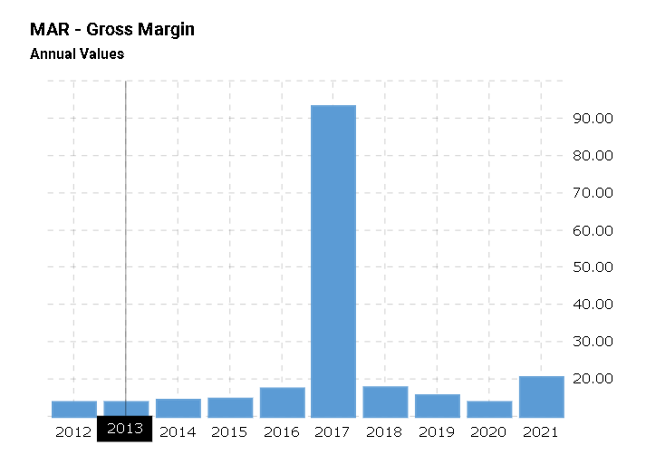
Figure 1: Bar chart of Gross Margin
Source: Macrotrends
The gross income ratio of Marriot Inc for the year 2020 is 13.80% and year 2021 is 20.21%. This can be shown in the above chart that the profits are better in 2021 as compared to the preceding period. The pattern followed is positive for the entity as contrasting with the previous results.
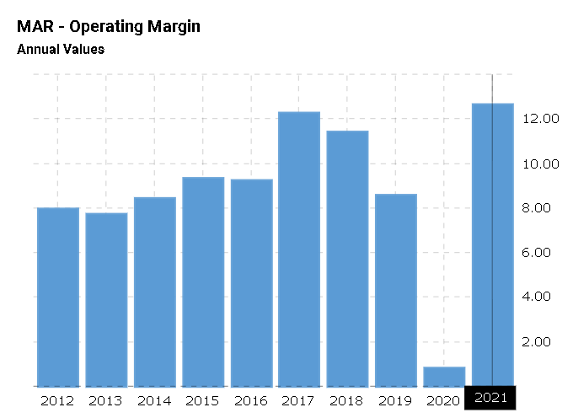
Figure 2: Operating income margin
Source: Macrotrends
The above figure shows the operating income earned by Marriott in the year 2020 is 0.7% and in the year 2021 is 12.62% a significant shift in the profit is addressed in 2021 which is very optimal for them (Abad-Segura, and González-Zamar, 2020).
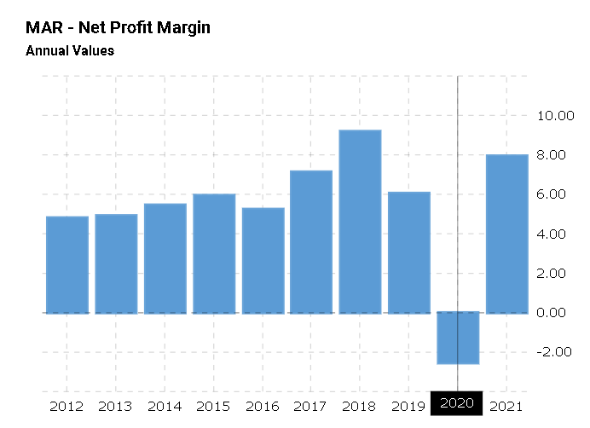
Figure 3: Net income margin
Source: Macrotrends
Figure 3 demonstrates that Marriott Inc in 2020 had a net loss of 2.52% and in 2021 it earns a 7.93% net profit from its revenue. The rise of 10.45% is noticed in the year as measured with the previous year. The positive trend in the results is shown in the Marriott.

Liquidity
To measure the cash position of the entity this ratio is used which checks whether Marriott has the optimal cash or not. To measure liquidity entity uses the current ratio.
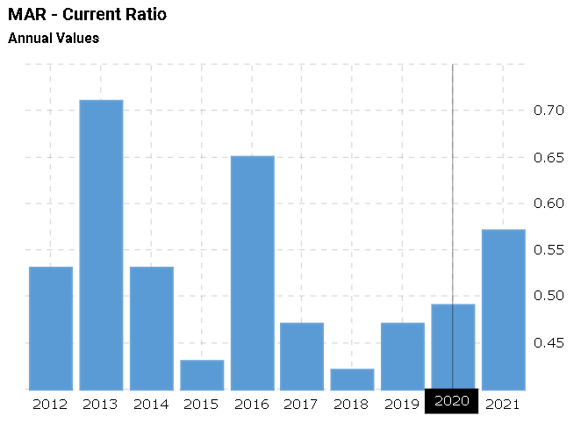
Figure 4: Current ratio
Source: Macrotrends
To check the firm’s capacity to pay its regular costs the current ratio will be used. The result of Marriott for the year 2020 is 0.49 and for the year 2021 is 0.56. The ratio improves in 2021 in a contrast to the preceding year. In general ratio equal or above to 2x would be the ideal case for any entity as the cash required by every entity to pay out its liabilities on time (Alshehhi, Nobanee, and Khare, 2018).

Gearing
To measure the gearing ratio debt-to-equity and long-term debt-to-capital are also measured to check the firm’s proportion of debt and equity to generate funding for the organization.
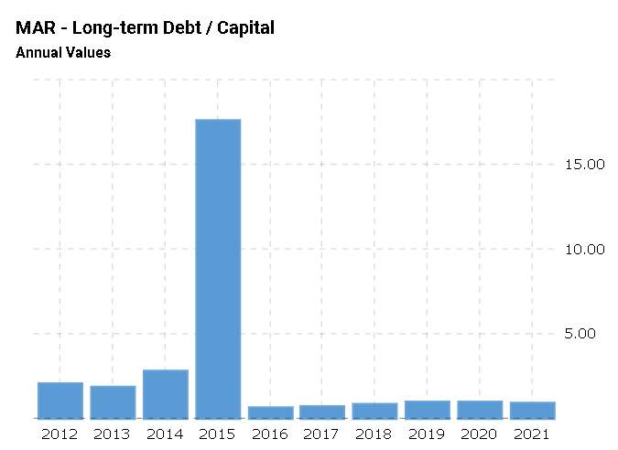
Figure 5: Long-term debt over capital
Source: Macrotrends

The above graph demonstrates that both year 2020 and 2021 in proportion to long-term borrowing over capital has not had much variability. The proportion decreases a little in 2021 in contrast with the year 2020. The proportion of the ratio in the year 2020 is 0.95 and in the year 2020 is 0.86. The firm needs to operate with a better proportion of borrowing and capital (Gundes, Atakul, and Buyukyoran, 2019).
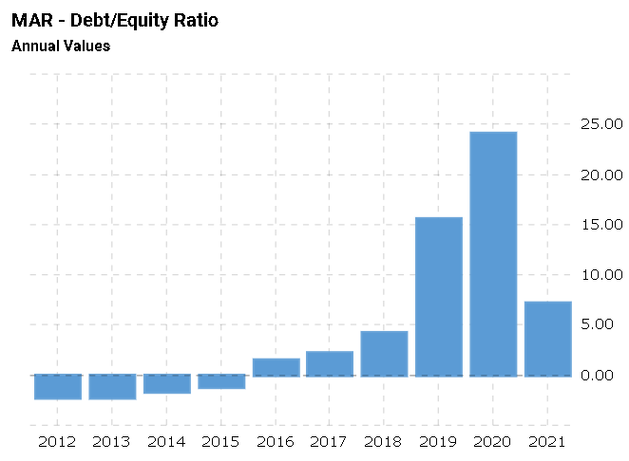
Figure 6: Debt-to-equity ratio
Source: Macrotrends
The debt-to-equity ratio of Marriott for the year 2020 is 24.13 which means the entity uses its current debt more as its long-term debt proportion is not much high. The entity might take the overdraft in that year to meet its expenses. The downfall in the debt was also reflected in the year 2021 as there is a significant shift from 24.13 to 7.16.

Knowledge from Ratio Analysis
b) Need to examine the drawback of ratio analysis, including the fluctuations arised in Hotel management and analysing the information seen in their financial statements (Pascal et al., 2021).

Benefits and Limitations of Ratio Analysis
Ratio analyses are only useful if they are based on comparable data. Lack of data on norms in the sector or historical results will restrict study. In order to evaluate the hotel sector's success, sufficient data is required for comparison with earlier periods. Hotel operations take place in an ever-evolving dynamic environment, making it difficult to draw meaningful comparisons and rendering financial ratios mostly irrelevant (EDUCBA. 2020).
Ratios are calculated using financial documents like the income statement/profit and loss account and the balance sheet, which are both limited by the nature of historical cost accounting. Inter-company and historical pricing comparisons might be skewed by inflation, different asset valuation methodologies, and other factors. Although this ratio is useful for comparing hotel performance over time, the fact that it is based on past costs means that it may not be able to account for fluctuations in the hotel industry's pricing strategy throughout the period covered by the ratio (‌Vaidya, 2019).
You may learn more about a corporation by analysing its ratios. The accuracy of the ratios and the depth of the image both rely on the accuracy of the underlying financial data. Poorly prepared accounts (such as those with inaccurate estimates of depreciation, bad debts, etc.) may lead to erroneous inferences derived from accounting ratios. There might be a number of reasons why a company's performance drops that the ratio doesn't pick up on, leading it in the incorrect direction. The company needs professional evaluation of the financial analysis of the corporation since it might lead to false conclusions.
The success of a firm in the past does not guarantee its continued success in the future. In fact, data may become stale by the time it is released and analysed. For example, Marriott's 2020 results are disastrous but might improve in 2021. While the ratio might provide you a general idea of the entity's financial health, it can't pinpoint the exact cause of a decline in performance (Soonthornchai, Namnai, and Apichottanakun, 2019).
c) Outline your understanding of ratios and their importance for decision-making.
Examination of Financial Reports
For both internal and external stakeholders, it is crucial that the company's financial statements and data be properly interpreted. We analyse the statistics in the income statement and balance sheet with the use of ratios. When it comes to monetary returns, each stakeholder has their own priorities. Long-term profit growth and dividend payments are of greater importance to equity investors. Creditors need prompt payment in order to avoid late fees and interest (Bragg, 2022).
Facilitates an Appreciation of the Business' Profitability
The profitability of a business may be gauged using several profitability ratios. Knowing the company's ROA and ROE might shed light on how profitable it is. The return on assets metric is calculated by dividing net income by total assets. It indicates how much money a business makes back on every dollar it spends. Profit after tax divided by stockholders' equity is known as return on equity. This ratio indicates the efficiency with which a business spends its investors' money. Profit margins (both gross and net) and other such ratios. Profit margins are a useful metric for assessing a company's capacity to generate revenue that can be reinvested.
Evaluation of Businesses' Productivity in Their Own Operations
We may evaluate the level of efficiency of the businesses by using a variety of ratios. Calculations such as the accounts receivable turnover ratio Receivables Turnover Statements Accounts receivable turnover, also known as debtor's turnover, is a metric used to assess a business's efficiency in offering credit to customers and collecting payments from them in a timely manner. Read more about the formula for calculating the accounts receivable turnover ratio, the fixed asset turnover ratio, and the inventory turnover ratio here. These ratios may be compared to similar businesses in the same sector to see which ones are being handled most effectively. To continue, it is a gauge of an organization's capacity to turn its assets into cash. Third, it analyses the company in its whole, including its cash flow, debtor payment terms, and inventory conversion times. That's why efficiency ratios are so important; boosting them means more money in your pocket (‌BBC Bitesize, 2022).
Companies' Availability of Working Capital
The company's ability to meet its short-term commitments is a measure of its liquidity. To clarify, we're referring to financial commitments and liabilities that may be settled in a year's time or less, or the business cycle. Things include unpaid wages, bills, taxes, and other such costs. Firm liquidity is measured by the current and quick ratios.

Conclusion
The report evaluated the financial ratio of Marriott Inc for the years 2020 and 2021. The result of the entity was measured in the study and provides that the result of Marriott Inc is better in 2021 as contrasted with the previous year which is 2020. The report helped to understand the concept of financial ratios used by enterprises and significantly hospitality sector such as profitability, gearing as well as liquidity ratios.
The report critically discussed the financial ratio used by the entity to take significant decisions. The merits of the financial ratio to take essential decisions would be covered with its various limitations in this report. The report helped to analyze that there are various reasons which can affect the financial position of the hospitality sector.

Bibliography
Abad-Segura, E. and González-Zamar, M.D., 2020. Global research trends in financial transactions. Mathematics, 8(4), p.614. https://www.mdpi.com/2227-7390/8/4/614/pdf
Alshehhi, A., Nobanee, H. and Khare, N., 2018. The impact of sustainability practices on corporate financial performance: Literature trends and future research potential. Sustainability, 10(2), p.494. https://www.mdpi.com/2071-1050/10/2/494/pdf
‌BBC Bitesize. 2022. Purpose and limitations of Ratio Analysis - Ratios - Higher Business management Revision - BBC Bitesize. [online] Available at: https://www.bbc.co.uk/bitesize/guides/zrxn47h/revision/5 [Accessed 26 Nov. 2022].
‌Bragg, S. 2022. AccountingTools. [online] AccountingTools. Available at: https://www.accountingtools.com/articles/what-are-the-limitations-of-ratio-analysis.html [Accessed 26 Nov. 2022].
EDUCBA. 2020. Advantages of Ratio Analysis | Top 10 Advantages with Explanation. [online] Available at: https://www.educba.com/advantages-of-ratio-analysis/ [Accessed 26 Nov. 2022].
Gundes, S., Atakul, N. and Buyukyoran, F., 2019. Financial issues in construction companies: bibliometric analysis and trends. Canadian Journal of Civil Engineering, 46(6), pp.329-337. https://www.academia.edu/download/61325499/Financial_issues_in_construction_companies.pdf
Macrotrends.net. (2022). Marriott Financial Ratios for Analysis 2009-2022 | MAR. [online] Available at: https://www.macrotrends.net/stocks/charts/MAR/marriott/financial-ratios [Accessed 25 Nov. 2022].
Pascal, M., Moreno, C., Dávila, I., Tabar, A.I., Bartra, J., Labrador, M. and Luengo, O., 2021. Integration of in vitro allergy test results and ratio analysis for the diagnosis and treatment of allergic patients (INTEGRA). Clinical and Translational Allergy, 11(7), p.e12052. https://onlinelibrary.wiley.com/doi/pdf/10.1002/clt2.12052
Soonthornchai, P., Namnai, K. and Apichottanakun, R., 2019. Financial Ratio Analysis that Challenges the Dairy Farmers to Enhance their Ability in Financial Management. Veridian E-Journal, Silpakorn University (Humanities, Social Sciences and arts), 12(6), pp.2093-2109. https://he02.tci-thaijo.org/index.php/Veridian-E-Journal/article/download/193431/161142
‌Vaidya, D. 2019. Ratio Analysis Advantages. [online] WallStreetMojo. Available at: https://www.wallstreetmojo.com/ratio-analysis-advantages/ [Accessed 26 Nov. 2022].

