Kelly Ann Whitcombe
P144754 | Graphic Design
branding and advertising: Past, present, and future
DISSERTATION PROPOSAL

Branding and Advertising: Past, Present, and Future

Throughout time, branding and advertising have been through various changes. From the emergence of the printing press, the invention of the television, and the boom of the internet. Branding and advertising have adapted to these changes and continue to suit new mediums for an increasingly opinionated audience. (Gallegos, 2016) I will explore the evolution of advertising and the way companies and people brand themselves in the past, present, and where it is heading in the future through current statistics. Thus, presenting my three keywords: Past, Present, and Future. These will be backed up by popular advertising techniques used by companies or people, such as, Marlboro, Kellogg’s, Cadbury, and Elon Musk. We learn not only by our successes but by our loses too, so I will be looking at advertisements that did not hit the mark and lost consumers because of it, such as, Pepsi, Dove, and Burger King. (Steinberg, 2017)

Past:
In the late 1800s, manufacturers had to think of ways to advertise their goods, which became more commoditized, to sell. Back then, printed advertisements were line-art with text all in black and white. Technology was not advance enough to produce prints will real pictures or photographs; however, it worked. (Soler, 2013)
Fast forward to the 1920s, the use of color grew immensely, along with large art-deco styled illustrations. A lot of text were used in their prints, which worked for a while, but sales began to slowly drop and the way we advertise and branded our products had to evolve once again to keep hold of their audience. (Soler, 2013)
We added information, color, and illustrations, but what was missing? Now was the time to add emotion into the mix. In the 1960s, advertisements tried to make their audience feel a certain way, whether it made you feel happy, curious, or even brave. It set a new viewpoint for people, convincing them they should buy or support something for whatever reason. (Soler, 2013) George Lois, advertising communicator who is well-known for his tons of marketing miracles that prompted innovative and populist changes in the world, related advertising to poison gas. He says, “Advertising is poison gas. The important thing is got to be that you implant an idea out there and everybody in a very human way understands it, grasps it, and is excited by it. If that end result doesn’t happen, I don’t care how beautiful I think something is, or how exciting the language is, if people don’t react, I’ve struck out.” (George Lois, n.d.)
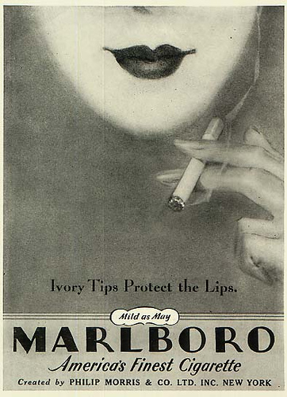
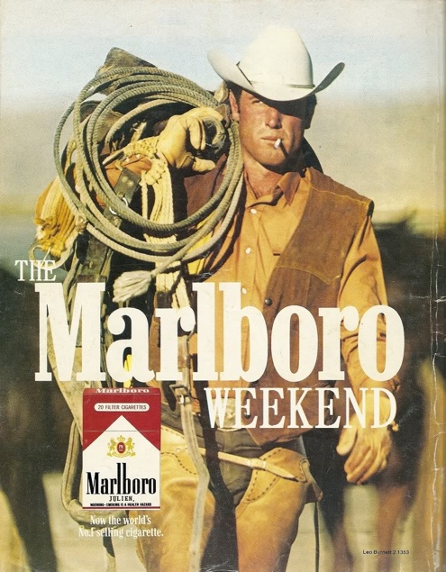
With the invention of the television, advertisements reached a whole new high. To create a connection between brands and their target audience, characters were developed around products and celebrities were used to sell everything and anything. For example, Marlborough Man, a well-known figure in the 1960s to the 1990s, was used to sell Marlboro cigarettes to more men. Before Marlborough Man, Marlboro aimed their product mainly towards women. (Gallegos, 2016)
Figure 1 Philip Morris, (1960), Marlboro
Figure 2 Marlboro, (1970), The Marlboro Weekend
However, in the 1950s, new studies arose that cigarettes cause cancer which got all cigarette companies scared and lost on what they were supposed to do. This is when Marlboro had to make a big turn and change their target audience to men and became the first ever lifestyle advertisers. What is lifestyle advertisement? It is when a brand tries to tie its product to something else in your life. This could be trying to sell a feeling, identity, attribute, satisfaction etc. For instance, Red Bull tries to sell “Athleticism” or GoPro tries to sell “Adventure” or Coke-Cola tries to sell “Happiness.” (Coffee Break, 2016)
People no longer wanted to be told the facts or information of a product rather the feeling it can give you and that’s what Marlboro did. With Marlborough Man who is a smoking, hardworking cowboy and living free, it gave the impression that you could be just like him with Marlboro cigarettes. So now instead of just focusing on selling the cigarettes, they were selling freedom and manliness too. Marlboro became one of the best-selling cigarettes and changed the advertising game forever. (Coffee Break, 2016)
I will also be looking at Kellogg’s Frosted Flakes and their character Tony the Tiger that is tied in with the product, as well as, Rice Krispies and their characters Snap, Crackle and Pop the gnomes. (Gallegos, 2016)

Present:
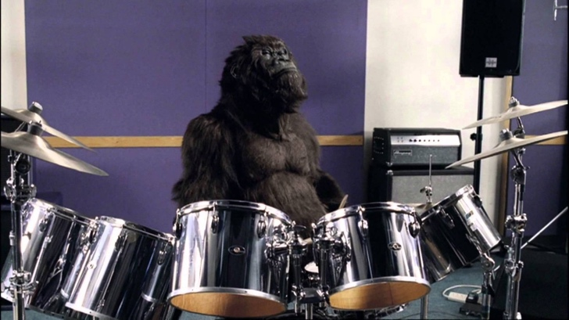
Now we realise the product does not have to be the centerpiece. Advertisements now try to home in on building a community and up their brand awareness. Brands want their advertisements to go viral, because they are either strange, so out there, or funny. A popular example would be the 2007 Cadbury Dairy Milk Gorilla advert. The advert did not even mention Cadbury. The advert consisted of a gorilla playing the drums to a well-known song, In the Air Tonight by (Phil Collins, 1981) . It was so bizarre and funny that people wanted to share it, and it spread like wild fire. Cadbury wanted everyone to feel like the brand was “cool” and a must-have. Who would not want to be as cool as a drum-playing gorilla? There are over 300 spoofs or parodies of the advert on the internet. (Gallegos, 2016)
Brands nowadays have better technology now to narrow down their target audience and who they want to advertise to.
Figure 3 A Glass and a Half Full Productions, (2007), Cadbury "Gorilla"
“Thanks to digital-production techniques, it’s easier than ever to get an ad on the air. And thanks to reams of consumer data culled from web-browser maneuvers, set-top box interactions and shopping patterns, it’s simple for an advertiser to devise a campaign aimed directly at a soda-drinker, new car buyer or first-time mother. In 2017, there’s no excuse for an advertiser not to know their target audience intimately.” (Steinberg, 2017)
However, brands still seem to miss the mark, badly. For instance, the 2017 Pepsi advert with famous model and public figure, Kendall Jenner. The advert featured Jenner at a photoshoot, but notices a crowd outside protesting with signs calling out for love. She joins the protest and they come up to a line of policemen where she hands over a can of Pepsi to one of the police officers, who takes a sip and smiles. Pepsi suffered extreme backlash and the protest ignited one of its own. People criticized Pepsi for being inconsiderate towards the Black Lives Matter movement, suggesting if the protestors were kinder (aka give police officers Pepsi) issues could be resolved. Pepsi pulled the advert and published a public apology, saying that it was not their intention to be insensitive to any protest or movement (Tom Batchelor, 2017). will explore other brands’ hits and misses, such as, the highly-anticipated John Lewis adverts, Burger King, and Dove (Steinberg, 2017) .
I will explore user-generated content as well in advertising. Brands today are trying to build trust between them are their consumers by partnering up with people who would buy the product. So basically, consumers are becoming the advertisers. A popular route most brands seem to be taking today is getting youtubers to promote and advertise their products. Even though youtubers today could be considered celebrities with the number of followers they have, youtubers still seem more like real people and are trustworthy to their viewers. This is a great method for brands that want to establish that trust to their target audience. (Gallegos, 2016)
A successful way a brand has gained their consumers trust is Patagonia clothing. They released an advert promoting and encouraging their customers to send back worn and torn items they have purchased to get fixed, oppose to trying to make them purchase new clothing items. “Think about it logically: if a brand is encouraging you to send back a product if it’s broken, you’re more likely to think it won’t break, because why the heck would they promise to do that if they’re selling a shoddy product?” (Gallegos, 2016)

Future:
Without a doubt, technology will continue to shape the future of not only advertising but everything. Technology continues to grow and develop, with 3D, augmented reality, and virtual reality. Brands and advertisers who are not keeping up with the times will soon be left behind. Josh Line, Executive Vice President, Marketing and Creative at Comedy Central says,
“There’s a lot of skepticism about the future of advertising, and so it’s daunting to make a prediction when things are changing so quickly. But I would argue advertising will be better and more valuable in the hearts and minds of consumers and, as a result, more effective. The forces of digital disruption are empowering consumers to get what they want, when they want it. And increasingly that means that they don’t want to be interrupted by an ad that isn’t good or relevant. That pressure is a good thing because it forces us to do better.” (Abramovich, 2017)

For my dissertation, I want to look into more details about virtual reality and where advertisement is heading with it. With the help of statistics of where advertising is going and valuable opinions of CEOs and creators, such as, Mark Read, Keith Eadie, and Mike Avon. I would also like to dig further on how people brand themselves for the future, like entrepreneur, Elon Musk. (Abramovich, 2017)
Elon Musk is CEO to Tesla and SpaceX and is known to be a visionary. “Musk is the unique case of an entrepreneur who is both internally and externally a champion of the brand. His social media reputation management for Tesla keeps the brand accessible, and he is hands-on on the business side (he is known to work 100 hours a week). His system of aspirational branding has positioned Tesla at the forefront of emerging technology, giving it the legitimacy to continue pushing the envelope. In short, Musk has ensured that his internal and external brand management reinforce and strengthen one another.” (Barua, 2015) How has he branded and advertised himself as well as his companies so well to the masses? He is quite down to earth and is always vocal to whoever wants to listen. Many people look up to him as an icon. Musk has always been passionate about reducing global warming and saving the world by using sustainable energy. He has used that passion to strive as an entrepreneur and inventor with SpaceX, Tesla, and SolarCity. Being passionate about something, especially global warming, is something a lot of people can relate to, and that is what makes Elon Musk so likable and perhaps trustworthy, which I have mentioned earlier is a key factor to advertising to the masses. (Brown, 2018)
Going into 2018, Elon Musk acknowledged his hardworking team and their great effort in creating and building Tesla vehicles, as well as, thanked everyone who owns a Tesla around the world. In the end however, he asked, “How can we improve further?” People could respond and send direct feedback on how he can further satisfy his customers’ needs. He did not stop there. Musk also took it upon himself to acknowledge the feedback and respond back. He is known to always bring his thoughts, ideas, and plans to social media, especially twitter, to show how transparent he is with his companies and what is going on “behind the scenes”, as well as, respond to customers who comment. (Brown, 2018)
I also want to touch upon the subject of data protection and how brands use data on the internet to target their audience to a specific group of people. This is a very recent battle between companies, advertisers, and consumers. Especially since Facebook and their data protection scandal all over the news. In my dissertation, I want to discuss how ad blocking and data protection could affect the advertising business. “Apple has been scaring up apocalyptic predictions for the future of advertising ever since it said its forthcoming mobile operating system would make it easier for apps to block ads in Safari browsers on the iPhone. Encouraged by the company, the scenario goes, consumers will shut marketers out to surf a perceived faster, cleaner, less-invasive web until the free internet collapses for lack of ad revenue.” (Maureen Morrison, 2015)
As a conclusion, my dissertation will consist of the three keywords: Past, Present, and Future. I will discuss these elements in Advertising and Branding and how it was, is and might be. It is a forever changing and evolving subject that is so important in our everyday lives. Are we changing the way advertising evolves or does it change us?

Bibliography

Abramovich, G. (2017) 7 Predictions About The Future Of Advertising. Online Available at: www.cmo.com/features/articles/2017/9/29/predictions-on-the-future-of-advertising-exb.html#gs.KLyRJlU (Accessed 02 May 2018).
A Glass and a Half Full Productions, (2007), Cadbury "Gorilla" (ONLINE). Available at: https://www.campaignlive.co.uk/article/cadbury-gorilla-wins-campaign-year/773064 (Accessed 4 May 2018).

Barua, M. (2015) How to Be a Brand Champion. Online Available at: https://blog.percolate.com/2015/08/what-elon-musk-and-richard-branson-have-in-common-a-system/ (Accessed 02 May 2018)
Brown, D., 2018. 1 Question Elon Musk Asked Tesla Customers That Was Crucial to the Brand's Reputation. (Online)
Available at: https://www.inc.com/david-brown/elon-musk-built-his-personal-brand-in-a-way-all-founders-should-emulate.html
(Accessed 02 May 2018).
Coffee Break, 2016. How Marlboro Changed Advertising Forever. (Video)
Available at: https://www.youtube.com/watch?v=q3mlO2bzHV8
(Accessed 29 April 2018).
Gallegos, J. A., 2016. The History and Evolution of Advertising. (Online)
Available at: www.tintup.com/blog/history-evolution-advertising-marketing/
(Accessed 29 April 2018).
George Lois, n.d. Biography. (Online)
Available at: www.georgelois.com/biography.html
(Accessed 29 April 2018).
Marlboro, (1970), The Marlboro Weekend (ONLINE). Available at: http://bossa.mx/2017/06/fun-facts-de-las-marcas-mas-famosas-del-mundo/ (Accessed 4 May 2018).
Maureen Morrison, T. P., 2015. Yes, There is a War on Advertising. Now What?. (Online)
Available at: http://adage.com/article/print-edition/a-war-advertising/300336/
(Accessed 02 May 2018).
Soler, M., 2013. Advertising's Past, Present, and Future: A Viewpoint. (Online)
Available at: martinsoler.com/insights/advertisings-past-present-and-future-a-viewpoint
(Accessed 29 April 2018).
Steinberg, B., 2017. Best and Worst Ads of 2017. (Online)
Available at: variety.com/2017/biz/news/best-and-worst-commercials-2017-pepsi-kendall-jenner-john-oliver-coca-cola-1202637371/
(Accessed 28 April 2018).
Tom Batchelor, C. H., 2017. Pepsi advert with Kendall Jenner pulled after huge backlash. (Online)
Available at:
(Accessed 01 May 2018).
Philip Morris, (1960), Marlboro (ONLINE). Available at: https://thesocietypages.org/socimages/2012/02/27/torches-of-freedom-women-and-smoking-propaganda/ (Accessed 4 May 2018).

