DS3: Digital Portfolio + Audio Reflection
What you are expected to do:​
Choose 3–5 pieces of digital work from this module. Examples:
  - Your spreadsheet
  - A document
  - A PowerPoint slide
  - A simple one page layout from Adobe Express
Record a short audio or video (5 minutes). Talk about:
  - What your portfolio shows
  - What skills you used
  - What tools you can use well now
  - What was hard at the start
  - What you can now do alone
  - How these skills help you in study, work, or daily life

Continue in this interactive book to learn more about this assessment, and understand how your work will be marked.

Your assessment for the module
You will do three assessments in this module that are connected as part of a portfolio.
They help you learn new digital skills and show your progress.
The three assessments are:
- DS1: My Digital Life – 20% (Due in Week 4)​
- DS2: Business Digital Task – 40% (Due in Week 7)​
- DS3: Digital Portfolio + Audio Reflection – 40% (Due in Week 10)​
In this resource, you will learn more about the third task.
What is this resource designed to do?

Awylson da Cruz/ID: 2542300

DS3: Digital Portfolio + Audio Reflection

1. What you are expected to do:​
A) Choose 3–5 pieces of digital work from this module
Outlook SD1 Screenshots: (is about learning how to send email and receive, open inbox, also write a subject)
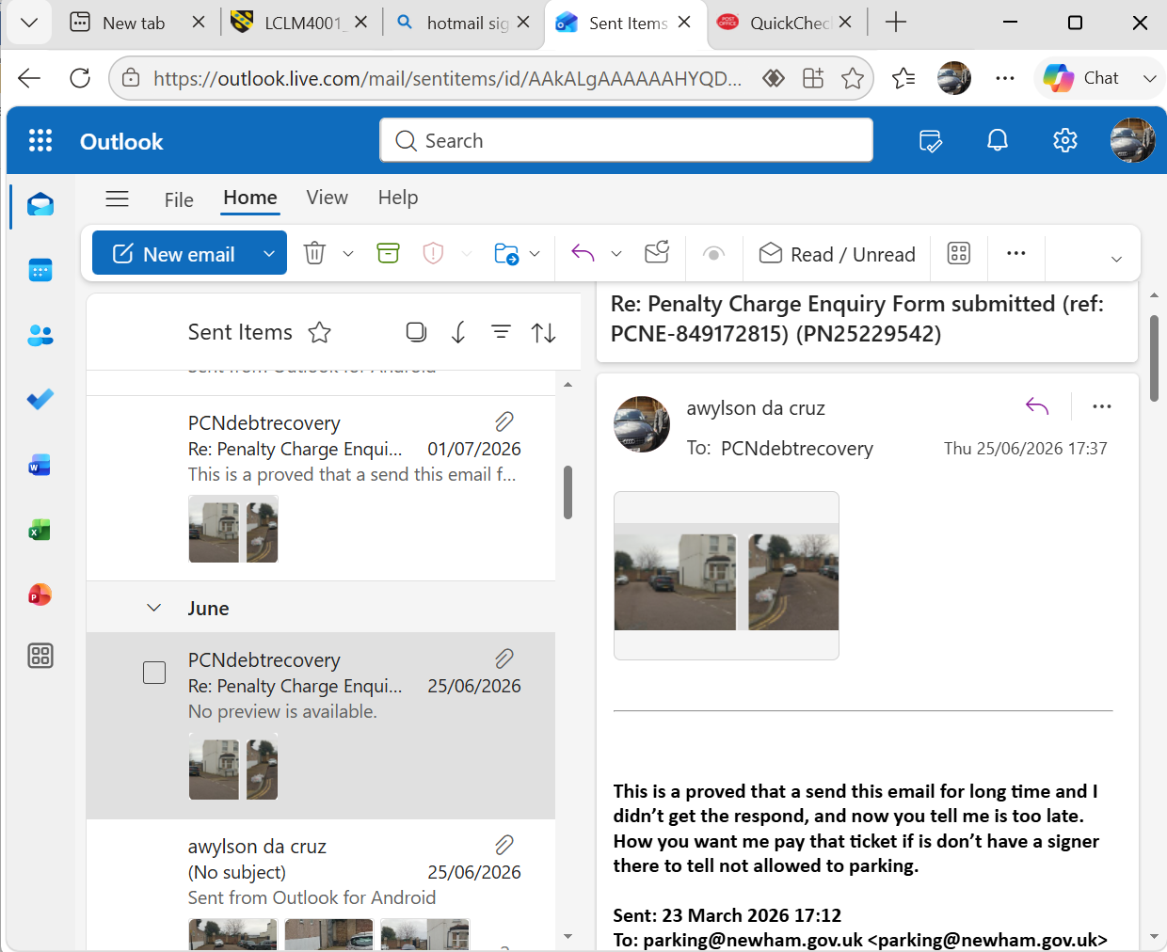

Excel DS2 Greenleaf Grocers: (Is about typing data, adding numbers, making tables, and creating charts)

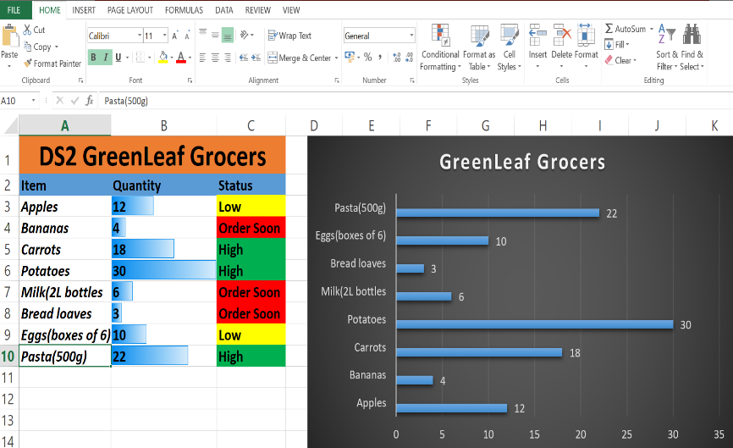
Word 2013: (Is a program for writing. You can type words, make letters, add pictures, make tables, and print your work).
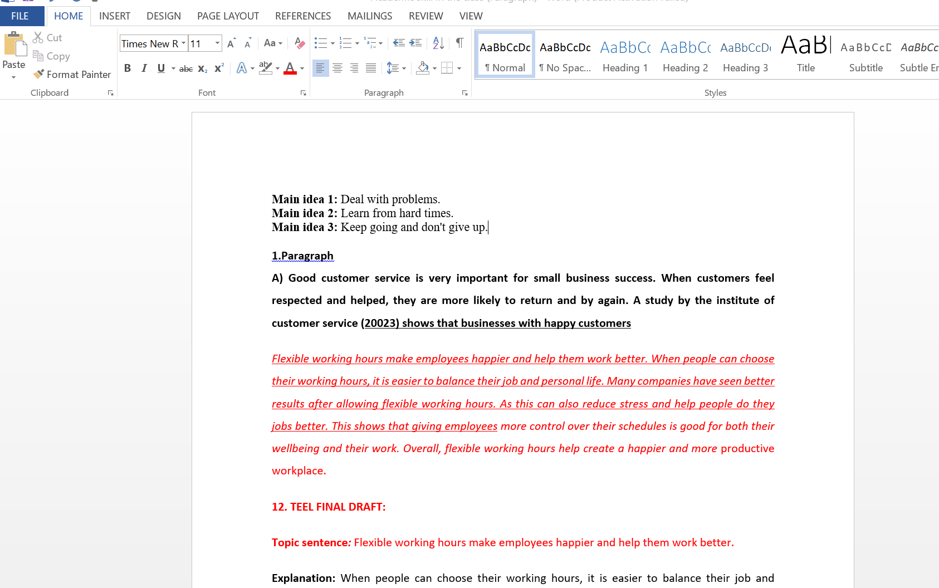

2. What do you need to include?
A) What your portfolio shows
My portfolio shows the work I did in this class. It has my Outlook, Excel, and Word work. It shows the digital skill I learned and how I can use those programs better now. I have improved my digital skills and I feel more confident using them
B) What skills you used
I used Word to write my work. I used Excel to make a table and use simple formulas. I used Outlook to send emails. I also learned how to save and organise my work.
C) What tools you can use well now
Now I can use Microsoft Word, Microsoft Excel, and Microsoft Outlook. I can use these programs by myself.
D) What was hard at the start?
At the start, Excel was hard for me. I did not know how to use formulas. Outlook was also new for me. After some practice, it became easier. Now I can use both better,
E) What you can now do alone
Now I can write documents, make spreadsheets, and send emails without help. I feel happy and more confident.
F) How these skills help you in study, work, or daily life

These skills help me at school because I can do my work better. They will help me get a job because many jobs use Word, Excel, and Outlook. They also help me in my daily life.

3. Record a short audio or video (5 minutes). Talk about Digital Tool that you learn.

Hello everyone.
My name is Awylson da Cruz.
Today, I would like to talk about my digital portfolio and the skills I learned in this course. My portfolio shows the work I did in this class. It includes my Microsoft Word work, Microsoft Excel work, and Microsoft Outlook work.
During this course, I learned many new computer skills. I learned how to use Microsoft Word to write and edit documents. I can save my work, change text, and create documents. I also learned how to use Microsoft Excel. At the beginning, Excel was difficult for me because I did not know how to use formulas. Now, I can create tables and use simple formulas.
I learned how to use Microsoft Outlook too. I can now send emails and reply to emails. Now I can use Word, Excel, and Outlook by myself. I feel happy and more confident using these computer programs.
These skills help me in my studies because I can complete my work using a computer. They can also help me in the future because many jobs use Microsoft Word, Excel, and Outlook.
I am happy with what I have learned in this course. I will continue practising to improve my digital skills.
Thank you for listening.

