Jayne Stead - 2126373
Rita Martinaitiene - 2128402
Hasan Nazmul
Managing Enterprise in the 21st Century
BMSW4006

Contents Page

Pg1 – Title Page
Pg2 – Table of contents
Pg3 – Executive Summary/Business overview
Pg4 – Services/Price list
Pg4 – Legal requirements and Management
Pg4,5- Market Audit, Competitors/SWOT
Pg6 – PESTLE Analysis
Pg8 - Marketing Plan 4p’s
Pg8,9– Financial Plan
Pg9 - References

Executive Summary
This business plan will be a well constructive plan of a Spa business it is a Health and wellbeing project, and the aim is to sell products and provide a service for a range of clients. This business will show the SWOT and pestle analysis of the business, as we are already aware that having SWOT and Pestle put in place in your business enables you to see the potential problems for the bigger picture. What is going wrong in the business and how it needs to be solved. The business plan will have the products and services that will be available at the spa. With a market audit table just simple stating the competition the spa will potentially have. With an overview of the overall business including legal requirements and management. And finally, will have a financially plan of the business for over a 3-year period.
Business and Company overview
The Therapeutic Wellbeing Spa is what the business’s is called and will be based in central London. The Therapeutic Wellbeing Spa is all about your health and wellbeing, Focusing on the mind body and soul. It will have a range of features that will suit a range of customer’s needs, and an experience you will always want in your life. This will be the perfect way for you to get a wonderful experience of the health benefits, and lovely atmosphere that will uplift your body but not only that leaving your mind and soul in a tranquil state because of some of the features that will be provided at the spa.
Maria C M & Stefano M (2021) says Spas can offer rehabilitation interventions for clients who may suffer with musculoskeletal and neurological disabilities alone or in association with other traditional therapies. So, spas are excellent for your overall wellbeing, but it can also have positive effects on the respiratory system. For example Reflexology which is an alternative therapy which is worked on the souls of the foot, the feet are representation of our body and with pressure points on each feet that indicate the internal organs. This alternative therapy has loads of benefits for you. Along with Aromatherapy massage and essential oils because essential oils, all have their own unique therapeutic properties. Which have positive effects on the body when absorbed through the skin into the bloodstream.
Bidur P & Alisa R et,.al (2020) says Spa business has seen continuous expansion and growth as it is directly related to wellness, which is a trend of health consciousness in aspects of prevention and promotion of both physical and mental health.
Product and Service
- Ice box recovery room (15 mins a session) - £45​
- Aromatherapy Steam room (20 mins a session) - £30​
- Aromatherapy body massage (1 Hour) - £50​
- Sauna 15-20mins - £20​
- Swedish Massage (1 Hour) - £50​
- Reflexology (1 Hour) - £75​
Legal Format/Management
MANAGEMENT.
JAYNE STEAD – MANAGER & COMPLEMENTARY THERAPIST
SUPERVISOR/RECEPTIONIST – RITA MARTINAITIENE
- Licences and Permits - In all businesses you first must apply for a licence for example if the spa is going to promote products and services, they first need to apply for licences and permits.
- Consultation forms – Client consultation forms are very important in Spa business as body massage is skin to skin contact and using essential oils. If something goes wrong and if the client has a contra-action which is caused by the therapist, it could potentially close your business. So, it’s very important you make sure the client has no contra-indications which can prevent them from having the treatment, you must be aware of all these things so client consultations are a must.
- Maintaining Clients modesty – This is very important so that the client feels comfortable, so having the correct towels etc that will fully cover clients body is very important.
- CRB checks – CRB checks will be required for employees to make sure we are taking on the right candidate for the job also making sure they have no criminal convictions.

Market Audit
 | Gym | Beauty Salons | The Spa
Price | Similar prices | Similar prices | Similar prices
Location | Possibility there will be one near by | May be a beauty salon next door | The same similar business could set up next door.
Range | Offer some of the same services. | More range of services provided | Ice box immersion
Table 1
Competitors
The types of competitors The Therapeutic Wellbeing spa will attract, are other beauty salons and gyms. As these provide similar treatments and focus on the same concept. They may have similar treatments that will be around the same price range as The Therapeutic Wellbeing Spa. To stand out from the rest we have created a special feature in the spa which will include an ice box immersion room. I believe this is a unique feature and will gain the type of customers The Therapeutic Spa would like to attract. The ice box immersion room is an ice-cold plunge where you submerge in freezing cold ice water for 10-15 minutes.
SWOT Analysis
The Spa SWOT analysis is a great way for you to get a more detailed understanding of what is going right in your spa and what is going wrong. It will give you an insight of what may need to be improved, what opportunities need to be explored and the kind of threats the company may be facing.

SWOT analyses the internal problems that may be affecting your business, identifying the weaknesses with the strengths to come up with ways that can improve the business. Ways in which we can improve the weaknesses using the strengths is, employing more qualified therapist’s that have a range of other treatments they can consider doing. SWOT is essential in business every year to make sure you are aware of many problems that may be occurring without you knowledge also, for example meetings with employees regularly so you can know if there are any problems that may be occurring.
Pestle Analysis
According to Shah MD S H & Shah M B et,.al (2023) Pestle analysis is one essential tool that executives can rely on to organise the factors within the macro environment .and how to recognise these factors impact the firms and the industries within them. Pestle is an anagram and shows six segments of the macro environment such as politics, economic, social, technology, environmental and legal. Executives carefully observe or examine these six segments to recognise major opportunities and threats and later adjust their companies’ strategies accordingly.
Political- Strict regulations you must observe because it is skin to skin contact, and to unsure product safety in this industry. There are a lot of strict regulations you must observe because anything that goes on the body that has a negative effect on the body. It is against the client’s health. So, there is so many laws you must observed to unsure your products and services are in line with governments regulations.
Technology Factors – technology factors are important factors and have influences on the business’s operations. Some of the benefits of the technology side is having a Partnership with digital platforms, like group-on as many people use these apps to get exclusive spa offers so all events will be on an app. There will be other apps but as group-on is one of the most digital apps used today that would be the one to require.
Social – More and more are people are becoming more health conscious now and understand the value of these types of treatments. In this case the spa industry is excelling as many young people are earning goof wages and are able to afford these kinds of treatments.
Marketing Plan
According to Radka M & Lubica S et,.al (2023) The aim of the marketing factors is to examine the importance and us of reviews in the marketing communications of selected spas enterprises on the internet. The subject of the research are reviews as an important part of the online reputation of the spa enterprises and the object of the reach is marketing communications on the internet. There will be specific marketing strategies put into place to enable we choose the right products, prices, place, and promotions.

Figure 1
Key Marketing Factors for The Therapeutic Wellbeing Spa
- Free products (Essential oil blends for the clients) everyone loves a freebie so we will regularly give clients a free blend of essential oils for client’s signs and symptoms. A free carrier oil that suits clients skin type will also be available.
Memberships.
- Quality of treatment.
- Loyalty cards – For every 5 treatments you will have you will get the 6th treatment for free.
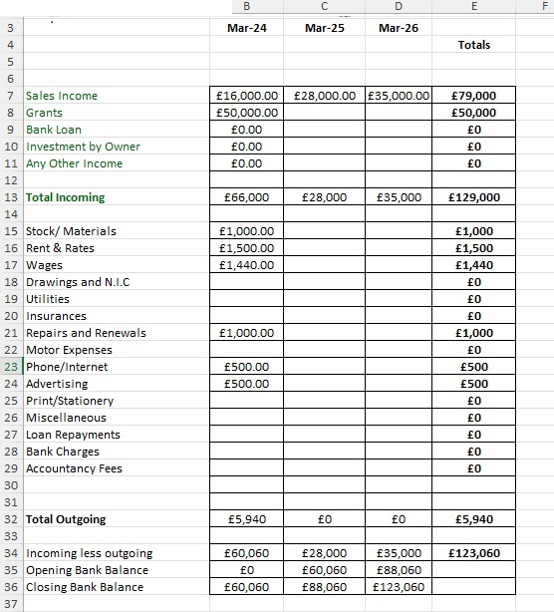
Figure 2
FINANCIAL PLAN – 3 - year period
Above is a table of the financial plan of a 3-year period, this table shows the financially planning of the Therapeutic Wellbeing Spa its show how the business will achieve goals and objectives. It is estimated and consists of the budgets and the requirements to start this business.

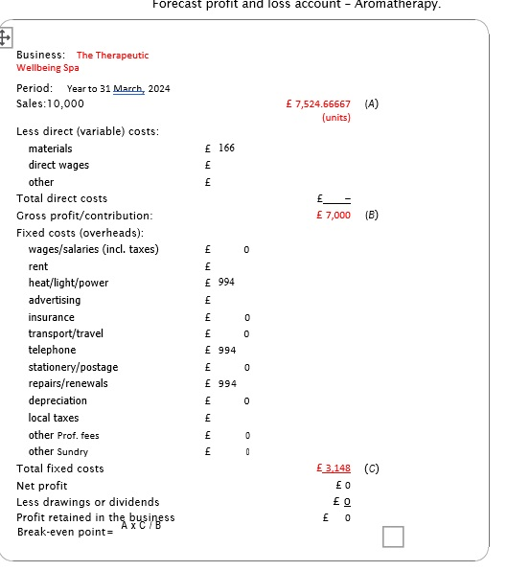
Figure 3
Figure 2 shows the forecast profit over a year using Aromatherapy, it shows a forecast of what The Therapeutic will gain and what they will potentially loss. to work out the breakeven code you must calculate A+C which then enable you to get an idea of how much sales you will get over the period of a year. It shows the number of people in units of how many customers the spa will need to break-even.

References
Bidur P,. Alisa R,. Sarita P (2020) (Examination of marketing mix factors in Chinese Tourists Demand for Spa Service in Middle-sized Bangkok Hotels)
Maria C M,. Stefano M (2021) (Spa Therapy interventions for post respiratory rehabilitations in COVID-19 subjects)
Radka M,. Lubica S,. Andrej M (2023) (Reviews on the internet Marketing Communication of the Spa Tourism Enterprise in Slovakia)
Shah MD S H,. Shah M M H,. Jeremy P B (2023) (Understanding External Factors and Conditions Affecting SME’s Through PESTLE analysis in Bangladesh)

