

Assignment

Student Name: Magdalena Urbanska

Student ID: 2245520

Module: Strategic Management

Module Code: LCMB7003

Lecturer’s Name: Jaya Gopalkrishnan

Submitted on: 10.01.2024

The Table of Contents

Executive Summary.................................................................................................................4

1. Introduction.........................................................................................................................5
1.1 The Objectives of The Report...................................................................................5
1.2 The Polish Heart’s Background.................................................................................5
1.3 The Polish Heart’s Vision Statement, Mission Statement and Objectives................6

2. The External – Macro Environment – Analysis...................................................................6
2.1 The Macro Environment............................................................................................6
2.2 The PESTLE Critical Analysis...................................................................................7
2.2.1 The Political Factors..................................................................................................8
    - The Economic Factors.............................................................................................9
2.2.3 The Social Factors....................................................................................................9
2.2.4 The Cultural Factors and The Hofstede’s Cultural Dimensions Model.....................9
2.2.5 The Technological Factors........................................................................................9
2.2.6 The Legal Factors...................................................................................................10
2.2.7 The Environmental Factors.....................................................................................10

3. The Internal – Micro Environment – Analysis....................................................................10
3.1 The Porter’s Five Forces Model Critical Analysis....................................................10
3.1.1 The Threat of New Entrants....................................................................................11
3.1.2 The Bargaining Power of Suppliers.........................................................................11
3.1.3 The Bargaining Power of Buyers (Customers)........................................................12
3.1.4 The Threat of Substitutes........................................................................................12
3.1.5 The Industry Rivalry................................................................................................12
3.2 The Industry Life Cycle...........................................................................................13

4. A Critical Analysis of The Strategies to Sustain Competitive Advantage..........................14
4.1 The Boston Consulting Group (BCG) (or Growth/ Share) Matrix............................14
4.2 The Ansoff Matrix....................................................................................................15
4.3 The VRIO Framework.............................................................................................16
4.4 The SWOT Critical Analysis....................................................................................17
4.5 The Value Chain Analysis.......................................................................................18
4.6 Local Responsiveness............................................................................................19
4.7 The Porter’s Generic Strategy Model......................................................................19

5. The Execution and Critical Analysis of The Strategy, Structure and Systems of The
Fine Dining Place..............................................................................................................20

6. The Application of Monitoring Tools to Monitor the Strategy............................................21

7. A Discussion, Analysis and Critical Evaluation of Green Strategy, Sustainability
and CSR Activities............................................................................................................21

8. Recommendation..............................................................................................................21

9. Conclusion........................................................................................................................22

References.............................................................................................................................23

Executive Summary

The report focuses on the designing of a strategic plan for a new potential fine dining restaurant named The Polish Heart, specialising in traditional Eastern and Central European cuisine and located in Tooting Bec, South London. The strategic plan for The Polish Heart has been modelled around an already existing and operating fine dining restaurant with traditional Eastern and Central European cuisine – Ognisko Restaurant – which is a part of The Polish Hearth – one of London’s oldest Polish Clubs – based in South Kensington, West London.

The strategic plan indicates that there have been a number of recommended future marketing strategies for The Polish Heart such as product development, diversification and market development.

The fine dining restaurant has a secure position on the fine dining market and has been heading for growth.

1. Introduction

  - The Objectives of The Report

To design a strategic plan for a new potential fine dining restaurant specialising in traditional Eastern and Central European cuisine – The Polish Heart – located in Tooting Bec, South London that has been modelled around an already existing and operating fine dining restaurant with traditional Eastern and Central European cuisine – Ognisko Restaurant – which is a part of The Polish Hearth – one of London’s oldest Polish Clubs – based in South Kensington, West London.

To conduct an external – macro environment – analysis and an internal – micro environment – analysis, including the macro environment, The PESTLE, The Porter’s Five Forces Model and the industry life cycle as well as to suggest future recommendations for the restaurant.

To analyse and evaluate the strategies to sustain competitive advantage such as The Boston Consulting Group (BCG) Matrix, The Ansoff Matrix, The VRIO Framework, The SWOT, the value chain, the local responsiveness and The Porter’s Generic Strategy Model.

To conduct the execution and critical analysis of the strategy, structure and systems of the fine dining place.

To apply the monitoring tools to monitor the strategy.

To discuss, analyse and critically evaluate The Green Strategy, Sustainability and The Corporate Social Responsibility (CSR).

  - The Polish Heart’s Background

The strategic plan for The Polish Heart has been modelled around an already existing and operating fine dining restaurant with traditional Eastern and Central European cuisine – Ognisko Restaurant – a part of The Polish Hearth – based in South Kensington, West London.

The Polish Hearth was founded in 1939 and ‘is one of London’s oldest Polish Clubs which today hosts a variety of theatrical, musical and other cultural events.’ (The Polish Hearth Corporate Website, 2022)

Ognisko Restaurant, a part of The Polish Hearth, is a Michelin starred London restaurant. (MICHELIN Guide, 2023)

The Polish Heart specialises in traditional Eastern and Central European cuisine and it is located in Tooting Bec, South London. The area is populated by a big Polish post war community. There is a Polish White Eagle Club in the area of Balham and Tooting Bec. (Wandsworth Council, 2022) There is a big business potential for The Polish Heart to grow in this part of London.

1.3 The Polish Heart’s Vision Statement, Mission Statement and Objectives

Vision Statement – ‘(...) stretching the organization’s reach beyond its grasp. Few now can see how the vision can be achieved, but can see that it would be great if it could be.’ (Barrow, Barrow and Brown, 2021, p.22) A vision statement is long term.

The Polish Heart’s Vision Statement

Our tradition, culture and heritage is fundamental in preserving the best taste of our dishes. We share the love and passion for our cuisine to offer the highest quality dining adventure for everyone.

Mission Statement – ‘(...) a direction statement, intended to focus your attention on the essentials that encapsulate your specific competence(s) in relation to the market/ customers you plan to serve.’ (Barrow, Barrow and Brown, 2021, p.23) A mission statement is short term.

The Polish Heart’s Mission Statement

To deliver the best dining experience through creating a magical ambience full of traditional inspiring decor, uplifting music and design, and unique atmosphere.

Objectives – ‘(...) milestones on the way to realizing the vision and mission are measured by the achievement of business objectives.’ (Barrow, Barrow and Brown, 2021, p.24)

The Polish Heart’s Objectives

To preserve our traditions and present to our guests an extraordinary place to fine dine and socialise in style.

To guarantee the highest quality of food and service, providing the integrity at every level.

To offer our guests the richness of our culture and make it as unique, inviting and inspiring for everyone as it can possibly be.

To speak to our guests’ senses by ensuring an extraordinary ambience of great taste, music, design and decor that never goes out of style.

To educate and inspire the generations to come with our values and principles deeply rooted in our heritage, and customs.

To maintain the highest standards of our fine dining services and meet all the expectations, and tastes of our audience.

2. The External – Macro Environment – Analysis

2.1 The Macro Environment

‘The macro-environment consists of broad environmental factors that impact to a greater or lesser extent many organisations, industries and sectors.’ (Whittington, et al., 2020, p.35)

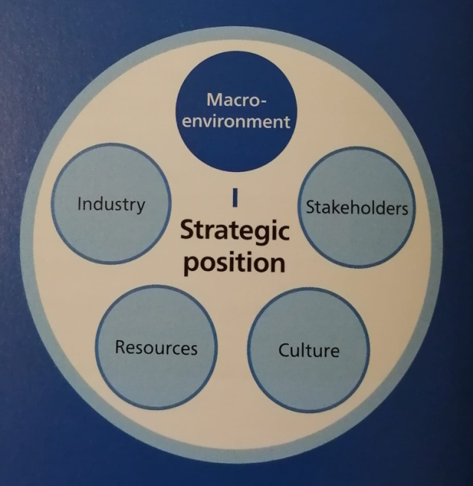

The Macro Environment

Source: Whittington, et al., 2020, p.34

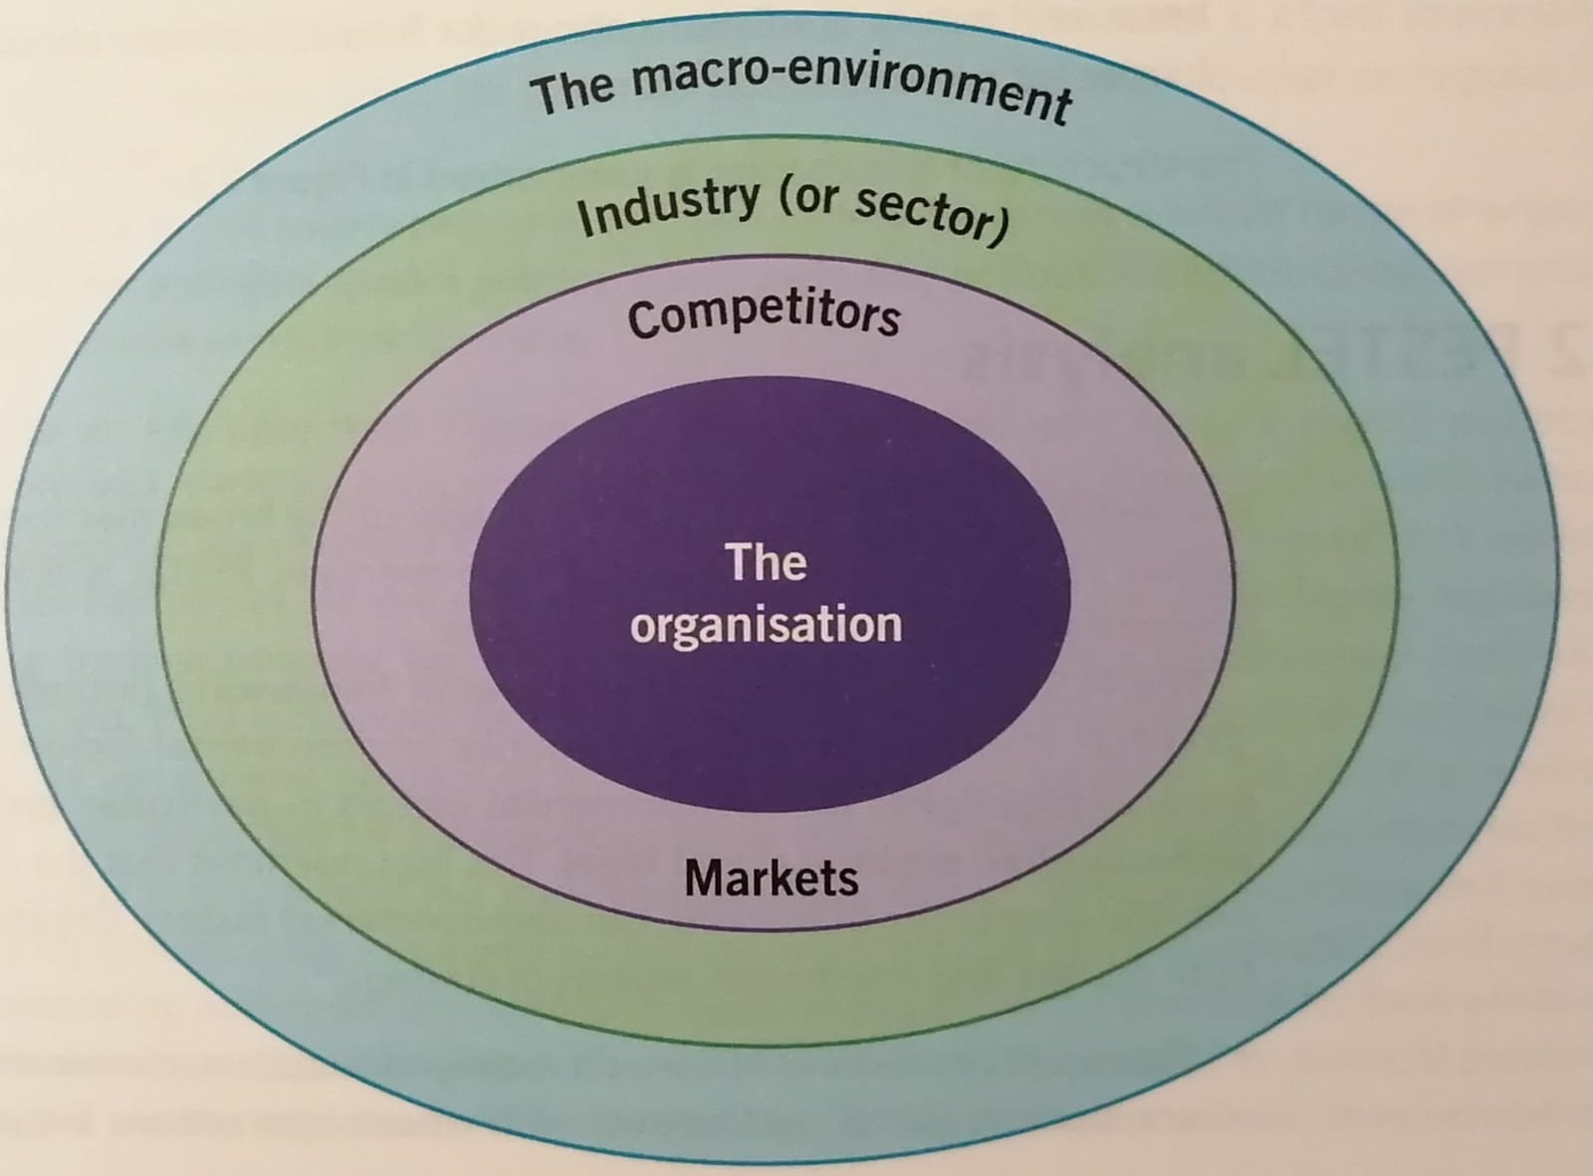

The Layers of The Business Environment

Source: Whittington, et al., 2020, p.35

The Polish Heart is a fine dining restaurant. The business operates within the fine dining market, food services sector and food industry.

2.2 The PESTLE Critical Analysis

The Macro Environment refers to the external forces outside an organisation that can impact an organisation by creating opportunities and/ or threats.

‘A PESTLE analysis is a tried-and-true approach for identifying macro-environmental factors that might impact an organization.’ (Cascade, 2023) The PESTLE factors include: political factors, economic factors, social factors, technological factors, legal factors and environmental factors.

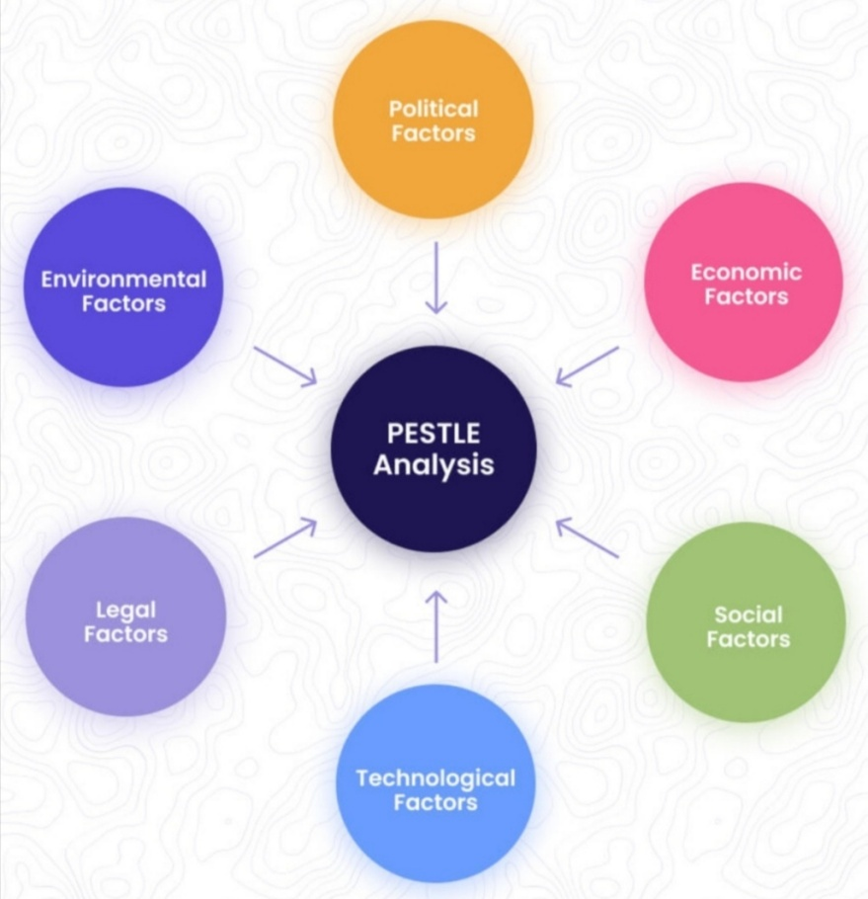

The PESTLE Factors

Source: Cascade, 2023

2.2.1 The Political Factors

Favourable and Unfavourable for The Polish Heart

- The political stability in the UK.
- Quotas.
- Taxes – rates and tariffs.
- There has been no free movement of labour after Brexit. The UK has been employing migrants from The European Union under The European Union Settlement Scheme – Settled and Pre Settled Status. The immigrants from outside the European Union are required working or student visas to remain in the country. (The Chartered Institute of Personnel and Development, 2023)
- The immigrant under The European Union Settlement Scheme need to generate a share code for work, rent or study purposes in the UK to prove their eligibility to work, rent or study in the UK. (GOV.UK, 2023)

2.2.2 The Economic Factors

Favourable and Unfavourable for The Polish Heart

- The economic stability in the UK, however a risk of recession before the end of 2024. (Elliott, 2023)
- The cost of inflation and increase of the cost of living. The increase of food prices. A widening gap between the rich and the poor. More people in debt.
- ‘(...) a stuttering growth over the next two years and GDP [gross domestic product] to only recover to its 2019 quarter four level in 2024 quarter three.’ (Elliott, 2023)
- A real wage growth of 7%, but only in London. (Elliott, 2023)
- The foodservice profit sector generated value sales of GBP72.6 billion (...) in 2022 (Yahoo! Finance, 2023) and ‘the outlook suggested a full recovery by 2024.’ (Statista Research Department, 2023)

2.2.3 The Social Factors

Favourable and Unfavourable for The Polish Heart

- A changing lifestyle and trends in the UK’s society.
- A growing vegan and vegetarian group of consumers.

    - The Cultural Factors and The Hofstede’s Cultural Dimensions Model

Favourable for The Polish Heart

- A big Polish community in Tooting Bec, South London as well as other parts of London such as Ealing Broadway or Greenford.

The Hofstede’s Cultural Dimensions Model ‘is a framework used to understand the differences in culture across countries and the ways that business is done across different cultures.’ (Wale, 2023)

The Model was created by Geert Hofstede in 1980 who conducted a survey in the 1960s and 1970s among over 100 IBM employees from 50 countries and across three regions in order to investigate the variations in values. (Wale, 2023)

Hofstede identified six dimensions to define culture: power distance, individualism, motivation towards achievement and success, uncertainty avoidance, long term orientation and indulgence. (Hofstede Insights Oy, 2023)

2.2.5 The Technological Factors

Favourable and Unfavourable for The Polish Heart

- No mobile apps or touch screen technology in place for customers or potential customers. (Ognisko Polskie (Polish Hearth) Ltd Corporate Website, 2022).
- No chatbot nor customer service on line to adapt a message quicker or cheaper. Customer service via phone or e-mail.
- No booking/ reservation app. (Ognisko Restaurant Corpotate Website, 2022).
- Digital or social media marketing.
- Membership discounts.
- Customer Relationship Management system with the customers’ data – relationship marketing.
- Internal and external data for planning and forecasting.
- No Artificial Intelligence, Virtual or Augmented Reality used to advertise. No embracing of technology, especially to target younger potential customers.
- Investment in Research and Development, but could be more.

2.2.8 The Legal Factors

Favourable for The Polish Heart

- Patent and copyright protection.
- Health and Safety rules and regulations.
- In accordance with Advertising Standards Authority.
- In accordance with Food Standards Agency.
- Strict employment law – recruitment and selection, minimum wage.

2.2.9 The Environmental Factors

Favourable for The Polish Heart

- Societal marketing concept.
- The Corporate Social Responsibility.
- Sustainability, but could be more.
- The Green Strategy, but could be more.
- Recycling.

The PESTLE Factors

After a critical analysis of The Polish Heart, it can be concluded that political, economic, social and technological factors are favourable and unfavourable for The Polish Heart. The cultural, legal and environmental factors are favourable at the same time.

3. The Internal – Micro Environment – Analysis

3.1 The Porter’s Five Forces Model Critical Analysis

The Porter’s Five Forces Model reveals ‘the most significant aspects of the competitive environment. They also provide a baseline for sizing up a company’s strengths and weaknesses: Where does the company stand versus buyers, suppliers, entrants, rivals, and substitutes?’ (Porter, 2011, p.65)

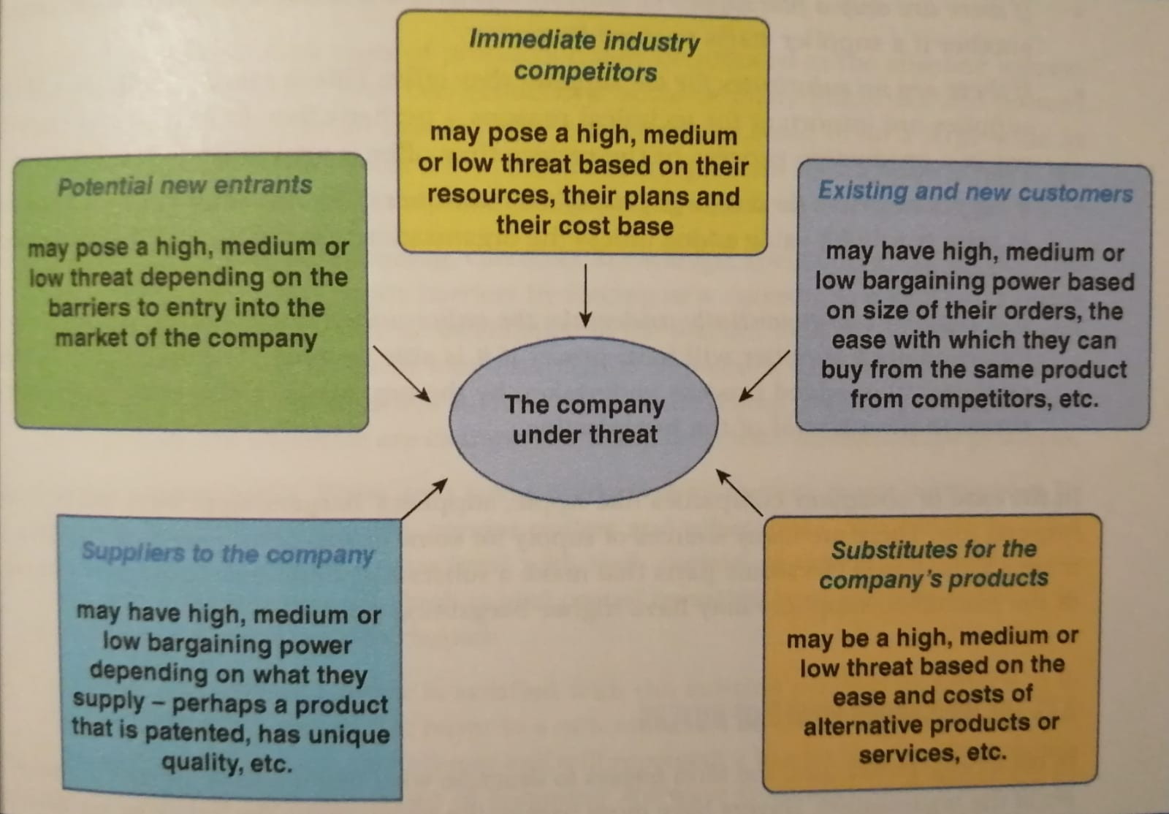

The Porter’s Five Forces Model

Source: Lynch, 2021, p.95

2.3.1 The Threat of New Entrants

Medium to High for The Polish Heart

- The barriers to entry are high, so the threat of new entrants for The Polish Heart is medium.
- Some examples of the barriers to entry include: high brand name and reputation, economies of scale or an extensive fine dining experience.
- Necessary Health and Safety compliance in place and Food Hygiene Ratings to pass.
- Constant research and development.
- Patent.
- Long term contracts with suppliers and strong relations with them.

2.3.2 The Bargaining Power of Suppliers

Low for The Polish Heart

- The Polish Heart partners with many local and international, especially Polish, suppliers and have developed strong long term relations with them. The bargaining power of suppliers is low.

2.3.3 The Bargaining Power of Buyers (Customers)

Medium for The Polish Heart

The Polish Heart has to compete with other fine dining restaurants in London. However, because The Polish Heart has a very high brand equity, the bargaining power of buyers (customers) is medium.

2.3.4 The Threat of Substitutes

Medium for The Polish Heart

- Other fine dining restaurants specialising in traditional Eastern and Central European cuisine and traditional Eastern and Central European food providers in London can be substitutes. Although The Polish Heart is unique, there is always a competition on the corner. The threat of substitutes is medium.

2.3.5 The Industry Rivalry

Low to Medium for The Polish Heart

- Few main strong and well established rivals such The Lowiczanka Restaurant at The Polish Social and Cultural Center. (SmartNet Solution, 2023)
- The local London community is very open and quicker to try new options available on the market.
- High marketing and exiting costs for the business.

The Porter’s Five Forces Analysis of The Polish Heart

The bargaining power of buyers (customers) and the threat of substitutes is medium for The Polish Heart. The threat of new entrants is medium to high for The Polish Heart. The industry rivalry is low to medium for The Polish Heart. The bargaining power of suppliers is low for The Polish Heart.

The research has shown there is only one medium to high force indicated for The Polish Heart. The forces are in most cases medium or low. The fine dining restaurant has a secure position on the fine dining market and has been heading for growth.

Advantages of The Porter’s Five Forces Model

- The Model assists the companies in learning about the industry and strategies as well as in seeking extra investments and inspiring their corporate growth, as a result.
- The Model acts as a guidance for the companies in the analysis of the main and most dangerous competitors on the market as well as helps them assess the challenges and external threats.
- Once the companies manage to identify their main competitors, they are able to gain more control on the market and, as a consequence, set their own rules of the game. (Alonso, 2023)

Disadvantages of The Porter’s Five Forces Model

- Although very insightful, the Model fails to provide a completely accurate analysis of the industry which may result in failing strategies.
- It is easy to misinterpret the main goal of the Model which is formulating the strategy rather than defining whether the industry is attractive or not.
- The Model does not take into account Innovation among forces which is a driver for the industry competition.
- The Model analyses the competitive forces at a point in time only, therefore, the five forces need to be re assessed by the strategists on a regular bases. (Alonso, 2023)

3.2 The Industry Life Cycle

‘Industries, like products and businesses, emerge and eventually decline at specific points in history; the time period between inception and eventual extinction (if applicable) is the industry’s life cycle.’ (Peterdy, 2024)

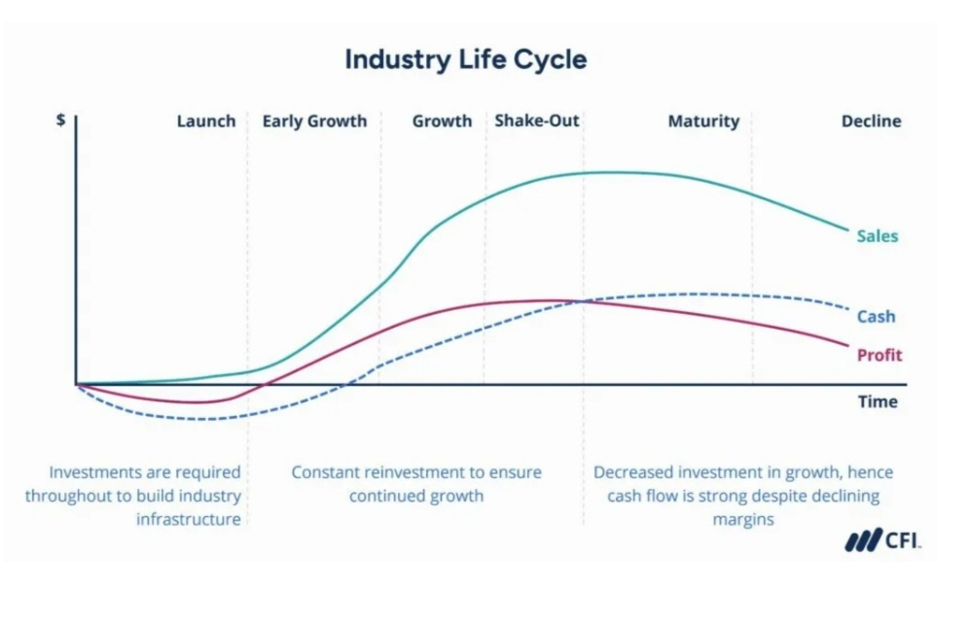

The Industry Life Cycle

Source: Peterdy, 2024

According to Amir El, ‘the restaurant industry is under construction. The Covid-19 Pandemic accelerated the speed of change in this industry. (...) There is a downside to this booming growth and profitability. (...) But from the business aspect (...) it seems like there is still profitability potential for fresh players in this industry.’ (El, 2022)

As a fact, the foodservice profit sector generated value sales of GBP72.6 billion (...) in 2022 (Yahoo! Finance, 2023) and ‘the outlook suggested a full recovery by 2024.’ (Statista Research Department, 2023) The industry has been recovering and heading for growth.

4. A Critical Analysis of The Strategies to Sustain Competitive Advantage

4.1 The Boston Consulting Group (BCG) (or Growth/ Share) Matrix

The directional development strategy.

The BCG Matrix ‘uses market share and market growth criteria for determining the attractiveness and balance of a business portfolio.’ (Whittington, et al., 2020, pp.256-257)

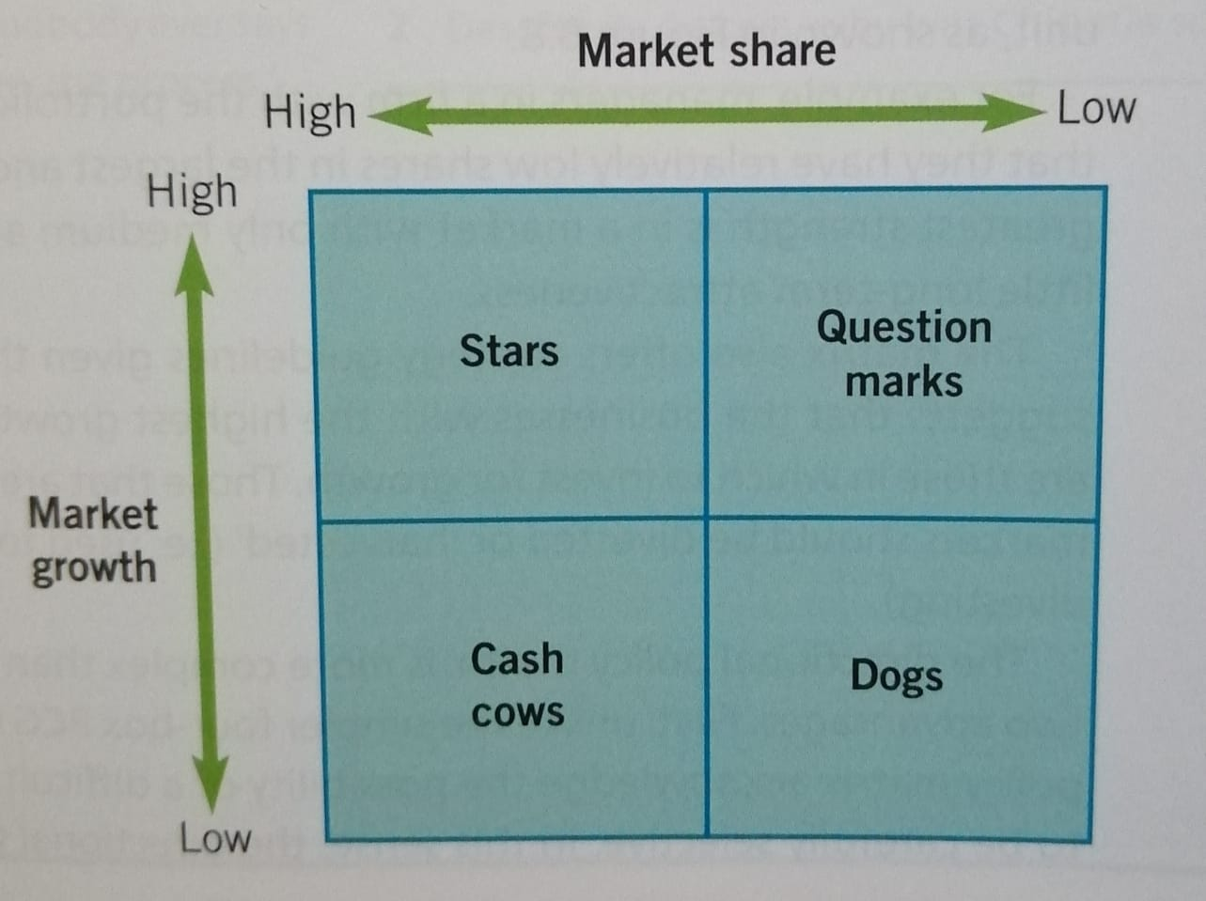

The Boston Consulting Group (BCG) (or Growth/ Share) Matrix

Source: Whittington, et al., 2020, p.257

A star – ‘(...) a business unit within a portfolio that has a high market share in a growing market.’ (Whittington, et al., 2020, p.257)

A question mark (or problem child) – ‘(...) a business unit within a portfolio that is in a growing market, but does not yet have high market share.’ (Whittington, et al., 2020, p.257)

A cash cow – ‘(...) a business unit within a portfolio that has a high market share in a mature market.’ (Whittington, et al., 2020, p.257)

Dogs - ‘(...) business units within a portfolio that have low share in static or declining markets and are thus the worst of all combinations.’ (Whittington, et al., 2020, p.257)

Ognisko Restaurant – a part of The Polish Hearth – that The Polish Heart has been modelled around – has been a cash cow. Ognisko Restaurant has a high market share in the mature fine dining market.

4.2 The Ansoff Matrix

The directional development strategy.

The model used for the analysis of the corporate growth strategy is The Ansoff’s Matrix - The Product/Market Expansion Grid/ Framework.

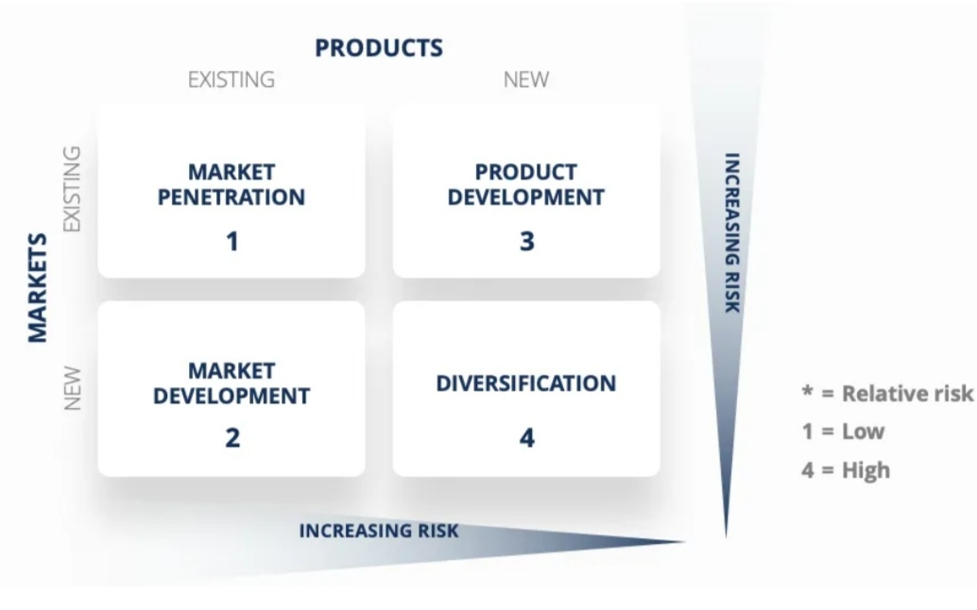

The Ansoff’s Matrix

Source: Peterdy, 2023

There are a few recommended future marketing strategies for The Polish Heart.

Product Development – the introduction of a new product into an existing market

A brand extension

It could be suggested that The Polish Heart expands on offering memorable gadgets or clothing that symbolise the Polish culture.

Diversification – the entering of a new market with a new product

The Polish Heart could also expand into a property industry altogether and introduce a chain of The Polish Heart Hotels, first in the UK and then abroad.

Market Development – the offering of an existing product to a new market

The Polish Heart could be taking experience from its experience in the fine dining sector and start the collaboration with airlines and cruise lines, and supply The Polish Heart products to the customers within the leisure industry.

As The Polish Heart is a Michelin starred London restaurant, collaborating with home delivery services delivering Michelin starred cuisine could be a real opportunity to generate a good profit fast.

The Polish Heart could also enter new European and global markets to offer their products and services.

4.3 The VRIO Framework

As Bass (2021) argues: ‘(...) it’s not enough for a resource to be Valuable. At best, this will only give you competitive parity with others who can acquire the resource. Neither is it enough for the resource to be Rare. Crucially, unless it’s also hard to Imitate, you’ll get a temporary advantage at best while competitors figure out ways to get or build up the resources themselves. Ultimately, if your resource is valuable, rare, hard to imitate, then you’ve got a chance as long as you can also Organise yourself to exploit it.’ (Bass, 2021, p.56)

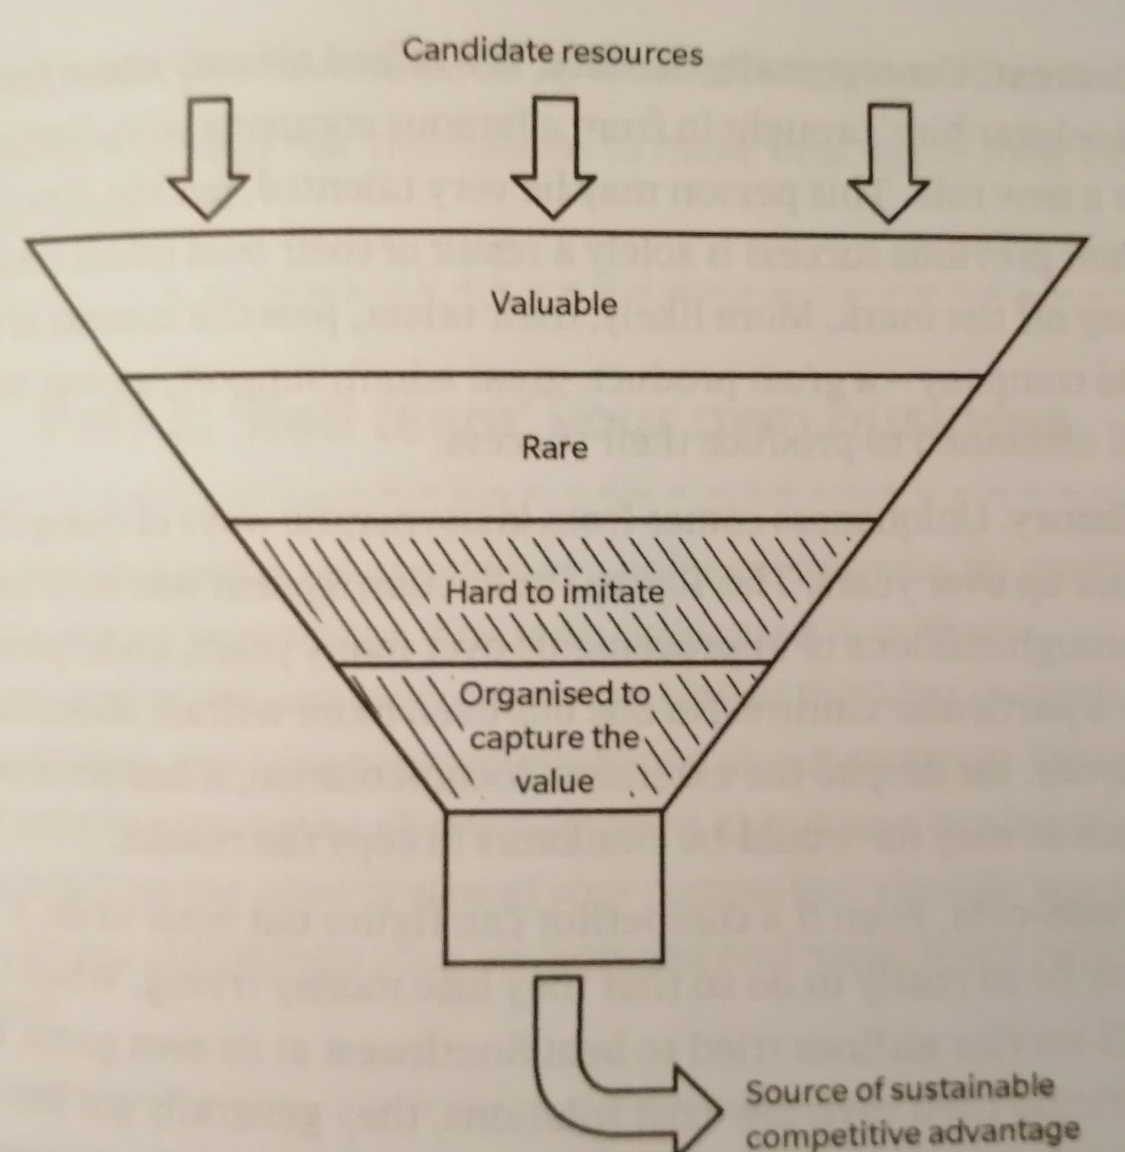

The VRIO Framework

Source: Bass, 2021, p.57

4.4 The SWOT Critical Analysis

‘Marketers often use a handy analysis called the SWOT analysis, a snapshot look at a brand’s strengths, weaknesses, opportunities, and threats.’ (Kaputa, 2022, p.23)

Strengths

- A strong brand equity.
- A unique selling point.
- A high quality of services and food.
- Competitive prices and still maintaining high quality. (Ognisko Restaurant Corporate Website, 2022)
- A variety of services offered: fine dining and entertainment provided. (Ognisko Restaurant Corporate Website, 2022)

Weaknesses

- The Eastern and Central European cuisine, although extremely healthy and tasty, it is sometimes not to everyone’s taste.
- Changing trends, lifestyle and eating habits in the UK’s society. Many alternatives to fine dining.

Opportunities

- A brand extension into memorable gadgets or clothes symbolising the Polish culture.
- Even more vegetable and vegan dishes on the menu to attract a wider range of new potential customers.
- A bigger focus on digital marketing and the use of technology such as artificial intelligence to help grow the new business and also attract younger more tech oriented customers.
- Product development – entering a property market, for example.
- ‘Supper, a home delivery service that delivers Michelin-starred restaurant cuisine, reported a 700% increase in orders since the start of the lockdowns (...)’ (El, 2022). As The Polish Heart is a Michelin starred London restaurant, collaborating with Supper and other home delivery services could be a real opportunity to generate a good profit fast.

Threats

- The increase in inflation.
- The exit from The European Union.
- The presence of existing and new potential rivals.

4.5 The Value Chain Analysis

The value chain are ‘various business activities and processes involved in creating a product or performing a service. (...) The concept was conceived by Harvard Business School Professor Michael Porter in his book The Competitive Advantage: Creating and Sustaining Superior Performance.’ (Stobierski, 2020)

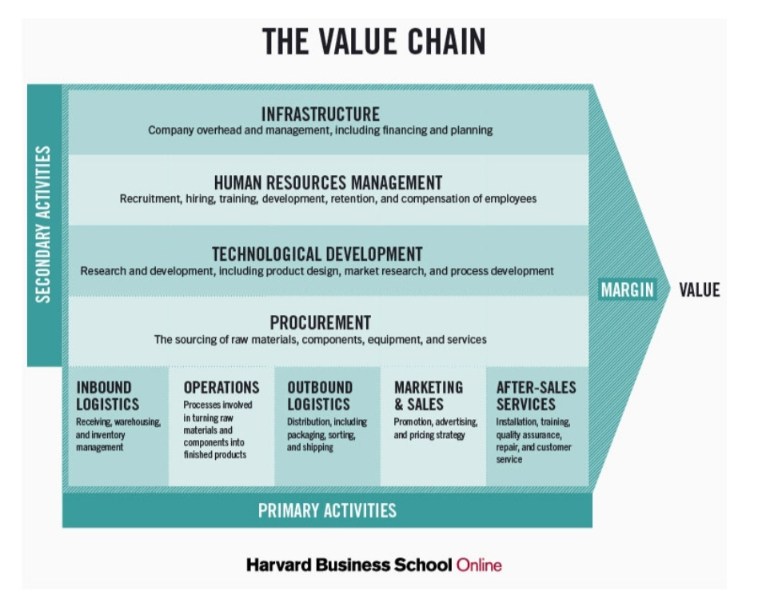

Source: Stobierski, 2020

To ensure a successful operating of the business and growing the competitive advantage, The Polish Heart should ensure a successful running of the components of a value chain, which are the primary and secondary activities.

The Polish Heart’s primary activities include inbound and outbound logistics, operations, sales and marketing as well as after sales services.

The Polish Heart’s secondary activities involve procurement, human resources management, infrastructure or research and development, to name a few.

4.6 Local Responsiveness

4.7 The Porter’s Generic Strategy Model

The directional development strategy.

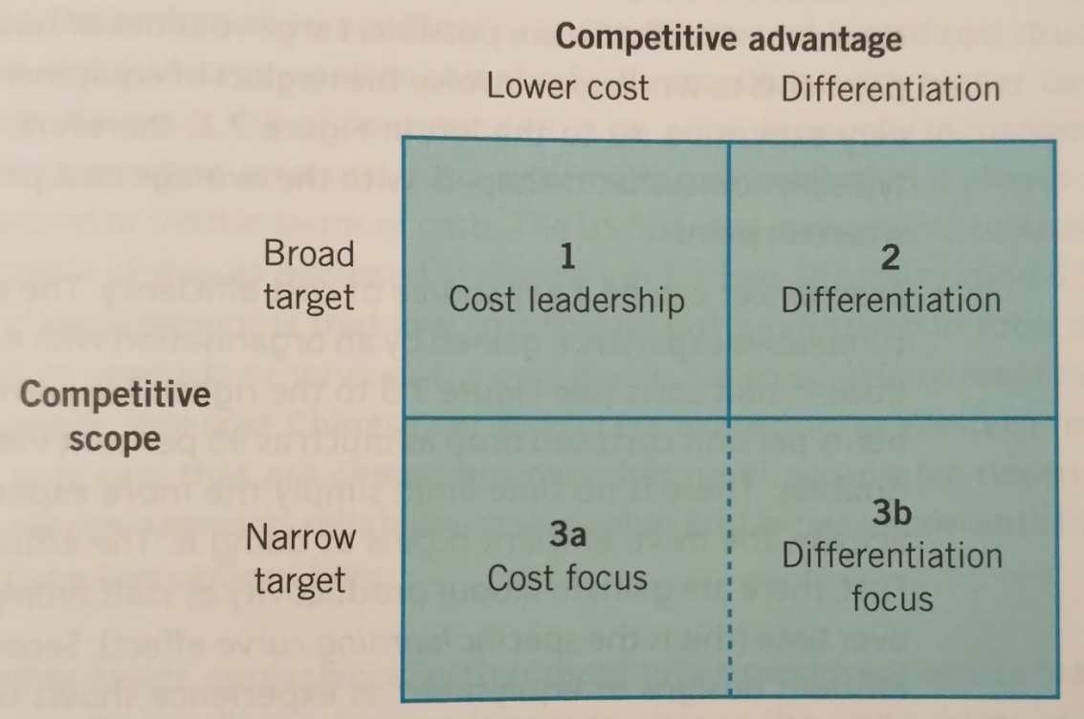

The Porter’s Generic Strategy Model

Source: Whittington, et al., 2020, p.205

Competitive Strategy

‘Competitive strategy is concerned with how a company, business unit or organisation achieves competitive advantage in its domain of activity. Competitive strategy therefore involves issues such as costs, product and service features and branding.’ (Whittington, et al., 2020, p.204)

Competitive Advantage

‘(...) competitive advantage is about how a company, business unit or organisation creates value for its users both greater than the costs of supplying them and superior to that of rivals.’ (Whittington, et al., 2020, p.204)

Sustainable competitive advantage is the core competency and capabilities of the organisation.

‘(...) generic strategies – cost leadership, differentiation, and focus (...) represent the alternative strategic positions in an industry.’ (Porter, 2011, p.13)

The fine dining restaurant The Polish Heart with its unique selling point is an example of a differentiation focus organisation.

5. The Execution and Critical Analysis of The Strategy, Structure and Systems of The Fine Dining Place

The Implementation and Execution of The Strategy

The foodservice profit sector generated value sales of GBP72.6 billion (...) in 2022 (Yahoo! Finance, 2023) and ‘the outlook suggested a full recovery by 2024.’ (Statista Research Department, 2023)

As Barrow, Barrow and Brown (2021) indicate, while researching the annual sales volume of a sample large restaurant employing 40 full time staff, the restaurant’s payroll can be estimated at £240,000 a year. The payroll expenses being a percentage of sales are about 40%. This data can be found in ‘(...) a book that lists operating ratios for the restaurant industry (published by the trade association)’. (Barrow, Barrow and Brown, 2021, p.62) Having taken all these factors into account, the annual sales volume of this restaurant can be estimated at £600,000. (Barrow, Barrow and Brown, 2021)

As The Polish Heart is a fine dining restaurant, it can be estimated that the annual sales volume of the business will be above £600K per annum. The Polish Heart is planning to capture a percentage of the fine dining market and generate the annual revenue of 1 million GBP, e.g., with a 1%, 2% or 3% increase in revenue in the first few years following the establishment.

6. The Application of Monitoring Tools to Monitor the Strategy

The key performance indicators – KPIs – are effective monitoring tools. Together with partnership reviews, they ensure the strategic partnership delivers a desired result. (Alnajar, 2023)

The Implementation of Effective Monitoring Tools

Monitoring tools can be software systems that track and analyse data, spreadsheets or templates filled in manually. The choice of monitoring tools varies from an organisation to an organisation and from a partnership to a partnership.

Effective monitoring tools, clearly defined KPIs and systematic partnership reviews are crucial to the success of a strategic partnership and the delivery of expected or desired results of The Polish Heart. (Alnajar, 2023)

7. A Discussion, Analysis and Critical Evaluation of The Green Strategy, Sustainability and The Corporate Social Responsibility (CSR)

8. Recommendation

It could be recommended that The Polish Heart offers even more vegetable and vegan dishes to attract a wider range of new potential customers.

The fine dining restaurant could have a bigger focus on digital marketing and the use of technology such as artificial intelligence to help grow the new business and also attract younger more tech oriented customers.

It could be suggested that The Polish Heart expands on offering memorable gadgets or clothing that symbolise the Polish culture.

The Polish Heart could also enter a property industry altogether and introduce a chain of The Polish Heart Hotels, first in the UK and then abroad.

The Polish Heart could be taking experience from its experience in the fine dining sector and start the collaboration with airlines and cruise lines, and supply The Polish Heart products to the customers within the leisure industry.

As The Polish Heart is a Michelin starred London restaurant, collaborating with home delivery services delivering Michelin starred cuisine could be a real opportunity to generate a good profit fast.

The Polish Heart could also enter new European and global markets to offer their products and services.

9. Conclusion

The report has focused on the designing of a strategic plan for a new potential fine dining restaurant named The Polish Heart, specialising in traditional Eastern and Central European cuisine and located in Tooting Bec, South London. The strategic plan for The Polish Heart has been modelled around an already existing and operating fine dining restaurant with traditional Eastern and Central European cuisine – Ognisko Restaurant – which is a part of The Polish Hearth – one of London’s oldest Polish Clubs – based in South Kensington, West London. The fine dining restaurant has a secure position on the fine dining market and has been heading for growth.

References

Alnajar, H. (2023) ‘Measuring Success in Strategic Partnerships: KPIs, Monitoring, and Reviews’, LinkedIn, 21 August. Available at https://www.linkedin.com/pulse/measuring-success-strategic-partnerships-kpis-reviews-%D8%AD%D8%A7%D8%B2%D9%85-%D8%A7%D9%84%D9%86%D8%AC%D8%A7%D8%B1?utm_source=share&utm_medium=member_android&utm_campaign=share_via (Accessed: 15 December 2023).

Alonso, T. (2023) ‘Porter's Five Forces (2023): The Definitive Overview (+Examples)’, Cascade, 13 July. Available at https://www.cascade.app/blog/porters-5-forces#:~:text=Porter's%20Five%20Forces%20are%20Threat,needed%20to%20make%20strategic%20choices (Accessed: 12 December 2023).

Barrow, C, Barrow, P. and Brown, R. (2021) The Business Plan Workbook: A Step-By-Step Guide to Creating and Developing a Successful Business. 10th ed. London: Kogan Page, pp.22-24 and 62.

Bass, A. (2021) Start with What Works. 1st ed. Harlow: Pearson Education Limited, pp.56-57.

Cascade (2023) ‘How To Do A Pestle Analysis In 6 Steps’. Available at https://www.cascade.app/blog/how-to-do-a-pestle-analysis (Accessed: 2 December 2023).

El, A. (2022) ‘Porter's Five Forces Analysis; is this the end of the Restaurant Industry?! Market Review’, LinkedIn, 6 March. Available at https://www.linkedin.com/pulse/porters-five-forces-analysis-end-restaurant-industry-market-amir-el (Accessed: 15 December 2023).

Elliott, L. (2023) ‘Risk of UK recession at next general election is 60%, says thinktank’, The Guardian, 9 August. Available at https://www.theguardian.com/business/2023/aug/09/risk-of-uk-recession-at-next-general-election-is-60-says-thinktank (Accessed: 10 December 2023).

GOV.UK (2023) ‘Check a job applicant’s right to work: use their share code’. Available at https://www.gov.uk/view-right-to-work (Accessed: 15 December 2023).

Hofstede Insights Oy (2023). ‘Country Comparison Tool’. Available at https://www.hofstede-insights.com/country-comparison-tool (Accessed: 3 December 2023).

Kaputa, C. (2022) The New Brand You: How to Wow in The New World of Work.1st ed. Boston: Nicholas Brealey Publishing, p.23.

Lynch, R. (2021) Strategic Management. 9th ed. London: SAGE Publications Ltd, p.95.

MICHELIN Guide (2023) ‘MICHELIN Guide’s Point Of View’. Available at https://guide.michelin.com/gb/en/greater-london/london/restaurant/ognisko (Accessed: 15 December 2023).

Ognisko Polskie (Polish Hearth) Ltd Corporate Website (2022). Available at http://www.ogniskopolskie.org.uk/ (Accessed: 8 December 2023).

Ognisko Restaurant Corporate Website (2022). Available at https://www.ogniskorestaurant.co.uk/ (Accessed: 8 December 2023).

Ognisko Restaurant Corporate Website (2022), ‘Our Menus’. Available at https://www.ogniskorestaurant.co.uk/menus (Accessed: 8 December 2023).

Ognisko Restaurant Corporate Website (2022). Available at https://www.ogniskorestaurant.co.uk/private-dining-1 (Accessed: 8 December 2023).

Peterdy, K. (2023) ‘Ansoff Matrix’, CFI Education Inc. Available at https://corporatefinanceinstitute.com/resources/management/ansoff-matrix/ (Accessed: 12 December 2023).

Peterdy, K. (2024) ‘Industry Life Cycle’, CFI Education Inc. Available at https://corporatefinanceinstitute.com/resources/management/industry-life-cycle/ (Accessed: 8 January 2024).

Porter, M. E. (2011) ‘The Five Competitive Forces That Shape Strategy’, HBR’s 10 Must Reads on Strategy. Boston: Harvard Business School Publishing Corporation, p.13 and 65.

SmartNet Solution (2023) ‘The Lowiczanka Restaurant’. Available at https://posk.org/en/lowiczanka-restaurant/ (Accessed: 16 December 2023).

Statista Research Department (2023) ‘Restaurants in the UK - statistics & facts’, 20 December. Available at https://www.statista.com/topics/3131/restaurant-industry-in-the-united-kingdom-uk/#topicOverview (Accessed: 8 January 2024).

Stobierski, T. (2020) ‘WHAT IS A VALUE CHAIN ANALYSIS? 3 STEPS’, Harvard Business School Online’s Business Insights Blog, 3 December. Available at https://online.hbs.edu/blog/post/what-is-value-chain-analysis (Accessed: 15 December 2023).

The Chartered Institute of Personnel and Development (2023) ‘Migrant workers and skills shortages in the UK: Role of immigration in tackling post-Brexit skills challenges’, May. Available at https://www.cipd.org/globalassets/media/knowledge/knowledge-hub/reports/2023-pdfs/2023-migrant-workers-skills-shortages-uk-report.pdf (Accessed: 15 December 2023).

Wale, H. (2023) ‘Hofstede’s Cultural Dimensions Theory’, CFI Education Inc. Available at https://corporatefinanceinstitute.com/resources/management/hofstedes-cultural-dimensions-theory/ (Accessed: 14 December 2023).

Wandsworth Council (2022) ‘Balham’s Polish White Eagle Club honoured in Downing Street for humanitarian work supporting the people of Ukraine’, 8 April. Available at https://www.wandsworth.gov.uk/news/2022-news/news-april-2022/balham-s-polish-white-eagle-club-honoured-in-downing-street-for-humanitarian-work-supporting-the-people-of-ukrainebalham-s-polish-white-eagle-club-honoured-in-downing-street-for-humanitarian-work-supporting-the-people-of-ukraine/ (Accessed: 15 December 2023).

Whittington, R., et al. (2020) Exploring Strategy, Text and Cases. 12th ed. Harlow: Pearson Education Limited, pp.34-35, 204-205 and 256-257.

Yahoo! Finance (2023) ‘United Kingdom (UK) Foodservice Market Size and Trends Report 2023: Cost Sector Channels, Consumers, Locations, Key Players and Forecasts to 2027’, 28 June. Available at https://finance.yahoo.com/news/united-kingdom-uk-foodservice-market-092800925.html (Accessed: 8 January 2024).

