EXPLORING THE INFLUENCE OF MACROECONOMIC FACTORS ON HOUSE PRICES IN THE UNITED KINGDOM

Name: Maiyara Mabel Florian Santana (2113112)
Lecturer: Essah Bar
Course: BA Business Management
Submission date: 21.11.25

Abstract
This study investigates the influence of key macroeconomic factors—interest rates, inflation, GDP growth, income levels, and mortgage credit expansion—on house prices in the United Kingdom between 2007 and 2023. The aim is to determine the magnitude and direction of these relationships within a period marked by major economic shocks, including the Global Financial Crisis, Brexit, and the post-pandemic inflation surge. A pragmatist research philosophy and mixed-methods approach were adopted, using secondary quantitative data sourced from the ONS, Bank of England, UK Finance, and major housing market indices. Descriptive statistics and Pearson correlation analysis were applied to identify long-run associations between the variables. The findings show that inflation and mortgage credit expansion exhibit the strongest positive correlations with house prices, while interest rates reveal a moderate relationship. The study recommends policy interventions focused on controlling credit growth, stabilising inflation, expanding housing supply, and implementing long-term affordability
Key words: Macroeconomic factors, house prices, price index

Table of Contents
Abstract 1
CHAPTER ONE: INTRODUCTION 4
1.1. Background of the Study 4
1.2. Research Aim and Objectives 5
1.3. Research Questions 5
1.4. Problem Statement 5
1.5. Significance of the Study 6
1.6. Rationale of the Study 6
1.7. Study Outline 6
1.8. Summary of the Chapter 7
CHAPTER TWO: LITERATURE REVIEW 8
2.1. Previous Research 8
CHAPTER THREE: RESEARCH METHODS AND METHODOLOGY 11
3.1. Introduction 11
3.3. Research Approach 13
3.4. Research Design and Strategy 14
3.5. Time Horizon 15
3.6. Data Collection Method 15
3.7. Data Analysis Method 16
CHAPTER FOUR: RESULTS AND DISCUSSION 17
4.1. Introduction 17
4.2. House Prices and House Price Index Trends 17
4.3. Effect of Inflation Rate on House Prices 18
4.4. Effect of Interest Rates on House Prices 20
4.5. Effect of Income Changes on House Prices 21
4.6. Effect of GDP Growth Rate on House Prices 22
4.7. Evolution of Macroeconomic Factors 23
4.8. Impact of Mortgage Credit Expansion on the UK Housing Market 23
CHAPTER FIVE: CONCLUSIONS AND RECOMMENDATIONS 25
References 25
Appendix 1 30

List of Figures
Figure 1 Saunders’ Research Onion 11
Figure 2 Induction and Deduction Models 14
Figure 3 Average House Prices (2005-2023) 17
Figure 4 House Price Index Trend (2007-2023) 18
Figure 5 Avg House Price vs. Inflation Rate 19
Figure 6 Avg Real House Price vs. Avg House Prices 20
Figure 7 Avg House Prices vs. Interest Rates 21
Figure 8 Income versus House Prices 22
Figure 9 Mortgage Credit Approvals (2007-2025) Trend 24

CHAPTER ONE: INTRODUCTION

Background of the Study
Debates about housing are common in developed economies because housing is essential to people's safety and well-being and because most households would consider buying a home to be the largest fixed capital investment. A major contributor to wealth, the housing sector is also a delicate and essential component of both national and international macroeconomies (Jones and Richardson, 2014). The housing market's performance and activity are therefore a crucial indicator of the degree of general financial and economic stability. Rising home prices are a major topic of controversy in both scholarly and political circles since the housing boom of the late 1990s and early 2000s, which led to the Global Financial Crisis (GFC) of 2007–2008 (Kennett et al., 2013). This has sparked a lot of research interest aimed at comprehending the underlying causes of the patterns in residential home prices. Even though the crisis caused a large decline and correction in home prices from their 2007 peak, they started to level off in 2011, and the rising trend had resumed by 2014 (Aalbers, 2015).
For the UK, both real house prices and average incomes have been on an upward trajectory from 1968 to 2018. House prices grew at a high and erratic rate from the late 1980s until about 2007–2008, surpassing both inflation and disposable earnings (White, 2015). The broad accessibility of financing is frequently cited as one of the factors driving this trend, along with demographic shifts and income growth, supply constraints, and housing market customer expectations (Meen, 2016). Mortgage financing and home buying are closely related in the UK. Purchasing a residential home is a costly endeavor for the majority of people and families, requiring a sizable capital commitment over an extended investment horizon (Aalbers, 2015). As a result, buyers are forced to finance their homes with long-term loans, which ultimately results in mortgages. Therefore, it can be said that historically, the mortgage and housing markets have been intertwined and coordinated.
Due to an increase in private rents and a high rate of occupancy in recent years, the UK housing industry contributes significantly to the economy. Housing as an asset affects wealth and consumption and is a significant motivator for household savings. The current housing tenure in the UK is generally divided between outright ownership, mortgages, and rental. While outright owners include both cash investors and homeowners who have paid off their mortgages, a larger percentage of current mortgage families are first-time buyers.
About 10% of rents are mortgages, demonstrating the importance of mortgages as a catalyst for housing finance (UK Finance, 2019). According to UK Finance (2019), 70% of home transactions in the nation are financed by mortgage credit, and as a result of rising house prices and rising sales, total yearly lending doubled to £268 billion in 2019. Because of the impact of house price volatility, it is crucial to comprehend the macroeconomic elements influencing the behavior of the residential property market. Furthermore, comprehending fluctuations in house prices requires an understanding of the mortgage industry and the macroeconomic variables influencing it. These elements will be examined in the context of the UK’s and the global community’s evolving financial, regulatory, and economic environments.

Research Aim and Objectives
The aim of the study is to establish the nature and type of relationship between macroeconomic factors and housing prices in the United Kingdom (UK) over the last two decades (2007 to 2023).
To achieve the aim above, the specific objectives that will guide the proposed research are stated below:
- To explore the key macroeconomic factors (supply and demand, inflation, GDP growth, income growth, and interest rates) that significantly influence housing prices in the UK.
- To assess the evolution of the macroeconomic indicators that drive housing prices in the UK in light of the changing regulatory, financial, and economic landscape.
- To determine the influence of mortgage credit expansion on the UK housing market.
- To evaluate the key macroeconomic drivers of the UK mortgage market.
- To identify the impact of major regulatory and policy changes in UK housing finance and the corresponding impact on trends in the UK housing market.

Research Questions
The guiding research questions are:
- How do key macroeconomic factors (supply and demand, inflation, GDP growth, income growth, and interest rates) affect housing prices in the UK?
- How have these macroeconomic factors evolved over the last two decades in light of changes in the UK’s changing regulatory, financial, and economic landscape?
- What is the impact of mortgage credit expansion on the UK’s housing market over the last two decades?
- What key macroeconomic drivers influence the UK mortgage market?
- How have policy and regulatory changes in UK housing finance affected trends in the housing market?

Problem Statement
The prices of houses in the UK have been fluctuating greatly in the last 20 years, and this is due to the economic cycles, government policies, and events in the global financial market. Although housing is significant to the wellbeing of individuals as well as the economic stability of a nation, the exact correlation between macroeconomic variables and the cost of houses is a debatable issue. Interest rates, inflation, unemployment, GDP growth, monetary policy, and other factors have been cited as some of the major drivers, but the degree to which they influence each other is not always clear. This knowledge gap poses a problem for policymakers, investors, and households in making informed decisions. It is thus important to understand the relationship between these macroeconomic variables and housing prices in the UK over the period 2007 to 2023 to come up with effective economic policies and to stabilize the housing market.

Significance of the Study
The research undertaken is relevant to the research as well as policy. In terms of academia, it furthers the knowledge on how macroeconomic conditions influence housing markets and ambiguities in the current literature on the UK. The study can provide insights to the policy makers on which of the macroeconomic factors are the most influential so that they can have better policies on housing, taxation, and monetary policies. To the financial institutions and investors, the findings offer evidence in risk assessment and investment strategies. To households, the paper brings out the impacts of the general economic situation on accessibility and affordability of housing. This study reinforces the connection between macroeconomic policy and the performance of the housing market, which is crucial to sustainable economic growth and social stability.

Rationale of the Study
The reason why this study has been conducted is due to the increasing issue of housing affordability and accessibility in the UK. House prices have increased faster than wages, making them unaffordable to first-time buyers since 2007, which has increased wealth inequality. Meanwhile, the UK economy has also had to deal with numerous shocks, such as the aftermath of the global financial crisis, Brexit, the COVID-19 pandemic, and the recent inflationary pressures. All these events have challenged the strength of the housing market and brought out the virtue of macroeconomic stability. The study, by systematically analysing the relationship between macroeconomic factors and housing prices in the 2007-2023 period, gives evidence-based insights that can be used in long-term housing strategies and economic planning.

Study Outline
The study will be divided into five main Chapters: Introduction, Literature Review, Research Methods and Methodology, Data Analysis and Discussion, Conclusion, Limitations, and Recommendations.

Summary of the Chapter
The Chapter focused on the background of the study to highlight the origin of the research, which is due to a rise in housing prices in the UK occasioned by changes in the global housing market. It focused on the research aim and related objective and research questions, as well as a problem statement, the significance of the study, and the rationale for the research. The Chapter provides context for the study.

CHAPTER TWO: LITERATURE REVIEW

Previous Research
Various scholars, for instance, Meen (2016), have discussed how the interaction of supply and demand affects the housing process. An imbalance between buyer interest and available homes can cause market shifts in terms of supply and demand in the housing market. In a market where there are many prospective buyers and few available properties, the sellers have the upper hand and may demand exorbitant prices. However, a buyer’s market is created when there are a lot of properties available for purchase, giving buyers additional negotiation power. Meen (2016) uses the supply and demand functions to model housing prices and argues that economic and demographic variables that affect the demand and supply metrics of housing can correspondingly control the housing prices.
Research on how housing market prices are set has modelled demand as a function of exogenous factors like disposable income and demographic trends, as well as indicators like financing costs and real house prices (Daniel et al., 2024; Stavridou et al., 2025). Economic models that concentrate on supply have demonstrated that the determination of housing prices happens differentially, with the existing housing stock potentially deteriorating and new construction rates gradually increasing (Aha, 2022). The amount of new building can be influenced by exogenous factors like loan costs and interest rates, as well as house values. Furthermore, in addition to macroeconomic variables like income and employment levels, demographic factors like the rate of urbanization and the creation of new households can affect demand (Miles and Monro, 2021).
Since GDP growth usually results in both increased demand for homes and growing property values, GDP can have an impact on housing prices. As demonstrated by the tech bubble of the late 1990s, which produced a robust housing market and consequently high property values, rising GDP can boost consumer optimism in an economy, which in turn can lead to higher appropriate investments (Li and Li, 2024). The opposite was true in 2008 following the global financial crisis, when falling GDPs lowered consumer confidence, which in turn caused a drop in both property values and purchases (Ahmad et al., 2023). Growing salaries are closely linked to GDP because they can boost consumer spending power, which in turn encourages greater housing investment and raises property values (Ahmad et al., 2023).
The study by White (2015) examined house price changes in the UK regions, including Greater London, using an error-correction framework, and is one of the most pertinent studies regarding the topic of this study. Quarterly data from the first quarter of 2008 to the first quarter of 2011 were used in that study. The findings support the cointegrating relationship between changes in real property prices in Greater London and important macroeconomic factors, including interest rates, gross mortgage lending, and income as determined by real gross value added. While changes in the money supply and housing stock were statistically negligible, net migration, albeit being statistically substantial, had the incorrect sign.
Using an error-correction model, Taltavull de La Paz and White (2012) also investigated the macroeconomic factors influencing UK home prices nationally. The study’s findings demonstrated that national UK house prices and macroeconomic factors such as income, mortgage lending, net migration, and interest rates have a cointegrating relationship, with the first two having the largest impact. Additionally, they verified that two structural breakdowns in 2001 and 2008 were statistically significant. Regional differences, the existence of ripple effects, and price convergence across regions are the main topics of several additional studies on UK home prices. Meen (1999) and Wood (2003) all attest to the presence of a “ripple effect” in home prices that starts in the London/Southeast region and spreads to other UK regions.
In a study of the UK affordability problem, Rossall (2015) divides the demand-side drivers of inflation in UK home prices into three areas, which he names “population,” “incentivization,” and “financialization.” Interest rates, hefty tax incentives for foreign purchasers, and government support for low-income buyers are examples of “incentivization” factors, whereas the drivers of population increase, such as immigration and domestic population growth, are examples of “population” variables. The components of investment demand—that is, demand from rich individuals both domestically and abroad, buy-to-let demand driven by the widespread availability of buy-to-let mortgages, and demand from institutional investors—are included in the “financialization” aspects. Most econometric studies of house prices have taken into account some of these factors, such as interest rates and population growth, but most of the others are hard to include directly in long-term econometric research because of the paucity of data.
Rossall (2015) contends that “investment demand” has corrupted the housing market in many areas and pushed average house prices out of the reach of average citizens, despite acknowledging the significant role that user demand and population growth have played in driving inflation in UK home prices. In a similar vein, Gallent et al. (2018) highlight how investment demand propels inflation in home prices. Gallent et al. (2018) contend that rather than being a simple insufficiency of supply to meet demand, the affordability crisis is essentially an “investment crisis” due to the sharp increases in home prices. They contend that two significant changes influenced the nature of the affordability crisis in the UK housing market. The first change was the conversion of housing from a useful tool for meeting people's and households’ fundamental needs for shelter to one that can be used for savings and investments. Low loan rates, government initiatives like tax breaks and less regulation, and robust long-term home price growth that solidified expectations of higher investment returns all contributed to this change. The second change that had an impact on the supply side was the state’s retreat from housing production and control and its growing dependence on market forces.

CHAPTER THREE: RESEARCH METHODS AND METHODOLOGY

Introduction
The method(s) that the researcher uses to gather, examine, and interpret data are a crucial component of every research project. Over time, research methodologies have evolved significantly, and there is frequently overlap between different approaches. A key idea in research is the concept of research paradigms or philosophies, which are basically presumptions made by the researcher about the nature of reality, its knowability, and the means by which it can be understood. This chapter discusses the many philosophical stances on social research as well as the philosophical focus of this investigation. After reviewing the many viewpoints on social research, the chapter goes on to describe and defend the study’s philosophical stance. The other research approaches are also presented, with the choice of the approach justified. The research design outlining the methods and techniques for data collection and analysis is also presented in this chapter.
The Saunders’ Research Onion model was adopted to guide the research process. The model delineates the research methodology into six distinct stages or ‘onions’: (1) Research Philosophy, (2) Research Approach, (3) Methodological choice, (4) Research Strategy, (5) Time Horizons, and (6) Techniques & procedures (Mardiana, 2020). This approach was selected because it breaks the research process down into phases that enable the researcher to guarantee rigor, which increases the study's validity and trustworthiness. Depending on the requirements of a study, the researcher can select from a variety of options within each category. The framework is shown in Figure 1 below.
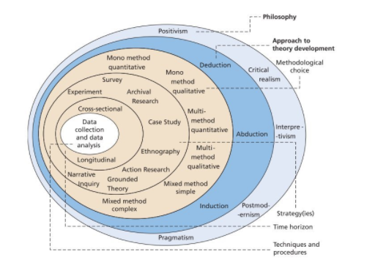
Figure 1 Saunders’ Research Onion
(Source: Mardiana, 2020)
  - Research Philosophies
The alternative knowledge claims and presumptions that researchers make about how they will discover what they wish to learn throughout an investigation are referred to as research philosophy (Creswell, 2014). A researcher’s philosophical viewpoint is based on the ontological and epistemological presuppositions they hold. There are various philosophical stances on how to do research. According to Saunders et al. (2015), there are four primary ones are pragmatism, positivism, interpretivism, and realism. Each has its own advantages and disadvantages. This study applies pragmatism as an approach.
The most popular social science research methodology is positivism, which aims to emulate the natural sciences. As a result, positivism is frequently taught as being synonymous with science (Neuman, 2011; Johnson and Duberley, 2000; Johnson et al., 2006). Creswell (2014) asserts that positivism is linked to deterministic assumptions. The main opponent of positivism in social science research is interpretivism. Interpretivism argues that the social world is too complicated to be reduced to a set of precise laws and that positivist approaches are inadequate to represent the rich experiences of human actors (Meng-Lewis and Xian, 2018; Prasad and Prasad, 2002). Another research paradigm that lies in the middle between positivism and interpretivism is realism. Xian and Meng-Lewis (2018) state that while realism and positivism both support an objective and scientific method of doing research and share an objectivist ontology, realists hold different epistemological stances.
The last philosophical stance to be discussed in this section is pragmatism, which is adopted in the study. A never-ending argument between positivists and anti-positivists is pointless, according to pragmatic researchers. In essence, pragmatists believe that knowledge claims emerge from events, circumstances, and outcomes as opposed to preexisting circumstances, as in post-positivism (Creswell, 2014). The problem is more significant than the approach because the focus here is on applying effective solutions to social issues. Pragmatists place a strong emphasis on practice when it comes to epistemology; every theory must originate from practice and personal experience, so our practical knowledge is superior to our theoretical knowledge (Mounce, 2000).
The philosophical foundation of mixed methods research is pragmatism, which is strongly supported by Patterson (1990) and Tashakkori and Teddlie (1998), who have emphasized the significance of concentrating on the research problem and then employing pluralistic approaches to gather information about the issue. Pragmatists reject the idea that there are preconceived beliefs that represent reality when they tackle a research problem (Xian and Meng-Lewis, 2018). They also do not think that humans can make meaning out of nothing (Rorty et al., 2004). Pragmatists contend that the approach we take should be dictated by our research topics. Depending on the topic under study, a researcher may adopt both objectivist and subjectivist epistemologies. As such, adopting several ontological and epistemological stances is entirely permissible, and there is no need to adhere to a single viewpoint in various projects, and occasionally even within the same one.
Pragmatism as a research philosophy supports this concept since it aims to provide answers to issues that have both quantitative and qualitative components. Pragmatism as a research philosophy allows researchers to use both quantitative and qualitative assumptions, as noted by Creswell (2014). The pragmatic research philosophy generally contends that the methodological decisions should be guided by what is most effective at a given moment in light of the study's goals and inquiries. Therefore, ideas are only important to pragmatists when they facilitate action (Kelemen and Rumens, 2008).
According to Morgan (2014), the pragmatic approach to inquiry illustrates a planning process that begins with the research question, proceeds to a study design, and then involves selecting one of the various methodologies. Therefore, pragmatism maintains that the research questions or aims are the primary factors that determine one’s methodological stance. The pragmatic view that it is ideal to operate within multiple philosophical domains is supported if the research questions do not recommend that a certain philosophy be selected (Saunders et al., 2015). Pragmatism was chosen as the paradigm for this study because it combines the many advantages of qualitative and quantitative approaches to offer a more thorough response to the research question of examining the influence of macroeconomic factors on house prices in the UK. This is further supported by Kelemen and Rumens’ (2008) contention that pragmatism gives the researcher the latitude to employ reliable, proven, and pertinent techniques for data collecting and analysis in order to meet the goals and inquiries of the study.

Research Approach
Every research project requires a guiding model to demonstrate the ultimate process of information acquisition, called a research approach. Two popular methods and their steps are depicted in Figure 2 below.
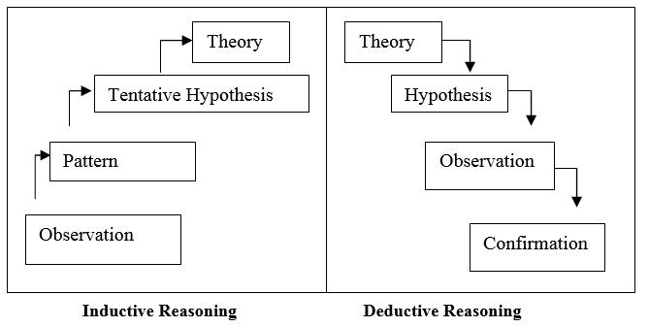
Figure 2 Induction and Deduction Models
The process of inductive reasoning begins with the researcher gathering information via observation or another technique, then looking for themes that may result in preliminary theories that are subsequently evaluated (Rott, 2021). Conversely, deductive reasoning begins with a survey of the literature, which aids in the development of hypotheses that are put to the test through the collection and analysis of evidence (Rott, 2021). This study uses the inductive reasoning approach, where a collection of secondary data is geared towards developing themes aligned with the research question.

Research Design and Strategy
The existence of a significant research question and a suitable approach to address it are crucial components of a successful research endeavour. There are essentially three primary methods for studying the social sciences: mixed-methods, quantitative, and qualitative techniques (Creswell, 2014), each having advantages and disadvantages. The collection of numerical data to address a particular study question is a general definition of quantitative research. O’Leary (2017) asserts that a quantitative approach to research is heavily dependent on measurable data and is frequently associated with positivist presumptions. In order to generate knowledge, the researcher mostly employs positivist claims, such as cause-and-effect reasoning, reduction to particular variables, hypothesis testing, measurement, observation, and theory testing (Creswell, 2014).
A mixed-method approach is adopted with a focus on collecting quantitative secondary data and some qualitative data. Quantitative modelling will be used to determine the factors and effects of macroeconomic indicators on housing prices (Trahan and Stewart, 2013). A large portion of the current research on factors influencing home prices has been strictly quantitative, identifying price determinants through econometric time-series modelling (White, 2015). As independent variables, these typically pinpoint and emphasize the main factors influencing changes in home prices.

Time Horizon
The longitudinal approach is adopted in the study as the aim is to establish the nature and type of relationship between macroeconomic factors and housing prices in the United Kingdom (UK) spanning the last two decades (2007 to 2023. Thus, the secondary data valid for consideration and inclusion are those related to the time period indicated.

Data Collection Method
A secondary data collection method was adopted in the study. The main sources of data included government publications, industry reports, expert reports, and pertinent scholarly sources. The study focuses on quantitative secondary data. The data can be categorised into two themes: housing market data and macroeconomic data. The sources of these data will be reputable and are outlined in Table 1 below:
Table 1 Types of Data and Projected Sources
Data Category | Variables | Projected Sources
Housing Market Data | House prices  House price index  Property Transaction Volume | UK Data Services (2007 to 2023)  Nationwide / Halifax & Land registry database (2007 to 2023)  ONS
 | House prices, GDP, inflation rate, income growth, house supply, house demand, policy, and regulation changes  Interest rates  Mortgage Data | UK Data Services  Bank of England (BOE)  UK Data Service, BOE, Council of Mortgage Lenders (CML), Financial Conduct Authority (FCA), European Mortgage Federation (EMF)

Data Analysis Method
There is a range of data analysis methods that can be applied to secondary data. A simple descriptive statistics approach is applied to the long-run relationship between two or more non-stationary variables (Orudzhev and Alizade,2021). With the background of the dissertation, the equation aids in establishing the fact that interest rates, inflation, GDP, and unemployment fluctuate with house prices over time (Winarno et al., 2021).
In this dissertation, a simple descriptive analysis and a simple correlation analysis will be used to evaluate whether the macroeconomic fundamentals are real causes of the house prices and not accidental. It offers a strong empirical foundation to claim that the changes in economic indicators have a long-term impact on the housing market. A simple Pearson correlation analysis method will be adopted in the study to establish relationships between the variables with an equation having the variables developed. This will be done using the Microsoft Excel software with linear graphs developed to show the relationships between the variables as well as other graphs to depict trends. The correlation analysis for the study is outlined below:
Y=β0​+β1​X1​+β2​X2​+β3​X3​+⋯+βk​Xk​+ε
Equation 1 Correlation Analysis Equation
Where:
HP (House Prices): This is the dependent variable, which demonstrates the average or index-based value of residential property prices in the UK.
INF (Inflation Rate): It is an indicator of the pace of growth in the general price levels, which influences the purchasing power and the cost of construction.
GDP (Gross Domestic Product Growth rate): It is a measure of the general economic performance, which is the national income and housing demand.
INC (Income Growth): It captures the changes in the household disposable income that determine the affordability and demand of housing.
IR (Interest Rate): It refers to the base rate or the mortgage lending rate of the Bank of England, which has a direct impact on the cost of borrowing and demand for houses.
MC (Mortgage Credit Expansion): It is a measure of the amount or the increase in mortgage lending, and it is a measure of the availability of credit and its influence on the home-buying activity.
ε = error term

CHAPTER FOUR: RESULTS AND DISCUSSION

Introduction
This section of the dissertation incorporates an analysis and presentation of the findings as well as pertinent discussions, in line with the research questions.

House Prices and House Price Index Trends
House prices/house price index are the dependent variables (DVs) in the study. To best understand the relationship between housing prices and macroeconomic factors, it is imperative to study the trends in housing prices from 2007 to 2023.
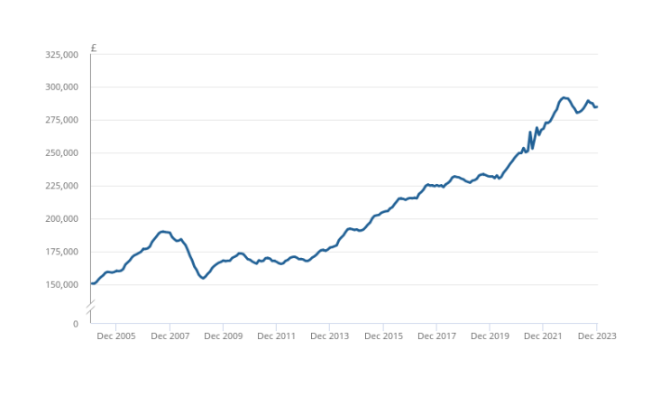
Figure 3 Average House Prices (2005-2023)
(Source: ONS, 2024)
As shown in Figure 3 above, the housing prices in the UK have generally been on an upward trajectory from 2007 expect in three instances: (1) 2007-2008 during the housing crisis, (2) 2019-2021 during COVID-19 pandemic, and (3) 2023 during the UK high inflation rate of 13.8% annually when housing prices were £4,000 lower than in the previous year (2022) (ONS, 2024). Figure 4 below shows the corresponding variation in the house price index. The graph indicates the volatility of the prices in the housing market, particularly in periods caused by the three factors discussed above.
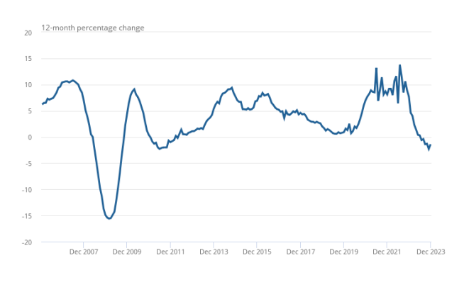
Figure 4 House Price Index Trend (2007-2023)
(Source: ONS, 2024)

Effect of Inflation Rate on House Prices
Data on the inflation rate as of December of each year from 2007 to 2023 from ONS (ONS, 2025) was used to assess the relationship with house prices based on the house prices for a similar month in the same period (see Figure 3). A simple correlation analysis of the two variables derived the outcomes shown in Figure 5 below:

Figure 5 Avg House Price vs. Inflation Rate
(Source: Author)
The trendline in Figure 5 above shows that the UK inflation rate has generally taken an upward trajectory, and so have the average house prices. Although this does not show a direct correlation, the result of the Pearson correlation analysis was a correlation coefficient (r) of 0.482 (See Appendix 1), which points to a considerable but not strong correlation between inflation rate and average house prices. This point is further supported by Figure 6 below, which shows the actual impact of inflation on house prices from the lens of the average real price.
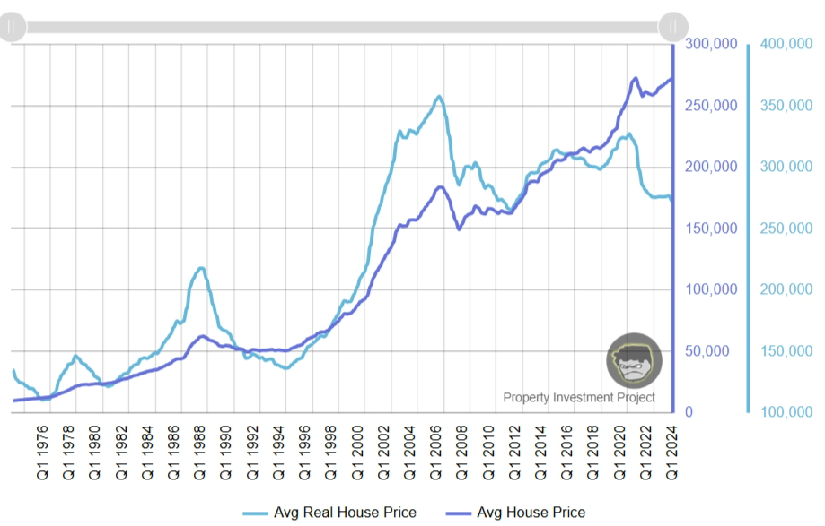
Figure 6 Avg Real House Price vs. Avg House Prices
(Source: Property Investment Project, 2025).
The purchasing power of a property in relation to other products and services over time is more accurately represented when home prices are adjusted for inflation, or "real house prices." This adjustment is essential for determining the actual changes in wealth or affordability for purchasers and homeowners, as well as for comparing the genuine worth of real estate across time. Over time, the same amount of money may purchase fewer goods and services due to inflation's erosion of money's purchasing power. For instance, the average price of a property in 2005 Q1 would have been £152,790. According to the ONS Retail Price Index (RPI), it would cost £310,932 to buy the same quantity of "retail goods" today. According to this comparison, the typical property's purchasing power has decreased since 2005 (Property Investment Project, 2025). Figure 6 paints a picture of how inflation is positively associated with house prices, with high levels of inflation leading to high property values and vice versa.

Effect of Interest Rates on House Prices
With a focus on interest rates from the BOE for the 2007-2023 period and the house prices for the same period, a correlation analysis yielded an r value of 0.32, which points to a positive, although relatively medium relationship between interest rates and average house prices. Figure 7 below shows the relationship between the average house prices (derived from Nationwide’s house price index) and interest rates (sourced from the BOE).
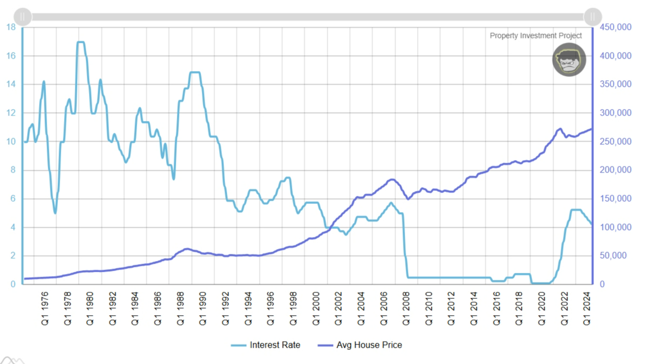
Figure 7 Avg House Prices vs. Interest Rates
(Source: Property Investment Project, 2025)
Figure 7 above shows that beyond 2007, the average house prices were on the rise, even with a significant decline in the interest rates. This contradicts the conventional impact where higher interest rates are known to increase the costs of borrowing, thereby reducing the affordability of loans and the demand for housing, leading to a slow growth in house demand and prices. By contrast, lower interest rates offered by financial institutions can drive housing demand, leading to a spike in prices, particularly in areas experiencing high housing demand (Miles and Monro, 2021). Figure 7 shows granular data that does not reveal the positive effects of a change in interest rate on house prices, which may be attributed to the type of data used (difference in the quarters) and failure to adjust for inflation, which influences purchasing power not only for property but all goods and services.

Effect of Income Changes on House Prices
A correlation analysis of the average weekly income (regular pay) (sourced from ONS, 2025) and house prices yielded an r value of 0.956. This demonstrates a strong positive correlation between income and house prices, where a rise in income leads to an increase in property prices, as the level of affordability in the housing market increases. As more people experience an increase in their income, the housing prices, especially in high-demand areas, increase since more and more people can afford to purchase property. The outcomes are supported by Figure 8 below, where house prices in the UK are seen to rise with increasing incomes. However, the figure also shows that the rate of increase in house prices is faster than that of income.
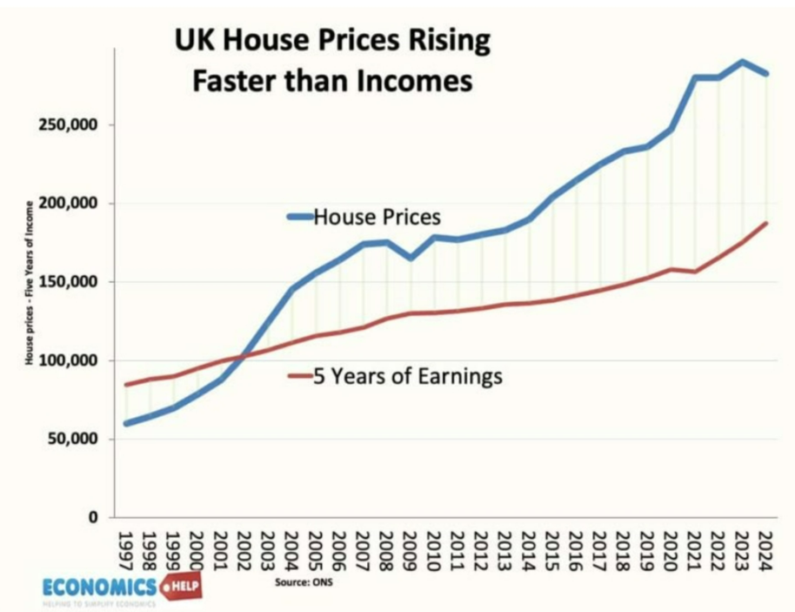
Figure 8 Income versus House Prices
(Source: Pettinger, 2025)

Effect of GDP Growth Rate on House Prices
From the correlation analysis, the relationship between year-on-year GDP growth rate (sourced from ONS, 2025) and house prices yielded an r value of 0.160. This shows a positive albeit weak correlation between the two. GDP growth rate does not necessarily reflect an increase in household income, as it may be brought about by other factors (Balcilar et al., 2023). Thus, the GDP growth rate may not necessarily translate to an increase in the affordability of houses, which would otherwise lead to an increase in house prices. Further, housing investment is just one of the many indicators of the total economic output (Canarella et al., 2021). Therefore, the relationship between GDP growth and housing investment would require further in-depth analysis to discern factors in the total economic output that are directly related to housing investment.

Evolution of Macroeconomic Factors
The macroeconomic indicators, including supply and demand, inflation, GDP growth, income growth, and interest rates that influence housing prices, have evolved in the last two decades owing to changes in the economic, financial, and regulatory global and local landscape. From 2000s to 2007, the boom in house prices was supported by the rapid credit growth, low real interest rates, and the increase in income (Coën and Pourcelot, 2024). Mortgage access was increased through financial innovations. The financial liberalisation and cheap long-term rates are associated with price gains internationally (Mumtaz and Šustek, 2023). The global financial crisis of 2008. The crisis was followed by a fall in prices. The credit crunch occurred, and the demand decreased. Between 2009 into the 2010s, the policy rates remained low and quantitative easing assisted recovery in prices despite the lag in wage growth (Bank of England, 2025).
From the 2010s to the early 2020s, systemic supply deficits were still there. New homes were restricted by the lack of planning and funding. Affordability was decreasing because prices exceeded earnings, particularly in London and the South. Analysis of GOV.UK and Commons show declines in proportions of social and affordable housing attributed to factors that include new regulatory standards. For instance, the UK government completed the transition to these new standards related to energy performance and electric vehicle charging points on 15 June 2023 (GOV.UK, 2025).
The recent years have witnessed policy shocks such as the pandemic and Brexit that caused changes in the housing demand patterns. Remote employment changed some of the regional demand. The inflation rate had soared after 2021, and in 2022 and 2023, central banks increased interest rates to combat inflation (Fleissig and Jones, 2023). Increased mortgage expenses lowered the activity of buyers and slowed the growth in nominal prices at certain times.

Impact of Mortgage Credit Expansion on the UK Housing Market
A leading indicator of home sales is the quantity of mortgages authorized to finance home purchases, according to BOE data. In May 2020, mortgage approvals for home purchases hit a record low due to the lockdown. After that, approvals rose dramatically near the end of 2020, but they are already declining. In September 2025, mortgage approvals for home purchases were up 2% from August 2025 and essentially steady from the previous year. September 2025 saw 65,944 mortgage approvals, up from 65,628 in September 2024 (House of Commons Library, 2025). Figure 9 below shows the approval trend, indicating variations in mortgage credit expansion over the years (2007 to 2025).
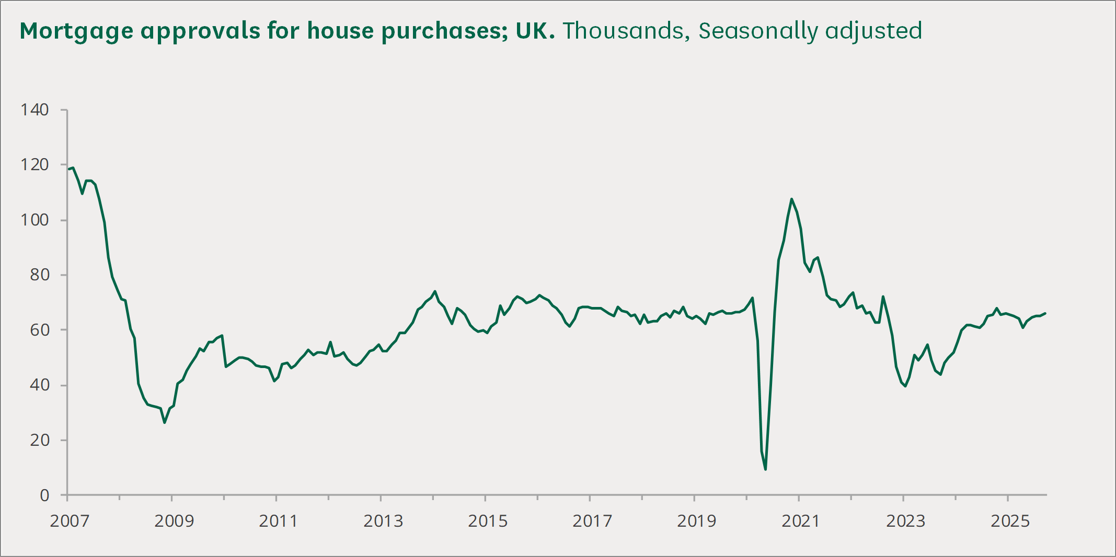
Figure 9 Mortgage Credit Approvals (2007-2025) Trend
(Source: BOE cited by House of Commons Library, 2025)
Mortgage expansion has significantly affected the UK housing market in the past two decades. The credit is increased more easily to purchase mortgages, and drives the prices up. Increased lending by the lenders will mean that more people will be able to borrow bigger amounts of money, and competition in the housing market will rise. The Help to Buy program evidence indicates that credit support, supported by the government, increased prices in England and Wales by a few percentage points (Carozzi et al., 2024). The composition of buyers is influenced by mortgage credit changes. Relaxed underwriting and programs are likely to boost first-time buyer activity and the purchase of new-build houses. Assessments of Help to Buy reveal that it assisted buyers in obtaining mortgages, but it did not contribute much to the growth of construction in restricted regions (GOV.UK, 2018).
The mortgage market is influenced by a range of macroeconomic forces. One of them is interest rates. Mortgage rates are directly affected by the policy rates of the BOE. Reduced policy rates decrease the cost of mortgages and increase the borrowing power and demand. Increased rates decrease approval and affordability. The money and credit reports of the Bank of England follow this connection (BOE, 2025).

CHAPTER FIVE: CONCLUSIONS AND RECOMMENDATIONS
The research found that the major macroeconomic variables that have a significant effect on house prices in the United Kingdom are inflation, interest rates, GDP growth, and the level of income. When the economy is booming and interest rates are low, housing prices would skyrocket, whereas economic recessions and tightening of monetary policies lead to a downward or flat increase. The statistics showed that the purchasing power is reduced by inflation, and affordability and housing demand are greater with the increase in GDP and income growth. It was found that interest rates played a vital role, as they would determine the costs to borrow mortgage and the behavior people would exhibit in investing in housing. The analysis has proved that variations in the housing market are in close relation to variations in these macroeconomic indicators, as it highlights the interdependence of the macroeconomy and the real estate sector.
To decrease volatility in the housing market, policymakers ought to seek to achieve stable macroeconomic environments by engaging in sound fiscal and monetary policies. Affordable housing schemes should be a priority of the government to counteract the effects of inflation and supply shortages. The Bank of England (BoE) must have policies on interest rates that balance between the growth of the economy and the affordability of houses. Mortgage lending regulations need to be tightened to avoid speculative bubbles and unsustainable debt levels by financial institutions. The next study would include regional housing data and policy variables to include differences in both affordability and market behaviour across the UK. These dynamics can be better understood to promote housing stability over the long term and equal access to home ownership.

References
Aalbers, M.B., 2015. The great moderation, the great excess and the global housing crisis. International Journal of Housing Policy, 15(1), pp.43-60.
Aha, B., 2022. The dynamic relationship between UK housing finance, house prices and their interplay with macroeconomic indicators (Doctoral dissertation, Birmingham City University). A Study of UK Housing Finance, Price Dynamics and their Reaction to Macroeconomic Drivers
Ahmad, N., Mobarek, A. and Raid, M., 2023. Impact of global financial crisis on firm performance in UK: Moderating role of ESG, corporate governance and firm size. Cogent Business & Management, 10(1), p.2167548. https://doi.org/10.1080/23311975.2023.2167548
Balcilar, M., Uzuner, G., Bekun, F.V. and Wohar, M.E., 2023. Housing price uncertainty and housing prices in the UK in a time-varying environment. Empirica, 50(2), pp.523-549.
Bank of England. 2025. What is happening with interest rates and how quickly might they fall? Available at: What is happening with interest rates and how quickly might they fall? | Bank of England (Accessed on 11 November, 2025).
BOE. 2025. Money and Credit - May 2025. Available at: Money and Credit - May 2025 | Bank of England (Accessed on 11 November, 2025).
Canarella, G., Gil-Alana, L., Gupta, R. and Miller, S.M., 2021. Persistence and cyclical dynamics of US and UK house prices: Evidence from over 150 years of data. Urban Studies, 58(1), pp.53-72.
Carozzi, F., Hilber, C.A. and Yu, X., 2024. On the economic impacts of mortgage credit expansion policies: evidence from help to buy. Journal of Urban Economics, 139, p.103611.
Coën, A. and Pourcelot, A., 2024. Monetary shocks and house prices in Europe. Journal of European Real Estate Research, 17(3), pp.331-372.
Daniel, E.I., Oshodi, O., Dabara, D. and Dimka, N., 2024. Towards closing the housing q in the UK: exploration of the influencing factors and the way forward. Construction Innovation, 24(4), pp.965-985. https://wlv.openrepository.com/bitstreams/b7656322-0d55-4e68-ac1c-c40e36329e9f/download
Fleissig, A.R. and Jones, B.E., 2023. UK household-sector money demand during Brexit and the pandemic. Economic Modelling, 123, p.106234.
Gallent, N., Durrant, D. and Stirling, P., 2018. Between the unimaginable and the unthinkable: Pathways to and from England’s housing crisis. Town Planning Review, 89(2), pp.125-144.
GOV.UK. 2018. Evaluation of the Help to Buy equity loan scheme. Available at: Evaluation of the Help to Buy equity loan scheme - GOV.UK (Accessed on 11 November, 2025).
GOV.UK. 2025. Housing supply: indicators of new supply, England: January to March 2025. Available at: Housing supply: indicators of new supply, England: January to March 2025 - GOV.UK (Accessed on 11 November, 2025).
House of Commons Library. 2025. Housing market: Economic indicators. Available at: Housing market: Economic indicators - House of Commons Library (Accessed on 11 November, 2025).
Ivanovski, Z., Ivanovska, N. and Korunovska, V., 2022. Engle & Granger cointegration test for GDP and public consumption in the Republic of North Macedonia. UTMS Journal of Economics, 13(2), pp.221-235.
Jones, C. and W. Richardson, H., 2014. Housing markets and policy in the UK and the USA: A review of the differential impact of the global housing crisis. International Journal of Housing Markets and Analysis, 7(1), pp.129-144.
Kennett, P., Forrest, R. and Marsh, A., 2013. The global economic crisis and the reshaping of housing opportunities. Housing, Theory and Society, 30(1), pp.10-28.
Li, N. and Li, R.Y.M., 2024. A bibliometric analysis of six decades of academic research on housing prices. International Journal of Housing Markets and Analysis, 17(2), pp.307-328. 10_1108_IJHMA_05_2022_0080-libre.pdf
Mardiana, S., 2020. Modifying research onion for information systems research. Solid State Technology, 63(4), pp.5304-5313.
Meen, G., 1999. Regional house prices and the ripple effect: a new interpretation. Housing Studies, 14(6), pp.733-753.
Meen, G., 2016. Spatial housing economics: A survey. Urban Studies, 53(10), pp.1987-2003. Spatial housing economics: A survey
Miles, D. and Monro, V., 2021. UK house prices and three decades of decline in the risk-free real interest rate. Economic Policy, 36(108), pp.627-684. ssrn-3508653 (1).pdf
Miles, D. and Monro, V., 2021. UK house prices and three decades of decline in the risk-free real interest rate. Economic Policy, 36(108), pp.627-684.
Mumtaz, H. and Šustek, R., 2023. Global house prices since 1950. London School of Economics and Political Science.
ONS. 2024. UK House Price Index: December 2023. Available at: UK House Price Index - Office for National Statistics (Accessed on 11 November, 2025).
ONS. 2025. Average weekly earnings in Great Britain: November 2025. Available at: Average weekly earnings in Great Britain - Office for National Statistics (Accessed on 11 November, 2025).
ONS. 2025. CPIH ANNUAL RATE 00: ALL ITEMS 2015=100. Available at: CPIH ANNUAL RATE 00: ALL ITEMS 2015=100 - Office for National Statistics (Accessed on 11 November, 2025).
ONS. 2025. Gross Domestic Product: Year on Year growth: CVM SA %. Available at: Gross Domestic Product: Year on Year growth: CVM SA % - Office for National Statistics (Accessed on 11 November, 2025).
Orudzhev, E. and Alizade, A., 2021. Cointegration analysis of the impact of Azerbaijan and Ukraine GDPs on the trade turnover between these countries. Journal of International Studies (2071-8330), 14(3).
Pettinger, T., 2025. UK House Price to Income Ratio and Affordability. Available at: UK House Price to Income Ratio and Affordability - Economics Help (Accessed on 11 November, 2025).
Property Investment Project. 2025. UK Real House Prices Adjusted For Inflation (From 1975 – 2024). Available at: UK Real House Prices Adjusted For Inflation (From 1975 - 2024) (Accessed on 11 November, 2025).
Rossall Valentine, D., 2015. Solving the UK Housing Crisis. The Bow Group: London.
Rott, B., 2021. Inductive and deductive justification of knowledge: epistemological beliefs and critical thinking at the beginning of studying mathematics. Educational Studies in Mathematics, 106(1), pp.117-132.
Stavridou, M., Dimopoulos, T. and Katafygiotou, M., 2025. Macroeconomic and Demographic Determinants of London Housing Prices: A Pre-and Post-Brexit Analysis. Real Estate, 2(3), p.10. Macroeconomic and Demographic Determinants of London Housing Prices: A Pre- and Post-Brexit Analysis
Taltavull de La Paz, P. and White, M., 2012. Fundamental drivers of house price change: the role of money, mortgages, and migration in Spain and the United Kingdom. Journal of Property Research, 29(4), pp.341-367.
UK Finance. 2019. The Changing Shape of the UK Mortgage Market: A Joint Report from UK Finance and Hometrack. UK Finance, London. [Google Scholar].
White, M., 2015. Cyclical and structural change in the UK housing market. Journal of European Real Estate Research, 8(1), pp.85-103.
Winarno, S., Usman, M. and Kurniasari, D., 2021. Application of vector error correction model (VECM) and impulse response function for daily stock prices. In Journal of Physics: Conference Series (Vol. 1751, No. 1, p. 012016). IOP Publishing.
Wood, R., 2003. The information content of regional house prices: can they be used to improve national house price forecasts?. Bank of England Quarterly Bulletin, Autumn.

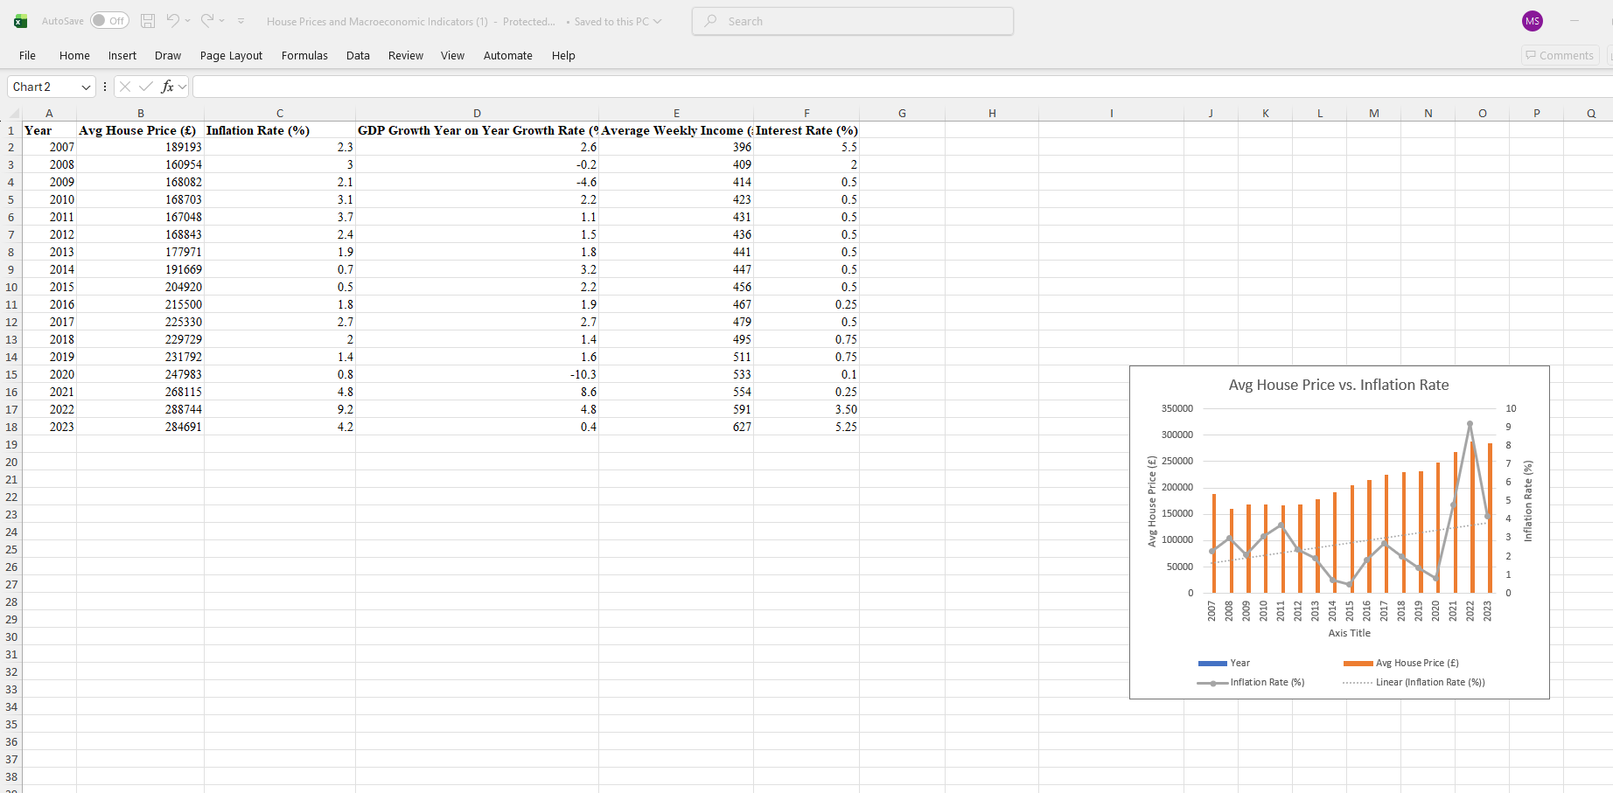
Appendix 1

