Software Solutions for Business
Assessment 1

Student Name: Fernel Ramirez Espinal
Student Number: 2508572
Alecta: Kwame Assa-Agyei

University Of Wales trinity Saint David
Course: CERTHE Computing Skills for the Workplace

Table of Contents
Introduction 1
Task 1. e-Commerce Website builders or software solutions 1
1.1 WooCommerce 1
1.2 Wix 1
Task 2. Mind-map of contemporary software applications 1
a. Mind mapping and explain the benefits of using mind mapping in business operations 1
b. Create a mind map of contemporary software applications 1
Task 3. Office Applications 1
a. Four office software solutions for business operations 1
MS Word 1
MS PowerPoint 1
MS Excel 1
MS Access 2
b. Practical demonstration of Two Office Features 2
Mail Merge 2
If Statement 2
Task 4. Communication and Collaboration applications 2
a. One contemporary Communication and one Online Collaboration applications/tools 2
MS Outlook 2
MS Teams 2
b. One feature of a freely available Communication (1) and one feature of a Collaboration (1) application 2
MS Outlook 2
Ms Teams 2
Conclusion 2
References 3

Introduction
Software applications are increasingly important features of business in the modern digital world, as they allow businesses to utilize modern tools for working effectively, communicating, and making decisions efficiently. E-commerce platforms, office productivity suites, and collaboration applications are among the modern tools organizations widely use to streamline workflows and remain competitive. The following report covers some selected e-commerce website builders, outlines how mind mapping is used in business, analyses office software solutions, and describes contemporary communication and collaboration tools. The content will demonstrate how we apply these technologies for the day to day aspects of businesses and the achievement of organizational success [1].

Task 1. e-Commerce Website builders or software solutions

1.1 WooCommerce

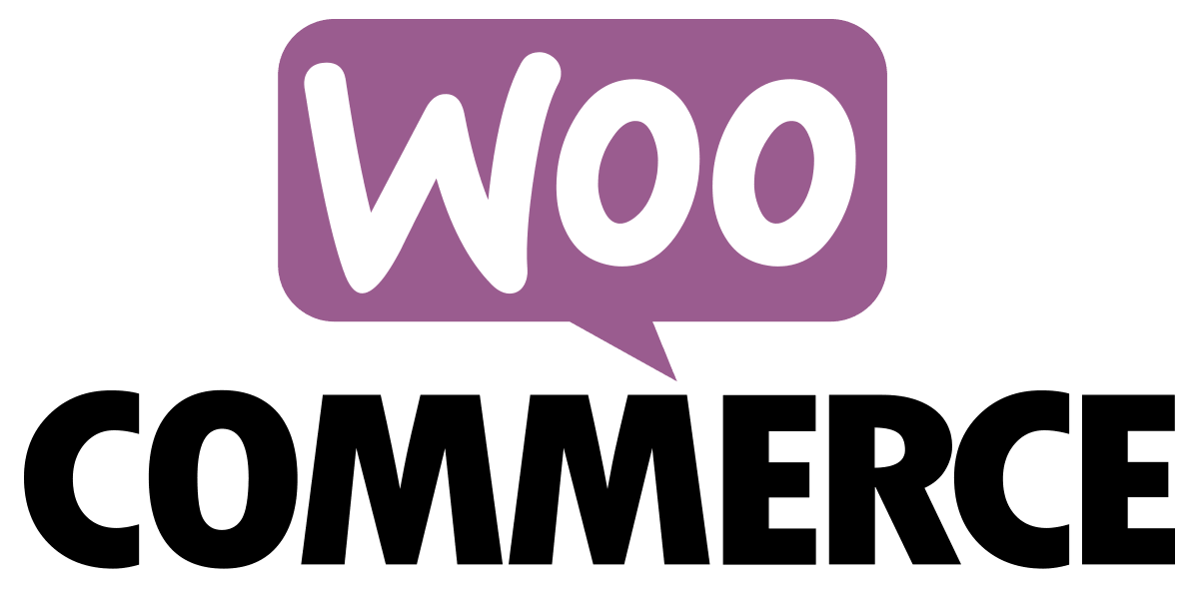
WooCommerce is a popular open-source e-commerce plugin developed for the WordPress framework. It lets companies create an entirely functional online store. For one, it comes with tons of customization at scale (thousands of themes and extensions) [2]. This allows businesses to customize their online stores for branding and operational needs. WooCommerce can provide secure payment gateways, help businesses manage inventory and analyze sales analytics and the platform can be used by small and medium sized businesses. Its open-source identity minimizes its cost and adds room for growth in the future [3].

1.2 Wix
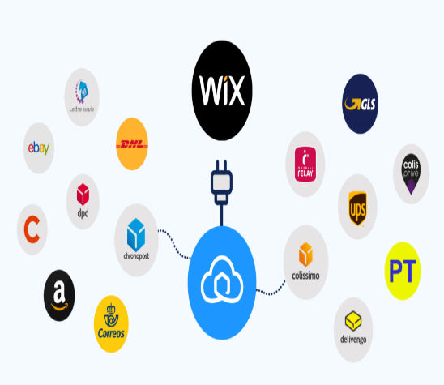
Wix is an easy-to-navigate cloud-based website builder with e-commerce capabilities [4]. It grants potential users the freedom to make online stores without knowing how to program. With its drag and drop interface, companies can design websites in a clean and efficient manner. Wix offers built in payment facilities, automatic tax computation, and order tracking functions. It further provides marketing features such as email campaigns, social media integration, and analytics. The fact that Wix is simple, plus the array of templates, makes it ideal for startups and small businesses looking for a one-stop shop e-commerce solution [5].

Task 2. Mind-map of contemporary software applications

Mind mapping and explain the benefits of using mind mapping in business operations

Mind mapping is a method of diagramming or visualising ideas, concepts and information into a meaningful frame of mind. Mind mapping has several valuable applications in business. First of all, it stimulates creativity by encouraging free-flowing idea generation. Employees can visually brainstorm solutions without linear confines [6]. Second, it simplifies and clarifies intricate information because it breaks it down in an understandable format. This eliminates confusion and aids decision making. Third, mind maps are an effective strategic planning tool. They assist companies in outlining tasks, allocating resources and identifying key priorities. Finally, mind maps improve cooperation, as members could readily communicate visual plans to each other and build on them within meetings or project discussions [7].

Create a mind map of contemporary software applications
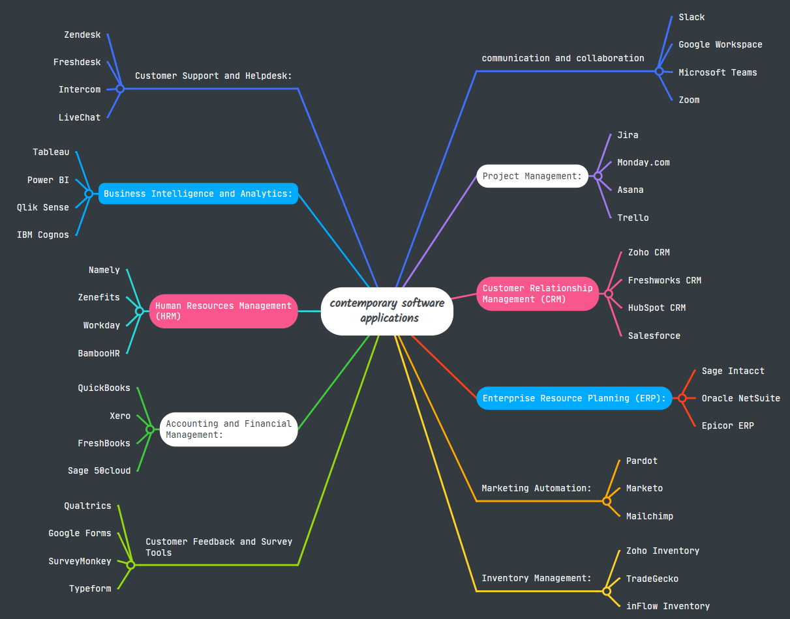

Task 3. Office Applications

Four office software solutions for business operations


MS Word
Microsoft Word is one of the most popular tools for writing and formatting documents. People use it for everything from letters and reports to proposals and forms. It comes with plenty of templates, design options, and editing tools that make your work look polished and professional. Plus, its collaboration features like comments, track changes, and real-time editing make it easy for teams to review and update documents together [8].
.

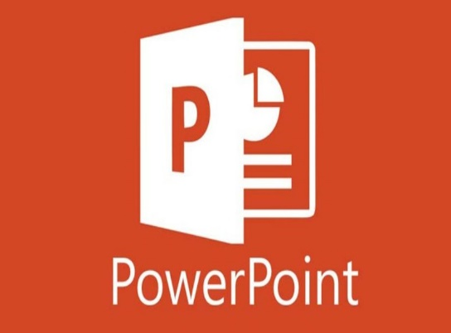
MS PowerPoint
Microsoft PowerPoint is a trusted tool for creating eye catching presentations. It’s often used in meetings, training sessions, and pitches to share ideas in a clear and engaging way. With its easy to use templates, animations, charts, and multimedia features, PowerPoint helps people organize their thoughts and tell their story visually so audiences can follow along and stay interested [9].


MS Excel
Microsoft Excel is more than just a spreadsheet program it’s a powerful tool that helps businesses make sense of numbers. With its wide range of formulas and functions, you can easily create budgets, track expenses, and even forecast future performance. Excel also comes with features like pivot tables, charts, and data visualisation tools, which make spotting trends and patterns much easier. Essentially, it turns raw data into meaningful insights, helping businesses make smarter, faster decisions [10].

MS Access

MS Access is a database management system that makes it easy to store, organise, and retrieve large amounts of structured data. Businesses often use it to build customised databases for tasks like keeping track of customers, managing inventory, or maintaining records. With Access, you can create forms to enter data, run queries to find exactly what you need, and generate reports to summarise information. It’s a practical tool for handling data in a way that keeps business operations organised and efficient [11].

Practical demonstration of Two Office Features

Mail Merge
Mail Merge is a handy feature in Microsoft Word that lets you create personalised documents like letters, envelopes, or labels without typing everything manually. For instance, a company can automatically insert each customer’s name and address from an Excel spreadsheet into a letter. This not only saves a lot of time but also reduces errors, making it especially useful when you need to send documents to a large group of people.
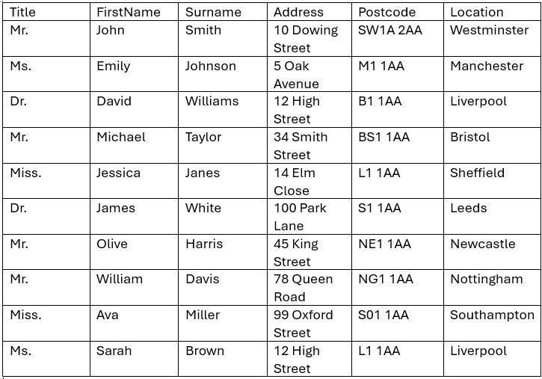

My Titles

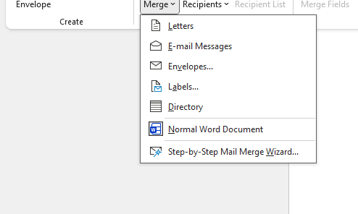

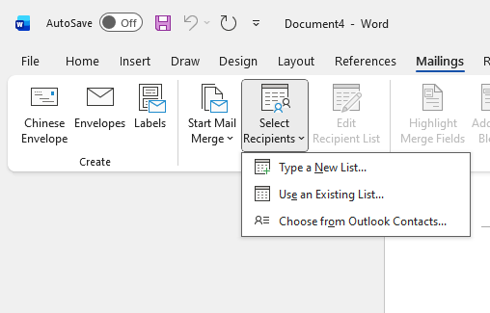

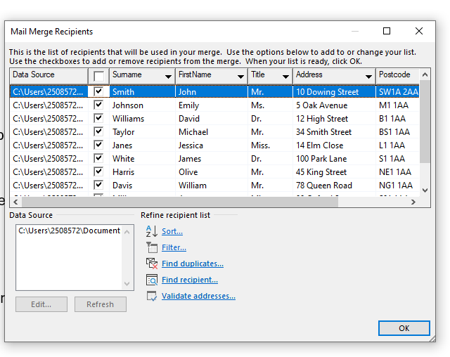

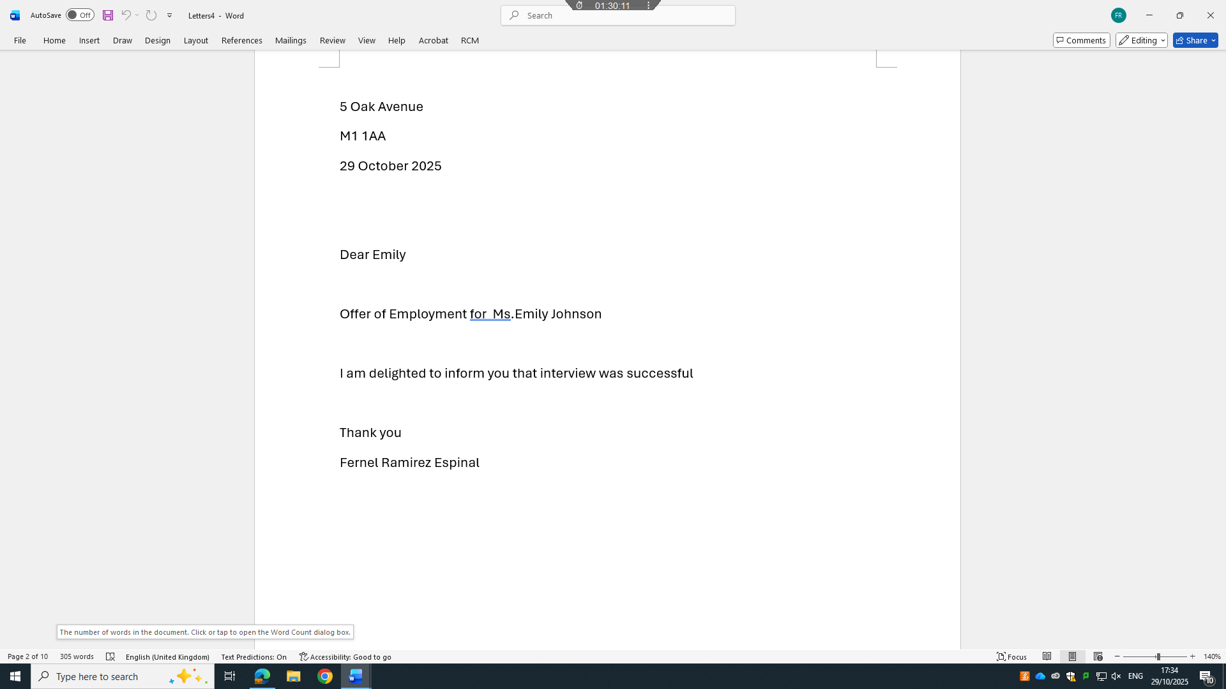

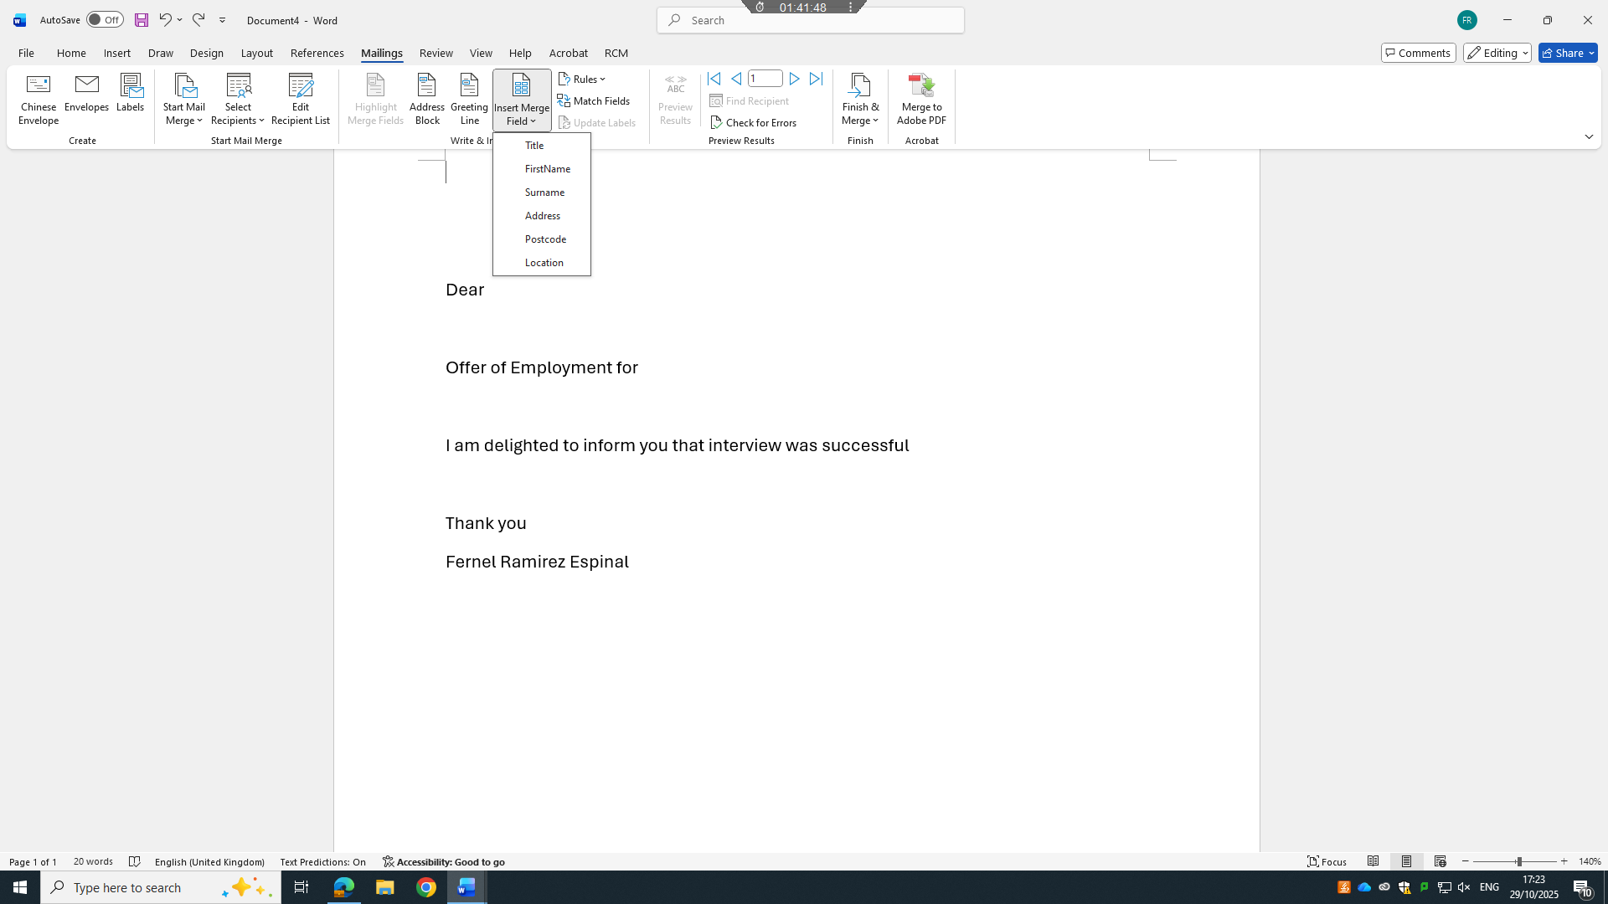

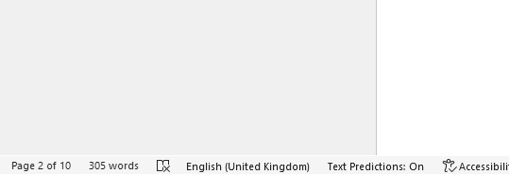

If Statement
The IF statement in Excel is a smart tool that helps you make decisions within a spreadsheet. It works by checking a condition and then returning one result if the condition is true and another if it’s false. For example, a business can use an IF function to automatically check whether sales targets have been met by comparing actual sales to the goals. This makes it much easier to assess performance quickly and ensures that reports are accurate and reliable.
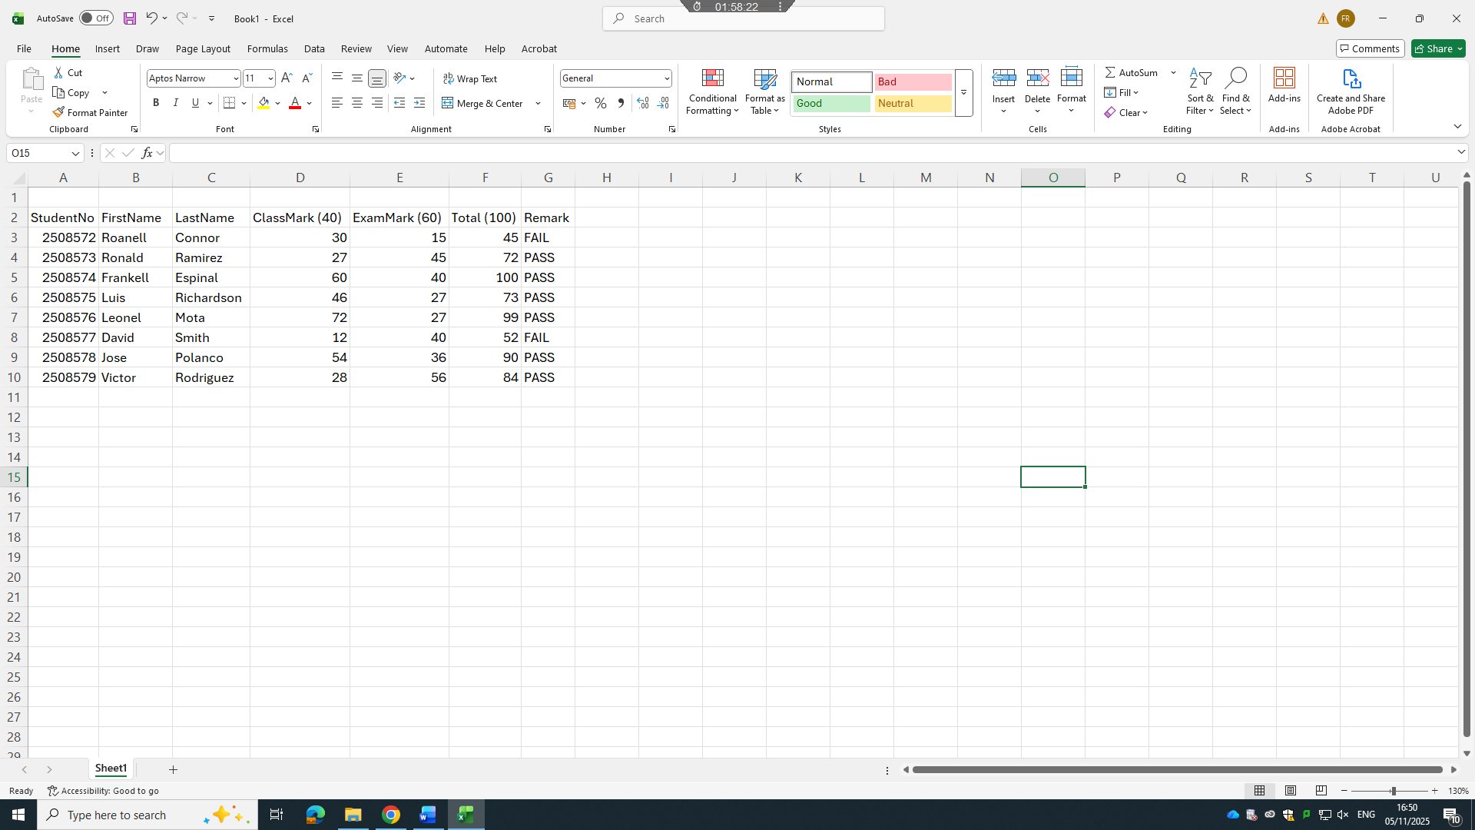

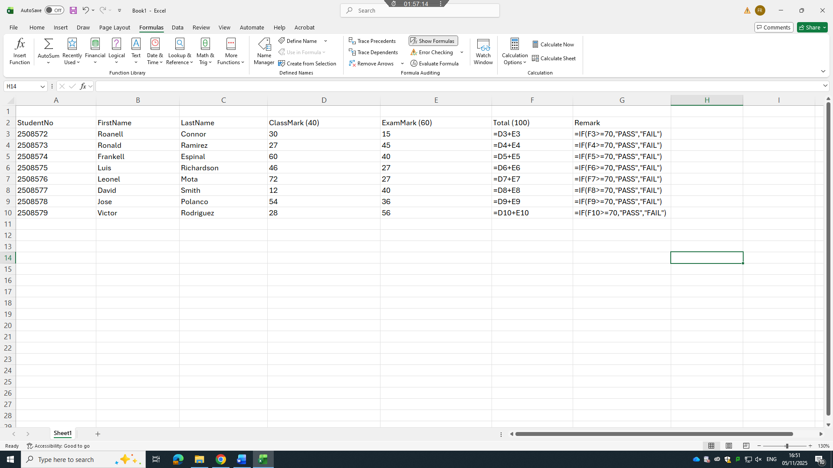

Task 4. Communication and Collaboration applications

One contemporary Communication and one Online Collaboration applications/tools


MS Outlook

Microsoft Outlook is a popular email and calendar app that helps businesses stay organised and communicate efficiently. It’s great for managing emails, scheduling meetings, setting reminders, and keeping track of tasks all in one place. Since Outlook works seamlessly with other Microsoft apps, it makes it much easier for teams to coordinate, share information, and manage their daily work without missing a beat [12].

MS Teams
Microsoft Teams is a collaboration platform that brings chat, video meetings, file sharing, and team workspaces all into one place. It makes it easy for employees to communicate in real time and work together on documents through the cloud [13]. Teams is especially useful for remote or hybrid work, helping teams stay connected, coordinate projects smoothly, and get work done efficiently no matter where they are [14].

One feature of a freely available Communication (1) and one feature of a Collaboration (1) application


MS Outlook
One handy feature in Outlook is the Focused Inbox, which automatically sorts your emails into Focused and Other tabs. This makes it easier to see the most important messages first, so you can stay on top of critical emails without getting distracted by less urgent ones. It’s a simple way to manage your inbox more efficiently and save time.

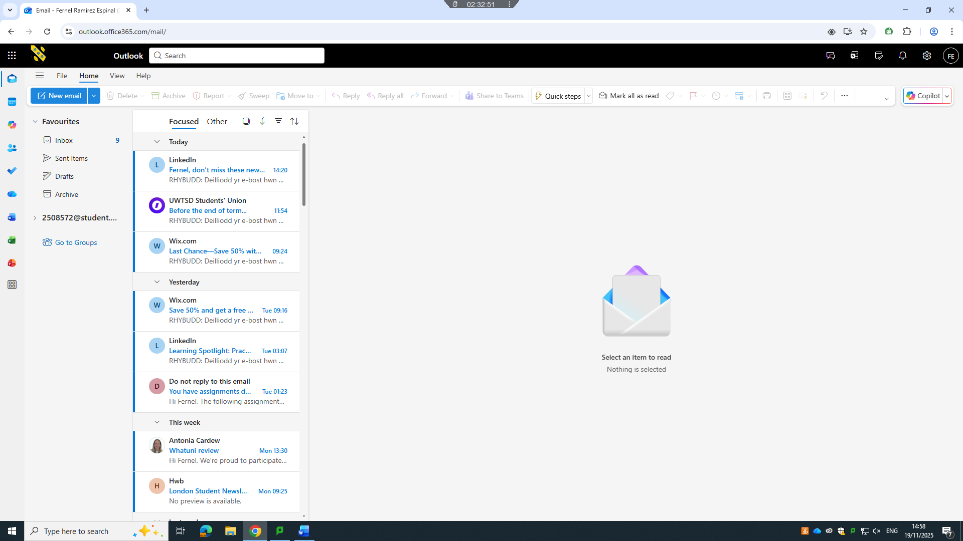

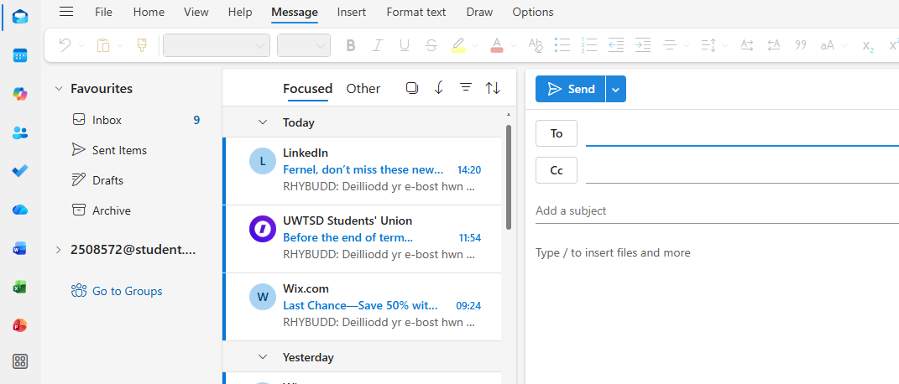


Ms Teams
Microsoft Teams is a collaboration platform that brings chat, video meetings, file sharing, and team workspaces together in one place. It makes it easy for employees to communicate instantly and work on documents together through the cloud. Teams is especially useful for remote or hybrid work, helping teams stay connected, coordinate projects smoothly, and get things done efficiently, no matter where everyone is located.

Conclusion
In today’s business world, modern software applications make work faster, easier, and more organised. E-commerce platforms like WooCommerce and Wix help businesses reach customers online with minimal hassle. Mind mapping encourages creativity and keeps ideas structured, while office tools such as MS Word, Excel, PowerPoint, and Access handle the essential day-to-day tasks that keep a business running smoothly. On top of that, communication and collaboration tools like Outlook and Teams make it simple for teams to stay connected and work together effectively. By bringing these technologies together, businesses can streamline their processes, boost productivity, and stay competitive in a fast-changing digital landscape.

References
[1] J. W. Satzinger, R. B. Jackson, and S. Burd, Systems Analysis and Design in a Changing World, 7th ed. Boston, MA: Cengage Learning, 2015.
[2] WooCommerce, “About WooCommerce,” 2024.
[3] WordPress Foundation, “WooCommerce Documentation,” 2024.
[4] Wix.com, “Wix eCommerce Overview,” 2024.
[5] S. McDowell, Building Websites with Wix: A Beginner’s Guide, New York, NY: TechPress, 2022.
[6] T. Buzan, The Mind Map Book, London: BBC Books, 2018.
[7] A. Harrison, “Using mind maps for business planning,” Journal of Business Strategy, vol. 41, no. 2, pp. 45–52, 2020.
[8] Microsoft, “Microsoft Word Product Guide,” 2024.
[9] Microsoft, “PowerPoint: Presentation Features,” 2024.
[10] J. Walkenbach, Excel 2021 Bible, Indianapolis, IN: Wiley, 2021.
[11] Microsoft, “Outlook – Product Overview,” 2024.
[12] A. Gupta, “Security features in enterprise email systems,” Information Security Journal, vol. 29, no. 4, pp. 210–218, 2021.
[13] Microsoft, “Microsoft Teams – Features and Functionality,” 2024.
[14] K. Turner, Modern Collaboration Tools in the Workplace, London: DigitalWork Press, 2023.
[15] Microsoft, “Manage your inbox with Focused Inbox,” 2023.
[16] R. Collins, “Cloud-based teamwork: The rise of real-time collaboration tools,” Technology Today, vol. 12, no. 3, pp. 33–40, 2022.

