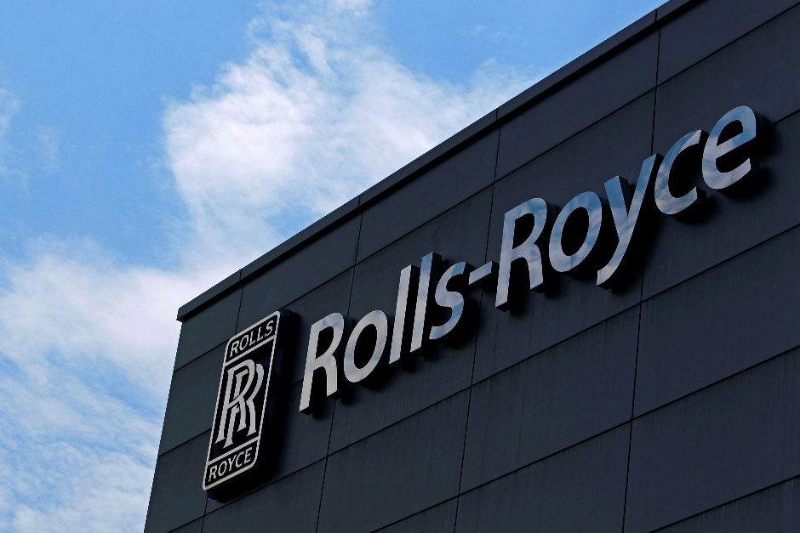

Global Business Environment

HAJAR Takidine
2312530
LCBB4016

Table of Contents
Artificial Intelligence and Digital Transformation 2
Geopolitical Supply-Chain Disruptions 3
Sustainability and the Energy-Transition Agenda 4
Impact on the Organisation 5
Conclusion 7

Introduction
Globalisation refers to the process through which trade, investment, ideas and technologies spread across national borders, linking markets and societies more closely together (IMF, 2023). For international businesses, it remains both an opportunity and a source of vulnerability. Digital technologies, political instability and global sustainability challenges have transformed what it means to operate internationally. As Ghemawat (2017) notes, today’s world is not flat but fragmented firms must adapt to differing markets, regulations and risks while staying globally connected.
Rolls-Royce Holdings plc is a prime example of a UK-based multinational navigating this complex landscape. Headquartered in London, the company designs, manufactures and services power systems for aviation, defence, marine and energy sectors in more than 50 countries (Rolls-Royce, 2024). With over 40,000 employees and customers that include major airlines and governments, Rolls-Royce sits at the intersection of advanced engineering, global supply chains and sustainability transitions.
This essay examines how three contemporary global forces, rapid artificial intelligence (AI) adoption, geopolitical supply-chain disruptions, and sustainability regulation linked to the energy transition are shaping Rolls-Royce’s international strategy and operations. It explores the opportunities these forces create the challenges they present, and how they influence the company’s innovation, competitiveness and talent strategy. The essay concludes with practical recommendations for strengthening Rolls-Royce’s global position.


Artificial Intelligence and Digital Transformation
AI and advanced analytics present major opportunities for Rolls-Royce to increase efficiency and innovate. The company has already embedded predictive analytics into its Intelligent Engine concept, where aircraft engines transmit real-time performance data to monitor health and predict maintenance needs (Rolls-Royce, 2024). This approach allows engines to remain in service longer, cuts fuel use and helps airlines avoid costly breakdowns, a clear competitive advantage.
AI also drives product innovation. In the company’s Ultra Fan engine programme, digital simulation and machine-learning models optimise blade design and thermodynamics, reducing time and cost in research and development. Rolls-Royce engineers use digital twins to test engines virtually before production, improving safety and shortening development cycles (Research Tree, 2024). In its defence division, AI supports predictive logistics and mission-planning tools, aligning with the UK’s Ministry of Defence digital strategy.
Beyond engineering, AI enhances business operations. Automated scheduling, AI-driven procurement analytics and algorithmic quality-control systems reduce bottlenecks and improve supply-chain visibility. These examples show what Davenport and Ronanki (2018) call “intelligent automation” where machines support human judgment rather than replace it.
Despite clear benefits, AI introduces ethical, technical and organisational risks. The aerospace and defence industry operates under strict safety and data-security standards; AI systems must be explainable and fully auditable (Gunning & Aha, 2019). Rolls-Royce faces the additional challenge of managing sensitive customer and government data across multiple jurisdictions with differing data-protection laws.
Workforce readiness is another concern. Introducing AI requires upskilling engineers and analysts to interpret digital outputs and maintain data integrity. Failure to adapt may create a digital skills gap that undermines competitiveness. Moreover, automation could displace some administrative roles, creating tension between efficiency gains and employee morale.

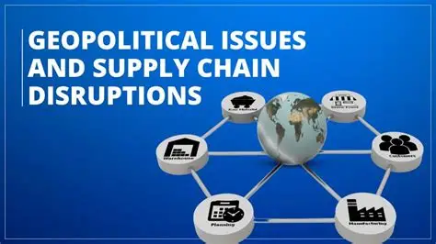
Geopolitical Supply-Chain Disruptions
Recent geopolitical shocks from Red Sea shipping disruptions to rising tension around China and Taiwan have forced global manufacturers to rethink supply-chain design. For Rolls-Royce, this turbulence provides a chance to re-engineer its network toward greater resilience. The company has begun diversifying suppliers and increasing local sourcing, aligning with the UK’s industrial strategy for secure supply of strategic components (Rolls-Royce, 2024).
In practical terms, Rolls-Royce’s move toward regional production hubs such as facilities in Germany, the US, and Singapore reduces exposure to single-route disruptions and shortens delivery times for customers. This “semi-globalised” model (Ghemawat, 2017) balances efficiency with security. Supply-chain stress has also encouraged closer partnerships with key suppliers, prompting shared innovation on additive manufacturing and advanced materials.
However, global supply-chain instability remains one of Rolls-Royce’s biggest operational risks. The company’s 2023 Annual Report identified component shortages and logistics bottlenecks as major cost pressures, contributing to additional provisions of around £400 million (Research Tree, 2024). Engine assembly depends on highly specialised parts sourced from around the world, leaving production vulnerable to delays.
Geopolitical uncertainty also complicates defence contracts. Sanctions, export-control rules and government budget cycles can disrupt procurement schedules. Furthermore, the company must balance its operations between Western alliances and emerging markets without breaching international regulations a delicate strategic act.
As Sheffi and Rice (2005) highlight, firms must constantly weigh resilience against efficiency. Building local capacity improves continuity but sacrifices some economies of scale, increasing unit costs and challenging profitability in competitive tenders.


Sustainability and the Energy-Transition Agenda
Sustainability regulation, particularly across Europe, is accelerating investment in cleaner technologies, an area where Rolls-Royce can lead. The company’s strategy, Power to Fly – Power to Lead, commits to achieving net-zero operations by 2050 and developing products that support customer decarbonisation (Rolls-Royce, 2025).
In civil aerospace, this includes engines compatible with 100 % sustainable aviation fuel (SAF) by 2025 and partnerships exploring hydrogen propulsion. In the power-systems segment, Rolls-Royce’s small modular reactor (SMR) programme offers a potential low-carbon energy solution that could deliver new export markets and long-term revenue. Aligning with EU and UK sustainability reporting rules, such as the Corporate Sustainability Reporting Directive (CSRD), enhances transparency and investor confidence (European Commission, 2024).
Sustainability also strengthens the employer brand. Younger engineers and data specialists increasingly choose companies aligned with climate goals, giving Rolls-Royce an edge in recruiting technical talent (Cone Communications, 2023).
Yet the sustainability transition is expensive and administratively complex. Complying with CSRD and similar frameworks demands detailed lifecycle reporting across global operations from raw-material extraction to engine end-of-life recycling (EFRAG, 2023). Data collection across thousands of suppliers adds cost and risk of inaccuracies.
Moreover, sustainability investments often yield long payback periods. Developing SAF-ready engines or nuclear SMRs requires billions in R&D with uncertain future returns, especially if regulatory approval or customer adoption lags. Competition from emerging clean-tech players could erode Rolls-Royce’s first-mover advantage.
The company also faces scrutiny over potential “greenwashing.” Any mismatch between sustainability claims and measurable outcomes could harm reputation (Lyon & Montgomery, 2015). To remain credible, Rolls-Royce must deliver verified performance improvements rather than rely solely on commitments.


Impact on the Organisation
Market Positioning
Together, these global forces are redefining Rolls-Royce’s market position. The integration of AI and advanced analytics supports a transition from pure manufacturer to digital-service provider, strengthening long-term relationships with airlines and governments. Sustainability leadership enhances brand reputation with environmentally conscious investors and customers, aligning with growing ESG investment trends.
However, higher costs from supply-chain regionalisation and green innovation may limit price competitiveness in emerging markets. Competitors such as GE Aerospace and Safran are pursuing similar digital and low-carbon strategies, narrowing differentiation. Maintaining premium positioning will therefore rely on consistent technological performance and service reliability rather than cost leadership.
Innovation and Competitiveness
AI and sustainability imperatives have become central to Rolls-Royce’s innovation model. Digital twin testing, additive manufacturing and modular engine architectures enable faster design iteration and improved performance (Brynjolfsson & McAfee, 2014). These advances underpin the company’s IntelligentEngine vision and may open opportunities in hybrid-electric and hydrogen propulsion.
Nevertheless, innovation depends on a robust supply base and stable funding. Supply-chain disruptions or policy uncertainty around clean-energy subsidies could slow progress. Competitiveness increasingly rests on how well Rolls-Royce integrates its digital, engineering and sustainability capabilities into coherent, scalable business models.
Talent Management
AI transformation and sustainability reporting demand new skill sets. Rolls-Royce’s Digital Academy and partnerships with universities aim to retrain thousands of employees in data analytics, automation and systems thinking (Rolls-Royce, 2024). At the same time, younger workers are attracted by purpose-driven engineering roles.
However, global talent mobility is constrained by visa policies and geopolitical divisions, making it harder to rotate specialists between facilities. The company must strengthen regional training and virtual collaboration programmes to maintain knowledge sharing. Wage inflation for scarce digital and sustainability talent also pressures costs.

Strategic Recommendations
- Develop a hybrid global–regional supply-chain model
Segment suppliers by criticality and location risk. Critical engine components should have at least two geographically diverse suppliers, supported by predictive analytics to forecast shortages. For less-critical items, maintain global sourcing for cost efficiency. Establish digital “control towers” integrating supplier data to improve real-time visibility (Lee, 2002; Christopher & Holweg, 2024).
- Institutionalise responsible AI governance
Create a cross-functional AI ethics board reporting directly to senior management to oversee algorithm transparency, safety and data privacy. Embed human-in-the-loop decision-making for all safety-critical systems. Partner with regulators and academic institutions to shape emerging aerospace AI standards (Gunning & Aha, 2019).
- Turn sustainability compliance into differentiation
Go beyond minimum CSRD reporting by offering customers verified carbon-footprint data and lifecycle-emission dashboards for engines and reactors. Position this transparency as a premium service differentiator rather than a cost burden.
- Accelerate “open innovation.”
Expand collaborations with start-ups, universities and clean-energy firms to speed up hydrogen, hybrid-electric and SMR technologies. Open innovation spreads R&D risk and enhances learning (Chesbrough, 2020).
- Invest in future-ready talent.
Build modular training programmes that grant micro-credentials in AI, sustainability and advanced manufacturing. Combine virtual international assignments with mentorship to retain global exposure despite mobility constraints (Chakroun & Keevy, 2018).
- Adopt scenario planning for geopolitical shocks.
Create a small geopolitical intelligence team to map potential crises ,from sanctions to shipping disruptions and test responses through simulation exercises (Wack, 1985; Boin et al., 2016). This proactive stance will enhance strategic agility.

Conclusion
The convergence of artificial intelligence, geopolitical instability and sustainability regulation defines the environment in which Rolls-Royce now competes. These forces simultaneously offer growth prospects and expose weaknesses. AI has transformed maintenance, design and customer service, but demands new skills and strong governance. Geopolitical turbulence disrupts supply chains yet pushes the firm toward more resilient, diversified operations. Sustainability regulation increases reporting complexity but reinforces Rolls-Royce’s long-term credibility and innovation in cleaner propulsion.
Ultimately, the company’s success will depend on how effectively it aligns digital transformation, supply-chain resilience and sustainability leadership within a coherent international strategy. In a world of “volatile globalisation,” adaptability, ethical technology use, and deep collaboration will define competitive advantage. For Rolls-Royce, mastering these dynamics is not just about navigating disruption — it is the pathway to enduring global relevance.

References
- Barney, J.B. (2001) ‘Resource-based theories of competitive advantage: A ten-year retrospective on “The resource-based view”’, Journal of Management, 27(6), pp. 643-650.
- Boin, A., Kuipers, S. and Overdijk, W. (2016) ‘Leadership in times of crisis: a framework for assessment’, International Review of Public Administration, 18(1), pp. 79-91.
- Brynjolfsson, E. and McAfee, A. (2014) The Second Machine Age. New York: W.W. Norton & Co.
- Chakroun, B. and Keevy, J. (2018) ‘Digital credentialing: Implications for the recognition of learning across borders’, UNESCO Education Research and Foresight Working Papers, No. 23.
- Chesbrough, H. (2020) ‘To recover faster from Covid-19, open up: Managerial implications from an open innovation perspective’, Industrial Marketing Management, 88, pp. 410-413.
- Christopher, M. and Holweg, M. (2024) ‘Supply chain resilience in a turbulent world’, International Journal of Operations & Production Management, 44(2), pp. 234-256.
- Cone Communications (2023) 2023 Purpose Study: The New Era of Stakeholder Capitalism. Boston: Cone Communications.
- Davenport, T.H. and Ronanki, R. (2018) ‘Artificial intelligence for the real world’, Harvard Business Review, 96(1), pp. 108-116.
- EFRAG (2023) European Sustainability Reporting Standards: Implementation Guidance. Brussels: European Financial Reporting Advisory Group.
- European Commission (2024) Corporate Sustainability Reporting Directive: Official Journal of the European Union. Brussels: European Union.
- Ghemawat, P. (2017) ‘Globalization in the age of Trump’, Harvard Business Review, 95(4), pp. 112-123.
- Gunning, D. and Aha, D. (2019) ‘DARPA’s explainable artificial intelligence (XAI) program’, AI Magazine, 40(2), pp. 44-58.
- IMF (2023) World Economic Outlook: Navigating Global Divergences. Washington, DC: International Monetary Fund.
- Lee, H.L. (2002) ‘Aligning supply chain strategies with product uncertainties’, California Management Review, 44(3), pp. 105-119.
- Lyon, T.P. and Montgomery, A.W. (2015) ‘The means and end of greenwash’, Organization & Environment, 28(2), pp. 223-249.
- Research Tree (2024) ‘Rolls-Royce Holdings – Full Year Results 2023’. Available at: https://www.research-tree.com/ (Accessed: 18 October 2024).
- Rolls-Royce Holdings plc (2023) Annual Report 2023. London: Rolls-Royce Holdings plc.
- Rolls-Royce Holdings plc (2024) Our Strategy. London: Rolls-Royce Holdings plc. Available at: https://www.rolls-royce.com/ (Accessed: 18 October 2024).
- Rolls-Royce Holdings plc (2025) Power to Fly – Power to Lead Strategy Update. London: Rolls-Royce Holdings plc.
- Sheffi, Y. and Rice, J.B. (2005) ‘A supply chain view of the resilient enterprise’, MIT Sloan Management Review, 47(1), pp. 41-48.
- Wack, P. (1985) ‘Scenarios: Uncharted waters ahead’, Harvard Business Review, 63(5), pp. 72-89.

