Reflective practice in the early year’s workforce. Chantelle Gauci 2200562
What is reflective practice.
Definition of reflection original came from (Dewey,1933) who points out reflection in the light of professionalism. (Schon,1983) further developed this into a process of reflective practice. (Dewey,1933) suggests reflection is a cognitive process. (Moss,2008) defines reflection as a rigorous process of constructing theories of the world testing them through dialogue, listening then reconstructing the theories which is evidently linked to the Reggio Emilia pedagogy of listening, (Rinaldi, 2005)
Reflective practice is defined as purposeful, meta-cognitive thinking to improve practice. It encompasses reflective thinking, reflective learning and reflective process. A dialogue of thinking and doing through which practitioners become more skilful.” (Schon,1983). It’s a continuous cycle of reflection and improvement. The term reflective is an idividuals capibity to capture a deeper concept to design a reflection of a collective situation. (Jones,2010).
(Dewey,1933) points out reflection arises from recognising a problem and aiming to find a solution for change to take place.
Conceptual framework for thinking about reflection is summarised as reflecting in action and reflection on action. Reflection in action is thinking in the moment and being spontaneous in practice. Reflection on action will happen after the event, you will immediately think how thinks can be delivered differently and what changes needs to made moving forward.
Reflective practice is desirable and is demanded by the early year’s foundation stage document (EYFS, 2008). It’s recognised as having the potential to make an impact to children’s lives in the way we approach the child and their individual needs.
(Wenger,1998) suggest reflective practice is a process of an ongoing learning process, requiring personal and professional qualities and attributes that merges as the individual takes ownership of the thinking process and measures for the outcomes for the children as individuals. (Schon,1987) highlights reflection is creatively applied and developed in collaboration with others.
Within the early years reflective practice is described as a process of turning experiences into learning. Reflecting on your experience in order to make changes and implement new ideas. Reflection requires taking the unprocessed, raw material of experience and engaging with it to have a clear understanding of what has happened. (Boud, D,2001). It involves a creative open-ended process with many potential interpretations, being involved in the process and involving others will lead onto endless possibilities. An essential element within the concept of ongoing learning and professional development.

Reflection and Professional practice within the early years.
Reflective practice withing the early years is the pathway connecting theory and practice. The cycle of reflection is essential to underpin the interactivity with children, families and other professionals.
(Aistear, 2009) states reflective practice requires practitioners to think about their work with children, planning and implementing the curriculum to best support the children’s interests and strengths.
According to (Siolta, 2006) reflective practice requires practitioners to be aware of in thought processes in a critical way of their daily tasks with an open mind to continuously improving and refining practice. (Longford CCC, 2017) was a useful source of information.
Reflective practice is a key part of learning for a practitioner it enables you to think about your professional practice, your ideas, challenge yourself to analyse personal experiences to enhance on learning. It provides you with a greater understanding of why things happen, recognises good practice, make changes and make improvements when necessary.
As highlighted by Nutbrown review (2012) an individual never stops learning and developing. A professional practitioner will continually need to enhance and develop their knowledge and skills to keep well updated with recent research and developments.
As a reflective practitioner you will identify your, strengths, skills and acknowledge areas of need for development, take professional responsibility for continuously improving the quality of your practice, consider the impact of their practice on the children, work in different ways and introduce new ideas, plan to maintain and develop their practice in the future.
Reflection is essential part of your practice, its beneficial to the children and the practitioner personally and professionally. Reflection needs to be used in everyday practice to improve your practice, ensure you are meeting individual’s needs, increase self-esteem, enable interactive environment, supports individuals targets and identifies professional development needs. As a professional practitioner peer observations will be a crucial way of reflecting on your practice as well as others. Observations need to be focused, short and provide constructive feedback with the aim to identify your strengths and areas of development.

Reflective models and theories.
Reflection in practice is advocated by many theorists acknowledging the positive effect the process has on individuals’ development and progress as a professional practitioner. The models are used to guide and support you to be able to reflect upon your practice. Although there are many different types of reflection models, they all focused on the learning cycle. Some models will consist of more stages than other models but overall will still achieve the same reflective outcome.
Schon’s theory is developed by the theory of Reflective practice, reflection on action and reflection in action.
According to (Schnon,1991) reflection is having the ability for professionals to think about what they are doing, while doing it. As a professional early years practitioner Schon’s theory is particularly useful in practical situations when teaching and observing children using your professional skills, knowledge and understanding to distinct between reflection during the event and reflection after the event. Schon places a huge emphasis on the role of professional practice and therefore notices reflection as an active way of synthesizing tacit knowledge and ability (Kinsella, 2010).
Reflection on action allows the practitioner to spend more time considering the situation, considering various interpretations, and thinking about how they could respond differently in the future (Hebert, 2015). By applying this to any situation you be carefully planning, informed by research, previous experience and focus with logical reasons. Reflection in action focuses on finding a solution to what is happening during the event, decision making, thinking about it during the event, and deciding how to act in the moment and acting immediately.

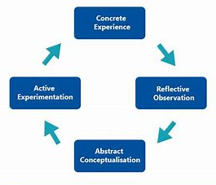
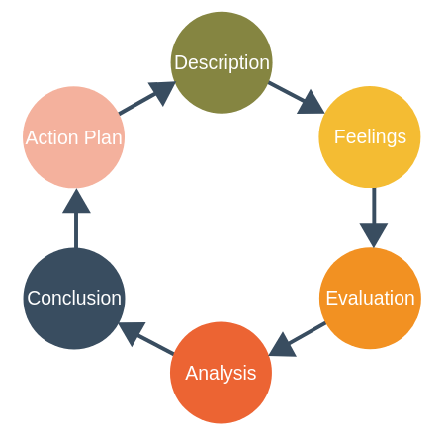
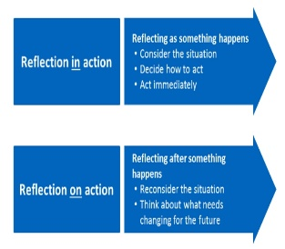

Kolb’s experimental learning cycle is another model of reflection that can be very a great model to use within your practice. The University of Hall (2022) points out Kolb’s learning cycle is based on four stages concrete experiences experience something, reflective observations where you will think about an experience, abstract conceptualisation at this stage you will be learning from experience analyse and explain your reflection then active experimentation is the final stage is about putting your learning into practice by implementing a theory you have learnt. (Brown, N no date) points out when the process has been fully engaged with new experiences will start to form another learning cycle.
As a professional practitioner you will begin to use many different reflection learning cycles until you become familiar and confident with the best model that fits your practice. The models provide you with a structure of where to begin when reflecting and guide you through the reflection process. Reflection plays a key part in your professional development. Although these reflection learning cycles suggests the importance of reflecting following the stages of the cycle it is not always relevant to your practice. Every situation is different a practitioner may need to adapt the way they reflect to how it bests fit the situation at the time. The reflection cycles are a good starting point to guide practitioners if you are unsure of were to begin when reflecting. Although the reflection cycles are a good staring point to reflection there are also many pros and cons to using them. (University of Cambridge, no date) points out the pros. It provides structure to follow, a useful starting point if you are unsure where to begin, assess all levels of a situation and you will know when you have completed the process. Moving onto the cons the reflection cycle implies the stages need to be address in a certain way, in different situations you may not always be able to start at the beginning of the learning cycle, models may not be applied in every situation and reflective practice is a continuous process.
(Dewey,1933) implies anybody working with children should not make the assumption things work because it has been done in the past. He suggests that’s its unlikely to be one right way to do something, practitioners need to use their ‘reflective intelligence’ to find the solution to what works best and what does not through problem solving and a regular basis.
Appleby, 2010) points out reflective is connected to empathy and questioning things that are taken for granted. (Craft, A and Paige-Smith, A , 2011) highlighted how early years practitioners are more and more expected to widen their knowledge within their practice and it involves a level of theoretical understanding of the children’s learning and development within the early years. Reflective practice and self-evaluation are fundamental to the Ofsted inspection process. Reflection promotes on going learning by developing an insight into professional practice, increasing self-awareness and allowing for a wider understanding of analysis and evaluation to strengthen critical inquiry and inform practice (Kirkham, 1997).

Gibbs reflective cycle is one of the most famous cyclical models of reflection used by professional practitioners. Gibbs reflection cycle was developed in 1988, it focuses on giving structure to learning from experience. Gibbs reflective cycle was inspired by Kolb’s learning cycle. It enables professional practitioners to effectively reflect on situations and experiences and learn from them. The university of Edinburgh points out reflection is used to acknowledge understanding of proof of practice based learning. As with other models Gibbs begins with an overview of the experience being reflected on. Its one of the most complex models having multiple stages. The University of Edinburgh (2020) toolkit highlight the six stages to Gibbs reflection cycle to begin we start with the description of the experience, then it encourages us to acknowledge our feelings and thoughts about the experience. The next stage involves evaluation of the experience both positive and negative then to analyse to understand the situation, leading on from this stage you will conduct a conclusion what you have learnt from it and how can you make changes to do things differently, finally an action plan how you will act in a similar situation, what change might you implement to make improvements. This model is a formal process of reflection that gathers research to create a theory to ensure the most effective form of reflection in practice. Gibbs reflection cycle Is valuable to professional practitioners to help them make sense of situations so they can reflect on what they did well and what they can improve on in the future.

As a practitioner you will be regularly reflecting on your practice, your setting will have their own version of a reflective accounts form that you will have access to. It’s a very useful resource. It will be broken down into steps for taking detailed notes for reflecting on the experience. The practitioner will include a brief description of the nature of the event, what you learnt from it, any changes or improvements and how it is relevant to your continuous professional development. As a practitioner following one of the above models is a great start to you journey of reflection it will help you to develop your skills, widen your knowledge and understanding and ensure you are providing a high standard level of care and education to all children in your care. Reflection plays a key part to developing a greater understanding of the development of the child, future planning aimed towards their best interests and ensuring all childing are achieving their full potential as lifelong learners.
(Expert program management,2008) Gibb’s Model of Reflection.
(Research Gate, 2008) Kolb’s Experiential Learning Cycle.
Donald Schnon ‘s Theory of reflective practice.

