


penetration testing on vulnerability assessment of A cloud-based infrastructure
Sneha Sindhe
2304464
Supervisor: Dr. Nitheesh Kaliyamurthy

Project submitted as part of the requirements for the award of
MSc in Cybersecurity and Digital Forensics

September 2024

DECLARATION OF ORIGINALITY

I, SNEHA SINDHE declare that I am the sole author of this Project; that all references cited have been consulted; that I have conducted all work of which this is a record, and that the finished work lies within the prescribed word limits.

This work has not previously been accepted as part of any other degree submission.

Signed: Sneha Sindhe
Date: 28/08/2024

FORM OF CONSENT

I, SNEHA SINDHE hereby consent that my Project, submitted in candidature for the MSc in Cybersecurity and Digital Forensics, if successful, may be made available for inter-library loan or photocopying (subject to the law of copyright), and that the title and abstract may be made available to outside organisations.

Signed: Sneha Sindhe
Date: 28/08/2024

COPYRIGHT ACKNOWLEDGEMENT

I acknowledge that the copyright of this project report, and any product developed as part of the project, belong to University of Wales Trinity Saint David, Swansea.

ABSTRACT
This project investigates the effectiveness of vulnerability assessments in enhancing the security of network infrastructure for a non-governmental organization (NGO). By analysing scholarly articles and credible sources, the study examines the strengths, limitations, trends, and challenges associated with vulnerability assessments. Utilizing the OpenVAS tool, real-time vulnerability assessment scans were conducted, revealing a range of security issues, including high and medium-severity vulnerabilities. These assessments provided valuable data for comparing the impact of different vulnerabilities on the overall security posture of the NGO’s network.

The findings were critical in formulating mitigation strategies for the identified vulnerabilities, leading to effective remediation efforts. Despite challenges posed by fluctuating variables during the implementation of vulnerability assessments, the evaluation of collected data supports the conclusion that such assessments significantly enhance the security of the NGO’s infrastructure.

This research provides a comprehensive understanding of how vulnerability assessments, particularly those identifying high and medium-severity issues, contribute to improving network security. The project recommends bi-annual (twice a year) vulnerability assessments for the NGO's real-time networks and emphasizes the need for continuous monitoring and periodic assessments to maintain robust security measures across the organization.

Table of Contents
COPYRIGHT ACKNOWLEDGEMENT 3
ABSTRACT 4
Table of Figures 9
Tables 10
Chapter 1 - INTRODUCTION 11
1.1 Background 13
1.2 Problem Statement 17
1.3 Aim 17
1.4 Data Privacy and the Simulation Method 17
1.5 Objectives 18
1.6 Approach of the study 19
1.7 Structure of the Project 19
Chapter 2 - RESEARCH & REVIEW OF LITERATURE 21
2.1 Introduction 21
2.2 Cloud-Based Infrastructure 21
2.3 Existing Literature Review 22
2.3.1 Analysis of Phase 1 22
2.3.2 Analysis of Phase 2 23
2.3.3 Analysis of Phase 3 23
2.3.3.1 Subnetwork X.X.3.0: 24
2.3.3.2 Subnetwork X.X.10.0: 24
2.3.3.3 Subnetworks 3.0 & 10.0 Comparison 25
2.3.3.4 Subnetwork X.X.5.0: 25
2.3.3.5 Subnetworks X.X.4.0 and Others: 25
2.3.3.6 Complete Subnetwork Comparison 26
2.3.4 Comparative Analysis 26
2.3.5 Conclusion 27
2.4 Review of Existing Infrastructure 27
2.5 Vulnerability Assessment 28
2.5.1 Types of Vulnerabilities 29
2.5.1.1 Vulnerability Scoring System 29
2.5.2 Vulnerability Scanning 31
2.5.3 Vulnerability Scanning Tools 31
2.5.3.1 OpenVAS (Open Vulnerability Assessment System) 31
2.5.3.2 Nmap 33
2.5.3.3 Nessus 33
2.6 Penetration Testing 33
2.6.1 Phases of Penetration Testing 34
2.6.2 Types of Penetration Testing 36
2.6.3 Penetration Testing Frameworks: 39
2.6.4 Penetration Testing Tools 41
2.6.5 Benefits of Penetration Testing 43
2.7 ORACLE VM VIRTUALBOX 44
2.8 Kali Linux 44
2.9 Threats, Vulnerabilities & Attacks 44
2.9.1 Wireless Threats, Vulnerabilities & Attacks 44
2.9.2 Further Threats, Vulnerabilities, and Attacks 46
2.10 Conclusion 46
Chapter 3 - RESEARCH METHODOLOGY 47
3.1 Introduction 47
3.2 Research Onion 47
3.3 Research Methodology 49
3.4 PHILOSOPHY 49
3.5 STRATEGY 50
3.6 APPROACHES 50
3.7 Research Time-Horizon 51
3.8 Research Techniques 51
3.9 Experimental Hypothesis 51
3.10 Gantt Chart 52
3.11 Contingency Plan 53
3.12 Conclusion 53
Chapter 4 - DESIGN & IMPLEMENTATION 54
4.1 Introduction 54
4.2 Problem Formulation 54
4.3 Project Design 54
4.3.1 Environment Setup 56
4.3.1.1 The Base Machine 56
4.3.1.2 Oracle VM VirtualBox 57
4.3.2 FortiClient VPN 58
4.3.3 OpenVAS Installation 61
4.4 Implementation 65
4.4.1 Initialization of Scan 65
4.5 Results of Implementation 67
4.6 Conclusion 68
4.7 Challenges 69
Chapter 5- Mitigation and evaluation 71
5.1 Introduction 71
5.2 Vulnerabilities 71
5.2.1 Microsoft SQL (MSSQL) Server End of Life (EOL) Detection 72
5.2.2 Cleartext Transmission of Sensitive Information via HTTP 73
5.2.3 DCE/RPC and MSRPC Services Enumeration Reporting 74
5.2.4 DCE/RPC and MSRPC Services Enumeration Reporting 75
5.3 Simulated Demonstration of High-Risk Vulnerability 76
5.3.1 Microsoft SQL (MSSQL) Server End of Life (EOL) Detection 77
5.4 Simulated Demonstration of Medium-Risk Vulnerability 84
5.4.1 SSL/TLS: Deprecated TLSv1.0 and TLSv1.1 Protocol Detection 84
Chapter 6 - CONCLUSIONS AND RECOMMENDATION 94
6.1 Project Summary 94
6.2 Conclusion 94
6.3 Recommendations for Further Research 95
Chapter 7 – Reflections 97
7.1 Technical Reflection 97
7.2 Personal Reflection 97
Chapter 8 – REFERENCES 99

Table of Figures
Figure 1: % of organizations where cybersecurity is seen as a high priority [2] 11
Figure 2: Total Malware Analysis [4] 12
Figure 3: Components of a Computer Network [7] 14
Figure 4: Cloud security risks and threats 15
Figure 5: Existing Network Infrastructure Diagram 28
Figure 6: Phases of Penetration Testing 35
Figure 7: Saunders’ Research Onion [78] 49
Figure 8: Research Onion [79] 50
Figure 9: Project Gantt Chart 54
Figure 10: Virtual Machine using FortiClient VPN 57
Figure 11: Virtual Machine Simulated Setup 58
Figure 12: Installation of operating systems 59
Figure 13: Operating system details 60
Figure 14: FortiClient VPN setup 61
Figure 15: FortiClient VPN connecting 62
Figure 16: FortiClient VPN connected 62
Figure 17: Updating Kali Linux 63
Figure 18: Installation of OpenVAS 64
Figure 19: Setting up the OpenVAS 64
Figure 20: GVM set-up check 65
Figure 21: GVM installation complete 65
Figure 22: Start GVM services 66
Figure 23: GVM web interface 66
Figure 24: Webpage warning 67
Figure 25: OpenVAS is installed 67
Figure 26: Scan Initialization 69
Figure 27: Vulnerability Scan Initialization 69
Figure 28: OpenVAS Scan 69
Figure 29: Vulnerabilities reports 70
Figure 30: Severity of Vulnerabilities 71
Figure 31: Vulnerability Distribution 72
Figure 32: VPN connection error 73
Figure 33: Simulated Environment 81
Figure 34: SQL management studio installation 82
Figure 35: Installation of SQL server 82
Figure 36: SQL Server setup 83
Figure 37: SQL Server management studio command line 84
Figure 38: Microsoft SMSS administrator tab 85
Figure 39: ping the Windows Server using in nmap 86
Figure 40: Unsupported version of SQL Server 87
Figure 41: supported version of SQL Server 2022 88
Figure 42: Simulated environment 89
Figure 43: IIS welcome page in Windows Server 90
Figure 44: TLS protocols 91
Figure 45: Enabled value to 1 for TLS Protocols 92
Figure 46: Enabled value to 1 for both the TLS Protocols 93
Figure 47: ping the Windows Server 93
Figure 48: IIS welcome page in Kali Linux 94
Figure 49: installation of nmap 94
Figure 50: scanning IP address of Windows Server for SSL/TLS protocols 95
Figure 51: continuation of the scan 95
Figure 52: finishing up the scan 96
Figure 53: changing the value to 0 97
Figure 54:Ping the windows server IP address 98
Figure 55: TLS protocols are no longer supported 98

Tables
Table 1: Phase 1 Vulnerability Severity Frequency 22
Table 2: Phase 2 Vulnerability Severity Frequency 23
Table 3: Phase 3 Vulnerability Severity Frequency 24
Table 4: CVSS v4.0 Ratings [34] 30
Table 5: List of NGO Subnetworks 69
Table 6: List of Vulnerabilities with their severity levels, impacts and solutions 72
Table 7: Vulnerability Table 84
Table 8: Vulnerability Table 94

Chapter 1 - INTRODUCTION
For technology to remain stable and secure, cyber security is essential. In the upcoming years, introducing new online apps and technologies will lead to a surge in the use and transaction of personal data, resulting in the adoption of increasingly comprehensive data-gathering techniques [1]. According to the 2024 Cyber Security Breaches Survey, phishing was the most prevalent threat, with 32% of UK organizations reporting hacks. The growing targeting of small enterprises highlights the necessity for stronger cybersecurity defences as shown in Figure 1. Even though awareness and training have increased, many firms continue to lack sophisticated
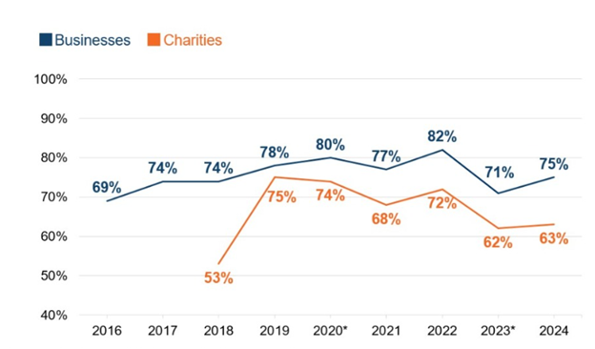
Figure 1: % of organizations where cybersecurity is seen as a high priority [2]

security procedures. The research emphasizes how crucial it is for the government to fund cybersecurity to defend against new and emerging threats [2]. The estimates say that cybercrime will continue to rise and damage the global economy by $10.5 trillion annually by 2025. The two biggest threats are ransomware, a major concern, and data breaches, which affect millions of individuals and organizations globally. The study highlights the need for robust cybersecurity defences because of the rise in cybercrimes affecting individuals and companies. To reduce these risks, awareness and proactive defensive strategies are critical [3].
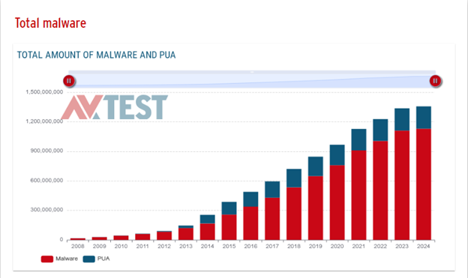
Figure 2: Total Malware Analysis [4]

The total amount of malware threats discovered since 2008 is displayed in the "Total Malware" graph above in Figure 2. It demonstrates the malware's exponential growth and the rise in cybersecurity dangers over time. The significance of bolstering cybersecurity measures to counter the growing number of attacks is highlighted by this statistic [4].

The project aims to conduct a comprehensive vulnerability assessment on a cloud-based infrastructure by adapting to penetration testing standards and frameworks, identifying vulnerabilities, and mitigating potential security risks to enhance the overall security posture of the infrastructure. The real-time network infrastructure will be helpful for future replication or protection. Cloud computing offers advantages like scalability, flexibility, and cost-efficiency but also introduces unique security challenges. The project will conduct network scanning to identify security weaknesses, analyse discovered vulnerabilities, develop mitigation strategies, and provide recommendations for enhancing the security posture of the cloud-based infrastructure.

Background
This project's network is cloud-based, with several virtual and real servers deployed across various subnets. This infrastructure includes Azure Virtual Machines (VMs) that fulfil a range of purposes, such as web servers, file servers, and domain controllers. The architecture also includes on-premises servers, creating a hybrid environment requiring strict security measures to protect important data and assure operational integrity. The subnet setup in this infrastructure is particularly significant since it demonstrates a prevalent configuration in modern enterprises: Azure-based virtual networks (VNets) that interface with on-premises devices. Enterprises in the United Kingdom frequently utilize this configuration, which combines cloud and on-premises resources to provide flexibility and control. The security of this hybrid infrastructure is crucial, as errors could lead to catastrophic breaches, especially in businesses that handle sensitive data, such as finance, healthcare, and public services.

The hardware and software components that facilitate connection, communication, and network operations make up the network infrastructure. Due to its vulnerability, network infrastructure security is frequently seen as the biggest security risk to organizations, providing the means for systems and services to operate both locally and online [5]. Network infrastructure is divided into several categories based on size, connectivity, and security. Local-area networks (LANs) are limited to a single location and can connect thousands of devices within an organization. Wide-area networks (WANs) use methods like satellite links and leased lines to reach coverage across large geographical areas [6][7]. These networks can accommodate shared data and remote working. Enterprise networks connect campuses, branches, and data centres over large areas. These infrastructures must offer high availability, scalability, and robustness to ensure constant data flow. Enterprise networks are essential for ensuring the smooth operation of an organization [6][8].

Computer networks are made up of links and nodes that use TCP/IP, firewalls, and anti-DDoS devices as communication protocols as shown in Figure 3. Network management cards offer a defence against online attacks [7]. They provide operations like internet access, resource sharing, and data transfer. Businesses may now function more smoothly thanks to the efficiency and scalability gains brought about by cloud services and networking innovations [8]. Numerous techniques and security measures attempt to secure systems both physically and electronically to minimize the level of hazard placed on a network to assist shield network infrastructure from impending attacks brought on by vulnerabilities and threats. Several software-based security techniques are necessary to create effective security rules and guidelines as discussed in [9]. Firewalls assist in defending and resolving conflicts between internal and external network systems by monitoring and filtering data streams and network connections.
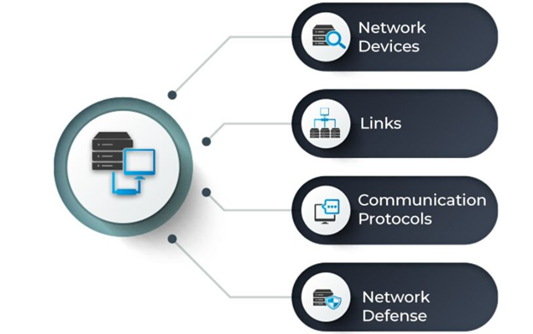
Figure 3: Components of a Computer Network [7]

Firewalls operate on the principles of packet filtering, application proxies, and stateful inspection. These mechanisms seek to analyse potentially hazardous activities within a network, intercept risky packets, and hide network infrastructure [10]. By establishing and authenticating encrypted connections between networks and devices using IPsec or SSL-based tools, virtual private networks (VPNs) also contribute to the protection of network systems and the data they hold. The characteristics that set firewalls and virtual private networks apart are contrasting the risks that each present, discussing their problems, and providing helpful advice on how to address their weaknesses [10].

Cyberspace and Vulnerabilities
Cyberspace, or the virtual environment in which internet communication and data exchange take place, is an important domain in today's interconnected world. It includes the internet, computers, and the networks that connect them. As organizations increasingly rely on cyberspace for operations, the risk of cyberattacks has increased significantly [11]. Vulnerabilities in cyberspace are flaws in a system, application, or network that allow attackers to obtain unauthorized access or damage. These vulnerabilities can be caused by a variety of circumstances, including outdated software, weak passwords, poorly designed systems, and insufficient access controls. Exploiting these vulnerabilities can have serious implications, including data breaches, financial losses, and reputational damage [11].

Common Vulnerabilities in Cloud-Based Infrastructures
Several typical vulnerabilities are frequently discovered in cloud-based infrastructures shown in Figure 4, such as the one used in this project:
- Outdated Protocols: Using outdated protocols like TLSv1.0 and TLSv1.1, which are no longer deemed secure [12].
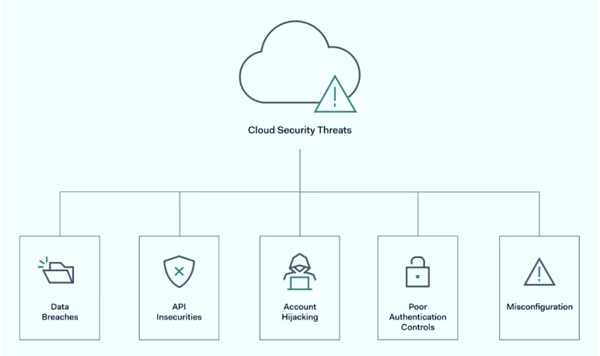
Figure 4: Cloud security risks and threats

- Misconfigurations: Incorrect cloud service setups, such as open ports or permissive firewall rules, can leave systems vulnerable to attacks [13].
- Unpatched systems: Failure to install security upgrades promptly exposes systems to known vulnerabilities [14].
- Weak Authentication: Inadequate password restrictions or a lack of multi-factor authentication can allow attackers to acquire access [15].
- Account hijacking: Phishing can be used to take over an administrator's account, giving hackers immediate access to cloud-hosted data without requiring internal network infiltration [15].
- Insecure APIs: Cloud services frequently rely on APIs for interaction. If these APIs are not secure, attackers may use them to obtain unauthorized access to cloud resources [15].
- Data Breach: Cloud settings contain massive volumes of sensitive information. If security measures are inadequate, the danger of data breaches increases, which can result in substantial financial and reputational damage [15].

Mitigating vulnerabilities and preventing attacks
To address these weaknesses and avoid potential attacks, businesses must adopt a proactive security posture:
- Regular updates and patching: Keeping all software and systems up to speed with the most recent security patches is critical for addressing known vulnerabilities [16].
- Secure Configuration: Ensuring all systems are securely set up, with only necessary services running and limited access provided [16].
- Strong Authentication: Use strong password restrictions and multi-factor authentication to prevent illegal access [17].
- Continuous Monitoring: Monitor network traffic and system logs consistently to discover and respond to abnormal activity [18].
- Penetration testing: Penetration Testing is the process of running regular tests to find and remedy security flaws before they are exploited by attackers [11].

UK-Based Companies, NGOs, and Organizations: Security Postures
Companies, NGOs, and organizations from a variety of industries in the United Kingdom have acknowledged the need for cybersecurity as an essential component of their business operations. The UK's National Cyber Security Centre (NCSC) offers information and resources to assist enterprises in strengthening their security postures in the face of the increased threat of cyber-attacks [14]. Many UK-based firms have implemented cybersecurity frameworks such as ISO 27001 and the NIST Cybersecurity Framework to guarantee they have strong security procedures in place. These frameworks give a structured approach to risk management and mitigation, which includes identifying and protecting vital assets, detecting security incidents, and recovering from attacks [17]. Despite these efforts, many firms continue to confront issues in fully protecting their cloud-based infrastructure. The rising usage of cloud services, along with a scarcity of experienced cybersecurity specialists, has created security flaws that attackers can exploit. Continuous vulnerability assessments and penetration testing are more important than ever because they enable businesses to identify and address security flaws before they become exploitable. Understanding and mitigating these risks allows UK-based firms to considerably improve their security posture, hence safeguarding operations and sensitive data [13].

Problem Statement
Despite the benefits of cloud computing, many firms do not completely understand or manage the significant security challenges it presents [12]. Vulnerabilities in cloud settings can result in data breaches, sensitive information loss, and large financial losses. This study aims to detect and eliminate vulnerabilities in a cloud-based architecture, consequently increasing overall security.

Aim
The aim of this project is to conduct a comprehensive vulnerability assessment on a cloud-based infrastructure by adapting to penetration testing standards and frameworks, identifying vulnerabilities, and mitigating potential security risks to enhance the overall security posture of the infrastructure.

Data Privacy and the Simulation Method
Due to the sensitive nature of the data included in this study, which focuses on the vulnerability assessment of an organization's cloud-based infrastructure, rigorous confidentiality procedures have been implemented. Data protection regulations and confidentiality agreements with the organization anonymized real-time data and specific network configurations.

We have used simulations to address this while maintaining the relevance and usefulness of the research. These simulations correctly model the organization's network environment, allowing for a thorough vulnerability assessment. The vulnerabilities revealed in this simulated environment are like those that could exist in the actual infrastructure, ensuring that the findings are both practical and insightful while protecting any sensitive information.

Objectives
The objectives are to:
- Review of Existing Literature: Conduct a thorough review of existing literature, previous vulnerability assessment (VA) reports, and relevant case studies to build a strong foundation for the research.
- Adapt to Suitable Research Methods (Research Onion): Plan the research by adopting suitable research methodologies using the Research Onion framework, ensuring a systematic and structured approach.
- Design and Implement Vulnerability Assessment in the Infrastructure and Simulated Environment: Develop and execute a vulnerability assessment plan within the provided cloud-based infrastructure and replicate the environment for testing purposes.
- Network Scanning Tool: Utilize the network scanning tool to scan the network infrastructure, identifying security vulnerabilities comprehensively.
- Identify Vulnerabilities, Categorize, and Assess: Identify the vulnerabilities discovered during the assessment, categorize them based on severity and impact, and conduct a detailed assessment.
- Propose Mitigation, Implement Mitigation, and Test: Propose appropriate mitigation strategies, implement them within the infrastructure, and conduct follow-up tests to verify their effectiveness.

Approach of the study
This project will conduct experimental evaluations of an anonymous real-time cloud-based network infrastructure. The assessment includes scanning the network, identifying vulnerabilities, and testing them in a controlled, simulated environment. The report will employ specialized vulnerability assessment technologies to conduct extensive vulnerability scans of the real-time network, producing critical comparative data. Previous studies identified in the literature review will influence the study approach used for the real-time network. A detailed comparison of the vulnerabilities discovered in the real-time network using two distinct scans will be provided, revealing vital information about the infrastructure's security. A few high-impact vulnerabilities will be evaluated in simulated situations to highlight the threat to the real-time infrastructure. The simulation findings can be used to identify critical areas of failure in the network and provide a breakdown of how such vulnerabilities can be exploited. Using the data gathered from both the research and the real-time assessment, a thorough vulnerability analysis report recommending mitigation steps for the detected vulnerabilities will be compiled and distributed to the relevant organization.

Structure of the Project
This project is divided into four pieces. The first step is to identify and share existing literature relevant to the project's aim. Discovering and understanding the role that vulnerability assessments nowadays occupy in the field of cybersecurity. The second section describes a detailed vulnerability assessment of the NGO network conducted using scanning tools to determine the NGO network's security posture. Part three is an analysis and comparison of freshly collected data to what was previously learned in the previous phases. Using this comparison analysis, we can conclude the effectiveness of vulnerability assessments in improving network infrastructure security.

Chapter 1 - represents the report's outline format, detailing the project's aim and objectives, as well as relevant background material that can help the project succeed.

Chapter 2 - focuses on existing literature relevant to the subject at present, getting into a variety of trustworthy published papers that cover topics such as cloud-based network infrastructure, penetration testing, and vulnerability assessments.

Chapter 3 - describes the chosen research approach and experimental hypothesis, which will be followed throughout the project. Justifying each approach used in the layered methodological structure.

Chapter 4 - presents the project's design, covering both the approach to implement and the implementation itself. Collected data and results are compiled and prepared for analysis.

Chapter 5 - provides a detailed account of the design and implementation of the task performed. It describes the setup of the compromised disk, the hardware and software requirements, and the steps taken to perform the analysis.

Chapter 6 - ends the project's findings by summarizing the report's achievements and what may be learned from the experience. The possibilities of future work and research are also discussed.

Chapter 7 – gives a personal reflection on the project by the writer. It includes a description of what went well, what challenges came up, and what could have been done differently to better the project.

Chapter 8 - contains a list of all the reference materials that were read and influenced this research. The reference list adheres to the IEEE citation standard, as used in the field of computing.

Chapter 2 - RESEARCH & REVIEW OF LITERATURE

Introduction
In this literature review, I aim to explore the current state of vulnerability assessments and penetration testing in cloud-based network infrastructure security. It analyses various tools, focusing on their effectiveness, cost, accuracy, user-friendliness, and comprehensiveness. The evaluation focuses on critical areas like network infrastructure and associated risks, vulnerabilities, and attacks. It also explores different methods and standards for penetration testing, identifying areas for improvement and weak points. The insights gained from this literature review will inform the methodology and justify the research outcomes, ensuring a comprehensive understanding of the field.

Cloud-Based Infrastructure
Cloud infrastructure consists of both physical and software elements, including servers, storage, networking equipment, and virtualization components, which provide storage, processing power, and software applications via the Internet [19]. Organizations are embracing cloud computing more and more in the contemporary digital era because of its affordability, scalability, and flexibility. However, their greater reliance on cloud services also makes them more vulnerable to several types of cyberattacks, which could jeopardize the integrity, confidentiality, and availability of their data [20]. Beyond just modifying current security procedures, a comprehensive plan is needed to address the unique security issues posed by cloud computing. It is imperative to conduct regular penetration testing and vulnerability assessments to improve the security posture of cloud-based infrastructure [21].

Cloud computing is a popular technology in the business world because it provides firms with several benefits, including cost savings, scalability, and flexibility [22]. However, moving sensitive data and vital company operations to the cloud creates several additional security vulnerabilities. To lower these risks and protect priceless digital assets, proactive vulnerability identification and mitigation inside cloud infrastructure is essential [23]. Because of the unique security risks that cloud computing presents, enhancing security posture requires a comprehensive strategy that includes frequent penetration tests and vulnerability assessments. Although cloud computing technologies offer many advantages, utilizing these technologies to their full potential requires addressing security risks [24].

Attackers looking to obtain material without authorization frequently target an organization's network and its infrastructure, which house a large amount of its confidential data. Networks need to be on the lookout for any vulnerabilities that could compromise their security because of this growing danger. The Sans Institute's writers examine several network architecture issues in [25], stressing the need for careful network infrastructure planning and implementation. The threat of internet-based attacks usually takes precedence over internal security systems, even though ignoring them could have detrimental consequences.

Existing Literature Review
The vulnerability assessments carried out in the previous year consisted of a two-phase approach aimed at evaluating the security posture of an NGO's network infrastructure. These assessments were primarily conducted using the OpenVAS security tool, known for its comprehensive scanning capabilities.

Analysis of Phase 1
The first phase of the assessment was conducted internally on April 8, 2022, focusing on two specific subnetworks (X.X.3.0 and X.X.10.0) [26]. During this phase, nine host devices were scanned, and 429 vulnerabilities were detected.

Severity | Frequency
High | 5
Medium | 42
Low | 1

Table 1: Phase 1 Vulnerability Severity Frequency

However, after applying a Quality of Detection (QoD) filter, only 48 of these vulnerabilities were deemed significant, comprising 5 high-risk, 42 medium-risk, and 1 low-risk vulnerability as shown in the Table 1. The limited scope of this scan, covering only two subnetworks, provided an initial snapshot of the vulnerabilities present but did not offer a comprehensive view of the entire network's security posture [26].

Analysis of Phase 2
A more extensive and external vulnerability assessment was conducted seven weeks later, between June 3rd and 4th, 2022. This phase expanded the scope to 13 subnetworks and included 25 host devices. The results were considerably different, with 1,863 vulnerabilities identified, of which 125 were significant after applying the QoD filter. The breakdown included 15 high-risk, 104 medium-risk, and 6 low-risk vulnerabilities as shown in the Table 2. A significant finding was the widespread use of deprecated SSL/TLS protocols, which posed a considerable risk if exploited by attackers [26].

Severity | Frequency
High | 15
Medium | 104
Low | 6

Table 2: Phase 2 Vulnerability Severity Frequency

Analysis of Phase 3
The third phase of the vulnerability assessment marked a significant and comprehensive evaluation of the NGO’s network infrastructure. Conducted across 14 subnetworks, a total of 20 vulnerability scans were executed using the OpenVAS software. These scans captured a total of 1,319 results, with 154 vulnerabilities meeting the Quality of Detection (QoD) filter criteria. This phase indicated a notable 23% increase in potential network threats compared to phase 2, signaling heightened vulnerability exposure within the network [27]. The identified vulnerabilities were concentrated in just five of the fourteen targeted subnetworks, affecting 21 host machines across both internal and external IP ranges.

Severity | Frequency
High | 24
Medium | 117
Low | 13

Table 3: Phase 3 Vulnerability Severity Frequency

The breakdown of the identified vulnerabilities by severity is as follows:
- High-Risk Vulnerabilities: 24 instances
- Medium-Risk Vulnerabilities: 117 instances
- Low-Risk Vulnerabilities: 13 instances
This distribution highlights the diverse range of threats present within the NGO's infrastructure, with a significant portion posing medium to high levels of risk as shown in the Table 3.

Subnetwork X.X.3.0:
Figure 20 depicts the vulnerability trends within the X.X.3.0 subnetwork across all three phases. Notably, phase 3 saw a dramatic 67% decrease in identified vulnerabilities compared to phase 2. This decrease is especially significant given that phase 2 had already recorded 83% fewer vulnerabilities than phase 1. This consistent reduction suggests that the vulnerability assessments conducted across these phases have had a cumulative positive impact on the security of the NGO’s network infrastructure, driving down the number of exploitable vulnerabilities over time [27].

Subnetwork X.X.10.0:
Similarly, the X.X.10.0 subnetwork exhibited a substantial decline in vulnerabilities during phase 3, as illustrated in Figure 21. Remarkably, phase 3 scans reported zero notable findings within this subnetwork after applying the assessment filters. This outcome strongly indicates that the previous assessments and subsequent remediation efforts have effectively bolstered the security of this segment of the network [27].

Subnetworks 3.0 & 10.0 Comparison
Despite the overall increase in identified vulnerabilities during phase 3, a closer examination of specific subnetworks reveals compelling trends, particularly in subnetworks X.X.3.0 and X.X.10.0. Continuing from the comparative analysis of these subnetworks from phases 1 and 2, phase 3 presents findings that strongly support the hypothesis that regular vulnerability assessments can enhance infrastructure security [27].

Subnetwork X.X.5.0:
A total of 118 vulnerabilities were detected within the X.X.5.0 subnetwork during phase 3, spread across 13 host devices. These included 18 high-risk, 88 medium-risk, and 12 low-risk vulnerabilities, averaging nine vulnerabilities per host. This sudden appearance of vulnerabilities challenges the consistency and reliability of the scanning tools, such as OpenVAS, used in these assessments. The previous absence of these vulnerabilities could be due to several factors, including changes in the network infrastructure over the 10 months between phases 2 and 3. These might include reconfiguration or relocation of systems within the X.X.5.0 subnetwork, causing the newly identified vulnerabilities to go undetected in earlier scans [27].

Subnetworks X.X.4.0 and Others:
In addition to the X.X.5.0 findings, phase 3 also uncovered five new vulnerabilities within the X.X.4.0 subnetwork, affecting one host device. It remains unclear whether these hosts were active during the phase 2 assessments. However, it is crucial to acknowledge that despite the detection of new vulnerabilities in phase 3, many previously vulnerable subnetworks have shown marked improvements. Specifically, subnetworks X.X.1.0, X.X.10.0, X.X.30.0, and X.X.234.0 exhibited no discernible threats during phase 3, while subnetworks X.X.3.0 and X.X.9.0 recorded a 67% and 50% reduction in vulnerabilities, respectively.
Overall, 80 of the 129 vulnerabilities identified during phase 2 were no longer present in phase 3, representing a 62% reduction in known threats and underscoring the positive impact of ongoing vulnerability assessments on the NGO’s network security [27].

Complete Subnetwork Comparison
The comprehensive nature of phase 3, with scans covering the entire network, allows for a thorough comparison with the results from phase 2, offering deeper insights into the evolution of the NGO’s network security posture. While phase 3 revealed a 23% increase in total identified vulnerabilities compared to phase 2, this uptick is primarily attributable to newly detected threats. A detailed analysis of the distribution of these vulnerabilities between the two phases uncovered that approximately 50% of the newly discovered vulnerabilities in phase 3 were concentrated in the X.X.5.0 subnetwork, which had previously shown no identified vulnerabilities.

Comparative Analysis
A comparison between the results of Phases 1 and 2 revealed a 36% decrease in total vulnerabilities within the X.X.3.0 and X.X.10.0 subnetworks. This decreases, along with the identification of new vulnerabilities, raised concerns about the accuracy and completeness of the initial scans. The discrepancies suggested that some vulnerabilities might have been missed during Phase 1 or mitigated before Phase 2.

The comparative analysis of the three phases reveals the dynamic nature of network security. Initial assessments provided a baseline, subsequent assessments expanded the scope and identified new threats and ongoing monitoring demonstrated the effectiveness of remediation efforts. Despite increased detected vulnerabilities in Phase 3, the reduction in previously identified threats underscores the value of regular vulnerability assessments. To maintain and improve network security, it is crucial to continue with regular assessments, prioritize high-risk vulnerabilities, and adapt remediation strategies based on evolving threat landscapes. This approach will help the NGO enhance its security posture and address both new and persistent vulnerabilities effectively [27].

Conclusion
The NGO's network infrastructure has undergone vulnerability assessments in three phases, providing a comprehensive view of its security landscape. Phase 1 identified a significant number of vulnerabilities, but the findings were not representative of the entire network. Phase 2 expanded the scope to 13 subnetworks, highlighting critical issues like deprecated SSL/TLS protocols. Phase 3 evaluated 14 subnetworks, revealing a significant reduction in vulnerabilities, particularly in new areas like the X.X.5.0 subnetwork. The analysis highlights the dynamic nature of network security, highlighting the importance of effective remediation and regular assessments for maintaining and improving security. To further enhance the NGO's security posture, it is crucial to continue regular assessments, prioritize remediation based on risk severity, and adapt strategies to address emerging threats. This approach will help mitigate current risks and fortify the network against future vulnerabilities, ensuring a resilient and secure infrastructure.

Review of Existing Infrastructure
The existing network infrastructure, as depicted in the provided image, comprises several key components across multiple subnetworks. The infrastructure includes a combination of Azure-based Virtual Machines (VMs) and on-premises physical servers, with distinct subnets dedicated to different functions. Below is an overview and diagram (as shown in the Figure 5) based on the infrastructure details:
- Office Subnet: X.X.0.0/16
- Firewall Subnet:
- Fortigate on X.X.1.6/30
- Visitor Wi-Fi on X.X.31.253/24
- DMZ subnet X.X.20.0/32 (no nodes)
- Azure AD Subnet: X.X.0.0/16
- Servers:
- ANGO - DC DNS: Virtual, WS 2019 Datacentre
IP: X.X.2.4
- ANGO - Web Server: Virtual, WS 2019 Datacentre
IP: X.X.3.23
- NGOHyperV1: Physical, WS 2019 Std
IP: X.X.2.1
- NGO - DC DNS DHCP: Virtual (Hyper-V), WS 2019 Std
IP: X.X.2.2
- NGO - File Server: Virtual (VMware), WS 2019 Std
IP: X.X.2.5
- NGO - Azure AD Sync: Virtual (Hyper-V), WS 2019 Std
IP: X.X.2.6
- NGO - App Server: Virtual (Hyper-V), WS 2019 Std
IP: X.X.2.7
- NGO - Exchange 2016: Virtual (Hyper-V), WS 2016 Std
IP: X.X.2.8
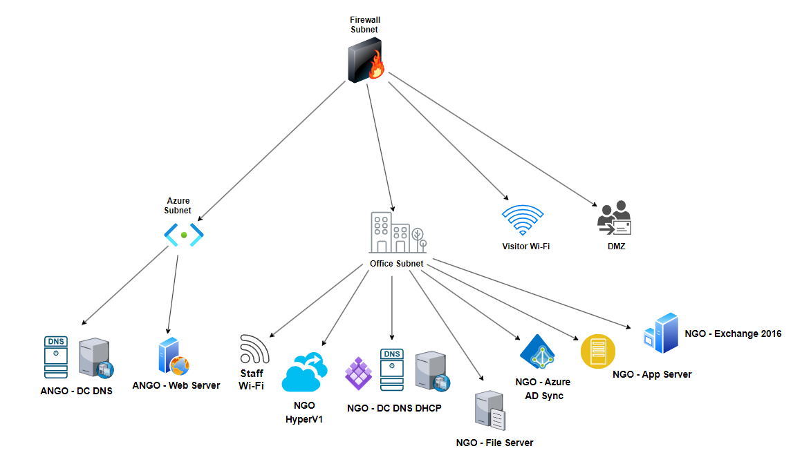
Figure 5: Existing Network Infrastructure Diagram

Vulnerability Assessment
The process of identifying, locating, classifying, and ranking security flaws in a computer system, program, or network is known as vulnerability assessment (VA) [28]. Vulnerability assessments can use a variety of techniques, instruments, and scanning processes to pinpoint the weak points in various networks and systems. Depending on how easily vulnerabilities in each system may be found, different types of vulnerability assessments may be used [28]. Vulnerabilities in a system or network are found, examined, and prioritized during a vulnerability assessment [23]. Usually, it entails these actions:
- Asset Discovery: Recognizing any asset that falls under the responsibility of the evaluation, including servers, workstations, network devices, etc.
- Vulnerability Scanning: Employing automated technologies to check the recognized assets for known flaws, configuration errors, and vulnerabilities.
- Vulnerability Analysis: Evaluating the vulnerabilities found, classifying them according to risk, and analysing them.
- Reporting: Producing a report with a list of the vulnerabilities found, their levels of severity, and remedial suggestions.

Vulnerability assessments are typically automated and provide a comprehensive view of the security posture of the environment being evaluated. They assist companies in determining their attack surface and prioritizing their cleanup [28][29].

Types of Vulnerabilities
Vulnerability assessments will assist in identifying the various services and versions of services operating inside a network to detect and catalogue potential vulnerabilities systems may encounter by using a variety of network assessment tools to help carefully map systems within a network [30]. The American National Institute of Standards and Technology has released over 200,000 [31] known software vulnerabilities as of this writing, endangering system security throughout the world. Regular network vulnerability assessments are now practically required to find any vulnerabilities that have been recorded and to develop a remediation plan that will effectively address any threats that may be present in the infrastructure [32].

Vulnerability Scoring System
Prioritizing vulnerabilities that represent the biggest risk to the network and its infrastructure is crucial when they are discovered. Vulnerability assessment standards, such as the Common Vulnerability Scoring System (CVSS), were created to help in determining the level of criticality associated with each vulnerability. An open framework called the CVSS is used to convey the features and level of severity of software vulnerabilities in comparison to other vulnerabilities [33]. On a scale from 0 to 10, a vulnerability's assigned threat ranking is composed of three distinct metric groupings. Table 4 defines how CVSS uses these scores to build a clear textual representation of vulnerabilities by placing them into a qualitative severity level scale.

Vulnerability Severity Levels | CVSS Score Range
None | 0.0
Low | 0.1 – 3.9
Medium | 4.0 – 6.9
High | 7.0 – 8.9
Critical | 9.0 – 10.0

Table 4: CVSS v4.0 Ratings [34]

The standardized vulnerability rating method used by CVSS is independent of platforms and vendors. The transparency of its individual qualities and scoring methodology is aided by the open architecture described. The specification document [33] has a thorough explanation of the computations and deviations of the CVSS.
The authors of [35] examine the absence of a theoretical and empirical basis for the current algorithm behind the CVSS formula. The sequence that was selected measures a vulnerability's technical severity rather than its security risk, which makes it unable to provide any meaningful information at all for making risk-based judgments.
The extreme dearth of supporting data for the selected deprivation formula raises concerns about the reliability and applicability of such a basic standard-setting computation. The authors also point out an incapacity to manage the possible relationship(s) between vulnerabilities. Neglecting to consider the possibility of exploiting chained vulnerabilities may result in erroneous rankings, hence increasing the risk to network infrastructure and security.

Vulnerability Scanning
An important component of vulnerability assessments is vulnerability scanning, which locates hosts on a network and their characteristics, such as open ports and operating systems. With the use of this data, the scanner can assist in identifying any network misconfigurations, out-of-date operating systems, or even fixes that haven't been issued. even guaranteeing that security policies are followed correctly throughout a network [36]. Holm concluded that although only 34-55 percent of network vulnerabilities are found by vulnerability scanners, the program is extremely capable of offering adequate remedial instructions for many those found (44-87 percent) [37].

Authors in [38], who replicate some of the project's intended actions, assess device security after controlled vulnerability assessment(s). One of the technologies used for this report's preparation was OpenVAS. Although the authors provide a testbed that appears to be adaptable and simple to set up, they do not include appropriate mitigation or remediation techniques to address any of the vulnerabilities found throughout the study. This is a problem I hope to address throughout this project.

Furthermore, the authors of this study do not disclose the likelihood of false positives. The lack of such information could be the result of the writers' general indifference or utter ignorance, both of which would compromise the report's authenticity and dependability.

Vulnerability Scanning Tools
Systems vulnerabilities can frequently be found more quickly thanks to network vulnerability scanning technology. Vulnerabilities such as SQL injection, buffer overflow, cross-site scripting, application misconfiguration, and others were found using vulnerability scanning. Vulnerability scanning can be done in two ways: using tools or manual testing.

OpenVAS (Open Vulnerability Assessment System)
OpenVAS (Open Vulnerability Assessment System) is a vulnerability scanning tool that focuses on host-based and network-based vulnerability scanning and is built upon an open-source foundation [39]. The vulnerability manager's implementation of several functions and adherence to international standards allows it to provide an active defence mechanism by gathering relevant data from network devices and evaluating the device's potential threat using its vulnerability library [40]. Based on the previously stated structure of the CVSS standards, each vulnerability that has been detected is assigned a threat level score.

The features, capabilities, and restrictions of the vulnerability scanning tools now in use are analysed and contrasted by the authors in [41] using corroborating data and information obtained from extensive questionnaires. When compared to its rivals in vulnerability scanning, such as OWASP and Vulcan, the authors determine that OpenVAS is a leader in community support, vulnerability coverage, tool coverage, and utilization level. However, it should be emphasized that OpenVAS's high resource requirements and dependence on powerful platforms for effective operation can affect user experience and performance. This is seen in [42], where writers noted a pattern in the usability problems OpenVAS users were having. It was noted that regular neglect of essential tasks, such as implementing suitable host scanning setups or addressing fundamental security issues, was occurring. Research indicates that hardly three people out of ten can fully utilize the vulnerability tool. The paper offers additional in-depth analysis of user-based testing results [42].

OpenVAS has several advantages over rival products. Businesses need to select a technology that streamlines the procedures of detection, assessment, and repair while providing extensive coverage of potential risks. Finding holes in a company's network, apps, and systems which can result in data breaches, monetary losses, and reputational harm that requires vulnerability assessment [43]. Because of its strong architecture, extensive vulnerability database, scalability, simplicity of customization, and strong community support, OpenVAS distinguishes out in the competitive landscape. It is evidence of the effectiveness of cooperative, open-source development, and its significance for cybersecurity cannot be overstated. Through the identification of these weaknesses and prompt implementation of mitigation measures, enterprises may strengthen their defences and protect their digital assets [43].

Nmap
Nmap [41] is an open-source framework-based network discovery and security auditing tool that is extensively used. With a robust feature set that allows it to do a variety of tasks like host discovery, port scanning, service identification, and firewall evasion [41], Tim Corcoran's "An Introduction to Nmap" [45] calls this well-known program an excellent multi-functional utility. Nmap also analyses a large network rapidly. Nmap uses novel techniques with raw IP packets to discover what hosts are on the network, what operating systems (and OS versions) they are running, what kind of firewalls or packet filters are in place, and a plethora of other details, including what services (name and version of the application) those hosts are providing [46]. It also includes a console and graphical user interface, and it works with all major operating systems. Nmap is the most widely used network scanning tool [47].

Nessus
The Nessus founded by Renaud Deraison in 1998, is a popular network vulnerability scanner that allows for scans for misconfiguration, open ports, software versions, and vulnerabilities that allow remote hackers to control or access sensitive data [47]. It has two versions: Home Feed release and Professional release. The Home Feed release receives the latest plugins based on the installation date, while the Professional release ensures the latest plugins are always available if the renewal date has not expired. Home Feed release can only scan a certain number of IP addresses at one time, while Professional Feed scans a wider range of addresses. Nessus can be installed on Windows or Linux operating systems, and both 32 and 64-bit versions are supported. The scanning results can be exported to various file types, such as HTML and CVS. The organization has been using Nessus since 2010 when it began conducting vulnerability scanning processes. The latest version of Nessus is 5.2.5 [47].

Penetration Testing
Penetration testing (PEN testing) is a method used to check the security of a system by simulating hacker attacks. It looks for weaknesses in software, hardware, and configurations [48]. This process examines all, an organization's computing resources, including people, software, and hardware, to find vulnerabilities. By simulating unauthorized attacks, PEN testing highlights potential risks and security gaps, helping administrators identify and fix security issues [49]. This approach is essential for reducing IT security costs and enhancing the overall security of the infrastructure because it offers a higher return on security investments [50]. It is the process of modelling actual attacks on a system or network to find and take advantage of security holes, also called ethical hacking or pen testing [23][51].

Because penetration testing is typically done manually by skilled security specialists, it provides a more accurate assessment of an organization's security posture. It validates the effectiveness of the security measures in place and improves the detection of vulnerabilities that automated scanning technologies could miss [26][52][53].

Phases of Penetration Testing
The penetration testing is primarily divided into five phases. Every penetration testing phase outlines the procedure used to carry out the test. Each will be covered in detail in the section that follows. Initialization is the first stage, which is completed by gathering all data as soon as feasible based on the aim.

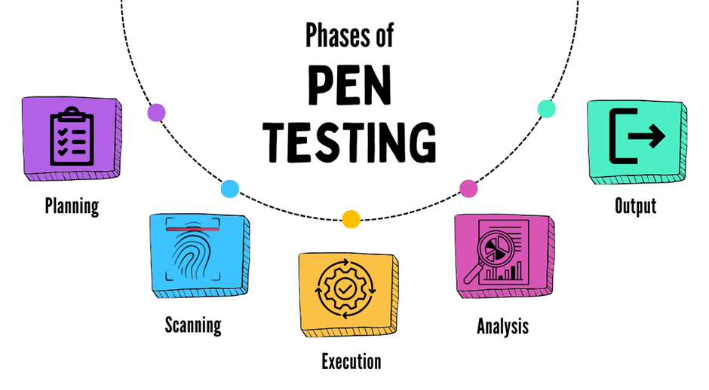
Figure 6: Phases of Penetration Testing
Sensing the resources and unsecured loopholes, an attack is later carried out [24], [48], [49]. Post-attack is another term for attack. It enumerates every single vulnerability along with the associated threat. Afterwards, a report highlighting the results of the coordinated pen test is given to the organization. Below is a detailed discussion of each phase along with a diagram as shown in Figure 6.

Planning phase
It involves collecting or organizing data according to the aim as much as feasible. Any kind of information is acceptable; examples include the IP address, domain server information, mail, network topology, and so on. This stage involves several actions, including target definition, test scope, intelligence decisions, and testing technique selection [26].

Scanning phase
In this stage, the attackers interact with the target and goal and detect any vulnerable areas or unprotected openings in the network or system. The following procedure also makes use of several tools, including FTP portals and sensors for open or shared devices. Attack vector mapping is used to identify weaknesses. During this stage, static analysis is also used to examine the logic, code, and functionality of the program while it is running [26].

Execution phase
As the name suggests, assumptions might be made at this stage. Attackers act during the execution phase, and they need to be highly skilled and experienced to carry it out accurately. To detect the range to which a system or program is capable of an admissible attack, an attack is launched on the targeted locations. Thus, an actual attack is happening at this point [26].

Analysis phase
Also known as the post-attack phase. The remaining phase, which involves gathering evidence, is carried out when penetration testing is over. During this phase, evidence of vulnerabilities or vulnerable areas is gathered. After that, it is turned into a report and sent to the appropriate authority. There is a chance that an attacker will find a different kind of risk and vulnerability than what would be found with common vulnerabilities. In the analysis phase, gathering evidence regarding exploited vulnerabilities, classifying risks from low to critical, and creating reports are the primary tasks [26].

Output phase
In this step, data regarding the test's results are compiled into an extensive report. It includes recommendations that were acquired during the analysis phase and the preceding stage, as well as a definition of vulnerabilities that were discovered. It usually contains a summary of every pen test that was completed. The findings rely on taking advantage of the weaknesses, identifying the risks, suggesting a remedy, and providing a summary [26].

Types of Penetration Testing
There are several types of management approaches for penetration tests, and each has different levels of system information available to network testers. Every technique can offer crucial insights into network security by showing how attackers with different levels of knowledge and expertise could find and take advantage of flaws.

White box Testing
White box testing makes use of complete network information access, such as host addressing, network mapping, and live services. By identifying known vulnerabilities and misconfigurations, this internal test approach can assist in assessing the effectiveness of internal vulnerability assessments and management controls [54]. This testing technique might offer a reliable indicator of the kinds of information that will be used by malevolent insiders in their attempt to compromise a network.

Black box Testing
Black box testing mimics a network attack in which the target's systems and infrastructure are unknown. Testers will look for methods to gain access to a target's internal IT assets when doing external testing. This strategy can offer a realistic simulation of how an actual attack might occur, showing potential attacker actions to get around the installed security infrastructure. Although a black box test has its uses, it's crucial to remember that numerous vulnerabilities may be undiscovered during the testing phase due to a lack of network information [54].

Gray box Testing
Gray box testers are tasked with probing deeper inside the network perimeter by evaluating the security of high-value parts of the network. Testers are frequently outfitted with different degrees of privilege to mimic scenarios in which hackers have broken into the network but have little to no knowledge of the architecture [54]. This testing technique can assist in demonstrating the strategies that attackers might employ to further integrate themselves into the network and obtain data.

Internal testing
Internal users with standard access privileges are used to launch an assault on the organization's computer network during internal testing. Through internal testing, the tester can calculate the potential damages that a disgruntled employee within the company could cause. By breaking into a system and identifying the causality as a user with regular access rights, the test target is tested in this manner [27].

External testing
Conducting an external attack on the target of the test is known as external testing. Determining the method by which an external attacker gains access to the network and the extent of their reach after seizing control is beneficial [27].

Firewall penetration
To search for vulnerabilities throughout the firewall security software, configuration settings, and operating system itself, firewall penetration involves attempting to breach the firewall and host on the test target. The findings will assist in locating misconfigurations and getting rid of badly executed security rules within the company [27].

Router penetration
Router penetration testing involves looking for specific vulnerabilities in router misconfigurations. Network traffic is directed via routing devices, and if a router is configured incorrectly, it can be used to sway network traffic. All network traffic is compromised when a routing device is compromised [27].

Application penetration
Application penetration is the methodical testing of an application to look for back-end or code-related vulnerabilities that could have allowed access to the application itself, the operating system underneath it, or the data it could access. To test online trade portals and other applications, such as games, antivirus software, and embedded apps, for application penetration and security issues, businesses hire specialists [27].

Password Cracking Penetration
Password Breaking One method of penetration is to use cracking tools to extract SAM files from Windows or to retrieve passwords and shadow files from Linux. A few password-cracking tools are pwdump3, l0phtcrack, and John the Ripper. The method involves locating the target individual's profile and attempting to decrypt password-protected files using a variety of password-cracking programs. After that, the group that cracks passwords creates a report and gives it to the company [27].

Intrusion Detection System
System for Detecting Intrusions Penetration is the process of trying to get past security measures on the inside as well as the outside of an IDS to identify any vulnerabilities. Many hackers and security consultants are familiar with the general IDS rule set, which includes common threshold values, even though they are unlikely to possess complete knowledge of the rule set of any given IDS. Their penetration method is built around getting around the standard IDS setup. To prevent IDS, the test ought to assist in locating weaknesses in IDS rules, signatures, or thresholds [27].

Social engineering
The phrase "social engineering" refers to an attack that depends on human error. It collects sensitive and important data by tricking reputable users with psychological manipulation. This type of attack is particularly risky as user errors are less foreseeable. PEN testing assists the company in assessing how well its employees follow its policies and guidelines. It also aids in enhancing the security training that staff members receive [26], [27].

Penetration Testing Frameworks:
Since no system is resistant to hackers, testing systems frequently against the most recent intrusion techniques is one of the most important aspects of cyber defence. The hazards of a data breach are greatly increased by virtualization on public servers, and it can be challenging to identify the attacker in such an environment. Within this scope, penetration testing (PT) on virtual environments (VE) enables the identification of actual risks within the VE, advises on how to mitigate threats and breaches and how much it will cost, offers a plan of action for resolving issues, enhances the protection system, and generates a comprehensive and useful security system report. The purposeful use of attack techniques to find possible system vulnerabilities is known as penetration testing or ethical hacking [50], [51], [52].

PTs can be a beneficial security investment even though they are expensive. To be beneficial to a company, a penetration test must meet certain requirements; it must be realistic, repeatable, dependable, and reportable. For a PT to be valuable to enterprises, they must meet four requirements: The test can be run multiple times (repeatable); it must identify system vulnerabilities and update intrusion techniques (realistic); it should include all risk exposure and mitigate weaknesses (reliable); and all actions should be logged, allowing for the creation of meaningful, practical, and reliable documentation with findings and recommendations (reportable) [53].

The Penetration Testing Standard functions similarly to a handbook, providing an outline and fundamental guidelines for assessing the security of computer systems. Numerous standards exist, each having advantages and disadvantages of their own. The best option for you will depend on the goals you have for the security test. For penetration testing, there are numerous frameworks and techniques available, and many individuals and organizations modify these to meet their requirements [55].

Open Web Application Security Project (OWASP)
A nonprofit organization called the OWASP offers free cybersecurity testing methodologies, tools, and guidance. The OWASP Testing Guide (OTG), which consists of three main parts, is one of their primary resources: The OWASP Testing Framework for Web Application Development assists developers in building safe online apps. Web application security testing guidelines are provided by the Testing Methodology for Web Applications. Reporting describes how to submit security test results.

By taking the following actions, developers can utilize this framework to test the security of their online applications: Information gathering to compile application-related data, Configure the information by setting up the testing environment, Logging to keep track of what happens, Session Testing to examine how user sessions are managed, Verify that users can only access what they are authorized to by performing an authorization test. To further enhance application security, OWASP also offers documentation, secure coding guidelines, tools, and security advice. Both web-based and mobile applications can be tested using their criteria [55].

Penetration Testing Execution Standards (PTES)
The PTES framework standard by Nickerson et al. was created in 2009. It describes how to carry out a penetration test. PTES's principal components are Pre-Engagement Conversations to organize and talk with the client about the test. Information gathering is about the target system known as intelligence gathering. Understanding potential system risks is known as threat modelling. Vulnerability analysis is to identify system vulnerabilities. Exploitation is to try to breach the system by utilizing the vulnerabilities found. After exploitation, we need to evaluate the effects and preserve access if required. Reporting to record the test's conclusions and outcomes. PTES can be used to assess the security of web applications in conjunction with other frameworks, like OWASP. PTES attempts to give a comprehensive overview of what needs to be done and what to anticipate for a successful penetration test [55].

Open-Source Security Testing Methodology Manual (OSSTMM)
The Institute for Open and Security Methodologies (ISECOM) unveiled the OSSTMM in 2000 as a framework for security testing. OSSTMM offers an organized approach to performing security tests by segmenting the procedure into doable steps and thoroughly covering a range of security areas. OSSTMM's functions are: At first, anyone could use and contribute to OSSTMM for free. As of version 4, users must pay a subscription fee to access OSSTMM. Version 3 is still open-source and free, though.
The various security domains in OSSTMM version 3 are arranged into parts known as "channels." It is easier to handle different aspects of the testing process independently because each channel focuses on a certain area of security testing. By grouping these channels together using techniques known as "module encapsulation methods," each channel or segment is regarded as a distinct module or unit. Every channel and module cover a distinct domain or area of security, including physical security, network security, and human security. Testers can concentrate on particular security aspects in an organized manner with the aid of this modular method [55].

National Institute of Standards and Technology (NIST):
Businesses can identify and lessen cyber dangers with the use of the cybersecurity framework offered by the National Institute of Standards and Technology (NIST). Both the nation's economy and security are at risk because of this. The following procedures are covered by NIST's recommendations for security assessment and penetration testing: The planning process includes developing a thorough plan, selecting what needs to be tested, and establishing objectives. Discovery is the process of learning as much as you can about the target systems to identify any potential weaknesses.

Attacking is the process of trying to take advantage of vulnerabilities found to determine whether an intruder may get access to the system. Reporting is the process of recording the results together with the actions taken, the things found, and suggestions for resolving any problems. NIST offers a list of tasks that must be completed during penetration testing, but it doesn't explain how to enumerate the hardware, software, platforms, and applications that require testing. This means that although the framework guides on what must be done, it does not provide all the details on how to accomplish it, particularly when it comes to creating an exhaustive inventory of every component in the system [55].

Penetration Testing Tools
Penetration testing is a procedure used to identify system vulnerabilities. These tests replicate numerous attacks on the targeted system using different tools. This work will cover the basics of using certain tools [56][57][58]. Penetration testing tools increase productivity, automate processes, and reveal problems that are challenging to find through manual examination. They support businesses in mitigating hazards and strengthening their cyber security. These technologies are essential for enabling asset discovery in complex, hybrid contexts, conducting security testing in large-scale modern IT environments, and assessing systems with compliance standards and security benchmarks. Although tools can never fully replace the creativity of a skilled pen tester, they can improve penetration test findings by broadening and deepening their scope [59].

Tool |  | Key Features
  Purpose
  Cost
 |  | - Discovery of hosts, operating systems, and open ports  - Suitable for both large and small networks | Free
  Nmap
  Network scanning and enumeration
 |  | - Searches for specific devices (e.g., webcams, Cisco devices)  - Scans and parses banners returned by devices | Free (Basic Plan)  Paid plans for more access
  Shodan
  Internet-wide device discovery
 |  | - Intercept requests/responses, even with HTTPS  - View/edit individual messages, configure interception rules  - Repeater tool [52][53] | Free (Community Edition)  Paid (Professional/Enterprise editions)
  Burp Suite
  Web application security testing
 |  | - Framework for finding, exploiting, and validating vulnerabilities  - Provides modules for different tasks (e.g., scanners, fuzzers, payloads) | Free (Community Edition)  Paid (Pro Edition)
  Metasploit
  Vulnerability exploitation and post-exploitation
Wireshark |  | - Captures network traffic in real time  - Displays packets in a human-readable format  - Decompresses files on the fly | Free
  Network packet analysis
Table: Pentesting Tools

Benefits of Penetration Testing
Cybersecurity company Kaspersky highlights the prevention of possible financial, operational, and reputational damages as one of penetration testing's possible advantages. Finding vulnerabilities before they are taken advantage of can assist reduce and mitigate cyber-related incidents, which can help an organization avoid suffering severely damaging losses. Additionally, it is proposed that penetration testing can help ensure that internal business standards, industry standards, and government standards are met. Finding a network's weak areas will help you make the necessary adjustments and corrections to any configuration issues that might be preventing certification [60].

The benefits of penetration testing are highlighted by the authors in [48]. These benefits include the acquisition of knowledge and proficiency in penetration testing using quality assurance tools. It also highlights how penetration testing may be used by businesses to gauge staff security awareness and based on that information, develop security investments that will improve staff knowledge. Additional research published by the authors supports the findings of Kaspersky, pointing out that by minimizing financial and reputational damages, penetration testing can help protect against failure and foster trust among stakeholders such as shareholders.

Authors in [61] list a few of the penetration testing's more obvious advantages. When vulnerabilities or programming errors are found during testing, network administrators can quickly address and safeguard their network before hostile users take advantage of these holes. This helps with the security and safety of user-sensitive data by lowering the possibility of both internal and external attacks.

ORACLE VM VIRTUALBOX
Developers can run different operating systems simultaneously on a single device with the help of the well-known open-source virtualization program Oracle VM VirtualBox. You may create and manage virtual machines running several operating systems on the same host with this cross-platform hypervisor, which works with Windows, Linux, Mac OS X, and Solaris x86 computers [62].

IT workers may expedite application deployment for both on-premises and cloud environments and save operating costs by utilizing VirtualBox. Kuhn et al. (2015) state that this tool is highly beneficial for software development and IT operations due to its versatility in testing, developing, and deploying databases and applications [63].

Kali Linux
Based on Debian, Kali Linux is an open-source Linux distribution that makes complex security audits and penetration tests easier. It runs on multiple platforms and is free for both information security specialists and fans. With hundreds of tools, configurations, and scripts with industry-specific customizations included in the bundle, users may focus on tasks like reverse engineering, computer forensics, and vulnerability discovery. It is compatible with the Filesystem Hierarchy Standard, free, and customizable. Experienced penetration testers should use it [64].

Threats, Vulnerabilities & Attacks

Wireless Threats, Vulnerabilities & Attacks
Attacks on wireless networks are often classified as either active attacks or passive attacks [65], with the former aiming to intentionally damage and interfere with the network by modifying or erasing sent data. Alternatively, there is a passive attack, which seeks to surreptitiously observe and record important network data, including open ports and prospective vulnerabilities, to be exploited maliciously if an active attack escalates in the future [66]. To lessen the possibility that an attack is ongoing or about to happen, these passive attacks frequently avoid doing any initial harm to the target network. The below Table presents a range of wireless attacks that wireless attacks may employ to compromise an unwary or unsecured network. Such attacks can impair or interfere with a network's infrastructure and operations.

Attack | Description
DoS Attack | These malicious attacks completely deplete a network's capacity and its resources, including system memory, network bandwidth, and processing power, rendering systems inoperable and crippling operable infrastructure [67].
Jamming Attack | Stealthily designed to interfere with and disrupt genuine wireless signals, irregular and complex radio signals overload equipment and make it harder for genuine devices to interpret received data packets [68].
Eavesdropping | Unauthorized users can obtain and intercept insecure wireless connections, giving them access to continuous device communications. Unauthorized people can survey confidential data that may be exploited in the future for nefarious purposes [69].
MitM (Man-in-the-Middle) Attack | Hidden attackers are positioned in the middle of what appears to be a reliable exchange of information between two parties. able to gather data sent between parties and even replicate a particular party. Targeted information includes private information like personal credentials [70].
SMTP Attack | Malicious clients will connect to an SMTP server or servers repeatedly to use up all its resources and prevent the SMTP service from operating normally. The availability of a crucial network resource will be immediately impacted by this flooding, which will keep happening with an increasing number of customers until the server crashes [71].

Further Threats, Vulnerabilities, and Attacks
To determine important components of cyber-security research, scholars map out the body of existing literature in a methodical manner. In [72] the authors discovered that, out of the 78 (seventy-eight) publications that were analysed, DoS and malware were the most often reported vulnerabilities in the field of cyber security, occurring 37% and 21% of the time, respectively. However, in those papers that were analysed, other noteworthy assaults such as session hijacking and MitM attacks only managed to achieve a frequency of 3%. These results highlight the serious dearth of knowledge about numerous additional security flaws and the risks that might arise from ignorance. Across the literature, organizations were determined to be responsible for 95% of victims. The main targeted applications were classified as network infrastructure and cyber-physical systems.

Conclusion
In conclusion, the importance of network infrastructure, penetration testing, vulnerability assessments, and understanding different types of threats and vulnerabilities in today's technology-driven environment have been emphasized by this literature research. It produced several important findings, such as the need for comprehensive security measures, the benefit of continuous evaluations, and the critical role that trained professionals play in identifying and mitigating security risks. Additionally, the investigation has shown how important it is to take proactive steps to address vulnerabilities and stay informed about emerging threats. This assessment emphasizes how critical it is to implement robust security measures and keep a close eye on this area to ensure the integrity, confidentiality, and availability of network infrastructure and data.

Chapter 3 - RESEARCH METHODOLOGY

Introduction
This chapter discusses the methodologies used for vulnerability assessment of cloud-based infrastructure, emphasizing the need for a comprehensive evaluation of the network's security posture. It uses a combination of theoretical and practical approaches, exploring various research approaches such as quantitative, qualitative, and mixed-method strategies. The chosen approach significantly influences the research methods and aligns with the study's objectives. The chapter also examines time horizons, creating a project planner to guide time management and ensure timely completion of the assessment. Ethical considerations are also addressed, highlighting potential risks and outlining mitigation strategies. By integrating these elements, the chapter lays the groundwork for a systematic evaluation of cloud-based infrastructure vulnerabilities, providing a clear roadmap for the research process.

Research Onion
The research approach for this study will be Saunders' research onion. The layered structure of the research onion allows for successful advancement and personalization, allowing for flexibility and the opportunity to select a methodology that is right for the selected topic [73]. By adopting a holistic approach and adhering to the progressive layers outlined by the methodology, the research onion can enhance research design and aid in research organization [74]. This is crucial for the project because it helps validate research findings and subsequent understandings by recording and elucidating the decisions made [75].

With its six unique layers, the research onion technique seeks to enhance decision-making at every stage of the project by offering an organized and transparent framework for selecting the best philosophy, approach, choice, strategy, time horizon, and data analysis for each project as shown in Figure 7. Peer reviews are facilitated by peers' ability to assess the research project more readily due to the framework's clear structure [76]. The replicability of the project can therefore be improved by peers having a common understanding of it, which is crucial for the legitimacy and rigor of science [77]. A summary of the project's systematic methodology, which follows the Saunders research onion structure as shown in Figure 8.
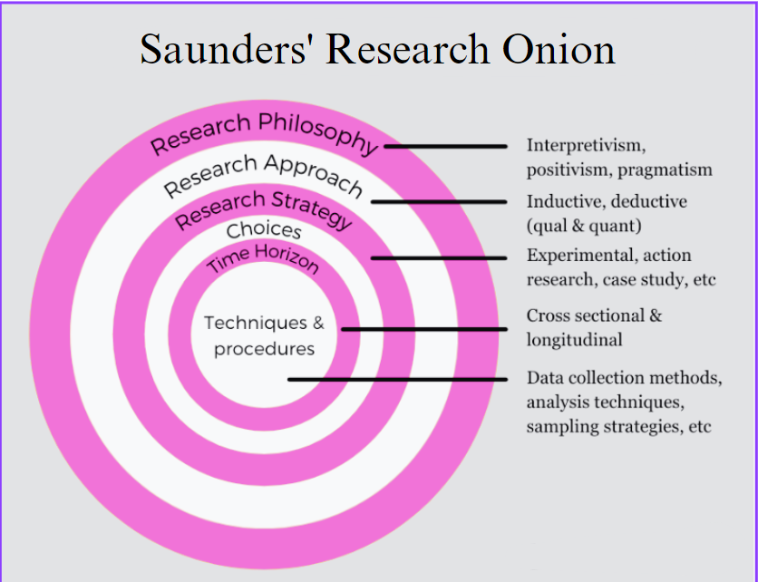
Figure 7: Saunders’ Research Onion [78]
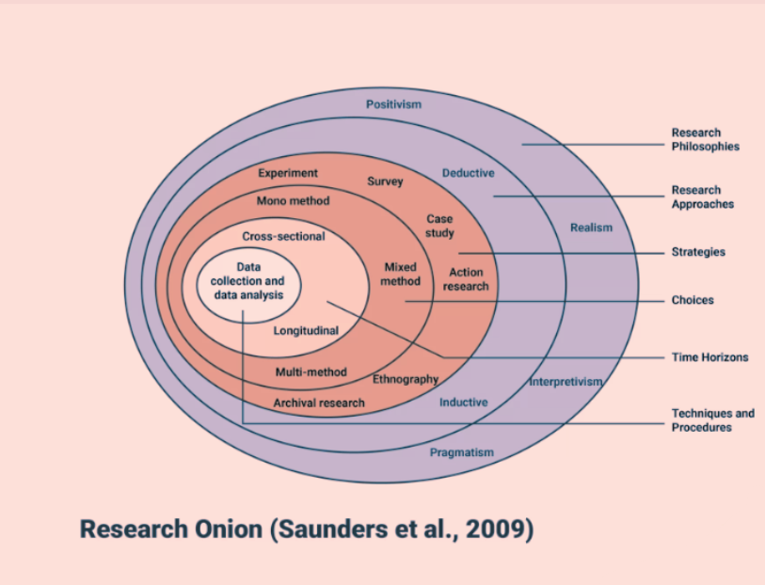
Figure 8: Research Onion [79]

Research Methodology
This chapter provides a comprehensive research methodology for assessing vulnerability in cloud-based infrastructure. It emphasizes the importance of a solid research foundation, using reliable sources like books, peer-reviewed journals, and databases like Science Direct and IEEE. The literature review provides context and situates the work within the broader field of current research. The methodology follows a mono-method quantitative approach, allowing for precise and objective data collection and measurement. This approach enhances comparability with other studies and the generalizability of findings. Combining theoretical and practical methods, this chapter lays the groundwork for a robust evaluation of the network's security posture. The methodologies are designed to systematically assess vulnerabilities, providing a thorough and reliable framework for the research. By adhering to this structured approach, the research not only meets its objectives but also contributes valuable insights to the larger body of knowledge in cloud security.

PHILOSOPHY
This project uses a pragmatic research philosophy to find and quantify security vulnerabilities using a methodical and objective approach. It stresses the use of factual data and systematic methodologies, making it ideal for thorough penetration testing and vulnerability assessment. The endeavour focuses on evaluating observable facts, discovering patterns, regularities, and correlations in acquired data, and testing a proposed hypothesis. This experimental approach is critical for determining the effectiveness of vulnerability assessments in improving network infrastructure security. The research focuses on real-world practical outcomes, in which we identify vulnerabilities in a live cloud-based infrastructure and then duplicate them in a simulated environment. One important aspect of the pragmatic approach is that it places a strong emphasis on comprehending how these vulnerabilities appear in real-world situations and how to mitigate or exploit them.

Advantages: A practical approach ensures the outcomes are repeatable and measurable, providing security recommendations with a solid foundation. Empirical data collected using applications such as OpenVAS is an important part of this process. It enables an emphasis on real-world applications and outcomes by emphasizing practical implications and empirical explanations. This technique provides a framework for making informed judgments in real-world contexts, addressing ethical issues indirectly, and testing and validating regulations.

Disadvantages: This approach's shortcoming is its incapacity to take into consideration the subtleties of human aspects in security, like insider threats or user behaviour. The pragmatic approach's popularity and breadth can occasionally cause misunderstandings and confusion, with some academics ignoring its broader philosophical stance in favour of concentrating just on its practical aspect.

STRATEGY
This study's research ethic is consistent with the experimental approach’s has deductive nature. The project may test current theories and notions thanks to deductive reasoning, especially when it comes to cloud infrastructure weaknesses and possible exploitation. Using this approach, the research seeks to unbiasedly investigate and verify the efficacy of vulnerability assessments in augmenting cloud-based systems' security. This method makes it easier to get solid evidence that either confirms or denies the hypothesis by carrying out tests in a controlled setting.

Advantages: Deductive reasoning facilitates a structured approach to hypothesis testing, which is ideal for the systematic nature of vulnerability assessments. This approach ensures that the research findings are closely aligned with established security frameworks.

Disadvantages: A potential drawback is the risk of overlooking novel vulnerabilities that do not fit within the established theories. To mitigate this, the project will ensure thorough up-to-date scanning protocols that account for the latest security threats.

APPROACHES
This project employs a systematic approach to data collection, analysis, and interpretation, focusing on validating pre-existing theories through empirical investigation. The deductive method is chosen for assessing cloud infrastructure security by testing known vulnerabilities. Deductive reasoning is used to formulate a hypothesis about the expected outcomes of security assessments. The hypothesis is rigorously tested through the experimental phase, determining whether the results support or reject the initial assumptions. This approach aligns with the pragmatic philosophy of the study and enhances the generalizability of the findings by building on established knowledge.

Research Time-Horizon
Current data that can show the relationship between the variables under study and aid in the understanding of the phenomenon are the focus of the investigation. A cross-sectional time horizon is thought to best fit the project and its limited flexibility when combined with this knowledge and the project's time limitations.

Research Techniques
Among the information to be gathered for the implemented experimental vulnerabilities assessments is the variance of current and mitigated vulnerabilities. A logical and consistent research process can be produced by using focused statistical analysis to find correlations in the data that match the layers of the methodology already in place.

Experimental Hypothesis
According to the developed experimental hypothesis, the deployment of a vulnerability assessment on the NGO's network serves as the independent variable, and the security of the network infrastructure serves as the dependent variable. Since the gathered information will originate from the same network source, it will eventually be included in a dependent sample.

"The deployment of a vulnerability assessment does not enhance the infrastructure security of the network," according to the null hypothesis (H₀). On the other hand, "the deployment of a vulnerability assessment does enhance the infrastructure security of the network," according to the alternative hypothesis (H₁). More statistical representations of these assumptions are possible.

H₀: Infrastructure Security before Vulnerability Assessment = µInfrastructure Security after Vulnerability Assessment
H₁: Infrastructure Security before Vulnerability Assessment ≠ µInfrastructure Security after Vulnerability Assessment

Throughout the project analysis, these theories will be reviewed to examine the data that has been acquired and determine whether vulnerability assessments may contribute to the improvement of network security architecture.

Gantt Chart
The Gantt chart is a popular tool in project management that helps to visualize a project's timeline and schedule. Gantt charts can assist in identifying relationships between tasks by giving a clear overview of all the tasks and activities that must be completed within a specified time frame. Such a feature can significantly reduce the possibility of a setback or disruption while also enhancing the project's efficiency and ability to move forward continuously.
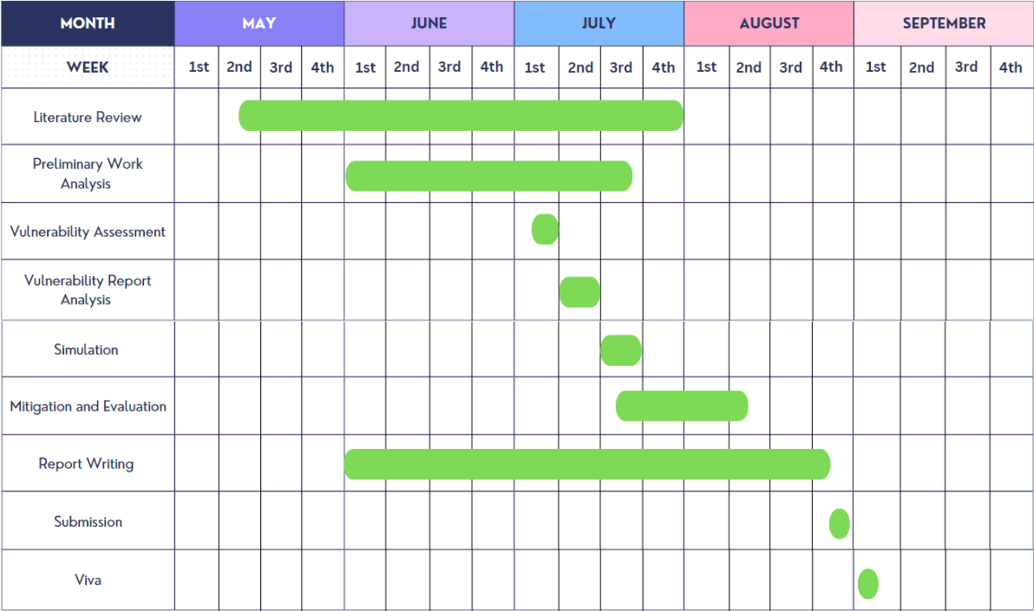
Figure 9: Project Gantt Chart
A Gantt chart that embodies the anticipated time distribution and allocation throughout the project is shown in Figure 9. It offers an easily modifiable period and a clear visual depiction of the planned schedule.

Contingency Plan
If no additional vulnerability assessments can be completed on the NGO network, a simulated vulnerability assessment must be performed. The use of virtualized software will enable the NGO to conduct simulated vulnerability assessments, select vulnerabilities uncovered during earlier phase scans, document them, and propose an effective mitigation approach. If the vulnerability assessment cannot be completed the recommended contingency plan will be implemented to allow the project to continue. Establishing such a contingency plan is critical to ensuring the project's integrity and its implementation. The simulated implementation will take place if the recommended contingency plan is adopted.

Conclusion
This chapter describes the chosen research methodology—the Saunders’ Research Onion - that will be used for this project. The text examines the diverse features provided by the influential technique, describing its methodical and layered approach that can facilitate better decision-making, offer a well-defined structure, and enhance the project's replication and credibility. A hypothesis formed from the project's experimental foundations is also documented, along with the applicable reasoning behind each chosen layer of the study onion. Throughout the project's initial investigation, maintaining a commitment to the selected philosophies and methodologies can help achieve the desired goal and ensure a successful implementation. The Gantt chart is suggested as a tool to help ensure that the project and its goals are progressed efficiently. To improve risk management and safeguard the integrity of the project and its execution, a necessary contingency plan is taken into consideration and prepared.

Chapter 4 - DESIGN & IMPLEMENTATION

Introduction
This chapter is organized into three sections: problem formulation, project design, and implementation. The first section discusses the topic that generated the study and the importance of its analysis. The second section provides a detailed examination of the project's design, including details on the hardware and software used to conduct the experiments. The methods utilized to conduct these tests are given in the last section, along with an explanation of how the objectives were met.

Problem Formulation
Although the prerequisite work has been analysed, the length of time that has passed after phases 2 and 3 means that most of the information it provides may be considered outdated. To ascertain the present security posture of the network infrastructure, another vulnerability assessment will be suggested and submitted to the NGO in the hopes of being approved. This implementation can assist in looking into the potential threat(s) against the NGO and confirming the existence of vulnerabilities within the network. It is possible to select suitable remediation and mitigation solutions with this knowledge. The problem addressed in this project is to determine whether NGO’s current security posture is sufficient to protect against potential cyber threats. This validation process is crucial to identifying any remaining vulnerabilities that could be exploited in future attacks.

Project Design
Subject to NGO agreement, an external vulnerability assessment will be carried out using a secure VPN connection provided by the network. The encrypted tunnel will allow for an exhaustive review of the target network and its infrastructure without compromising the research project. The collected data will be critical for analysing the effectiveness of infrastructure security measures and furthering our understanding of vulnerability assessments in network security. Following the security rules and permissions established by the NGO network administrators and security policy, the given network account for usage with the VPN client has no administrative rights and only provides network access.

Oracle VM Virtual Box was installed on the base computer (ROG Zephyrus) and Kali Linux OS is installed over the Virtual Machine as shown in the Figure 10. Access to NGO’s network was achieved using FortiClient VPN for the initial network scan using OpenVAS, which generated reports exposing Common Vulnerabilities and Exposures (CVEs) in the system.
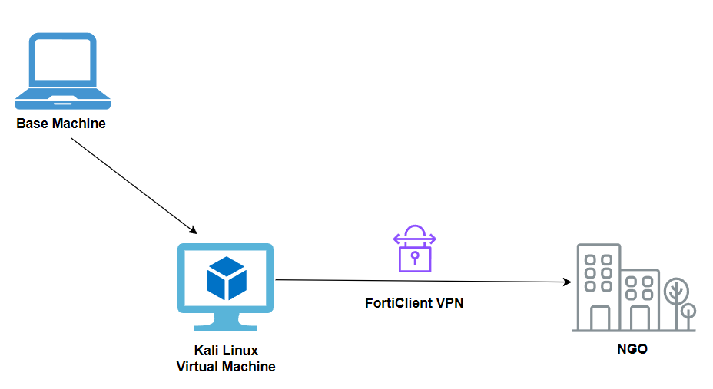
Figure 10: Virtual Machine using FortiClient VPN

At this stage, a comprehensive copy of the vulnerability assessment reports was sent to the NGO. These reports contained a list of Common Vulnerabilities and Exposures (CVEs) found in the cloud-based infrastructure and were produced using OpenVAS. In addition, we have developed a simulated environment as shown in the Figure 11 to better understand the implications and exploitability of these vulnerabilities. We are running penetration tests and replicating the vulnerabilities in a simulated environment. By using this procedure, we may investigate the practical effects of these vulnerabilities without compromising the live infrastructure.

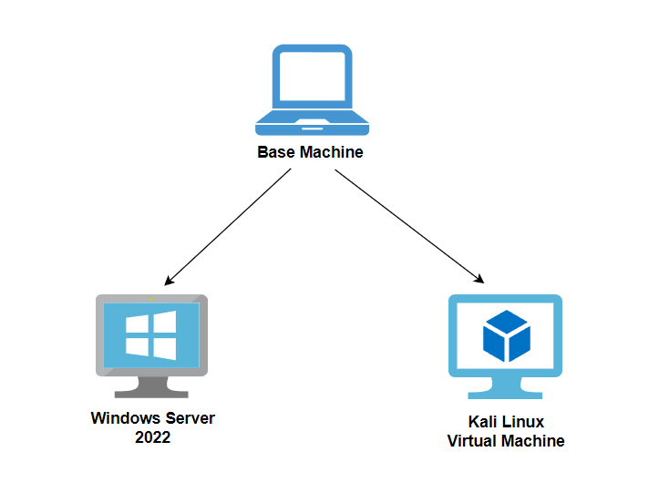
Figure 11: Virtual Machine Simulated Setup
To replicate and pen test these scenarios we have set up this simulated environment including few installations.

Environment Setup
The procedures used to set up the experiments are described in this section.

The Base Machine
We utilized two different types of base machines for distinct tasks: vulnerability assessment and penetration testing. This separation allowed us to tailor each machine to the specific requirements of its task, ensuring optimal performance and accuracy.
The computer chosen for the base machine was:

Vulnerability Assessment
Device name: ROG Zephyrus
Processor: G17 G713PU AMD Ryzen 9
Edition: Windows 10

Penetration Testing
Device Name: Legion 5 15IMH05
Processor: Intel(R) Core (TM) i7-10750H CPU @ 2.60GHz 2.59 GHz
Installed RAM: 16.0 GB
System type: 64-bit operating system, x64-based processor
Edition: Windows 10 Home Single Language

Oracle VM VirtualBox
Oracle VM VirtualBox (VirtualBox) was installed on both the base machine. A virtual machine was created in VirtualBox using Kali Linux 2022.2-virtualbox-amd-64, with an OS Debian (64-bit). The base memory was 10038 MB with 3 processors, the acceleration was Nested Paging, KVM Paravirtualization as illustrated in Figure 12.
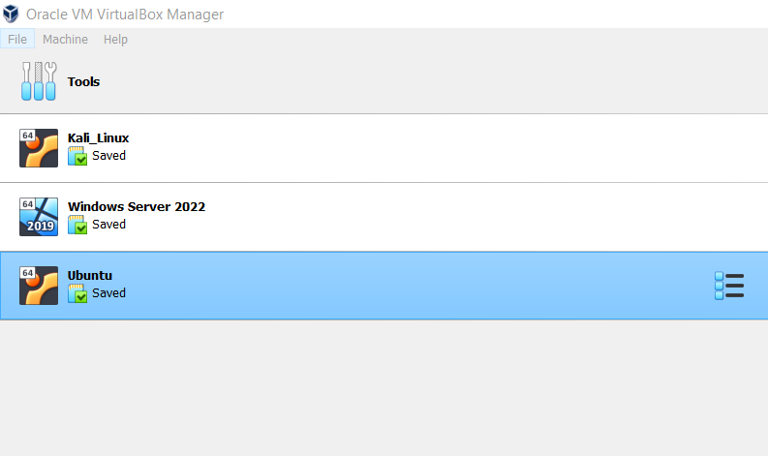
Figure 12: Installation of operating systems
NAT network adapter is installed with Intel PRO/1000 MT Desktop as shown in the Figure 13.
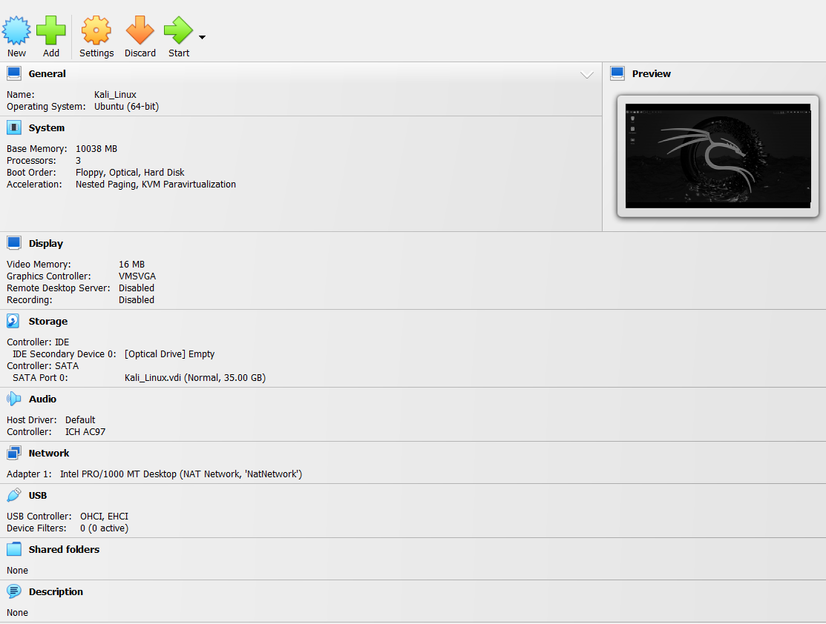
Figure 13: Operating system details

FortiClient VPN
FortiClient VPN was installed on the base machine and opened using credentials provided by NGO and Connected to the VPN, purposely concealed to ensure confidentiality, as shown in the Figure 14,15 and 16.
With FortiClient, end users’ devices can benefit from the full range of features offered by Fortinet’s Advanced Threat Protection, all in one package. It is crucial to make sure that your endpoint security integrates robust prevention with detection and mitigation since the endpoint serves as the ultimate destination for malware looking to obtain sensitive data, network access, and credentials [79]. Established over two decades ago in Sunnyvale, California, Fortinet is a prominent cybersecurity company offering more than fifty enterprise-level solutions. Fortinet is a major provider of networking and cybersecurity solutions with 1,015 US patents. The business’s Fortinet Security Fabric offers centralized visibility across Fortinet and more than 500 third-party solutions in addition to automating protection, detection, and response. FortiOS, the company’s main operating system, was created naturally on a common management and
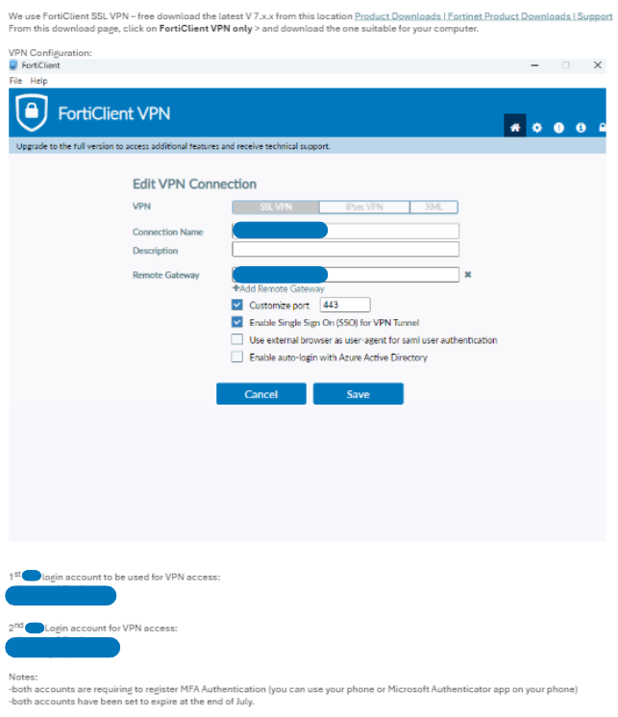
Figure 14: FortiClient VPN setup

security basis. Using AI and machine learning algorithms, the business processes and analyses more than 100 billion events daily. Fortinet, a firm listed on the Nasdaq 100 and the S&P 500, is a nominee for the list of Fortune Magazine’s Most Admired Companies [79].
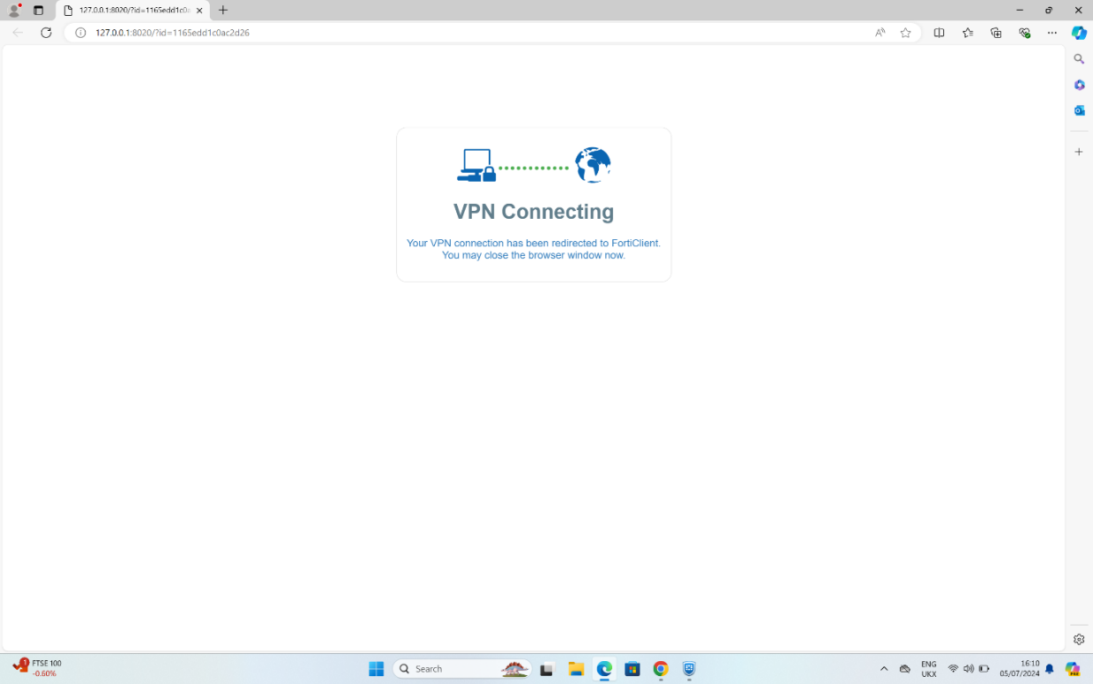
Figure 15: FortiClient VPN connecting
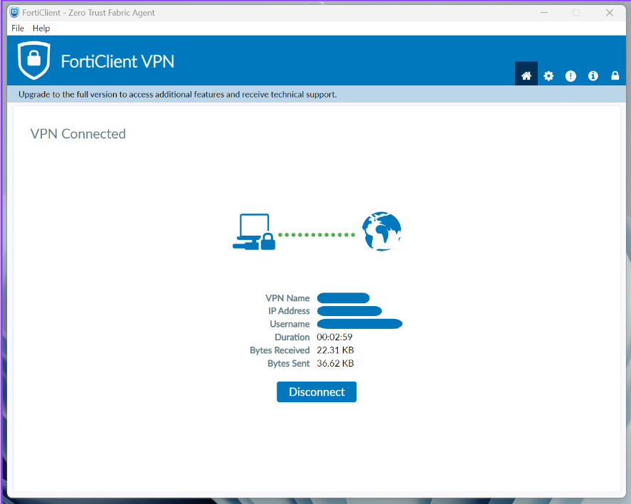
Figure 16: FortiClient VPN connected

OpenVAS Installation
Initially verify that Kali Linux is updated using the below command in the Figure 17.
$ sudo apt update

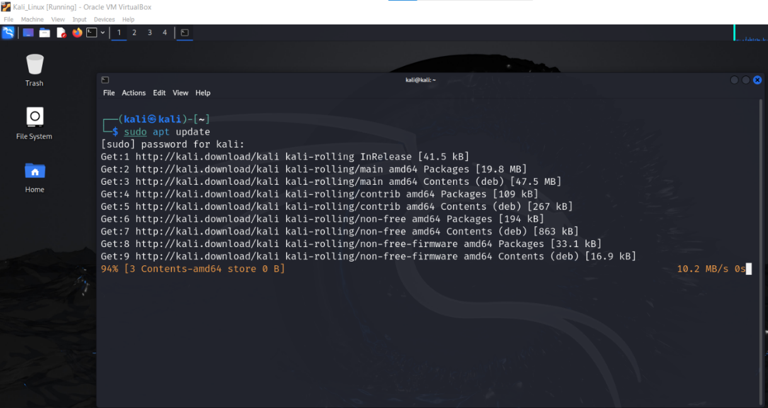
Figure 17: Updating Kali Linux

To install OpenVAS on our Kali Linux system run the following command shown in the Figure 18.
$ sudo apt install openvas

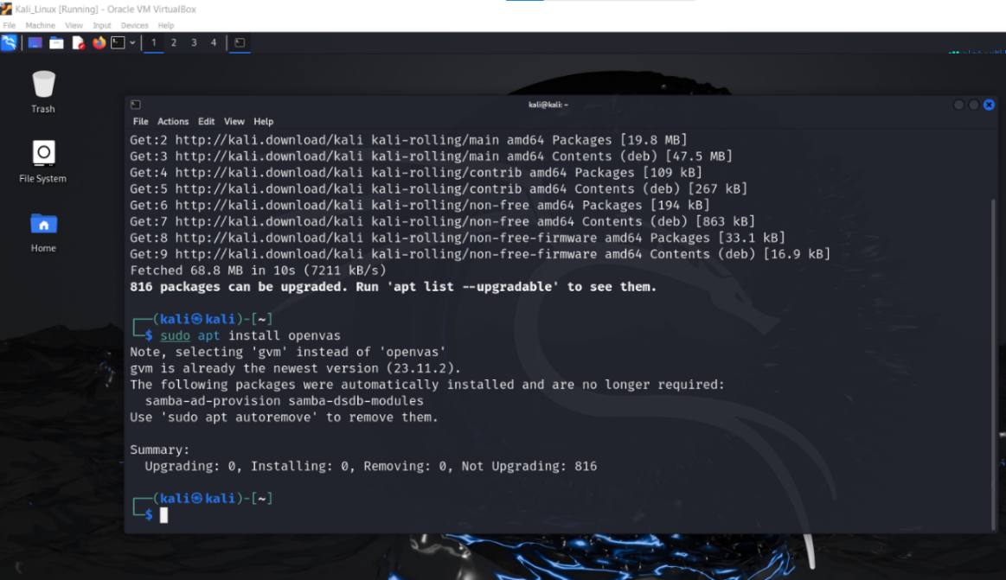
Figure 18: Installation of OpenVAS
The installer must then be launched to configure OpenVAS and download several network vulnerability tests (NVT).
Run the following command to start the setup process shown in the Figure 19.
$ sudo gvm-setup

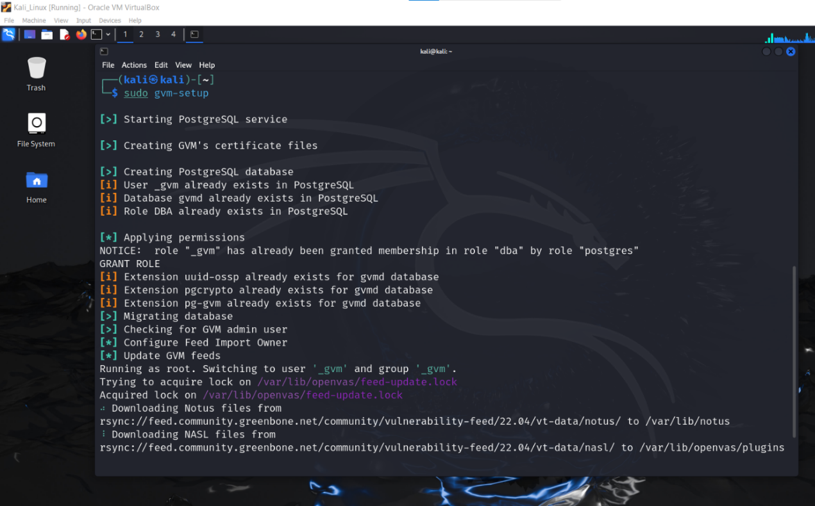
Figure 19: Setting up the OpenVAS

Additionally, OpenVAS will create an admin account and generate a password for it automatically. This account is shown in the setup output's last section.

To ensure that GVM was set up correctly run the command as shown in the Figure 20.

$ sudo gvm-check-setup
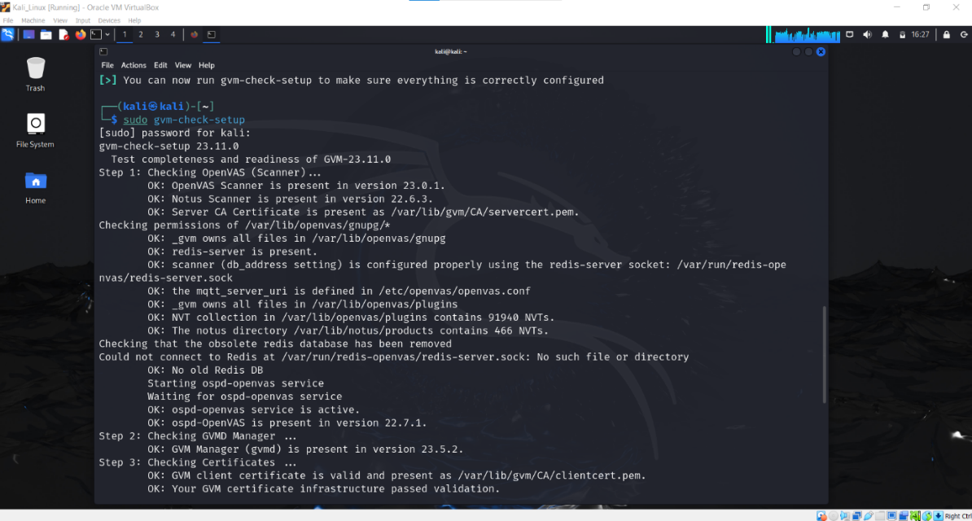
Figure 20: GVM set-up check
We need to receive confirmation that the installation went off without a hitch once everything is finished as shown in the Figure 21.
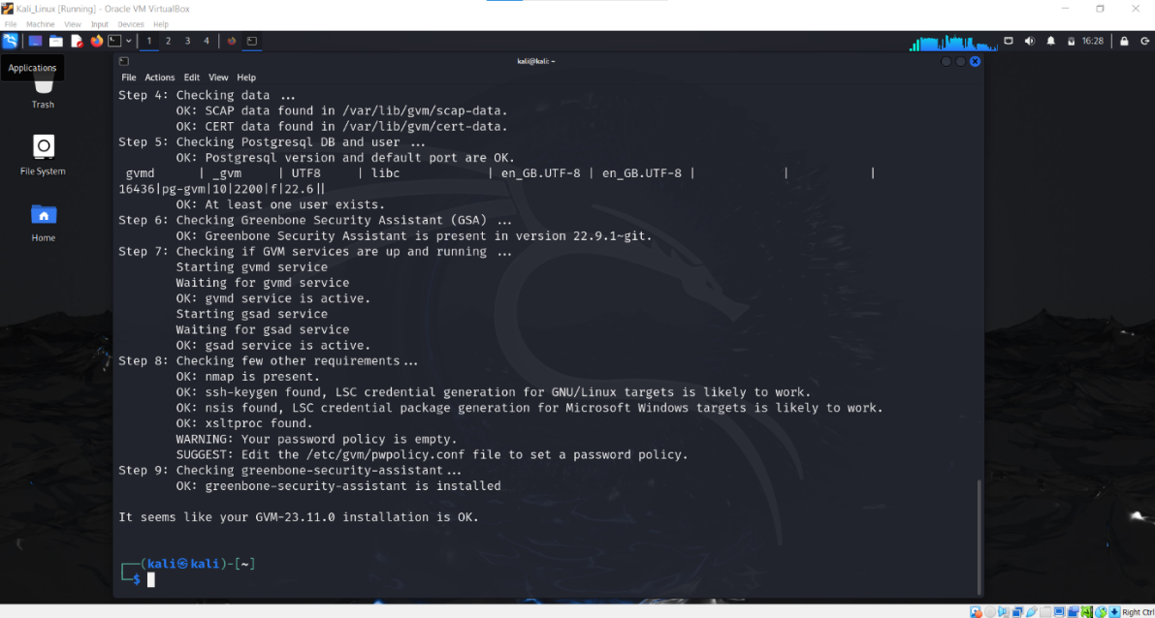
Figure 21: GVM installation complete
Run the following command to start the services as shown in the Figure 22.
$ sudo gvm-start

Figure 22: Start GVM services
The web interface is running locally on port 9392 and can be accessed through https://localhost:9392 as shown in the Figure 23.
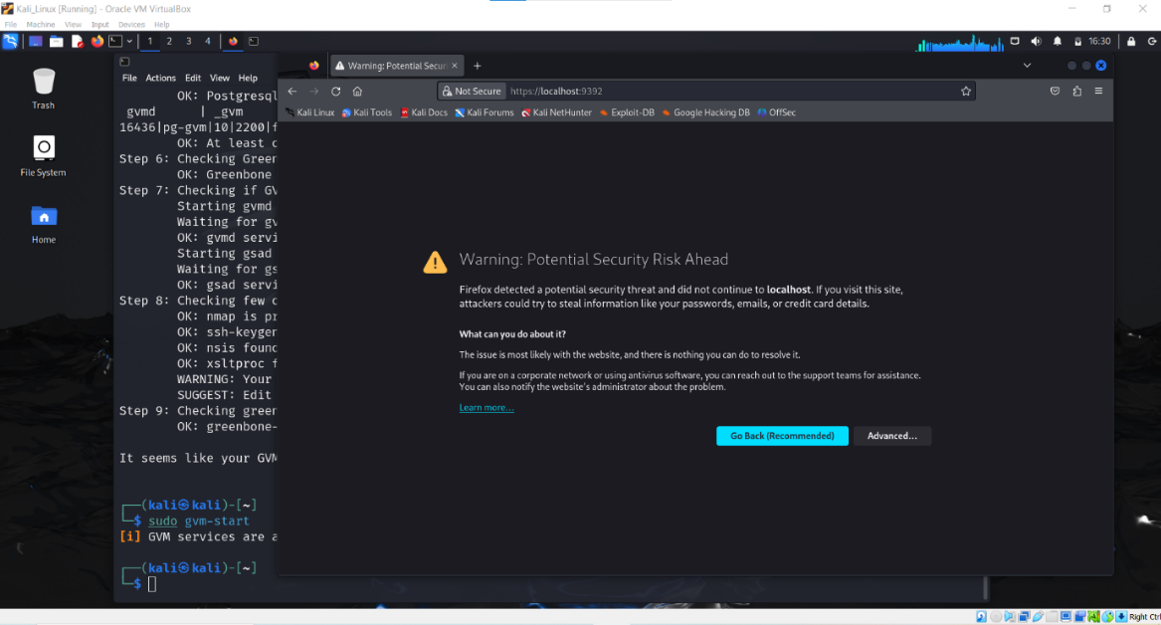
Figure 23: GVM web interface

First time you want to open this URL you will get a security warning. Click on Advanced and Accept the Risk and Continue. The next step is to accept the self-signed certificate warning and use the automatically generated admin credentials as shown in the Figure 24.
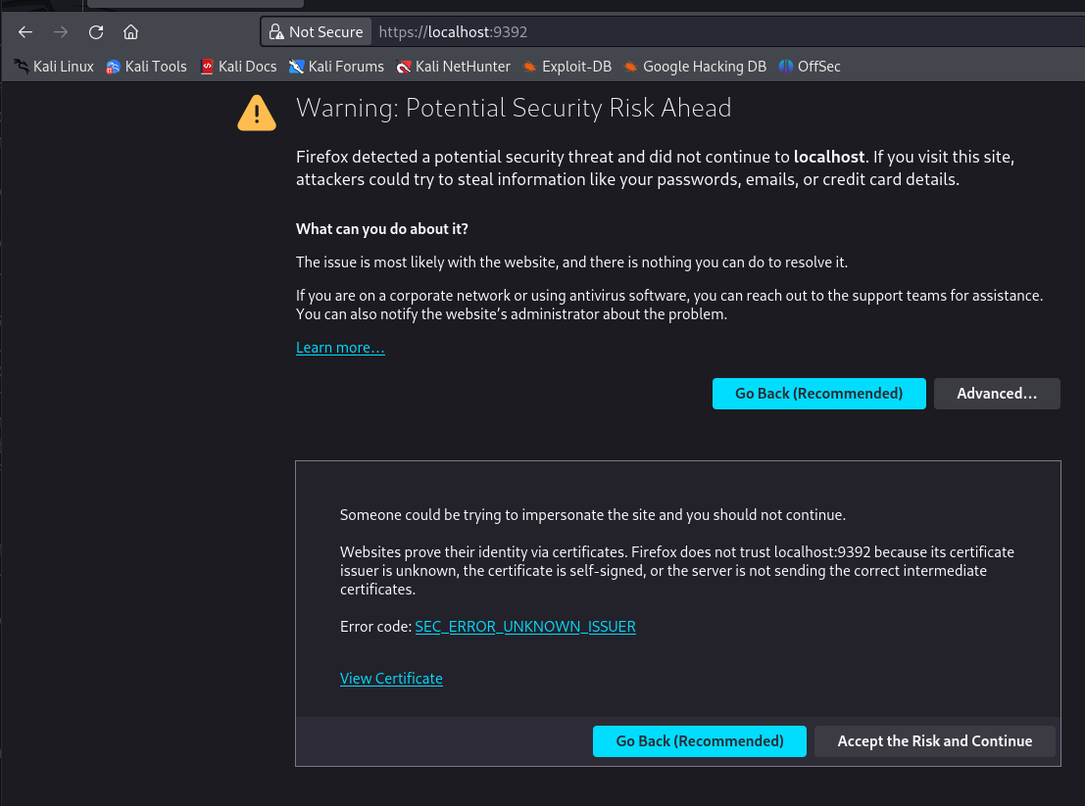
Figure 24: Webpage warning
OpenVAS was installed on to the virtual machine as illustrated in Figure 25.

Figure 25: OpenVAS is installed

Implementation
As the environment setup is completed, we will go to the implementation step. The project was implemented over two days (6th - 7th July 2024) to provide me enough time to do a thorough full network vulnerability assessment, which included all known subnetworks and their host machines. With this time, any problems identified may be examined and addressed without compromising the task at hand.

Initialization of Scan
Before deployment, the NGO provided knowledge about the network infrastructure, including each subnetwork and IP address tables. This information generated a list of targets within OpenVAS and applied to each relevant scan. Configured targets determine the IP range of host devices targeted by OpenVAS during a vulnerability scan. Each unique subnetwork target was formed using the default configuration which targeted all TCP ports on recognized host machines as shown in the Figure 26 and 27. While narrowing the number of ports to be checked can limit the scope and accuracy of a vulnerability assessment, scanning all 65,535 TCP ports on each prospective host system can take a long time. Scans assist you in detecting vulnerabilities in currently running services. Scanning lets you map the target's attack surface by identifying all operating services and their possible vulnerabilities. This is critical for discovering vulnerabilities, comprehending the attack surface, and planning future exploitation actions.
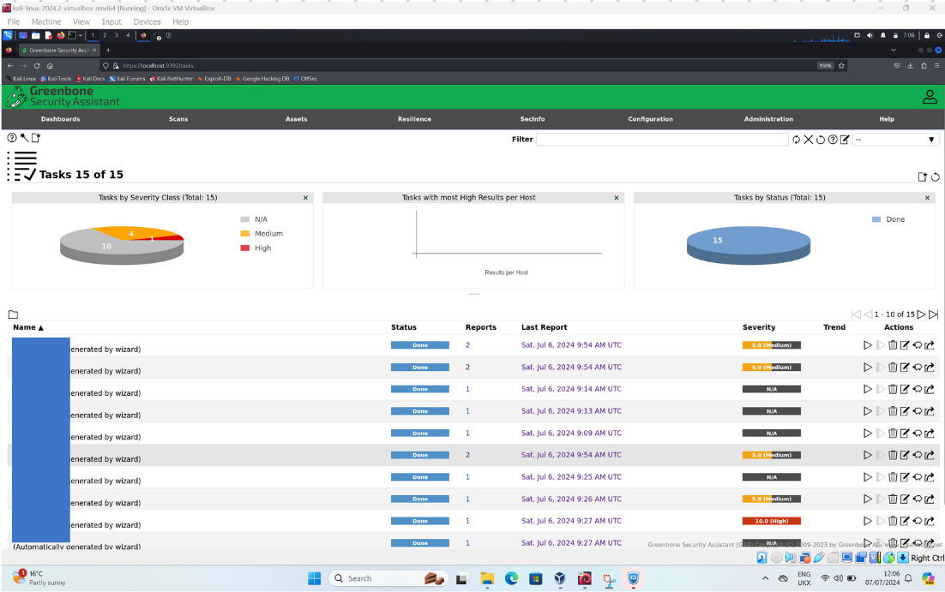
Figure 26: Scan Initialization

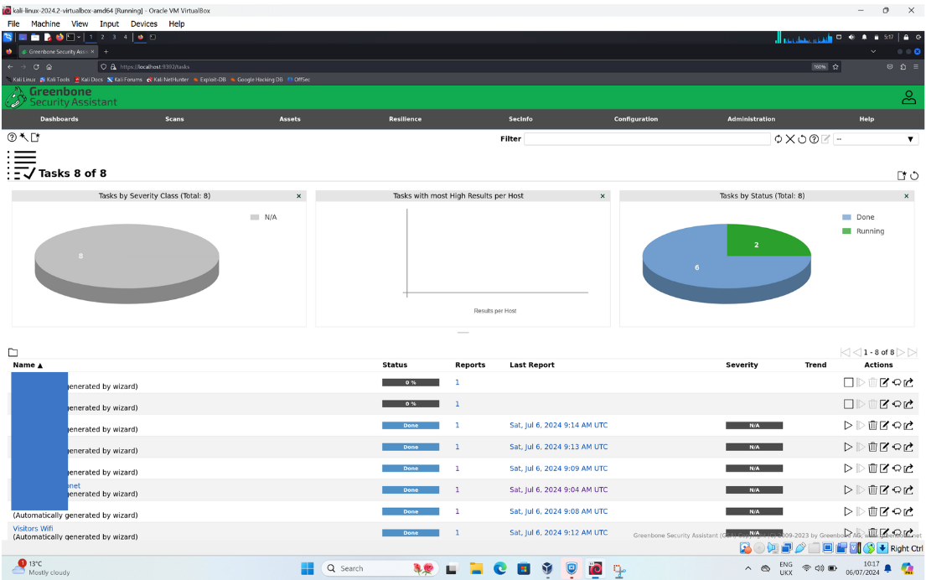
Figure 27: Vulnerability Scan Initialization

The vulnerability scan has been listed in the queue as shown in the Figure 28.
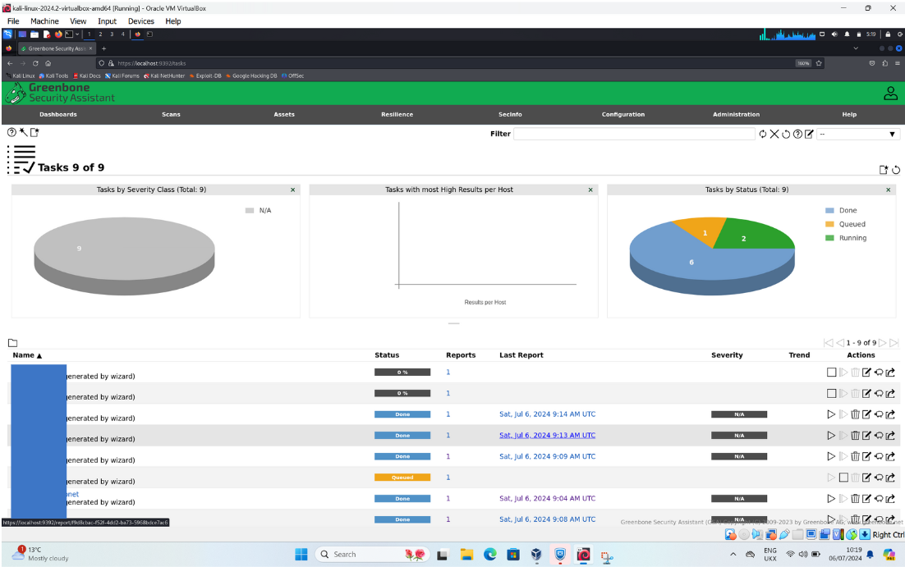
Figure 28: OpenVAS Scan

Results of Implementation
A collection of internal and external subnetworks, each with corresponding internal and external IP addressing systems, made up the NGO network. Understanding this separation will help in understanding and forecasting possible explanations for vulnerabilities within each subnetwork that may exist.
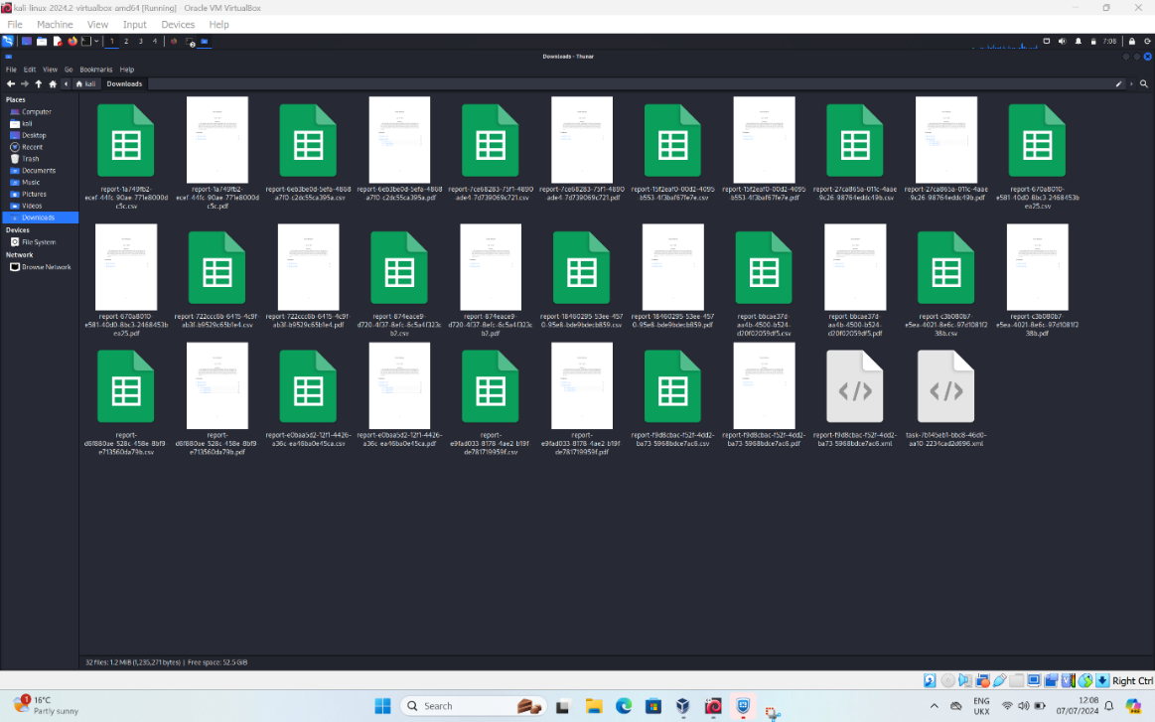
Figure 29: Vulnerabilities reports
The Table 5 shows the structure of the NGO subnetworks, including their alignment within the network and the number of potential hosts.

Subnet Name | Subnet IP Address | Internal/External | No. of Hosts
Azure Subnet | X.X.0.0/16 | Internal | 65,534
Office Subnet | X.X.0.0/16 | Internal | 65,534
Firewall Subnet | X.X.1.6/30 | External | 2
Visitor Wi-Fi | X.X.31.0/24 | External | 254
DMZ Subnet | X.X.20.0/32 | External | 1

Table 5: List of NGO Subnetworks

Following the successful completion of the configured vulnerability scans, any important vulnerabilities will be revealed in line with the analysed OpenVAS provided reports. To help lower the possibility of false positives, only vulnerabilities that were found and had a minimum quality of detection (QoD) of 70% were included in each generated report as shown in the Figure 29. The results of these simulations will provide insightful information that will strengthen the significance of mitigation and provide a clearer picture of how malicious attacker can take advantage of these vulnerabilities.

The results from the scan showed a list of vulnerabilities listed below:
- SSL/TLS: Deprecated TLSv1.0 and TLSv1.1 Protocol Detection
- DCE/RPC and MSRPC Services Enumeration Reporting
- Microsoft SQL (MSSQL) Server End of Life (EOL) Detection
- Cleartext Transmission of Sensitive Information via HTTP

Conclusion
The implementation included 17 unique vulnerability scans, each of which assessed and highlighted any vulnerabilities or configuration problems found inside the NGO's network infrastructure. We came across four different vulnerabilities with high and medium severity level as shown in the Figure 30. The distribution of vulnerabilities is shown in the Figure 31.

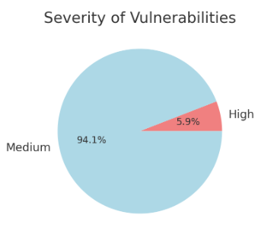
Figure 30: Severity of Vulnerabilities

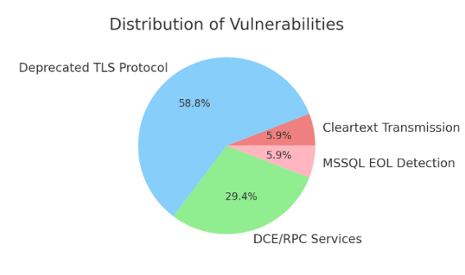
Figure 31: Vulnerability Distribution

Challenges
VPN Connection Error
Connection attempts to the given NGO VPN were often met with a unique error code during the test environment setting, indicating that the VPN server was unavailable. The error prompt, together with the message and error code that accompanies it, is shown in Figure 32.
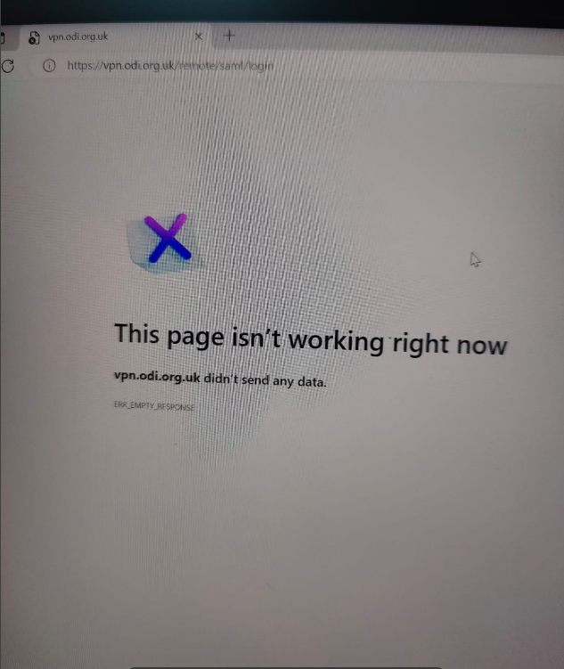
Figure 32: VPN connection error

Chapter 5- Mitigation and evaluation

Introduction
The proposed mitigation and remedial plan in this report will largely focus on vulnerabilities identified during the vulnerability assessment that have one high risk and one medium risk CVSS score from the OpenVAS assessments. Each vulnerability will be identified, and relevant remedial techniques will be supplied to the NGO network to help mitigate key threats.

Vulnerabilities
The proposed mitigation and remedial method in the generated report will largely focus on vulnerabilities discovered during the scan that receive a high risk CVSS score from OpenVAS assessments. Each vulnerability will be identified, and relevant remedial techniques will be supplied to the NGO network to help mitigate key threats.

OpenVAS discovered 17 vulnerabilities in total across the host computers throughout the vulnerability assessment. It's crucial to remember that these vulnerabilities were restricted to 4 distinct threat types that appeared on different devices and at varied frequencies as shown in the Table- 5.1. The resulting OpenVAS reports and their thorough examination of each discovered vulnerability will enable the documenting of high and medium-threat vulnerabilities, including their descriptions and matching mitigation solutions.

Vulnerability | Severity  Level | Impact | Solution
Microsoft SQL (MSSQL) Server End of Life (EOL) Detection | High | Systems running EOL software are vulnerable to unpatched security flaws, increasing the risk of compromise. | Upgrade to a supported version of Microsoft SQL Server.
Cleartext Transmission of Sensitive Information via HTTP | Medium | Sensitive data transmitted in cleartext can be intercepted and accessed by attackers. | Implement HTTPS to encrypt data in transit.
DCE/RPC and MSRPC Services Enumeration Reporting | Medium | May allow unauthorized users to gather sensitive information about the network services available on the host. | Limit access to DCE/RPC services to trusted hosts or use firewall rules to restrict access.
SSL/TLS: Deprecated TLSv1.0 and TLSv1.1 Protocol Detection | Medium | An attacker could exploit known cryptographic flaws to eavesdrop on communications. | Disable deprecated TLSv1.0 and TLSv1.1 protocols.

Table 6: List of Vulnerabilities with their severity levels, impacts and solutions

Microsoft SQL (MSSQL) Server End of Life (EOL) Detection
Microsoft SQL Server is popular software used by organizations to manage and store important data. It uses a language called SQL (structured query language) to perform tasks like retrieving and managing data. SQL Server is known for being powerful, scalable, and reliable, making it essential for organizations to make informed decisions based on accurate data [80].

However, like most software, older versions of SQL Server eventually become outdated as new versions are released. When a version becomes outdated, it's no longer supported by Microsoft, which means it stops receiving security updates. This leaves the software vulnerable to attacks because any existing or new security flaws won't be fixed. If an organization continues using an outdated SQL Server version, it puts their network and data at risk. Hackers could exploit these vulnerabilities to access or damage the data, leading to serious security issues. Therefore, it's crucial to update or replace old SQL Server versions to keep the network safe and secure.

Description
The Microsoft SQL Server being used is outdated and is no longer supported by Microsoft. This means it doesn't receive any new security updates or fixes, making it vulnerable to hackers who could exploit known weaknesses in the software.

Impact
The server is at high risk because it has unpatched security flaws. These flaws can be easily exploited by attackers, which could lead to sensitive data being stolen or the entire system being taken over.

Mitigation
Regarding the security issues connected to an End of Life (EOL) SQL Server, the NGO has two main options. One option is to replace the outdated SQL Server with Microsoft's Azure SQL service, which runs on cloud computing and offers better security and more frequent updates. As an alternative, the NGO should upgrade to a more recent version of SQL Server, like SQL Server 2019 or 2022, if it wants to maintain its database on its servers. Microsoft continues to support these versions and releases security upgrades regularly to help guard the database against possible intrusions. Both strategies try to maintain SQL Server security by offering the most recent updates and assistance.

Cleartext Transmission of Sensitive Information via HTTP
When sensitive data—like usernames, passwords, or credit card numbers—is transferred over the internet via HTTP (Hypertext Transfer Protocol) rather than HTTPS (HTTP Secure), a vulnerability arises. Because HTTP is an unsecured protocol and does not encrypt data, it is simple for unauthorized parties to intercept and read data. Anybody with network access can view data sent over HTTP since it is sent as plain text. Attackers can see everything being sent, including sensitive data, by using tools to intercept data as it moves between the browser and the server. Man-in-the-middle attacks are another possibility, wherein data is captured or changed without the knowledge of either party. Sensitive data, including login passwords and financial information, is seriously in danger from this vulnerability, which could result in financial loss or illegal access.
Description
Sensitive information, such as passwords and credit card data, is transmitted via an insecure HTTP connection. This means that the data is unencrypted, allowing attackers to intercept and access it.

Impact
Attackers can intercept the data as it travels between the client and the server because it is not encrypted. Data breaches may result from disclosing private data such as passwords and usernames. By using this vulnerability, attackers might perform a "man-in-the-middle" attack, whereby they surreptitiously capture or alter the data that is being sent.

Mitigation
The fundamental response to the risk of sending sensitive data via HTTP is to encrypt the data first using SSL/TLS. This encryption ensures that sensitive data, such as credit card information, usernames, and passwords, is safely transmitted. Setting up the server to automatically redirect all HTTP traffic to HTTPS is also necessary. To prevent possible surveillance or unauthorized access, this redirection ensures that users are always directed to a secure, encrypted connection before inputting any sensitive information. Instead of using HTTP, you should use HTTPS to protect sensitive data. SSL/TLS encryption is used by HTTPS to protect data during transmission. This guarantees that all confidential data is encrypted and shielded from prying eyes. Furthermore, make sure that before users enter any sensitive information, your application connects them to the HTTPS version of the website.

DCE/RPC and MSRPC Services Enumeration Reporting
DCE/RPC and MSRPC are protocols for communicating between software components on a network. They allow different applications or systems to request and execute functions on remote machines. When connected to a network, these services can be accessed and queried by anybody with the necessary rights. Attackers can use this vulnerability to enumerate the many services and programs running on the target computer or network. This enumeration method entails connecting to these services, typically via port 135, and running specified queries to determine what services are available. This enumeration has two effects: it discloses information, increases the possibility of an attack, and escalates privileges. Attackers can obtain thorough knowledge about the network's structure, uncover weaknesses or weak points, and possibly gain greater levels of access to the system or network.

Description
Remote Procedure Call (RPC) services, such as Distributed Computing Environment (DCE/RPC) and Microsoft RPC (MSRPC), are available over the network. This vulnerability enables attackers to enumerate, or list, the services running on the network. This allows them to obtain extensive information on the infrastructure.

Impact
With the capacity to enumerate these services, attackers can discover more about the network's configuration. This knowledge could help them plan future attacks, such as privilege escalation, in which they try to get higher-level access to the system.

Mitigation
To mitigate the risks related to the enumeration vulnerability of the DCE/RPC and MSRPC services, it is imperative to put in place multiple critical safeguards. First, make sure that only reliable organizations are allowed to connect to RPC services to restrict access to them. Authentication techniques and network access controls can help achieve this. Second, to stop outside parties from querying these services, employ firewalls to stop illegal access to RPC ports, usually port 135. To eliminate potential vulnerabilities and minimize the attack surface, stop any superfluous RPC services. By putting these tactics into practice, you may greatly improve network security and guard against data leaks and other associated risks.

DCE/RPC and MSRPC Services Enumeration Reporting
The usage of outdated versions of TLSv1.0 and TLSv1.1, which are no longer supported or recommended due to known security weaknesses, makes the Transport Layer Security (TLS) protocol, which encrypts data transferred between clients and servers, vulnerable. These weaknesses include methods for decrypting or altering data, in addition to shortcomings in encryption algorithms. Security updates and patches to fix recently found vulnerabilities are no longer provided for these versions due to a lack of updates. Man-in-the-middle attacks, data breaches, and noncompliance with industry standards and regulations become more likely as a result. Important information may be compromised by attackers who intercept and alter data transferred between clients and servers. Older procedures can also lead to a failure to follow industry standards and laws, which could lead to fines or other issues.

Description
TLSv1.0 and TLSv1.1, the out-of-date and unsafe TLS (Transport Layer Security) protocols, are being used over the network. Attackers can take advantage of known security holes in these protocols.

Impact
Using these outdated protocols raises the possibility of assaults, such as man-in-the-middle attacks, in which an attacker intercepts and potentially accesses sensitive information transferred via the network. Furthermore, reliance on outdated protocols might result in noncompliance with modern security standards and regulations (e.g., PCI-DSS), and any new vulnerabilities discovered in these protocols will go unaddressed because they are no longer updated.

Mitigation
It is important to disable TLSv1.0 and TLSv1.1 over the servers, making sure they no longer accept connections utilizing these out-of-date versions, to reduce the hazards associated with older TLS protocols. Adopt TLSv1.2 or later instead, as it offers better protection against known flaws and increased security features. You can improve the security of your communications and better protect sensitive data by changing your server settings to require the usage of these more secure protocols.

Simulated Demonstration of High-Risk Vulnerability
One way to demonstrate high-risk flaws in the NGO network is to utilize them to highlight the consequences of disregarding recognized hazards. Although a black box penetration test might target vulnerable hosts, the lack of time and resources made the plan unachievable. To illustrate the high-risk vulnerabilities found and their threat to the NGO network infrastructure, a simulated demonstration will be carried out instead. The experiments will be conducted in a simulated environment that will allow for a safe evaluation of any potential impacts.

In this simulation, we'll create a controlled setup that mirrors the NGO’s network to demonstrate how these vulnerabilities might be exploited. This way, we can safely explore the potential impacts without risking the actual NGO network. Our goal is to show how ignoring these vulnerabilities can lead to significant problems. By using the simulation, we'll help highlight the importance of addressing these issues and securing the network effectively. We have developed a simulated environment as shown in the Figure 11.

Microsoft SQL (MSSQL) Server End of Life (EOL) Detection
The vulnerability we are working with involves detecting whether Microsoft SQL Server is running a version that is no longer supported by Microsoft (i.e., it has reached its End of Life or EOL). Running unsupported software poses significant security risks, as there are no more security patches or updates provided for these versions.

The goal is to identify the EOL SQL Server version, replicate the vulnerability in a simulated environment, and then provide mitigation steps.

Setting Up the Environment includes:
Kali Linux: This will serve as attacker machine.
Windows Server 2022: This will be the target machine where SQL Server is installed as shown in Figure 33.
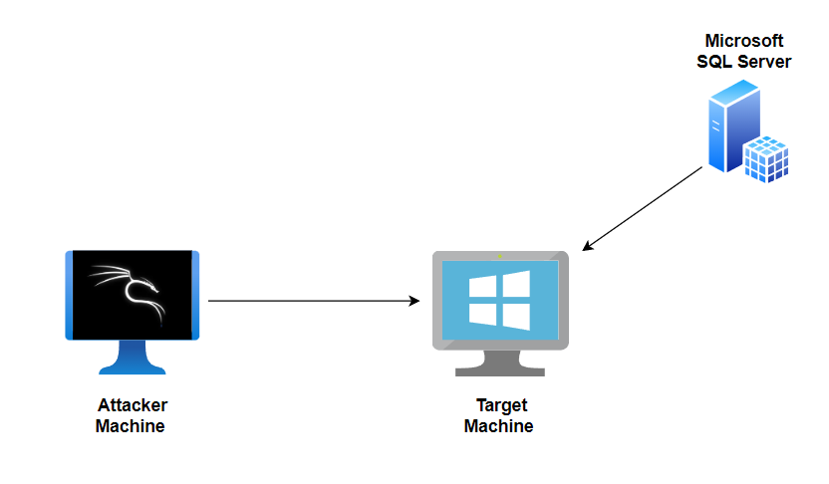
Figure 33: Simulated Environment
Downloaded an older version of SQL Server (like SQL Server 2008 or SQL Server 2012) from Microsoft's official website or other trusted sources. Ensure it's an unsupported version to replicate the vulnerability as shown in Figure 34.
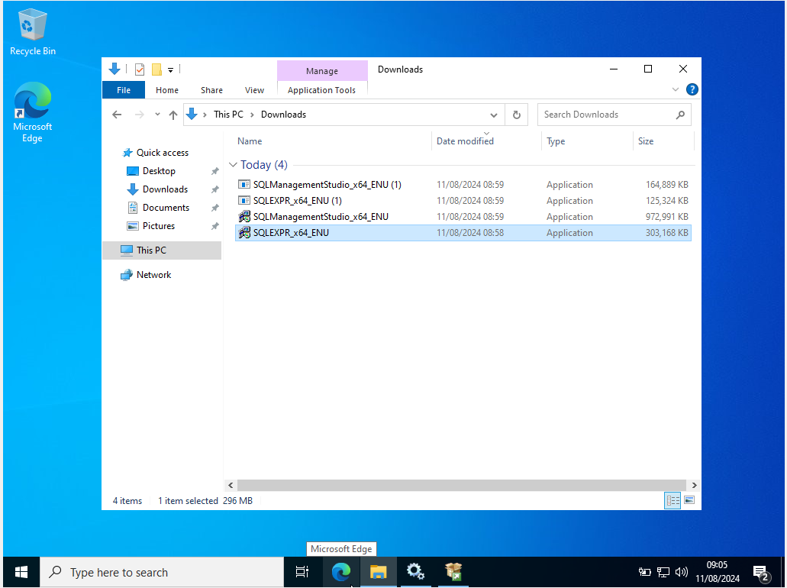
Figure 34: SQL management studio installation
Run the installer on your Windows Server 2022.
Follow the on-screen prompts to install SQL Server.
Choose the "New SQL Server stand-alone installation" option.
Proceed with the default settings or configure as needed.
When asked to select the instance features, ensure the Database Engine Services are selected as shown in Figure 35.
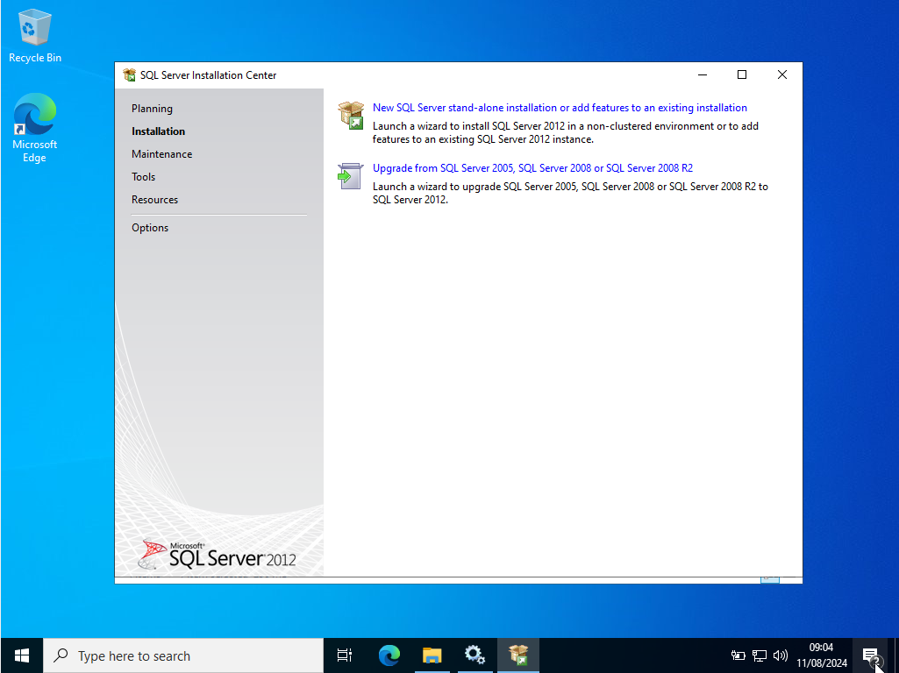
Figure 35: Installation of SQL server

Set up the authentication mode. Mixed Mode (SQL Server and Windows Authentication) is recommended for this test.
Set a strong password for the sa (System Administrator) account.
Complete the installation as shown in Figure 36.
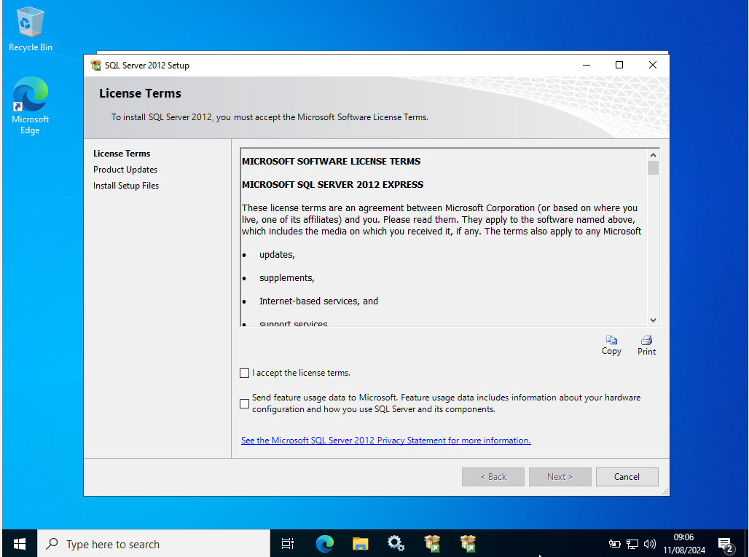
Figure 36: SQL Server setup
Once the installation is complete, open SQL Server Management Studio (SSMS) to ensure that the SQL Server is running correctly as shown in Figure 37 and 38.
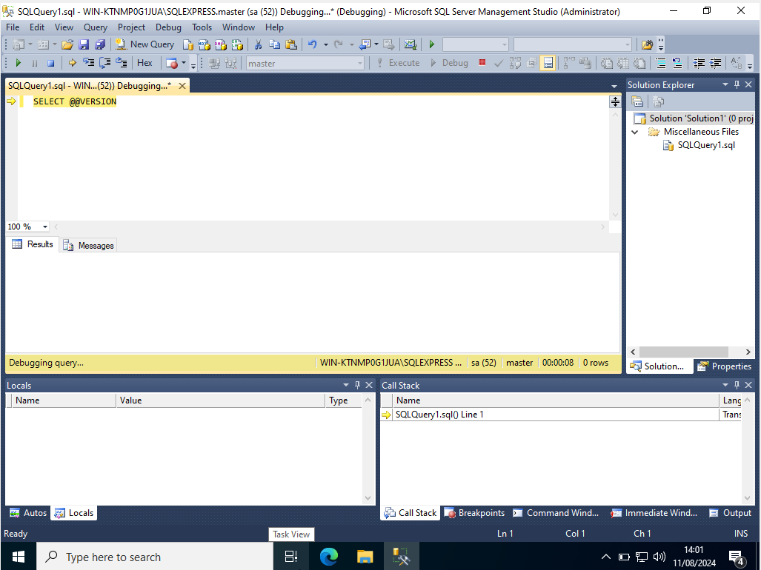
Figure 37: SQL Server management studio command line
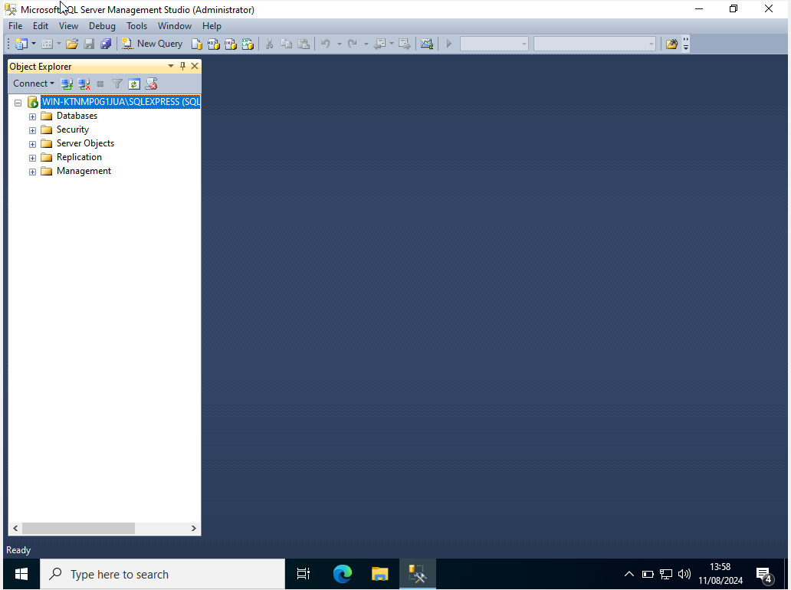
Figure 38: Microsoft SMSS administrator tab
The next step is to detect whether it's an EOL version from the Kali Linux machine.
Install Nmap on Kali Linux:
sudo apt update
sudo apt install nmap

Use Nmap to scan the Windows Server and detect the SQL Server version as shown in Figure 39.
nmap -sV -p 1433 10.0.2.4

-sV attempts to determine the version of the service running on port 1433 (the default port for SQL Server).
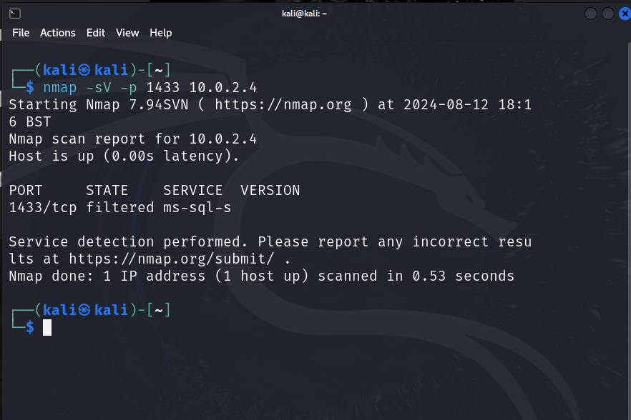
Figure 39: ping the Windows Server using in nmap
After identifying that you're running an unsupported version of SQL Server, the best course of action is to mitigate this vulnerability by upgrading to a supported version as shown in Figure 40.
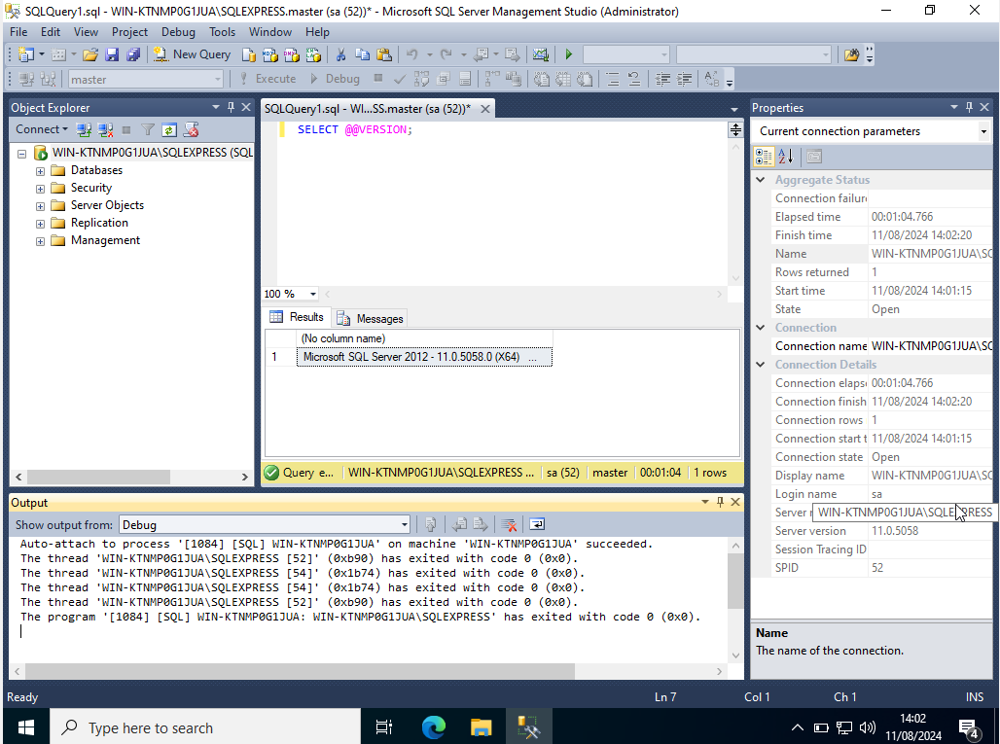
Figure 40: Unsupported version of SQL Server

Mitigation steps
Download the latest supported version of SQL Server (e.g., SQL Server 2022) from the Microsoft website.
Run the installer on your Windows Server.
Choose the "Upgrade from a previous version of SQL Server" option.
Follow the on-screen instructions to upgrade as shown in Figure 41.
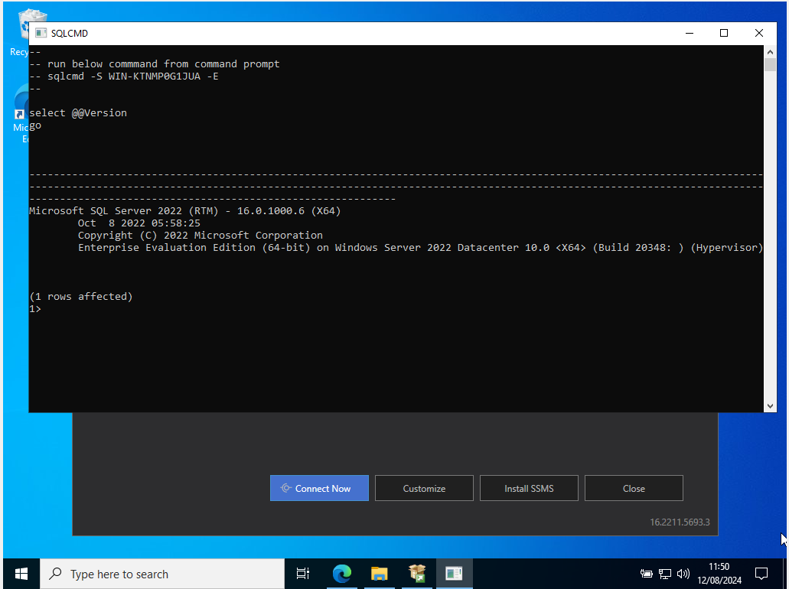
Figure 41: supported version of SQL Server 2022

Vulnerability | Attack Description | Status of the attack | Mitigation | Success/ Failure
Microsoft SQL Server End of Life (EOL) | Detecting whether SQL Server is running a version that is no longer supported by Microsoft (EOL). | Successful | Upgrade to a supported version of SQL (e.g., SQL Server 2022). | Success

Table 7: Vulnerability Table

Simulated Demonstration of Medium-Risk Vulnerability
In this simulation, we'll build a controlled environment that mimics the NGO's network to show how these vulnerabilities can be exploited. This allows us to safely investigate potential implications without compromising the NGO network.

We aim to demonstrate how ignoring these vulnerabilities can result in serious difficulties. We will use the simulation to emphasize addressing these vulnerabilities and properly protecting the network.

SSL/TLS: Deprecated TLSv1.0 and TLSv1.1 Protocol Detection
Setting Up the Environment includes as shown in the Figure 42:
Kali Linux (Attacking machine)
Windows Server 2022 (Target machine)
Web Server (e.g., Internet Information Services (IIS))
Nmap (Network scanning tool)
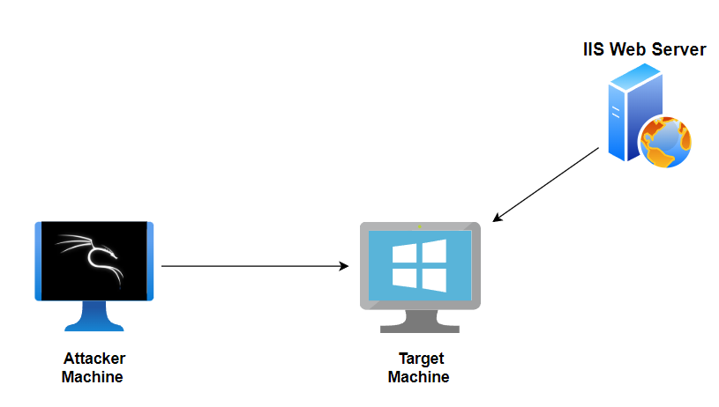
Figure 42: Simulated environment

Install and configure a web server on Windows Server 2022 to use deprecated TLS protocols (TLSv1.0 and TLSv1.1).
Log in to your Windows Server 2022 VM.
Open Server Manager:
Click on the Start menu and select "Server Manager."
Add Roles and Features:
In Server Manager, click on "Add roles and features."
Click "Next" until you reach the "Server Roles" section.
Check the box for "Web Server (IIS)" and click "Next" until you reach the "Confirmation" section.
Click "Install" to install IIS.

Once IIS is installed, you can confirm by opening a web browser and navigating to http://localhost. You should see the default IIS welcome page as shown in the Figure 43.
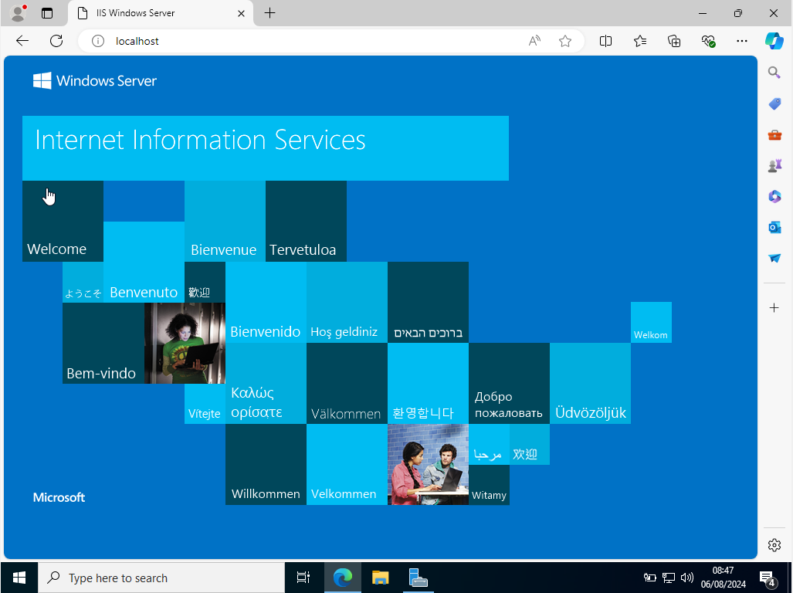
Figure 43: IIS welcome page in Windows Server

Configure IIS to Use Deprecated TLS Protocols
Open the Registry Editor:

Press Win + R, type regedit, and press Enter.
Navigate to the TLS Protocols Path:

Go to HKEY_LOCAL_MACHINE\SYSTEM\CurrentControlSet\Control\SecurityProviders\SCHANNEL\Protocols.

Under Protocols, create new keys for TLS 1.0 and TLS 1.1.
Create Subkeys for Client and Server:

For each protocol (TLS 1.0 and TLS 1.1), create subkeys named Client and Server.
Right-click on TLS 1.0, select New > Key, and name it as Client.
Right-click on TLS 1.0, select New > Key, and name it as Server.
Repeat these steps for TLS 1.1 as shown in the Figure 44.
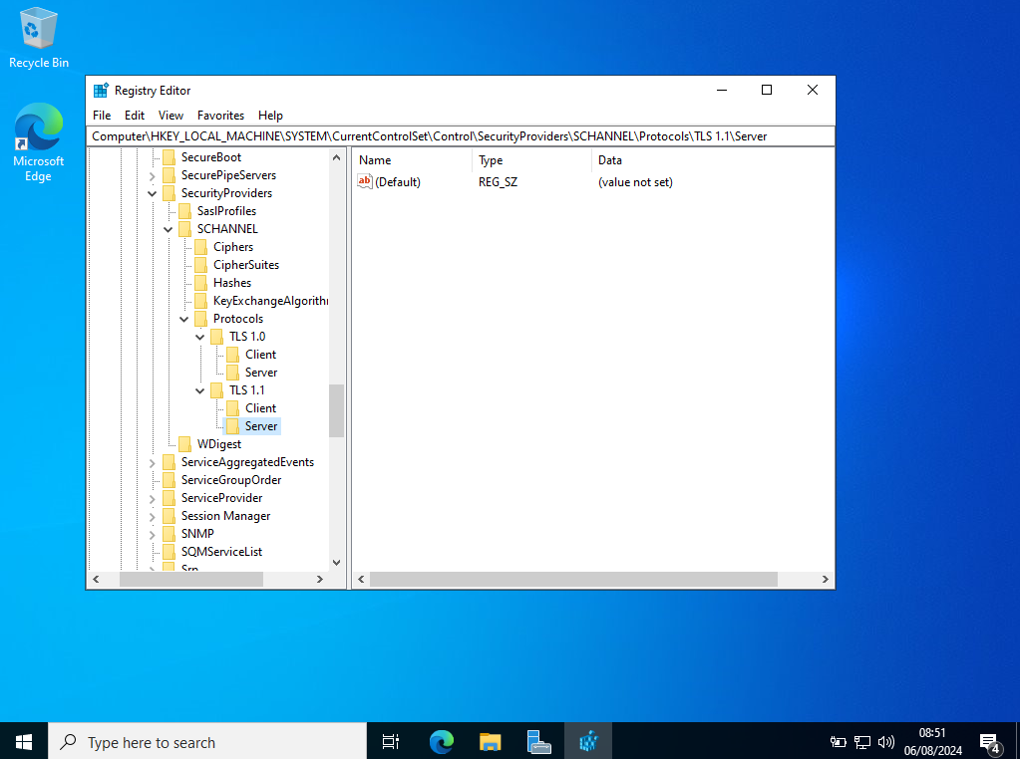
Figure 44: TLS protocols

For each Client and Server subkey, create a new DWORD (32-bit) Value named Enabled.
Set the Enabled value to 1 for each Client and Server subkey under TLS 1.0 and TLS 1.1 as shown in the Figure 45 and 46.
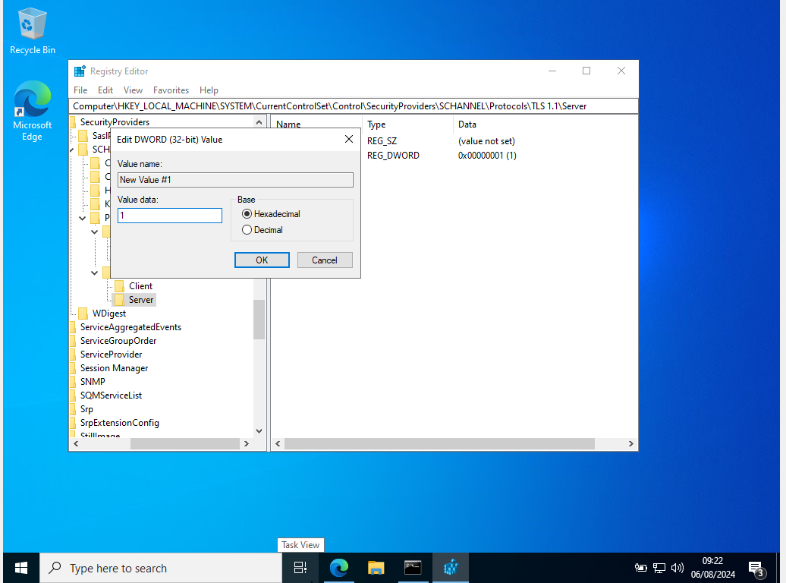
Figure 45: Enabled value to 1 for TLS Protocols
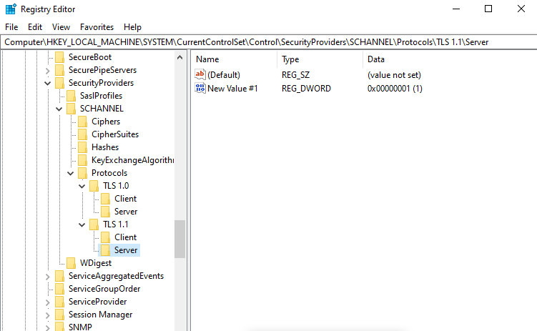
Figure 46: Enabled value to 1 for both the TLS Protocols

Restart your Windows Server to apply the changes.
Log in to your Kali Linux VM.
Ping the Windows Server IP Address:
ping 10.0.2.4
You should see responses indicating that the server is reachable as shown in the Figure 47.
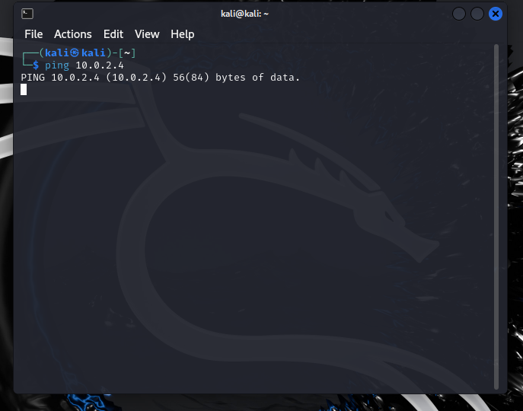
Figure 47: Ping the Windows Server
Open a web browser on Kali Linux.
Type the IP address of your Windows Server into the address bar (e.g., http://10.0.2.4) and press Enter.
You should see the same default IIS welcome page, confirming that the web server is accessible from Kali Linux as shown in the Figure 48.

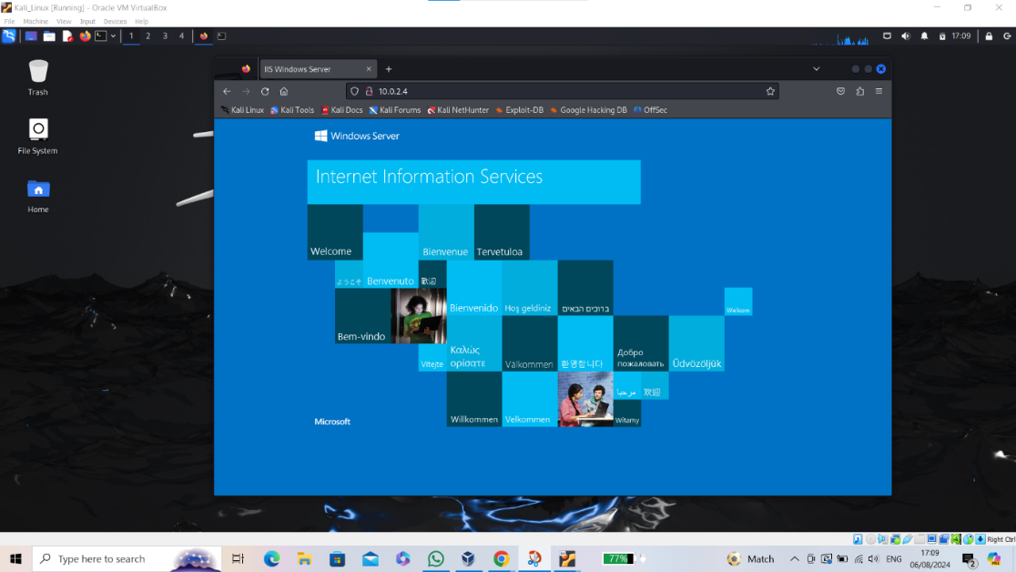
Figure 48: IIS welcome page in Kali Linux

Install nmap as shown in the Figure 49.
sudo apt-get update
sudo apt-get install nmap

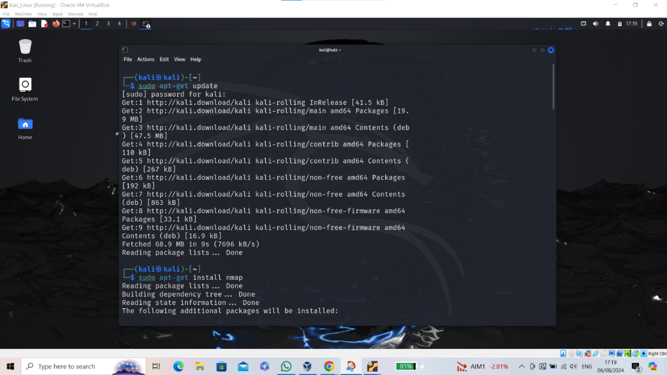
Figure 49: installation of nmap
Use Kali Linux to scan the Windows Server and detect deprecated TLS protocols.
Use nmap to scan the target IP address of your Windows Server for SSL/TLS protocols as shown in the Figure 50,51 and 52.
nmap --script ssl-enum-ciphers -p 443 <target-IP>
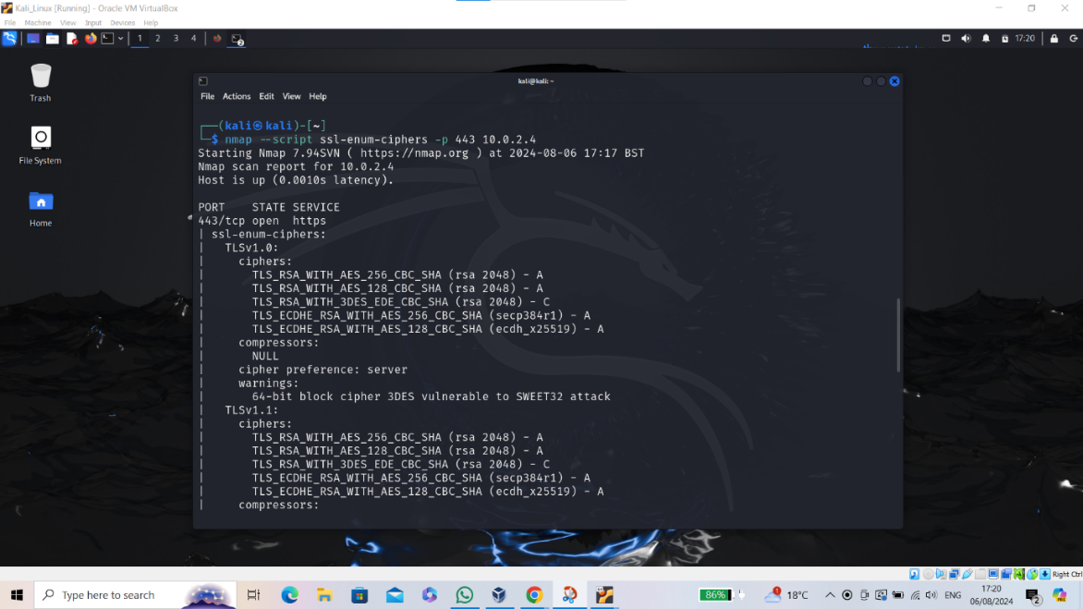
Figure 50: scanning IP address of Windows Server for SSL/TLS protocols
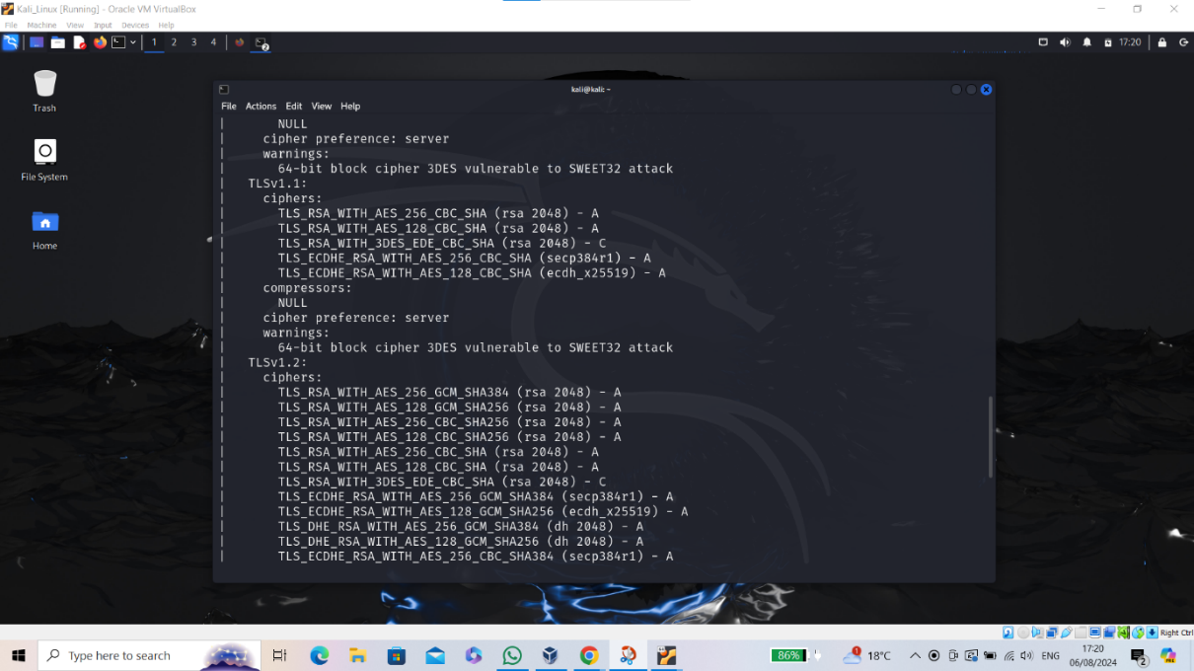
Figure 51: Continuation of the scan
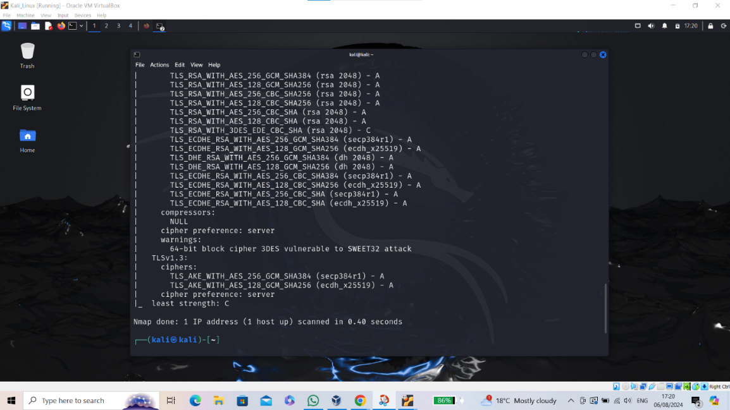
Figure 52: finishing up the scan

Mitigating the vulnerability
Open the Registry Editor:

Press Win + R, type regedit, and press Enter.
Navigate to the TLS Protocols Path:

Go to HKEY_LOCAL_MACHINE\SYSTEM\CurrentControlSet\Control\SecurityProviders\SCHANNEL\Protocols.
Ensure the Enabled DWORD value is set to 0 for both Client and Server subkeys under TLS 1.0 and TLS 1.1 as shown in the Figure 53.
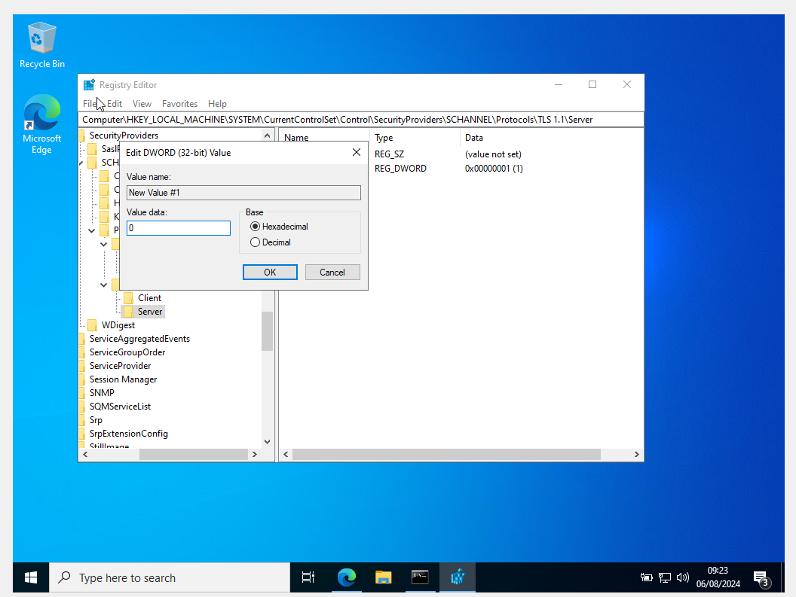
Figure 53: changing the value to 0
Restart your Windows Server to apply the changes.
On your Kali Linux VM, repeat the nmap scan to ensure that TLSv1.0 and TLSv1.1 are no longer supported as shown in the Figure 54 and 55.
nmap --script ssl-enum-ciphers -p 443 <target-IP>
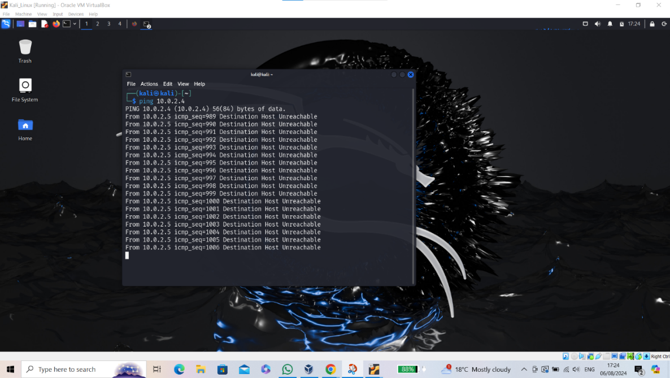
Figure 54:Ping the windows server IP address
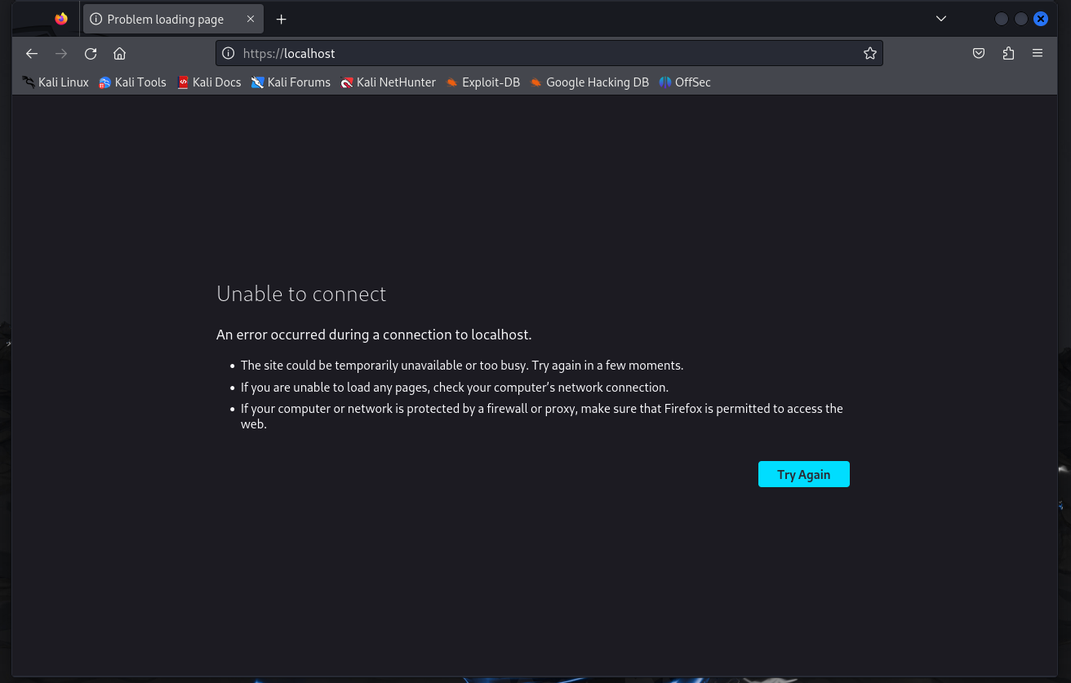
Figure 55: TLS protocols are no longer supported

Confirm that TLSv1.0 and TLSv1.1 are no longer listed in the supported protocols. Following the steps helped me identify and mitigate the deprecated TLS protocols vulnerability on my Windows Server 2022 in a simulated environment.

Vulnerability | Attack Description | Status of the attack | Mitigation | Success/ Failure
SSL/TLS: Deprecated TLSv1.0 and TLSv1.1 Protocol Detection | Detection of deprecated TLSv1.0 and TLSv1.1 protocols using nmap from Kali Linux after configuring IIS on Windows Server 2022 to use them. | Successful | Disable TLSv1.0 and TLSv1.1 by setting the Enabled DWORD value to 0 in the Registry Editor for both Client and Server subkeys under each protocol. | Success
Table 8: Vulnerability Table

Chapter 6 - CONCLUSIONS AND RECOMMENDATION

Project Summary
This project explored numerous aspects of vulnerability assessments to improve the security of a real-time network while also understanding how each component directly affects the security of network architecture. Through an extensive examination of academic literature and reliable sources, such as published whitepapers and peer-reviewed articles, the report offered a thorough grasp of the benefits and drawbacks of vulnerability assessments, along with new developments and difficulties in the industry. Future comparison analyses that could further highlight the importance of vulnerability assessments in network security can be built upon the foundation formed by the analysis of preliminary assessment data.

The project's specific goal was to evaluate the NGO network's vulnerabilities in real time and offer relevant mitigation techniques to help address these threats. With the aid of properly chosen tools, this objective was accomplished, and additional vulnerability evaluation to obtain comparative data was made possible. This information was essential for determining how well the earlier evaluations of the real-time network worked. Through comparative research, the gathered data also assisted in determining the infrastructure of the NGO's present security posture. During the evaluation, the project found high-risk and medium-risk vulnerabilities and recorded the necessary corrective actions and mitigation strategies that the NGO can use to improve the security of its infrastructure.

Conclusion
The security of organizations and their network infrastructure is facing an increasing challenge due to the emergence of sophisticated cyber-attacks. The spread of new technologies encourages creativity, but it also makes infrastructure more complex, which accelerates the appearance of newly discovered vulnerabilities and zero-day attacks. Because of these circumstances, it is more important than ever for organizations to keep on top of the constantly changing landscape of cyber threats. Organizations can actively monitor and prevent cyber threats by mitigating detected vulnerabilities by keeping constant knowledge of the security posture of their infrastructure, a capability made possible by vulnerability assessments.

This project has demonstrated with thorough investigation and real-world application that vulnerability assessments are crucial for figuring out the security posture of the current network infrastructure and for guiding corrective measures to create a safe networking environment. The proposed alternate hypothesis of this report is supported by the network scans carried out for the project phases, which provided important details into the NGO's network and effectively increased its security. The NGO's efforts to improve its network infrastructure will surely continue to be supported by the carefully selected findings from the project's mitigation phase. These findings also provide important information that advances our knowledge of how vulnerability assessments affect infrastructure security.

Recommendations for Further Research
The research that has been conducted offers a lot of possibilities for further investigation. Future research should focus on determining how well vulnerability assessments function in other network infrastructure contexts, such as cloud-based systems, where the attack surface is very different from that of traditional networks. The study of other vulnerability assessment tools in comparison to the ones used in this project is another exciting direction for future research.

The tools used in a vulnerability assessment have a significant impact on their efficiency, which is impacted by several variables such as the application's vulnerability database. Variations in these databases' coverage and accuracy can cause variances in the outcomes. Tools like Nessus, for example, use specialized scoring schemes like the Common Vulnerability Scoring System (CVSS), but they place more emphasis on evaluating the danger associated with a threat than just its technical seriousness. This new method of rating vulnerabilities may yield significantly different findings and maybe very different outcomes.

In addition to offering a more comprehensive understanding of a network's weaknesses, comparing data gathered from several tools can also demonstrate which ones are the most accurate and trustworthy for assessments. Finding such a tool could improve future vulnerability assessments and related studies' reliability and accuracy.

Chapter 7 – Reflections

Technical Reflection
Reflecting on the process of this project, it is possible to conclude that most of the work that had been planned to be carried out was successful and carefully documented. The project's success can be attributed in great part to the integrated SMART objectives established at its inception, which gave clear guidance towards achieving the overall goal. While contingency plans were established to assist the project if necessary, using them eventually became unnecessary.

Despite the project's successes, there were a few areas where additional effort may improve the report and its conclusions. One piece of advice from the previous chapter is to include additional scanning tools to broaden the scope of the assessment and better understand the impact of software variables on the effectiveness of vulnerability assessments. Furthermore, performing more extensive study and critical analysis of reliable literature could improve our understanding of vulnerability assessments and stimulate the investigation of alternate methodologies in future attempts.

Personal Reflection
During this project journey, I met several difficult situations that pushed me to my limits and challenged my courage. In these moments, I had to find ways to overcome the challenges in front of me and keep working towards my goal. Reflecting on my achievements, I realize that this project was both challenging and worthwhile after completion. It has greatly contributed to the growth of my academic and personal skills, providing useful experiences that I will apply to future programs to improve my work and to better myself.

Being in charge of the project's planning and coordination pointed out the need for organization and time management when dealing with large projects. Ensuring that tasks were completed quickly to make the greatest use of available time was problematic, particularly considering the project's connection to industry with the NGO. By breaking down the overall aim of the project into smaller achievable goals, I was able to gain a better understanding of its depth and better focus my time toward reaching the desired outcome. This understanding can be seen in the Gantt chart, which displays the project's framework. The ability of task breakdown that I learned during this project will be essential in future projects, allowing me to track progress and solve issues before they conflict with planned goals.

The project also helped me improve my creative and problem-solving abilities when faced with unforeseen challenges. These difficulties appeared not just during implementation but also throughout the design and writing of the report. For example, identifying appropriate information for critical analysis was difficult, especially given the rapid and constantly shifting nature of the cybersecurity industry. Additional issues found during deployment were addressed previously in the study. Despite these problems, I gained the ability to approach challenges with a positive, passionate attitude, understanding that disappointments are not indicators of failure but rather opportunities to grow. I completed my project successfully by having a positive mindset and an organized approach to problems, and I want to use these strategies in future tasks.

With these freshly acquired talents and abilities, I am convinced that I can dedicate myself more effectively to future projects. I am determined to use the skills I have fully acquired from this experience possible.

Chapter 8 – REFERENCES
[1]D. Acemoğlu, A. Makhdoumi, Azarakhsh Malekian, and Asuman Ozdaglar, “Too Much Data: Prices and Inefficiencies in Data Markets,” Library Union Catalog of Bavaria, Berlin and Brandenburg (B3Kat Repository), vol. 14(4), Sep. 2019, doi: https://doi.org/10.3386/w26296.
[2]“Introduction | Administration Guide,” Fortinet.com, 2024. https://docs.fortinet.com/document/forticlient/7.4.0/administration-guide/725845/introduction (accessed Aug. 25, 2024).
[3]“What is Cloud Infrastructure? | Microsoft Azure,” azure.microsoft.com. https://azure.microsoft.com/en-gb/resources/cloud-computing-dictionary/what-is-cloud-infrastructure
[4]gov.uk, “Cyber security breaches survey 2024,” GOV.UK, Apr. 09, 2024. https://www.gov.uk/government/statistics/cyber-security-breaches-survey-2024/cyber-security-breaches-survey-2024
[5]A. Behl, “Emerging security challenges in cloud computing: An insight to cloud security challenges and their mitigation,” 2011 World Congress on Information and Communication Technologies, Dec. 2011, doi: https://doi.org/10.1109/wict.2011.6141247.
[6]A. Zaharia and P. Bischoff, “300+ Terrifying Cybercrime & Cybersecurity Statistics (2024),” Comparitech, Mar. 27, 2024. https://www.comparitech.com/vpn/cybersecurity-cyber-crime-statistics-facts-trends/#Headline_cybercrime_statistics_for_2019-2024 (accessed Jul. 24, 2024).
[7]R. Aburukba, Y. Kaddoura, and M. Hiba, “Cloud Computing Infrastructure Security: Challenges and Solutions,” IEEE Xplore, Jul. 01, 2022. https://ieeexplore.ieee.org/stamp/stamp.jsp?tp=&arnumber=9851812 (accessed Dec. 19, 2022).
[8]A.-T. - T. I. I.-S. Institute, “AV-ATLAS,” AV-ATLAS. https://portal.av-atlas.org/
[9]A. S. George and S. Sagayarajan, “Securing Cloud Application Infrastructure: Understanding the Penetration Testing Challenges of IaaS, PaaS, and SaaS Environments,” Partners Universal International Research Journal, vol. 2, no. 1, pp. 24–34, Mar. 2023, doi: https://doi.org/10.5281/zenodo.7723187.
[10]A. Atieh, “Assuring the Optimum Security Level for Network, Physical and Cloud Infrastructure,” Oct. 2021, doi: https://doi.org/10.14293/s2199-1006.1.sor-.ppztvgd.v1.
[11]A. Raturi, S. Kumar, and A. Joshi, “Security Risk Assessment & Mitigation Framework for Cloud-based IT Systems,” IEEE Xplore, Nov. 01, 2022. https://ieeexplore.ieee.org/document/10007263/
[12]Cisco, “What Is Computer Networking?,” Cisco. https://www.cisco.com/c/en/us/solutions/enterprise-networks/what-is-computer-networking.html
[13]I. Khalil, A. Khreishah, and M. Azeem, “Cloud Computing Security: A Survey,” Computers, vol. 3, no. 1, pp. 1–35, Feb. 2014, doi: https://doi.org/10.3390/computers3010001.
[14]R. Mohanakrishnan, “What Is a Computer Network? Definition, Objectives, Components, Types, and Best Practices,” Spiceworks, Feb. 10, 2022. https://www.spiceworks.com/tech/networking/articles/what-is-a-computer-network/
[15]Amazon, “What is Computer Networking? - Beginner’s Guide to IT Networking - AWS,” Amazon Web Services, Inc., 2023. https://aws.amazon.com/what-is/computer-networking/
[16]G. Kostadinov and T. Atanasova, “Security Policies for Wireless and Network Infrastructure,” 2019. Available: https://www.iict.bas.bg/pecr/2019/2-GKostadinov-TAtanasova.pdf
[17]S. Jingyao, S. Chandel, Y. Yunnan, Z. Jingji, and Z. Zhipeng, “Securing a Network: How Effective Using Firewalls and VPNs Are?,” Lecture Notes in Networks and Systems, vol. 70, pp. 1050–1068, Feb. 2019, doi: https://doi.org/10.1007/978-3-030-12385-7_71.
[18]K. Hashizume, D. G. Rosado, E. Fernández-Medina, and E. B. Fernandez, “An analysis of security issues for cloud computing,” Journal of Internet Services and Applications, vol. 4, no. 1, p. 5, 2013, doi: https://doi.org/10.1186/1869-0238-4-5.
[19]M. Jensen, J. Schwenk, N. Gruschka, and L. L. Iacono, “On Technical Security Issues in Cloud Computing,” 2009 IEEE International Conference on Cloud Computing, 2009, doi: https://doi.org/10.1109/cloud.2009.60.
[20]S. Subashini and V. Kavitha, “A Survey on Security Issues in Service Delivery Models of Cloud Computing,” Journal of Network and Computer Applications, vol. 34, no. 1, pp. 1–11, Jan. 2011, doi: https://doi.org/10.1016/j.jnca.2010.07.006.
[21]T. Mather, Subra Kumaraswamy, and Shahed Latif, Cloud security and privacy : [an enterprise perspective on risks and compliance]. Beijing ; Köln: O’reilly, [20]10, 2009.
[22]NordLayer, “Cloud Security Threats, Risks & Vulnerabilities | NordLayer Learn,” nordlayer.com. https://nordlayer.com/learn/cloud-security/risks-and-threats/
[23]“OWASP Top Ten Web Application Security Risks | OWASP,” owasp.org. https://owasp.org/www-project-top-ten/#
[24]NIST, “Cybersecurity Framework,” National Institute of Standards and Technology, 2024. https://www.nist.gov/cyberframework
[25]“Penetration Testing Maturity Assessment Tools,” CREST, Jan. 05, 2024. https://www.crest-approved.org/buying-building-cyber-services/penetration-testing-maturity-assessment-tools/ (accessed Aug. 15, 2024).
[26]V. Bode, “A Review Paper on Unified Threats Management Prof . Ms,” Academia.edu, 2018. https://www.academia.edu/96116177/A_Review_Paper_on_Unified_Threats_Management_Prof_Ms (accessed Aug. 16, 2024).
[27]Student Report, 2022.
[28]Student Report, 2023.
[29]A. Dizdar, “What Are Penetration Testing and Vulnerability Assessment?,” Bright Security, May 30, 2022. https://brightsec.com/blog/penetration-testing-and-vulnerability-assessment/
[30]M. Kozlovszky et al., “Cloud security monitoring and vulnerability management,” Repository of the Academy’s Library (Library of the Hungarian Academy of Sciences), Jun. 2013, doi: https://doi.org/10.1109/ines.2013.6632823.
[31]K. Xynos, I. Sutherland, H. Read, E. Everitt, and A. Blyth, “Penetration Testing and Vulnerability Assessments: A Professional Approach,” Aug. 2010. Available: https://ro.ecu.edu.au/cgi/viewcontent.cgi?article=1015&context=icr
[32]“NVD - Results,” Nist.gov, 2024. https://nvd.nist.gov/vuln/search/results?isCpeNameSearch=false&results_type=overview&form_type=Basic&search_type=all&startIndex=0 (accessed Aug. 17, 2024).
[33]J. Yeo, “Using penetration testing to enhance your company’s security,” Computer Fraud & Security, vol. 2013, no. 4, pp. 17–20, Apr. 2013, doi: https://doi.org/10.1016/s1361-3723(13)70039-3.
[34]First, “CVSS v3.0 Specification Document,” FIRST — Forum of Incident Response and Security Teams, 2013. https://www.first.org/cvss/specification-document
[35]“NVD - Vulnerability Metrics,” nvd.nist.gov, Jun. 27, 2024. https://nvd.nist.gov/vuln-metrics/cvss#
[36]T. Machalewski, M. Szymanek, and A. Czubak, “European Council for Modelling and Simulation www.scs-europe.net ECMS Digital Library http://www.scs-europe.net/dlib/dl-index.htm,” Jun. 2024. Accessed: Aug. 17, 2024. [Online]. Available: https://www.scs-europe.net/conf/ecms2024/ecms2024proceedings.pdf
[37]K. A. Scarfone, M. P. Souppaya, A. Cody, and A. D. Orebaugh, “Technical guide to information security testing and assessment.,” NIST, 2008, doi: https://doi.org/10.6028/nist.sp.800-115.
[38]H. Holm, “Performance of automated network vulnerability scanning at remediating security issues,” Computers & Security, vol. 31, no. 2, pp. 164–175, Mar. 2012, doi: https://doi.org/10.1016/j.cose.2011.12.014.
[39]A. M. Dissanayaka, S. Mengel, L. Gittner, and H. Khan, “Security assurance of MongoDB in singularity LXCs: an elastic and convenient testbed using Linux containers to explore vulnerabilities,” Cluster Computing, vol. 23, no. 3, pp. 1955–1971, Jul. 2020, doi: https://doi.org/10.1007/s10586-020-03154-7.
[40]“OpenVAS - OpenVAS - Open Vulnerability Assessment Scanner,” www.openvas.org. https://www.openvas.org/index.html
[41]Y. Xia, jin Wang, C. Liu, and K. Yu, “Design and Implementation of Vulnerability Scanning Tools for Intelligent Substation Industrial Control System Based on Openvas,” IOP Conference Series: Earth and Environmental Science, vol. 440, p. 042031, Mar. 2020, doi: https://doi.org/10.1088/1755-1315/440/4/042031.
[42]K. Kritikos, K. Magoutis, M. Papoutsakis, and S. Ioannidis, “A survey on vulnerability assessment tools and databases for cloud-based web applications,” Array, vol. 3–4, p. 100011, Sep. 2019, doi: https://doi.org/10.1016/j.array.2019.100011.
[43]M. U. Aksu, E. Altuncu, and K. Bicakci, “A First Look at the Usability of OpenVAS Vulnerability Scanner,” Proceedings 2019 Workshop on Usable Security, 2019, doi: https://doi.org/10.14722/usec.2019.23026.
[44]M. Sharma, Ieee.org, 2024. https://ieeexplore.ieee.org/stamp/stamp.jsp?tp=&arnumber=10511864 (accessed Aug. 27, 2024).
[45]S. - young Im, “Performance evaluation of network scanning tools with operation of firewall | IEEE Conference Publication | IEEE Xplore,” ieeexplore.ieee.org. https://ieeexplore.ieee.org/stamp/stamp.jsp?tp=&arnumber=7537162
[46]“Nmap,” Nmap.org, 2024. https://nmap.org/
[47]T. Corcoran, “72.pdf on Egnyte,” Egnyte, 2021. https://sansorg.egnyte.com/dl/DcEpHH8uFk
[48]N. I. Daud, K. A. Abu Bakar, and M. S. Md Hasan, “A case study on web application vulnerability scanning tools,” 2014 Science and Information Conference, Aug. 2014, doi: https://doi.org/10.1109/sai.2014.6918247.
[49]H. M. Z. A. Shebli and B. D. Beheshti, “A study on penetration testing process and tools,” 2018 IEEE Long Island Systems, Applications and Technology Conference (LISAT), May 2018, doi: https://doi.org/10.1109/lisat.2018.8378035.
[50]A. M. Patel and H. R. Patel, “Analytical Study of Penetration Testing for Wireless Infrastructure Security,” IEEE Xplore, 2019. https://ieeexplore.ieee.org/document/9032741 (accessed Apr. 24, 2021).
[51]P. Shi, F. Qin, R. Cheng, and K. Zhu, “The Penetration Testing Framework for Large-Scale Network Based on Network Fingerprint,” IEEE Xplore, Jul. 01, 2019. https://ieeexplore.ieee.org/document/8805839 (accessed Nov. 21, 2020).
[52]M. Parveen and Mohammed Ali Shaik, “Review on Penetration Testing Techniques in Cyber security,” Aug. 2023, doi: https://doi.org/10.1109/icaiss58487.2023.10250659.
[53]S. Basu, “Vulnerability assessment vs. Penetration testing : Know the difference,” www.getastra.com, Mar. 28, 2022. https://www.getastra.com/blog/security-audit/vulnerability-assessment-vs-penetration-testing/
[54]M. Swanagan, “Vulnerability Assessment VS Penetration Testing,” PurpleSec, Feb. 16, 2023. https://purplesec.us/learn/vulnerability-assessment-vs-penetration-testing/
[55]“Penetration Testing,” www.ncsc.gov.uk, Jan. 10, 2022. https://www.ncsc.gov.uk/guidance/penetration-testing#section_2
[56]“Vulnerability and penetration testing,” GOV.UK. https://www.gov.uk/service-manual/technology/vulnerability-and-penetration-testing
[57]K. Božić, N. Penevski, and S. Adamović, “Penetration Testing and Vulnerability Assessment: Introduction, Phases, Tools and Methods,” Proceedings of the International Scientific Conference - Sinteza 2019, 2019, doi: https://doi.org/10.15308/sinteza-2019-229-234.
[58]“burpsuite | Kali Linux Tools,” Kali Linux. https://www.kali.org/tools/burpsuite/
[59]PortSwigger, “Burp Suite Scanner,” Portswigger.net, 2019. https://portswigger.net/burp
[60]“7 Pentesting Tools You Must Know About | HackerOne,” www.hackerone.com. https://www.hackerone.com/knowledge-center/7-pentesting-tools-you-must-know-about
[61]“Kaspersky Cybersecurity Services Learn more on kaspersky.com #bringonthefuture.” Accessed: Aug. 28, 2024. [Online]. Available: https://content.kaspersky-labs.com/se/media/en/business-security/enterprise/catalogue-2017-css-en.pdf
[62]Y. Khera, D. Kumar, Sujay, and N. Garg, “Analysis and Impact of Vulnerability Assessment and Penetration Testing,” 2019 International Conference on Machine Learning, Big Data, Cloud and Parallel Computing (COMITCon), Feb. 2019, doi: https://doi.org/10.1109/comitcon.2019.8862224.
[63]“Oracle VM VirtualBox | Oracle Technology Network | Oracle,” Oracle.com, 2018. https://www.oracle.com/virtualization/technologies/vm/virtualbox.html
[64]D. Kuhn, C. Kim, and B. Lopuz, “Chapter 12: VirtualBox for Oracle,” Linux and Solaris Recipes for Oracle DBAs, pp. 325–344, 2015, doi: https://doi.org/10.1007/978-1-4842-1254-7_12.
[65]“Features,” Kali Linux. https://www.kali.org/features/
[66]C. Badica, Information, Communication and Computing Technology. Springer Science+Business Media, 2020. doi: https://doi.org/10.1007/978-981-15-9671-1.
[67]I. C. Eian, K. Y. Lim, M. X. L. Yeap, H. Q. Yeo, and F. Z, “Wireless Networks: Active and Passive Attack Vulnerabilities and Privacy Challenges,” Oct. 2020, doi: https://doi.org/10.20944/preprints202010.0018.v1.
[68]N. Tripathi and N. Hubballi, “Application Layer Denial-of-Service Attacks and Defense Mechanisms,” ACM Computing Surveys, vol. 54, no. 4, pp. 1–33, Apr. 2021, doi: https://doi.org/10.1145/3448291.
[69]H. Pirayesh and H. Zeng, “Jamming Attacks and Anti-Jamming Strategies in Wireless Networks: A Comprehensive Survey,” IEEE Communications Surveys & Tutorials, pp. 1–1, 2022, doi: https://doi.org/10.1109/comst.2022.3159185.
[70]W. Yang, Z. Zheng, G. Chen, Y. Tang, and X. Wang, “Security Analysis of a Distributed Networked System Under Eavesdropping Attacks,” IEEE Transactions on Circuits and Systems II: Express Briefs, vol. 67, no. 7, pp. 1254–1258, Jul. 2020, doi: https://doi.org/10.1109/tcsii.2019.2928558.
[71]A. Mallik, “MAN-IN-THE-MIDDLE-ATTACK: UNDERSTANDING IN SIMPLE WORDS,” Cyberspace: Jurnal Pendidikan Teknologi Informasi, vol. 2, no. 2, p. 109, Jan. 2019, doi: https://doi.org/10.22373/cj.v2i2.3453.
[72]H.-C. Chen, J.-Z. Sun, S.-S. Tseng, and C.-E. Weng, “A New Approach for Detecting SMTPFA Based on Entropy Measurement,” Lecture notes in computer science, pp. 349–359, Jan. 2012, doi: https://doi.org/10.1007/978-3-642-35606-3_41.
[73]M. Humayun, M. Niazi, N. Jhanjhi, M. Alshayeb, and S. Mahmood, “Cyber Security Threats and Vulnerabilities: A Systematic Mapping Study,” Arabian Journal for Science and Engineering, vol. 45, no. 1, Jan. 2020, doi: https://doi.org/10.1007/s13369-019-04319-2.
[74]A. Bryman, “Social Research Methods,” Oxford University Press, 2016. Available: https://ktpu.kpi.ua/wp-content/uploads/2014/02/social-research-methods-alan-bryman.pdf
[75]A. Melnikovas, “Towards an Explicit Research methodology: Adapting Research Onion Model for Futures Studies,” Journal of Futures Studies, vol. 23, no. 2, pp. 29–44, Dec. 2018, doi: https://doi.org/10.6531/JFS.201812_23(2).0003.
[76]M. Crotty, “The Foundations of Social Research,” SAGE Publications Ltd, 1998. https://uk.sagepub.com/en-gb/eur/the-foundations-of-social-research/book207972
[77]D. Phair and K. Warren, “Saunders’ Research Onion: Explained Simply,” Grad Coach, Jan. 2021. https://gradcoach.com/saunders-research-onion/
[78]N. Tshitadi, “Understanding the Research Onion (Saunders et al., 2015) - Nephsonic,” Nephsonic, Jan. 18, 2024. https://nephsonic.com/understanding-the-research-onion-by-saunders-et-al-2016-a-comprehensive-guide-for-writing-an-effective-research-methodology-chapter/
[79]Fortinet, “Learn more about Fortinet and the Security Fabric,” Fortinet, 2024. https://www.fortinet.com/corporate/about-us/about-us
[80]rwestMSFT, “End of support options - SQL Server,” learn.microsoft.com, Apr. 29, 2024. https://learn.microsoft.com/en-us/sql/sql-server/end-of-support/sql-server-end-of-support-overview?view=sql-server-ver16

