University of Wales Trinity Saint David
Wales Institute of Science and Art

Evaluating the Effectiveness of Chosen Maintenance Strategies for Dedicated Equipment
Plant and Asset Engineering – ACMA6007

Student Name: Martin Ashe
Student Number:2223791
Year: 2026

Abstract

This report evaluates the maintenance strategy for Robot 19, a robotic welding cell used in exhaust assembly production, and proposes improvements to enhance reliability and operational performance. The current time-based preventative maintenance approach was assessed using performance data, maintenance records, and a simplified Failure Modes and Effects Analysis (SFMEA). Analysis identified that availability losses and limited fault detection contribute to unplanned downtime and reduced equipment effectiveness.
To address these issues, an enhanced maintenance strategy incorporating reliability-centred maintenance (RCM), condition-based monitoring (CBM), total productive maintenance (TPM), and data-driven maintenance was proposed. A phased implementation plan was developed to support controlled deployment, alongside a cost-benefit analysis demonstrating that reducing breakdowns would provide significant financial savings and a short payback period.
The proposed strategy is expected to improve equipment reliability, reduce downtime, and support proactive maintenance decision-making. The findings demonstrate that transitioning to a data-driven, reliability-focused maintenance approach offers measurable operational and financial benefits for Robot 19 and similar manufacturing assets.

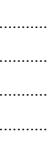
Table of Contents
Abstract 2
List of Figures 5
List of Tables 6
Glossary of Terms 7
1. Introduction 1
1.1. Aim and Objectives of the Report 1
1.2. Company Background 1
2. Review of Existing Maintenance Practices 2
2.1. Description of Equipment 2
2.2. Maintenance Strategy and Types Identified 4
2.3. Performance Measurement 5
2.4. Strengths and Weaknesses 7
2.5. Justification of Current Strategy 7
2.6. Failure Modes and Reliability Analysis 8
3. Enhanced Maintenance Strategy and Future Approach 10
3.1. Reliability-Centred Maintenance (RCM) 10
3.2. Condition-Based Maintenance (CBM) 10
3.3. Total Productive Maintenance (TPM) 11
3.4. Data-Driven Maintenance 12
3.5. Proposed Maintenance Strategy 13
3.6. Implementation Plan 15
4. Analysis of Implementation Costs and Resource Requirements 16
4.1. Implementation Cost & Resource Analysis 16
4.2. Change Management Considerations 17
5. Conclusions and Recommendations 18
6. References 19
7. Appendix 22

List of Figures

Figure 1: Jaguar Land Rover Diesel Exhaust System 2
Figure 2: Robot 19 Box Closing Cell 3
Figure 3: Robot 19 materials. 3
Figure 4: Hydraulic power pack. 4
Figure 5: ShireSystem work orders for Robot 19. 5
Figure 6: Robot 19 OEE chart. 6
Figure 7: Example P-F curve for a ball bearing (Bengtsson and Lundström, 2018). 11
Figure 8: Wire feed roller (Mig-welding.co.uk, 2026). 12
Figure 9: Proposed implementation schedule for Robot 19 maintenance improvements. 16

List of Tables

Table 1: Robot 19 Maintenance FMEA. 8
Table 2: Proposed Maintenance Strategy Table. 13

Glossary of Terms

Abbreviation | Definition
CBM | Condition-Based Maintenance
CMMS | Computerised Maintenance Management System
DDM | Data-Driven Maintenance
IIoT | Industrial Internet of Things
MCSA | Motor Current Signature Analysis
MIG | Metal Inert Gas
MTBF | Mean Time Between Failures
MTTF | Mean Time to Failure
OEE | Overall Equipment Effectiveness
PLC | Programmable Logic Controller
RCM | Reliability-Centred Maintenance
ROI | Return on Investment
RPN | Risk Priority Numbers
SFMEA | Simplified Failure Modes and Effects Analysis
TPM | Total Productive Maintenance

Introduction

Aim and Objectives of the Report

The aim of this report is to critically evaluate the maintenance strategy of a robotic welding cell and propose improvements based on reliability-centred maintenance principles. To achieve this, the report will assess the current maintenance practices applied to the system and evaluate their effectiveness in supporting operational performance. It will analyse the reliability and performance of the equipment, including identifying key failure modes and associated risks, and examine how existing maintenance strategies impact availability, quality, and overall equipment effectiveness. Based on this analysis, the report will propose improved maintenance approaches, including the application of reliability-centred, condition-based, and data-driven maintenance techniques. Finally, the report will assess the costs, resource requirements, and implementation considerations associated with these proposed improvements.

Company Background

Tenneco-Walker (U.K.) Limited is a subsidiary of Tenneco, a global Tier 1 automotive supplier employing over 60,000 people across 223 sites in 28 countries. The company supplies major vehicle manufacturers with products including emissions control systems, ride performance components, and aftermarket solutions, delivering directly to original equipment manufacturers such as Ford, BMW, and Jaguar Land Rover (Tenneco, 2025).

The Merthyr Tydfil site, part of the Clean Air division, manufactures exhaust systems for the light vehicle sector, primarily for Jaguar Land Rover, as illustrated in Figure 1. The facility employs over 200 people, operates a three-shift pattern, and produces approximately 4,500 assemblies per week. Welding operations, particularly robotic MIG welding cells, are critical to production efficiency, product quality, and overall equipment effectiveness.
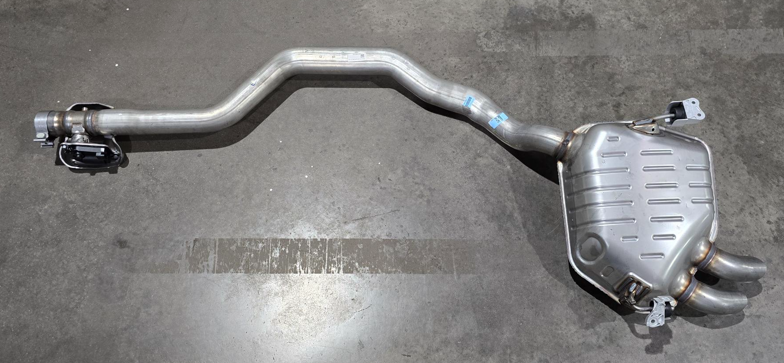
Figure 1: Jaguar Land Rover Diesel Exhaust System

Review of Existing Maintenance Practices

Description of Equipment

The analysis in this report is based on Robot 19, an automated welding cell used in the production of muffler assemblies, as shown in Figure 2. The cell positions and clamps muffler shells around a central core assembly, after which the seam between the shells is welded to form a completed muffler box – a depiction of this process is illustrated in Figure 3.

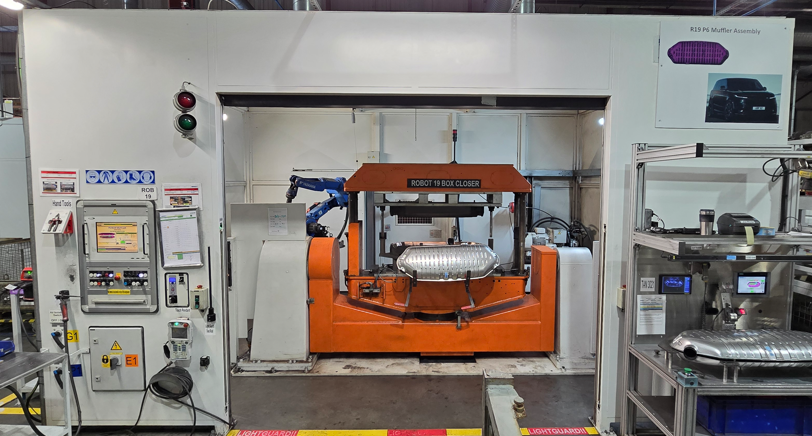
Figure 2: Robot 19 Box Closing Cell
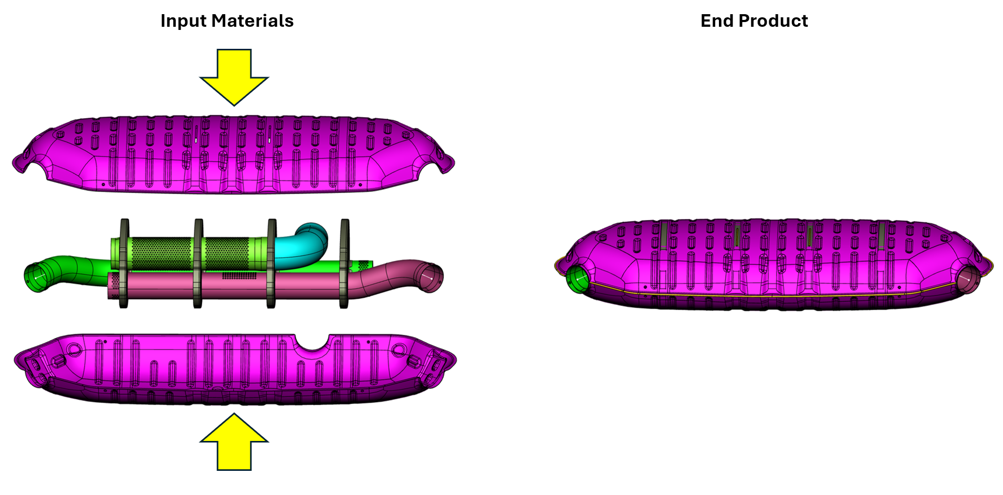
Figure 3: Robot 19 materials.

The system consists of an electrically servo-driven two-axis manipulator with upper and lower fixtures, actuated by two hydraulic cylinders supplied by a hydraulic power pack (Figure 4) capable of generating up to 20 tonnes of force. A MIG welding torch, rated at 400 A, is mounted on a six-axis robotic arm to perform the welding operation. Safety systems, including light guards, floor scanners, and interlocked access doors, are integrated into the cell. Overall system operation is coordinated through a programmable logic controller (PLC) and an industrial PC.

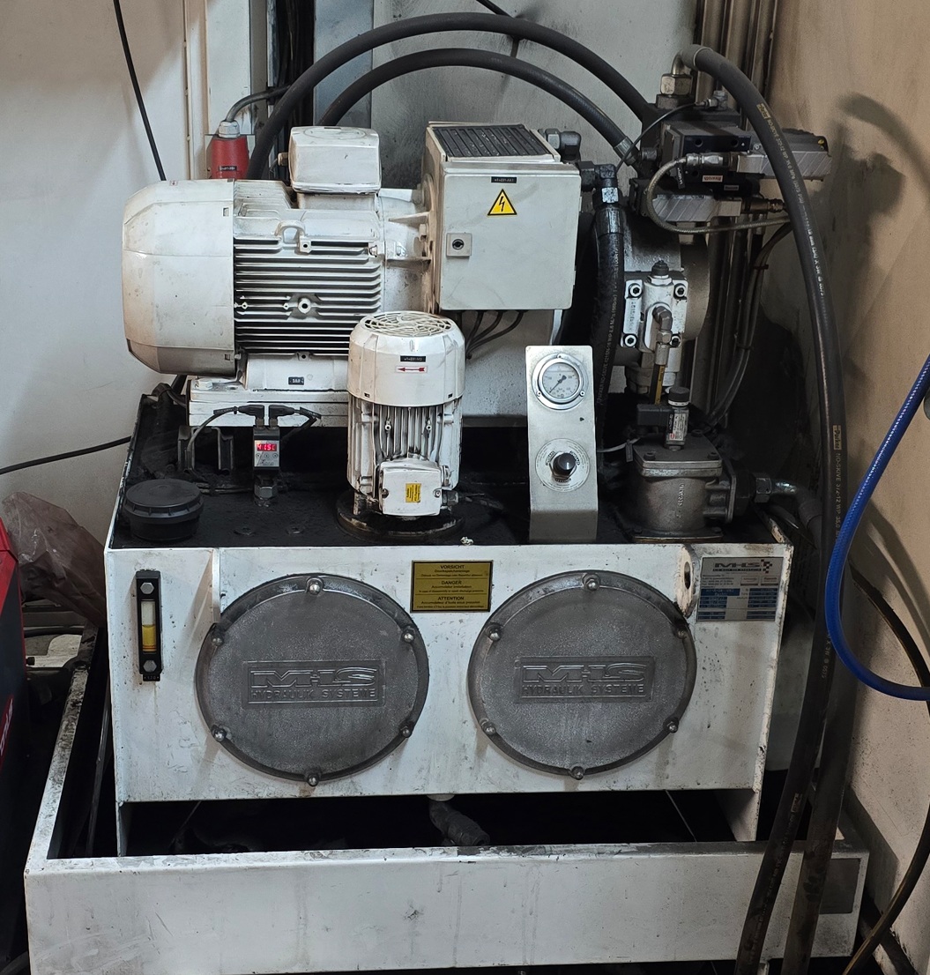
Figure 4: Hydraulic power pack.

Maintenance Strategy and Types Identified

Preventative maintenance activities for Robot 19 are scheduled and tracked using ShireSystem, a Computerised Maintenance Management System (CMMS). The system is used to log machine breakdowns, schedule planned maintenance tasks, and monitor key reliability metrics such as Mean Time Between Failures (MTBF) and Mean Time To Failure (MTTF). An example list of work orders recorded within the system is shown in Figure 3.
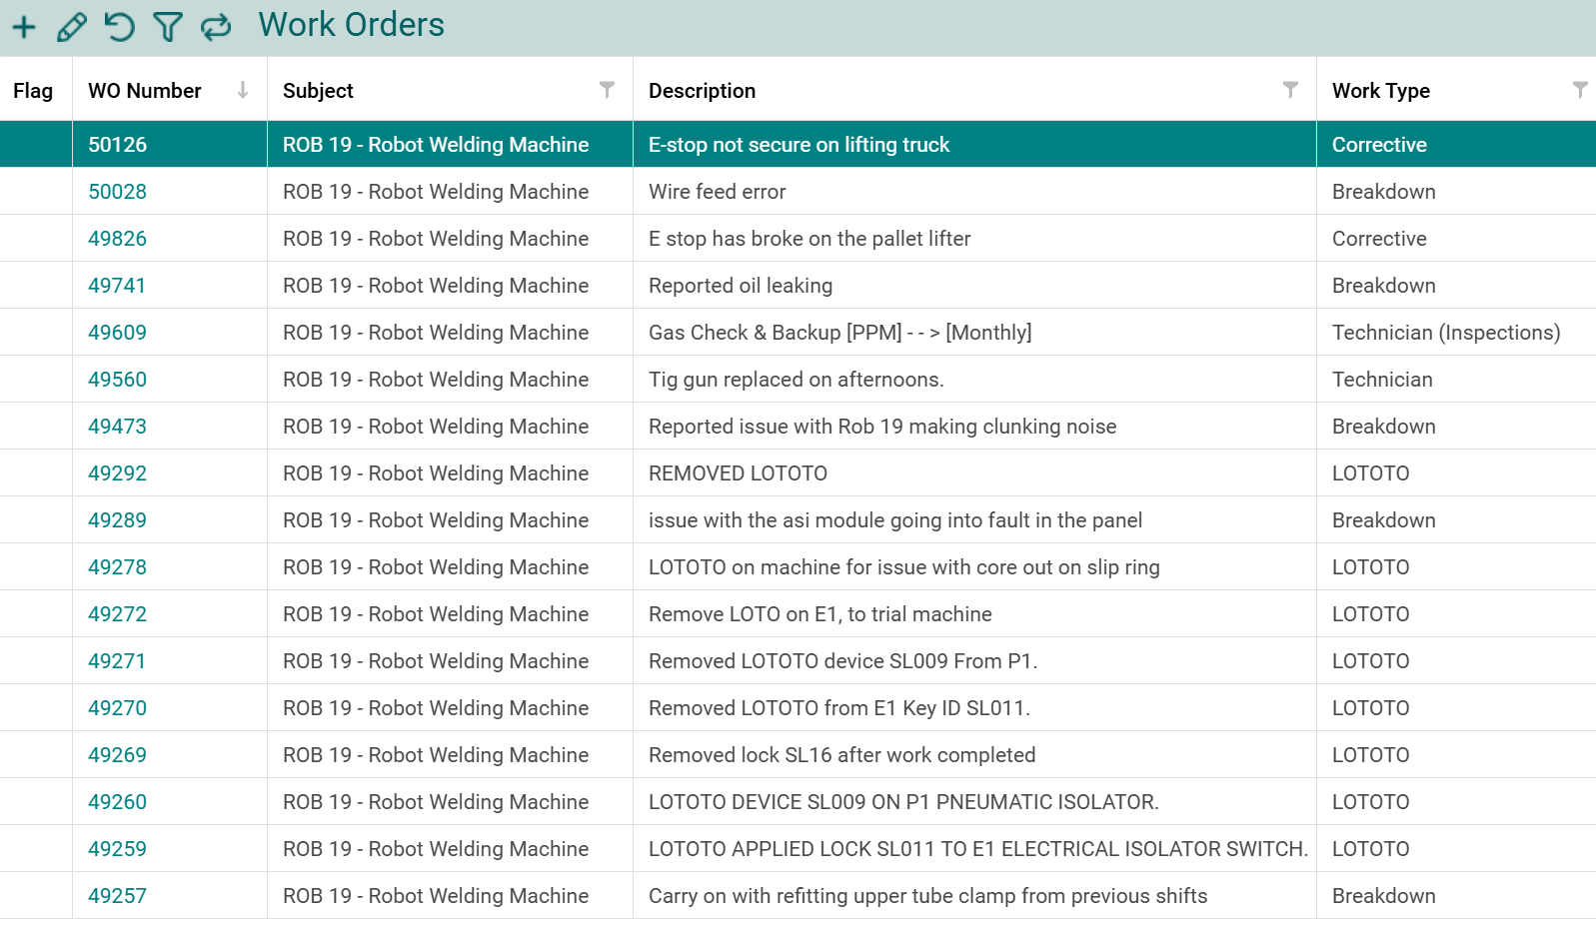
Figure 5: ShireSystem work orders for Robot 19.

Three types of planned maintenance activities are currently implemented on the cell. These include a generic robot-welding cell maintenance service conducted every 3 months, monthly welding gas checks and equipment data back-ups, and periodic robot and welding equipment inspections. These activities involve checks of electrical systems, mechanical components, welding equipment, and safety devices to ensure the cell continues to operate safely and reliably.

Performance Measurement

Tenneco’s primary metric for assessing equipment performance is Overall Equipment Effectiveness (OEE), which is calculated by multiplying availability, performance, and quality, and expressed as a percentage (Bicheno and Holweg, 2016). OEE is widely used in manufacturing as a quantitative tool for identifying production losses and highlighting areas for process improvement.
The average OEE for Robot 19 between January 2025 and March 2026 was 84.4% (Figure 4), which is close to the widely cited world-class benchmark of 85% (Dewi, Alhilman and Atmaji, 2020). Analysis of the OEE components indicates that availability is the primary source of loss within the system, with an average value of approximately 90%. As the cell does not require product changeovers, setup and adjustment losses are minimal, suggesting that downtime is largely attributable to equipment breakdowns. This is supported by Muchiri and Pintelon (2008), who highlight that availability losses are strongly influenced by equipment reliability and the effectiveness of maintenance practices. This suggests that the reduced availability observed in Robot 19 is likely linked to the effectiveness of the current time-based maintenance strategy.
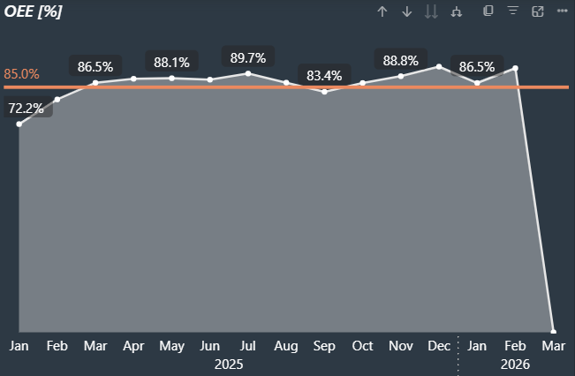
Figure 6: Robot 19 OEE chart.

Strengths and Weaknesses

The current maintenance strategy for Robot 19 demonstrates several strengths. Planned preventative maintenance activities allow work to be scheduled in advance, minimising disruption to production and supporting consistent output. The structured nature of time-based maintenance also results in relatively low management costs and reduced spare parts inventory, as maintenance intervals are predictable. Additionally, the use of OEE provides an integrated measure of maintenance effectiveness, production efficiency, and product quality, enabling performance monitoring and identification of improvement opportunities (Muchiri and Pintelon, 2008).
However, the strategy presents notable limitations. Time-based maintenance relies on average equipment life and experience, which may lead to unnecessary maintenance or unexpected failures (Mobley, 2014). The absence of condition monitoring limits early fault detection, reducing predictive capability. Furthermore, the approach does not prioritise maintenance based on asset criticality, potentially leading to inefficient resource allocation. While OEE can provide useful insights into equipment performance, its effectiveness depends on data quality; poor data collection due to human error can reduce the accuracy and reliability of the results.

Justification of Current Strategy

Time-based preventative maintenance practices have been employed at Tenneco’s Merthyr Tydfil plant since its opening in 2014, with these legacy approaches being retained and adapted by successive maintenance management teams. This strategy provides a structured, predictable approach to asset management, supports production planning, and requires relatively low implementation costs compared to more advanced techniques. While discussions have taken place regarding the introduction of condition-based monitoring systems, resource limitations, initial investment costs, and the need for specialist skills have restricted their adoption. As a result, the current approach reflects a balance between operational reliability, cost control, and available organisational capability.

Failure Modes and Reliability Analysis

A simplified Failure Modes and Effects Analysis (SFMEA) has been applied to Robot 19 using the maintenance FMEA table to identify key failure modes, their causes, and associated risks (Table 1). SFMEA is a structured approach that evaluates failures based on severity, occurrence, and detection, enabling prioritisation through the calculation of Risk Priority Numbers (RPN).
The analysis highlights several failure modes within the cell, each assessed for its impact on production, quality, and safety. High severity ratings are assigned to failures that result in loss of function or production stoppage, reflecting their critical impact on throughput. Occurrence ratings are based on historical maintenance data and operational experience, while detection ratings reflect the effectiveness of current controls (Mobley, 2014).
The FMEA table indicates that many failure modes have limited detectability due to reliance on scheduled maintenance and operator observation. As identified by Chong, Ng and Goh (2015), improving detection capability is key to reducing overall risk, as enhanced monitoring can significantly lower RPN values by enabling earlier fault identification.

Table 1: Robot 19 Maintenance FMEA.

Enhanced Maintenance Strategy and Future Approach

Reliability-Centred Maintenance (RCM)

Reliability-Centred Maintenance (RCM) is a structured approach used to optimise maintenance strategies by focusing on asset functions, potential failure modes, and the consequences of those failures. It seeks to ensure that systems continue to operate as required by selecting maintenance tasks based on risk and functional importance rather than fixed time intervals (Moubray, 1991). Applying this methodology, Patil and Bewoor (2022) demonstrated a reduction in total cost of ownership while improving the lifespan and safety of steam boiler systems.
The SFMEA conducted for Robot 19 provides a robust foundation for RCM implementation, as it identifies failure modes, their causes, and associated Risk Priority Numbers (RPNs). These outputs enable maintenance to be targeted towards high-risk items, particularly those with high severity and low detectability.
In practice, RCM could be applied to Robot 19 by introducing condition-based monitoring for critical subsystems identified in the FMEA. For example, vibration or temperature monitoring could be applied to the robot servo drives to detect early signs of wear or misalignment, while pressure or leakage monitoring could be implemented on the hydraulic system to identify loss of clamping force. Preventive maintenance tasks could then be adjusted based on failure criticality, improving reliability and reducing unplanned downtime.

Condition-Based Maintenance (CBM)

Condition-Based Maintenance (CBM) serves as the operational backbone of an RCM strategy, shifting maintenance from reactive or time-based intervals to real-time asset health assessments. By utilising non-intrusive technologies, CBM seeks to bridge the gap between theoretical research and practical industrial application to ensure machines operate within nominal limits (Hurtado Carreon and Veldhuis, 2025). This is achieved through a data-driven approach focusing on inspection, replacement, and prognosis (Quatrini et al., 2020).
As illustrated in the P-F curve for a ball bearing (Figure 6), the strategy relies on identifying the "Potential Failure" (P) point - where an incipient fault, such as a microscopic race defect, first becomes detectable via vibration analysis - before it reaches "Functional Failure" (F). For critical mechanical components like the bearings and gears in Robot 19, vibration monitoring remains the most predominant procedure to recognise these issues (Kumar et al., 2018). By monitoring this P-F interval, maintenance can be scheduled proactively, preventing catastrophic breakdown and maximising the asset's remaining useful life.
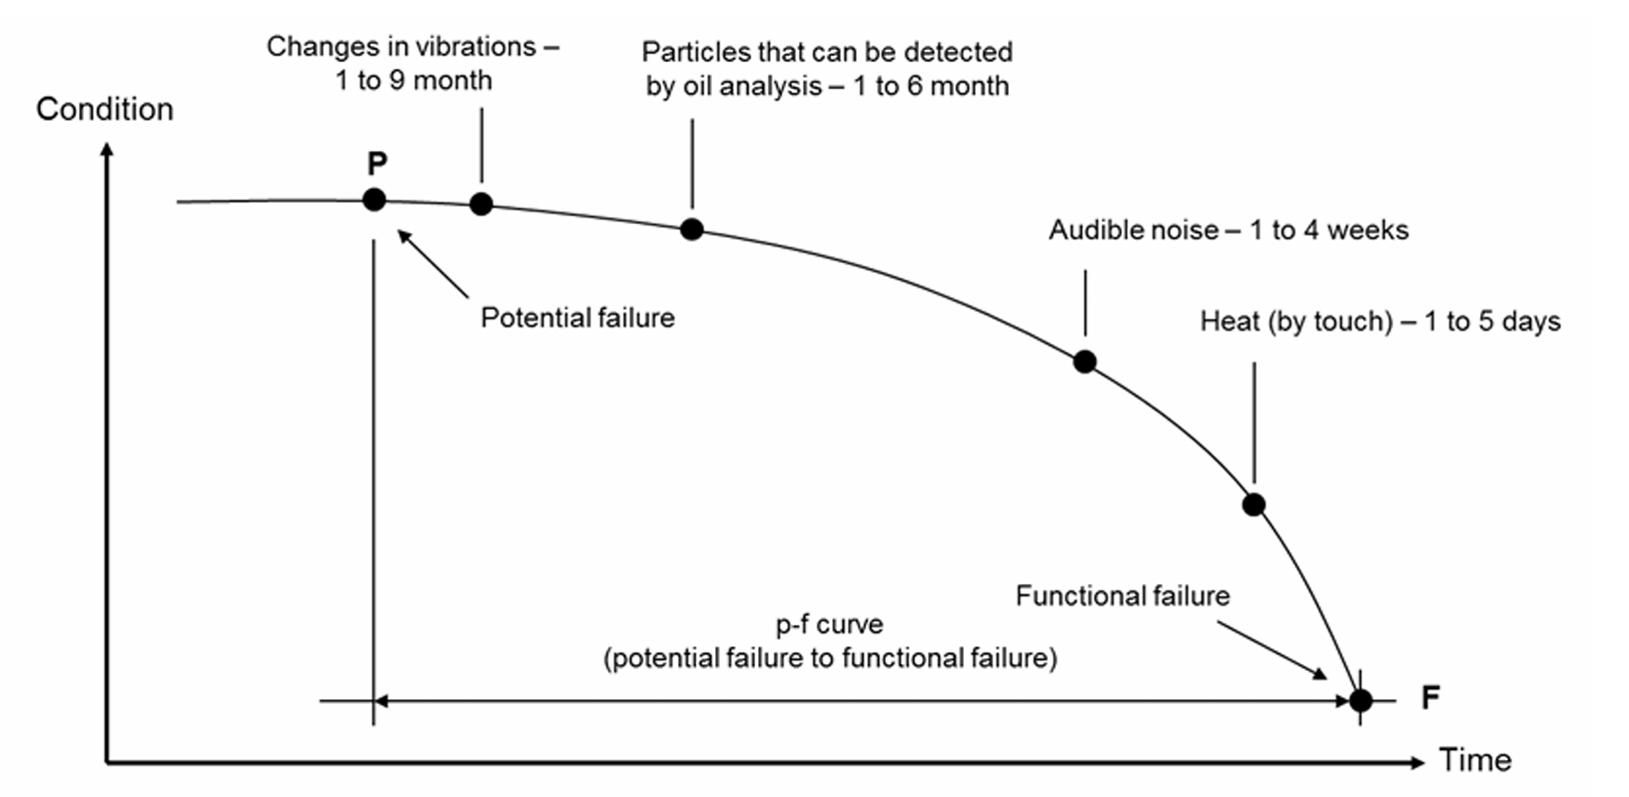
Figure 7: Example P-F curve for a ball bearing (Bengtsson and Lundström, 2018).

Total Productive Maintenance (TPM)

Total Productive Maintenance (TPM) is a holistic approach that integrates maintenance and production by promoting operator involvement in routine equipment care and continuous improvement (Yang and Yang, 2024). Unlike traditional maintenance, TPM encourages autonomous maintenance, where operators carry out basic “clean and inspect” tasks to identify early signs of deterioration (Borris, 2006).

For Robot 19, this could include regular checks of weld wire feed rollers for debris build-up (Figure 7), cleaning of the welding torch to remove spatter, inspection of safety floor scanners for contamination, and monitoring for hydraulic oil leaks. These activities improve fault detection and allow maintenance specialists to focus on more complex issues, ultimately enhancing equipment reliability and overall operational performance (Yang and Yang, 2024).
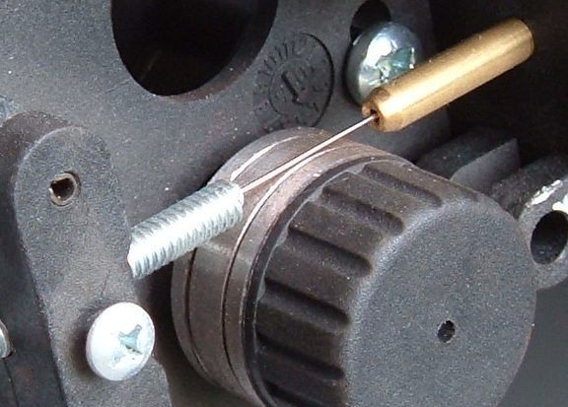
Figure 8: Wire feed roller (Mig-welding.co.uk, 2026).

Data-Driven Maintenance

Data-Driven Maintenance (DDM) utilises industrial data and advanced analytics to shift maintenance from reactive decision-making to predictive, optimised strategies. For Robot 19, this approach can build on existing performance data, such as OEE and historical breakdown records, to identify patterns in failure behaviour and support more informed maintenance decisions.
For example, automated machine criticality assessments can use production and downtime data to rank assets based on their impact on throughput and bottleneck creation, allowing maintenance resources to be prioritised effectively (Gopalakrishnan, Subramaniyan and Skoogh, 2022). This could be supported by the existing ShireSystem CMMS, which already captures maintenance and failure data but is not currently being fully utilised for advanced analytics, representing a clear opportunity for improvement. In addition, real-time data from sensors, such as motor current or cycle times, can be analysed to detect deviations from normal operating conditions and predict potential failures.
This approach aligns with Industry 4.0 principles, where interconnected systems and Industrial Internet of Things (IIoT) technologies enable real-time data acquisition and predictive maintenance through advanced analytics, supporting improved operational performance (Silvestri et al., 2020).

Proposed Maintenance Strategy

The proposed maintenance strategy for Robot 19 transitions from the current generic 3-month schedule towards a targeted, multi-layered regime informed by the SFMEA and specific reliability metrics. By quantifying equipment performance through Mean Time Between Failures (MTBF) and Mean Time to Failure (MTTF), maintenance intervals can be optimised to align with actual degradation patterns rather than arbitrary calendar dates. This data-driven approach directly improves Overall Equipment Effectiveness (OEE) by reducing both unplanned downtime and excessive "over-maintenance" during scheduled stops.
As detailed in the Proposed Maintenance Strategy Transition Table 2, the existing Shire PPM tasks have been reclassified based on risk, technical feasibility, and the specific configuration of Robot 19. High-frequency visual inspections, such as gas checks and torch neck condition, are transitioned to TPM activities performed by operators. This move empowers first-line machine operators and fosters a sense of "ownership," as identified in the TPM bottom-up perspective. Furthermore, low-value manual tasks, such as cell data backups, are automated via network-based scheduling to ensure 100% data integrity.
Table 2: Proposed Maintenance Strategy Table.
A critical strategy component is transitioning high-criticality assets, such as hydraulic motors, to Condition-Based Monitoring (CBM) to mitigate winding insulation and electrical failures. Rather than relying on elapsed time, this approach uses Motor Current Signature Analysis (MCSA) and continuous temperature monitoring to detect incipient faults, such as broken rotor bars or air-gap eccentricities. By identifying these issues within the P-F interval via current waveform analysis and infrared thermography, maintenance interventions for Robot 19 become data-driven and proactive. This optimised strategy prevents catastrophic motor failure while maximising the equipment’s remaining useful life (Kumar et al., 2019).

Implementation Plan

The proposed maintenance improvements for Robot 19 will be implemented using a phased approach to minimise operational disruption and allow validation at each stage. The first phase involves assessing the current system to confirm failure priorities and define monitoring requirements. Following this, condition-based monitoring (CBM) equipment will be procured and installed on critical components. Alarm thresholds and monitoring limits will then be defined, and baseline condition data collected to establish normal operating behaviour.
Subsequent activities include reprogramming Robot 19's control systems to support automated backups and improved data capture, developing TPM documentation, and updating Shire's planned maintenance instructions. Training will then be delivered to maintenance technicians, process technicians, and operators. A pilot implementation on one shift will allow performance evaluation and identification of corrective actions before full rollout across all shifts. The detailed implementation timeline is presented in Figure 8, with the total implementation period estimated at approximately 19 weeks.
Figure 9: Proposed implementation schedule for Robot 19 maintenance improvements.

Analysis of Implementation Costs and Resource Requirements

Implementation Cost & Resource Analysis

The financial justification for transitioning Robot 19 to an RCM-based strategy is rooted in reducing the significant "hidden" costs of unplanned downtime. In 2025, the existing maintenance configuration resulted in 58.5 hours of breakdown time, costing the business £13,338 annually – the actual figure is higher due to replacement parts, although this information is not readily available. This figure is primarily driven by lost contribution (£9,945) and unabsorbed overheads, far outweighing the direct labour costs of repair (Appendix 1).
The proposed implementation requires a total capital and resource investment of £4,816.50 (Appendix 2). This includes £4,050 for specialised hardware, such as ABB Ability Smart Sensors for motor monitoring (MKE Engineering Group, 2025) and automated TCP programming, and £766.50 for resource costs, including TPM training and CMMS integration.
By shifting to a combination of CBM and TPM, the strategy aims to reduce machine breakdowns by 50%. This reduction alone would save the business approximately £6,669 per annum (Appendix 3). Furthermore, by reclassifying tasks, the annual PPM resource expenditure is projected to drop from £578.20 to £306.60, despite the increased frequency of operator-led TPM checks. Consequently, the new strategy offers a Return on Investment (ROI) within approximately nine months. Beyond direct savings, this proactive approach stabilises OEE and mitigates the risk of catastrophic motor failures, ensuring long-term asset profitability.

Change Management Considerations

Successful implementation of the revised maintenance strategy requires effective management of organisational and behavioural change. Change management is defined as a structured process for transitioning from a current state to a desired future state while addressing the people-side of change (Galli, 2018). The proposed improvements introduce new responsibilities for operators, increased data usage, and condition-based decision-making, which may generate resistance if not managed effectively.
Kotter’s 8-step model provides a suitable framework, beginning with establishing urgency by highlighting downtime costs and reliability risks, followed by forming a cross-functional team that includes maintenance, production, and engineering personnel. Developing and communicating a clear vision ensures staff understand the benefits of CBM and TPM activities. Empowering employees through training and pilot trials supports adoption, while short-term wins from reduced breakdowns reinforce engagement. Sustaining improvements requires embedding updated procedures within Shire and standard work documentation, ensuring the new maintenance strategy becomes part of routine operations (Kotter, 2012).

Conclusions and Recommendations

This report evaluated the effectiveness of the current maintenance strategy applied to Robot 19 and identified opportunities to improve reliability, availability, and operational performance. Analysis of existing practices showed that the cell operates with an Overall Equipment Effectiveness (OEE) of approximately 84.4%, with availability losses primarily driven by equipment breakdowns and time-based maintenance limitations. The SFMEA further highlighted limited fault detectability and the absence of condition monitoring as key contributors to reliability risk.
To address these limitations, a revised maintenance strategy was proposed that incorporates reliability-centred maintenance (RCM), condition-based monitoring (CBM), total productive maintenance (TPM), and data-driven maintenance. This integrated approach enables maintenance activities to be prioritised according to failure criticality, improves early fault detection, and promotes operator involvement in routine equipment care. The proposed phased implementation plan supports controlled deployment, while a cost analysis shows that reducing breakdowns by 50% delivers significant annual savings and achieves a return on investment within the first year.
Overall, transitioning to a reliability-focused, data-driven maintenance strategy is expected to reduce unplanned downtime, stabilise OEE, and improve asset utilisation. It is recommended that the proposed implementation plan be adopted for Robot 19, with future expansion to similar robotic welding cells across the plant.

References

Bengtsson, M. and Lundström, G. (2018) ‘On the importance of combining “the new” with “the old” - One important prerequisite for maintenance in Industry 4.0’, Procedia Manufacturing. Elsevier B.V., pp. 118–125. Available at: https://doi.org/10.1016/j.promfg.2018.06.065.
Bicheno, J.R.. and Holweg, Matthias. (2016) The Lean Toolbox 5th Edition. Fifth. Buckingham: Picsie Books.
Borris, Steven. (2006) Total productive maintenance. New York: McGraw-Hill.
Chong, K.E., Ng, K.C. and Goh, G.G.G. (2015) ‘Improving Overall Equipment Effectiveness (OEE) Through Integration of Maintenance Failure Mode and Effect Analysis (Maintenance-FMEA) in a Semiconductor Manufacturer: A Case Study’, 2015 IEEE International Conference on Industrial Engineering and Engineering Management (IEEM) [Preprint].
Dewi, S., Alhilman, J. and Atmaji, F.T.D. (2020) ‘Evaluation of Effectiveness and Cost of Machine Losses using Overall Equipment Effectiveness (OEE) and Overall Equipment Cost Loss (OECL) Methods, a case study on Toshiba CNC Machine’, IOP Conference Series: Materials Science and Engineering. Institute of Physics Publishing. Available at: https://doi.org/10.1088/1757-899X/847/1/012020.
Galli, B.J. (2018) ‘Change Management Models: A Comparative Analysis and Concerns’, IEEE Engineering Management Review, 46(3), pp. 124–132. Available at: https://doi.org/10.1109/EMR.2018.2866860.
Gopalakrishnan, M., Subramaniyan, M. and Skoogh, A. (2022) ‘Data-driven machine criticality assessment–maintenance decision support for increased productivity’, Production Planning and Control, 33(1), pp. 1–19. Available at: https://doi.org/10.1080/09537287.2020.1817601.
Hurtado Carreon, A. and Veldhuis, S.C. (2025) ‘Practical Application of Condition-Based Monitoring (CBM) Technologies in the Modern Manufacturing Industry: A Review’, Processes. Multidisciplinary Digital Publishing Institute (MDPI). Available at: https://doi.org/10.3390/pr13124084.
Kotter, J.P.. (2012) Leading change. Boston: Harvard Business Review Press.
Kumar, S. et al. (2018) Condition based maintenance of bearings and gears for fault detection-A review, Materials Today: Proceedings. Available at: www.sciencedirect.comwww.materialstoday.com/proceedings.
Kumar, S. et al. (2019) ‘A Comprehensive Review of Condition Based Prognostic Maintenance (CBPM) for Induction Motor’, IEEE Access, 7, pp. 90690–90704. Available at: https://doi.org/10.1109/ACCESS.2019.2926527.
Mig-welding.co.uk (2026) Mig Welding Wire Feed Configuration. Available at: https://www.mig-welding.co.uk/wire-feed.htm (Accessed: 3 April 2026).
MKE Engineering Group (2025) ABB Smart Sensors. Available at: https://www.mke.co.uk/electrical/abb-smart-sensors (Accessed: 7 April 2026).
Mobley, Keith. (2014) Maintenance Engineering Handbook. McGraw-Hill Professional.
Moubray, John. (1991) Reliability-centred maintenance. Oxford: Butterworth-Heinemann.
Muchiri, P. and Pintelon, L. (2008) ‘Performance measurement using overall equipment effectiveness (OEE): Literature review and practical application discussion’, International Journal of Production Research, 46(13), pp. 3517–3535. Available at: https://doi.org/10.1080/00207540601142645.
Patil, S.S. and Bewoor, A.K. (2022) ‘Optimization of maintenance strategies for steam boiler system using reliability-centered maintenance (RCM) model – A case study from Indian textile industries’, International Journal of Quality and Reliability Management, 39(7), pp. 1745–1765. Available at: https://doi.org/10.1108/IJQRM-07-2021-0216.
Quatrini, E. et al. (2020) ‘Condition-based maintenance-An extensive literature review’, Machines. MDPI AG. Available at: https://doi.org/10.3390/MACHINES8020031.
Silvestri, L. et al. (2020) ‘Maintenance transformation through Industry 4.0 technologies: A systematic literature review’, Computers in Industry, 123. Available at: https://doi.org/10.1016/j.compind.2020.103335.
Tenneco (2025) Tenneco. Available at: https://www.tenneco.com/ (Accessed: 12 October 2025).
Yang, Y. and Yang, B. (2024) ‘Employee participation in total productive maintenance – a bottom-up perspective’, International Journal of Quality and Reliability Management, 41(1), pp. 269–290. Available at: https://doi.org/10.1108/IJQRM-12-2022-0353.

Appendix

Appendix 1 – Annual costs for 2025 (PPMs and machine breakdowns)

Appendix 2 – Revised maintenance strategy implementation costs
Appendix 3 – Forecasted annual costs (PPMs and machine breakdowns)

