Booklet
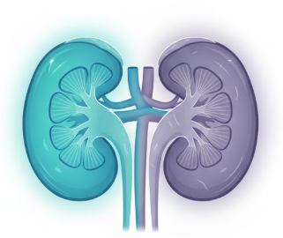
Chronic Kidney Disease Management: A Professional Guide to Evidence-Based Care and Clinical Practice
Student Name: Mst. Sima
Begum
Student ID: 2433426
Lecturer: Muhammed khan
Module Code: LCHS7003
Assignment Title: Information Booklet on Long-Term Condition Management

Understanding Chronic Kidney Disease: A Silent Struggle

Over seven and a half million people in the United Kingdom are affected by chronic kidney disease (CKD), a degenerative disorder that reduces kidney function. Accumulation of waste in CKD patients, on the other hand, results in the onset of anaemia, cardiovascular disease, and fluid imbalance. At first, the symptoms are mild. Lifestyle and genetics can cause CKD, diabetes, and hypertension. Currently, due to its higher incidence in the elderly population and that incidence increases with age, it requires early diagnosis-and treatment!98-99
Chronic kidney disease (CIKD) has five phases, which change from a triggered kidney degeneration to a fifth period which at least requires dialysis or possibly simply a transplant. An 18 GFR is too low, indicating that the disease is worse. Chances are that progression of the disease is determined by multiple components, such as the environment, genetics, diabetes, hypertension, tobacco and unhealthy diet. Regular examinations are necessary because the majority of people with chronic renal illness are diagnosed at a later stage.
Issues of a physical, mental, and social nature can be brought on by chronic renal illness. The symptoms of chronic kidney disease (CKD) include fatigue, fluid retention, elevated blood pressure, and the accumulation of fluid in the lungs. It is possible that dialysis or a kidney transplant could cause feelings of depression, worry, and tensions. On account of diminished mobility, fatigue, and an inability to participate in day-to-day activities, chronic kidney disease affects not only the somatic domain but also the psychosocial aspects of patients. Because of physical restrictions or to ongoing treatment like dialysis, the disease can spiral into depression, anxiety, and social isolation. And, there needs to be something done to support the substantial emotional and financial burden placed on carers as well this should all be included within a comprehensive package of care."
Lifestyle and pharmaceutical treatments delay CKD progression. Guidelines suggest maintaining blood pressure (<130/80 mmHg), diabetes with glycaemic management, and reducing proteinuria with ACE inhibitors or ARBs. Preventing CKD aggravation requires smoking cessation, food change, and exercise.

Table of Contents
1. Introduction 4
2. Understanding Chronic Kidney Disease (CKD) 5
Definition of CKD 5
Stages of CKD 5
Prevalence of CKD 5
3. Physical, Psychological, and Social Impacts of CKD 7
Physical Impacts 7
Psychological Impacts 7
Social and Economic Impacts 8
4. Evidence-Based Treatments for CKD 9
Medical Management 9
Dialysis 9
Lifestyle Modifications 10
5. Theoretical Perspectives and Models for CKD Management 11
UK Model: NHS and Social Care Model 11
International Model: Chronic Care Model (CCM) 12
Comparison and Integration 12
6. Current Local and National Health and Social Care Agendas 14
Regional Policy Variations 14
Investment and Implementation Programs 15
7. Recommendations for Person-Centered Care 16
Self-Management Support Framework 16
End-of-Life Care Considerations 16
8. Conclusion 18
9. Reference list 19

1. Introduction
Chronic kidney disease initially manifested as a reduction in the glomerular filtration rate (GFR) of below 60 ml/​min/1.73m² for three months duration or longer is an unfavorable situation characterised by permanent renal damage (Yamada and Nakano, 2023). Here, chronic kidney disease (CKD) imposes a public health burden with an estimated 7.2 million people in the UK affected. Waste is filtered out by your kidneys, which also maintain fluid balance and control blood pressure. The accumulation of waste in the kidneys can lead to a number of complications, including anemia, cardiovascular disease, and electrolyte imbalances (Rashed-Al-Mahfuz et al., 2021).
Chronic kidney disease (CKD) has become a public health concern due to its growing prevalence and effect. In most cases, early sickness goes unnoticed by symptoms. There are a lot of people who wait until their condition is serious before it gets treated. Chronic kidney disease can be brought on by a number of factors, including genetics, obesity, diabetes, hypertension, and smoking (NHS, 2022).
Significant clinical repercussions are associated with chronic kidney disease (CKD). This pamphlet on pathophysiology, evidence-based management, and patient care is required to be read by healthcare personnel to ensure proper care. The brochure is intended for medical professionals, carers, and patients suffering from chronic renal illness. to improve the understanding of chronic kidney disease, as well as therapy and results.
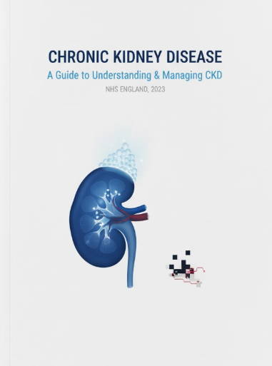

2. Understanding Chronic Kidney Disease (CKD)

Definition of CKD
Kidney function is impaired by chronic renal sickness. This syndrome is characterised by a decrease in GFR of less than 60 mL/min/1.73 m2 during the course of three months. Chronic kidney disease can lead to end-stage renal disease (ESRD), which necessitates either dialysis or a kidney transplant (Stewart et al., 2024).
Problems associated with chronic kidney disease include diabetes, hypertension, genetics, diet, and smoking. Early symptoms that go unnoticed can potentially delay diagnosis. It is possible for the illness to make breathing more difficult due to weariness, oedema in the legs and ankles, high blood pressure, and fluid accumulation (NHS, 2021).

Stages of CKD
Moderate chronic kidney disease is the first stage, while renal failure is the fifth stage. Various stages of renal waste filtration (GFR) procedures.
- Stage 1: Kidney damage with normal or high GFR (90 or above).
- Stage 2: Mild decrease in kidney function (GFR 60-89) (Ghiyasvandian et al., 2021).
- Stage 3: Moderate decrease in kidney function (GFR 30-59).
- Stage 4: Severe decrease in kidney function (GFR 15-29).
- Stage 5: Kidney failure (GFR less than 15), requiring dialysis or a kidney transplant.
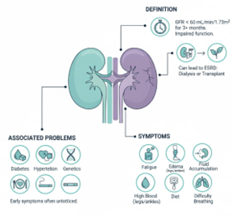
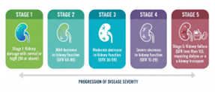
Figure 1: Review and Stage of CKD

Prevalence of CKD
- Countries with low and intermediate incomes are responsible for ten percent of the disease's prevalence. According to (Burnier and Damianaki, 2023), one in ten people in the United Kingdom suffer from chronic renal disease. The prevalence of this condition rises with age and is more prevalent in people who are older. Chronic renal disease is the second most common kind of chronic illness among adults aged 65 to 84 in the United Kingdom (Jančič, Močnik and Marčun Varda, 2022).
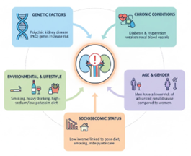
Figure 2: Prevalence of CKD
Risk Factors for CKD
The progression of chronic kidney disease is dependent on a number of factors:
- Genetic Factors: Genes associated with polycystic kidney disease significantly raise the risk of chronic kidney disease (CKD).
- Chronic Conditions: Chronic kidney disease (CKD) is caused by the weakening of renal blood arteries, which is caused by diabetes and hypertension (Iyengar and McCulloch, 2021).
- Environmental and Lifestyle Factors: The risk of chronic kidney disease (CKD) is increased by smoking, heavy drinking, and diets that are high in salt and poor in potassium (Burnier and Damianaki, 2023).
- Age and Gender: When compared to women, men had a lower risk of developing advanced renal disease.
- Socioeconomic Status: People with low incomes are more likely to suffer from chronic kidney disease (CKD) due to poor eating habits, smoking, and inadequate medical care.

3. Physical, Psychological, and Social Impacts of CKD
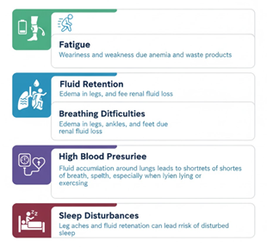Figure 3: Summary of Physical Impacts

Physical Impacts
CKD has a substantial impact on the health of its patients. In spite of the absence of any early signs, the condition may worsen and cause difficulties with one's health. Persistent signs of the body:
- Fatigue: CKD is characterised by weariness and weakness, which are caused by anemia and waste products (Cao et al., 2022).
- Fluid Retention: Renal fluid loss is the cause of oedema in the legs, ankles, and feet.
- Breathing Difficulties: It is possible for fluid to accumulate around the lungs, which can lead to shortness of breath, particularly when lying and exercising.
- High Blood Pressure: Low kidney function raises blood pressure, which in turn increases the risk of renal disease (Hannan et al., 2021).
- Sleep Disturbances: Sleep disturbances may occur as a result of leg aches and fluid retention brought on by chronic renal sickness.

Psychological Impacts
Chronic renal disease may cause distress to both the body and the mind. Patients suffering from chronic renal disease observe:
- Depression and Anxiety: Chronic kidney disease (CKD) can trigger feelings of hopelessness and anxiety due to the unpredictability of the condition. Dialysis can be a significant source of concern for individuals who are in the latter stages of renal failure.
- Stress: Stress induced by regular doctor visits, treatments, and lifestyle changes can adversely affect both a person’s mental and physical health.
- Cognitive Decline: The functioning of the kidney correlates with cognitive skills, more so attention and memory (Chen, Oldenburg and Hsueh, 2021).

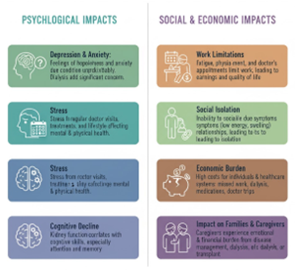
Figure 3: Psychological Impacts and Social and Economic Impacts

Social and Economic Impacts
Chronic kidney disease (CKD) in children have important social and financial consequences as exemplified by:
- Work Limitations: As a whole, the CKD-patients are tired and physically impaired, but have to get doctors' appointments, so can't even think of working. It could also lead to loss of earnings and quality of life (Mima, 2022).
- Social Isolation: Togetherness is restricted when you are unable to socialize due to symptoms of CKD (loss of energy, swelling); conversations between family members may became strained. Maybe the result is social isolation (Kihara and Suzuki, 2025).
- Economic Burden: CKD is expensive for both individuals and healthcare systems. It is stressful to miss work, and the costs associated with dialysis, medications, and trips to the doctor are high.
- Impact on Families and Caregivers: As a result of disease management, carers experience both emotional and financial burden. Chronic kidney disease (CKD) dialysis or transplantation might leave carers feeling exhausted (Grenda, 2020).

4. Evidence-Based Treatments for CKD

Medical Management
There are numerous treatments for chronic kidney disease that have been shown to decrease the progression of the disease, alleviate symptoms, and enhance quality of life:
Blood Pressure Control: To protect the kidneys, blood pressure should be controlled. The treatment for hypertension includes ACE inhibitors, ARBs, and diuretics (Hawthorne et al., 2023).
Blood Sugar Control: It is essential for diabetics to maintain control of their blood sugar levels. The glucose level is controlled with insulin and oral hypoglycemics.
Phosphate Binders: Phosphorus levels in the blood that are elevated due to chronic renal disease have an impact on both the heart and the bones. Put phosphate binders under control (Rashed-Al-Mahfuz et al., 2021).
Erythropoiesis-Stimulating Agents: In patients with chronic kidney disease, erythropoietin, which stimulates erythropoiesis, is used to treat anemia (NHS, 2021).
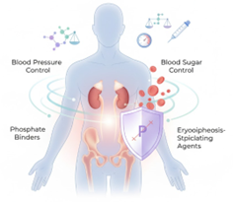
Figure 4: Medical Management

Dialysis
Dialysis becomes necessary when kidney function deteriorates to the point where the kidneys are unable to fulfil their function as they once did. The two most common forms of dialysis are as follows:
Haemodialysis: With haemodialysis, waste and excess fluid are removed from the blood by the use of a dialyser, which functions as an artificial kidney. The process of haemodialysis is one that i s normally carried out at a dialysis centre three times each week (NHS, 2022).
Peritoneal Dialysis: In the process of peritoneal dialysis, the peritoneum, which is the lining of the abdominal cavity, is utilised to filter blood. Exchanges of fluids during dialysis can be performed at home, but they must be performed on a daily basis (Kalantar-Zadeh et al., 2021).
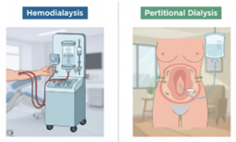Figure 5: Dialysis Procedure
Kidney Transplantation
Surgical transplantation is the most effective treatment for end-stage renal disease. Damaged kidneys are replaced with healthy kidneys from donors who are either alive or deceased. There are, however, concerns regarding the availability of organs, compatibility, and the treatment of permanent organ rejection (Kalantar-Zadeh et al., 2021).

Lifestyle Modifications
Diet: Salt, potassium, and phosphorus levels need to be decreased in patients with chronic renal failure, while protein and water levels should be kept the same.
Exercise: Exercise is an effective method for managing chronic renal disease as well as cardiac disease.
Smoking Cessation: Quit smoking; it makes chronic kidney disease (CKD) worse and raises the risk of cardiovascular disease (Grenda, 2020).
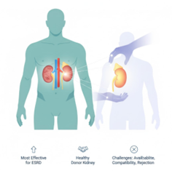
Figure 6: Kidney Transplantation

5. Theoretical Perspectives and Models for CKD Management
In order to improve the outcomes of chronic kidney disease (CKD), the Chronic Treatment Model (CCM) promotes the collaboration of several disciplines, self-management support, and clinical decision support. There are a variety of theoretical models that can assist in the management and treatment of chronic kidney disease (CKD) (Raoofi et al., 2021).
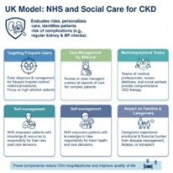
Figure 7: NHS and Social Care Model

UK Model: NHS and Social Care Model
Care for chronic renal disease is provided by the National Health Service of the United Kingdom in a proactive and risk-based manner. 22% of people over the age of 35 in the United Kingdom have chronic kidney disease (CKD). In order to identify potential health risks, the National Health Service (NHS) monitors blood pressure and kidney function (Ghiyasvandian et al., 2021).
The patient risk assessment is necessary in order to identify patients who are problematic. In patients who are hospitalised frequently, early identification of chronic kidney disease (CKD) improves outcomes and minimises the number of needless hospitalisations. It was found that frequent users of NHS RightCare had thirty percent fewer hospital admissions as a result of early identification and individualised care (Dias et al., 2020).
The cases are supervised by NHS matrons. Complex chronic kidney disease patients are supervised by nurses or health case managers. It is possible to reduce readmissions by increasing patient happiness (Caillard and Thaunat, 2021).
Nephrologists, dietitians, nurses, and social workers are all encouraged to work together on holistic treatment by the National Health Service (NHS). The National Health Service (NHS) promotes self-management. Telemedicine and mobile health apps helped patients better control their symptoms and adhere to treatment plans, which resulted in a 22% reduction in the number of hospital visits.
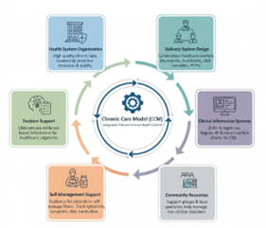
Figure 8: Chronic Care Model (CCM)

International Model: Chronic Care Model (CCM)
The Chronic Care Model (CCM) developed by Wagner et al. is used to treat chronic kidney disease (CKD) all over the world. Integrated therapy and proactive, patient-centered health control are also topics that are supported by CCM. There are six components related to one another:
Health System Organisation: The management of chronic kidney disease is impacted by healthcare in the UK. In the year 2023, the National Health Service (NHS) allocated one million pounds to research on the early identification and care of chronic kidney disease (CKD). Ten percent of people who suffer from chronic kidney disease live in countries with low and intermediate incomes, which highlights the necessity of increasing spending on healthcare (Cusumano, Tzanno-Martins and Rosa-Diez, 2021).
Delivery System Design: It is necessary for primary care physicians, dietitians, and nephrologists to collaborate in the treatment of chronic renal illness. Improved patient outcomes and fewer hospital admissions have been achieved through the implementation of the RightCare project inside the English National Health Service (NHS). A study found that integrated care can cut hospitalisations by thirty to forty percent (NHS, 2021)
Decision Support: The clinical decision support systems used for the management of chronic kidney disease monitor renal function and blood pressure. Early intervention and a 20% reduction in clinical errors are both made possible by solutions. It is possible that they will result in a 25% quicker diagnosis (Chen, Oldenburg and Hsueh, 2021).
Self-Management Support & Community Resources: CKD hospitalisations were reduced by 22% thanks to telemedicine and mobile applications. CKD patients who receive community support have a 25% lower incidence of depression and anxiety (NHS, 2021).

Comparison and Integration
With the Chronic Care Model and the NHS and Social Care Model, it is possible to develop a care plan for chronic kidney disease that is centred on the patient. The CCM integrated care and proactive management are modelled after the risk assessment and case management practices of the NHS. The combination of techniques improves both the treatment of chronic kidney disease and the quality of life (Hannan et al., 2021).
The case management of NHS matrons may be incorporated into the team-based individualised care plans developed by CCM. CKD treatment necessitates self-management, which is something that both regimens encourage (Grenda, 2020).

6. Current Local and National Health and Social Care Agendas
Over recent years, the NHS Long Term Plan for 2019 has emphasized the early identification and proactive management of CKD, aiming to leverage digital health technologies and precision medicine to identify and treat the disease at ever earlier stages, in an attempt to eventually mitigate the need for urgent, expensive interventions such as dialysis and kidney transplantation (Wang and Hart, 2021).
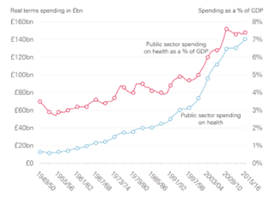
Figure 9: Spending money on CKD in UK (Arıcı, 2024; Kihara and Suzuki, 2025)
Talking about chronic problems that follow asthma, Ask About Asthma raises awareness of the condition. It is encouraged by the advertisement that people enquire about the availability of prompt and appropriate treatment for chronic conditions such as chronic kidney disease (CKD), particularly in child patients (Yamada and Nakano, 2023).
The National Quality Outcomes Framework (QOF) recognises general practitioners for meeting CKD care levels. As part of the amendments that took effect in 2020/21, general practitioners were required to maintain patient records pertaining to chronic kidney disease (CKD) and adhere to recommendations regarding diagnosis, monitoring, and treatment (NHS, 2022).
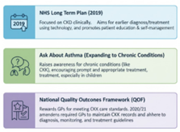
Figure 10: Current Local and National Health and Social Care

Regional Policy Variations
The treatment of chronic renal disease in the United Kingdom differs from region to location in order to serve different populations:
- England: Asthma and chronic renal illness toolkits provided by NHS RightCare contribute to the improvement of healthcare in England. RightsCare encourages patient self-activation and individualised treatment in order to lessen the burden placed on hospitals and improve the course of chronic renal disease (Iyengar and McCulloch, 2021).
- Wales: The Welsh government is working to improve respiratory health, particularly to address chronic kidney disease. In addition, there will be experts on chronic renal disease and respiratory leads from Wales available (NHS, 2021).
- Scotland: In the Scottish Respiratory Management Action Plan 2021-2026, the diagnosis, management, and prevention of chronic renal illness are highlighted as the most important priorities. Individuals suffering from chronic renal disease benefit from the availability of medical training (Stewart et al., 2024).
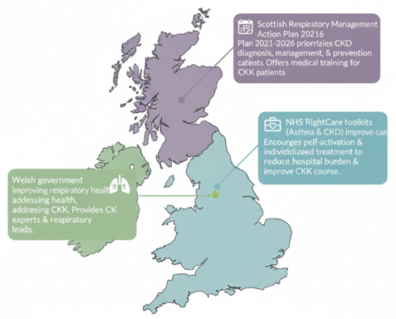
Figure 11: Map of Regional Policy Variations (Chen, Knicely and Grams, 2019; Pethő et al., 2024)

Investment and Implementation Programs
- CKD care has received significant investments from the government of the United Kingdom and local health authorities in order to enhance the delivery of services and the outcomes for patients (NHS, 2021).
- NHS England made an investment of more than one million pounds in respiratory health groups that were treating chronic kidney disease (CKD) in the year 2023. These funding are distributed to a number of different early detection and care trial initiatives (Jančič, Močnik and Marčun Varda, 2022).
- Certain asthma biologics have been designated as Rapid Uptake Products by the Accelerated Access Collaborative (AAC), which will increase the number of patients with chronic kidney disease who have access to innovative medicines. Those who must deal with difficult issues are helped (Raoofi et al., 2021).

7. Recommendations for Person-Centered Care
PCCA may be helpful in the management of chronic disorders such as CKD. The choices, values, and circumstances of the individual are given priority during the planning and decision-making process about care.
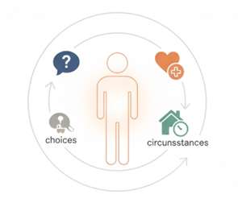
Figure 12: Person-Centered Care

Self-Management Support Framework
- The lives of individuals with chronic kidney disease can be improved with full self-management with assistance. Coaching in healthcare, care coordination, and assistance from peers all contribute to a reduction in hospitalisations and an increase in patient satisfaction (Grenda, 2020).
- Individualised Action Plans Patients who suffer from chronic renal disease require guidance on their lifestyle, treatment, and monitoring. It is necessary to alter the plans in order to accommodate the requirements of the patients (Kihara and Suzuki, 2025).
- For the purpose of promoting self-management, recording symptoms, receiving prescription reminders, and utilising telehealth technologies are all beneficial. By using smart inhalers and apps, chronic kidney disease (CKD) can be recognised and treated in real time (Hannan et al., 2021).
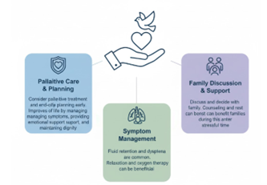
Figure 13: End-of-Life Care Considerations

End-of-Life Care Considerations
End-stage renal disease (ESRD) patients receive palliative care to manage fluid overload, dyspnoea, pain, and emotional, spiritual, and psychological requirements. Multidisciplinary input is needed when deciding on dialysis discontinuation or kidney transplantation. By including these components of the care plan at an earlier stage, the patient's quality of life is improved. At the end of life, palliative care helps treat symptoms, provides emotional support, and ensures that the patient's dignity is maintained (Hannan et al., 2021).
- CKD is typically accompanied with fluid retention and dyspnea. A relaxation and oxygen therapy session might be beneficial during this time period.
- At the time of death, discuss and make a decision with family. It may be beneficial for the family to get counselling and get some rest during this stressful time (Wang and Hart, 2021).

8. Conclusion
Chronic kidney illness affects millions of people around the world. Chronic kidney disease (CKD) affects a significant portion of the population in the United Kingdom and has significant mental, emotional, and social repercussions. Patients, families, and healthcare systems are all impacted by chronic kidney disease (CKD), which necessitates early detection, treatment that is supported by evidence, and comprehensive care.
Integrated care of CKD is enhanced by the NHS, the Chronic Care Model and social care. Use of these strategies enhances patient empowerment, integrated patient care and interprofessional collaboration. Individualised CKD care decreases hospitalisations and trial patients’ lives.
The burden of chronic kidney disease (CKD) is reduced, and the quality of life of patients is improved, thanks to the Long-Term Plan of the National Health Service (NHS). The outcomes for patients and their families can be improved by the implementation of a complete and integrated approach that encourages proactive self-management and empowers patients.

9. Reference list
Arıcı, M. (2024). Management of Chronic Kidney Disease. Springer.
Arif, M.S., Mukheimer, A. and Asif, D. (2023). Enhancing the Early Detection of Chronic Kidney Disease: A Robust Machine Learning Model. Big Data and Cognitive Computing, [online] 7(3), p.144. doi:https://doi.org/10.3390/bdcc7030144.
Burgos-Calderón, R., Depine, S.Á. and Aroca-Martínez, G. (2021). Population Kidney Health. A New Paradigm for Chronic Kidney Disease Management. International Journal of Environmental Research and Public Health, [online] 18(13), p.6786. doi:https://doi.org/10.3390/ijerph18136786.
Burnier, M. and Damianaki, A. (2023). Hypertension as cardiovascular risk factor in chronic kidney disease. Circulation research, [online] 132(8), pp.1050–1063. doi:https://doi.org/10.1161/circresaha.122.321762.
Caillard, S. and Thaunat, O. (2021). COVID-19 vaccination in kidney transplant recipients. Nature Reviews Nephrology, 17(12), pp.785–787. doi:https://doi.org/10.1038/s41581-021-00491-7.
Cao, Y.-L., Lin, J.-H., Hammes, H.-P. and Zhang, C. (2022). Flavonoids in Treatment of Chronic Kidney Disease. Molecules, 27(7). doi:https://doi.org/10.3390/molecules27072365.
Chen, T.K., Knicely, D.H. and Grams, M.E. (2019). Chronic Kidney Disease Diagnosis and Management. JAMA, [online] 322(13), pp.1294–1304. doi:https://doi.org/10.1001/jama.2019.14745.
Chen, T.-T., Oldenburg, B. and Hsueh, Y.-S. (2021). Chronic care model in the diabetes pay-for-performance program in Taiwan: Benefits, challenges and future directions. World Journal of Diabetes, 12(5), pp.578–589. doi:https://doi.org/10.4239/wjd.v12.i5.578.
Cusumano, A.M., Tzanno-Martins, C. and Rosa-Diez, G.J. (2021). The Glomerular Filtration Rate: From the Diagnosis of Kidney Function to a Public Health Tool. Frontiers in Medicine, [online] 8. doi:https://doi.org/10.3389/fmed.2021.769335.
Dias, D.B., Mendes, M.L., Caramori, J.T., Falbo dos Reis, P. and Ponce, D. (2020). Urgent-start dialysis: Comparison of complications and outcomes between peritoneal dialysis and haemodialysis. Peritoneal Dialysis International: Journal of the International Society for Peritoneal Dialysis. doi:https://doi.org/10.1177/0896860820915021.
El Nahas, M. and Levin, A. eds., (2009). Chronic Kidney Disease. [online] Oxford University Press. doi:https://doi.org/10.1093/med/9780199549313.001.0001.
Ghiyasvandian, S., Shahsavari, H., Matourypour, P. and Golestannejad, M.R. (2021). Integrated Care model: Transition from acute to chronic care. Revista Brasileira de Enfermagem, 74(suppl 5). doi:https://doi.org/10.1590/0034-7167-2020-0910.
Grenda, R. (2020). Torque teno (TTV) viral load as a biomarker of immunosuppressive strength after kidney transplantation in children. Pediatric Nephrology, 36(1), pp.1–3. doi:https://doi.org/10.1007/s00467-020-04607-2.
Hannan, M., Ansari, S., Meza, N., Anderson, A.H., Srivastava, A., Waikar, S., Charleston, J., Weir, M.R., Taliercio, J., Horwitz, E., Saunders, M.R., Wolfrum, K., Feldman, H.I., Lash, J.P. and Ricardo, A.C. (2021). Risk Factors for CKD Progression: Overview of Findings from the CRIC Study. Clinical journal of the American Society of Nephrology: CJASN, [online] 16(4), pp.648–659. doi:https://doi.org/10.2215/CJN.07830520.
Hawthorne, G., Lightfoot, C.J., Smith, A.C. and Wilkinson, T.J. (2023). Multimorbidity prevalence and patterns in chronic kidney disease: findings from an observational multicentre UK cohort study. International Urology and Nephrology, 55(8), pp.2047–2057. doi:https://doi.org/10.1007/s11255-023-03516-1.
Iyengar, A. and McCulloch, M.I. (2021). Paediatric kidney transplantation in under-resourced regions—a panoramic view. Pediatric Nephrology. doi:https://doi.org/10.1007/s00467-021-05070-3.
Jančič, S.G., Močnik, M. and Marčun Varda, N. (2022). Glomerular Filtration Rate Assessment in Children. Children, 9(12), p.1995. doi:https://doi.org/10.3390/children9121995.
Kalantar-Zadeh, K., Jafar, T.H., Nitsch, D., Neuen, B.L. and Perkovic, V. (2021). Chronic kidney disease. The Lancet, 398(10302), pp.786–802. doi:https://doi.org/10.1016/s0140-6736(21)00519-5.
Kihara, M. and Suzuki, Y. (2025). Evidence-based Clinical Practice Guideline for Chronic Kidney Disease 2023. Health Evaluation and Promotion, [online] 52(2), pp.362–369. doi:https://doi.org/10.7143/jhep.52.362.
Lohia, S., Vlahou, A. and Zoidakis, J. (2022). Microbiome in Chronic Kidney Disease (CKD): An Omics Perspective. Toxins, 14(3), p.176. doi:https://doi.org/10.3390/toxins14030176.
Mima, A. (2022). A Narrative Review of Diabetic Kidney Disease: Previous and Current Evidence-Based Therapeutic Approaches. Advances in Therapy, 39(8), pp.3488–3500. doi:https://doi.org/10.1007/s12325-022-02223-0.
National Health Service (2022) Personalised palliative and end of life care. Available at: https://www.england.nhs.uk/eolc/personalised-care/ (Accessed: 12 November 2025)
National Health Service (2022) Social Prescribing. Available at: https://www.england.nhs.uk/personalisedcare/social-prescribing/ (Accessed: 12 November 2025)
National Health Service (2021) Long Term Plan. Available at: https://www.longtermplan.nhs.uk/wp-content/uploads/2019/01/the-nhs-long-term-plan-summary.pdf (Accessed: 12 November 2025)
National Health Service (2021) Supported self management. Available at: https://www.england.nhs.uk/personalisedcare/supported-self-management/ (Accessed: 12 November 2025)
National Health Service (2021) Care coordination. Available at: https://www.england.nhs.uk/personalisedcare/supported-self-management/care-co-ordination/ (Accessed: 12 November 2025)

Raoofi, S., Rafiei, S., Rezaei, S., Ahmadi, S., Masoumi, M., Sharifi, A. and Ghashghaee, A. (2021). Hemodialysis and peritoneal dialysis—health-related quality of life: systematic review plus meta-analysis. BMJ Supportive & Palliative Care, 13(4), p.bmjspcare-003182. doi:https://doi.org/10.1136/bmjspcare-2021-003182.
Rashed-Al-Mahfuz, Md., Haque, A., Azad, A., Alyami, S.A., Quinn, J.M.W. and Moni, M.A. (2021). Clinically Applicable Machine Learning Approaches to Identify Attributes of Chronic Kidney Disease (CKD) for Use in Low-Cost Diagnostic Screening. IEEE Journal of Translational Engineering in Health and Medicine, 9, pp.1–11. doi:https://doi.org/10.1109/jtehm.2021.3073629.
Stewart, S., Kalra, P.A., Blakeman, T., Cranmer-Gordon, H. and Sinha, S. (2024). Chronic Kidney disease: detect, diagnose, Disclose—a UK Primary Care Perspective of Barriers and Enablers to Effective Kidney Care. BMC Medicine, [online] 22(1). doi:https://doi.org/10.1186/s12916-024-03555-0.
Pethő, Á.G., Tapolyai, M., Csongrádi, É. and Orosz, P. (2024). Management of chronic kidney disease: The current novel and forgotten therapies. Journal of Clinical & Translational Endocrinology, [online] 36. doi:https://doi.org/10.1016/j.jcte.2024.100354.
Wang, J.H. and Hart, A. (2021). Global Perspective on Kidney Transplantation: United States. Kidney360, 2(11), p.10.34067/KID.0002472021. doi:https://doi.org/10.34067/kid.0002472021.
Yamada, S. and Nakano, T. (2023). Role of Chronic Kidney Disease (CKD)–Mineral and Bone Disorder (MBD) in the Pathogenesis of Cardiovascular Disease in CKD. Journal of Atherosclerosis and Thrombosis, 30(8), pp.835–850. doi:https://doi.org/10.5551/jat.rv22006.

