Advanced Cybersecurity
ACCB6000
Research, Implement, Analyse and Propose viable strategy

Jordan Griffiths
2017103
17/11/2022

Table of Contents
Abstract 3
Introduction 4
Research (1500 Words) 4
Advances 4
Recent Threats and Vulnerabilities 5
Recent Attacks 5
Defence approaches/mechanisms 6
Implement and Analysis(2000 Words) 7
Task 1 7
Task 2 7
Activity 2 7
Activity 3 8
Activity 4 8
Activity 5 9
Activity 6 10
Task 3 10
Activity 2 10
Activity 3 13
Activity 4 18
Activity 5 22
Activity 6 28
Mitigation strategy proposal (1000 Words) 33
Lending Hands Technical weakness 33
Potential security weaknesses and mitigation 33
Conclusion 34
Bibliography 35
Annexure 41
Activity 2 41
Activity 3 49
Activity 4 65
Activity 5 71
Activity 6 80

Figure 1- Principles of Info Sec - 'The Most Dangerous Malware Attacks to Data' 8
Figure 2 10
Figure 3 11
Figure 4 11
Figure 5 12
Figure 6 12
Figure 7 13
Figure 8 13
Figure 9 14
Figure 10 14
Figure 11 15
Figure 12 16
Figure 13 16
Figure 14 16
Figure 15 17
Figure 16 17
Figure 17 18
Figure 18 18
Figure 19 19
Figure 20 19
Figure 21 19
Figure 22 20
Figure 23 20
Figure 24 21
Figure 25 21
Figure 26 22
Figure 27 22
Figure 28 23
Figure 29 24
Figure 30 24
Figure 31 25
Figure 32 25
Figure 33 26
Figure 34 26
Figure 35 27
Figure 36 27
Figure 37 28
Figure 38 28
Figure 39 28
Figure 40 28
Figure 41 29
Figure 42 29
Figure 43 30
Figure 44 31
Figure 45 31
Figure 46 31
Figure 47 32
Figure 48 32
Figure 49 32
Figure 50 32
Figure 51 32
Figure 52 33
Figure 53 33
Figure 54 33
Figure 55 36

Abstract
Throughout the world, Cybersecurity has been found in businesses and organisation. This even applies to the Lending Hands Non-Governmental Organization. With the recent small sized security breach, I have taken to write this report that will detail the ongoing research in the field of cyber security. This will include the advances, recent vulnerabilities/threats and recent defence approaches to these threats. To further analyse the threats Lending Hands could face, I have completed lab activities, found in the annexure, as well as test alternative tools. The conclusion I have reached is that there are a wide variation of vulnerabilities that Lending Hands could face, yet multiple mitigation strategies to counter these vulnerabilities, as well as strengthen their cyber security.

Introduction
In this report I will be discussing the literature in advancements in technologies relating to cybersecurity, case studies relating to recent attacks and vulnerabilities as well as the approaches in place for defending against attacks. I will also analyse attack tools, to then propose a strategy to mitigate these attacks.

Research (1500 Words)
In this section of the report, I will be discussing the research and literature that will involve the advances, recent cyber attacks and the strategies found to defend against these attacks.

Advances
According to journal author ‘A.Mathew’ recent advancements in technologies regarding cybersecurity include the use of machine learning [1]. The study he had done suggested that machine learning was efficient in addressing the cyber-security risks involved in information systems. This was done using algorithms to solve the main security issues such as the analysis of malware, IDS(Intrusion Detection System), spam detection and Android malware detection [1].
In comparison, author ‘Anand Handa’,conducted studies using machine learning to discover the effects of machine learning on cyber security issues [2]. They did this by using examples of malware analysis, as well as the analysis of ‘anomaly based’ intrusion detection of prevalent attacks and zero-day malware detection [2].
For alternative security risks, journal author ‘M. Rege’ uses machine learning to study offense and defensive activities with cybersecurity [3]. The author uses ‘predictive learning’ or ‘pattern discovery’ on a machine learning model to for example, can be used to predict IP address in the event of a DDOS(Distributed Denial of Service) attack. The author then concluded that the advancement of machine learning in cybersecurity would be of ‘vital importance’ [3].
Another advancement in recent literature is the analysis of federated deep learning compared to non-federated learning [4]. The analysis involved security and privacy systems based on federated learning that are applied to IoT(Internet Of Things) devices. The federated learning systems where then also analysed by the blockchain and IDS/malware systems in IoT applications [4]. The conclusion reached by the journal article authors is that federated deep learning outperforms non-federated learning by having a high accuracy in detecting attacks, as well as assuring the privacy of data on devices [4].
A journal article from 2018 suggested a device authentication scheme that features algorithms can be used to defend against certain cyber-attacks, if configured correctly into a ‘serialisation chip’ [5]. The chip would be required as device can lack resources to process complex algorithms to authenticate or are not universally applied to devices [5].

Recent Threats and Vulnerabilities
Relating to the scenario given, one journal article [6] describes the recent threats that E-commerce businesses face in 2021 are common threats of credential theft, compromised/stolen devices, social engineering attacks and phishing attacks [6].
Another research article suggested that a emerging threat to cybersecurity is the use of AI to carry out cyber-attacks [7].They conducted an investigation into efficient the use of their attack, using techniques driven by AI [7]. In their findings they show that ‘56%’ of AI driven cyberattacks techniques were done in the access and penetration stage,’12%’ in the exploitation phase, ‘11%’ in the recognisance phase and ‘9%’ in the delivery phase [7]. The investigation also found that some cybersecurity methods are unable to mitigate and even detect AI attacks, due to how fast, complex and difference in variants in attacks.
One recent vulnerability, according to researchers is within cloud computing [8]. Research has found that the vulnerabilities of cloud computing are ‘unclear responsibilities and roles’, lack of enforcement of these roles, vulnerabilities within an applications as well as operating systems and non-effective procedures for physical security [8] [9]. The threats that these vulnerabilities can lead to are cloud security attacks, which according to research can involve wrapping attacks to even malware injection attacks [8] [10].
Alternatively, recent research also shows that that threats and vulnerabilities that can be faced even in NGOs such as the Lending Hands could include ‘shared technology vulnerabilities’ [11]. Shared technology vulnerability involves a cloud service provider service being shared within an ‘infrastructure, application and/or platform’ [12]. The vulnerability becomes apparent when a guest OS can access an entire system through shared levels [12].
Again relating to the NGO, another recent vulnerability found in research is the recurring element of human error [11] [13] [14]. The vulnerability of human error will allow the chances of cyber-attacks increase, which will planned around the organisations errors. An increased chance of human errors can also be found where the business users are lacking in knowledge, understanding and training of business/IT systems [15] [16]. This can lead to an increase of employees clicking any malicious links that can lead to any security breaches [15].
Research also suggests that social engineering tasks can be used by attackers to gain from any human vulnerabilities [17], which include the multitude of factors that can affect organisation employees. These can involve stress, workload, experience and even age [17].These vulnerabilities can lead to the increase of social engineering attacks that be unknown to untrained employees. These attacks can involve the well-known phishing attacks, yet can also involve the use of baiting attacks, tailgating attacks, pretexting attacks, fake software attacks and email/phone scams [18].
Recent threats also involve potential sophisticated attacks such as keyloggers. Research suggests that keyloggers are a threat that has recently been rising. According to author ‘Waterson’ the 2020 pandemic to covid saw a 723 cases of keylogging attacks [19]. The author suggested that the recent threat, would turn to the biggest threat that be faced by organisations due to keylogging malware and screen grabbing malware [19]. Relating to Lending Hands organisation, these attacks could threaten any sensitive data shared internally.

Recent Attacks
With all these threats and vulnerabilities attackers will take the knowledge of them and turn their eyes on various organisations and businesses. This section will involve recent cases of cyber attacks on organisations throughout the world.
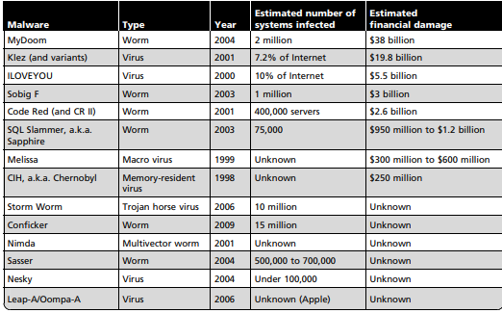
Figure 1- Principles of Info Sec - 'The Most Dangerous Malware Attacks to Data'
According to author ‘Whitman’ and ‘Mattord’ [20], figure 1 contains the most ‘dangerous attacks’ to data. They will date from 1998 to 2009 and show cases such as the ‘ILOVEYOU’ virus to the most ‘recent’ ‘Conficker’ worm attack [20].
To look at more recent cases of cyber attacks one could at the Stuxnet attack in 2010 [21]. This attack involved the development deployment of a worm on a Iranian industrial control system, which then spread to more computer systems [21]. The worm spread when an infected USB was left within the lobby of the industrial building, which then found itself connecting to the LAN [22] [23].
Another recent attack the organisation can look at is the Marriott data breach in 2020 [24] [25] [26], or even the phishing attack on ‘Akamil’ organisation in 2019 which was aided by google translate [27]. Another recent attack is the ‘WannaCry’ ransomware attack on the NHS(National Health Service) of England in 2017 [28] [29], which could’ve been caused by the lack of training to NHS staff even with a mandatory training scheme, yet with only ‘12%’ reaching that goal in 2018 [29].
Another recent attack in the industry is the DDoS (distributed denial of service) attack on the US based service GitHub, which according to journal author ‘Chadd’ it is the ‘largest DDoS attack in history’ [30]. This attack saw that at least 1.35 terabytes were reached in the attack [30] [31], as well as rendering the service offline for hours [30].

Defence approaches/mechanisms
With all these recent threats and vulnerabilities, there are also certain approaches and mechanisms that can be implemented within the NGO for defence.
According to research, [18] the simplest defence or mitigation strategy to social engineering attacks are having a definite security plan, which will provide employees with a ‘simulated scenarios’ and training. This would then aid them to detect and report any social engineering attacks. This strategy can also work for any phishing attacks [18].
Further research [19] also shows that having a anti-screen capture methods to ensure that attackers can not see any real data being shared or shown on organisation devices [19]. Journal article author ‘Waterson’ also suggests that a adequate form of defence against keylogging attacks is to have a ‘kernel level’ keylogging protection methods in place [19].
According to National Cyber Security Centre annual review of 2020 [32], their ‘ACD(Active Cyber Defence)’ programmes can stop a range of attacks on ‘citizens, institutions and businesses’ [32] through the use of multiple services. These include:-
- Aiding owners of a public website find and repair common security concerns through a web checking service [32].
- Prevent any access to malicious domains through a protective DNS [32].
- The use of a takedown service to find malicious sites and alert owners to remove them from then internet [32].
- Mail checking services to ensure security of domains to further prevent spoof emails [32].
- A vulnerability disclosure service to find and report vulnerabilities in key services [32].
- ‘Host based capability’ service to detect threats on a organisation's network [32].
Alternative research [33] also suggests technical defences such as encryption to mask and hide any business information shared within an organisation. Further defence approaches to be used are firewalls in place to protect the organisations computer system as a ‘first line’ of defence against any cyber-attacks on the organisation [33]. Further defences would also include the use of intrusion detection systems, anti-malware software within OS’, and to relate to Lending Hang NGO, a solid policy of physical defence to prevent any damage to information systems through human errors [33]. This would include addressing human threats such as ‘ unauthorized access, misuse and theft’ [33].
This then can also be applied to other attacks such as ransomware [34]. Effectively training the users on ransom ware attacks, after their information systems are set up, would effectively lower the risks of any data breaches and further ransomware attacks.

Implement and Analysis(2000 Words)

Task 1
All lab activities completed will be show within annexure 1.

Task 2
This section will include the identification of alternative tools used for each of the activities.

Activity 2
Subfinder

Tool Description: Subfinder is a enumeration tool that attackers may utilise to gain passive information on subdomains and any other pieces of data. It weas written in a way that a user may have a ‘out of the box’ experience as it is easy to install and use. The main effective element being the speed of enumeration.

Where downloaded: I downloaded the Subfinder tool on the official page for Kali Linux tools. This is because this will greatly decrease the chances of downloading any malicious software that can be used to attack my virtual network.
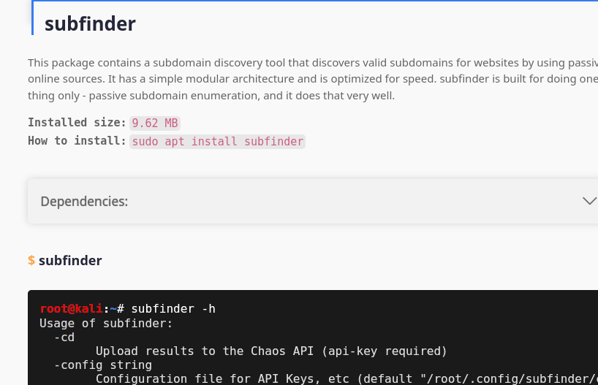
Figure 2

Activity 3
Advanced IP Scanner
Tool Description: Advanced IP Scanner is a free to use tool that is capable of analysing network scanner and local area networks . The tool is also capable of allowing users to gain access to any shared folders across a network.

Where downloaded: The tool was download from the official Advanced IP Scanner website. This will greatly decrease the chances of downloading any malicious software that can be used by attackers [35].

Activity 4
Hosted Scan Security
Tool Description: Hosted Scan Security is a webtool that allows users to analyse their domains based on a URL link, network IP addresses and hostnames. Once entered the webise will deliver scan results and reports to a email that has been used to sign into the website. The tool may provide attackers insight and information about the vulnerabilites of a IP address or website. This is due to the various scans that can be performed.

Where downloaded: The tool that was used was on the official page of Hosted Scan. It was not downloaded as the tool is a host based tool [36].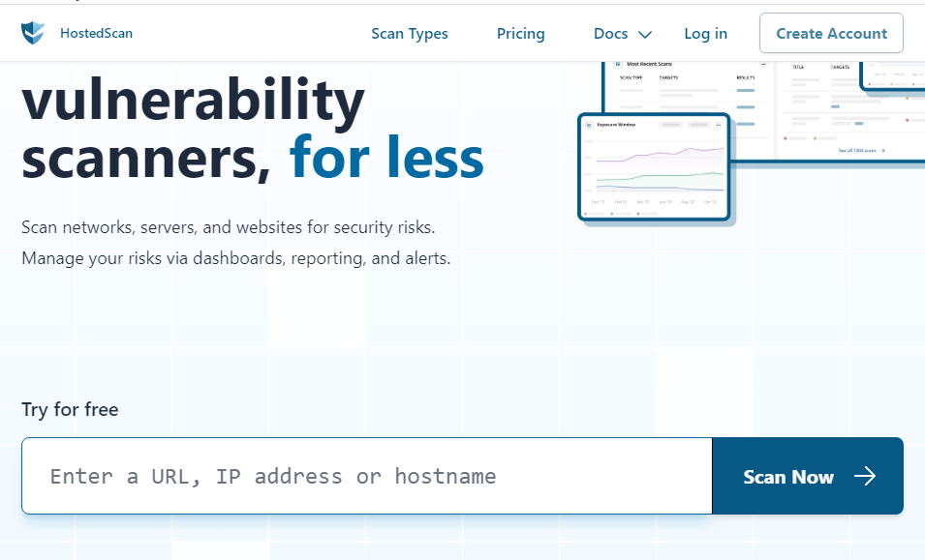
Figure 3

Activity 5
Maltego
Tool Description: Malgeto is a tool available to install on Kali Linux. The tool is considered an alternative to Nessus, as it aids users to visualise the layout and architecture of an organisation’s network as well as a data mining tool in real time [37] [38].

Where downloaded: The Maltego tool was available to install in Kali Linux as it was a supported package. This would be preferable to installing it from any websites as that can increase risks of downloading and installing malicious software.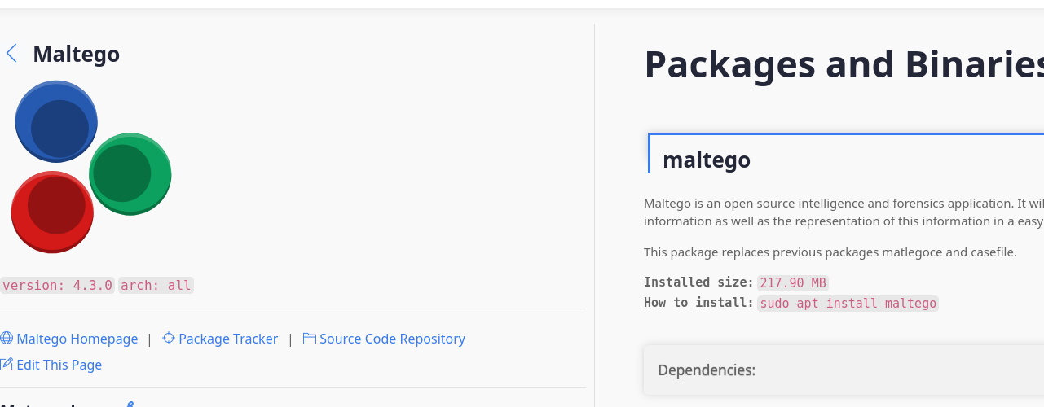
Figure 4

Activity 6
Ettercap
Tool Description: Ettercap is a tool available on Kali Linux that can be installed and used to perform various attacks within a network. These attacks can range in variety from MiM(Man in the Middle) attacks and IP spoofing. The may sniff a network for available IP addresses and their connection which then can be put onto a target list [39].

Where downloaded: For my Virtual Machine in Kali Linux, Ettercap was already installed. Yet, if I were to install the tool on any device I would refer to the tool’s official page. I would do this because that would lower any chances of being vulnerable to attackers.
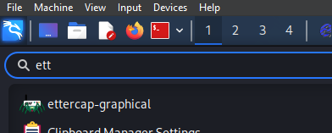
Figure 5

Task 3

Activity 2
Subfinder
Implementation and features: I implemented the tool as an alternative to Sublister in Activity 2 part 2. To implement I first began with installing the tool using the ‘sudo apt install subfinder’ command within Kali linux.

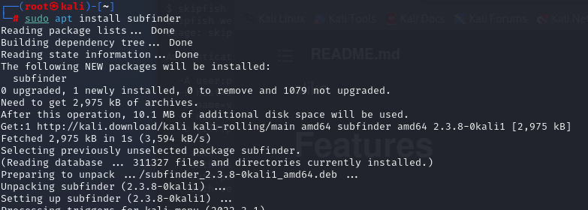
Figure 6
This figure shows the installation process for Subfinder.
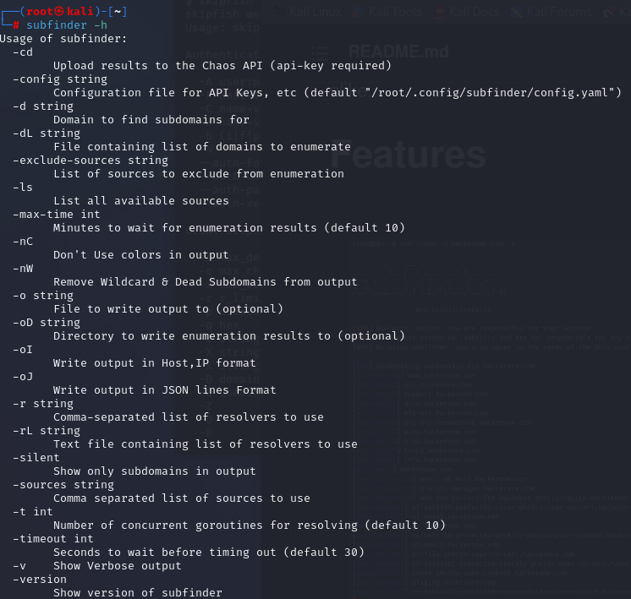
Figure 7
The figure shows the ‘-h’ command that displays the tools commands and usage.
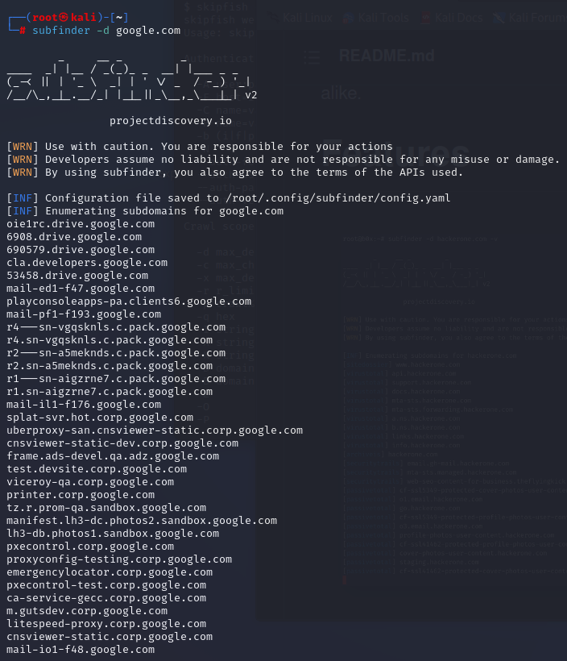
Figure 8
This figure shows me using the tool to perform a subdomain scan on Google.com with the ‘-d’ command.
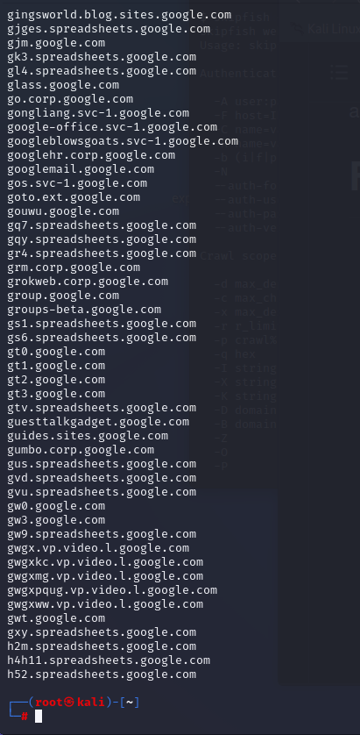
Figure 9
This figure shows the many subdomains that was outputted from the command.
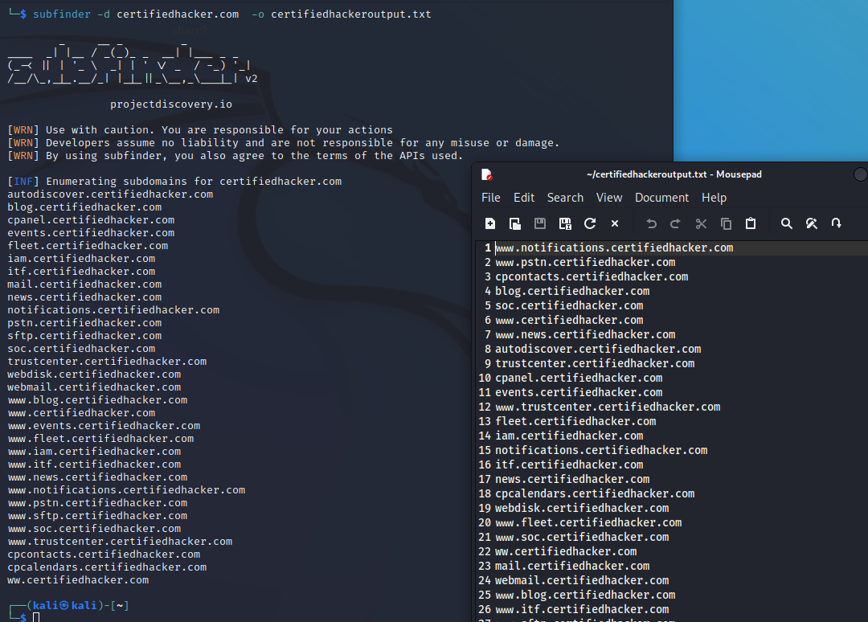
Figure 10
There is and option for Subfinder to even save the outputted sub domains to a text file using ‘-o’ command, which can be used in other tools. As seen above this was done on certifiedhacker.com.
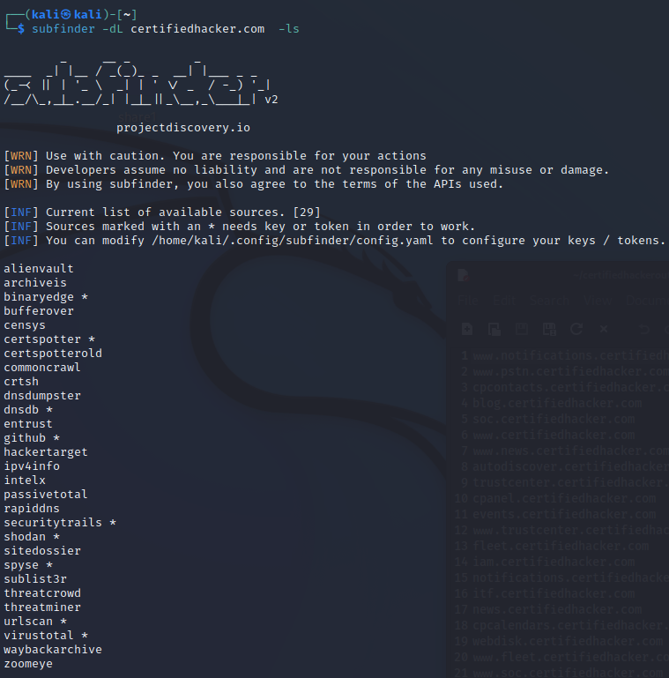
Figure 11
As seen from the figure above, another command that can be used within Subfinder, is the ability to output the available sources of subdomains [40] [41].
Pros: On of the pros to using Subfinder, is that it allows the attacker to quickly gather information on a website and gather any hidden domains and subdomains. This would be due to the ‘out of the box’ design of the tool.
Cons: Cons for the tool may include the lack of sources available for the tool to perform scans more optimally. Another con is that it may not deliver detailed scans such as port scans that can be found in Sublist3r.
Sublist3r
Pros: The pros to Sublist3r is that is much faster than other footprinting tools, as well as having effective features such as subbrute modules or port scanning [42].
Cons: A con to Sublist3r is that it can return few results than one can expect when running long and complex commands. Another con is that the brute for modules have features that are limited in detail. One major flaw to Sublist3r is that it is outdated which can
Summary: In summary, Sub finder can be an effective tool if a user wants to gather information as quickly as possible, yet if they wish to gather more detailed information, they could refer to Sublist3r.

Activity 3
Advanced IP Scanner
Implementation and features:
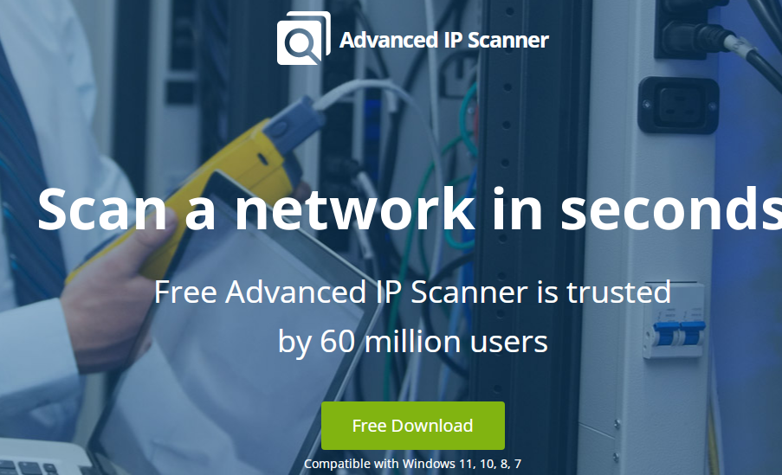
Figure 12
To begin the implementation of the tool, I first begun by going to the official site and downloading the tool.

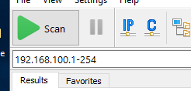
Figure 13
The first step of the tool is to scan the entire network for available IP addresses.
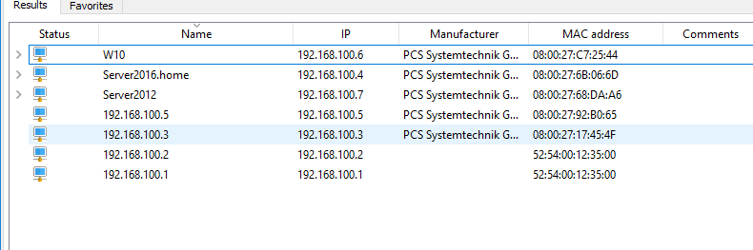
Figure 14
Once the scan is complete, all of the available IP addresses are returned. Along with IP addresses, their MAC address, status and Names and manufacturer names are outputted as well.

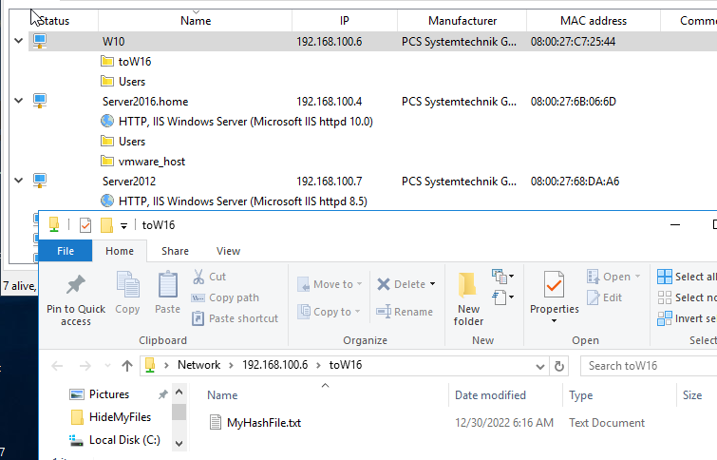
Figure 15
As advertised, the tool also allows me to see any files that have been shared to every user.
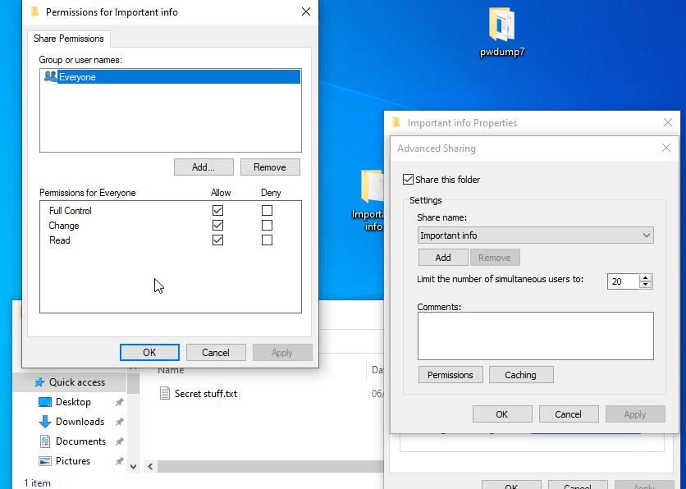
Figure 16
To test this, I went on the target machine and created a ‘important folder’, that is to be shared with everyone, with full control.

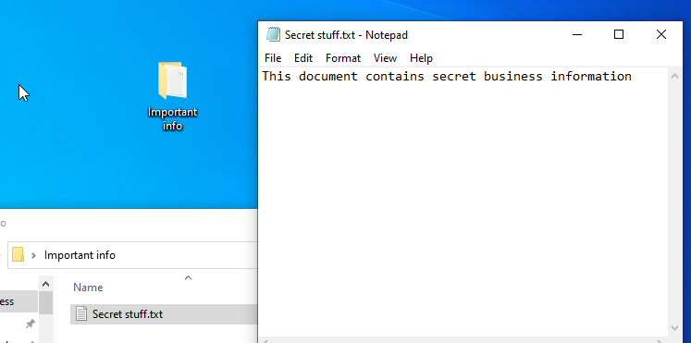
Figure 17
I then added a secret document to add to the folder.

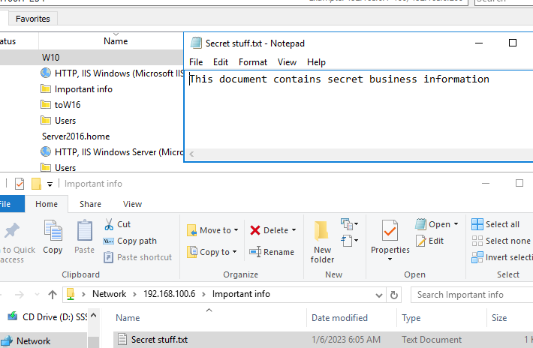
Figure 18
After adding permissions to the folder, it was now visible after another scan. I was also able to open the folder, access and read the secret document.
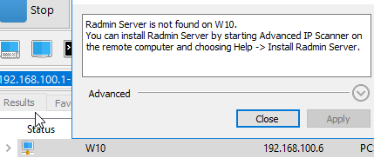
Figure 19
With the similar tools installed on the target machine, a user on Advanced IP Scanner would be able to view and even control the targets machine.
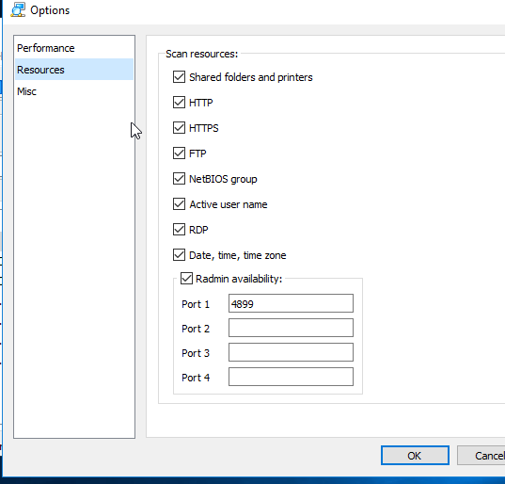
Figure 20
The tool also allows different resources of a machine to be scanned, when enable I will then scan again.
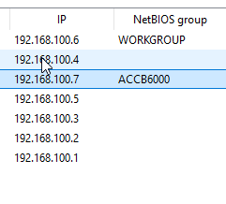
Figure 21
After scanning again, new information such as the NetBIOS group names have become available to me.
Pros: The pros to Advanced IP Scanner is that it is easy to use and easy to scan networks and gain access to any folders or data that has be allowed to share across the network with full control permissions. Another pro to the tool is that free to install and use, as it has a ease of use interface [43].

Cons: A con to the tool is that it can be unsuitable to certain devices such as MAC and iOS. Another con is that the tool itself does have a limited amount of features, as it can have much more and detailed features such as in depth network analysis or port scanning.

Megaping
Pros: A pro to Megaping is that has detailed features such as port scanning, IP scanning, security scanning, TCP port scanning, domain names, adapter names and more [44].
Cons: A Con to the tool is that the interface is outdated, which may deter users from the tool.
Summary: In Summary, Advanced IP Scanner is a more up to date tool, yet will lack detailed features that can be found in Megaping.

Activity 4
HostedScan Security
Implementation and features:
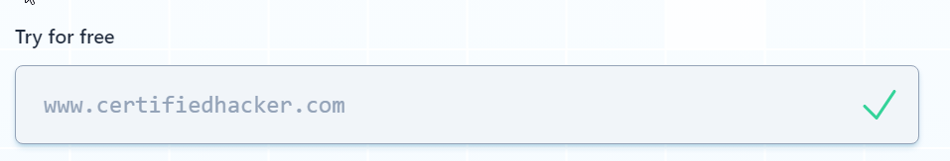
Figure 22
To begin the implementation of Hosted Scan Security, I would load the website. Once loaded I would enter a website URL that can be used for educational purposes. In this case it would be ‘www.certifiedhacker.com’ and ‘www.itsecgames.com’.

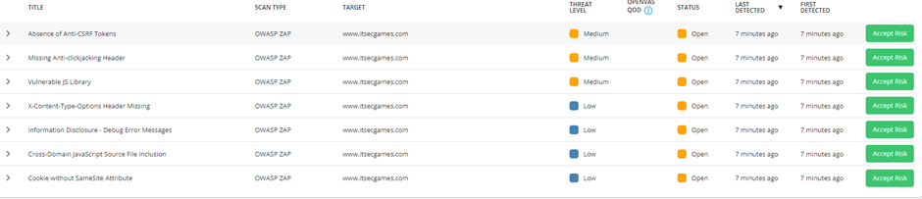
Figure 23
Once the scan is complete, results will be sent to the email that the account for the website has been linked to . Results include the targets, scan types, levels of threats and the list of all threats to the website.
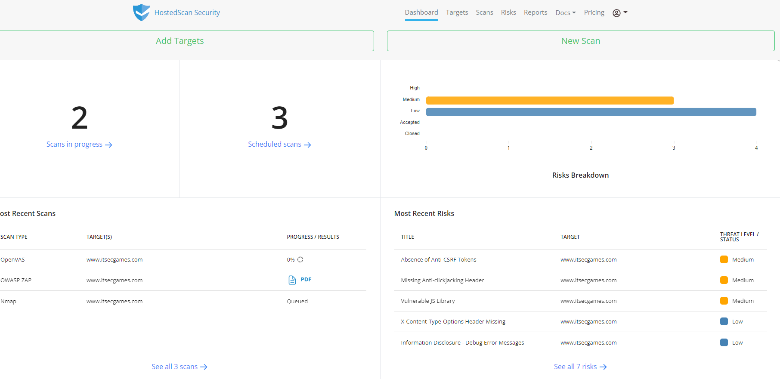
Figure 24
The dashboard of the website may also breakdown the risks to the website using bar graphs.
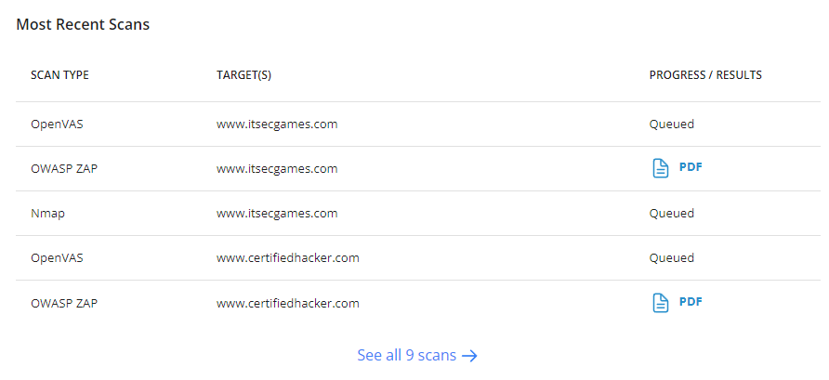
Figure 25
The tool can also give more detailed information via reports depending on the scan type.

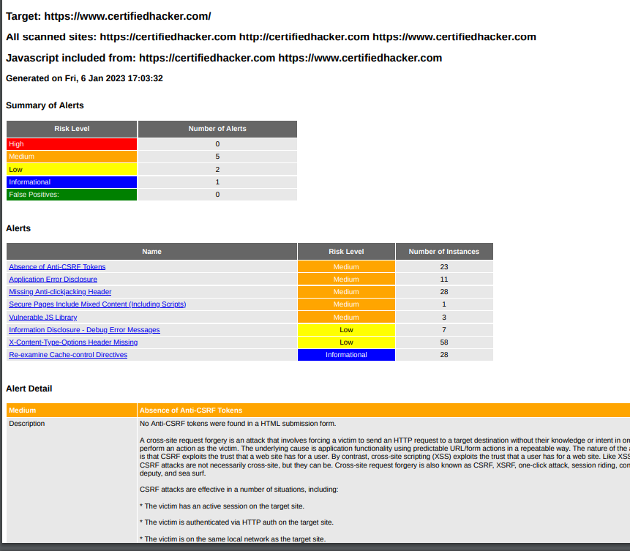
Figure 26
Above is as an example of a report concerning vulnerabilities concerning ‘www.certifiedhacker.com’. Alert details will also give information about specific threats to the website.
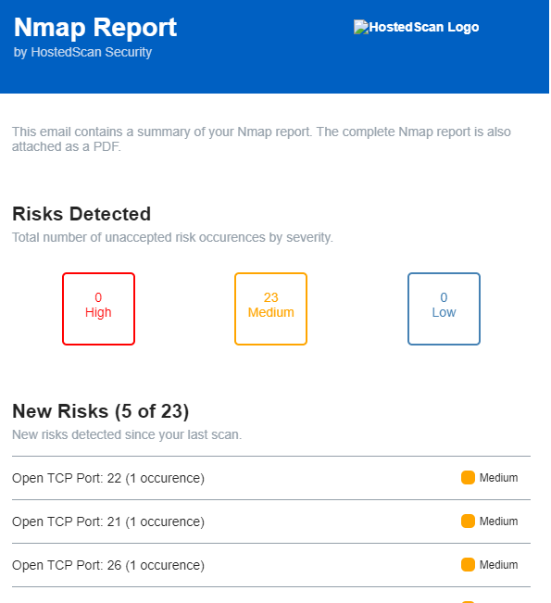
Figure 27
The tool also utilises online forms of other tools such as nmap. Using the scan, I was able to detect any open ports and the risk levels they pose.

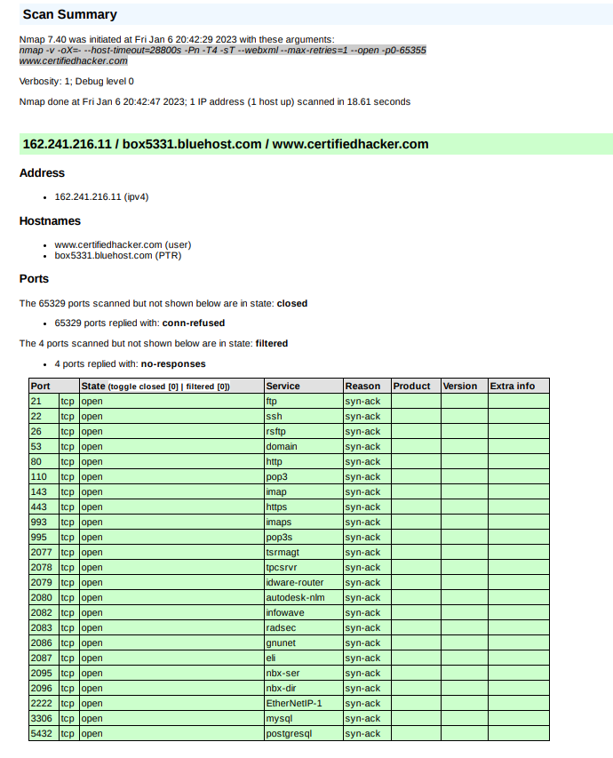
Figure 28
Further details concerning the open ports can be found in various formats.
HostedScan Security
Pros: The pros to HostedScan Security is that it enables a user to see in detail the vulnerabilities that affect a website. The alert details will also say what attacks the vulnerabilities will lead to. Many features of Nessus is also available on Hosted Scan security.
Cons: Scanning can only be used a limited amount of times, whereas paid premium allows you to scan an infinite amount of times. Some vulnerabilities will not appear in the scan reports, which can lead to undetected vulnerabilities that attackers can benefit from.

Nessus
Pros: A pro to Nessus is that it is free to use as well as easy to use with little set up and configuration needed in its set up and installation [45] [46].
Cons: A con to Nessus is that to provide further detailed features, it must go through the payment process that can be costly to small organisations. Another disadvantage to the tool is that it does not allow a detailed view of security policies of any remote systems [47].
Summary: In summary, HostedScan Security is a worthwhile tools that can still be used to gather information on vulnerabilities within a website. While being exploitable, details concerning the vulnerabilities within reports tell of measure to fix various vulnerabilities found. In comparison to Nessus, Nessus would be the recommended tool to gather information on vulnerabilities.

Activity 5
Malgeto
Implementation and features:
To begin the implementation of Malgeto, I followed the steps to install the tool within the Kali Linux terminal.
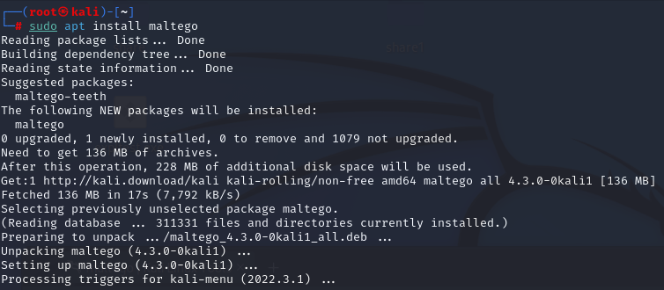
Figure 29
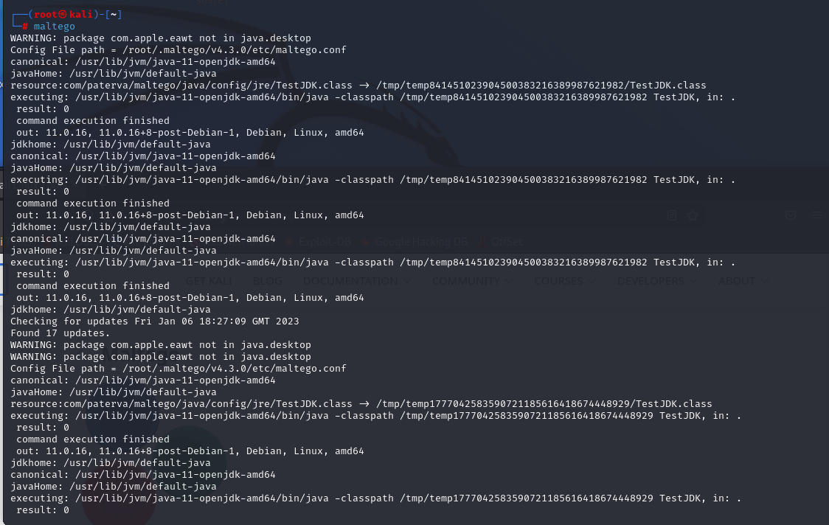
Figure 30
Upon installation, I run the tool for the first time to load it.
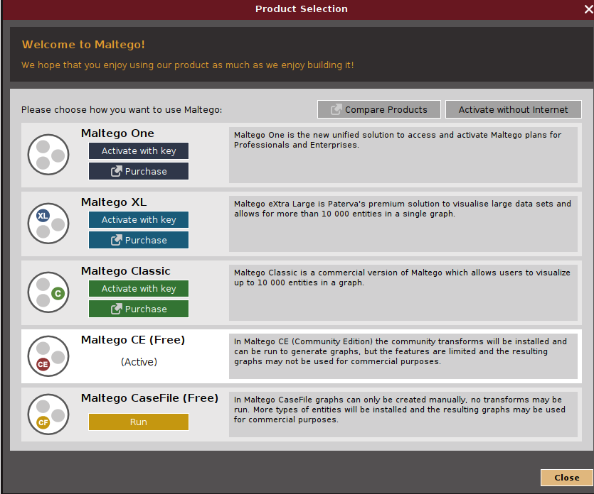
Figure 31
After running the program, I will choose to use the Maltego Community Edition.
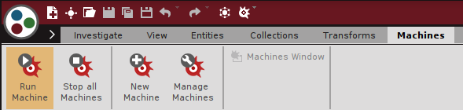
Figure 32
Once I have chosen the product type for the tool, I will go to the machines tab and then press run machine.

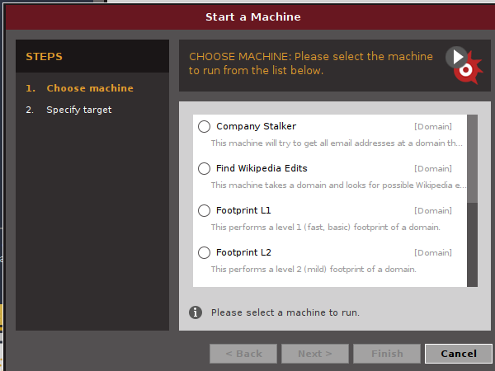
Figure 33
When choosing a machine there are list to choose. The first I will try is the ‘URL to Network and Domain’.
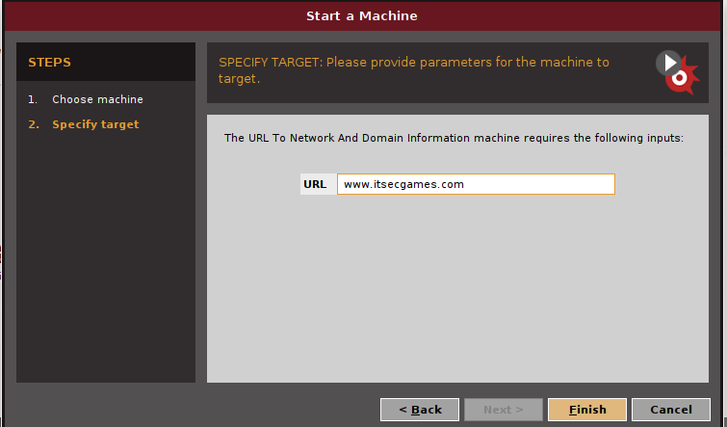
Figure 34
I then will specify the target to be ‘www.itsecgames.com’
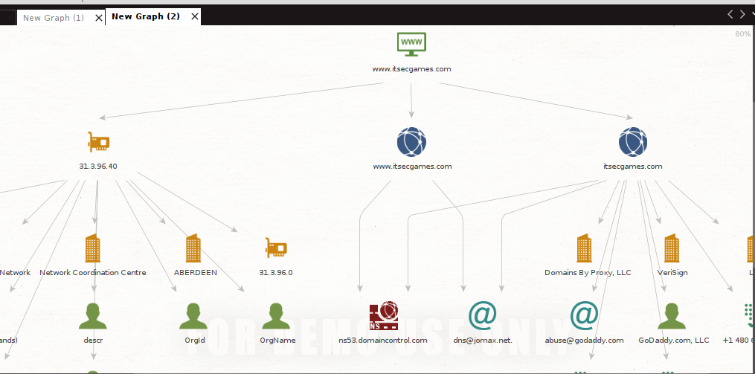
Figure 35
After clicking finish, the tool will then map out the network, gathering various details such as email addresses, IPv4 addresses, location details and phone numbers.
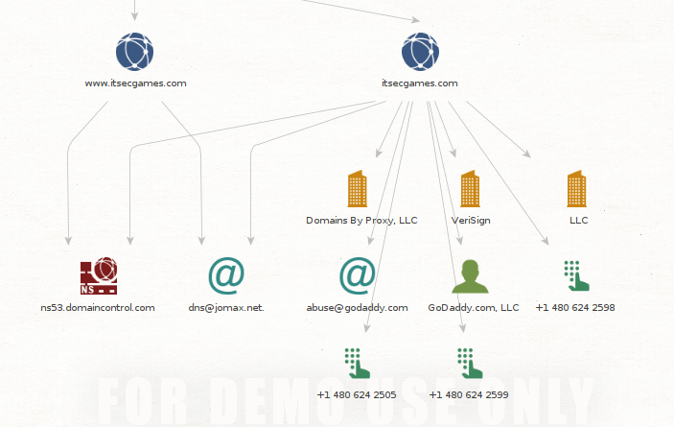
Figure 36
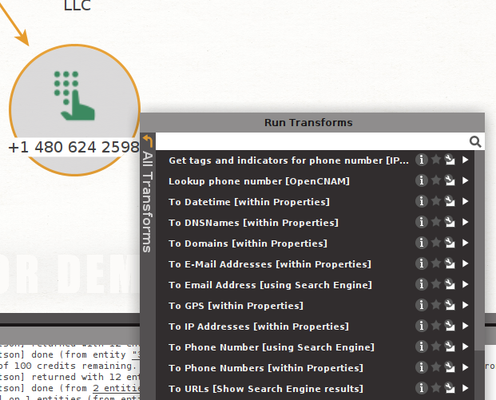
Figure 37
When right clicking an entity, a user may be able to run transforms.
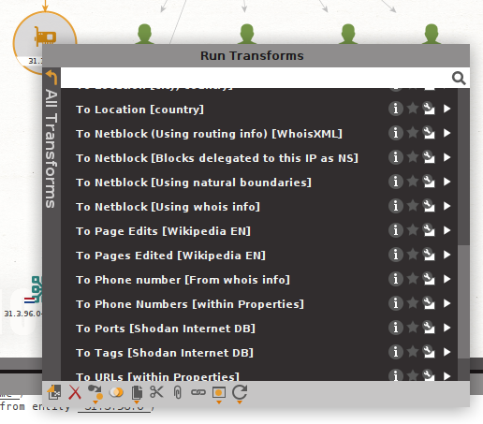
Figure 38
Depending on the entity type, one may be able to verify pjone numbers or use routing info on certain IP addresses.

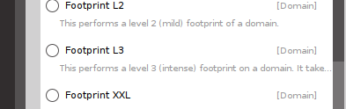
Figure 39
Alternatively we can attempt to run another machine. In this instance I will attempt to run ‘Footprint L3’.

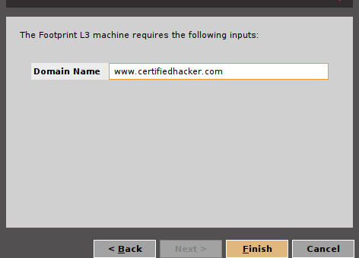
Figure 40
I will also attempt it on another educational based website such as ‘www.certifiedhacker.com’.

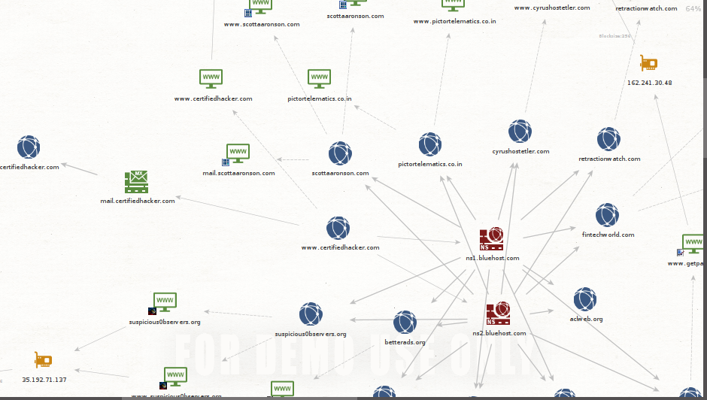
Figure 41
After clicking finish the tool may return a more detailed visualisation of the map.

Figure 42
Depending on the level of footprint, the higher will be more useful to organisations that have larger operations. If the network map is larger than expected, then the tool will appropriately label each entity according to its colour.

Pros: One of pros for Maltego is that it offers an easy to read visualisation on the mapping of a network. This can involve relationships between various entities throughout the network, such as IP addresses, employees, groups, other websites and networks and even documents [48] [49].

Cons: One of the cons Maltego is that it does not combine the location and names of entities. Another con is that the tool does not support translation or conversion of data from one language to another [37].

Social Engineering Toolkit
Pros: The pros to the social engineering toolkit is that the source code is widely available, which can lead to many new features potentially appearing on the tool. Another pro to the tool is that there are many social engineering attacks available on the toolkit such as penetrating testing, as well as attack methods such as phishing or baiting attacks [50].

Cons: A con to the social engineering toolkit is that it is not supported on Windows, which may prevent certain user from learning and defending against attack methods within the toolkit.

Summary: In summary, Maltego is an effective tool for social engineering as a large amount of information can be gathered about an organisation, from IP addresses to social groups within an organisations network. In comparison to alternative tools such as Social Engineering toolkit, it is a good foundation for an attackers hacking phase. The tool can also be effective or organisations like ‘Lending Hands’ to best defend against such vulnerabilities detected with the tool [51] [52].

Activity 6
Ettercap
Implementation and features:

Figure 43
To begin the implementation of Ettercap, I began searching for the tool within Kali Linux.

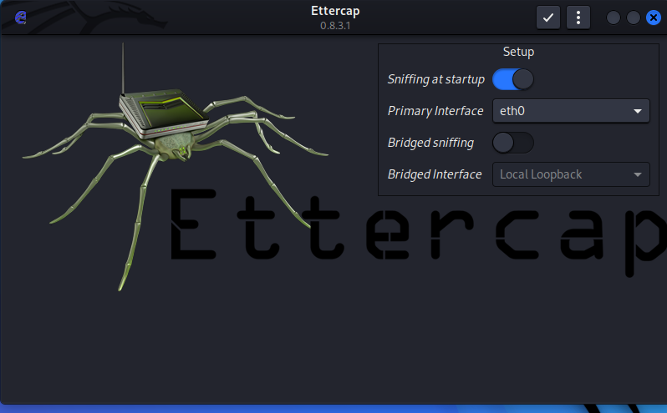
Figure 44
Upon launching the tool I set the network to sniff as ‘eth0’ and to sniff on start up.
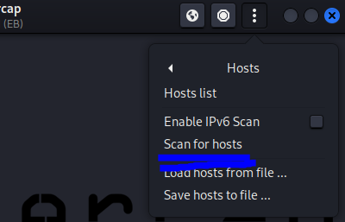
Figure 45
To gain hosts, I press the additional information menu -> hosts and then scan for hosts.
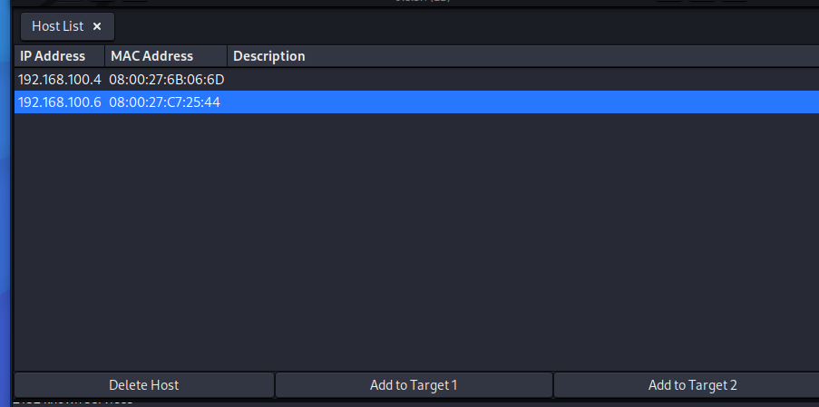
Figure 46
Upon the completion of the scan, I was able to detect 2 virtual machines with their IP addresses.
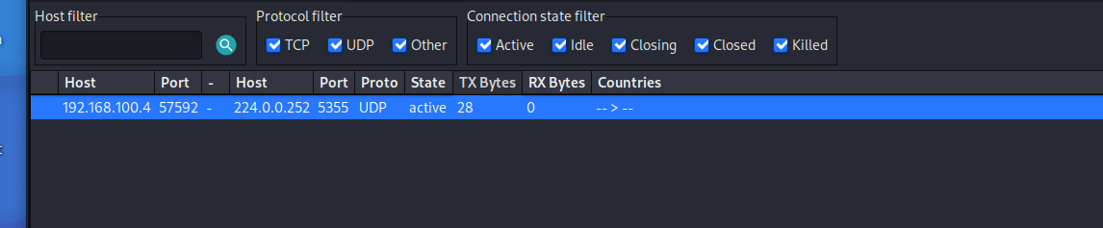
Figure 47
To learn more information, I may go into the additional information menu and then view connections.
Figure 48
When the connections have been acknowledged, I may be able to add the IP addresses to 2 target lists for future attacks.
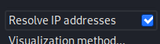
Figure 49
When viewing the connections I may also resolve any IP addresses.
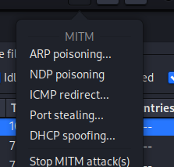
Figure 50
To now attack the targets, I will click the MiM menu and then proceed to run a ARP Poisoning.
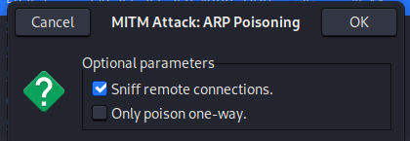
Figure 51
Before running the attack, I can enable the attack to sniff remote connections.
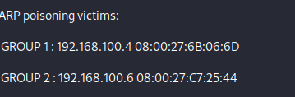
Figure 52
Once the attack has run, the tool will then acknowledge that the two target groups are now being targeted with ARP Poisoning attacks.
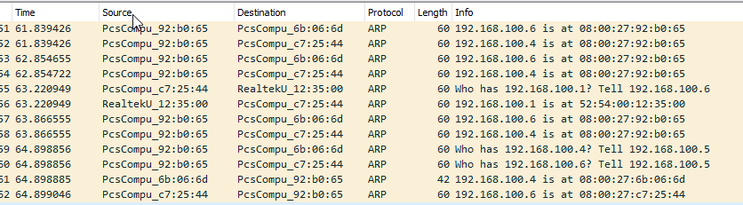
Figure 53
To confirm if the attacks are working as intended, I may launch wireshark within Kalli Linux. As shown in the figure above, the tool is now send ARP packets to both of the targets. Should one of the machines now open a website login page that does not have a HTTPS encryption, then attackers may use this to gather username and password information.
Figure 54
Alternatively, the tool also supports other attack methods such as NSP Poisoning and DHCP spoofing.

Ettercap
Pros: The pros of Ettercap is that allows for scanning of IP addresses within a network making it an effective tool for reconnaissance as well as hacking. The tool allows its user to analyses the protocols and connections made within a network. The tool allows for multiple methods to attack such as ICMP redirection or Port stealing. Another pro to the tool is that it is completely free to use and easy to download [53].

Cons: The disadvantages the tool has is that is quite outdated compared to other hacking tools such as Responder, especially in terms of its GUI. The tool is unsupported on other platforms such as Windows, which will limit the amount of user that may encounter the tool.

Responder
Pros: A advantage to Responder is that it comes inbuilt into Kali Linux’s packages, meaning it is easy to download and use. Another pro to Responder is that it provides effective methods of attack such using LMNR poisoning against target machines and gathering password hashes [54].

Cons: A con to the responder tool is that it can sometimes result in a unreachable device when attempting to run any penetration testing. Another con to the tool is that it cannot respond to requests that have been made within the ‘Analyse’ mode [55] [56].

Summary: In summary, both tools are effective in attacking systems and then gather information such password hashes, that can also be used further with tools such as Cain or Rainbow crack to crack the hashes from the systems.

Mitigation strategy proposal (1000 Words)
The Lending Hands NGO could be exposed in their technical security which attackers can exploit. To prevent these attacks, I will propose strategies that will enable Lending hands to strengthen any cybersecurity within their organisations.

Lending Hands Technical weakness
Within the Lending hands organisation, there may be technical weaknesses within their access control systems. This can involve the actions of tailgating from unauthorised personal, where employees will hold doors open out of common courtesy [57]. Mitigation to this would involve the use of mandatory ID badges for all employees in the organisation [57]. This would improve their security significantly as Lending Hands shares a workspace with 3 other businesses. Other mitigation strategies might involve the use of fingerprint scanning to better increase the security of Lending Hand’s workspace [58].
One Technical weakness that Lending Hands may have is the usage of domain controllers. This might be due to unauthorised access from users through compromised credentials belonging to users and admins [59] [60].This can even include the addition of guest domain users to local administrator groups [60].The mitigation for this would be to remove any guest users from local administrator groups or at least have there for a short period of time [60]. Mitigation strategies towards domain controller threats include the backing up of data, learning from any vulnerabilities detected with the domain controls and make sure that domain controllers do not use browsers as this could lead to malware being downloaded [61].

Potential security weaknesses and mitigation
Through the lab activities, Lending Hands may have additional technical weaknesses that require for them to strengthen their cybersecurity. As mentioned in the literature review, training staff members to be aware of any links sent to them, verify before clicking, check website security statuses and pay attention to the punctuation of URL and email links [62].To make defence against foot printing attacks stronger, training can even include the examination of a HTML source as well as cookies before clicking on any links or logins within a website [63].Protection against malicious websites through phishing may even be mitigated through certain tools similar to AntiPhish or even tools encountered in the lab activities such as Netcraft that provide anti-phishing services against malicious websites [64] [65].Another mitigation strategy mentioned in the literature review is establishing defence plans against social engineering attacks [18].
Other methods that may prove effective to prevent any footprinting measures is to delete any old or outdated software that can be exploited by attackers to gain information about the organisations network [66]. Other mitigation strategies may involve having less information being exposed about the organisation on the internet, as these details can be traced from public websites or work laptops [67].
To better defend against scanning attacks, research suggest that simply installing firewalls to better detect and cease any port scans, implementation of TCP wrappers or self-scanning tests to discover vulnerabilities in the network [68]. This can even be done using tools discovered in the lab activities such as Nmap or even an alternative tool such as Advanced IP Scanner [69]. Another mitigation to vulnerabilities is to establish IPS(Intrusion Prevention Systems) and IDS(Intrusion Detection System) within the organisations [70].
To test out these systems tools such Maltego or Social Engineering Toolkit may be used to measure the strength of these systems [70]. To further defend against social engineering attacks, Lending Hands may have to better strengthen their password polices in the workplace. This would involve using multi factor authentication, greater password complexity, a diversity of passwords and even changing password once a year [71].
A mitigation to vulnerabilities is to find the vulnerabilities themselves [72]. They can often include:-
- Any misconfigured devices leaving the network open to attackers
- Protocols left unsecured which leaves the network open to sniffing tools
- Any systems left unpatched, which may be due to neglection of technicians. This may lead to attackers inserting malicious software into the network.
A mitigation strategy to better defend against social engineering attacks involves having steps to verify a user that shares any files or links within or to the network [73]. This involves verifying emails by looking at the headers, observing the hyperlink that has been sent or ask for proof of identity [73]. Another method of mitigation for social engineering attacks include the hesitation when faced with a sense of urgency when being requested to click any links or download any malicious hardware [73].
Once necessary mitigation strategy against social engineering attacks is to implement spam filters in the organisations email software. Another strategy is also to ensure that the various system defences are enabled on each machine. This includes the activation of firewalls, the installation of any anti-virus software, ensure the verification of HTTPS websites and login pages, ensure that the organisations browser of choice has enhanced protection enabled [74].
Some research suggest that one mitigation strategy for defences against attacks such as ARP spoofing can include the use of a Spoof Detection System in place at the organisations workplace, which may involve the use of biometric access system [75] [76]. To prevent other forms of attacks such as ARP Poisoning, research suggest that simply verifying using tools such as arpwatch of X-ARP that can monitor a network and create alerts to member of staff with administrative privileges [77].
Figure 55
Discussed in the lab activities, A good mitigation strategy can include the implementation of tools such as Wireshark, as they may detect any ARP or LLMNR poisoning attacks, easily visualize them for users and filter the information captured [78]. Another effective mitigation against LLMNR poisoning attacks are ensuring to disable LLMNR, NBT-NS and ensuring that there is a network traffic filtration in place [79].

Conclusion
In conclusion, the Lending Hands NGO has a few notable technical weaknesses. Much more vulnerabilities can be identified with the use of tools within the lab activities and alternative tools used. Despite this, there are many mitigation strategies that can be implemented to further secure their cyber space.

Bibliography

[1] | A. Mathew, “Machine Learning in Cyber-Security Threats,” SSRN Electronic Journal, p. 7, 2021.
[2] | A. H. a. A. S. a. S. K. Shukla, “Machine learning in cybersecurity: A review,” Wiley Interdisciplinary Reviews: Data Mining and Knowledge Discovery, vol. 9, no. 4, p. 1, 2019.
[3] | M. Rege, “Machine Learning for Cyber Defense and Attack,” in The Seventh International Conference on Data Analytics, 2018.
[4] | O. F. M. J. L. S. M. A. Ferrag, “Federated Deep Learning for Cyber Security in the Internet of Things: Concepts, Applications, and Experimental Analysis,” IEEE Access, vol. 9, pp. 138509-138542, 2021.
[5] | A. H. a. K. Quresh, “Internet of Things Device Authentication Scheme Using Hardware Serialization,” International Conference on Applied and Engineering Mathematics, pp. 109-114, 2018.
[6] | A. S. F. A. M. K. K. J. I. M. U.-H. J. A. S. Liu Xiang, “Cyber security threats: A never-ending challenge for e-commerce,” Frontiers in Psychology, vol. 13, 2022.
[7] | A. A. S. M. V. C. O. L. F.-S. &. V. P. Blessing Guembe, “The Emerging Threat of Ai-driven Cyber Attacks: A Review,” Applied Artificial Intelligence, vol. 36, no. 1, pp. 2-35, 2021.
[8] | T.-S. Chou, “Security Threats on Cloud Computing Vulnerabilities,” International Journal of Computer Science and Information Technology, vol. 5, no. 3, pp. 79-88, 2013.
[9] | D. C. a. G. Hogben, “Cloud Computing Benefits, Risks and Recommendations for Information Security,” The European Network and Information Security Agency, 2009.
[10] | A. S. C. a. M. L. Dhore, “CIDT: Detection of Malicious Code Injection Attacks on Web Application,” International Journal of Computer Applications, vol. 52, no. 2, pp. 19-26, 2012.
[11] | S. Pericherla, “Cloud Computing Threats, Vulnerabilities and Countermeasures: A State-of-the-Art,” The ISC International Journal of Information Security, vol. 15, no. 1, pp. 1-58, 2022.
[12] | A. A.-Y. Nabeel Khan, “Identifying Cloud Security Threats to Strengthen Cloud Computing Adoption Framework,” Procedia Computer Science, vol. 94, pp. 485-490, 2016.
[13] | S. K. a. P. Carayon, “A HUMAN FACTORS VULNERABILITY EVALUATION METHOD FOR COMPUTER AND INFORMATION SECURITY,” in Proceedings of the Human Factors and Ergonomics Society Annual Meeting, Wisconsin, 2003.
[14] | M. L. F. E. B. a. Z. Q. Kwesi Hughes-Lartey, “Human factor, a critical weak point in the information security of an organization's Internet of things,” Heliyon, vol. 7, no. 3, pp. 1-13, 2021.
[15] | S. K. C. C. K. N. P. P. S. K. E. P. a. S. B. Nifakos, “Influence of Human Factors on Cyber Security within Healthcare Organisations: A Systematic Review,” Sensors, vol. 21, no. 15, p. 5119, 2021.
[16] | W. A. A. R. e. a. Gordon WJ, “Assessment of Employee Susceptibility to Phishing Attacks at US Health Care Institutions,” JAMA Netw Open., pp. 1-9, 9 3 2019.
[17] | G. E. X. S. Montañez Rosana, “Human Cognition Through the Lens of Social Engineering Cyberattacks,” Frontiers in Psychology, vol. 11, pp. 1-18, 2020.
[18] | F. a. N. K. Salahdine, “Social Engineering Attacks: A Survey,” Future Internet, vol. 11, no. 4, p. 89, 2019.
[19] | D. Waterson, “How Keyloggers Work and How To Defeat Them,” OUP Public Health Emergency Collection , vol. 63, no. 1, pp. 40-41, 2021.
[20] | M. E. W. H. J. Mattord, “Software Attacks,” in Principles of Information Security, Cengage Learning, 2016, p. 82.
[21] | D. E. Denning, “Stuxnet: What Has Changed?,” Future Internet , vol. 4, no. 3, pp. 672-687, 2012.
[22] | P. a. B. Y. Mueller, “The Stuxnet Worm,” Département des sciences de linformatique, pp. 466-566, 2012.
[23] | K. K. N. Z. Sajal K. Das, “Chapter 25 - Security and Privacy in the Smart Grid,” in Handbook on Securing Cyber-Physical Critical Infrastructure, Elsevier Inc. , 2012, pp. 637-654.
[24] | J. Valinsky, “Marriott discloses data breach possibly affecting over 5 million customers,” CNN Business, 1 4 2020. [Online]. Available: https://edition.cnn.com/2020/04/01/business/marriott-hack-trnd/index.html. [Accessed 2 12 2022].
[25] | M. A. W. P. a. M. A. S. Siddiqi, “A Study on the Psychology of Social Engineering-Based Cyberattacks and Existing Countermeasures,” Applied Sciences, vol. 12, no. 12, p. 6042, 2022.
[26] | L. K. A. K. M. Tong, “How to design and strengthen cyber security to cope with data breach in the hotel industry?,” in APacCHRIE 2022 Conference, Hong Kong, 2022.
[27] | H. C. N. L. K. I. Alkhalil Zainab, “Phishing Attacks: A Recent Comprehensive Study and a New Anatomy,” Frontiers in Computer Science, vol. 3, pp. 1-23, 2021.
[28] | A. S. H. a. D. E. S. Djenna, “Internet of Things Meet Internet of Threats: New Concern Cyber Security Issues of Critical Cyber Infrastructure,” Applied Sciences , vol. 11, no. 10, p. 4580, 2021.
[29] | E. G. N. R. J. ,. A. D. Saira Ghafur, “The challenges of cybersecurity in health care: the UK National Health Service as a case study,” Lancet Digital Health, vol. 1, no. 1, pp. 1-3, 2019.
[30] | A. Chadd, “DDoS attacks: past, present and future,” Network Security, vol. 2018, no. 7, p. 1, 2021.
[31] | A. V. A. S. a. M. N. M. Pelloso, “A Self-Adaptable System for DDoS Attack Prediction Based on the Metastability Theory,” IEEE Global Communications Conference, vol. 8, no. 6, pp. 1-6, 2018.
[32] | National Cyber Security Centre, “Annual Review 2020,” 2020. [Online]. Available: https://www.ncsc.gov.uk/files/Annual-Review-2020.pdf. [Accessed 4 12 2022].
[33] | M. A. a. C. Bach, “Defense Mechanisms For Computer-Based Information Systems,” International Journal of Network Security & Its Applications (IJNSA), vol. 5, no. 5, pp. 1-7, 2013.
[34] | S. H. Sittig DF, “A Socio-Technical Approach to Preventing, Mitigating, and Recovering from Ransomware Attacks,” Applied clinical informatics, vol. 7, no. 2, pp. 624-632, 2016.
[35] | Advanced IP Scanner, “Advanced IP Scanner - Download,” Famatech, 2022. [Online]. Available: https://www.advanced-ip-scanner.com/ . [Accessed 7 1 2023].
[36] | HostedScan, “Vulnerability scans, automated for any business,” HostedScan, 2023. [Online]. Available: https://hostedscan.com/. [Accessed 7 1 2023].
[37] | P. Z. D. L. Parul Khanna, “Experimental Analysis of Tools Used for Doxing and Proposed New Transforms to Help Organizations Protect against Doxing Attacks,” Procedia Computer Science, vol. 94, pp. 459-464, 2016.
[38] | Maltego, “What is Maltego?,” Maltego, 28 9 2022. [Online]. Available: https://docs.maltego.com/support/solutions/articles/15000019166-what-is-maltego-. [Accessed 7 1 2023].
[39] | D. Norton, “An Ettercap Primer,” Computer Science, 2004.
[40] | Kali Linux, “SubFinder -- Discover Hidden Sub-Domains,” Kali Linux, 5 11 2021. [Online]. Available: https://www.kalilinux.in/2021/10/subfinder-discover-hidden-sub-domains.html. [Accessed 8 1 2023].
[41] | PentesterLand, “Subdomains Enumeration Cheat Sheet,” PentesterLand, 14 11 2018. [Online]. Available: https://pentester.land/blog/subdomains-enumeration-cheatsheet/#subfinder. [Accessed 8 1 2023].
[42] | Six2dez, “Subdomains Tools Review: a full and detailed comparison of subdomain enumeration tools,” Blog - Yes We Hack, 18 2 2022. [Online]. Available: https://blog.yeswehack.com/yeswerhackers/subdomains-tools-review-full-detailed-comparison/. [Accessed 8 1 2023].
[43] | J. Santos, “Advance IP Scanner Review: Secure Your Network and View Results Effortlessly,” Top Reviews, 4 11 2022. [Online]. Available: https://www.topsevenreviews.com/advanced-ip-scanner-review/. [Accessed 8 1 2023].
[44] | M. Santillana, Software informer, 16 7 2022. [Online]. Available: https://megaping.informer.com/. [Accessed 8 1 2023].
[45] | S. Cooper, “Nessus Vulnerability Scanner Review,” Compritech, 10 10 2022. [Online]. Available: https://www.comparitech.com/net-admin/nessus-vulnerability-scanner-review/. [Accessed 8 1 2023].
[46] | R. Bhardwaj, “Nessus: Network Vulnerability Scanner,” Network Interview, 2022. [Online]. Available: https://networkinterview.com/nessus-network-vulnerability-scanner/. [Accessed 8 1 2023].
[47] | “Jason Hoffman,” Wisdom Plexus, [Online]. Available: https://wisdomplexus.com/blogs/openvas-vs-nessus/#NessusPros. [Accessed 7 1 2023].
[48] | R. C. Klaus Schwarz, “Design of Professional Laboratory Exercises for Effective Stateof-the-Art OSINT Investigation Tools - Part 3: Maltego,” International Symposium on Electronic Imaging, pp. 1-24, 2021.
[49] | H. Jethva, “Top 10 Best Open Source Intelligence Tools – OSINT – (Pros and Cons),” Cloud Infrastructure Services, 12 10 2022. [Online]. Available: https://cloudinfrastructureservices.co.uk/top-10-best-open-source-intelligence-tools-osint/. [Accessed 8 1 2023].
[50] | Linux Security, “Social-Engineer Toolkit (SET),” Linux Security, 8 5 2021. [Online]. Available: https://linuxsecurity.expert/tools/social-engineer-toolkit-set/. [Accessed 8 1 2023].
[51] | PhoenixTS, “The Social Engineering Toolkit (SET) and Maltego,” PhoenixTS, 28 1 2016. [Online]. Available: https://phoenixts.com/blog/the-social-engineering-toolkit-set-or-maltego/. [Accessed 8 1 2023].
[52] | G. Khawaja, “Internet Information Gathering,” in Kali Linux Penetration Testing Bible, Wiley, 2021, pp. 89-103.
[53] | S. Cooper, “Ettercap Review Including Alternatives,” Comparitech, 9 3 2022. [Online]. Available: https://www.comparitech.com/net-admin/ettercap-review/. [Accessed 8 1 2023].
[54] | Travis, “How To Use Responder In Kali Linux,” Systran Box, 26 2 2022. [Online]. Available: https://www.systranbox.com/how-to-use-responder-in-kali-linux/. [Accessed 8 1 2023].
[55] | Giedrius, “Is It Safe to Use Responder During a Pentest?,” Bug Hacking, 23 2 2022. [Online]. Available: https://bughacking.com/is-it-safe-to-use-responder-during-a-pentest/. [Accessed 8 1 2023].
[56] | D. Dieterle, “Quick Creds with Responder and Kali Linux,” Cyber Arms, 2 2022. [Online]. Available: https://cyberarms.wordpress.com/2018/01/12/easy-creds-with-responder-and-kali-linux/. [Accessed 8 1 2023].
[57] | Enhanced Telecommunications, “Access Control Points that are Easy to Overlook,” Enhanced Telecommunications, 29 3 2019. [Online]. Available: https://www.etd.com/access-control-weak-links/#:~:text=The%20biggest%20weakness%20for%20access,someone%20coming%20in%20behind%20them.. [Accessed 9 1 2023].
[58] | Secure Pass, “Access control systems: types, advantages, & disadvantages,” Secure Pass, 9 2021. [Online]. Available: https://thesecurepass.com/blog/access-control-system. [Accessed 9 1 2023].
[59] | Pondurance, “The Domain Controller...An Achilles' Heel,” Pondurance, 2021. [Online]. Available: https://www.pondurance.com/resource/whitepapers/domain-controller-compromises/. [Accessed 9 1 2023].
[60] | J. Carson, “Active Directory Security and Hardening: An Ethical Hacker’s Guide to Reducing AD Risks,” Delinea, 2023. [Online]. Available: https://delinea.com/blog/active-directory-security-guide-to-reducing-ad-risks. [Accessed 9 1 2023].
[61] | D. Murphy, “Securing Domain Controllers to Protect Active Directory – Why and How?,” Lepide, 12 10 2022. [Online]. Available: https://www.lepide.com/blog/securing-domain-controllers-to-protect-active-directory-why-and-how/#:~:text=Possible%20Threats%20to%20Domain%20Controler,-A%20hacker%20who&text=leak%20the%20security%20configuration%20information,computers%2C%20users%2C%20and%. [Accessed 9 1 2023].
[62] | IT Governence, “What is Social Engineering? Examples & Prevention Tips,” IT Governence, 9 1 2023. [Online]. Available: https://www.itgovernance.co.uk/social-engineering-attacks. [Accessed 8 1 2023].
[63] | Grey Campus, “Footprinting Methodology,” Grey Campus, 2023. [Online]. Available: https://www.greycampus.com/opencampus/ethical-hacking/footprinting-methodology. [Accessed 9 1 2023].
[64] | E. K. a. C. Kruegel, “Protecting users against phishing attacks with AntiPhish,” in 29th Annual International Computer Software and Applications Conference, 2005.
[65] | M. Foster, “Netcraft Analysis: Online Speed Testing Tools,” 25 2 2013. [Online]. Available: https://www.setda.org/master/wp-content/uploads/2013/09/Netcraft-Analysis_-Online-Speed-Testing-Tools.pdf. [Accessed 8 1 2023].
[66] | A. Ainhoren, “5 Must-Know Tips for Reducing Your Company's Digital Footprint,” Rapid 1, 7 8 2018. [Online]. Available: https://www.rapid7.com/blog/post/2018/08/07/5-must-know-tips-for-reducing-your-companys-digital-footprint/. [Accessed 9 1 2023].
[67] | Codepath, “Footprinting,” Codepath, [Online]. Available: https://guides.codepath.com/websecurity/Footprinting. [Accessed 9 1 2023].
[68] | T. G. Mesevage, “What Is Port Scanning?,” Datto, 1 8 2022. [Online]. Available: https://www.datto.com/uk/blog/what-is-port-scanning#:~:text=Install%20a%20Firewall%3A%20A%20firewall,progress%20and%20shut%20them%20down.. [Accessed 8 1 2023].
[69] | C. Badrick, “DEFENDING AGAINST PORT SCAN ATTACKS,” Turn-Key Technologies, 3 1 2019. [Online]. Available: https://www.turn-keytechnologies.com/blog/article/defending-against-port-scan-attacks/. [Accessed 9 1 2023].
[70] | P. Z. L. Parul Khanna, “Experimental Analysis of Tools Used for Doxing and Proposed New Transforms to Help Organizations Protect against Doxing Attacks,” Procedia Computer Science, vol. 94, pp. 459-464, 2016.
[71] | R. Grimes, “How Hackers Steal Passwords & Protection Tips,” KnowBe4, 26 4 2022. [Online]. Available: https://blog.knowbe4.com/how-hackers-get-your-passwords-and-how-to-defend. [Accessed 7 1 2023].
[72] | V. Paula, “Network Vulnerability Scanning: How to Mitigate Security Risks,” IT Chronicles , 12 9 2022. [Online]. Available: https://itchronicles.com/security/network-vulnerability-scanning-how-to-mitigate-security-risks/. [Accessed 9 1 2023].
[73] | Kapersky, “Ways to avoid social engineering attacks,” Kapersky, 2023. [Online]. Available: https://www.kaspersky.co.uk/resource-center/threats/how-to-avoid-social-engineering-attacks. [Accessed 9 1 2023].
[74] | J. T. Nguyen, “Five Ways to Prevent Social Engineering Attacks,” Maureen Data Systems, 2018. [Online]. Available: https://www.mdsny.com/5-ways-to-prevent-social-engineering-attacks/. [Accessed 9 1 2023].
[75] | K. A. V. R. R. Nixon, “ Spoof Detection Schemes,” in Handbook of Biometrics, Boston, Springer, 2008, pp. 403-404.
[76] | P. Pandey, “Prevention of ARP spoofing: A probe packet based technique,” in 3rd IEEE International Advance Computing Conference, 2013.
[77] | R. Grimmick, “ARP Poisoning: What it is & How to Prevent ARP Spoofing Attacks,” Varonis, 27 4 2021. [Online]. Available: https://www.varonis.com/blog/arp-poisoning. [Accessed 9 1 2023].
[78] | CompTIA, “What Is Wireshark and How Is It Used?,” CompTIA, [Online]. Available: https://www.comptia.org/content/articles/what-is-wireshark-and-how-to-use-it. [Accessed 9 1 2023].
[79] | S. Grinberg, “LLMNR & NBT-NS Poisoning and Credential Access using Responder,” Cynet, 8 6 2020. [Online]. Available: https://www.cynet.com/attack-techniques-hands-on/llmnr-nbt-ns-poisoning-and-credential-access-using-responder/. [Accessed 9 1 2023].

Annexure

Activity 2
Part 1
1. What is the outcome of the above two ping commands? What is the reason for the two outcomes?
Answer= The outcome for the two commands are that both failed to ping. The reasoning for this is that 1472 and 1743 are bad values for the “-I" command as it means to apply TTL or Time to Live setting to the ping. The outcome for the commands states that the range for the -I command must be 1 to 255. Reference= https://www.howtogeek.com/355664/how-to-use-ping-to-test-your-network/
2. By issuing the -i command, you are setting the TTL to a certain value to check the time span of the packet. By setting the TTL to 1, 2, 4, 5, 9 etc what piece of information did you gather?
Answer= By issuing the -I command I would change the number of hops the packet will send. Using –I 5 to –I 12 resulted in the packet expiring in transit, yet when using -I 14, the IP then sent a reply meaning it took 14 hops for the packet to send to the IP.
Evidence= 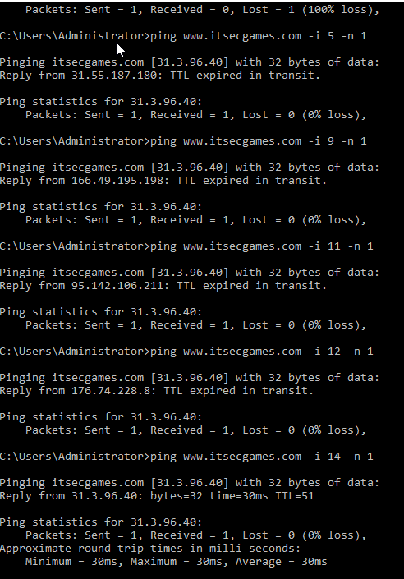
3. Do a research in the internet and find out what are the options, you can use with ping command and what are their functionalities with suitable example?
Answer= Other ping commands can include –r which detail the amount of hops you want to perform in a ping. Another command for example is using the –s command which will determine the number of hops you want to be timestamped.
Evidence= 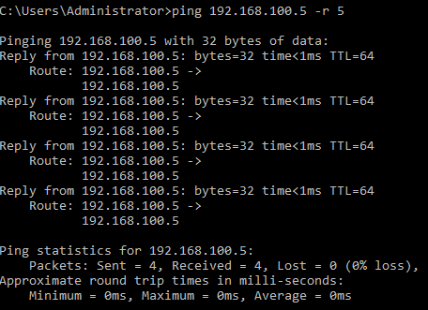
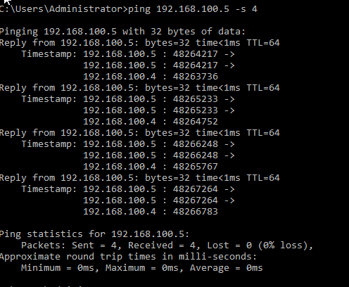
Reference= https://www.whatsupgold.com/blog/it-basics-the-ping-utility-explained https://www.paessler.com/it-explained/ping https://www.lifewire.com/ping-command-2618099
4. By issuing the above steps, you may get the records of domain from an authoritative server. What is so important in getting the information like this?
Answer= The reason that it is important in getting a server this way as it will enable any administrator to troubleshoot any connection issues a network may have. This can also help the discovery of any vulnerabilities that attackers can take advantage of.
Reference= https://learn.microsoft.com/en-us/windows-server/administration/windows-commands/ping .
5. How can we prevent our Infrastructure from these kinds of attack? Could you reflect your reviews in a short description with appropriate citations? Why do we get an output like this?
Answer= The number of ways one can prevent these kind of attacks is to establish firewalls.
Reference= https://purplesec.us/prevent-ping-attacks/
Part 3
1. What information did you gather? Did you get the result below? If so, why? If not, what would be the reason for an outcome like the below one?
Answer= The result I received was the one shown below. The reasoning for this is that the website's coding within the syntax may be may have spelling mistakes and or it is offline. Reference= https://www.ionos.co.uk/help/hosting/troubleshooting-for-php/what-is-a-parse-error/#:~:text=If%20the%20PHP%20code%20contains,missing%20brackets%2C%20or%20extra%20characters.
Evidence= 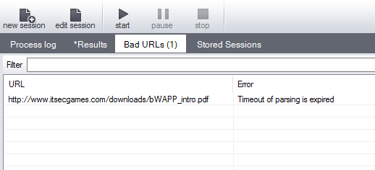

2. What information did you gather?
Answer= The information gathered was phone numbers, fax details, metadata, links and eamil addresses associated with the target website.
Evidence= 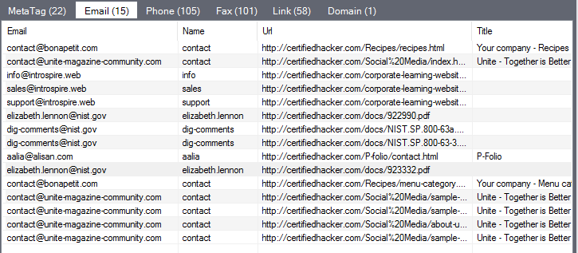
Part 4
9. What information did you gather?
Answer= The information I gathered on one of the emails associated with the target website is an IP address, what mail server it is running, what port it is running on and if there is a HTTP and FTP server running. Additional information gathered is the location of the server and all hop IP addresses and names.
Evidence= 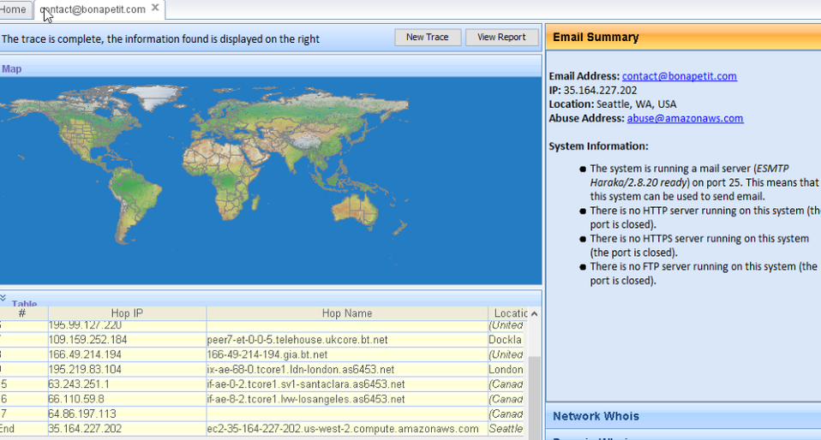
Part 5
1. Search internet for TCPView Software. List out the websites which offers a download. Which website/ link do you think is safe to download the software? Why?
Answer= The link I downloaded the tool from was the official link for tool, as this decreased the likely hood of downloading malicious software.
2. How many Endpoints are listed? How many are Listening? How many Endpoints are Established?
Answer= The number of endpoints that are listed are 88. The number of endpoints that are listening are 23, while the number of endpoints established are 21.
Evidence=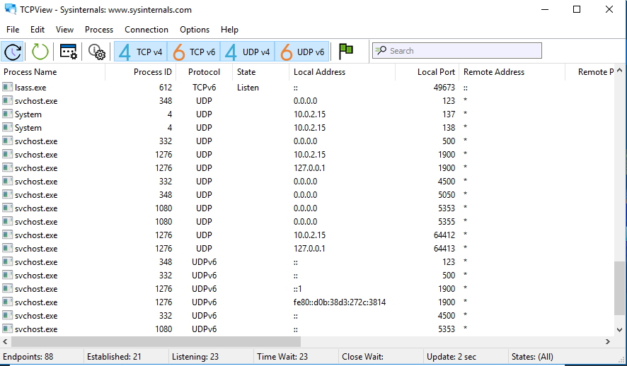
3. Open any browser and browse any website. Eg: google.com, cisco.com etc What happens in the TCPView window?
Answer= The TCPView window will add more endpoints and determine which are established and listening. For example, since I had google open, when running TCPView, the endpoints were 88, whereas they would be lower if the browser were closed.
Evidence=
You could see a lot of colors highlighting in the tool. What is represented by the colors? Close a process (my choice would be the web browser) and see what happens?
Answer= When closing a process, such as google chrome, the endpoints decreased to 46, while 2 were established and still 23 listening.
Evidence=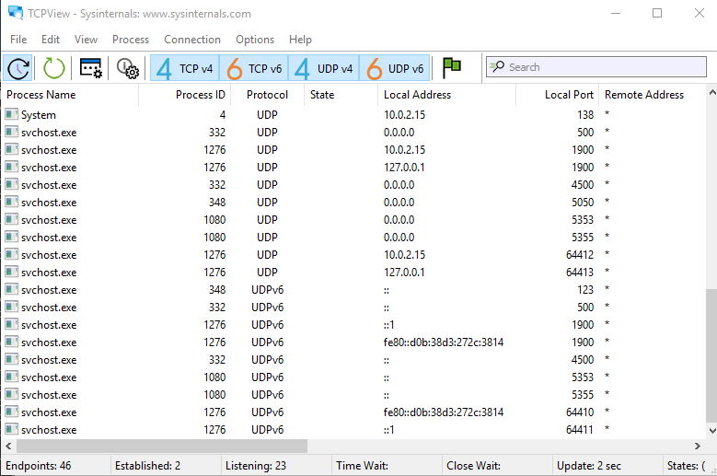
Part 6
1. What information did you gather?
Answer= The information I gathered was host information with 90 total hosts found.
Evidence= 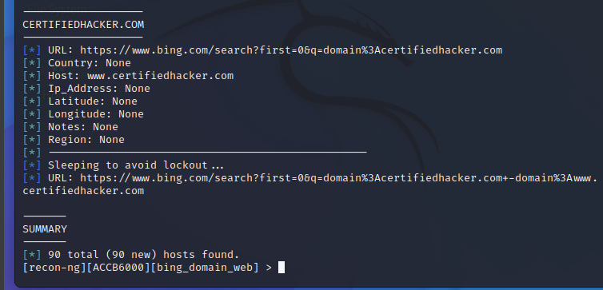
2. Do research on the internet and find out other modules to find out more hosts. Document them with their operations, functions, and screenshots.
Answer=
Evidence=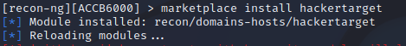
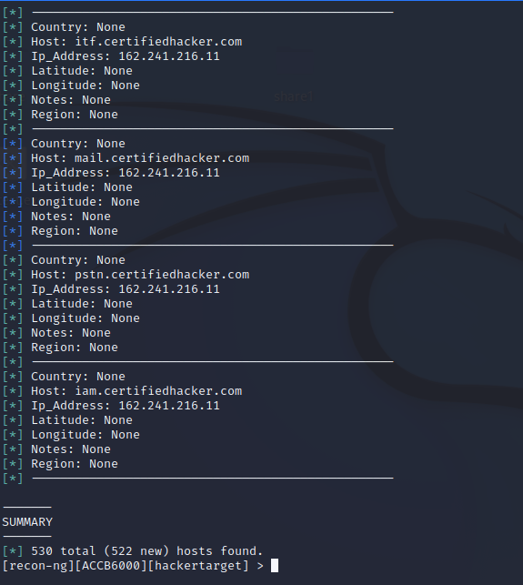
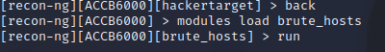
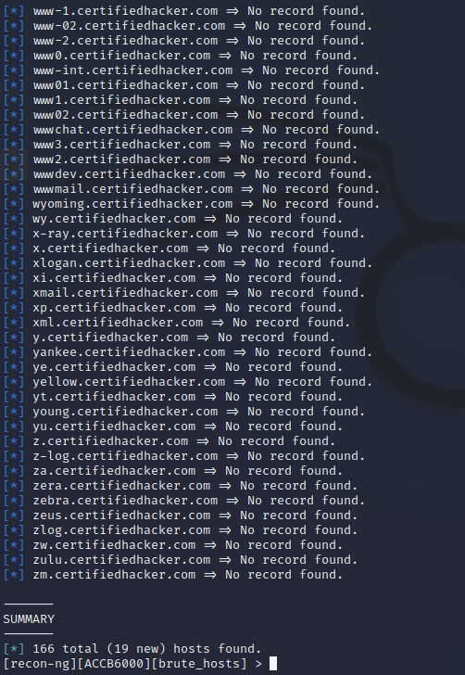
Reference= https://hackertarget.com/recon-ng-tutorial/ https://hannahsuarez.github.io/2017/recon-ng-modules/

Activity 3
Part 1
- What is the other method to send an ICMP packet?
Answer= Another method to send a ICMP packet, is to use to ping function which will send a ICMP echo request. Reference= https://linuxhint.com/understanding-icmp-echo-requests/#:~:text=Sending%20an%20ICMP%20Echo%20Message,it%20to%20the%20specified%20device.
- What are the other TCP flags? List out the commands to send other TCP flags, execute the commands and capture the outputs. Write a brief note to reflect your understanding on using HPING to send TCP flags. Include what is the purpose, what intelligence did you gather etc
Answer= Other commands that can be done are commands such as “hping3 -F –P -U 192.168.100.6 -p 80 –c 1”. This will test a port number 80 and perform the ‘XMas scan’. The information I gathered using this command was that port 80 was closed as it replied with a RA flag.
Evidence= 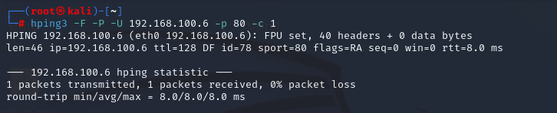

Reference= https://iphelix.medium.com/hping-tips-and-tricks-85698751179f
- Based on your observation and research done so far with HPING tool, what is your understanding about the usage of this tool? Could you list out the pros and cons of using this tool?
Answer= Based on my observation the hping3 tool can be effective in the reconnaissance phase of hacking. The various commands can retrieve useful information about a network such as whether it is open or not and what are the response times.
Reference= https://www.ncbi.nlm.nih.gov/pmc/articles/PMC7506579/ https://www.techrepublic.com/article/solutionbase-see-what-hackers-see-with-the-hping-utility/
- By sending this UDP packet, what did you observe at the Target machine? Demonstrate the steps of Observation here. (Document the Outcome)
Answer= What I observed on the target machine was a tcp packet sending an acknowledgement packet from a different ip address. The length of the packet was 0.
Evidence=

- Observe the TCP Packets in the Target using Wireshark. Could you locate the TCP Packets? (Document the Outcome)
Answer= Using wireshark on the target machine, I was able to observe the tcp packets being sent from the attacker machine.
Evidence= 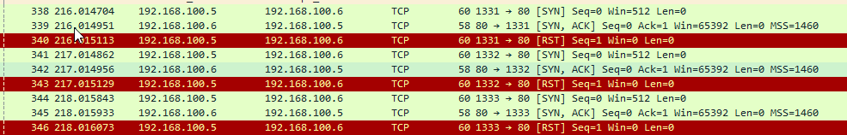

- Observe the flooding TCP Packets in the Target machine using Wireshark. Could you look at the information of TCP packets transmitted to and from attacker machine?
Answer= Using wireshark I was able to view the TCP packet flood, as well as the packets from and to the target and attacker machines.
Evidence= 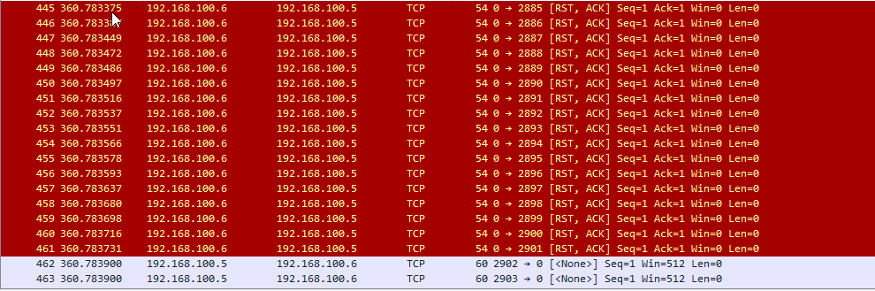
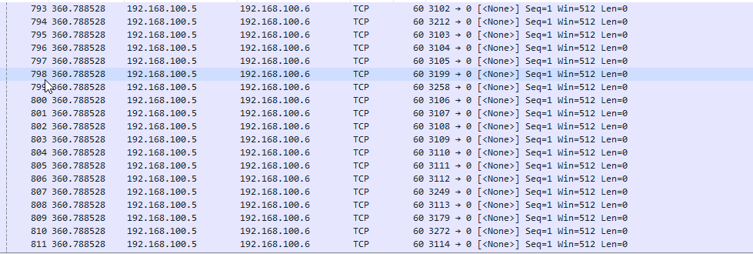

Part 2
- Do an Internet Search about MegaPing. What is this tool for? Which website did you download MegaPing? Why?
Answer= Megaping is used to scan an entire networks , which will then provide detailed information about shared folders, services drives, open ports and many other pieces if information. The link I downloaded the tool from was the tools official page. This was to decrease the likely hood of downloading malicious software and being targeted by attackers.
Reference= https://magnetosoft.com/product-megaping/#:~:text=MegaPing%20can%20scan%20your%20entire,domains%2C%20printers%2C%20and%20more.
- Based on your research earlier at Step 2, you might have known that MegaPing tool could look for potential vulnerabilities within your network. Did you manage to discover any vulnerabilities in your network?
Answer= The vulnerabilities I discovered using the tool was the elevated risk on ports 80 and 139 on the windows 12 machine. I also found vulnerabilities on the ports 135,445,2103,2105.
Evidence= 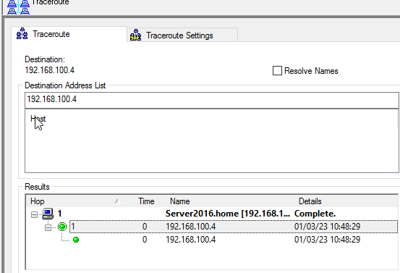
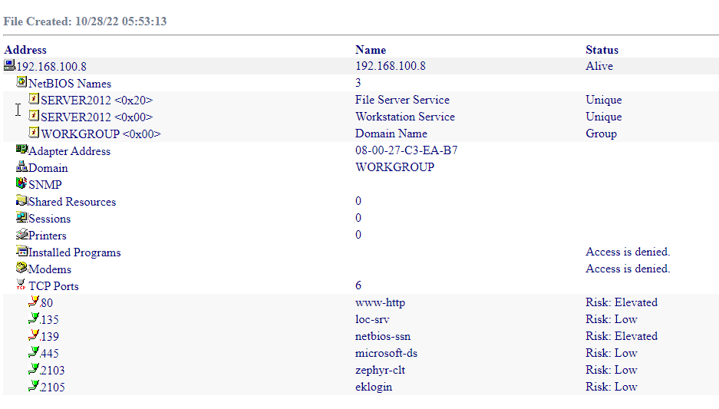
Part 3
- Based on your usage of this tool, and earlier tools within your lab network, what are the additional details you gathered after using this tool?
Answer= The additional details I have gathered using this tool was information concerning mac addresses, response times, IP address, host names, I/f manufacturer names, possible OS information, netBIOS and domain names.
Evidence= 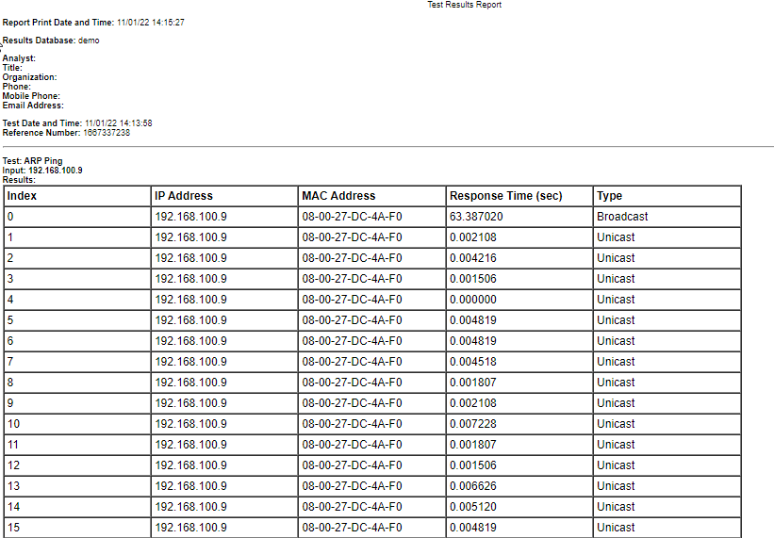
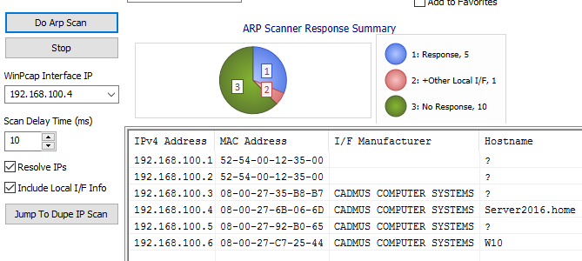
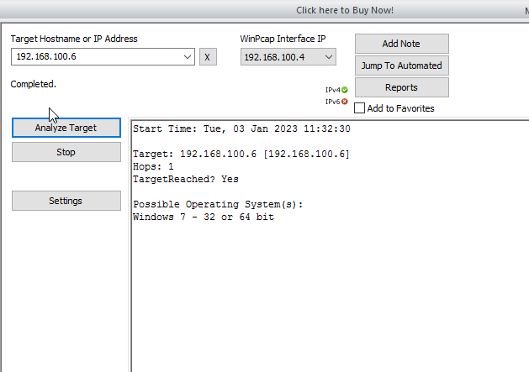
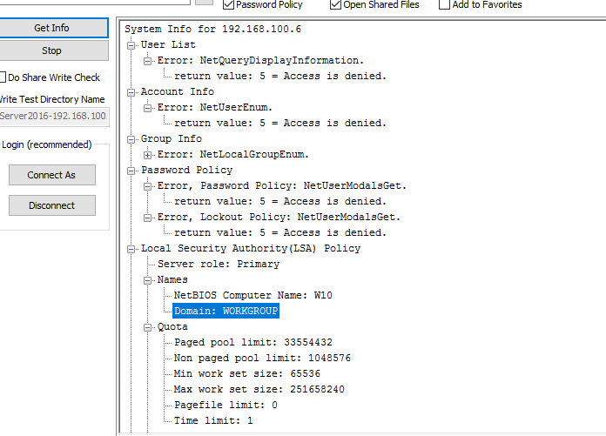
Part 4
- We are initiating ACK Scan to display the port. Could you observe that the ports are in ignored states. ✓ Why? ✓
Answer= The reason why the ports are in an ignored states is because the tool could not properly determine the state of the port.
Reference= https://forums.itpro.tv/topic/4075/nmap-problems
- Is it because of Firewall? Is our Firewall Off or On? Try the viceversa
Answer= The difference between the scans with and without firewalls on is that without the firewalls, the scan took 6.75 seconds. Yet when the firewall was on, the scan took 21.71 seconds to complete. Evidence= 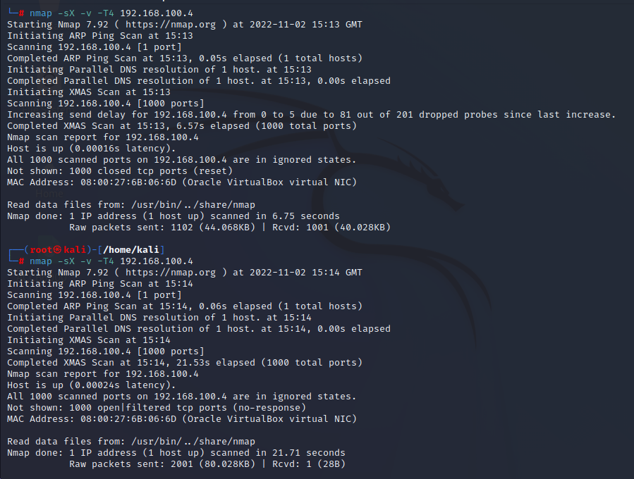
- In all my scans, the ports are in ignored states. Could you able to find out a way to identify the status of the ports? Do some research
Answer= A way to determine the status of ports is to issue a –sU command within nmap. This will send a udp packet to a target ip’s ports and will determine the status of port if any response has been received. Alternatively the –open command can also be used to scan any ports that have an open state.
Evidence= 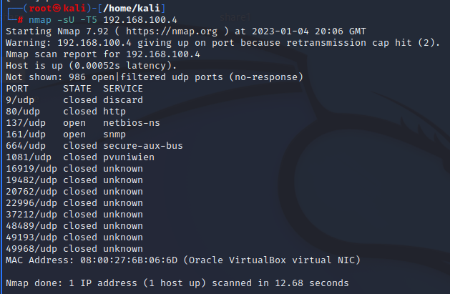
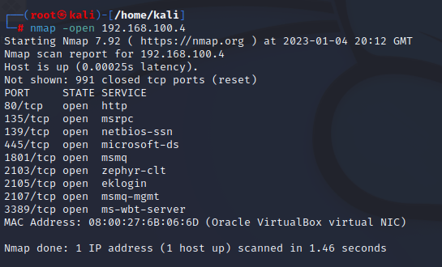
Reference= https://techtalk.gfi.com/scanning-open-ports-in-windows-part-3-nmap/

- Observe the output. Why is the difference?
Answer= The difference between the scans is that first scan, nmap could not determine the IP 192.168.100.4’s IP ID sequence generation, which then led to the entire command being dropped. The next scan was able to determine the IP ID sequence of 192.168.100.6 which resulted in the IP being used as a zombie machine against 102.168.100.4.
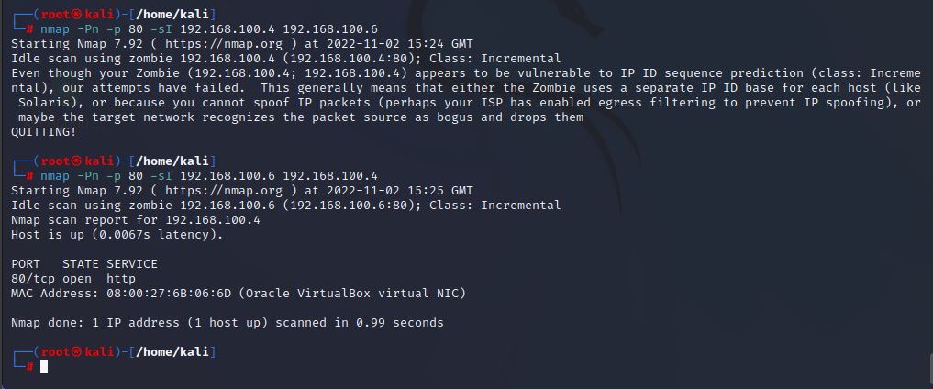
Reference= https://nmap.org/presentations/CanSecWest03/CD_Content/idlescan_paper/idlescan.html https://nmap.org/book/osdetect-usage.html
- Observe the output.
Answer= The output I have observed is that all IP addressed within the networks is active.
Evidence=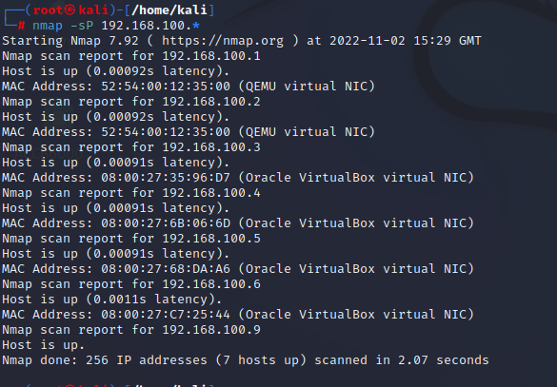
- After using various tools so far, what are the details you have gathered? Document them. Include your previous activity information too
Answer= The details I have gathered so far from the tools gathered
Part 5
- Which link did you use to download the tool? Why? What is the purpose of this tool?
Answer= The link I downloaded the tool from was the official link as this was likely to decrease the chances of being attacked through malicious software.
- What is your IP Address? What is your location? Could you locate/see any proxy detected? Which tool did you use to find the above information?
Answer= The information gathered using whatismyIP.com, was my public IPv4 address. The tool said that my location is Milton Keynes and that my internet service provider is BT. The tool could not find any proxy detection.
Evidence=
- Use tools, that you have used so far during information-gathering phase to further analyse. What did you get? Did you manage to identify your proxy server or type?
Answer= When using the proxy switcher tool, I used a similar whatismyip tool. The information displayed is my proxy ip address and proxy location. The tool also did not identify any proxy server information.
Evidence= 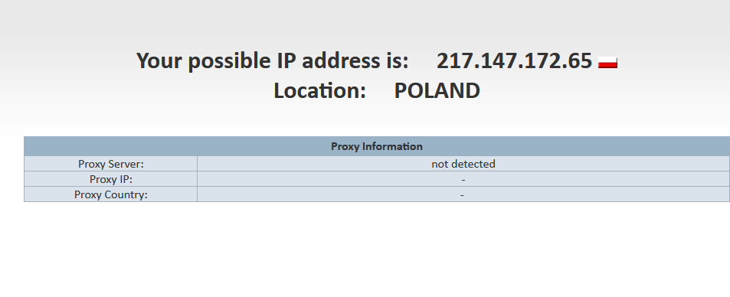
- Based on your usage of this tool, and the analysis done, write your understanding on using Proxy tools like this.
Answer= Based on the usage of this tool, my understanding on proxy tool is for the user to browse the internet anonymously by hiding the users IP address and location. Another use for tools such as proxy switcher is that they increase protection to hackers.
Reference= https://www.javatpoint.com/what-is-a-proxy-server-and-how-does-it-work
- Referring to the above screenshot, what is the Proxy type DCH?
Answer= The proxy type DCH is referred to a ‘hosting provider', 'content delivery network’ or a ‘data center’. This means that the P address will belong to a web hosting service and will be regarded suspicious if an online order is sent from one of these proxy types.
Screenshot= 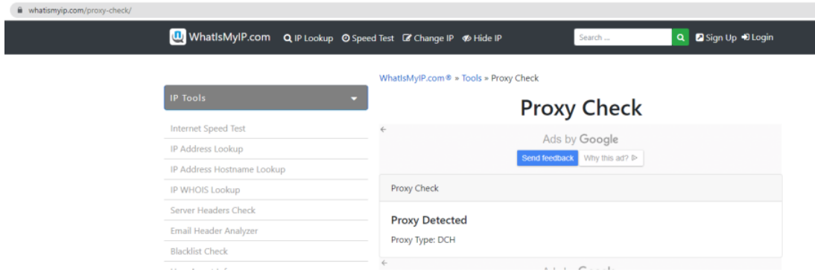
Reference= https://proxyway.com/guides/types-of-proxies#:~:text=What%20Does%20%22Proxy%20Type%3A%20DCH,and%20not%20a%20residential%20user. https://blog.ip2location.com/knowledge-base/how-different-proxy-types-can-affect-your-business/ https://www.rapidseedbox.com/blog/types-of-proxy#028
Part 6
- . What is TCP Window Size? b. list out the values below.
Windows TTL= 128
Windows TCP Window size: 65,535
Linux TTL= 64
Linux TCP Window size: 1GB
Free BSD TTL= 64
Free BSD TCP Window size: 1GB?
Server 2016 TTL= 128
Server 2016 TCP Window size: 64 KB
Cisco Router TTL= 255
Cisco Router TCP Window size: 65,536 Bytes
Reference= https://learn.microsoft.com/en-us/troubleshoot/windows-server/networking/description-tcp-features https://www.oreilly.com/library/view/cisco-ios-in/156592942X/re417.html#:~:text=The%20maximum%20size%20of%20the%20window%20is%2065536%20bytes.
- From the above output, could you determine what is the Operating System running in 10.10.10.11 host machine? d. What details did you gather? e. What assumptions could be made with the gathered information?
The OS possibly running in the 10.10.10.11 host machine is the Kal8i Linux machine. This is based on the TTL size, which is 64. This follows the TTL sizes of Linux based machines.
Part 7
- Which link did you use to download the tool? Why? What is the purpose of this tool?
Answer= The link I downloaded the tool from was the official link. This was to decrease the likelihood of attacks through the download of any malicious software. The purpose of the tool is the automation of discovering devices and the mapping of internal networks. This would occur through multiple scans.
Reference= https://www.solarwinds.com/network-topology-mapper#:~:text=Network%20Topology%20Mapper%20Network%20mapping,Perform%20multi%2Dlevel%20network%20discovery
- If you are using Network Topology Mapper from Solarwinds, a) what option did you select on the following “Would you like to send anonymous data to SolarWinds about how you use Network Topology Mapper?” b) Why did you select the stated option?
Answer= The option I chose was ‘No, I would not like to participate’. I chose this as I would not like data of my network, whether anonymous or not, being shared to a 3rd party. If they are comprised then attackers may be able to trace back any network information.
Part 8
- Which link did you use to download the tool? Why? What is the purpose of this tool?
Answer= The link I downloaded the tool from was the official link. This was to decrease the likelihood of attacks through the download of any malicious software. The purpose of the tool is to scan networks by IP Ranges, domains, computers. Based on these scans' reports can also be made for further detail.
Reference= https://magnetosoft.com/product-global-network-inventory/
- What is the difference between both the scans?
Answer= The difference between the two scans is that using the tool currently logged in as the user brought more results than being connected as another user.
Reference=
- Using user credentials, did you manage to gather information like Software’s Installed, Services Running, NetBIOS information, Users, User Groups, Operating System etc? Yes!! – What is your gathered information? No!! – Why? Reason out and do research, troubleshoot, and gather the above information.
Answer= The information I have gathered application information, installed software and running services.
Evidence= 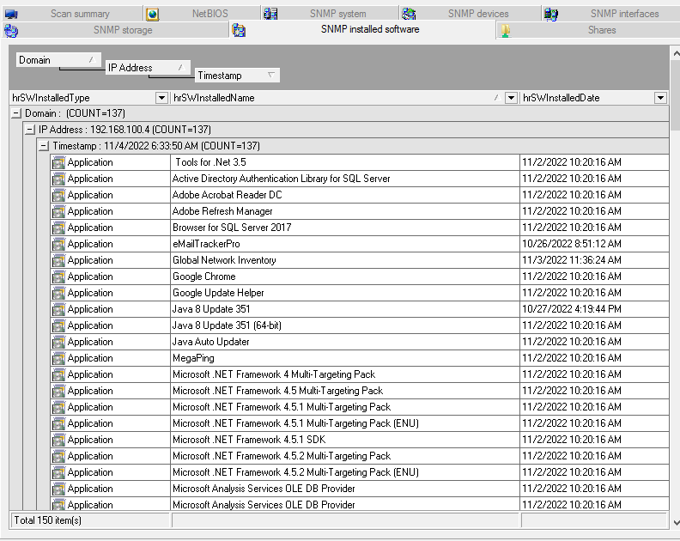
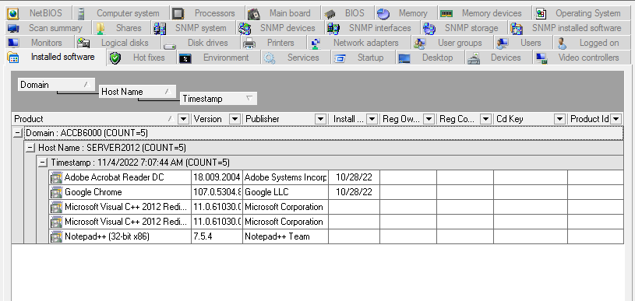
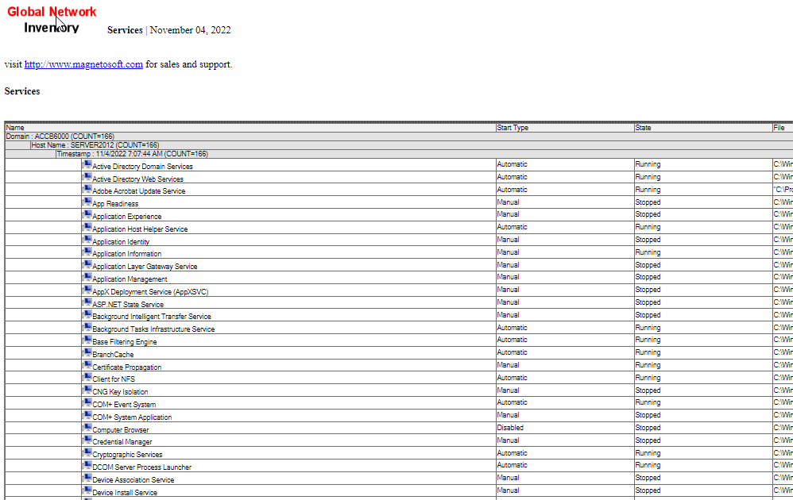
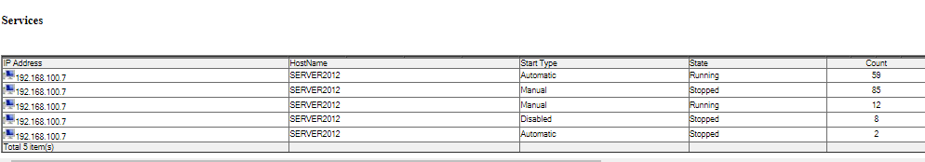
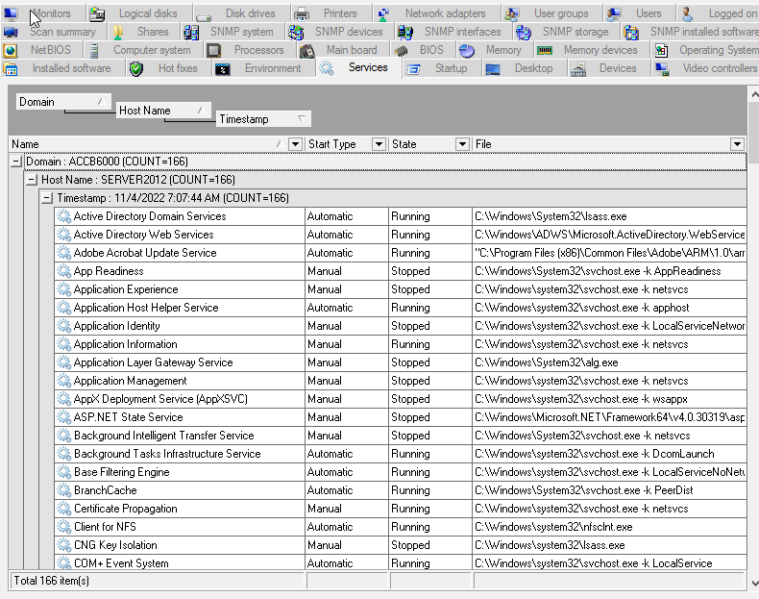
Part 9
- Which link did you use to download the tool? Why? What is the purpose of this tool?
Answer= The link I downloaded the tool from was the official link. This was to decrease the likelihood of attacks through the download of any malicious software. The purpose of the tool is to scan
Reference= https://nmap.org/book/inst-windows.html https://nmap.org/
- Nmap -O Nmap -O -v what is the difference between the above two commands?
Answer=The difference between these two scans is that while the ‘-O’ command may scan and detect open ports, the ‘-v’ command will increase the level of verbosity, giving out more information in the output.
Reference= https://www.stationx.net/nmap-cheat-sheet/
Evidence= 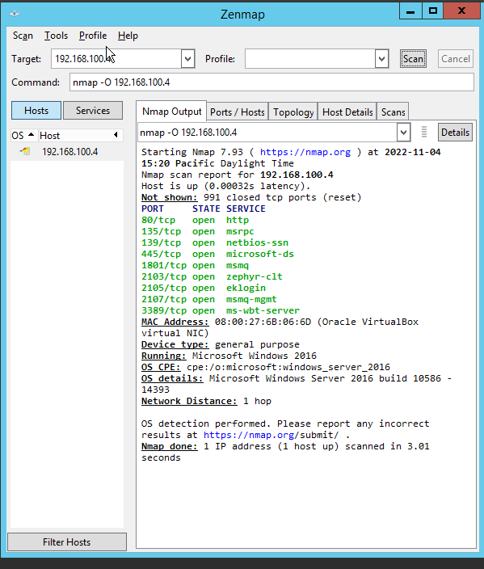
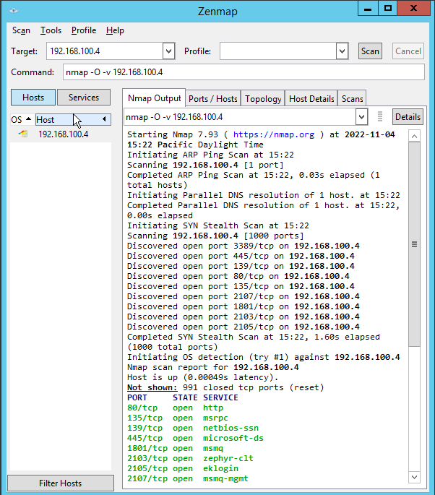
- Do research on net use. Know what is the purpose of net use command? Which OS versions is that supported?
Answer=The purpose of the net use command is that used to manage any network connections within a Windows OS. The OS’ it has support for are the various Windows OS’. This would include from Windows Server 2008 to Windows Server 2012 as well as Windows 10.
Reference= https://www.easeus.com/knowledge-center/net-use-command.html https://learn.microsoft.com/en-us/previous-versions/windows/it-pro/windows-server-2012-r2-and-2012/gg651155(v=ws.11)
Part 10
- This lab activity has a number of nmap commands. Could you list out all the descriptions of these commands? For example, the 1 st command used here is nmap -sP 10.10.10.0/24 What is the purpose of this command? This scan lists the hosts that responded to the ping within the specified range of IP addresses. By using this command, you could determine the status like up and live hosts in the target network. This is also known as Ping sweeping.
Answer= -The sP command is a ping scan only command, The –sS command is a TCP SYN port scan command, while the -ssV –O commands are the commands to find services running in ports as well as to find the OS that the system runs.
Reference= https://www.comparitech.com/net-admin/nmap-nessus-cheat-sheet/
- Which is the default port for SNMP?
Answer= The default port for a SNMP are wither the UDP 161 or UDP 162 ports.
Reference= https://www.thousandeyes.com/learning/techtorials/snmp-simple-network-management-protocol#:~:text=What%20is%20an%20SNMP%20port,Traps%20to%20the%20SNMP%20Manager.
- Above two commands are same but outputs are different. Could you justify why the outputs are different? What actions was taken before executing the command second time?
Answer= The reasoning behind this is that the command had to load before the script could be run a second time.
Reference= https://nmap.org/nsedoc/categories/brute.html
- Know about MSF console. Do research on Metasploit. A very useful tool in Kali Linux. Refer to Metasploit.com, Github for references
Answer= Metasploit is a tool that is used to collect various attack information, priorities these attack methods, and then find methods that can be used to bolster defenses.
Reference= https://www.rapid7.com/products/metasploit/
- After enumerating the target on SNMP, what information did you gather? In similar method, could you try to enumerate LDAP on an ADDS and modify domain user accounts?
Answer=
Reference=

Activity 4
Part 1
- Which link did you use to download the tool? Why? What is the purpose of this tool?
Answer= I've downloaded this tool from the official Nesses website, As this will decrease the likelihood of downloading malicious software. The purpose of this tool is to scan your internal network and find any vulnerabilities that it may have. The tool may also provide way to strengthen your network.
Reference= https://www.tenable.com/products/nessus/nessus-essentials
- Why would we turn off ping the remote host option?
Answer= This is because that a ping sent to the remote host might cause the firewall to filter and block any incoming packets.
- Why would we set them to unlimited?
Answer= This is because will be able to perform a routine scan on the network, as there are a maxium amount of packets being sent to the TCP Port.
Reference= https://www.tenable.com/blog/unlimited-discovery-scanning-with-securitycenter-and-nessus https://docs.tenable.com/nessus/Content/AdvancedSettings.htm
- Use the report and classify action plan/ mitigation steps to overcome the vulnerabilites. a. To do that, categorize all the listed vulnerabilites based on its severity. b. Select one of the vulnerability and propose a mitigation/ action plan. 18.Document your report and Mitigation plan with proper/adequate citations.
Answer= The vulnerability that I have gathered is a security update for Windows SMB Server. The proper mitigation plan for this is to install any of the emergency patches that have been released by Microsoft for Windows systems that are no longer supported.
Evidence=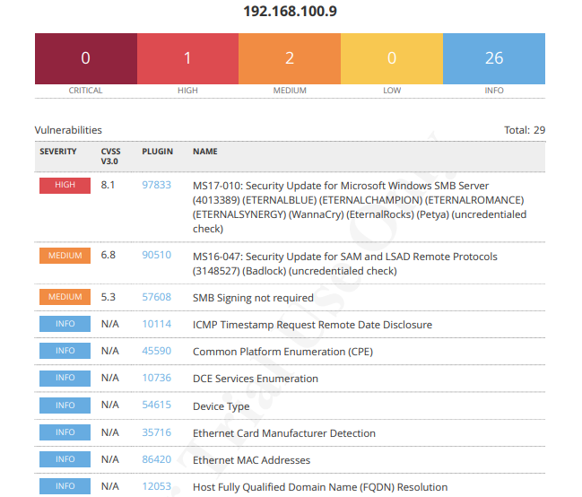
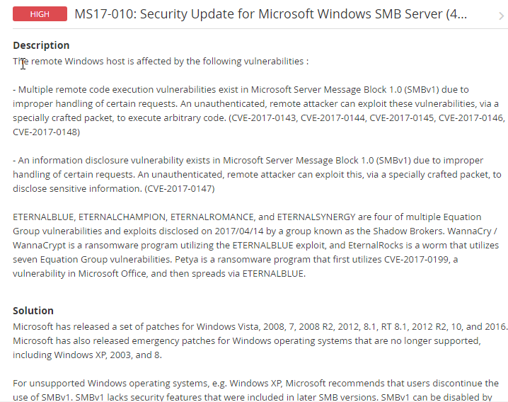
Reference= https://www.tenable.com/plugins/nessus/97737
Part 2
- Which link did you use to download the tool? Why? What is the purpose of this tool?
Answer= I've downloaded this tool from the official Kali Liunx tool page, as this will decrease the likelihood of downloading malicious software. The purpose of this tool is to scan your internal network and find any vulnerabilities that it may have. The tool may also provide a way to strengthen your network.
Reference= https://www.tenable.com/products/nessus/nessus-essentials
- Click on the vulnerabilities and look at all the vulnerabilities listed for the target machine. View the detailed report about all the listed vulnerabilities and create a list based on High, Medium categories.
Answer= The report I have made has listed medium and high-risk vulnerabilities.
Evidence=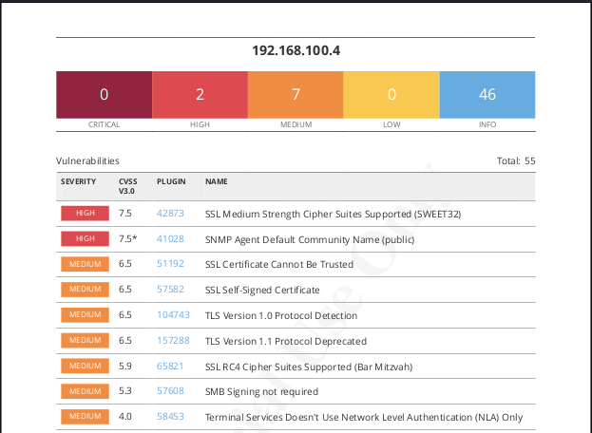
- Based on your categorization, select the Top listed vulnerability, and propose your mitigation steps/ strategies. Refer to websites/ databases which we have covered during our lectures to list out the necessary mitigation steps, citations etc.
Answer= The highest vulnerability that has been detected is a SSL Medium strengh Cipher suites supported. To mitigate this vulnerability, the solution is to reconfigure the application to avoid the use of any medium strength ciphers used.
Evidence=
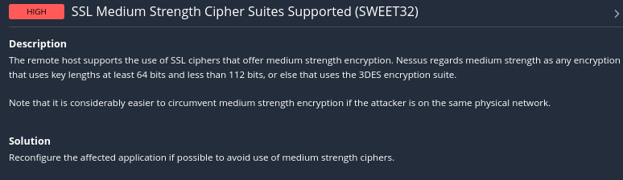
Reference= https://www.tenable.com/plugins/nessus/42873
Part 3
- Which command did you issue to download Nikto? Why? What is the purpose of this tool?
Answer= I've downloaded this tool from the official Kali Linux tool page, as this will decrease the likelihood of downloading malicious software. The purpose of this tool is a open-source vulnerability scanner that can detect thousands of problems and capture any of the vulnerabilities found.
Evidence= 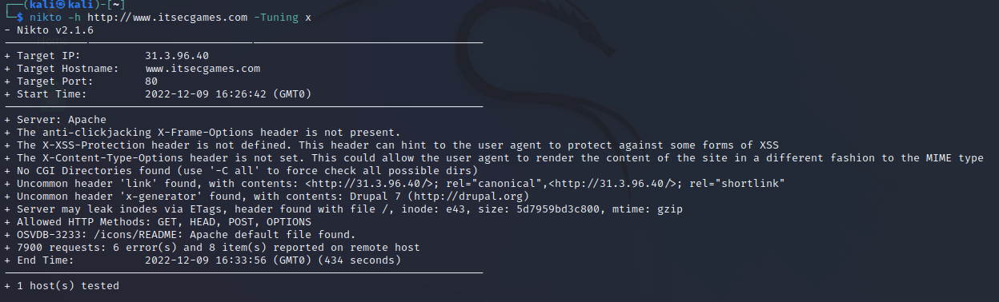
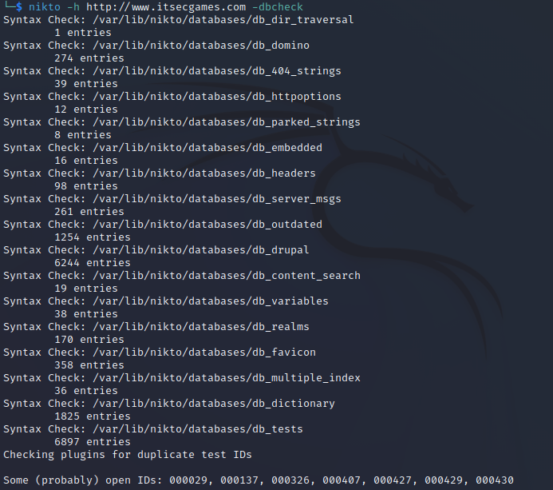
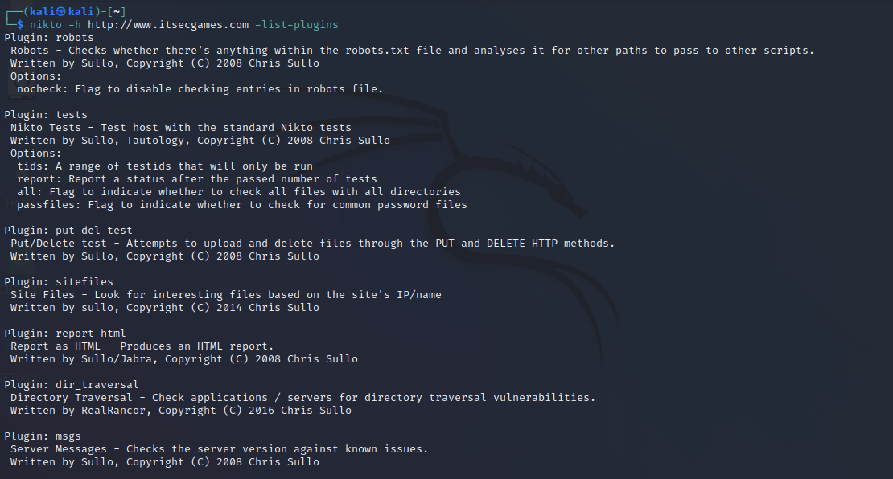
Reference= https://www.kali.org/tools/nikto/ https://www.cyber-today.com/what-is-nikto-tool-in-kali-and-how-to-use-it/
- Use other commands to scrutinize the target network. List out the commands you used, and the vulnerabilities identified. 8. Write a report to provide your thoughts and observation on your target’s security posture and exposure. Submit in Moodle

- Use other commands to scrutinize the target network. List out the commands you used, and the vulnerabilities identified.

Activity 5
Part 1
- What is your understanding about SE Toolkit?
Answer= My understanding of the SET toolkit is that it allows you to perform various social engineering actions that can result in information such as password hashes being obtained.
Reference= https://www.trustedsec.com/tools/the-social-engineer-toolkit-set/
- What is Spear-Phishing Attack? What are their vectors? What are the other Social Engineering Attacks found in SEToolkit? Try to simulate one of the attacks (not listed in the activity) and document the outcome.
Answer= Spear Phishing is a communication method such as an email, that can be used to phish for information from a target. Other attack methods within the toolkit include website attack vectors, Mass mailer attacks or a payload and lister creator.
Evidence=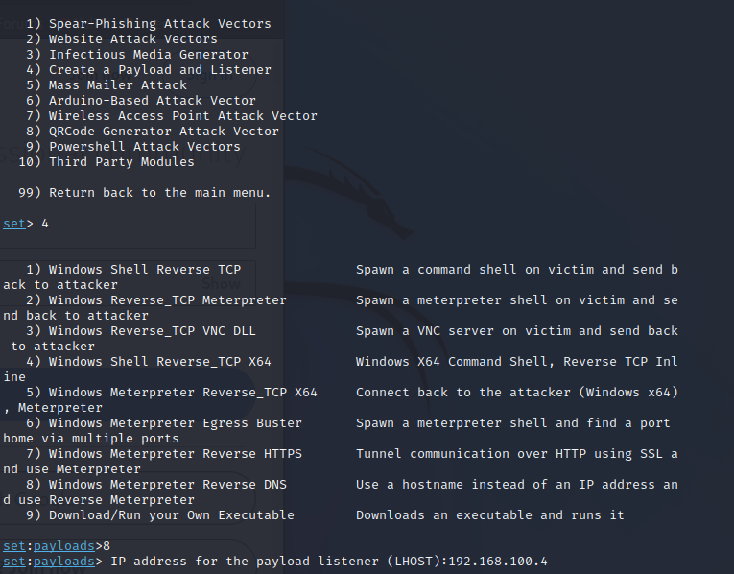
Reference= https://www.kaspersky.co.uk/resource-center/definitions/spear-phishing
- What would you do to target a victim outside your network? By giving this private IP address of the attacker, will you receive the harvested information if your target is outside your local network? Document your thoughts with necessary references, screenshots, and citations.
- What catchy name did you use? Document the steps with adequate screenshots.
- Which webpage opened on clicking the link? Document your observations on the webpage.
Answer= The website that opened upon clicking the link is a fake host site for a facebook login page.
Evidence= 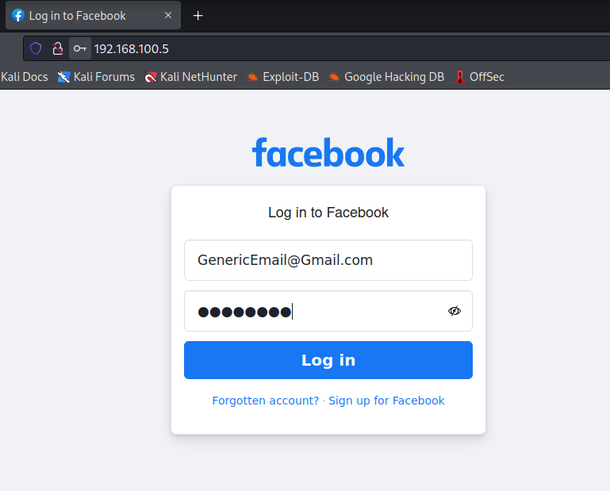
- What happened after clicking login? What is your observation here?
Answer= The observation I have made is that the users password hashes have been captured.
Evidence=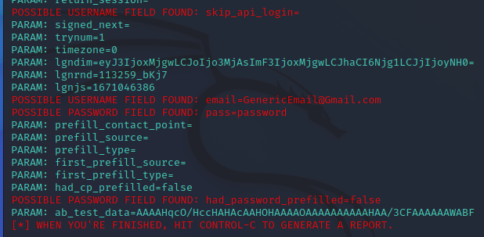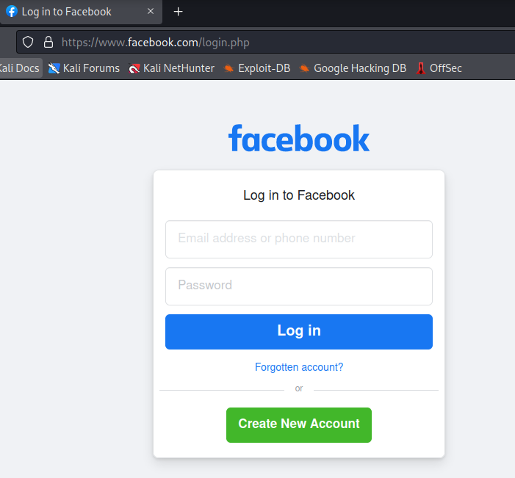
Part 2
- Which link did you use to download the tool? Why? What is the purpose of this tool?
Answer= I've downloaded this tool from the official tool page, as this will decrease the likelihood of downloading malicious software. The purpose of this tool is to verify the security of webpages once you enter them.
Reference= https://www.netcraft.com/
- Name of the website visited: Risk Rating of the website: Other relevant details: Click on the Site Report: Relevant details about the website: (Repeat this for all the website you are visiting) Referring to our previous task, did you check the link you generated to harvest the credentials using Netcraft toolbar? What is the outcome?
Answer= The websites I visited is ITsecgame, which returned no risk rating. I then visited the phony factbook login page, which returned a 9-risk rating.
Evidence=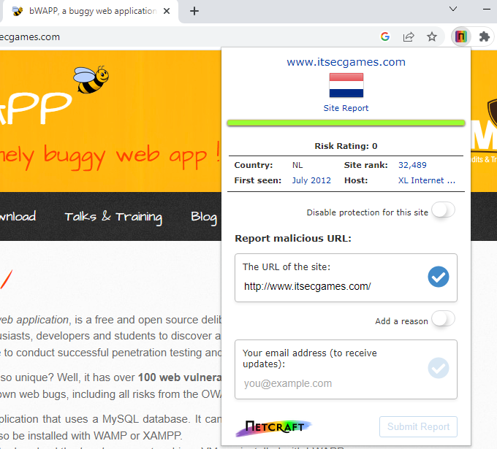
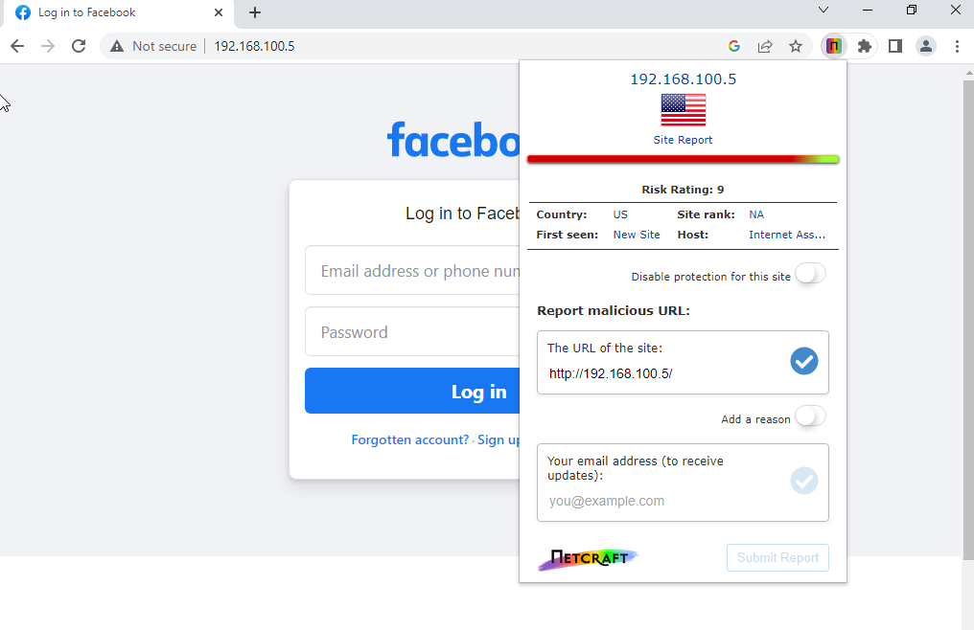
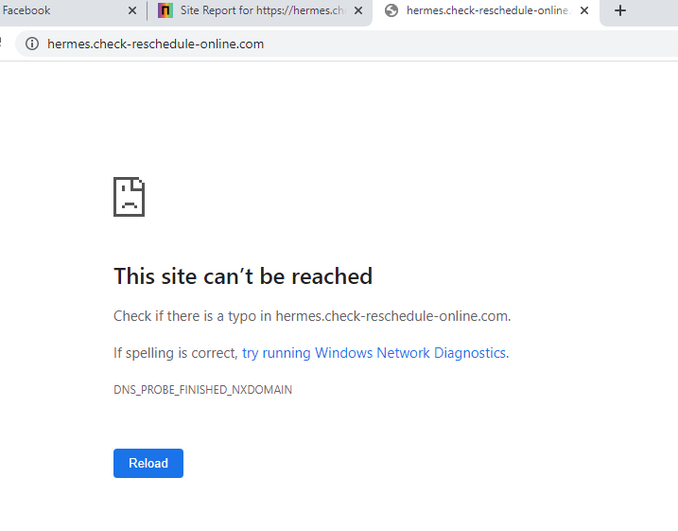
- How did netcraft toolbar respond to the phishing site? What action did you take? Why
Answer= The toolbar responded with a red warning stating that the website I have entered is a phishing page.
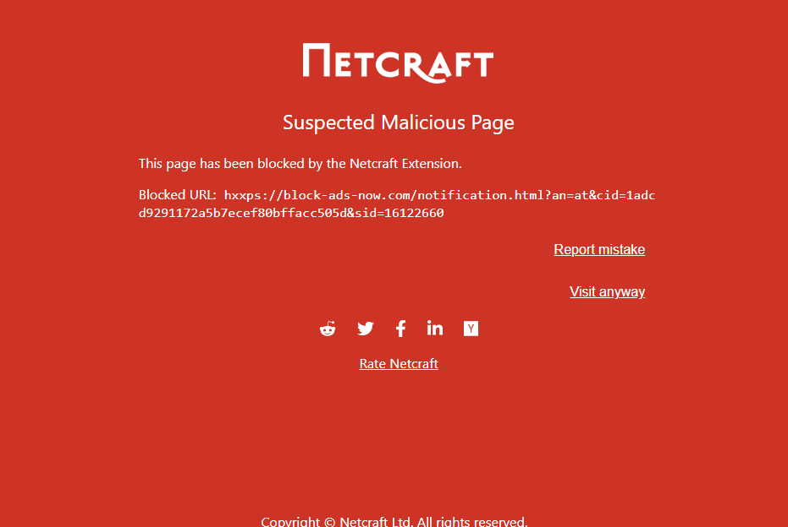
- Which link did you use to download the tool? Why? What is the purpose of this tool?
Answer=The link I had used was the official website. The purpose of this tool is to verfiy the validity of any webpage.
Evidence=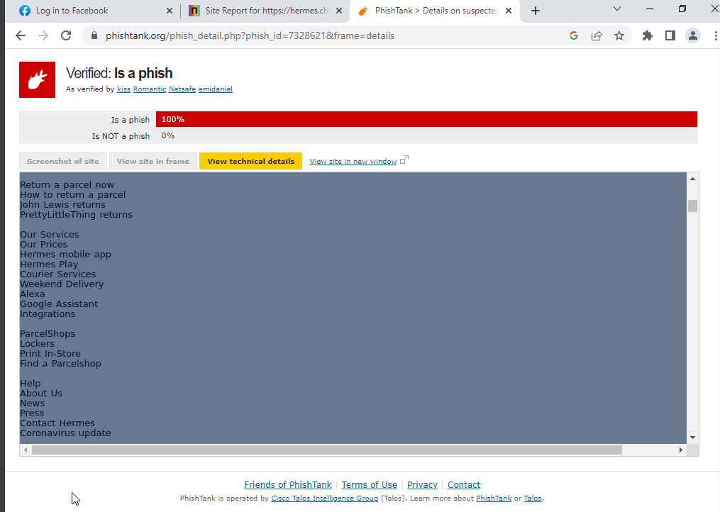
Reference= https://phishtank.org/
- Name of the visited LINK: Risk Rating of the website: Other relevant details: Click on the Site Report: Relevant details about the website:
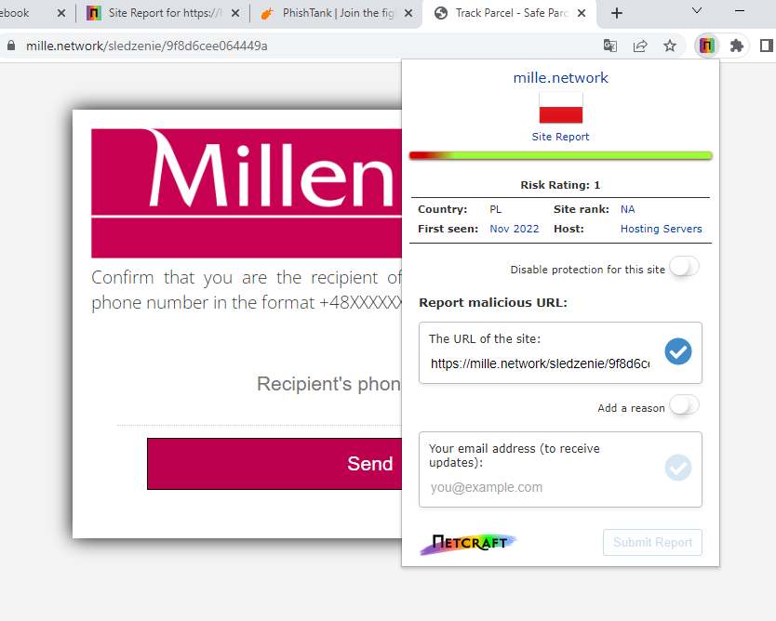
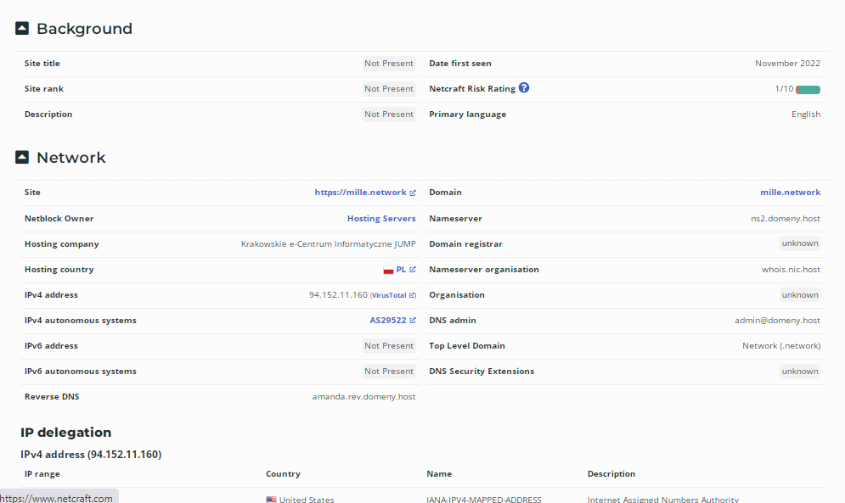
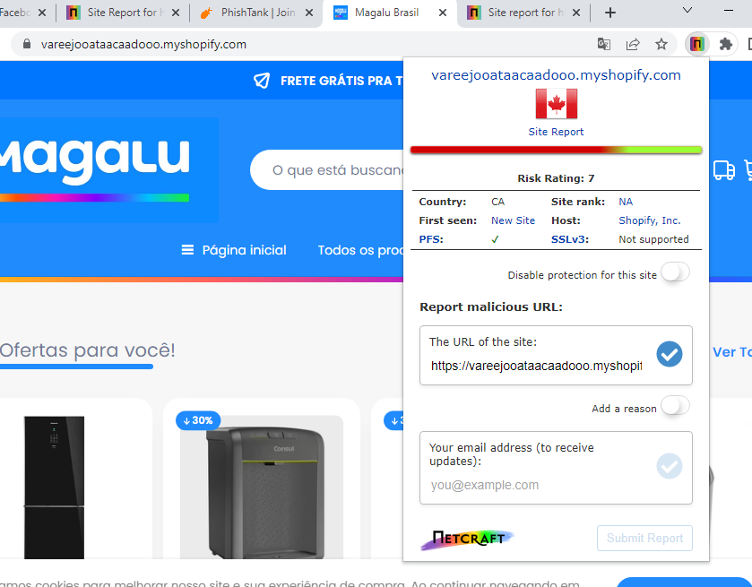
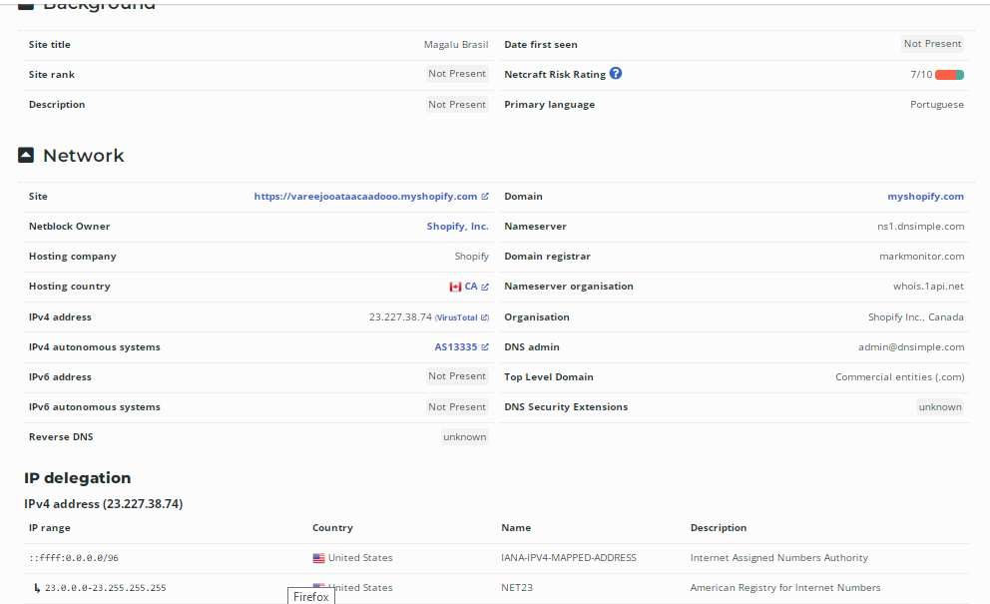

Activity 6
Part 1
- What is your understanding about Metagoofil Tool? What is the purpose of this tool?
Answer= The purpose of this tool is to gather information on any targets through the extraction of metadata.
Reference= https://www.geeksforgeeks.org/metagoofil-tool-to-extract-information-from-docs-images-in-kali-linux/
- (While executing these metagoofil commands to extract metadata from your target website, this happens. What will you do? Research and document the error and its mitigation steps) What is this exception? • Why this exception occurs? • How to overcome this exception and successfully extract metadata you’re your target? • Refer Whitepapers, Literatures and in-text cite them, • Using the knowledge and understanding gathered from the research, demonstrate the method to overcome the exception. Illustrate the steps with adequate and appropriate screenshots.
Answer= My solution to this problem was to wait a period of 12 hours, as the IP blocking had ceased.

Evidence=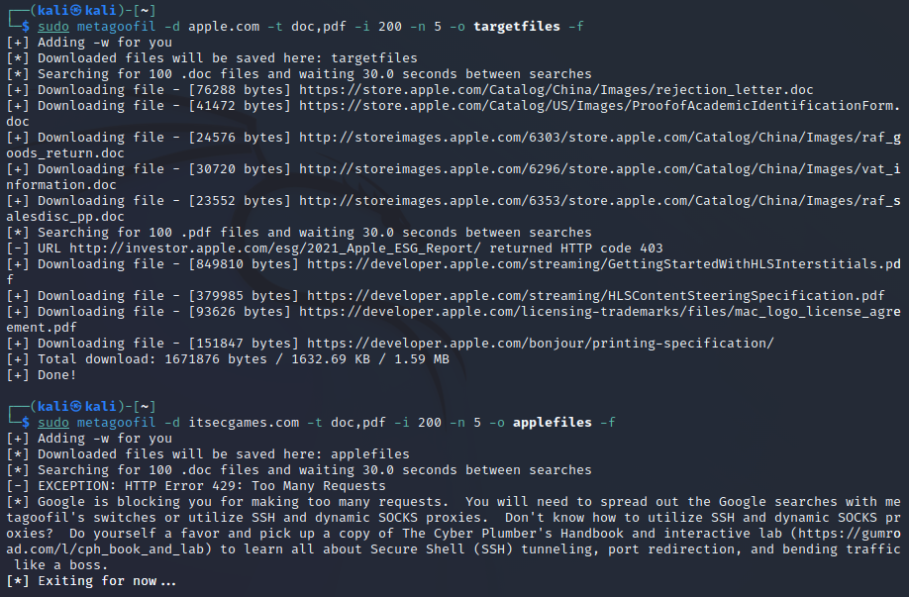
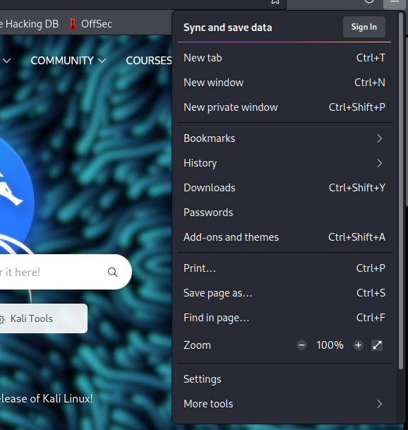
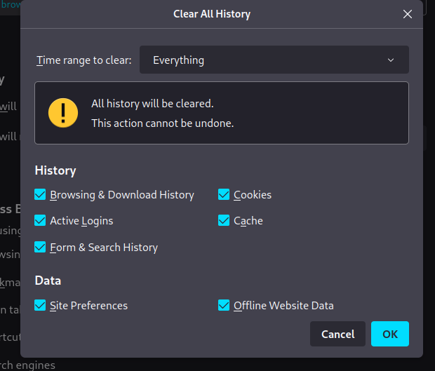
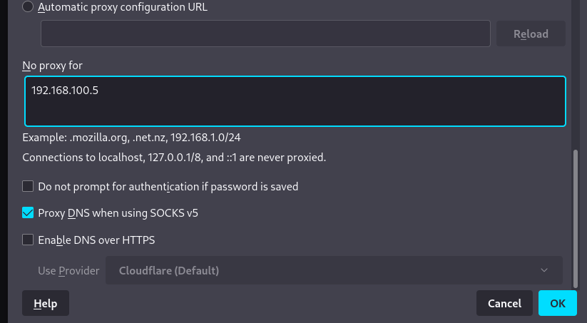
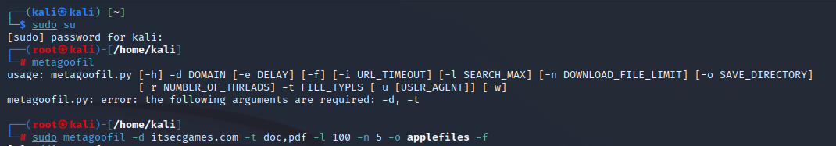
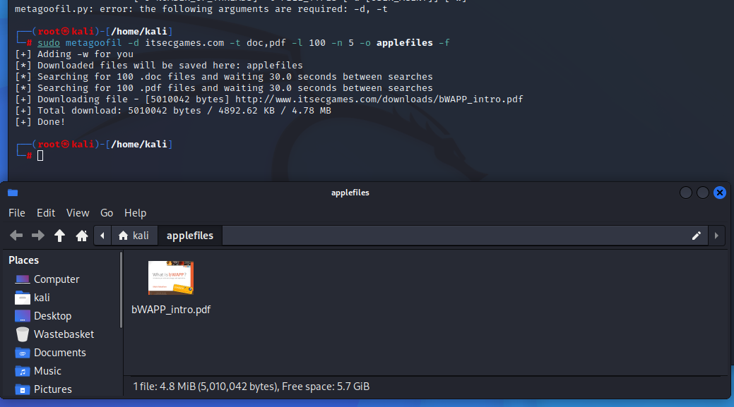
- From gathering those metadata, what useful information did you gather? How is Metagoofil tool useful for your attack?
Answer= From the informaion gathered, I have encountered various documents being downloaded into my file system.
Evidence= 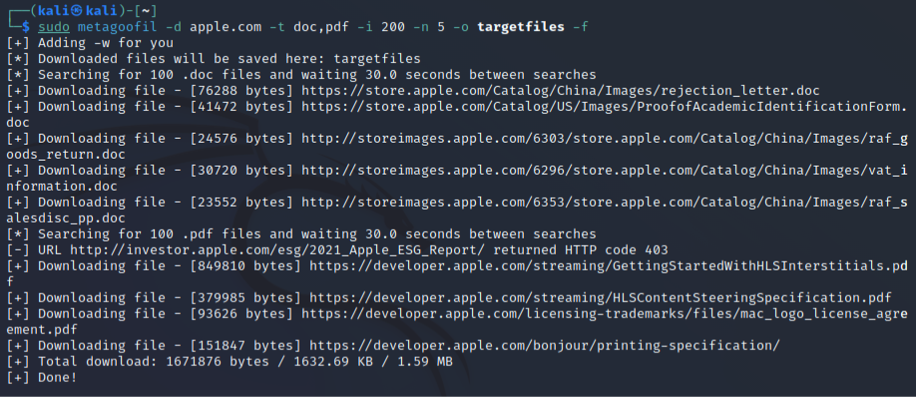

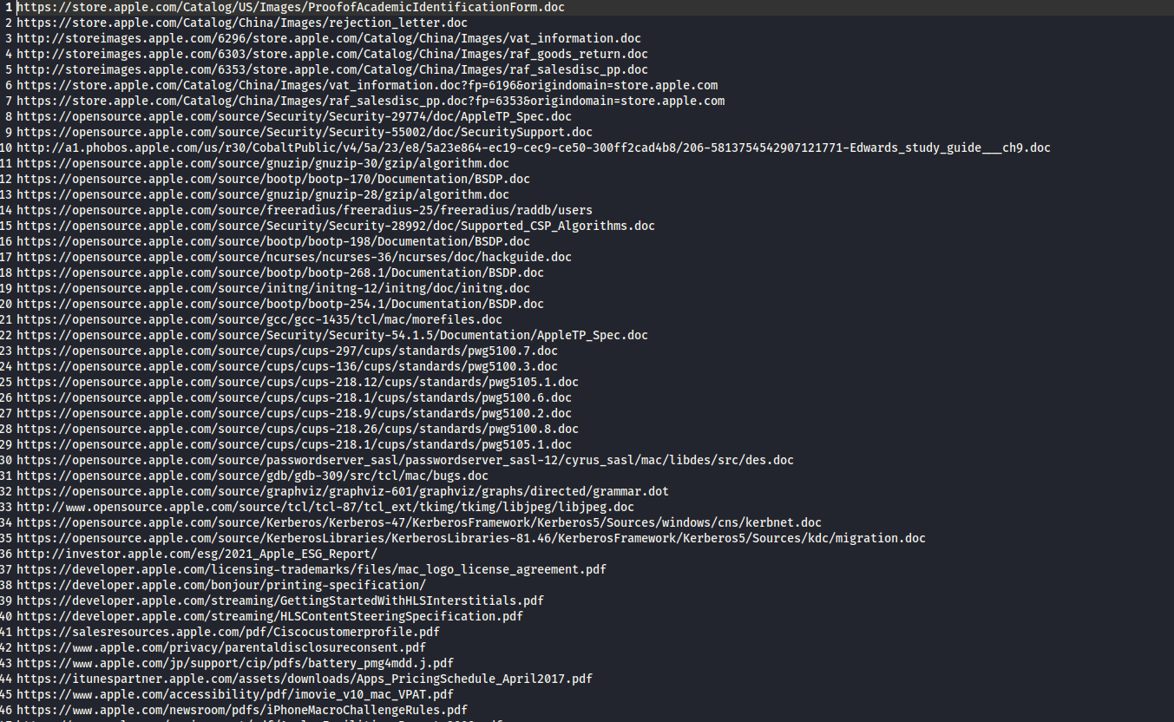
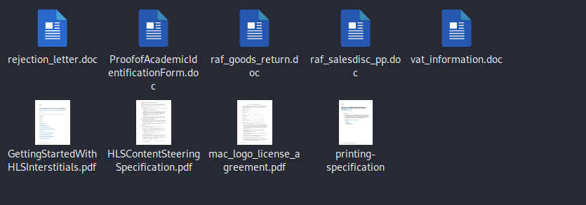
Part 2
- What is LLMNR/NBT-NS? By Spoofing LLMNR/NBT-NS what happens?
Answer= LLMNR is what is referred to as Link Local Multicast Name Resolution which is a protocol that does not send or respond to queries in TCP.
Reference= https://learn.microsoft.com/en-us/openspecs/windows_protocols/ms-llmnrp/6806998e-034d-4c39-8398-5af8bfd52d7e
- What is the outcome when you open the correct shared folder? What is the outcome when you open a wrong shared folder?
Answer= The outcome I have seen is that the NTLM hashes have been saved and can now be extracted.
Evidence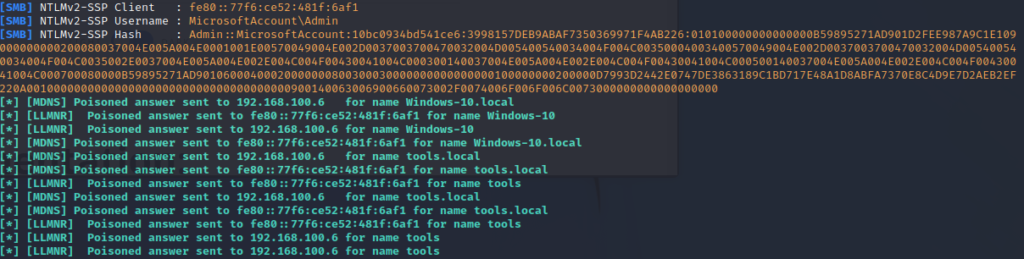
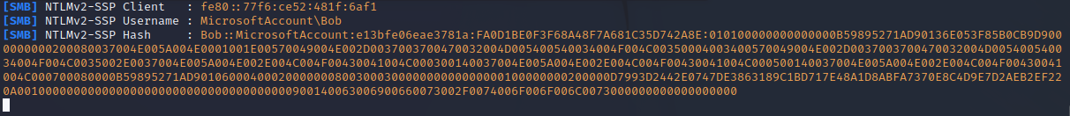
- What do you see? Did you get the username and passwords of your victim?
- Do research to find out different ways to convert the collected data (Hash files) into actual text. What tools could you use to crack the hashes? List out the tools. (Hint: Use one of the tools other than John the ripper to crack the hashes and submit the work as a part of your Coursework.)
Answer= Other methods to crack the hashes is to use tools such as Ophcrack, will use rainbow tables.
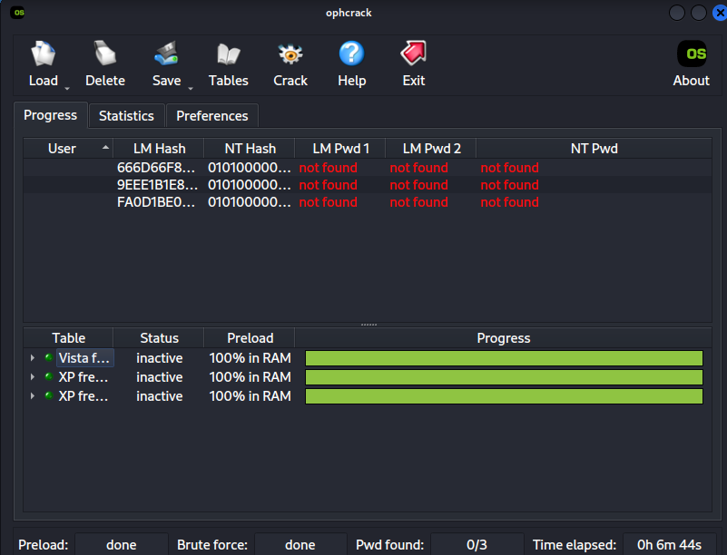
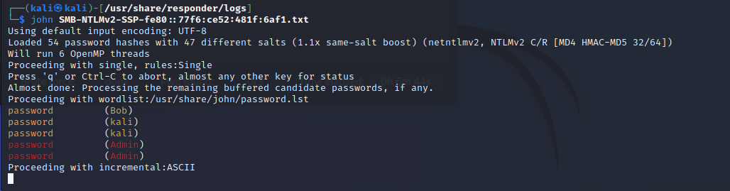
- Did you get the username and passwords of your victim?
Part 3
- Which link did you use to download these tools? Why? What is the purpose of these tools?
Evidence=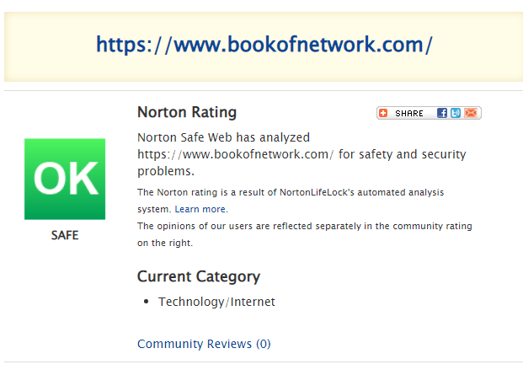
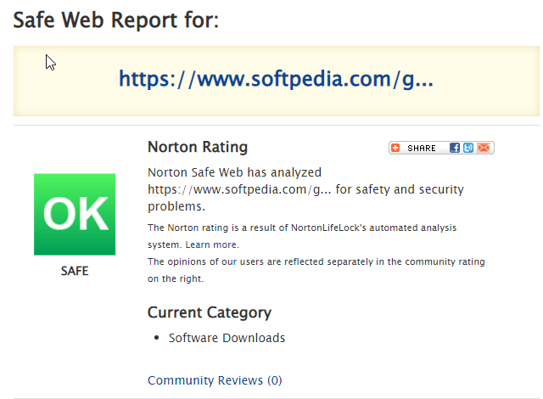
- So, which hash would you select from Winrtgen?
- There are different hash types present in the list. What are they used for? Do research on different kinds of hashes and their purpose.
- Minimum Length : Maximum Length : Chain Count
Evidence=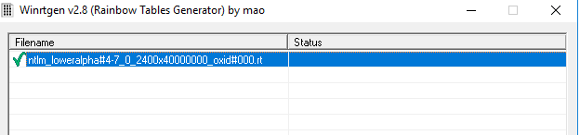
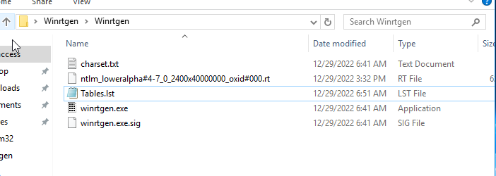
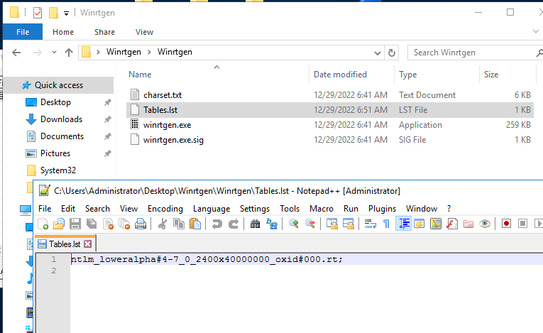
- If yes, how did the tool gather the password hashes. If No, why? What error did you get? Do research and troubleshoot the error. Possible Error: The system cannot execute the specified program
Answer= The possible error is that the command is not run as administrator.

Evidence=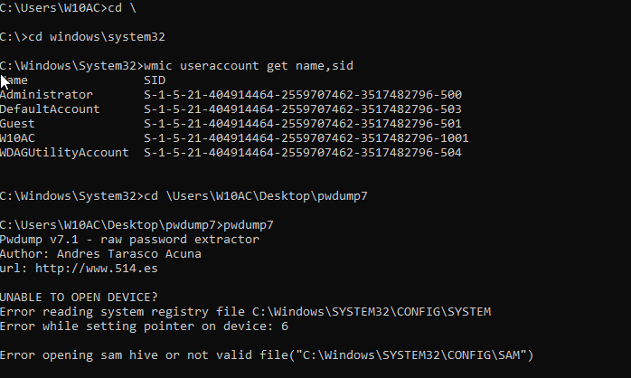
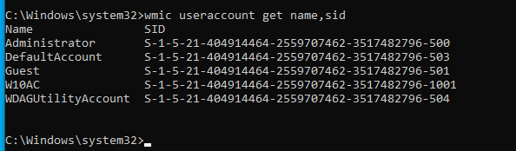
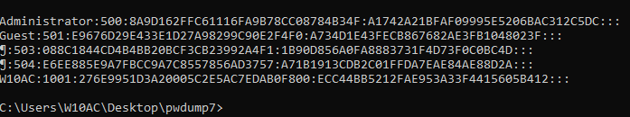
- What is your understanding on the entire process of using Winrtgen, Rainbow Crack and Pwdump Tools.
Part 4
- What is a metaspoilt framework? What is the use of msfvenom?
Answer- The use of msfvenom is to payload creator that can be used to exploit any target machines.
Ref - https://www.offensive-security.com/metasploit-unleashed/msfvenom/ https://blog.knoldus.com/what-is-msfvenom-how-to-use-it/
- What is vnc?
Answer= VNC is a type of remote control software that can be used to gain access to other remote desktops.
https://www.techtarget.com/searchnetworking/definitions
- . Report a. What is a metaspoilt framework? b. What is the use of msfvenom? c. Screenshot with illustrations on creating a Shared Directory for the Payload d. What is VNC? e. Your outcome

Evidence= 
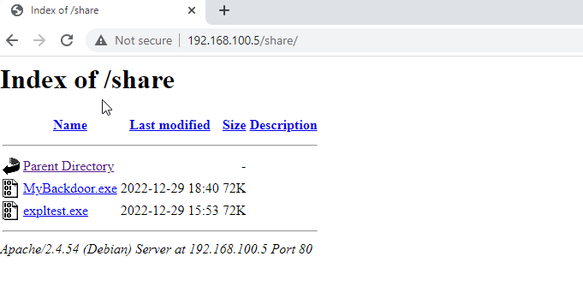
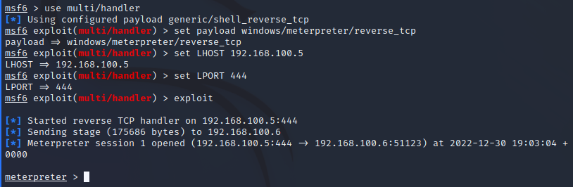
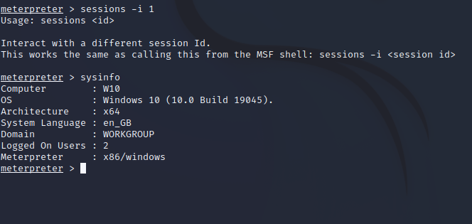
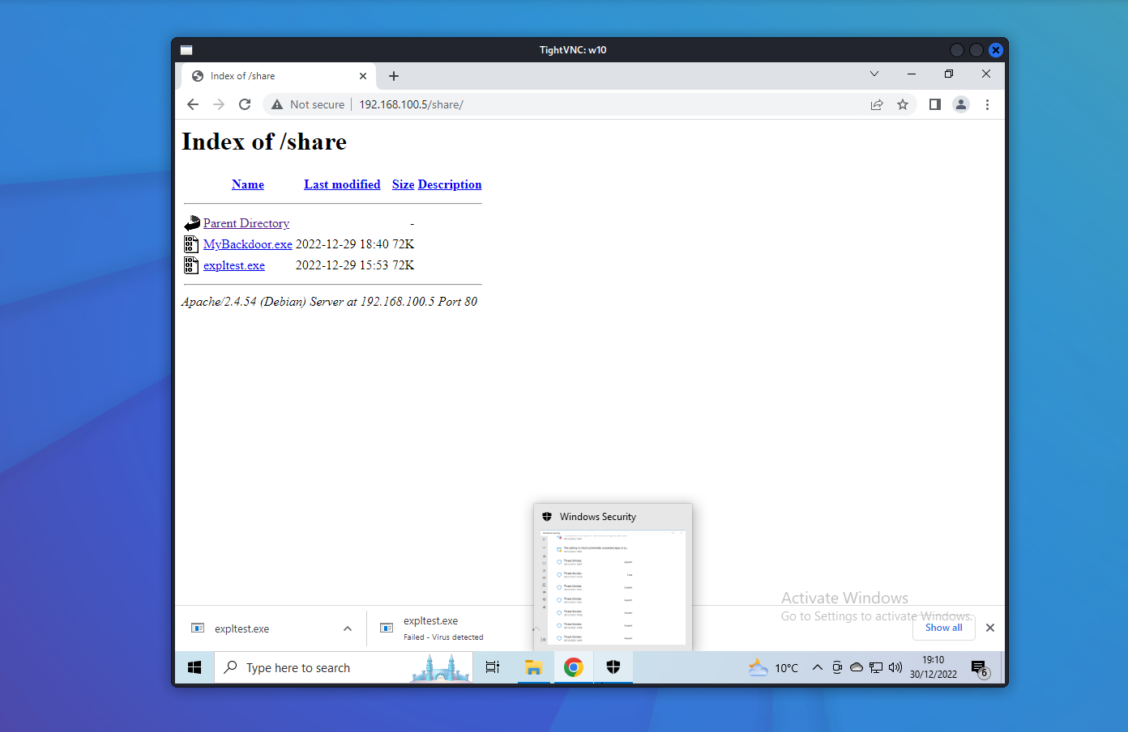
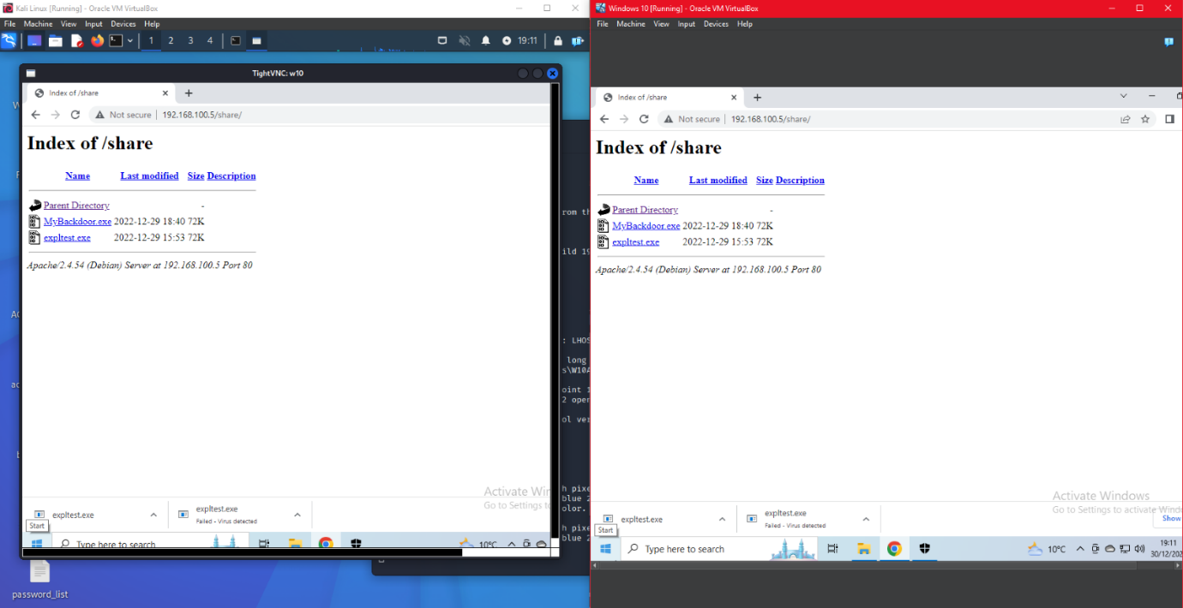
Part 5
- What is a Backdoor?
- What is a Shikata_ga_nai payload?
- So far, we have created two different payloads. What is the difference between them? Do research to different payloads and its purposes. Use adequate literatures to in-text cite. (Use the work for your Coursework)
Reference= 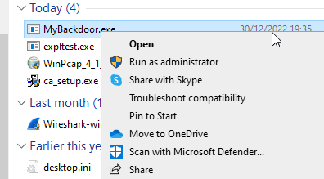
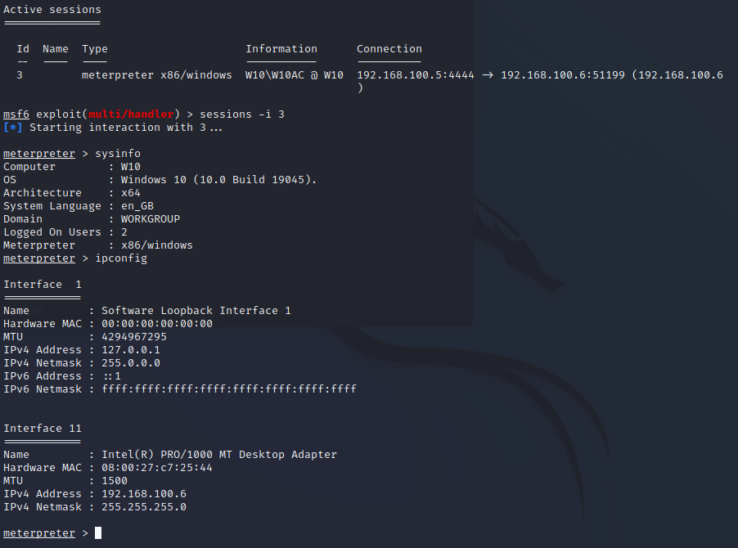
- Using a similar command like above, check if the Meterpreter server is running as administrator. Which command would you use to confirm this?
Reference= 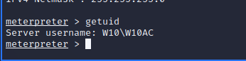
- Confirm the working directory. Which command would you use to confirm the working directory?
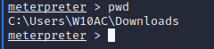
Reference= https://www.offensive-security.com/metasploit-unleashed/meterpreter-basics/
- Did you get access to the confidential file? What is the confidential data present in the document? If Yes, proceed further. If No, troubleshoot.
Evidence= 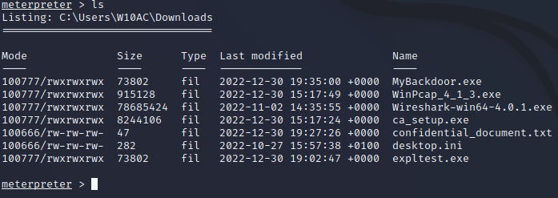

- What is MACE Value?
Evidence=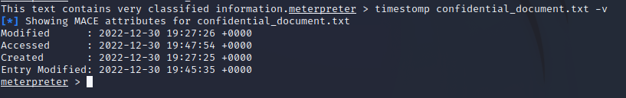
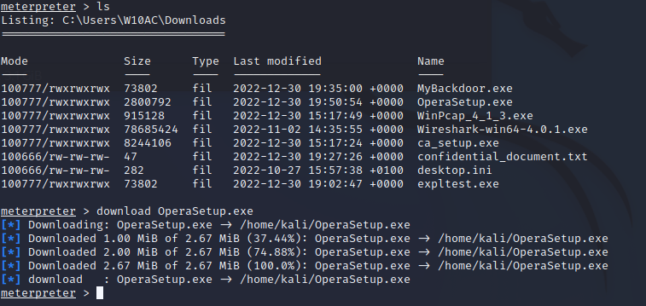
- Use the same techinque to capture the webcam snapshots and streams. Record the steps with adequate screenshots.
Evidence= 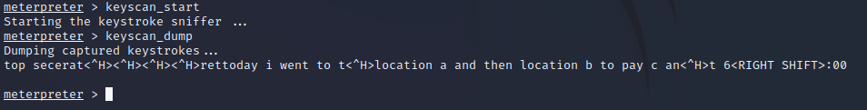
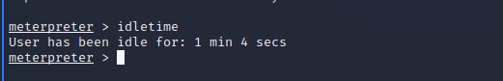
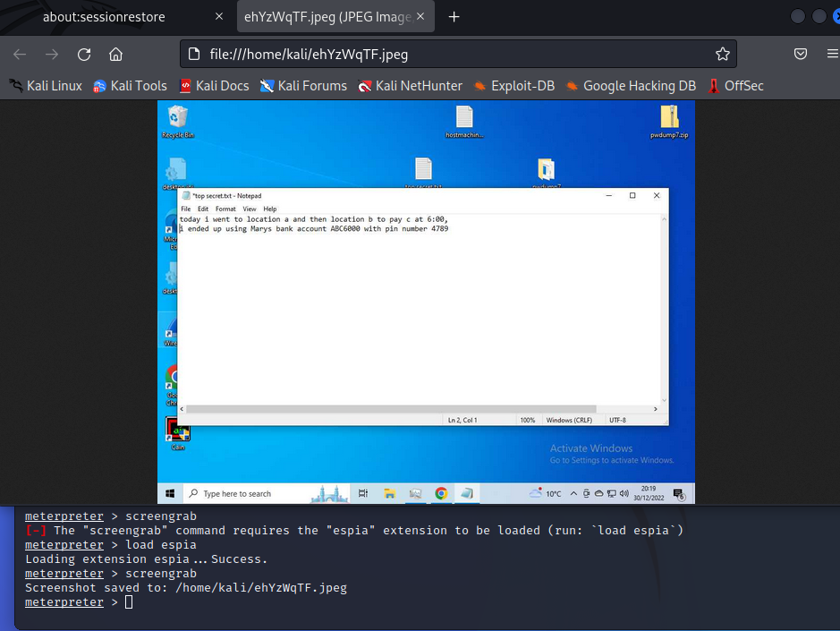
Reference= https://www.offensive-security.com/metasploit-unleashed/screen-capture/
Part 6
- What is your File System Format?
- Check the size of the exe files and the notepad files. What is the file sizes? Notepad: Exe: NPP.exe Exe: PwDump7.exe
Evidence= 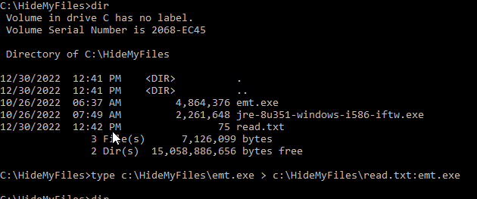
- Check the file size again. What is the file sizes? Notepad: Exe: NPP.exe Exe: PwDump7.exe Any Changes? Yes or No. Why?
Evidence=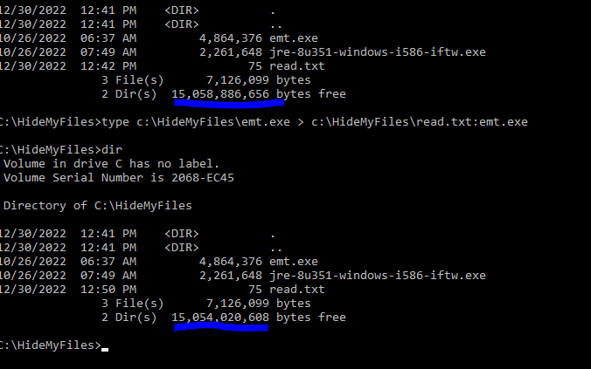
- What happened when executing the above command? Did the file execute? If Yes, go to next step. If no, Troubleshoot
Evidence= 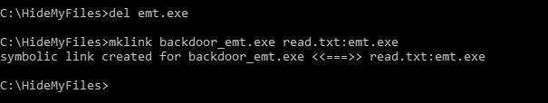
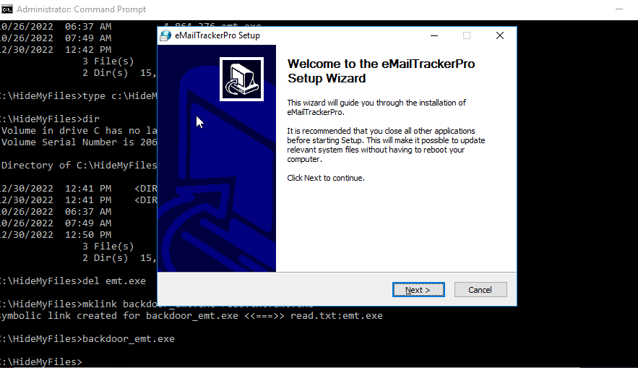
- What happened when executing the backdoor? Did the file execute?
Evidence=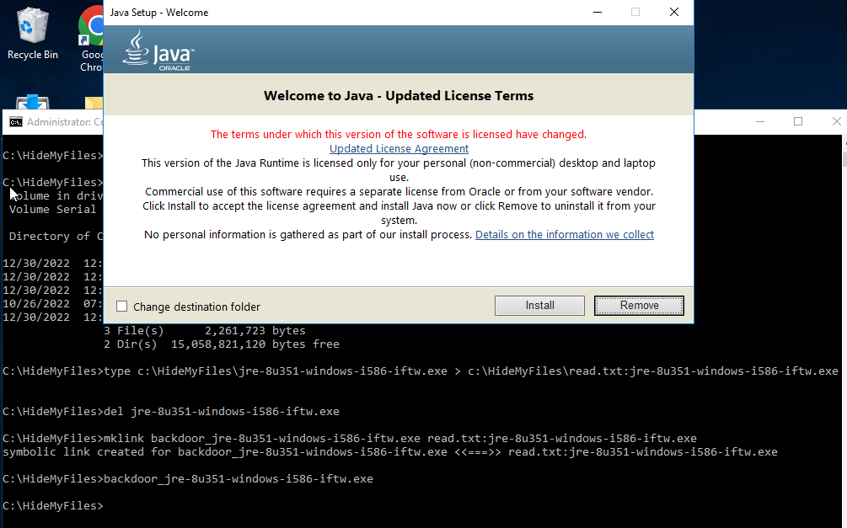
- No, it wont execute the exe file. A error message pops out stating required DLL File was not found or missing. Do research to find out steps to execute the exe file along with the required DLL File. Document the step with adequate screenshot and description. You shall use these identified steps in your coursework.
- By hiding files using NTFS File Streams, what could you achieve?
Part 7
- What is Auditpol? How is it helpful in covering tracks? Set various Auditpol policies and document with screenshots List out similar tools that are used for covering tracks.
Evidence= 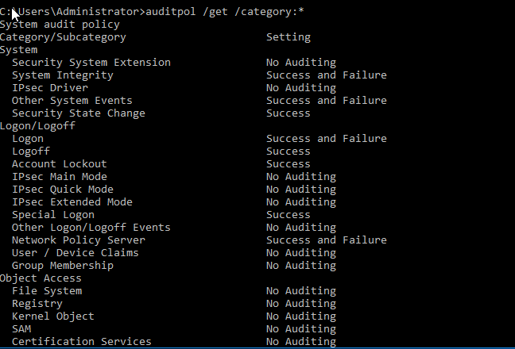
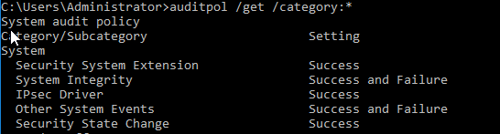
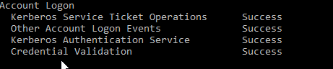
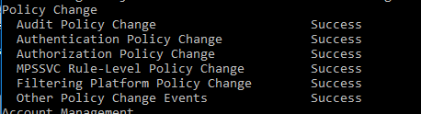
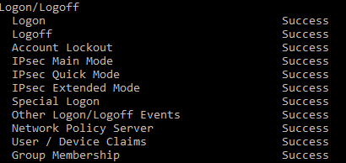
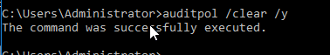
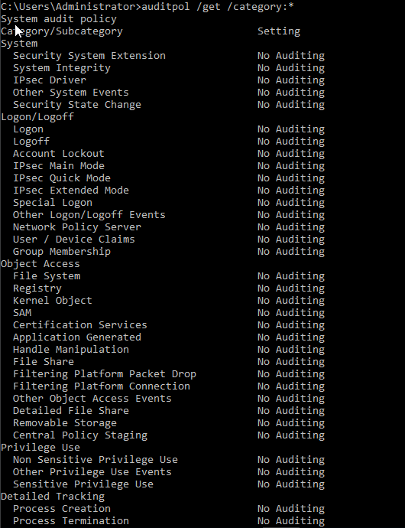

Understanding on all the activities 2. Understanding about various tools used 3. New/ Similar tools you identified and used 4. Compare and Contrast the tutorial tools with your identified tools 5. Rate yourself: How confident are you to do footprinting, reconnaissance, vulnerability assessment, social engineering, gaining access, escalating privileges, and covering tracks activity ethically? 6. Any other Troubleshooting Steps, you need to share?

