

INITIAL DISSERTATION IDEA
(NOT ASSESSED)

This document is not assessed and will be used to help identify a suitable supervisor for the candidate

Student Name:
Deepinder Singh Chhabra

Initial Topic Title:
Big Data and Value Creation

To explore how Big Data (Fourth Paradigm or Data Revolution) can provide strategic options/choices for the value creation in the enterprise setting by means of improved agility, relevance and profitability. What are the challenges associated with adopting digital strategy and how to overcome them? Carry out critical review of existing proposed frameworks to develop, adopt Big Data Strategy and its success in value creation. Suggest improvements in the framework, its adoption and implementation.

Reason for choice of topic:
To change employment direction

Initially Identified Theoretical Basis (e.g. Marketing, HRM, Digital Marketing, Entrepreneurship etc. Write about 50-100 words to give an idea of the theoretical area and concepts you might be using:

Value creation is one of the key objectives of the enterprise (Koller, 1994). Big Data is new oil and untapped data may mean lost opportunities. Untapped Big Data may hold key to new customer insights, innovation, improved business models, improved efficiency and effectiveness in various functions within organisation such as Marketing, HR and Logistics etc.

Big Data adoption and analytics may appear to be an easy task, however, only 0.5% of the big data in enterprise is ever analysed (Marr, 2015) and only a small percentage of the enterprises are leveraging the Big Data for strategic completive advantage (See Figure below).

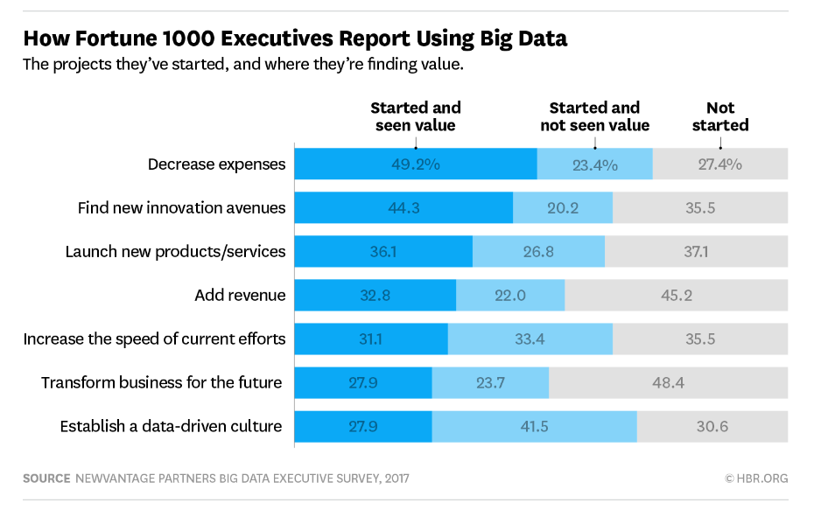

The focus of this study would be to identify the challenges associated with Big Data strategy and how to overcome this.
This may cover following areas of the Management
Big Data (associated Data Analytics/AI/Machine Learning)
Strategic Management (Strategy development, Transformation, Value Creation), Financial Management (ROI, NPV Cash Flow of the financial benefits of adopting a Big Data strategy)

Initial Proposed Methodological Choice (Qualitative / Quantitative / Mixed Methods and why you have chosen these):

Initial Idea is to use Qualitative Methods but it may lead to Mixed Methods after initial discussions.

Ideas for Data Collection Methods (Survey, Interviews etc., and why you have selected these):

There may also be possibility to use interviews /surveys with case studies. The survey and interviews may contain closed and open ended questions. This may approach may offer an opportunity to code the closed questions and use text analysis technique to draw insights from the responses to open ended questions.

An acceptable sample size would have to be agreed, with appointed Dissertation Supervisor, ensure the adequate credibility to the research carried out as part of dissertation.

Interviews/Surveys will be conducted with /CDO/CIO/CTO.

Koller, T. (1994), What is value-based management?, McKinsey Quarterly, Aug 1994.
Marr, B. (2015), Big Data: 20 Mind-Boggling Facts Everyone Must Read, Forbes, Sept 2015, https://www.forbes.com/sites/bernardmarr/2015/09/30/big-data-20-mind-boggling-facts-everyone-must-read/#153116e617b1, accessed on 27/10/2017
Bean, R (2017). How Companies Say They’re Using Big Data, HBR, April 2017, https://hbr.org/2017/04/how-companies-say-theyre-using-big-data, accessed on 29/10/2017

