

Marketing plan for six senses hotel
Name: Md Mustakim Miah Burhani
Student Number: 2246150
The module title: Marketing Essentials BMIH4005
Program: BA International Hotel Management
Lecturer’s Name: Dale Clarke. BA(Hons), DET, MA, MSc, PhD
candidate
Submission date: 15/06/23
Word count: 1250

Marketing Plan for six senses

Introduction
‘Six Senses’ are well-known multinational hotel chains that operate businesses in the hospitality industry, but have various ways of attracting customers. This task is about proper planning, marketing methods, and strategies. Hotel Six Senses operates its business as a luxury hotel brand and provides a sustainable and emotive experience to its visitors (Armstrong et al., 2014)

Situation analysis:
5Cs, SWOT, and Porter’s five forces analysis. SWOT analysis is a popular scheme used by businesses. The 5 Cs are a combination of 5 key elements; company, customers, competitors, climate, and collaborators.

Company

Six Sense is well known for its hospitality and services to its guests and operates as a chain business. Six Sense started its journey in 1995. They offer diverse types of loyalty programs as a reward for consistent customers.

SWOT analysis of the six senses is as follows:

Strengths:

Six Senses has 1.317M overviews and 48.4% on Facebook, also
to promote its business-owned television, website, and digital marketing activities. Targeting the guests such as families, as the resort is offering outside picnics, cooking classes, and pools. Finally, Six Senses are set up in 16 hotels and resorts’ separate locations, comfortable rooms with mandatory services, and around 5,000 employees. (Owler, 2023)

Weaknesses:
High setup costs, top prices of products, and services. Also, they don’t aim to serve the mid-range product and economical prices. Lastly, fewer young people are taken for an adventure. (Cristina Miceli, 2022)
Opportunities:
To partner with local dealers and stores to receive help from local finding trends. Additionally, opening out to new popular locations, business centre–oriented offering additional services. Partnering with travel agencies. (Islam and M.M., 2021). Also, making customers feel happy, as they enjoy parties.

Threats:
Rise in taxes, changes in the trend of user behaviour, and fierce competition. (Patrick Landman, 2022). On the other hand, the organisation operates promotional activities for the mass audience. And Six Senses luxury and health-oriented experience.

Customer: profile/segmentation and targeting
The segmentation generally operates based on customers' needs and preferences of the target market. Six Sense segmented itself based on the demographic, psychographics, and behaviour of the customers.
Segment A; Business class people with kids,
Segment B: Professionals, political leaders,
Segment C: Athletes, actors, artists so on.

Target market and position: Six Senses operates different types of marketing strategies as a luxury brand and positioning itself based on luxury (Kim et al., 2021)

Competitors:
The main competitors are Banyan Tree, Aman Resort, four seasons, and more.

Collaborators: Six Senses to collaborate with the United States Coalition on Sustainability and SustainChain™ and Summer 2022 xarraca x Free 00, the exclusive candle collaboration between Vyrao and Six Senses, has launched. Finally, Lighting Science partners with six senses hotel resort spas.

Climate PESTLE Macro Analysis is as follows:
Political Factors: Government policy, political stability, and motivated factors could affect business.
Economic Factors: Overall economic forces could affect taxation, labour cost, etc.
Social Factors: Social aspect, attitude, and trends that influence and target market.
Technological Factors: Investment in technological Research and Development can affect the business ( Saxena,2022).
Legal Factors: The health and safety laws vary due to which business is impacted; Six Senses has been comfortable with diversity in its staff (Saxena,2022).
Environment Factors: The hotel also focuses to remove and avoid all virgin plastic materials from its hotel and spa.

Objectives(SMART)
Specific: The mission and vision are specified.
Measurable: To make the target based on their expert guidelines.
Achievable: Only increasing the price where the amount is realistic and capable.
Relevance: To Update products and prices when it is good for business.
Time-bound: Plan a diary based on a timeline.

Strategy
Six Senses Hotels Resorts Spas have been awarded the best hotel brand in 2019. Six Sense commitment to wellness, sustainability, and a fun and quirky way of doing things. They continue to offer guests exceptional experiences that help them reconnect. It also gives them the courage to push beyond the boundaries, to be bold and different, and create more than just places to stay and stand for something.
The Six Senses brand unites a multinational, and multicultural portfolio of properties, with each host bringing the values to life in their own way. Hotel Six Senses provides its services to luxury audiences, it focuses on premium customers, and the segment is a specific narrow group of customers (Jobber, D. and Ellis-Chadwick, F., 2019).
Six Senses Hotel brings their customers a positive vibe, and also brings them closure to nature, well-being, and multiple cultures brought together to try to make every guest happy “We want our places and spaces to help you reconnect and explore what it means to be mentally, physically, spiritually, and emotionally happy.” (Neil Jacobs, 2023)
Tactics:
The marketing mix has 7 elements: product, price, place, promotion, people, process, and physical evidence (see Appendix 5). Six Senses Hotel is a full-service hotel, designs, and distribution of packages for holidays and a menu that includes a food and beverage service, pools, special event services, weddings, and meetings. (Owler, 2023)
“Family is at the heart of all Six Senses cultures and communities.” (Families at Six Senses, Patrick Landman).

Six Senses Climate Action Plan
Gannt Chart of marketing activities:
Advertising:(display, video, and mobile advertising) views from June to November, Twitter, YouTube, LinkedIn page, and Direct email click rate from March to May.
Personal selling: SMO Tiktok views, SEO Google views from July to October. Sales promotion: tea and biscuit include promotional code Feb to July.
public relations: events, and social media messages from May to July.
Direct selling: Email marketing, Affiliate, Influence, views, royalty, click rate, feedback Feb to Oct. (see Appendix 3).

Additional Action:
Six Senses strengthen nature-based solutions to carbon sequestration wherever possible. Including mangrove forests and seagrass beds. As well, in the farm-to-fork approach, properties have organic gardens and farms growing local, seasonal produce in soil. Similarly, each operating hotel lays out plans to reduce energy use and builds from that annual reduction. Also, Six Senses use solar electricity and some places use solar heating. Finally, Six Senses property with sales added directly from house-bottled water and popular stuffed animal mascots that reflect each location.

Control
The gain of the company has made extensive investments to create a digital ecosystem to drive smart trade, product quality, and supply-chain swiftness. It is trying to bring the benefits of the digital revolution to operational efficiency and keep pace with growing market circumstances. The marketing plan will be measured through profit. People use the hotel service and give good feedback. These are the core components that need to be measured in confirming success. Further, Hotel Six Senses always prefer to communicate with its customers in a personalised way as the customers expect from these organisations, and to engage positive attitudes (Millward L., 2020).

SOSTAC (see Appendix 4)

Conclusion:
Six Sense uses different situation analysis tools for identifying the target audience and segmenting its market. As this organisation works with customer services and uses different marketing communication channels and electric tools. Six Senses is at the top of all hotels, as it defines as a luxury hotel with a high standard of service, better at satisfying the needs of a customer, and has more interest in the well-being of the customers. Six Senses is removing exposure to all plastics for guests and communities in and around its properties.

References:
1.Luxury resorts, wellness spas, and Five-star hotels: Six senses., 2023. Luxury Resorts, Wellness Spas, and Five Star Hotels | Six Senses. Available at: https://www.sixsenses.com/en (Accessed: 16 May 2023).
2.IHG, (2019) ‘IHG further expands luxury footprint with acquisition of Six Senses Hotel Resorts Spas’ Available at:https://www.ihgplc.com/en/news-and-media/news-releases/2019/ihg-further-expands-luxury-footprint-with-acquisition-of-six-senses-hotels-resorts-spas (Accessed on 2 February 2023)

3.Armstrong, G., Adam, S., Denize, S. and Kotler, P., 2014. Principles of marketing.Pearson Australia.
4.Cavusgil, S.T., Deligonul, S., Ghauri, P.N., Bamiatzi, V., Park, B.I. and Mellahi, K., 2020. Risk in international business and its mitigation. Journal of World Business, 55(2), p.101078.
5.Darmawan, D. and Grenier, E., 2021. Competitive Advantage and Service Marketing Mix. Journal of Social Science Studies (JOS3), 1(2), pp.75-80.
6. Gursoy, D., Buttle, F. and Bowie, D., 2022. Hospitality Marketing: Principles and Practices. Routledge.
7. Farooq, (2023) ‘PESTLE Analysis of the hotel industry’ Available at: https://www.marketingtutor.net/pestle-analysis-of-the-hotel-industry/ (Accessed on 02 February 2023)
8. Iacobucci, D., Petrescu, M., Krishen, A. and Bendixen, M., 2019.The state of marketing analytics in research and practice. Journal of Marketing Analytics, 7, pp.152-181.
9. Islam, M.M., 2021. Segmenting, targeting and positioning in Islamic marketing. Journal of Islamic Marketing, 12(7), pp.1385-1404.
10.Jobber, D. and Ellis-Chadwick, F., 2019. EBOOK: Principles and Practice of Marketing, 9e. McGraw Hill.
11. Kim, Y.R. and Lin, S.C., 2021. The non-linear relationship between brand diversification and hotel owner performance: The roles of ownership structure and location as moderators. Journal of Hospitality and Tourism Management, 49, pp.235-243
12. Percy, L., 2023. Strategic integrated marketing communications. Taylor & Francis.
13.Zhu, Y., Chen, C., Zhang, G., Lin, Z., Meshram, S.G. and Alvandi, E., 2023. Investigation of West Lake Ecotourism Capabilities Using SWOT and TOPSIS Decision-Making Methods. Sustainability, 15(3), p.2464.
14. Zook, Z. and Smith, P.R., 2016. Marketing communications: offline and online integration, engagement, and analytics. Kogan Page Publishers.
15. Brotherton, B, An introduction to the UK hospitality industry: a comparative approach, Butterworth-Heinemann, New York, 2010, p. 134
16. Bailly, Piccolin, Termen, Viola, Weilenman and Menor, (2019) ‘SWOT Analysis’ Available at: https://blogmarketing81.home.blog/2019/05/07/swot-analysis/ (Accessed on 02 February 2023)
17.Unknown author, Unknown date, Six Senses Hotels, Available at: https://www.sixsenses.com/en/about-us (Accessed on 28 January 2023)

Appendices:

Appendix 1:(photos of six senses)
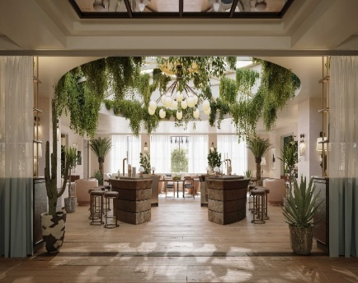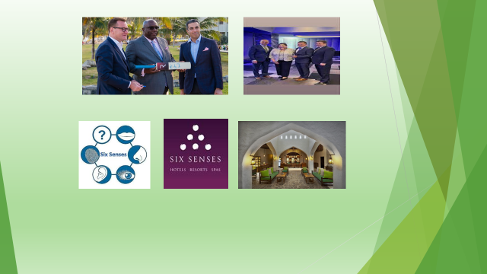
Appendix 2:(SOSTAC)
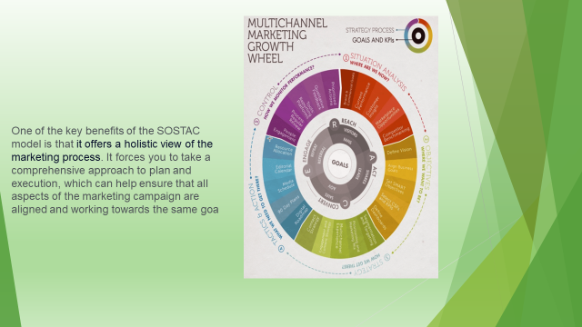
Appendix 3: (Gannt chart )

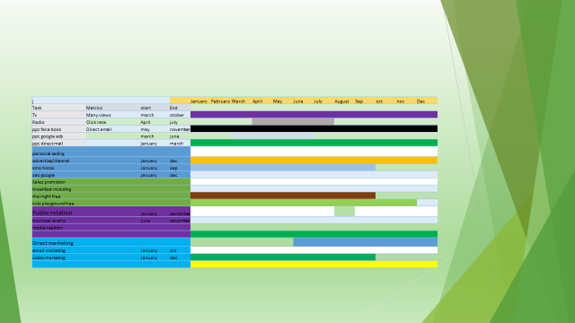

Appendix 4: Control



Appendix 5: strategy



Appendix 6: 7 p’s marketing mix


