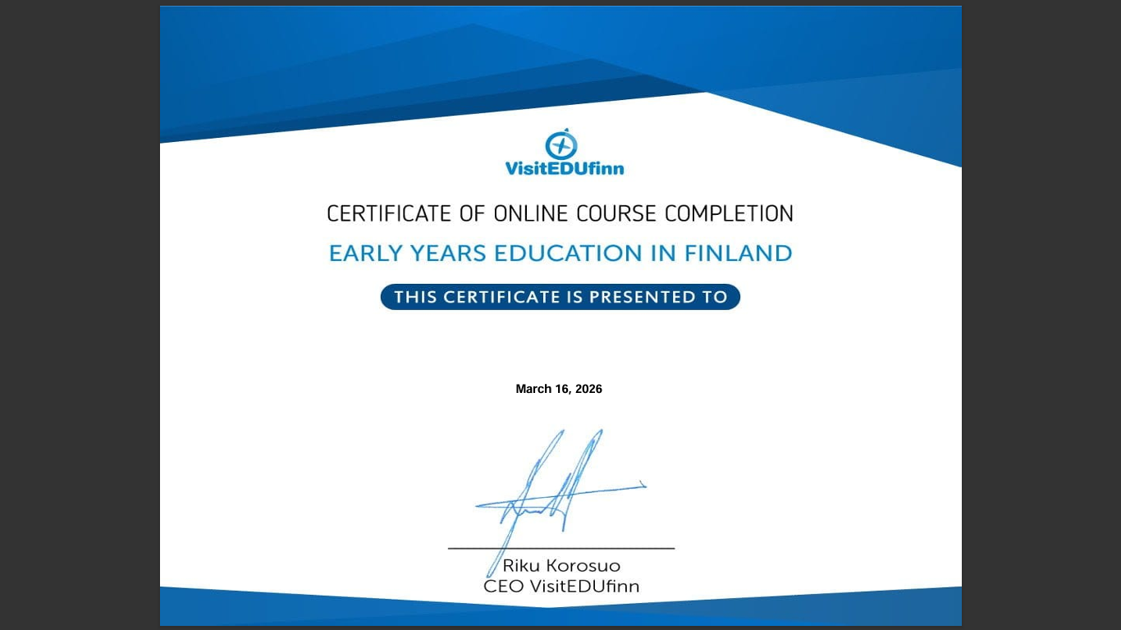
Evidence of certificate of online course completion, early years education in Finland
Gwenllian Leworthy 2303980 Early Years Education and Care

