Submission #4– Interim submissions, 500 words each
Name: Greg Thompson
Number: 1705753
Module: work-based project
Date: 20.02.20

What new skills did you learn in the period?

During this time period the site has been extremely busy, but we are still on target for completion at the end of March. The recent stormy weather over the last 3 weeks has been a concern as it has been difficult to keep the men working throughout the weeks, as no felting works can be laid in the rain and once wind speeds are greater than 17 mph it is recommended the men do not work on the roof. Fortunately, there is a lot of rainwater goods, for example fascia, soffit, gutter and downpipes that need to be installed throughout the school. This allowed our men to continue working throughout the severe weather and to ensure that we were still on target for the proposed date of completion.
The skill I have learnt in this time frame is that there needs to be a plan devised at the beginning of the job, to set aside jobs that can be completed when the weather is wet so that the work force keeps working to targets regardless of the weather.

How have you been able to adapt / use the new skills learnt within the work environment? e.g. time management / technical / soft skills

The Management of J Randall Roofing Ltd have always encouraged me to save wet weather work for the workforce to complete on wet/ rainy days. However, it is a difficult aspect of the job to balance as you have deadlines to meet and jobs to complete on the project. It is essential therefore to be in communication with the client to inform them of any setbacks to targets due to the poor weather.
I have always found this aspect difficult to manage but in this instance I informed the client that there would be certain areas of the roof that would not be completed due to the fact that they were part of the planned wet weather work and so they would be completed later in the project.

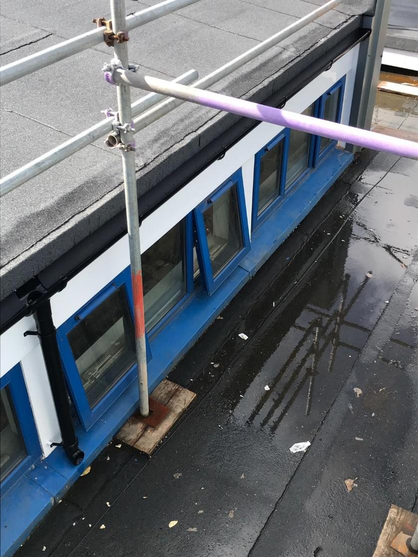
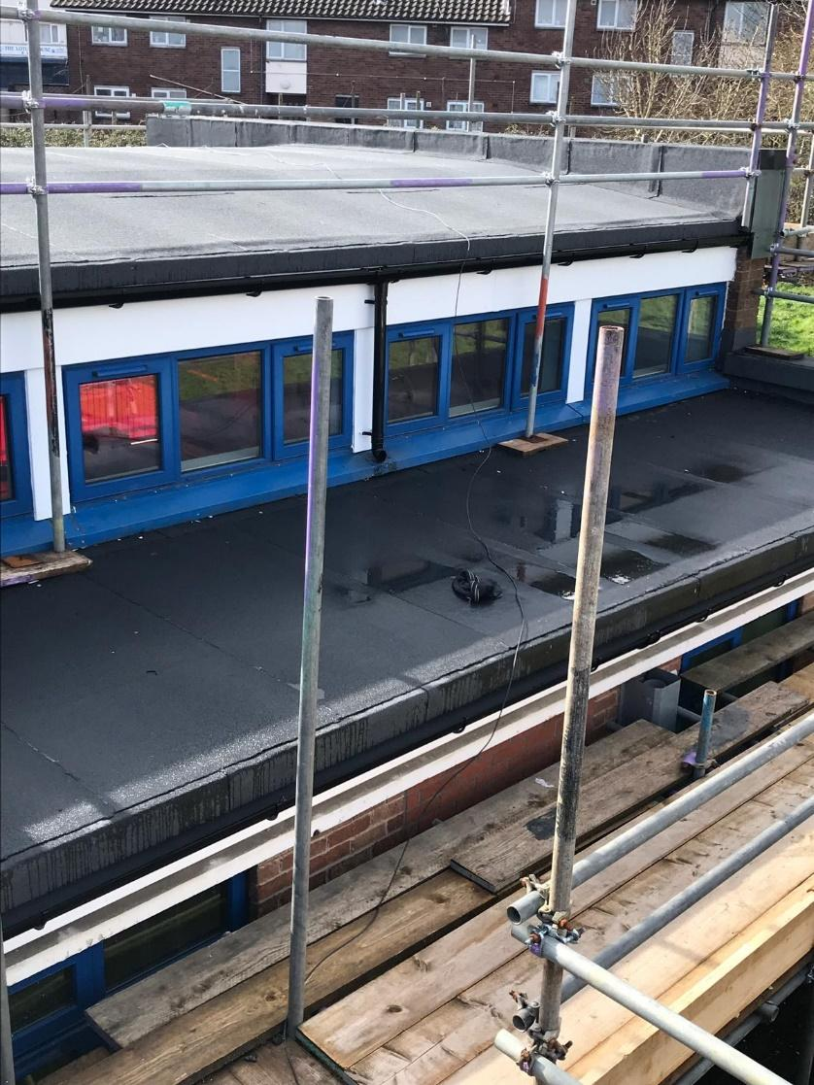
Photos taken from site of the guttering and fascia’s completed in wet weather

What was the highlight and why?

The highlight was having the satisfaction of knowing that we are still on target after all the bad weather we have had. It is testament to our workforce that when the weather is dry, they have worked tirelessly to make sure we stay on target.

What part of the task / activity were most challenging and least challenging?

The most challenging part was laying the men off work when all the wet weather work had been completed. I try my best to ensure we keep the site open every day, but it was just not possible with the amount of rain we have had in the last 3 weeks.

How are you progressing according to your objectives (learning contract)?
In relation to the objectives I set at the start of the project I am on track in succeeding. The project programme of works below is being followed and we are on target to finish within the timescale given.
Trying to keep a record of what is bought and the waste we have on site is still an issue that I have not yet fully resolved. This will be my next area I wish to improve on going forward.
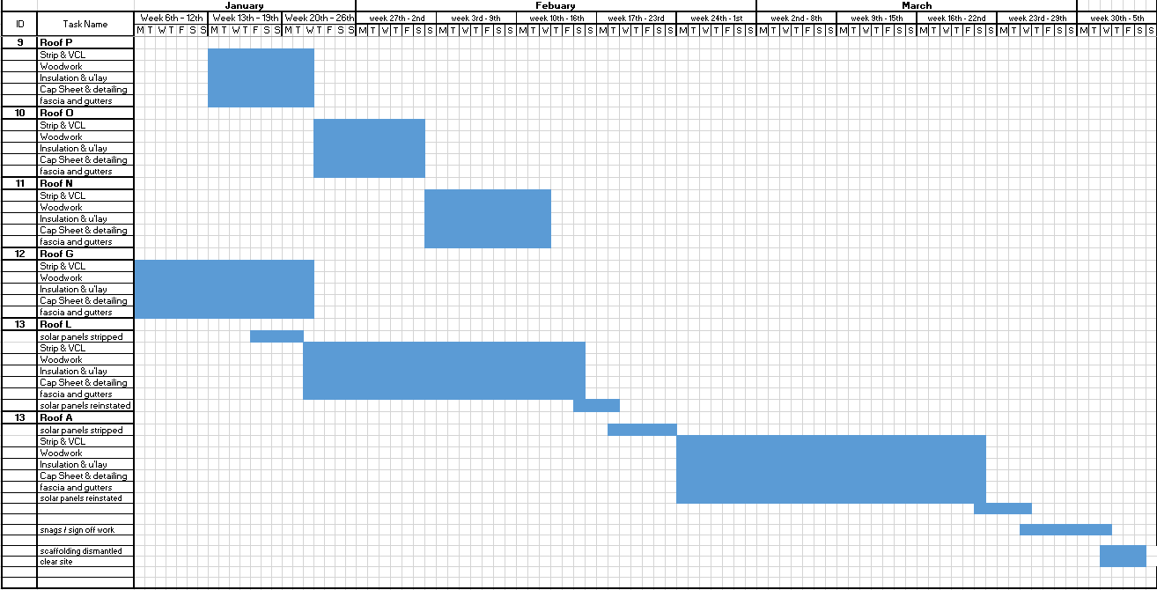

Programme of works for Greenway Primary school – J Randall Roofing Contractors (this has been cropped to only show the last 5 roofs as the first 8 have been completed)

