

Name: Md Mehedi Hasan
Student ID: 2506709
Module Name: Marketing Management
Module Code: LCMB7024
Lecturer's Name: Dr Laila Maazouz (London)
Word Count: 2615

Table of Contents
Element 1: STDP Analysis -Veloce-CyberBike 4
Introduction to Tesla & New Brand Concept 4
Market Appeal & Consumer Trends 4
Segmentation Analysis 4
Targeting Strategy 5
Differentiation Strategy 6
Positioning Strategy 6
Element 2: Marketing Mix (4Ps) 7
Product Strategy 7
Price Strategy 8
Place (Distribution) Strategy 9
Promotion Strategy 10
Conclusion 11
Element 3: Marketing Strategy Pitch 12
Element 4: Reflection 13
Introduction to the Learning Experience 13
Learning from Brand Development and STDP 13
Developing the Marketing Mix Strategy 13
Experience Preparing the Poster and Pitch 14
Skills Gained 14
Areas for Further Improvement 14
Conclusion 15
References 16
Appendix 18
Element 3: Marketing Strategy Pitch 18

Element 1: STDP Analysis -Veloce-CyberBike

Introduction to Tesla & New Brand Concept
Tesla is popularly known as an electric mobility innovator that provides high technology, sustainability, and quality cars. The vision of the company is to drive the conversion of the world to clean energy (Tesla, 2021). With the development of UK urban centres, many people cannot afford to use traditional means of transportation due to disruptions such as traffic congestion, air pollution and high commuting costs (Galatoulas, Genikomsakis and Ioakimidis, 2020).
In response to such challenges, Tesla presents a new category of products called Veloce-CyberBike that consists of high-quality electric bicycles and scooters that allow flexible and quick movement in cities (Wolniak, 2023). Micro-mobility denotes small electric cars to be used in short-distance transport.
The brand leverages the energy efficiency of Tesla batteries, smart connectivity, and safety sensors to provide a clean, convenient, and high-technology commuting lifestyle. The product is very attractive to the UK consumers who appreciate sustainability, innovation and affordable travelling options.

Market Appeal & Consumer Trends
The UK consumer behaviour is moving towards smart and green mobility. The increasing population of cyclists and electric vehicle owners is unwilling to be in traffic, to save money on transportation, or to lead healthier lifestyles (Cipriani, 2023). There is a specific demand among younger people who want to experience mobility in their personal technologies, such as GPS tracking, automating control and safety in their apps.
The high brand trust and the high-tech features of Tesla provide Veloce-CyberBike with a competitive edge at first instance, as it can be used as a daily commuter and lifestyle upgrade.

Segmentation Analysis
Segmentation refers to the separation of the entire market into smaller segments that have similar requirements.
Segmentation Base | Description | Why It Matters
Demographic | Ages 18–40, students, professionals with medium–high income | More willing and able to spend on premium technology (Galatoulas, Genikomsakis and Ioakimidis, 2020)
Geographic | Major UK cities like London, Birmingham, Manchester (Hubbard, 2024) | Dense populations and strong cycling infrastructure
Psychographic | Tech-savvy, eco-conscious, lifestyle-focused consumers | Strong alignment with Tesla’s innovative and sustainable brand
Behavioural | Daily commuters, subscription users, early adopters | High product usage → steady demand and brand loyalty
Table 1: Segmentation Analysis
Source: Author
These market segments are financially and behaviourally prepared for smart mobility solutions. City consumers tend to face delays during travel and need quick and autonomous transport solutions (Silva, 2020). The psychographic fit is high since they like modern technology and environmental awareness. In behavioural terms, commuters will use the product on a daily basis, which will result in constant brand interaction and subscription income.

Targeting Strategy
Target Group | Needs & Travel Habits | Targeting Method
Primary Target: Young urban professionals (22–35) (Hubbard, 2024) | Quick commute, premium lifestyle, digital interaction | High-end product features + flexible subscription (Hubbard, 2024)
Secondary Target: University students & delivery riders | Affordable commuting & independence | Entry-tier pricing + campus/location-based access
Table 2: Targeting Strategy
Source: Author
Young professionals are most suited to high-end models since they demand convenience and intelligent automation. Students offer growth potential through volume pricing. Brand awareness is raised because delivery riders use it every day. The two-sided strategy guarantees extensive penetration and preserves high-end branding (Galatoulas, Genikomsakis and Ioakimidis, 2020).

Differentiation Strategy
Feature Category | Veloce-CyberBike Offering | Typical Competitor Offering
Battery & performance | Long-range Tesla battery with fast charging | Standard battery, shorter distance
Smart connectivity | Tesla App control, GPS safety monitoring (Diggelen, 2018) | Limited or basic tracking apps
Charging network | Compatibility with Tesla charging points | Home or limited public charging
Automation | Collision alerts, adaptive lights | Manual safety function only
Ownership model | Purchase + subscription bundle | Either-or, not integrated
Table 3: Differentiation Strategy
Source: Author
With the help of the reliable technology ecosystem provided by Tesla, Veloce-CyberBike can be more than a bike; it is an interconnected mobility platform. The main competitive advantage of traditional brands is the design of the hardware, whereas Tesla also offers smart data insights, long-lasting power performance, and access to an established charging network (Diggelen, 2018). This produces a unique long-term value benefit.

Positioning Strategy
The positioning of Veloce-CyberBike will be:
An innovative and high-performance UK urban commuting e-mobility solution with a high level of digital safety.
This positioning highlights the innovative brand name of Tesla, which will provide users with a mobility product that is fashionable, smart, and eco-friendly. It also supports Tesla's lead on cars for the future of urban transportation (Ruggieri et al., 2021).

Element 2: Marketing Mix (4Ps)
The marketing mix explains the tactical choices that are adopted in supporting the brand strategy and creating value for the target market. In the case of Veloce-CyberBike, Tesla can use the 4Ps model (Product, Price, Place, Promotion) to cater to urban commuters in the UK who require a fast, convenient and technologically advanced mobility product (Silva, 2020). All the aspects below illustrate the mechanisms through which Tesla can make sure that it remains consistent with its positioning as a high-end smart mobility provider.

Product Strategy
The product can be described as all the factors that bring benefit to the consumer, such as design, performance, features and other services. Veloce-CyberBike has been designed as a brand of high-quality electric bicycles and scooters that fuses cyber-aesthetic design with technological perfection by Tesla (Mintel, 2019). It provides a contemporary mobility concept of lifestyle that will lend credence to the daily commuting patterns of UK dwellers in metropolitan and overcrowded cities. Smart integration with the Tesla app helps the riders not only to be convenient and secure, but also long-range batteries will guarantee that the rider will be able to use throughout the week (Kotler, Keller and Chernev, 2022).
Product Element | Description | Customer Value Created
Design & Build Quality | Premium lightweight frame and cyber styling | Comfortable and stylish commuting experience
Battery & Range | High-efficiency Tesla battery cells | Dependable travel with fewer charging interruptions
Smart System Integration | GPS, anti-theft, app-based control | Improved digital convenience and enhanced security (Laukkarinen, 2024)
Autonomous Safety | Collision sensors and adaptive lights | Increased protection in complex UK traffic
Charging Ecosystem | Compatibility with Tesla charging infrastructure | More charging options compared to competitors (Statista, 2024)
Product Variants | Standard, Pro and Campus versions | Choice for different economic and lifestyle needs
Table 4: Key Product Features and Customer Value
Source: Author
The above description shows the contribution of each feature to the needs of commuters. Veloce-CyberBike is not a basic mobility product, but a connected urban product (Laukkarinen, 2024). It offers reliability in the long term by updating the devices over the air and maintaining the devices in systematic plans (Kotler, Armstrong and Balasubramanian, 2023). The presence of model variants will help Tesla attract both high-end purchasers and users who are more cost-conscious without compromising an innovative brand image.

Price Strategy
Price refers to a financial amount charged to the customer in exchange for the product and the advantages it offers. Being a high-end electric mobility product with the support of advanced technology, Veloce-CyberBike implements a value-based pricing strategy. This enables it to price higher based on a better range, digital connectivity, and brand equity of Tesla as opposed to pricing based on the cost of production only (Wolniak, 2023). The presence of a flexible pricing system contributes to the decrease of the barriers to ownership, and various target segments can comfortably implement the product.
Pricing Component | Strategy | Customer Benefit
Core Product Price | Premium pricing reflecting advanced engineering | Reinforces superior product status and exclusivity
Subscription Option | Flexible short or long-term rental plans | Makes access easy for those avoiding high upfront costs (Cipriani, 2023)
Service Bundles | App features and maintenance plans combined | Simplifies ownership and ensures dependable use
Student & Campus Plan | Lower-priced variants for younger users (Hubbard, 2024) | Expands affordability for the secondary target market
Upgrade Programme | Trade-in support for frequent technology adopters | Improves long-term value and brand loyalty
Table 5: Pricing Strategy Components and Customer Impact
Source: Author

The pricing strategy provides the option of owning and subscribing. This can be said to be true more in a market where the younger people might be concerned about convenience and less monetary commitment (Kapousizis et al., 2024). Tesla can provide an asset-based, low-priced campus version to ensure that it does not lose the premium aspect of the core brand in the name of inclusivity. The organisation also provides recurrent revenue, which enhances the survival of Tesla's business, besides elevating customer access.

Place (Distribution) Strategy
Place is the medium and means of delivering goods to the consumer at the appropriate place and time. In the case of Veloce-CyberBike, the location and reach play a significant role since the product facilitates daily commuting (Hooley, 2020). Tesla thus uses the omnichannel distribution model, which combines the online sphere with the real spaces being in close proximity to the commuter flows. This will make sure that his or her consumers have easy access to buying, testing, or servicing their bikes at large urban centres in the UK.
Channel Type | Distribution Approach | Strategic Purpose
Tesla Retail Stores | Test-ride experience and personalised guidance | Builds confidence in performance and technology Ruggieri et al. (2021)
Online Store & Tesla App | Direct ordering, customisation, and delivery | Creates seamless access from anywhere
University Campus Partnerships | Retail kiosks and pick-up points | Focuses on student markets with high usage demand (Kapousizis et al., 2024)
Urban Mobility Hubs | Locations near stations and offices (Wolniak, 2023) | Integrates with daily commuting pathways
Corporate Leasing Programs | Employer-supported mobility plans | Encourages mass adoption through workplace benefits
Table 4: Distribution Channels and Strategic Purpose
Source: Author
This updated distribution model will help Tesla to retain direct control of customer experience and brand message. Proximity to primary and secondary target users is made possible through campus and workplace channels. Mobility hubs enhance the frequency of interaction, as Veloce-CyberBike will become visible and available during the high commute times (Wolniak, 2023). This is aided by the Tesla app, whose initial centralisation of purchase, delivery, and servicing will be on a single platform. Combined, these resolutions enhance the long-term product presence both in the physical and digital marketplace.

Promotion Strategy
Promotion refers to the process of communication that is applied to create awareness and convince purchasers. In the case of Veloce-CyberBike, the promotional messages aimed to promote the need to be more sustainable, fast, and smart, only values that have a heavy influence on the choice of urban mobility (Hague, 2019). The communication plan focuses on digital platforms because the target audience consumes mobile devices and online networks extensively. The general objective will be to create brand desire, test ride influence, and conversions to paid subscription or purchase.
Promotional Method | Application | Expected Outcome
Digital Marketing | Advertisements on social and online media channels | High visibility among tech-active consumers
Influencer Collaborations | Endorsements by cycling, tech and lifestyle figures (Hooley, 2020) | Builds credibility and trend relevance
Test-Ride Demonstrations | Events in workplaces and university campuses | Increases trial, reducing uncertainty before purchase
Referral Incentives | Reward schemes for customer invitations | Low-cost acquisition and improved retention Ruggieri et al. (2021)
Brand Community Engagement | In-app cycling events, milestones and rewards | Enhances loyalty and emotional brand connection
Table 6: Promotional Activities and Expected Outcomes
Source: Author
This marketing mix will make the customers engage with the product and the brand group. The test-ride events are especially valid as customers get to have a feel of the performance themselves, which is essential to mobility products. Promotion by word of mouth, created by referrals, contributes to the promotion of adoption in an organic way. The advertising campaign supports Tesla as a progressive trendsetter in green technology and invites commuters to join a new trend in transportation.

Conclusion
The marketing mix that is developed to target Veloce-CyberBike has an integrated approach that is compatible with the goal of Tesla to venture into sustainable micro-mobility. The product strategy will provide a smart and high-end user experience, the pricing strategy will provide flexibility and continued commitment, the distribution strategy will guarantee availability in high-demand locations, and the promotional strategy will help in effective interaction with the target audience by using the current and modern digital communication tools. A combination of these factors would secure the position of the brand as the most sophisticated, convenient, and appealing electric commuting alternative in the UK cities.

Element 3: Marketing Strategy Pitch
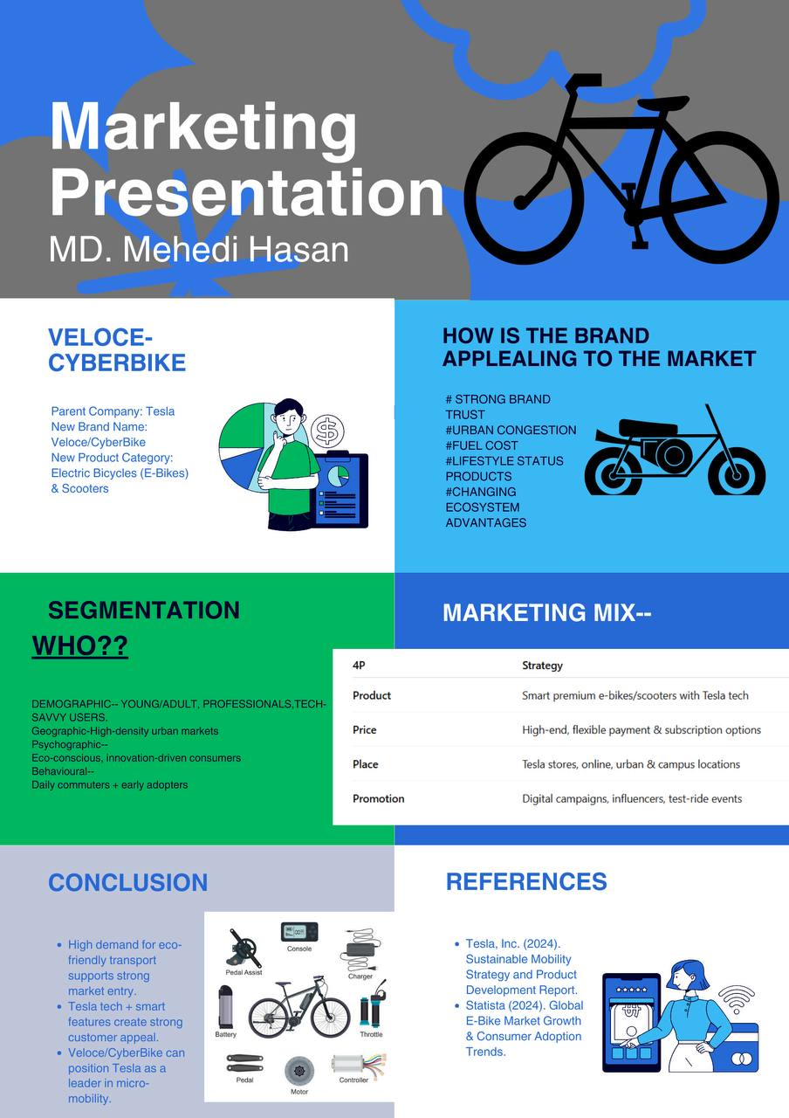

Element 4: Reflection

Introduction to the Learning Experience
The creation of the Veloce-CyberBike brand concept and marketing plan has been a very valuable learning experience that broadened my conceptual knowledge as well as my practical abilities. Prior to undertaking this project, my branding strategy was primarily based on the product features only (Wolniak, 2023). This assignment taught me that effective brand development involves strategic alignment with the needs of the customers, competitive markets and proper communication of the value.

Learning from Brand Development and STDP
The development of the brand in the STDP framework, which is an approach of Segmentation, Targeting, Differentiation, and Positioning, assisted me in transitioning into a creative concept and towards a market-oriented approach (Diggelen, 2018). I became more capable of measuring customer behaviour, making decisions that promise the most potential market, and reasoning these decisions logically. Formulating the positioning statement helped me to understand the importance of being clear and consistent in the way in which customers create their perceptions. I understood that differentiation is not just about the high functionality but also the emotional and functional value that is developed for the user.

Developing the Marketing Mix Strategy
The preparation of the 4Ps framework also improved my critical thinking on the success of products in competitive markets. I was also taught how to tie all the marketing decisions to the overall strategic objectives. Indicatively, the creation of a subscription pricing strategy made me realise how to strike a balance between brand loyalty and affordability among the youthful consumers (Ruggieri et al., 2021). The distribution planning helped me to be more aware of the way physical and digital channels should be integrated with commuting trends within urban areas.

Experience Preparing the Poster and Pitch
The composition of the poster has taught me to exercise proper visual communication. I also got to know that less is usually more important than providing too much information. The choice of the visuals and colours, and layout involved thinking with details and design that made me acquire better skills in digital presentation (Galatoulas, Genikomsakis and Ioakimidis, 2020). The pitch also helped me feel more confident about my ability to explain marketing concepts in a clear and convincing manner. I have realised the essence of talking with lean text and high engagement with the audience when discussing strategic ideas.

Skills Gained
The project helped me to develop a number of professional skills which are critical, and these skills include:
- Strategic marketing decision making.
- Critical thinking and analysis writing (Cipriani, 2023).
- Visual presentation design and visual communication.
- Innovation with formal structures.
- Commercial sensitivity in the decisions of products and prices.
These gains have made me feel better equipped to play a positive role in future academic and industry marketing projects.

Areas for Further Improvement
Although I made progress, I found that there were other areas that I could work on. I would also like to gain better research skills by incorporating more real-life data in the planning phase. This would assist in defending decisions with a lot of confidence. Also, I want to improve my presentation skills when it comes to storytelling to make brand pitches memorable and emotional. Lastly, better time management in the future will enable me to polish the content and seek other creative options prior to the plan's finalisation.

Conclusion
In general, this assignment helped me to use theoretical knowledge in a practical project, which demanded innovation, decision-making, and communication. The strategic frameworks and creative design enhanced my educational knowledge and professional preparedness. I am more inclined to approach future brand development tasks with a more systematic, evidence-based approach and have more appreciation of how marketing actually shapes real consumer behaviour.

References
Hague, P.N. (2019). The business models handbook : templates, theory and case studies. London, United Kingdom: Kogan Page Limited.
Hooley, G. (2020). Marketing Strategy and Competitive Positioning, 7th Edition. Pearson UK.
Kotler, P., Armstrong, G. and Balasubramanian, S. (2023). Principles of Marketing. 19th ed. Harlow: Pearson.
Kotler, P., Keller, K.L. and Chernev, A. (2022). Marketing Management. 16th ed. Hoboken, Nj: Pearson Education.
Silva, T.D. (2020). Integrating Business Management Processes. 1st ed. Productivity Press eBooks. New York: Routledge. doi:https://doi.org/10.4324/9781003042839.
Statista (2024). European Union: Population Growth 2024| Statista. [online] Statista. Available at: https://www.statista.com/statistics/253389/population-grwoth-in-the-european-union-eu/?srsltid=AfmBOopS_X3W3QLwunf_hC7kyiZYPCHa2oRUSqT2q23z-nbF20oO5JJa [Accessed 11 Dec. 2025].
Cipriani, C. (2023). eBike: from Sustainability to Management of Electric Mobility Innovations Evaluation of the Bosch eBike System’s Sustainability Strategy. [online] webthesis.biblio.polito.it. Available at: https://webthesis.biblio.polito.it/29666/ [Accessed 10 Dec. 2025].
Diggelen, A. van (2018). ‘It Feels like the Hand of God Thrusting You up the road’. BBC. [online] 7 Jun. Available at: https://www.bbc.com/news/business-44301182 [Accessed 12 Dec. 2025].
Galatoulas, N.-F., Genikomsakis, K.N. and Ioakimidis, C.S. (2020). Spatio-Temporal Trends of E-Bike Sharing System Deployment: a Review in Europe, North America and Asia. Sustainability, [online] 12(11), p.4611. doi:https://doi.org/10.3390/su12114611.
Hubbard, B. (2024). TRL Urges UK Government to Take a More Holistic Approach to Micromobility Regulatory Reform - Zag Daily. [online] Zag Daily. Available at: https://zagdaily.com/opinion/trl-urges-uk-government-to-take-a-more-holistic-approach-to-micromobility-regulatory-reform/ [Accessed 11 Dec. 2025].
Kapousizis, G., Sarker, R., Baran Ulak, M. and Geurs, K. (2024). User Acceptance of Smart e-bikes: What Are the Influential factors? a cross-country Comparison of Five European Countries. Transportation Research Part A: Policy and Practice, [online] 185, p.104106. doi:https://doi.org/10.1016/j.tra.2024.104106.
Laukkarinen, E. (2024). Revolutionizing Business Models – Analysis of Product Service Systems in European Bicycle Industry. [online] aaltodoc.aalto.fi, pp.51–56. Available at: https://aaltodoc.aalto.fi/items/d0c97bf3-2a8d-4ed4-8e7b-45f4ce7eda1c [Accessed 10 Dec. 2025].
Mintel (2019). 14% of UK Cyclists Intend to Buy an e-bike in the next. [online] www.mintel.com. Available at: https://www.mintel.com/press-centre/on-your-e-bike-14-of-uk-cyclists-intend-to-buy-an-e-bike-in-the-next-year/ [Accessed 10 Dec. 2025].
Ruggieri, R., Ruggeri, M., Vinci, G. and Poponi, S. (2021). Electric Mobility in a Smart City: European Overview. Energies, 14(2), p.315. doi:https://doi.org/10.3390/en14020315.
Tesla (2021). Tesla Vision Update: Replacing Ultrasonic Sensors with Tesla Vision. [online] www.tesla.com. Available at: https://www.tesla.com/en_GB/support/transitioning-tesla-vision [Accessed 10 Dec. 2025].
Wolniak, R. (2023). European Union Smart Mobility–Aspects Connected with Bike Road System’s Extension and Dissemination. Smart Cities, 6(2), pp.1009–1042. doi:https://doi.org/10.3390/smartcities6020049.

Appendix

Element 3: Marketing Strategy Pitch

