Marketing Plan written for: Ibis Hotel
Student Name: Parbjota Rhoud
Student ID Number; 2212646
Marketing Essentials:BMIH4005
Lecturer: Christopher Wilkin

Table of Contents
1 Introduction 3
2 Situation Analysis 3
2.1 Company: SWOT analysis 3
2.2 Customers 4
2.3 Competitors 4
2.3.1 Perceptual Map 5
2.4 Collaborators 5
2.5 Climate: PESTLE (Macro analysis) 6
3 Objectives 6
4 Strategy 7
5 Tactics 8
5.1 Marketing mix 8
6 Action 9
7 Control 9
8 Conclusion 10
9 References 11
10 Appendices 14

Introduction
The purpose of the marketing plan is to grab all relevant opportunities and ensure that the organisation's objectives are achieved with the relevant set of marketing activities. The marketing plan also works to help identify the target audience and implement strategies to reach them (Stevens et al. 2021). However, the current report is based on defining the marketing strategy for Ibis Hotel and targeting a new set of customers for the hotel post-pandemic. To frame the plan, the SOSTAC model is used where the situational analysis will be conducted using PESTLE, SWOT and Porter Five. Later on, objectives, strategy, tactics, action and control will be provided to ensure the safe implementation of the plan.

Situation Analysis
5 'C's

Company: SWOT analysis

Strengths  - Contributes in the economy of the country.  - On online websites it is ranked with positive reviews for its services.  - Loyalty programs are offered to the customers (Rachmawati et al., 2020).  - 24 hours service is provided to the customers. | Weaknesses  - Customers usually fail to recognize it as a brand.  - The hotel has been mainly investing in the sector of the food and beverages.  - It offers over-emphasis on its other sub-brands.
Opportunities  - It is growing largely in Asian as well as African tourists destinations.  - The hotel has obtained growth through social media platforms | Threats  - Rapidly the growth of competitors in the market is increasing (Gheribi, 2018).

Customers
Segmentation | Targeting | Positioning
-The marketing plan will target customers of Birmingham.  -Price-conscious consumers.  -Both male and female.  -Targets customers who love design and creativity.  -Business travellers and family travellers | -Targets customers who love design and creativity.  -People who desire comfort with affordability. | -The hotel is positioned as a budget hotel with affordable prices

Competitors
Bargaining power of the buyer | Travelling consumers are savvy, and therefore, they are able to explore online and choose the best hotel suiting their pocket needs (Cheng et al., 2021). Hence, the power is high.
Bargaining power of supplier | Multiple suppliers are available to fulfil the resource demands of the hotels in the UK; therefore, the power is low.
Threat of substitution | There are a variety of hotels ranging from small B&B to large exotic hotels varying in price and services. Thus, the threat is high.
The threat of new entrants | The initial cost of investing in hotels is high, creating barriers for new entrants (Eskerod et al., 2019).
Degree of rivalry | A fierce rivalry is present among the hotels. The competitors’ hotels are large with more accommodation space. The graph provides insight into the hotels in the UK.  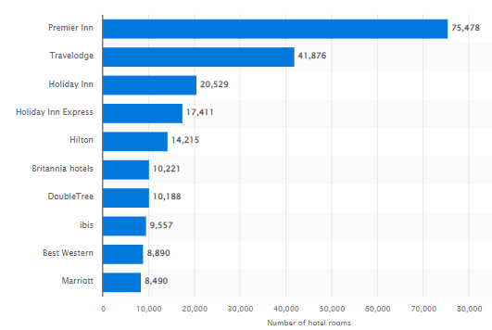  Figure 1: UK Hotel brands  (Source: Statista 2022)

Perceptual Map
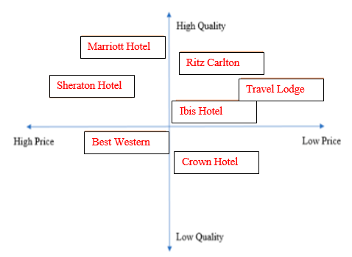

Collaborators
Majorly, the performance of the hotel is associated with Accor, one of the popular hotels in France. In the association of the partnership, it is associated with a number of sectors, such as; Air France airline, standard chartered bank, and Hertz. Ibis has its franchise located in more than 67 countries (Christina and Loredana, 2019). In the notion of environmental support provided by the hotel the utility of eco-friendly products are utilized in the hotel made with organic resources. Also, it is part of planet 21 programs to support the environment.

Climate: PESTLE (Macro analysis)
Political | -Travel bans impact the hotel industry (Davahil et al., 2020).  -Brexit caused staff shortages.  -The government imposed a 12.5% reduced VAT on hospitality-related activities (Parliament of UK 2022).
Economic | -Inflation in the UK elevated to 9.6% from 8.8% (ONS UK 2022).  -The unemployment rate increased to 4.9% affecting the hospitality sector (BBC 2020).
Social | -Increased social media usage.  -Changes in consumer preferences post-pandemic.
Technological | -Smart lighting technology, the Internet of Things and real-time changes has changed the hospitality industry (Law et al., 2018)
Legal | -The hotel is protected under the Copyright, Design and Patent Act 1988 (CLA 2022).  -Consumer and employment rights must also be protected.
Environmental | -Hygiene practices need to be focused on.  -Sustainability is a prime area.

Objectives
-SMART target
The aim of the marketing plan is to target a new set of customers and broaden the customer base for Ibis Hotel, ensuring that it competes effectively with its rivals in the industry.
- To increase website interaction for Ibis Hotel by 10% by elevating SEO keyword usage by the first quarter of 2022.
- To increase the follower base for Ibis by 30% annually using social media campaigns.
- To find new leads and increase purchasing rate by 10% by making use of influencer promotion by the second quarter of 2022.
- To accelerate the rate of customer referrals by 15% by developing sales strategies by mid of 2022.

Strategy
The Value proposition of Ibis Hotel is to lead as a budget hotel and offer the highest service level to the customer with comfort and the best market prices. The pricing strategy with ultimate comfort differentiates the hotel from the others, who charge a premium for luxury and comfort. Consumers are price conscious when choosing travel comforts, and therefore, the low price of the hotel will serve to target the audience. The communication strategy that the hotel will adopt will include a focus on interacting with consumers using social media channels. The marketing will evoke travel aspirations and will attract consumers with the initiative of providing affordability post-pandemic to enjoy a stress-free journey.
Additionally, based on Bowman’s strategy clock, the focus will be given to low prices with value-added services. Hence, no compromise on quality will be entertained. Thus the proposed strategy will harmonise with the communication tools to reach the target audience.
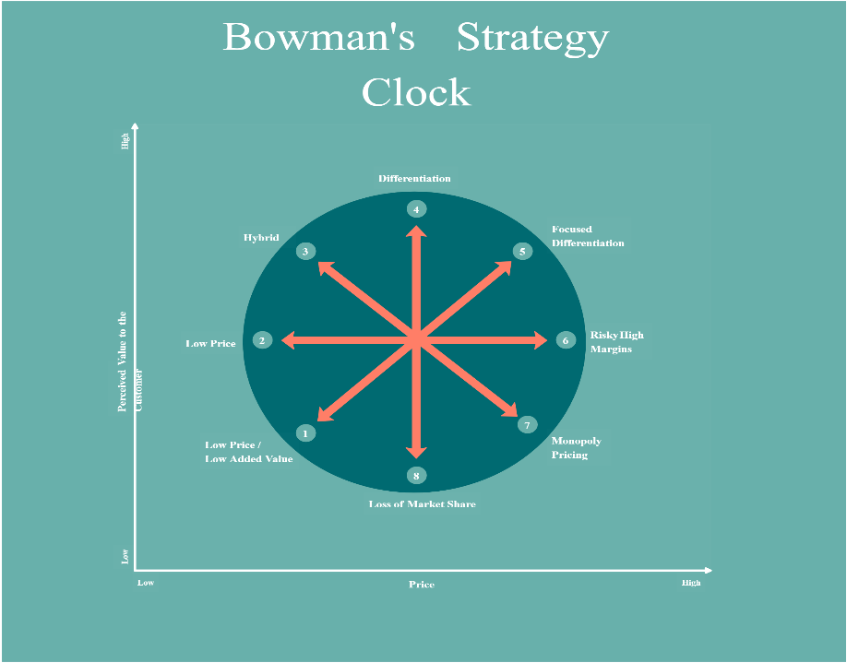

Tactics

Marketing mix
The notion of the marketing mix is supported by four major aspects that play a role in planning the respective notion into the major market.

-Product
In the aspect of the product from marketing mix, it refers to the notion being offered through the business. The Ibis is a globally known hotel with budget-friendly hotels supported by Accor. In a number of countries, the hotel services are offered by Ibis to its guests. Every floor of the hotel is designed with creative and innovative ideas with attention-seeking pieces. The main focus of the service is family travelers. The current plan of the hotel is to prompt the service of the hotel by training employees to deal with guests with valuable treatment, collaboration and innovating with the partners to improve the services of the hotels, and improve the infrastructure of the hotels in attracting customers.
-Place
Ibis is largely scattered in more than 67 countries globally. More than 200 hotels of Ibis are found in France. The functioning of the hotel Ibis is reported in every major developed country, such as; England, Japan, Korea, and Russia. During the Pandemic, one stay was offered to the customers of Ibis hotel in Heathrow, which impacted its revenue in 2020 (Vinod, 2022).
-Price
Ibis is known for its budget friendly services towards the customers. The current pricing strategy of the hotel is to allow customers to explore international services of the hotel at economical prices. It has been analyzed that Ibis has adopted the notion of value based pricing strategy (Cheng, 2019). The flexible pricing strategy of the Ibis is offered to the customers in the emerging seasons of the vacations. Also, to maintain its brand identity, promotional offers are offered to the customers to attract more guests. During the emerging festivals of the month 20 or 10 percent off is given on the services.

-Promotion
In Ibis hotel the promotion of the services is provided to its customers through online. Through the association of the Accor hotel of France, major discounts are offered once a year to its customers. Campaigns are performed in order to promote the hospitality business of the hotel. A slogan of the hotel, “for you and you” has attracted a number of customers towards the hotel. Discount cards are offered to the loyal customers to accelerate the promotion.

Action
For the success of a strategy to be implemented, appropriate planning is required to implement the tactics. Moreover, attention to detail, prioritising people and management and ensuring effective time management lead to the desired outcome. The below presented Gannt chart provides insights into the marketing activities schedule that will help stay on track. The selection of marketing channels includes social media channels, specifically Instagram and Facebook, due to their increasing usage. Influencer marketing will also be focused on reaching a wider audience.
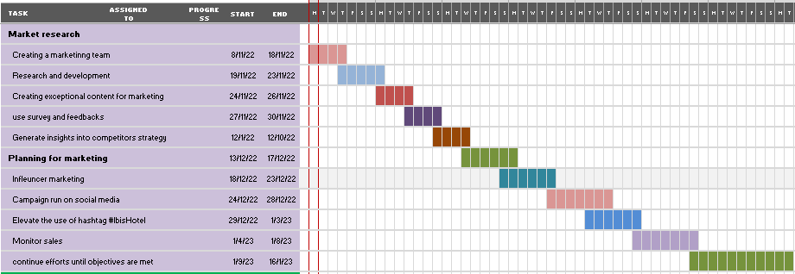

Control
For Ibis Hotel, the Unique Selling Point is the focus on affordability and being light on consumer pockets. It also attracts consumers with unique and creative hotel designs making it an ideal location for business travellers and those travelling with family. However, to control the marketing efforts, a control system needs to be in place to monitor and measure the efficiency of the marketing plan. Therefore, to measure success, the marketing team will keep a count of the new customer, judge their positive attitudes, keep an eye on growing profits, analyse social media channels, oversee likes and comments and the growing number of followers and also measures the increasing traffic on the website.

Conclusion
From the overall use of the SOSTAC model for developing an effective marketing plan, it is analysed that there are abundant growth opportunities for the hotel. The hotel can effectively conquer the top position in the hotel industry, especially after the pandemic when a consumer seeks affordability when making spending decisions. The competitor’s strategy may pose a threat to the functioning of a marketing plan, but a positive attitude and differentiation will ensure that the brand is able to engage with the target audience effectively.

References

BBC 2020. Hospitality worst-hit as unemployment rises again. [Online] Available at https://www.bbc.com/news/business-55313752 . [Accessed on 28 November 2022].
Cheng, J., 2019. Research and Suggestions on Declining Market Shares of Ibis Budget Hotels. Open Journal of Social Sciences, 8(1), pp.253-261.
Cheng, L., Craighead, C.W., Crook, T.R. and Eckerd, S., 2021. Leaving it on the table? An examination of unrealised bargaining power in multimarket buyer-supplier exchanges. Journal of Operations Management, 67(3), pp.382-406.
CLA 2022. What is copyright? [Online] Available at https://www.cla.co.uk/what-is-copyright [Accessed on 28 November 2022].
CRISTINA, M. and LOREDANA, T., 2019. THE FRANCHISE-A WAY TO DEVELOP HOTEL BUSINESSES. Agricultural Management/Lucrari Stiintifice Seria I, Management Agricol, 21(1).
Davahli, M.R., Karwowski, W., Sonmez, S. and Apostolopoulos, Y., 2020. The hospitality industry in the face of the COVID-19 pandemic: Current topics and research methods. International Journal of Environmental Research and Public Health, 17(20), p.7366.
Eskerod, P., Hollensen, S., Morales-Contreras, M.F. and Arteaga-Ortiz, J., 2019. Drivers for pursuing sustainability through IoT technology within high-end hotels—an exploratory study. Sustainability, 11(19), p.5372.
Gheribi, E., 2018. Competition Strategies of Selected International Hotels Groups on the Polish Market. J Tourism Hospit, 7(381), pp.2167-0269.
Law, R., Chan, I.C.C. and Wang, L., 2018. A comprehensive review of mobile technology use in hospitality and tourism. Journal of Hospitality Marketing & Management, 27(6), pp.626-648.
ONS UK 2022. Consumer Price Inflation. [Online] Available at https://www.ons.gov.uk/economy/inflationandpriceindices#:~:text=Consumer%20price%20inflation%2C%20UK%3A%20October%202022&text=The%20Consumer%20Prices%20Index%20including,from%208.8%25%20in%20September%202022. [Accessed on 28 November 2022].
Parliament of UK 2022. VAT on tourism. [Online] Available at https://commonslibrary.parliament.uk/research-briefings/sn06812/ [Accessed on 28 November 2022].
Rachmawati, M., Handayani, E., Kuswanto, Y. and Saud, M.H., 2020. The effect of service quality, consumer relations management on customer satisfaction and implications for customer loyalty: A study of Ibis Pasteur Bandung Hotel. PalArch's Journal of Archaeology of Egypt/Egyptology, 17(4), pp.3010-3025.
Statista 2022. Leading hotel chain brands in United Kingdom (UK) in 2018, by a number of rooms. [Online] Available at https://www.statista.com/statistics/809752/leading-hotel-brands-by-number-of-rooms-united-kingdom-uk/ [Accessed on 28 November 2022].
Stevens, R.E., Loudon, D.L., Wrenn, B. and Warren, W.E., 2021. Marketing planning guide. CRC Press.
Vinod, B., 2022. Introduction to Hotel Revenue Management. In Revenue Management in the Lodging Industry (pp. 1-50). Springer, Cham.

Appendices


