Content page
1. Introduction and history
2. 7 health board structure of NHS and 4 trusts
3. 3-5 all about the health boards
4. about the health boards continued
5. Funding
6. Funding continued
7. Advantages and disadvantages
8. Spending
9. Recommendations and conclusion
10. References
Donna Evans – Dr Jayne Griffith Parry
A Report into the effectiveness of the current structure of NHS Wales
This thesis explores the effectiveness of the current structure of NHS Wales and where the NHS was established, where funding as developed from and how the government has influenced it and how it went through a structural change in 2009.
This report demonstrates the understanding of NHS Wales, the national health service was formed in 1948 on the 5th of July, as stated on social health association (2019) Its founding father was Aneurin Bevan who was part of Labour who set up NHS , he based it on the principles which was free at the point of use, available to everyone and is paid out of general taxation.
before NHS set up the healthcare service many people had to pay for primary and hospital care services.
Health in wales (2019) suggests that the NHS was to be funded from taxes and based on Free point of delivery, comprehensive, equity and equality.
The main purpose of the health service was designed to improve or cure the physical and mental health of the people of England and Wales and the prevention, diagnosis and treatment of illness (1946 NHS Act).
According to Rivett (1998) the NHS in the UK was founded on the principles which included:
The service was financed 100percent from central taxation, everyone was eligible for care, even tourists of the country Care was entirely free at the point of use although prescription charges and dental charges were subsequently introduced, at this point we did not have a vast growing population and technology which is causing the ageing population to get bigger which is unaffordable with the structure and system that is continuing to provide health care.
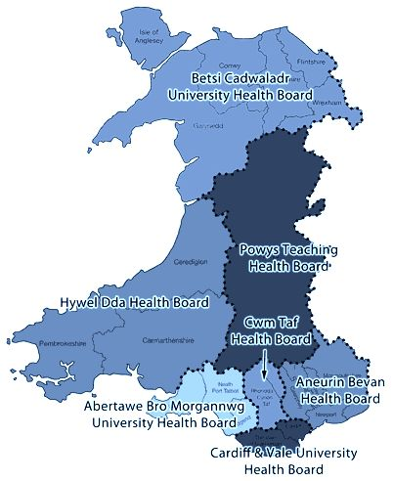
The seven health boards will be discussed and how it is structured. On the 1st of October 2009 there was a change within the health board structure with the 22 local health boards and 7 of the NHS trusts in wales was just replaced to the 7 new health boards which are Aneurin Bevan, Betsi Cadwaladr, Cardiff and vale university, Cwm Taf Morgannwg, Hywel Dda, Powys teaching, Swansea bay University, (NHS direct 2019) states that the new health board duty will be responsible for planning funding and delivering primary care services, hospital and community services which mental health service are included in this. Wales.nhs.uk (2019) proposes that the old system was over-bureaucratic with simplified management structures, more money can be channelled to services that is needed financially, this will be the first time that NHS Wales will have integrated organisations that can provide better care.
The NHS currently has 4 trusts these are:
The welsh ambulance service
Trust for Emergency service
Velindre NHS trust which offers specialist care for cancer patients
Health education and improvement Wales
Welsh ambulance (2020) explains that The welsh ambulance trust board has 13 members which is a chairman, 7 non-executive directors and a chief executive, and lastly 4 directors, The main roles are to set the policy of the trust, manage people and the resources and measure resources effectively and most importantly establish government systems to enable it to measure progress and performance, and also work in partnership with stakeholders internal and external.
Velindre wales (2017) states that Velindre University NHS trust is responsible for 1.5 million patients of care, It has been asked by Welsh Government to develop plans for all patient centred cancer patients it has plans to create a new cancer centre for Cardiff and improve on services for south/east Wales.
National assembly Wales (2020) suggests that Health education improvement wales is the newest service that looks to improve education development including training and careers throughout Wales.
The board Committees of Velindre University NHS Trust are:
Charitable Fund committee
Audit committee
Information Governance and IM&T Committee
Workforce & organisational Development committee
Planning and performance Committee
Research, Development and innovation Committee
Quality & Safety Committee
The seven Health Boards must focus on:
Changing behaviour not structures
Collaboration not confrontation
Planning not commissioning Whole systems not hospitals
Clinical engagement
Partnership working and Wellness not illness
Powys health board
Powys is one of the most rural countries in the UK whilst the county has 25percent of the land mass only 4 percent is the population.Powys NHS wales (2019) states it a commissioning organisation, A plan was put in to place Integrated Medium-term plan (IMTP) which as required under the NHS wales finance act (2014) It’s a commissioning organisation, whilst a large percentage of the budget is devoted to NHS services, 2.5 million of service delivery is commissioned through the third sector.
Abertawe Bro Morgannwg University Health Board
This is one of the most densely populated in Wales with some 17 percent of Wales’ population. This equates to 499,400 people. 45.7 per cent of the LHB’s residents live in Swansea with 27.5 per cent and 26.8 per cent living in Neath Port Talbot and Bridgend local authority areas respectively.
Betsi Cadwaladr University Health Board
The LHB covers almost a third of Wales landmass and is the largest in terms of population, which includes 23 per cent of Wales population or 678,500 people in the area. The health board has a budget of £1.3 billion and a workforce of approximately 16,500.This health board has three main hospitals and also coordinates the work of 109 GP practices and NHS services provided by dentists, opticians and pharmacists in north Wales.
Aneurin Bevan University Health Board
it’s the operational name of Aneurin Bevan University Local Health Board. The Health Board covers the areas of Blaenau Gwent, Caerphilly, Monmouthshire, Newport, Torfaen and South Powys.
The Health Board employs over 13,000 staff, The health board is supported by the senior management team and lead by a chairman, non-executive directive and the chief executive and other executive directors.
Cwm Taf Health Board
The LHB covers only three per cent of Wales but is the second most densely populated area. It has 10 per cent of Wales population or 289,400 people in the area.
Hywel Dda Health Board

The LHB covers a quarter of Wales landmass and is the second most sparsely populated area. It has 13 per cent of Wales population or 375,200 people in the area. Carmarthenshire is the most populated local authority area within the LHB with 47.9 per cent of the population, followed by 31.4 per cent in Pembrokeshire and 20.7 per cent in Ceredigion.
Cardiff and Vale University Health Board
The LHB is the smallest in terms of area but the most densely populated in Wales. It has 14.9 per cent of Wales’ population or 445,000 people in the area. 72.1 per cent of the population live in Cardiff and 27.9 per cent living in the Vale of Glamorgan.
Bate and Baker (2016) proposes that responsibility for the NHS in Wales has been devolved to the Welsh Government since 1999. but the difference between NHS Wales and England is the ‘purchaser-provider split’ – in Wales, Local Health Boards are responsible for both funding and provision of NHS services. Law Wales (2019) explains that devolved government in wales had 4 sources of being financed
Money allocated from the UK Government
Money raised in Wales by means of taxation
Borrowing
Money being received from the European Union
Hm Treasury controls were the overhaul expenses in the UK each year a portion is allocated to Wales and this portion, known as the ‘’ block grant’’ is the basis of the welsh governments annual budget, The block government is paid to the secretary of state of Wales who then transfers to the Welsh Government. National assembly committees argue with the draft budget before it is finalised and approved by national assembly for wales.
The secretary of state health (2010) states that because people are living longer the system is under strain this is why there has been increased pressure, costs and demands for the NHS whilst having to be under budget and unfortunately cannot meet the needs it was supposed to This means the NHS has had to change its structure.
National assembly (2019) proposes All ideas and any proposed plans are accountable by the Minister of Health and opposed to the National Assembly Wales The chief executive of WALES responsibility is to report back to the minister which then they are liable for planning, designing, promoting primary community and secondary services, establishing local needs within the government policy following a set structure.
The welsh Government is the main source of NHS wales funding NHS Wales ( 2019) suggests that they deliver the service through each local health board as every one of them is solely responsible for distributing all NHS healthcare within that area, when it reconstructed in 2009 the main aim was for just to deliver care as opposed to the trust and local health that existed before that year. Healthcare districts is much more manageable, it has said there is a negative to this as funds are allocated to each department annually and if not spent, they could have a reduction in the following year. NHS (2019) states that just in wales alone the NHS come in contact with 22 million times per year below are some statistics
There are more than 700,000 out patients appointments every year
More than 600,000 inpatient treated each year
More than 1,059,000 seen in accident and emergency each year
Advantages
There are many advantages for the change towards a more cohesive healthcare because it will improve patient care and help the NHS to better manage their limited resources into the 7 health boards individually
An integrated care system encourages collaboration between different organisations for the healthcare sector with the aim to integrate services and improve patient health in local areas.
Disadvantages
channel 4 (2017) suggest that if central government switched NHS Wales to a needs based system, Wales could spend a staggering £181 per person a year on health care.
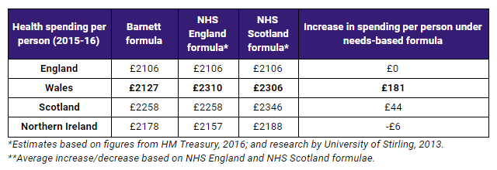
There is no doubt the NHS is in crisis due to funding. BBC wales (2018) suggests that Mental health takes more than 11% of NHS Wales budget
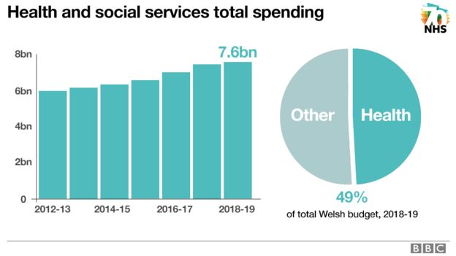
The NHS Wales is eating up more than £7.5bn including social services in 2018/2019 this is almost half of all the Welsh Government's spending, for just the mental health sector it costs around £228.79 per head. Professor Marcus Longley is a health economist who has investigated NHS finances and has since become chairman of Cwm Taf health board in the south Wales valleys he states in his own words "Financially the story has been a bit of a mess really," he said. "For the first 10 years of this century the health service in the UK had about 50% real terms increase in resources - huge. ‘’ Marcus Longley (2018)
A healthier Wales the welsh government is committed to producing a plan to improve NHS Wales, Government wales (2019) states that they will tackle
Improving access to mental health support for children and young people
Further improvements to crisis and out-of-hours provision
Improving the access and range of psychological therapies
Supporting vulnerable groups.
Recommendations to help Mental Health
Focus on early intervention and prevention, Loneliness and isolation has be known as an issue for someone who suffers with mental health so having more support networks out there more access to local groups making mental awareness more accepted in local communities so everyone can come together stronger and better.
Funding issue – Long waiting lists
If the funding system was changed and used more efficiently, Wales online (2017) explains that if the needs based formula was used then Wales would receive around £181 per person. Dr David Baily Chairman of wales suggests that the Barnett Formula is outdated and disadvantages Wales.
Conclusion
The NHS began on the basis that healthcare should be free to everyone is funded through national taxation because of the growing population, advances in healthcare which is needed to provide a sustainable health system which is effective as it seems to be NHS needs to change its funding as its no doubt that it is in crisis financially. Changing of structure have been a disadvantage as the NHS is getting more in debt and its said that the outdated formula is in need of evaluation for an improvement.
1946 NHS act parliament (2020) Available on: www.parliament.uk/about/living-heritage/transformingsociety/livinglearning/coll-9-health1/health-01/nhs-act-page-2/ ( Accessed on 15.1.20).
BBC news (2018) NHS 70: What lessons for Wales from around the UK? Available at: https://www.bbc.co.uk/news/uk-wales-44629110 (Accessed on 08.12.19).
Channel 4 (2017) Fact check. NHS Wales: Badly run by labour or underfunded by Westminster? Available at: https://www.channel4.com/news/factcheck/nhs-wales-badly-run-by-labour-or-underfunded-by-westminster ( Accessed on 14.01.20)
Health in Wales (2019) Budget & charges Available at: http://www.wales.nhs.uk/nhswalesaboutus/budgetcharges ( Accessed on 01.12.19).
Health in Wales (2020) History in context Available at: http://www.wales.nhs.uk/nhswalesaboutus/historycontext ( Accessed on 07.01.19).
Law Wales (2016) How is devolved government in Wales financed? Available on:https://law.gov.wales/constitution-government/government-in-wales/finance/?lang=en#/constitution-government/government-in wales/finance/?tab=overview&lang=en ( Accessed on 07.1.20).
NHS direct Wales (2020 ) Health boards Available on: https://www.nhsdirect.wales.nhs.uk/localservices/localhealthboards/ ( Accessed on 01.12.19).
NHS WALES (2020) Governance E-Manual.NHS funding Available at: http://www.wales.nhs.uk/governance-emanual/nhs-funding ( Accessed on 10.01.20)
NHS Wales Statistics(2016) House of commons library NHS Wales statistics Available at: https://researchbriefings.parliament.uk/ResearchBriefing/Summary/SN06994 ( accessed on 01.12.19).
NHS Wales (2020) Structure Available on: www.wales.nhs.uk/nhswales0 ( Accessed on 15.01.20).
NHS Wales (2020) Why are we changing structure? Available at: http://www.wales.nhs.uk/documents/NHS%20Reform%20leaflet_October%202009.pdf (Accessed on 01.01.20).
Powys teaching health board (2016) Available at:http://www.powysthb.wales.nhs.uk/sitesplus/documents/1145/IMTP%20Everyday%20-%20Stakeholders.pdf ( Accessed on 10.01.2020).
Rivett, G. (1998) from cradle to grave: Fifty years of the NHS. London King’s Fund Publishing.
Socialist health association (2019) Promoting health and well-being from the application of socialist principles. The start of the NHS 1948 Available at: https://www.sochealth.co.uk/national-health-service/the-sma-and-the foundation-of-the-national-health-service-dr-leslie-hilliard-1980/the-start-of-the-nhs-1948/ ( Accessed on 01.12.19).
The organisation of the NHS in the UK: comparing structures in the four countries (2015) Available at: www.assemblywales.org/research ( accessed 10.01.19).
Velindre university NHS trust Wales( 2019) Delivering quality care and excellence Available at: http://www.velindre-tr.wales.nhs.uk/home ( Accessed 05.01.2020).
Wales online (2017) The huge under-funding in Welsh NHS Available at: https://www.walesonline.co.uk/news/health/how-much-waiting-times-surgery-13544453 (Accessed on 13.01.20)
Welsh Government (2020) NHS Wales planning framework Available at: https://gov.wales/sites/default/files/publications/2019-09/nhs-wales-planning-framework-2020-to-2023.pdf ( Accessed on 07.12.19)

