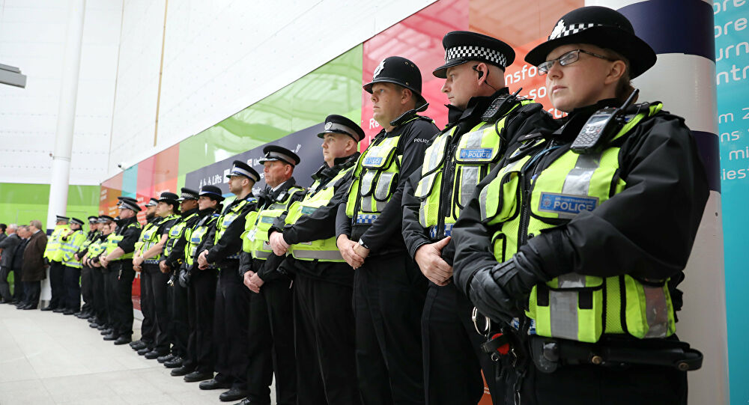

How Individual’s Beliefs, Attitudes and Values impact on workplace behavior
  - in police
Natalia Weronika Michalak | Developing Workplace Critical Thinking | 20.11.2020

  - Speaker Notes
Today I will present organization which employees work for public safety and civils protection. Police are main force and first to contact with everyday crime, are responsible for maintaining public order and safety, enforcing the law, and preventing, detecting, and investigating criminal activities. All these activities know as policing are represented by body officers’ civils authority of government.
Official government statistic from bulletin end-year update of the Police workforce in England and Wales in every single year providing detail information about officers. Information include statistics of numbers employ officers.
The most updated report from March 2020 shows is 129,110 full-time equivalent (FTE) officers. Number of FTE increased from year 2019 about 4,9% from year before and the largest change from year to year since 2003/04.
But are we can have named these increased numbers of police organizational success?
Looking forward same documents says is 7,141 full-time equivalent (FTE) police
officers left the 43 territorial police forces (excluding transfers) in 2019. Down about 246 FTE from year 2018.
And only approximately 5% of leavers from year-to-year is dismissal or contract terminated. Which is means only approximately 357 police officers leaving police forces.
I come to conclusion is small amount of leaving FTE officers are organizational success. But is that number mean it can be providing by all employees’ satisfaction from the fact of organizational values, beliefs and attitudes.

But let’s start from begging. What is Police values, beliefs and attitude?
On North-Yorkshire police website we can find information taking as beliefs of every applicant on that position as individuals from all backgrounds who can demonstrate how they inspire and influence those around them; are courageous and show compassion to others, who respect race and diversity and treat people with dignity and respect at all times. – example of those beliefs are Code of Ethics create to apply to all officers, all levels, in every role. It sets out clearly defined principles for our officers and staff to uphold as they work to protect our communities.
Values are driven from beliefs. In Competency and Values Framework Police guidance we can find very clear cycle described heart of values going to competencies (knows also as attitude-skills, knowledge and abilities).

Most important values are:

-Public service

-Transparency

-Impartiality

-Integrity
Each clusters are one of three different levels structures separated in pair of two examples of competencies (but they are not applying to values).
Clusters (attitude):
Inclusive, enabling and visionary leadership
police delivery support and inspire
police are collaborative

Intelligent, intelligent and informed policing
police analyse critically
police are innovative and open-minded

Resolute, compassionate and committed
police are emotionally aware
police take ownership

In overall all citizens could agree on argument is police complete their duties, indeed if citizens want to report crime or offence call for police first.
Public experience and perceive has marked a feeling on their safety in HMIC (Her Majesty’s Inspectorate of Constanbury) research report from 2015/16 feel safety in overall.
Publications tests about 26,000 people in different categories but most interesting is 74% people feel safety after dark, so 26% respondents feel unsafe.
Going further in same publication same group of people was ask is last year give satisfaction in last 12-months police service provides anti-social behaviour and crime group of 17,000 people vote views of policing change for worse as dissatisfied in 55%.
Backing to North Yorkshire police’ website in recruitment process they looking in candidates to demonstrate the following strengths:
-Community service
-Problem solving
-Dealing with change etc.
Relation between statistics of dissatisfaction and police candidates strengths is related with public service.
Some of the officers from BBC article “Do the public still trust the police” (2014) were taken of example in untrusted in whole police public services. In article we have an example of Metropolitan police facing the problem legal action again five deceived women with policeman under cover. Another example was found about undercover Scotland Yard officers tried to influence the family of the murdered black young girl Stephen Lawrence.
Prom that point is easy to see are some of the police officers stand against their values. But both of the public services example are big cases involved media to follow the investigation.
Is it that mean is public trust can be suggested by watching only bad news?
"We need to put what we see in the media in context," says Chief Superintendent Irene Curtis, president of the Police Superintendents Association of England and Wales. - “whilst I don't condone any of the conduct of officers who do bad things, who are corrupt (…) police staff out there do a fantastic job day in, day out."
In same article we can find polling firm, ComRes in October how likely people think they can trust police in media telling the truth.
82% people asked for that question said they trust in overall. However small percentage of people still doesn’t think is police in TV says the truth.

But that can be double-edged sword. Some good news and values can be the inspiration for some individuals. That happened to Dylan Thomas the youngest-officer who implement values from early age suggest him the way what he want to follow.
Dylan says” I love helping the community, something that I’ve come into police to do.”- his supervisor Elin says his strong side in individual attitude is:
-enthusiastic, he’s open for challenges ready to respond to incidents, good at talking to people and noisy which double-helped him with public communication.

He’s personal value compare to police profile. Suggest is statistics and public opinions give the bigger picture and made the conclusion.
Police like every organization have outstanding behaviors but the importance of the public service is undeniably successful. Increased from year to year the number of employ officers’ willingness respect from public society.
If we looking deeper in statistics the implementation of public trust and same percentage of officers from the last 40 years changed for batter. Policeman job role is still not same trustful like doctor job role but at same have tendency to growth from year-to-year.
Because of easier confrontation with truth, all citizens live in convenient time when is easier to confront with that truth.
Also communication on many levels are much more advantageous so at the same now peoples have building some awareness.
However, if in the police history we can find particulars examples of bad behaviors are more likely to stay remember in public minds. Negative examples impact on all organization that’s why approximately 26% of the people have not trust in individuals’ values.
Values and attitude must go in pair there, in job role closely related to law organization working for government like police must be influenced by values to be compare with attitude, otherwise attitude cross the trust public line and meet with consequences against organization.
That’s why conclusion provides us to the point when I have complete Toulmin’s model.
CLAIM: Police values, beliefs and attitude successfully impact on workplace behavior
Backing:
Bad news hasn’t got big impact on overall score in UK
Backing: Growth number of employed officers
Grounds :Number of FTE officers increased from year 2019 about 4,9% from year before and the largest change from year to year since 2003/04. Only 357 police officers left company’s forces.
Warrant: Police are always first force to report crime or offence call
Backing: from 26,000 people 74% said feel safe in the night
Backing: 82% people said they trust police in tv
Qualifier (exceptions) –
Values, beliefs and attitude confirms expectations with new candidates
Rebuttal : Bad attitude on particular examples stops trust and got bigger impact on organizational workplace behavior

HARVARD REFERENCES:
BBC Bitesize. 2020. How to become a police officer: Dylan's story - BBC Bitesize. [ONLINE] Available at: https://www.bbc.co.uk/bitesize/articles/zb3gmfr. [Accessed 20 November 2020].
BBC News. 2020. Do the public still trust the police? - BBC News. [ONLINE] Available at: https://www.bbc.co.uk/news/magazine-26730705. [Accessed 20 November 2020].
North Yorkshire Police. 2020. What are we looking for in a Police Officer? - North Yorkshire Police | North Yorkshire Police. [ONLINE] Available at: https://northyorkshire.police.uk/jobs/police-officers/looking-police-officer/. [Accessed 20 November 2020]
Competency and values framework (CVF) | College of Policing. 2020. Competency and values framework (CVF) | College of Policing. [ONLINE] Available at: https://beta.college.police.uk/career-learning/career-development/competency-and-values-framework-cvf. [Accessed 20 November 2020].
The Week UK. 2020. Does the public still trust the police? | The Week UK. [ONLINE] Available at: https://www.theweek.co.uk/105584/does-the-public-still-trust-the-police. [Accessed 20 November 2020].
North Yorkshire Police. 2020. Ethics and standards - North Yorkshire Police | North Yorkshire Police. [ONLINE] Available at: https://northyorkshire.police.uk/about/ethics-and-standards/. [Accessed 20 November 2020].
PDF BIBLIOGRAPHY:
https://www.justiceinspectorates.gov.uk/hmicfrs/wp-content/uploads/HMIC-public-views-of-police.pdf
https://paas-s3-broker-prod-lon-6453d964-1d1a-432a-9260-5e0ba7d2fc51.s3.eu-west-2.amazonaws.com/s3fs-public/2020-11/competency_and_values_framework_guidance.pdf
http://eprints.lse.ac.uk/33155/1/La_Vie_des_idees_-_final_english.pdf
https://ac299a4b87076a66ac1c-ba8981882613ab522a836b37c94562dc.ssl.cf3.rackcdn.com/content/uploads/2015/08/Code_of_Ethics.pdf

Competency and values framework (CVF) | College of Policing. 2020. Competency and values framework (CVF) | College of Policing. [ONLINE] Available at:

