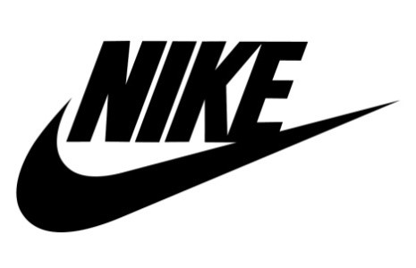

University of Wales Trinity Saint David
BA (Hons) Business Management
Entrepreneurship LCBB5013
Gigel Ruse 2130478

Contents
Introduction 3
Task 1 – Business Plan Development 3
1.1 Company overview, products, objectives and USP 3
1.2 Business Environment and Competitor Analysis 5
1.3 Market Segmentation & Market Strategies 7
Market Segmentation: Precision Targeting on a Global Scale 7
1.4 Financial Planning 8
Conclusion 11
References 11

Introduction
This extensive business plan examines Nike, Inc., a giant in the athletic sector. Designed for the LCBB5013 Entrepreneurship course, this document explores Nike in great depth, focusing on its operations, strategy, and finances. It covers all the requirements for the assessment by delving into the company's history, competition, advanced marketing, and sound financial planning. By conducting thorough research, this report provides a comprehensive overview of Nike and its future strategy in a changing global market.

Task 1 – Business Plan Development

Company overview, products, objectives and USP
Nike, Inc. is the world leader in the sales of athletic footwear, apparel, and equipment. Founded in 1964 by Phil Knight and Bill Bowerman as “Blue Ribbon Sports” (BRS) (Britannica Money, 2026), the company aimed to revolutionize the world of athletic performance. With an initial investment of $1,000, BRS earned $8,000 in revenue during its first year of operation, after selling 1,300 pairs of footwear (PrimeRevenue, n.d.). In 1971, the company rebranded as Nike, Inc., changing its name and introducing its iconic “Swoosh” logo (Gupta, S.K. 2025). Based out of Oregon, the company currently operates in over 190 countries worldwide. According to Nike (n.d.), the company's mission is to "bring inspiration and innovation to every athlete, making the company accessible to all types of athletes and individuals from all parts of the planet and all diversity of populations.

Products
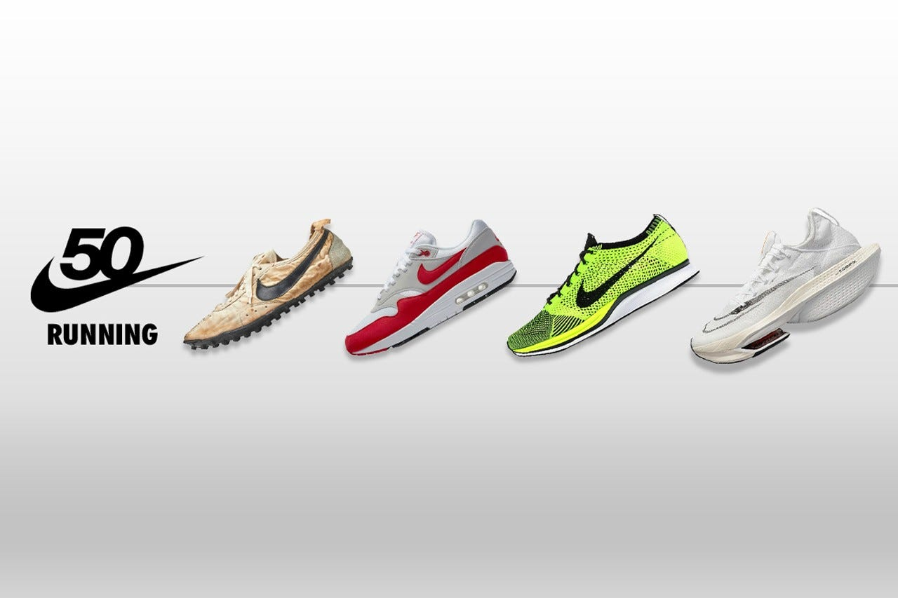
(0*DQjppkTFMfKMDy3f (1280×853))
Nike offers a wide range of products and services in the sports and lifestyle category. Its products include athletic footwear for activities such as running, basketball, and football (including brands like Air Jordan and Air Max, apparel for athletic activities with features like Dri-FIT fabrics, and equipment and accessories for sports enthusiasts (Nike, n.d.) Nike’s Consumer Direct Acceleration or CDA strategy allows the company to create and distribute its products in a way that creates a premium consumer experience (Mccartney, P. 2025). By using data collected through its digital applications, Nike can gain insights into its consumers to better optimize its inventory. The limited-edition release of Nike shoes through its SNKRS application is an example of its successful use of data to create a better consumer experience.
Objective
Nike has several strategic objectives to balance between operational and visionary growth. The company’s short-term objectives are focused upon inventory optimization, accelerated digital growth, and agile innovation. For the long term, Nike has set objectives regarding sustainability leadership, strategic market expansion, and becoming the dominant footwear company for women’s business.
Unique Selling Point (USP)
Nike’s USP is embedded in the brand’s ethos, commitment to innovation, and emotional connection with the consumers. The brand’s iconic slogan “Just Do It” encapsulates the idea of persevering and believing in oneself. Nike has leveraged the presence of several elite athletes (e.g., Jordan Brand), consistently delivers technologically superior shoes (e.g., Nike Air, Flyknit, Vaporfly), and tells inspiring stories to connect with and show the cultural relevance to its audience (e.g., “Dream Crazy” campaign) (Aldrich, J. 2024). Overall, Nike’s brand successfully sells the feeling of being an athlete, which is an aspirational brand and product to many individuals.

Business Environment and Competitor Analysis
Nike’s strategic position in the sportswear market is analyzed in the following SWOT analysis, incorporating market data and strategic information from 2024-2025.
Strengths (Internal Factors) | Weaknesses (Internal Factors)
1. Unrivaled Brand Equity and Recognition  As of 2024, Nike is the world’s most valuable apparel brand, with a brand value of $33B. | High Manufacturing Concentration in Asia - Approximately 95% of Nike’s footwear production is in Southeast Asia.
2. Relentless Focus on Innovation  As part of its corporate culture, Nike channels considerable resources into its research and development (R&D) division, investing in them to create products that outpace competition in terms of innovation. | Labor Practice Controversies - Nike is often the subject of criticisms regarding its labor practices in its contract manufacturers.
3. Digital and Direct-to-Consumer Focus  Nike has committed itself to the digital world to streamline the customer experience. Digital channels allow the company to increase its profit margins and collect customer data to enhance the customer experience. | Potential Over-Reliance on "Classic" Franchises - The company’s over-reliance upon its popular “classic” shoe styles has led Nike to implement a “transition year” in FY2025 to reduce the impact of this over-reliance.
4.Power of its Athlete Endorsements  By licensing its brands to the world’s most prominent athletes, Nike has ensured that it is synonymous with athletic excellence. | High Operating Costs - Nike’s costs in areas like marketing and product R&D are some of the highest in the due to the company’s commitment to aggressively marketing its brands and introducing innovative new products (over $4B in FY2023) (NIKE, Inc. n.d.).
Opportunities (External Factors) | Threats (External Factors)
Growth of the Athleisure Market  As more people embrace athleisure fashion, the market for Nike’s clothing line is expanding. | Intense and Fragmented Competition - Nike is amongst the most fragmented industries worldwide, with numerous companies competing with Nike for both the attention and spending of consumers, including rivals like Adidas and Puma, as well as growing brands like Lululemon and Hoka.
Expansion in Women’s Sport and Wellness  Due to the growth of the women’s market, Nike has identified this as the company’s largest area of growth. | Macroeconomic Uncertainty - The global economic climate introduces uncertainty into Nike’s revenue streams, as a downturn in the economy can lead to consumers spending less on luxury products.
Sustainability  By launching its “Move to Zero” initiative in 2016, Nike has focused on ensuring that its production facilities produce as much sustainable manufacturing as possible. | Counterfeit Products - Nike suffers revenue losses due to the growing market for counterfeit Nike products.
Expanding into Emerging Markets  By tapping into the growing economies of countries like India, the nations of Southeast Asia, and the countries of Latin America, Nike is encountering a massive growth opportunity for the company. | Geopolitical Conflicts - As the world’s major trading powers experience geopolitical conflicts with one another, Nike is exposed to the potential increase in tariffs and other trade barriers between the company and others.

Competitor Analysis
Nike operates in a highly competitive market with several major players.
Competitor | Strategic Focus and Key Differentiators | Comparison with Nike and Market Positioning
Adidas AG | Specializes in football heritage, sustainability, and limited-edition collaborations with high-profile figures. | Adidas is stronger in Europe and soccer markets but trails behind Nike’s valuation and market share in the United States for basketball and streetwear.
Lululemon Athletica Inc. | Sells high-end athleisure with a focus on building a wellness and fitness community around the brand. | Lululemon excels in the premium yoga brand and has also entered the performance footwear market, threatening Nike’s expansion into the women’s shoe market.  .
Under Armour, Inc. | Creates performance-driven apparel and accessories for athletes and focuses on American team sports. | Under Amour has a strong foothold in the North American youth sports market but struggles to compete with Nike’s vast global brand appeal.
Hoka One One / On Running | Creates highly technical shoes with specialized technologies to support athletes (Hoka One One produces maximalist shoes with thick, cushioned insoles; On Running is known for its CloudTec system). | On Running is rapidly gaining market share in the dedicated runner market, threatening Nike’s dominance in this niche market.

With a ‘Good, Better, Best' pricing model Nike ensures its brand is highly visible, and its marketing budget for FY2023 is $4.05 billion or more (Forbes 2025).

Market Segmentation & Market Strategies

Market Segmentation: Precision Targeting on a Global Scale
Nike employs a market segmentation strategy that allows it to maintain its dominant market position. Nike segments its customers on the basis of demographics, psychographics, and behavior to offer the appropriate product and marketing strategies to each group of customers around the globe.
Demographic Segmentation: Nike mainly targets customers between the ages of 15 and 45, who are the most physically active. Additionally, Nike offers both gender-specific designs within its stores and online as part of initiatives like “Women’s First” and offers products at different price points to ensure that people of all income levels can purchase their goods (Marcom Central, 2025).
Geographic Segmentation: Nike segments its operations into four main regions: North America, EMEA (Europe, the Middle East, and Africa), Greater China, and APLA (Asia-Pacific and Latin America). For instance, basketball is popular in Greater China while Global Football is popular in the EMEA region.
Psychographic and Behavioral Segmentation: Nike segments its customers according to their “Athletic Mindset.” For example, Nike understands that its most prominent customer groups include: Performance athletes who value technology such as the Vaporfly series of shoes, fitness enthusiasts who want the comfort of shoes that aid in their pursuit of health and well-being, lifestyle and sneakerhead individuals who value the “hype” associated with limited edition products available through its SNKRS app, and those who value sustainability and eco-friendly goods who are attracted to its “Move to Zero” initiative (Sunil, M. 2023).
Nike’s segmentation strategy ultimately allows the company to produce the appropriate products for each segment of customers and ensure that they are distributed to each group, maximizing their overall engagement with Nike.
The Marketing Mix (4Ps): A Masterclass in Integrated Brand Building
The marketing mix is the foundation of Nike’s marketing strategy. Based on the company’s “Consumer Direct Acceleration” goals, Nike has vastly transformed the traditional marketing mix to produce one of the most advanced marketing models within the industry.
Product Strategy
Product innovation remains at the forefront of Nike’s production. Its famed “speed lane” allows the company to take designs created by the Bowerman Footwear Lab from concept to Nike shelves in a matter of weeks [8]. Additionally, Nike constantly creates innovation under programs like Aero-FIT and Nike Mind to provide athletes with the best available products. Nike’s “Swoosh” represents its signature quality and performance products. Additionally, Nike includes other brands like Jordan and Converse that allow it to cater to other segments of the market without detracting from its status as the premier athletic shoe company.
Pricing Strategy
Nike uses a Value-Based Pricing model, as it features some of the most technological and high-quality shoes in the market. For its innovative products like Alphafly shoes, Nike uses a Price Skimming model to set initial prices high to allow it to garner high initial revenues. However, as with all manufacturers, Nike also uses a Tiered Pricing model: $60-$70 for entry level shoes, $120-$140 for mid-range shoes, and $250-$300 for shoes made for the Olympics and other elite athletic competitions (Mateos, G. 2020).
Place Strategy
Nike’s Place strategy centers on its “Consumer Direct Acceleration” model. Nike sells its products through Nike Direct Channels (Nike.com, Nike App) to retain 100% of its revenue and to gain data on their customers. Additionally, Nike owns its retail stores across the world that offer customers an immersive retail experience. Finally, Nike also partners with other companies to ensure that its products are available to the highest number of individuals possible. For instance, Nike is a tenant in locations like Foot Locker and JD Sports.
Promotion Strategy
Nike has some of the most innovative and advanced promotion strategies in the market. The company creates deep emotional connections between its customers and Nike through its advertising. For instance, Nike’s “Dream Crazy” and “You Can’t Stop Us” advertisements include messages of inclusivity and diversity while also promoting their products (Marcom Central, 2025). Additionally, Nike has significant sponsorships with sports competitions of all levels, as well as athletes of all categories. Finally, Nike utilizes its significant presence on social media platforms to advertise their products and connect with their fans through influencers on these platforms.
Online and Digital Marketing Strategy
As a “digital-first” company, Nike has designed its online and digital marketing strategy with its Nike Membership program at the centre. Nike uses its membership program to foster customer loyalty and gain data about its customers. For instance, through the Nike Training Club and Nike Run Club applications, Nike can offer customers personalized programs to improve their fitness. Additionally, the company creates the SNKRS application to allow fans to purchase its latest and most “hype” shoes. Finally, Nike seeks to offer customers an immersive experience both in and outside of its stores, creating in-store experiences that work in tandem with the digital experiences customers have with Nike brands.

Financial Planning
4.1 Financial Evolution: From a Handshake to a Multi-Billion Dollar Empire
From its initial investment of $1,000 in 1964, Nike has grown to surpass $200 billion in 2024 in terms of market capitalization (Li, J. 2023). The company relies on sound financial management to fuel its growth.

Historical Growth of Nike:
1964: As a company named Blue Ribbon Sports (BRS), the company earned $8,000 in revenue with the sale of 1,300 imported running shoes.
1972: After changing its name to Nike, the company earned $1.96 million.
1980: Upon its initial public offering (IPO), the company gained $22 million.
1990s: With the development of the Air Jordan shoes in 1985 and its “Just Do It” campaign in 1988, Nike began to expand globally. Its revenue reached $3 billion in 1991.
2020s: By introducing its Consumer Direct Acceleration (CDA) strategy, Nike revolutionized the way that consumers interacted with its brand. The company earned $51.4 billion in revenue during fiscal year 2024 (FY2024).
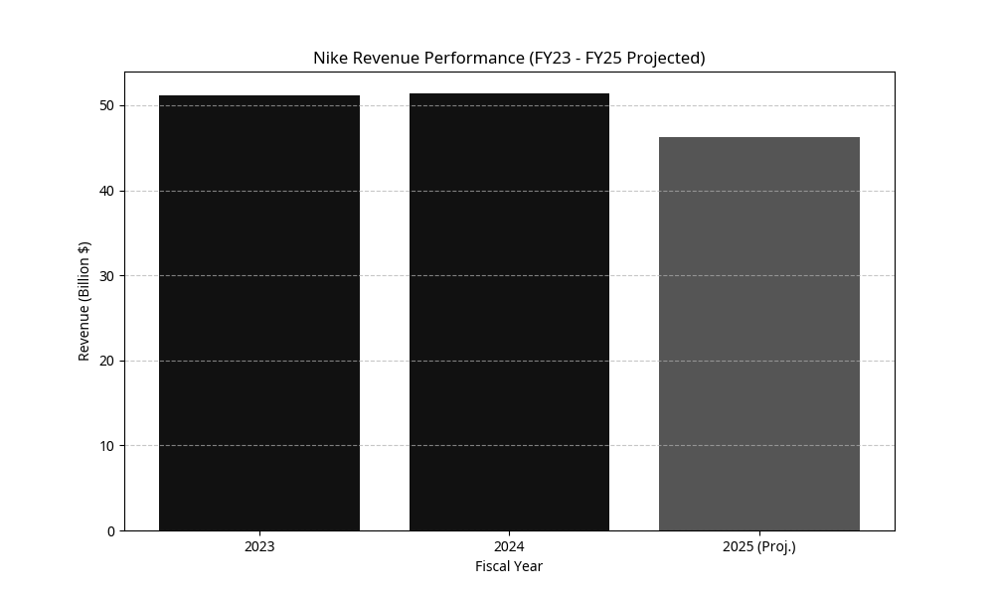
Nike’s financials show the operational health of the company. The fiscal years 2023 to 2025 illustrate the brand’s ability to adapt to a particularly challenging transition year to focus on sustainable and profitable growth for the brand.

Metric | Fiscal Year 2023 | Fiscal Year 2024 | Fiscal Year 2025 (Projected/Interim)
Total Revenue | $51.2 Billion | $51.4 Billion | $46.3 Billion (Reflects strategic transition)
Net Income | $5.1 Billion | $5.7 Billion | $3.9 Billion (Projected, impacted by restructuring)
Gross Margin | 43.5% | 44.6% | 44.2%

Analysis of the “Transition Year” (FY2025): The decision to decrease revenue by 10% in FY2025 is a decision to decrease the reliance on classic products that have been distributed so far, and to instead allocate resources towards innovative platforms for the company’s products Li, J. 2023). The motivation for this decision indicates the company’s commitment to the long-term vitality of the company. Additionally, the projected decrease in net income is due to the company’s restructuring of the company and its investments into various initiatives that will allow the company to remain competitive and successful in its projected future.
Nike’s financial planning is a sophisticated and dynamic process, characterized by strategic investments in innovation, aggressive marketing, and a relentless focus on expanding its direct-to-consumer (D2C) capabilities. These financial strategies are meticulously aligned with the company’s overarching goal of driving sustainable long-term growth, enhancing brand equity, and maximizing shareholder value. Nike’s financial health is robust, underpinned by consistent revenue generation, disciplined capital allocation, and a proactive approach to managing market fluctuations and economic headwinds. The company consistently generates substantial revenue from its diverse product portfolio across various geographic segments. Its financial planning involves a delicate balance between investing in future growth initiatives and returning value to shareholders. This section delves into Nike’s recent fiscal performance, its historical growth trajectory, and foundational funding mechanisms.

Early Funding and Its Transformative Impact on Growth
Nike’s early growth was made possible through reinvesting their profits and securing several credit lines that would allow the company to grow at a rapid rate without having to relinquish control.
Bootstrapping and Reinvestment (1964-1971): During Nike's early years as Blue Ribbon Sports, Phil Knight and Bill Bowerman reinvested profits back into the business to purchase additional inventory and support expansion. Although the company relied heavily on reinvestment, it also experienced continual cash-flow challenges and used bank financing to support growth (Wasserman, N. and Anderson, K. 2010)
Japanese Trading Company Credit (Nissho Iwai): The sports brand was able to secure a significant line of credit from the Japanese trading company, Nissho Iwai, which allowed them to purchase their manufacturing facilities and start creating Nike products.
The IPO Capital and Strategic Deployment (1980 onwards): The initial public offering of Nike in 1980 would net the company $22 million, which would be used to purchase additional manufacturing and research facilities to accelerate their company’s growth.

Future Financial Outlook: Sustained Investment in "Newness" and Digital Transformation
Predictions of Nike’s future financial outlook indicate that the company will continue to make aggressive investments into various aspects of its business. Nike will invest nearly $1 billion annually into consumer-facing activities to ensure that it continues to grow and earn profits in the future (Nike 2024).
The areas of focus for Nike will include:
Investing in marketing to ignite the heat of the brand once again.
Channeling resources into hiring designers and scientists to conceptualize the next line of Nike products.
Investing substantially into AI and data analytics platforms for its Nike apps to ensure a profitable direct-to-consumer model.
Investing into modernizing its supply chain to improve efficiency and supply its products to consumers better.
Overall, Nike is making financial investments into various aspects of its business to ensure that it maintains its competitive edge and market dominance in the sportswear industry.

Conclusion
Nike, Inc. is another excellent example of the entrepreneurial success story. From a startup company to the undisputed king of sportswear worldwide, Nike has achieved this through innovation, leadership, and an understanding of the athletic needs. The journey from Phil Knight’s $500 investment to the global powerhouse that Nike, Inc. is today is a testament to the company’s capacity to understand and conquer market trends. Nike has thrived in a complex market full of competition from other sportswear companies worldwide. The company’s unique strengths position it to dominate the sportswear market further. Although Nike faced a challenging year in fiscal 2025 as they curtailed the distribution of classic shoes, the company took a courageous stance to foster further growth for the brand. Nike’s many internal strengths and Demand Creation marketing strategies position the company well for the future of being a digital-first, direct-to-consumer company. Nike has also conquered the challenges of using technological advancements to create products that tell emotional stories to customers, creating a moat of competition for its rivals in the sportswear market. Ultimately, Nike, Inc. has succeeded in selling an idea to its customers that allows them to feel connected to the brand and embrace a desirable lifestyle. Through innovation and inspiration, Nike, Inc. remains at the vanguard of the sportswear industry and a true entrepreneurial success story.

References
- Britannica Money (2026) Nike, Inc. | History, Logo, Headquarters, & Facts. Available at: https://www.britannica.com/money/Nike-Inc (Accessed: 11 June 2026).
- Gupta, S.K. (2025). Nike SWOT 2024 | SWOT Analysis of Nike. [online] Business Strategy Hub. Available at: https://bstrategyhub.com/swot-analysis-of-nike-nike-swot/ (Accessed 11 June 2026).

- PrimeRevenue (n.d.) Shoe Dog – Nike\'s Early Years Were a Constant Battle for Cash. Available at: https://primerevenue.com/resources/blog/shoe-dog-nikes-early-years-constant-battle-cash/ (Accessed: 11 June 2026).

- NIKE, Inc. (n.d.) About Nike - The official website for NIKE, Inc., Converse and Jordan. Available at: https://about.nike.com/en/ (Accessed: 11 June 2026).

- Nike (2024). Nike, inc. reports fiscal 2024 fourth quarter and full year results. [online] Nike.com. Available at: https://investors.nike.com/investors/news-events-and-reports/investor-news/investor-news-details/2024/NIKE-Inc.-Reports-Fiscal-2024-Fourth-Quarter-and-Full-Year-Results/default.aspx (Accessed 23 June 2026)

- Mccartney, P. (2025). Nike Creates New Innovation Engine to Power Athletes Faster — NIKE, Inc. [online] Nike.com. Available at: https://about.nike.com/en/newsroom/releases/nike-new-innovation-engine-announcement (Accessed 23 June 2026).

- Li, J. (2023). Financial Analysis, SWOT Analysis and Poter Five Forces Analysis for Nike. Highlights in Business Economics and Management, [online] 23(2), pp.1164–1170. Available at: https://www.researchgate.net/publication/381564006_Financial_Analysis_SWOT_Analysis_and_Poter_Five_Forces_Analysis_for_Nike (Accessed 25 June 2026).

- MarcomCentral (2025). Changing The Game: A Nike Marketing Case Study - MarcomCentral. [online] MarcomCentral. Available at: https://marcom.com/changing-the-game-a-nike-marketing-case-study/ [Accessed 26 Jun. 2026].

- Macrotrends (n.d.) NIKE - 46 Year Stock Price History | NKE. Available at: https://www.macrotrends.net/stocks/charts/NKE/nike/stock-price-history (Accessed: 25 June 2026)

- Aldrich, J. (2024). The History of Nike | Crepslocker. [online] Crepslocker. Available at: https://www.crepslocker.com/blogs/sneaker-news/the-history-of-nike (Accessed 24 June 2026).

- Forbes (2025). Nike (NKE). [online] Forbes. Available at: https://www.forbes.com/companies/nike/.

- Sunil, M. (2023). Nike, Inc | EBSCO. [online] EBSCO Information Services, Inc. | www.ebsco.com. Available at: https://www.ebsco.com/research-starters/business-and-management/nike-inc (Accessed 26 June 2026).

- Mateos, G. (2020). Nike’s Pricing strategy withing the extended marketing mix. [online] Medium. Available at: https://medium.com/@gemamateos.gmc/nikes-pricing-strategy-withing-the-extended-marketing-mix-52e644f67954 (Accessed 26 June 2026).
- Wasserman, N. and Anderson, K. (2010). Knight the King: The Founding of Nike. www.hbs.edu, [online] 22(Harvard Business School Case 810-077), p.22. Available at: https://www.hbs.edu/faculty/Pages/item.aspx?num=38269 [Accessed 26 Jun. 2026].

