
Assessment component: Financial performance and management of Toyota
Student ID: 2527935
Student Name: Krish Ghanshyambhai Sharma
Course Name :- Financial Management
Lecturer Name :- Shengfeng Mai
Term :- February 2026
Word Count :- 5145
Submission Deadline :- 24th April 2026

Table of Contents
Introduction 3
1. Financial Health check 3
2. Working Capital Management Analysis 9
3. Strategic Financial Restructuring Plan 11
4. Investment Appraisal and Capital Budgeting 16
Conclusion 20
Reference list 21
Appendices 24
Appendix 1: Ratio analysis 24
Appendix 2: Investment appraisal calculations 29
Appendix 3: Tables of three statements 32

Introduction
Financial management plays a pivotal role to analyse and optimise the performance of an organisation. This report is going to evaluate the financial condition of Toyota Motor Corporation based on various key areas of the financial analysis. The financial health of this company is going to be analysed through the financial statements and ratios. This study further evaluates the working capital management of the company to propose a relevant financial structuring plan. In addition, the study applies investment appraisal and capital budgeting methods to assess suitable investment decisions for long-term financial planning.

1. Financial Health check
Analysis of the past five-year financial statements
Toyota Motor Corporation’s financial health has been evaluated to analyse its financial statements across the five years from 2020-2024. The examination of the financial performance over multiple years helps to recognise trends in cost efficiency, revenue growth and overall financial stability.
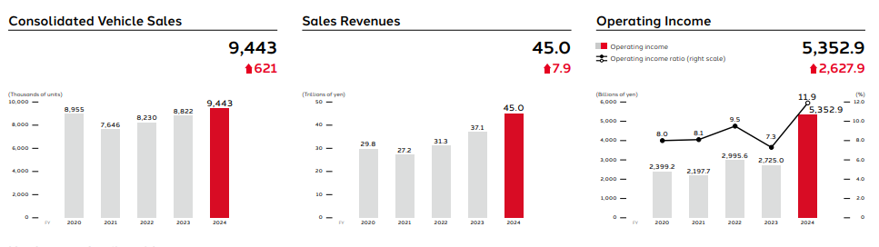
Figure 1: Financial summary of Toyota
(Source: Annual reports, 2024)
Figure 1 illustrates a consistent growth in profitability and revenue from 2020 to 2024. shows Toyota's total sales revenue has increased to 45.0 trillion yen in 2024 from the previous years (Annual reports, 2024). In 2024, its net income increased to 5,352.9 billion of yen, along with 9,443 (thousands of units) consolidated vehicle sales from the previous period. Total net income attributable to Toyota has grown to 4644.9 billion yen in 2024. The financial performance of this company has grown significantly in 2024 due to the improvement of international automobile demand and its expansion into technological innovation and manufacturing capacity. This automotive organisation also benefited from the increasing demand for energy-efficient and hybrid vehicles that has contributed significantly towards its sales performance. Apart from this, Toyota has exhibited some fluctuations in 2020 and 2021 in terms of the supply chain issues and international economic disruptions. Although, this company significantly recovered and gained potential financial performance in the following years.
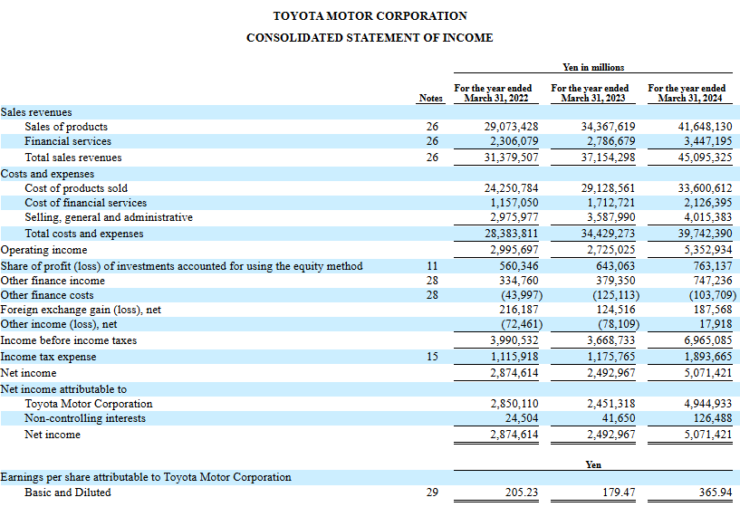
Figure 2: Income statement of Toyota
(Source: Sec.gov, 2024)
The income statement has shown that the company has maintained a strong net profit over the past five years. Figure 2 displays an increase of net income of 5071421 million yen in 2024 in comparison with previous periods (Sec.gov, 2024). Its improved cost management strategies and operational efficiency have allowed it to maintain profitability within the economic uncertainty. Besides this, its major focus on innovation, technological development and international expansion has strengthened its competitive edge within the automotive sector.
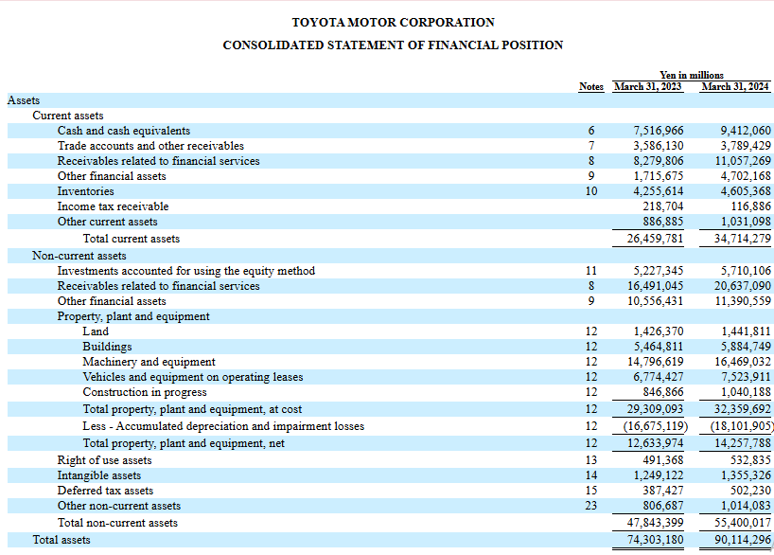
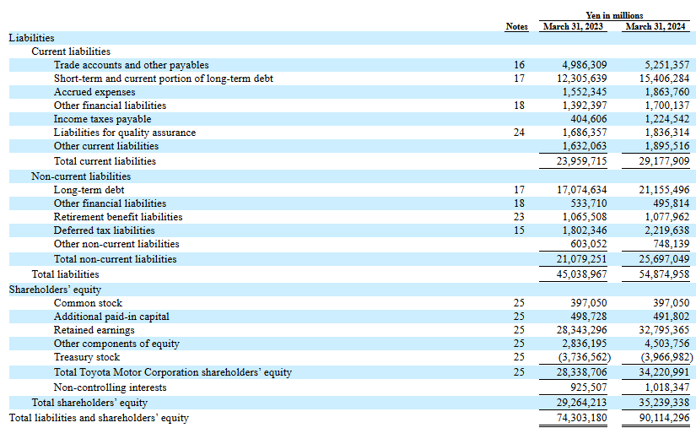
Figure 3: Balance sheet of Toyota
(Source: Sec.gov, 2024)
Figure 3 exhibits Toyota’s balance sheet, highlighting a stable financial position. The total assets have increased to 34,714,279 million yen in 2024 from 26,459,781 million yen in 2023. The current assets of an organisation are enhanced due to the continued investment in research and development, manufacturing facilities and technological advancement (Sec.gov, 2024). In addition, a balanced capital structure has been maintained by Toyota in terms of the integration of shareholders’ equity and liabilities, reflecting its growth to maintain financial stability.
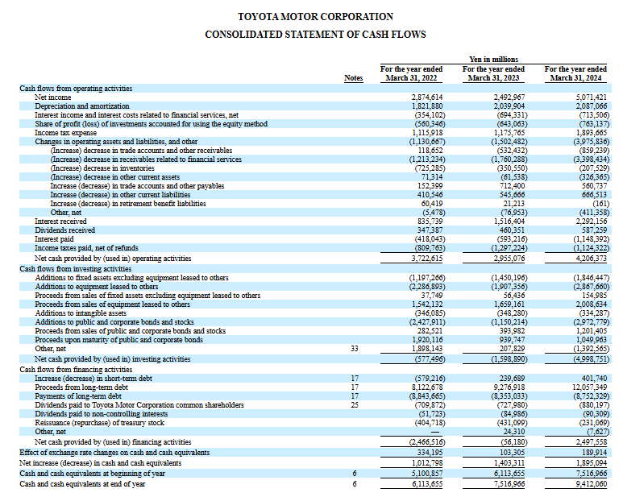
Figure 4: Balance sheet of Toyota
(Source: Sec.gov, 2024)
Figure 4 shows the cash flow statement, reflecting Toyota’s potential financial management. Its positive operating cash flows have demonstrated that the company has generated the required cash based on its core business operations for investment.
Ratio analysis
Profitability
Profitability ratio is helpful to analyse the ability of a company to produce earnings through its operations. As stated by Andoko and Angeline (2023, p.60), the net profit margin shows the portion of income which persists as profit after the deduction of all expenses. The net profit margin of Toyota has increased to 11.25% in 2024 from 7.07% in 2020. Despite a decline in this profit margin in 2024, it has recovered substantially in 2024. Such an improvement has highlighted that operational efficiency and cost management of Toyota have been improved, being supported through higher demand for vehicles and exchange rates. Therefore, ROA has illustrated the ability of Toyota to produce profit from its assets. The value of ROA has risen to 5.63% in 2024 from 3.91% in 2020; however, it has dropped in 2023 to 3.35%. The upward trend of this ratio has shown a greater efficiency of Toyota to utilise its assets more effectively. The level of strong profitability has demonstrated the competitive position of Toyota within the international automotive sector.
Liquidity
The liquidity ratio can evaluate the financial ability of a company to cover its short-term financial obligations. It has been analysed that the current ratio of Toyota has improved to 1.19 in 2024 from 1.04 in 2020. This has shown an enhancement of its current assets respective to current liabilities. A current ratio above advocates the firm has enough cash assets to meet its liabilities to show a healthy liquidity position (Blessing and Sakouvogui, 2023, p. 110). In addition, the company’s quick ratio has improved to 1.03 in 2024 from 0.90 in 2020. It shows that the liquid assets of this company, including receivables and cash, are capable of covering its short-term obligations. Moreover, the firm’s liquidity position has indicated a cautious improvement, such as effective financial stability with prudent working capital management.
Efficiency
The asset-turnover ratio of Toyota has declined to 0.55 in 2024, compared with 0.50 in 2020. It has shown the company’s underutilised inventory, reflecting an inefficient manufacturing process. Besides this, the inventory turnover ratio also reduced from 5.93 in 2020 to 4.99 in 2024, highlighting the problems of reduced liquidity, higher costs and overstocking. Toyota’s inability to control operating costs has indicated inefficiency in supply chain and production management.
Gearing
In the context of the analysis of an organisation’s reliance on debt financing and financial leverage, the gearing ratio is mainly used. Toyota’s D/E ratio is considered stable across five years renegade between 1.49 and 1.56. It has been displayed that a balanced capital structure has been maintained through the company, along with a moderate dependency on debt financing. Although financial risk can be increased by higher leverage, a reliable ratio highlights effective management of the company regarding debt obligations. On the other hand, the company’s debt ratio is nearly 0.60–0.61, showing that around 60% assets are financed based on debt. However, it has outlined a substantial borrowing level; the prudent generation of cash flow and profitability has decreased the financial risk. The maintenance of an efficient gearing structure has allowed Toyota in financing towards large-scale investments, including EV technology, R&D and international expansion.
Investment
Companies use investment ratios to evaluate the returns delivered to the shareholders. EPS of Toyota has increased from 150.79 in 2020 to 365.38 in 2024. It has shown its prudence over financial performance and profitability. In terms of the company’s higher earnings, the dividend payout ratio has reduced to 20.5%. It suggests that Toyota focus on investment to gain future growth with a higher profitability rate.
Cash flow
Cash flow ratio is used by the company to analyse its ability to produce cash in meeting financial obligations. Toyota’s operating cash flow has increased to 14.42 in 2024 from 12.71 in 2021. It has shown the company’s potential generation of operating cash in proportion to current liabilities. This has highlighted that the organisation has enough cash flow in the current year to reinforce its financial commitment for the short-term period. Besides this, Toyota has been able to generate sufficient operating cash flows, as its cash flow to debt ratio is reliable between 0.07 and 0.09 in coverage of the total debt. A firm’s financial flexibility has been improved through a robust operating cash flow to support strategic and investment initiatives (Wu et al. 2024, p. 1195).
Identification of trends, strengths and threats
Toyota’s financial analysis from 2020 to 2024 has outlined multiple significant trends. One of the main trends has been considered compatible growth in profitability and revenue across 5 years. This company’s net income and sales have grown, highlighting potential international demand regarding vehicles as well as its ability in adapting towards changing market conditions. An improvement over profitability has shown the operational efficiency of Toyota due to its priority on hybrid vehicles and innovation. Continuous improvement across liquidity position is another major trend (Ayomide and Godwin Olaoye, 2024, P.14). Both the quick and current ratios have displayed the ability of Toyota, highlighting a reliable financial structure in managing operational expenses.
A balanced capital structure has represented a core strength of Toyota. The maintenance of a steady debt level regarding equity has exhibited controlled borrowing and modest financial leverage. Toyota’s investment across R&D, technological innovation, and market expansion has been guided by the inception of cash flow. Multiple threats have been found in Toyota. Efficiency indicators have shown some reduction in operational efficiency, mainly in utilisation of assets and inventory management. Such issues highlight challenges over the supply chain and fluctuations across manufacturing levels. Toyota has faced external risks including disruption in the supply chain, international economic uncertainty, and growing competition within the automotive sector (Annual reports, 2024). Apart from challenges, substantial cash flow, improving profitability and liquidity have delivered a potential foundation to sustain growth in the long term to maintain its competitive position.

2. Working Capital Management Analysis
Working capital management (WCM) stands for the procedure in managing a company’s short-term assets along with liabilities in ensuring sufficient liquidity and business operations. WCM has played a vital role to maintain a firm’s financial stability as it can determine the business’s ability to meet its operational expenses and short-term obligations (Lefebvre, 2022, p.724). In the context of large MNCs such as Toyota, an efficient management of working capital can allow for the decrease of financial risks, optimise cash flows and improve profitability.
Cash operating cycle
The cash operating cycle, or the cash conversion cycle (CCC) is used to measure the time needed for a firm in converting its investments regarding inventory and resources into cash inflows from customers. The cash operating cycle shows a company’s working capital efficiency to manage its receivables, inventory and payables (Ijuwo, 2024, p. 20). This involves three main elements such as receivables collection period, the inventory conversion period and the payables deferral period.
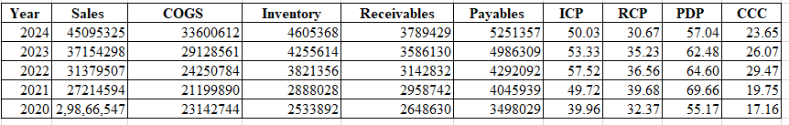
Figure 5: Cash operating cycle
(Source: Self-created)
Figure 5 denotes that CCC has been computed to add the ICP and RCP and subtract the PDP. During 2020-2024, the CCC values of Toyota have ranged between 17.16 days and 29.47 days. It has been found that the cycle has risen to 29.47 days in 2022 from 17.16 days in 2020, reflecting a slower turnover of inventory and receivable collection. In 2024, effective working capital management has been identified in Toyota with an improvement of the CCC value of 23.65 days. Despite such a slight improvement, the shorter CCC has suggested that Toyota should collect receivables and manage inventory effectively to get benefits from supplier credit terms.
Recommend strategies to improve liquidity through working capital reforms
The improvement of liquidity is necessary to maintain stable business operations and ensure that an organisation can meet its short-term financial obligations. The reform of an effective working capital is helpful for companies to optimise the management of receivables, inventory and payables that influence the efficiency of cash flow. For Toyota Motor Corporation, the maintenance of potential liquidity is significant regarding the capital-centric nature of vehicle manufacturing and the complications related to international supply chains.
Efficient inventory management is one of the significant strategies for improving liquidity. Automation manufacturing needs a large number of raw materials and elements that may result in high inventory holding costs. It has been found that Toyota has implemented the manufacturing system of Just-In-Time (JIT) that ensures that materials are received only for the required producing procedure. The JIT method has been used by Toyota to fulfil orders from customers as fast as possible (Toyota, 2026). Such an approach has lowered storage costs, decreased excess inventory and shortened the inventory conversion period to improve the position of cash flow.
Another key strategy includes strengthening the policies of credit management. Toyota has sold vehicles based on credit arrangements and dealership networks. This depicts that for the maintenance of liquidity; receivable management has played a key role. This organisation can improve its liquidity to assess customers’ and dealers' creditworthiness before the extension of credit. The provision of incentives, including the implementation of automated invoicing systems and earlier payment discounts, can decrease receivables collection period and encourage quick payments (Bessonova, Bessonova and Shevchenko, 2024, p.148). Supplier relationship management is another strategy to improve the efficiency of working capital. The company can maintain its long-term partnerships with international suppliers to negotiate favourable payment terms.
The extension of the payable deferral period can enable Toyota to reserve cash for a longer time beyond disrupting supplier relationships. As opined by Dorrah and McCabe (2024, p.244), effective cash flow management is supported through the negotiation of strategic suppliers. Besides this, the improvement of operational efficiency would offer potential liquidity in the business. The improvement of logistics coordination, streamlining the manufacturing process and reduction of production delays would help to enhance inventory turnover and shorten manufacturing cycles. Digital analytical tools and advanced financial monitoring systems can assist managers to track the performance of working capital. Based on the implementation of such working capital reforms, Toyota will be able to strengthen its liquidity position to maintain sustainable and efficient business operations.
Comparison of short-term vs long-term financing options
Organisations mainly depend on types of financing such as long-term financing and short-term financing. Such financing options differ in the context of purpose, duration and financial implications. Long-term financing is funds which can be repaid in terms of a long time, generally more than one year. An organisation’s financial stability is achieved through long-term financing as repayment is outspread over multiple periods (Rambaud, Pascual and Santandreu, 2022, p.553). The main examples include corporate bonds, long-term bank loans and equity financing. Such sources are used for the investments, involving funding R&D, buying machinery and market expansion.
A short-term financing option is a type of fund which should be repaid within one year. Bank overdrafts, trade credit, short-term bank loans and commercial paper are identified as main examples. Short-term financing has delivered fast access to funds, offering higher flexibility (Fallahi et al. 2023, p.3245). The sources of short-term financing have been used to support regular operations, including the management of the shortages of working capital, payment of wages and buying raw materials. Although, it includes refinancing risks and higher interest costs whether the organisation is unable in repaying the borrowed funds over the given period. For Toyota, a balanced integration of long-term and short-term financing is frequently used. It has been analysed that short-term financing has supported the requirement of working capital, while long-term financing has funded long-term growth and strategic investments.

3. Strategic Financial Restructuring Plan
Recommend financial restructuring options
Financial restructuring is considered one of the significant strategies used by organisations in strengthening capital structure and improving financial performance to increase long-term growth. The recommendation of financial restructuring can help Toyota to maintain competitiveness within the evolving automotive sector, which is influenced through sustainability requirements, technological innovation and electrification. Divestiture is a significant restructuring option that includes the sale of underperforming or non-core business units. Toyota needs to prioritise the resources regarding high-growth potential areas, such as hybrid and electric vehicles along with new mobility technologies. As mentioned by Wu, Gao and Hu (2024, p.3098), divestiture can produce additional cash inflows, which may be reinvested in technological innovation or research and development. Mergers or strategic alliances in order to mobility and technology firms can be another vital option. The automotive sector has been experiencing rapid transformation due to the development of artificial intelligence, autonomous driving and digital mobility services. In this case, mergers can allow Toyota to access advanced technologies, share research costs and expand market reach to minimise financial risk.
Debt restructuring or refinancing can be recommended as a suitable restructuring for Toyota. Equity injection refers to increasing capital to issue new shares for investors. Equity financing would deliver substantial funds regarding long-term investments, including the development of electric vehicles, expansion of production capacity and improvement of technological infrastructure. However, it may dilute ownership; it can strengthen the capital base of the organisation to minimise dependency on debt financing. Debt restructuring or refinancing can be another effective restructuring approach for Toyota. This company would improve cash flow management and minimise financial costs to refinance loans at lower interest rates and negotiate existing debt terms. In this case, this restructuring option can increase the organisation’s ability and strengthen its financial stability for investment in future growth opportunities.
Impact on shareholder value, debt structure, and operational flexibility
An organisation’s shareholder value, capital structure and operational flexibility have been influenced through financial restructuring decisions. The adoption of financial restructuring strategies can provide both operational and financial implications to Toyota Motor Corporation.
Shareholder value
Shareholder value is one of the effective impacts of financial restructuring. Shareholder value stands for the return which investors perceive based on dividend payments and capital appreciation (Arhinful et al. 2024, p.99). In this case, the initiatives of restructuring, such as divesting non-core assets, will improve shareholder value to allow the firm to focus on the resources related to the segment of profitable business. For instance, if Toyota focuses on high-growth areas, including hybrid technologies and electric vehicles, this will increase its profitability and revenue growth to enhance shareholder wealth. In addition, technological partnerships and strategic alliances can create value to expand market opportunities and accelerate innovation.
Debt structure
For Toyota, the debt structure will be another key consideration. Debt restructuring can help the company to minimise its borrowing costs in improving financial stability. Through the negotiation of existing debt firms with lower-cost financing, the organisation can decrease its financial risk to improve capital structure. As stated by Putri and Willim (2024, p.28), a balanced capital structure of both equity financing and debt helps a company to maintain financial flexibility to control the cost of capital. Although, higher dependency on debt can decrease investor confidence and enhance financial risk.
Operational flexibility
Financial restructuring can influence a firm’s operational flexibility that refers to the business’s capability in adapting towards the changes of technological developments and market conditions. For instance, mergers or strategic partnerships with technology organisations can provide Toyota with access towards advanced innovations. It will allow the organisation in responding effectively towards regulatory requirements and consumer preferences. Therefore, the improvement of capital structure based on refinancing or equity injections can deliver greater financial resources to Toyota to invest in sustainable technologies and production expansion. Such investments will increase operational flexibility to enable the organisation in pursuing new business opportunities to maintain potential financial stability. Moreover, well-planned financial restructuring will strengthen the long-term competitiveness of Toyota to support effective value creation for shareholders.
International and ethical considerations
In the context of implementation of the strategic financial restructuring plan, organisations should consider various international and ethical factors which may influence long-term sustainability and financial performance. For Toyota, operating the business in multiple international markets has exposed the company towards challenges associated with currency fluctuations, taxation policies, inflationary pressures and CSR.
Taxation policy
One of the significant global considerations is taxation policy. Multiple countries have applied varying tax incentives, corporate tax rates and regulatory framework which influence a business’s corporate financial decisions. While Toyota restructures its investments and operations, it should evaluate the forming of international partnerships, tax implications regarding relocating manufacturing facilities or divesting business units. As mentioned by Levia and Wahyudi (2025), prudent tax planning can improve profitability of a firm to minimise financial burdens. Although, the company should avoid the aggressive tax avoidance strategies which may disrupt its reputation in the market leading towards regulatory penalties. In this case, the transparency of the compliance and transparency with tax regulations is necessary to sustain corporate credibility and investor confidence.
Currency risk
Currency risk is another important factor that arises when an organisation conducts transactions over several countries. Toyota has sold its products in more than 170 countries and regions with 72 producing companies worldwide (Toyota, 2026). As an international manufacturer with operations across Europe, Asia and North America, it has generated revenue and incurred costs within various currencies. The fluctuations of exchange rate can affect profitability, mainly when revenue is generated in one currency and manufacturing cost occurs in another. The strategies of financial restructuring may involve diversified production locations and currency hedging methods to minimise exposure over foreign exchange risk.
Inflation
Inflation is another significant consideration within financial restructuring. Increasing inflation enhances production costs such as labour, raw materials and transportation expenses. Within the automotive sector, inflation can impact supply chain management and production operations. High inflation rate has increased in 2022 and 2023 to challenge this sector, leading to fluctuation in car buying intentions of customers in many markets (Statista, 2025).
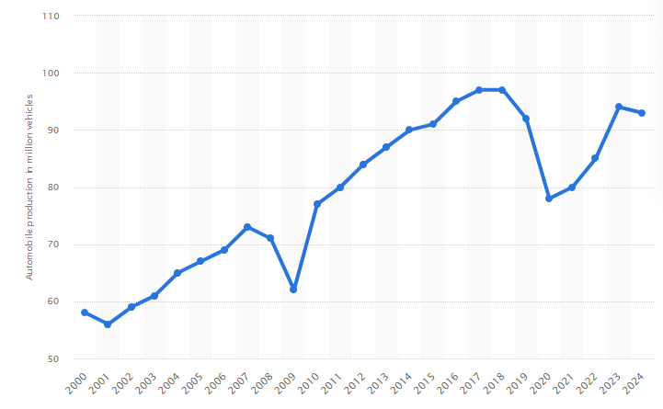
Figure 6: Worldwide motor vehicle production 2000-2024
(Source: Statista, 2025)
Figure 6 shows that 93 million motor vehicles are manufactured worldwide in 2024, decreasing slightly in comparison with previous years (Statista, 2025). Hence, it is important to Toyota to adjust its cost management practices, pricing strategies and capital investment decisions in maintaining profitability in terms of the inflationary conditions. In addition, proactive cost control mechanisms and long-term financial planning are necessary to mitigate the inflation-associated risks.
CSR
Toyota should address ethical responsibilities and corporate social responsibility (CSR) along with financial considerations. For investors, consumers and regulators, social, environmental and ethical responsibility are important. It has been found that a criticism has been faced by the company associated with CSR and environmental transparency. Greenpeace Australia has filed a complaint to accuse Toyota in 2023 regarding greenwashing in the year 2023 (Theguardian, 2023). Financial restructuring strategies of Toyota must align with its potential commitment towards environmental protection and sustainable mobility. In addition, its investment into hybrid technologies, electric vehicles and environmentally friendly production processes can illustrate how financial decisions may support its sustainability goals for the long-term. Based on the integration of ethical consideration over restructuring plans, Toyota would be able to increase its corporate reputation within the automotive sector to ensure sustainable business growth and maintain stakeholder trust.

4. Investment Appraisal and Capital Budgeting
Investment appraisal is considered one of the most significant methods of financial management for the evaluation of a company’s viability over a long-term investment project. Investment appraisal helps to analyse whether a project can make an effective financial return regarding capital invested (Olayinka, 2022, p.55). Capital budgeting techniques, including Net Present Value (NPV), Average Rate of Return (ARR), Payback Period (PBP), Internal Rate of Return (IRR) and Profitability Index (PI) have been used for making proper decisions within investment.
NPV
An investment’s profitability has been evaluated by the net present value to compare the PV over future cash flows within the initial investment. A positive NPV shows that a project can produce value for shareholders, and a negative NPV denotes a lower return compared with the required rate of return (Czipf, 2025, p.161). In the context of calculation, –£8.68 million and –£8.30 million of NPV have been generated by Project A, while Project C has performed better with –£1.98 million of NPV. However, a positive NPV cannot be generated by any of the projects regarding 10% of discount rate. Project C has indicated the least negative value, which is closer to the required return.
Payback Period (PBP)
The PBP can access the required time for a firm in coverage the initial investment based on the cash inflows of the project. A shorter payback period is less risky due to recover the investment faster. Based on the calculation, 4.50 years of payback period has been generated by Project A, while Project B has taken a longer period of 4.55 years. In addition, Project C has recovered its investment more quickly with 3.60 years of payback period. It has been shown that Project C has allowed the organisation to meet its capital needs earlier in comparison with the projects of A and B. In terms of the perspective of liquidity, Project C is regarded as the most effective option.
Average Rate of Return (ARR)
ARR analyses an investment’s profitability in terms of the accounting profit to evaluate the average profit from the average investment. ARR is computed 3.2% in Project A, 4% in Project B and 12% in Project C. It has been found that stronger profitability has been achieved by Project C to generate higher average earnings in comparison with the other two projects.
Internal Rate of Return (IRR)
IRR refers to the discount rate at which a project’s NPV has become zero. When a project’s IRR exceeds its required rate of return, a project is accepted. Investors prefer IRR to anticipate the best return through the investment within a project (Wangchuk, 2022, p. 27). The IRR of the project has been computed 2.72% in Project A, 3.26% in Project B and 8.59% in Project C. Hence, Project C has illustrated its strongest performance regarding the IRR value of 8.59%. However, the IRR of the three projects is lower than 10% of the cost of capital. Project C has been considered significant in offering a higher return rate than Projects A and B.
Profitability Index (PI)
PI has been used by the company to measure the value generated per unit of the investment. Profitability index displays the absolute monetary achievement to measure efficiency and account for the time value of money (Trevisan et al. 2024, p.2076). Both Project A and Project B have generated 0.83 of PI, the highest PI has been created by Project C with the value of 0.96. Despite having the value of 1 in all projects, Project C has exhibited one of the most effective outcomes to deliver the highest value in proportion to the initial investment.
Recommendation of the project with justification
On the basis of the investment appraisal method, the most relevant option of investment is considered as Project C. This is suitable due to having the shortest payback period, the highest IRR, ARR and PI in comparison with other projects. However, its NPV is recognised as slightly negative in order to the discount rate of 10%, Project C has illustrated one of the significant options with extensive financial performance.
Project C’s selection can be justified to consider the operational stability and financial condition of Toyota. Based on the ratio analysis, it has been analysed that a prudent financial position has been maintained by the company with sufficient liquidity, substantial operating cash flows and rising profitability. Such financial abilities can enable this automotive company in undertaking appropriate investment in guiding through innovation and business growth.
Toyota has been able in financing project with enough cash generation, which may offer higher returns in the future. Project C is most relevant to produce larger inflows within the investment period’s middle years. As opined by Sinaga et al. (2023, p.1080), the payback period is a simple technique that helps to identify the length of time of an investment can take to reach towards the break-even point. This structure can improve the company’s ability and internal cash production in the competitive automobile sector, in funding additional projects associated with advanced EV technologies and Research and Development. Besides this, potential cash flows in the midterm may increase flexibility and liquidity to manage investment in the supply chain, operational costs and the strategies of international expansion. In this case, with the long-term strategic goals and financial strength of Toyota, Project C is aligned effectively to improve business success for the future.
In terms of non-financial factors, the selection of Project C is also effective to support the business growth. A major transformation has been recognised in the automotive sector due to rising demand for EV and hybrid vehicles, environmental regulations and innovation in technology. Hence, for the maintenance of the competitive edge, Toyota should invest in technologies. The potential revenue of Project C can support business expansion, solutions in sustainable mobility and R & D. As stated by (2022, p. 15400), the technology development plan of an automobile company is a key to innovation to improve business growth within the dynamic sector. Moreover, this project would increase the loyalty of customers to assist product innovation to meet their changing preferences. Overall, the consideration of both financial and non-financial factors, Project C, exemplifies the most appropriate decision for investment to maintain competitiveness and increase business growth.
Best project combination with justification of using capital rationing
Capital rationing stands for the procedure of limiting or rationing the available money regarding new and profitable projects. Managers should choose the combination of projects which can increase the financial return of the company over the investment constraint. Hence, Toyota has a maximum limit of £100 million of investment, with the initial investment of each project being £50 million. In this case, the organisation would perceive only two projects among the three available projects.
Possible project combinations:
Combination | Investment (£m)
A+B | 100
A+C | 100
B+C | 100
Table 1: Project combinations
(Source: Self-created)
Table 1 depicts the total investment of each combination to identify reliable projects for Toyota.
Using the results of NPV
Project | NPV (£m)
A | -8.68
B | -8.30
C | -1.98
Table 2: Project combinations after using NPV
(Source: Self-created)
Table 2 shows NPV of each project to consider appropriate projects for Toyota.
Calculation of total NPV:
A+B = −8.68+(−8.30)
= -16.98
A+C = −8.68+(−1.98)
=-10.66
B+C = −8.30+(−1.98)
= -10.28
Based on the above, it has been found that all combinations of projects have generated a negative value of NPVs by 10% discount rate. However, the combination of Project B and Project C has resulted in the least negative NPV. It has been shown that this combination can reduce financial loss and contribute a higher return in comparison with other combinations. In the context of a strategic perspective, the selection of Projects B and C will contribute several operational benefits to Toyota. Project C can generate higher cash inflows to support the company’s future investments to improve its cash flow position. Additionally, Project B can deliver a reliable and consistent cash inflow to minimise financial uncertainty. In terms of £100 million of capital rationing constraint, Toyota must undertake Project B and Project C for investment in supporting financial stability and return in the long-term.

Conclusion
It has been concluded based on the above analysis that between 2020 and 2024, a consistent performance and financial stability of Toyota have been identified. This organisation has illustrated its significant revenue, operating cash flow and growth, highlighting a robust operational effectiveness and financial management. Ratio analysis indicates a stable capital structure along with improved liquidity, which is important for long-term investment. However, various efficiency-related issues are associated with supply chain management and inventory; financial flexibility has been maintained through the organisation. Therefore, the working capital has highlighted its efficient management over short-term resources. The project is recommended as the most relevant project for the investment of Toyota, along with the consideration of integrating Projects B and C under capital rationing.

Reference list
Andoko, A. and Angeline, A., (2023). The Influence Of Debt To Equity Ratio, Operating Profit Margin Ratio And Operating Expense Toward Entity Income Tax Of Infrastructure, Utility And Transportation Companies Listed On The Indonesia Stock Exchange. IJOSPOL-International Journal of Social, Policy and Law, 4(1), pp.58-68.
Annualreports, (2024). Annual Report. Available at: https://www.annualreports.com/Company/toyota-motor-corp [Accessed on 12.03.2026]
Arhinful, R., Mensah, L., Amin, H.I.M. and Obeng, H.A., (2024). The influence of cost of debt, cost of equity and weighted average cost of capital on dividend policy decision: Evidence from non-financial companies listed on the Frankfurt Stock Exchange. Future Business Journal, 10(1), p.99.
Ayomide, A. and Godwin Olaoye, E.O., (2024). Technological Innovations Enhancing Short-Term Liquidity in Financial Institutions. Financial Economics, pp.1-14.
Bessonova, A., Bessonova, S. and Shevchenko, A., (2024). Optimization of Receivables of an Enterprise as a Tool for Strengthening Financial Efficiency. Економіка розвитку систем, 6(2), pp.146-150.
Blessing, H. and Sakouvogui, G., (2023). Impact of liquidity and solvency ratios on financial performance: a comprehensive analysis. Indonesia Auditing Research Journal, 12(3), pp.102-115.
Chen, Y., (2022). Research on collaborative innovation of key common technologies in new energy vehicle industry based on digital twin technology. Energy Reports, 8, pp.15399-15407.
Czipf, C., (2025). The impact of changing energy prices, interest rates, and investment costs on the net present value and internal rate of return for alternative energy projects. Discover Sustainability, 6(1), p.161.
Dorrah, D.H. and McCabe, B., (2024). Integrated agent-based simulation and game theory decision support framework for cash flow and payment management in construction projects. Sustainability, 16(1), p.244.
Fallahi, S., Mellquist, A.C., Mogren, O., Listo Zec, E., Algurén, P. and Hallquist, L., (2023). Financing solutions for circular business models: Exploring the role of business ecosystems and artificial intelligence. Business Strategy and the Environment, 32(6), pp.3233-3248.
Ijuwo, A., (2024). Effect of Working Capital Management on Profitability of Listed Consumer Good Companies in Nigeria. Journal of Advance Research in Business, Management and Accounting (ISSN: 2456-3544), 10(1), pp.12-25.
Lefebvre, V., (2022). Performance, working capital management, and the liability of smallness: a question of opportunity costs?. Journal of Small Business Management, 60(3), pp.704-733.
Levia, C.M. and Wahyudi, I., (2025). The Influence of Tax Planning, Profitability, And Costs Operations For Earning Management. Best Journal of Administration and Management, 3(3), pp.156-169.
Olayinka, A.A., (2022). Financial statement analysis as a tool for investment decisions and assessment of companies’ performance. International Journal of Financial, Accounting, and Management, 4(1), pp.49-66.
Putri, R.L. and Willim, A.P., (2024). Analysis of the effect of assets structure, earning volatility and financial flexibility on capital structure in consumer goods industry sector companies on the Indonesia stock exchange. LBS Journal of Management & Research, 22(1), pp.25-36.
Rambaud, S.C., Pascual, J.L. and Santandreu, E.M., (2022). Staggered loans: a flexible modality of long-term financing for SMEs in global health emergencies. Quantitative Finance and Economics, 6(4), p.553.
Sec.gov (2022). Financial result of 2020. https://www.sec.gov/Archives/edgar/data/1094517/000119312520139717/d792902dex991.htm#:~:text=Due%20to%20the%20effects%20of,on%20equity%20securities%20in%20FY2020. [Accessed on 12.03.2026]
Sec.gov (2022). Financial result of 2022 and 2021. https://www.sec.gov/Archives/edgar/data/1094517/000119312522146839/d323794dex991.htm#:~:text=For%20reasons%20such%20as%20government,like%20through%20%E2%80%9CToyota%20Times.%E2%80%9D [Accessed on 12.03.2026]
Sec.gov (2023). Financial result of 2023. https://www.sec.gov/Archives/edgar/data/1094517/000119312523179181/d360541d20f.htm [Accessed on 12.03.2026]
Sec.gov (2024). Financial result of 2024. https://www.sec.gov/Archives/edgar/data/1094517/000119312524167462/d807954d20f.htm [Accessed on 12.03.2026]
Sinaga, A.S., Sari, M.M., Hutasuhut, A.A., Zahara, S.T., Amanda, A., Fitri, A. and Caesario, M.A., (2023). Comparison of capital budgeting methods: NPV, IRR, PAYBACK PERIOD. World Journal of Advanced Research and Reviews, 19(2), pp.1078-1081.
Statista, (2025). Automobile production. Available at: https://www.statista.com/statistics/262747/worldwide-automobile-production-since-2000/?srsltid=AfmBOoreEEiKFedWKQZyNQSXrRq0-hcYLU2mlinh9MwVJ5ul9KtJqdE1 [Accessed on 12.03.2026]
Statista, (2025). Inflation in automotive sector. Available at: https://www.statista.com/topics/1487/automotive-industry/?srsltid=AfmBOoowK11vuGR_SKIpIm19biUI_SB39TZJYEwy9e_6frcBnbG50PNc#editorsPicks [Accessed on 12.03.2026]
Theguardian, (2023). Greenwashing. Available at: https://www.theguardian.com/business/2023/mar/03/toyota-accused-of-greenwashing-in-greenpeace-complaint-filed-to-accc [Accessed on 12.03.2026]
Toyota, (2026). About company. Available at: https://www.toyota-europe.com/about-us/toyota-in-the-world [Accessed on 12.03.2026]
Trevisan, R., Ladu, M., Ghiani, E. and Balletto, G., (2024). Achieving net zero condominiums through energy community sharing. Sustainability, 16(5), p.2076.
Wangchuk, P., (2022). Application of depreciation net present value and internal rate of return in engineering projects a brief literature review. Journal of Applied Engineering, Technology and Management, 2(1), pp.25-30.
Wu, W., Le, C., Shi, Y. and Alkaraan, F., (2024). The influence of financial flexibility on firm performance: the moderating effects of investment efficiency and investment scale. Journal of Applied Accounting Research, 25(5), pp.1183-1202.
Wu, X., Gao, Y. and Hu, Y., (2024). Examining the effect of technology-related divestitures on exploratory innovation: evidence from China. European Journal of Innovation Management, 27(8), pp.3083-3112.

Appendices

Appendix 1: Ratio analysis
Profitability ratios
Net profit margin
 | 2024 | 2023 | 2022 | 2021 | 2020
Net profit | 5071421 | 2492967 | 2874614 | 2282378 | 2111125
Revenue | 45095325 | 37154298 | 31379507 | 27214594 | 29866547
Net profit/Revenue *100 | 11.25 | 6.71 | 9.16 | 8.39 | 7.07

Return on Assets (ROA)
 | 2024 | 2023 | 2022 | 2021 | 2020
Net profit | 5071421 | 2492967 | 2874614 | 2282378 | 2111125
Total Assets | 90114296 | 74303180 | 67688771 | 62267140 | 53972363
Total income/ Total Assets | 5.63 | 3.36 | 4.25 | 3.67 | 3.91

Efficiency Ratio
Asset turnover ratio
 | 2024 | 2023 | 2022 | 2021 | 2020
Revenue | 45095325 | 37154298 | 31379507 | 27214594 | 29866547
Assets | 90114296 | 74303180 | 67688771 | 62267140 | 53972363
Revenue/Assets | 0.50 | 0.50 | 0.46 | 0.44 | 0.55

Inventory turnover ratio
 | 2024 | 2023 | 2022 | 2021 | 2020
Cost of goods sold | 33600612 | 29128561 | 24250784 | 21199890 | 23142744
Average inventory | 6733175 | 6166292 | 5265370 | 4157974 | 3899412
Cost of goods sold/ average inventory | 4.99 | 4.72 | 4.61 | 5.10 | 5.93

Investment Ratio
Earnings per share (EPS)
 | 2024 | 2023 | 2022 | 2021 | 2020
Net income | 5071421 | 2492967 | 2874614 | 2282378 | 2111125
Total number of shares outstanding | 13880 | 13920 | 13950 | 13980 | 14000
Net income/Total number of shares outstanding | 365.37 | 179.09 | 206.06 | 163.2602 | 150.794643

Dividend Payout Ratio
 | 2024 | 2023 | 2022 | 2021 | 2020
Dividend per share | 75 | 65 | 60 | 48 | 44
EPS | 365.38 | 179.09 | 206.07 | 168.3 | 150.79
Dividend per share/EPS*100 | 20.53 | 36.29 | 29.12 | 28.52 | 29.18

Cash flow Ratio
Operating Cash Flow Ratio
 | 2024 | 2023 | 2022 | 2021 | 2020
Cash flow from operations | 4206373 | 2955076 | 3722615 | 2727162 | 2398496
Current liabilities | 2,91,77,909 | 2,39,59,715 | 21842161 | 2,14,60,466 | 1,79,02,377
Cash flow from operations /Current liabilities | 14.42 | 12.33 | 17.04 | 12.71 | 13.40

Cash flow to debt ratio
 | 2024 | 2023 | 2022 | 2021 | 2020
Operating cash flow | 4206373 | 2955076 | 3722615 | 2727162 | 2398496
Total Debt | 54874958 | 45038967 | 40533951 | 37978811 | 3,26,33,351
Operating cash flow/ total debt | 0.08 | 0.07 | 0.09 | 0.07 | 0.07

Gearing Ratio
Debt-to-equity ratio
 | 2024 | 2023 | 2022 | 2021 | 2020
Total Debt | 54874958 | 45038967 | 40533951 | 37978811 | 32633351
Total shareholders’ equity | 35239338 | 29264213 | 27154820 | 24288329 | 21339012
Total Debt /total shareholders’ equity | 1.56 | 1.54 | 1.49 | 1.56 | 1.53

Debt ratio
 | 2024 | 2023 | 2022 | 2021 | 2020
Total debt | 54874958 | 45038967 | 40533951 | 37978811 | 3,26,33,351
Total assets | 90114296 | 74303180 | 67688771 | 62267140 | 53972363
Total debt/total assets | 0.61 | 0.61 | 0.60 | 0.61 | 0.60

Liquidity Ratios
Current Ratio | 2024 | 2023 | 2022 | 2021 | 2020
Current assets | 3,47,14,279 | 2,64,59,781 | 23722290 | 2,27,76,800 | 1,86,42,531
Current liabilities | 2,91,77,909 | 2,39,59,715 | 21842161 | 2,14,60,466 | 1,79,02,377
Current assets/Current liabilities | 1.19 | 1.10 | 1.09 | 1.06 | 1.04

Quick ratio
 | 2024 | 2023 | 2022 | 2021 | 2020
Current assets-inventories | 3,01,08,911 | 2,22,04,167 | 19900934 | 1,98,88,772 | 1,61,08,639
Current liabilities | 2,91,77,909 | 2,39,59,715 | 21842161 | 2,14,60,466 | 1,79,02,377
Current assets-inventories/Current liabilities | 1.03 | 0.93 | 0.91 | 0.93 | 0.90

Graphs

Appendix 2: Investment appraisal calculations
Net present value (NPV)
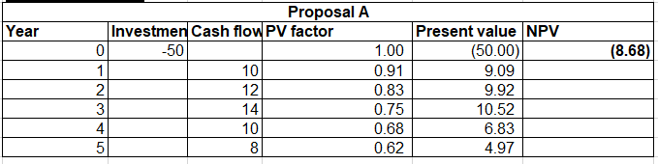
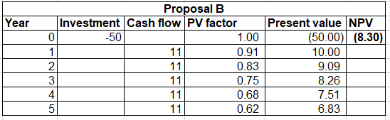
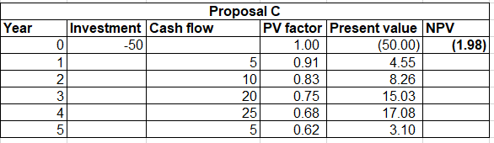
Payback period (PBP)
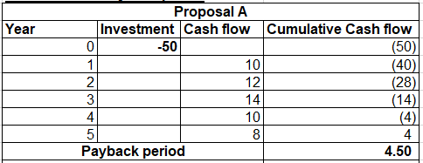
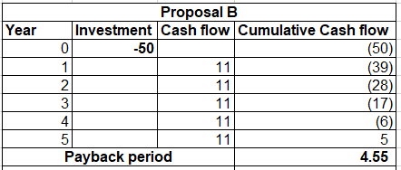
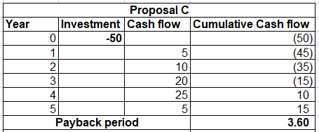
Internal rate of Return (IRR)
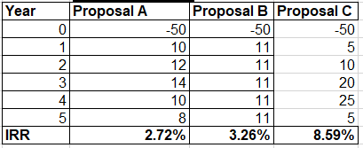
Profitability Index (PI)
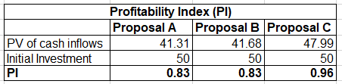
Accounting Rate of Return (ARR)
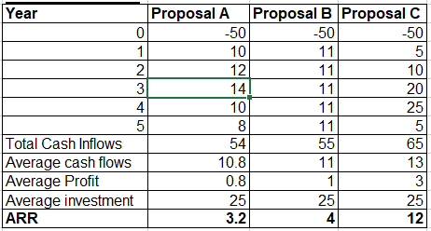

Appendix 3: Tables of three statements
Year | Revenue | Cost of Sales | Operating Income | Net Income
2024 | 45,095,325 | 33,600,612 | 5,352,900 | 5,071,421
2023 | 37,154,298 | 29,128,561 | 3,470,000 | 2,492,967
2022 | 31,379,507 | 24,250,784 | 3,000,000 | 2,874,614
2021 | 27,214,594 | 21,199,890 | 2,990,000 | 2,282,378
2020 | 29,866,547 | 23,142,744 | 2,700,000 | 2,111,125
Table 1: Consolidated Income Statement (¥ million)

Year | Total Assets | Total Liabilities | Shareholders’ Equity
2024 | 90,114,296 | 54,874,958 | 35,239,338
2023 | 74,303,180 | 45,038,967 | 29,264,213
2022 | 67,688,771 | 40,533,951 | 27,154,820
2021 | 62,267,140 | 37,978,811 | 24,288,329
2020 | 53,972,363 | 32,633,351 | 21,339,012
Table 2: Consolidated Balance Sheet (¥ million)

Year | Operating Cash Flow | Investing Cash Flow | Financing Cash Flow
2024 | 4,206,373 | -3,400,000 | -900,000
2023 | 2,955,076 | -2,900,000 | -700,000
2022 | 3,722,615 | -3,200,000 | -800,000
2021 | 2,727,162 | -2,400,000 | -600,000
2020 | 2,398,496 | -2,200,000 | -500,000
Table 3: Consolidated Cash Flow Statement (¥ million)

