REPORT TEMPLATE
Module: Introduction to Web and Database Concepts (ACCA4023)
Assignment: HTML & CSS Web Development
Student Name: Liliana Stryzhakovska
Student ID: 2518099
Course: Computing Skills For The Workplace
Submission Date: 19/04/2026

Table of Contents

Introduction ………………………………………………………………………………… 3

Requirements ……………………………………………………………………………… 3

Implementation …………………………………………………………………………… 3

Website Screenshots …………………………………………………………………… 4

Results (HTML & CSS) ………………………………………………………………….. 6

Fixes ……………………………………………………………………………………………. 6

Research …………………………………………………………………………………….. 6

Usability ……………………………………………………………….……………….. 7

Accessibility …………………………………………………………..……………… 7

SEO ………………………………………………………………………………………. 7

Website Evaluation ………………………………………………………..…………… 7

Usability & Utility ………………………………………………………..……….. 7

SEO Techniques Used ………………………………………………….……….. 7

Accessibility (WCAG 2.1) ……………………………………………..……….. 7

Website Comparison ………………………………………………………….………. 7

Usability …………………………………………………………………………….….. 7

Accessibility …………………………………………………………………………… 7

SEO …………………………………………………………………………………….…. 8

Mobile Friendliness …………………………………………………………….…….. 8

Conclusion …………………………………………………………………….…………… 7

References (IEEE Format) ………………………………………………….……….. 9

Appendices (HTML & CSS Code) …………………………………………..…….. 9

1. Introduction (Abstract)
This report evaluates the design and development of a multi-page website created for a beauty and aesthetic services business named “Glow Lab”. The website includes four main pages: Home, Services, Prices, and Book Appointment. The purpose of the website is to present services, display pricing information, and allow users to book appointments through a simple online form.
The design focuses on a soft, feminine aesthetic using a beige, cream, and gold color palette to create a professional and elegant user experience.

2. Requirements
The Glow Lab website was developed to meet both functional and design requirements.
Functional requirements: the website must include four pages: Home, Services, Prices, and Book; users must be able to navigate between pages using a navigation menu; the Prices page must display services with clear pricing; the Book page must include a form to collect user details (name, email, phone, date, and additional information); all links must use relative paths to ensure the site works after compression into a ZIP file.
Non-functional requirements: the website must have a consistent, clean, and visually appealing design; it should use a soft color palette (cream, beige, gold, grey); the layout must be readable and user-friendly; the site should be lightweight and load quickly using HTML and CSS only; basic responsiveness should be considered for different screen sizes.

3. Implementation

The website was developed using HTML and CSS. It consists of four main pages: Home, Services, Prices, and Book Appointment. Each page was created using a consistent layout and styling to maintain a unified design.

Website Screenshots:

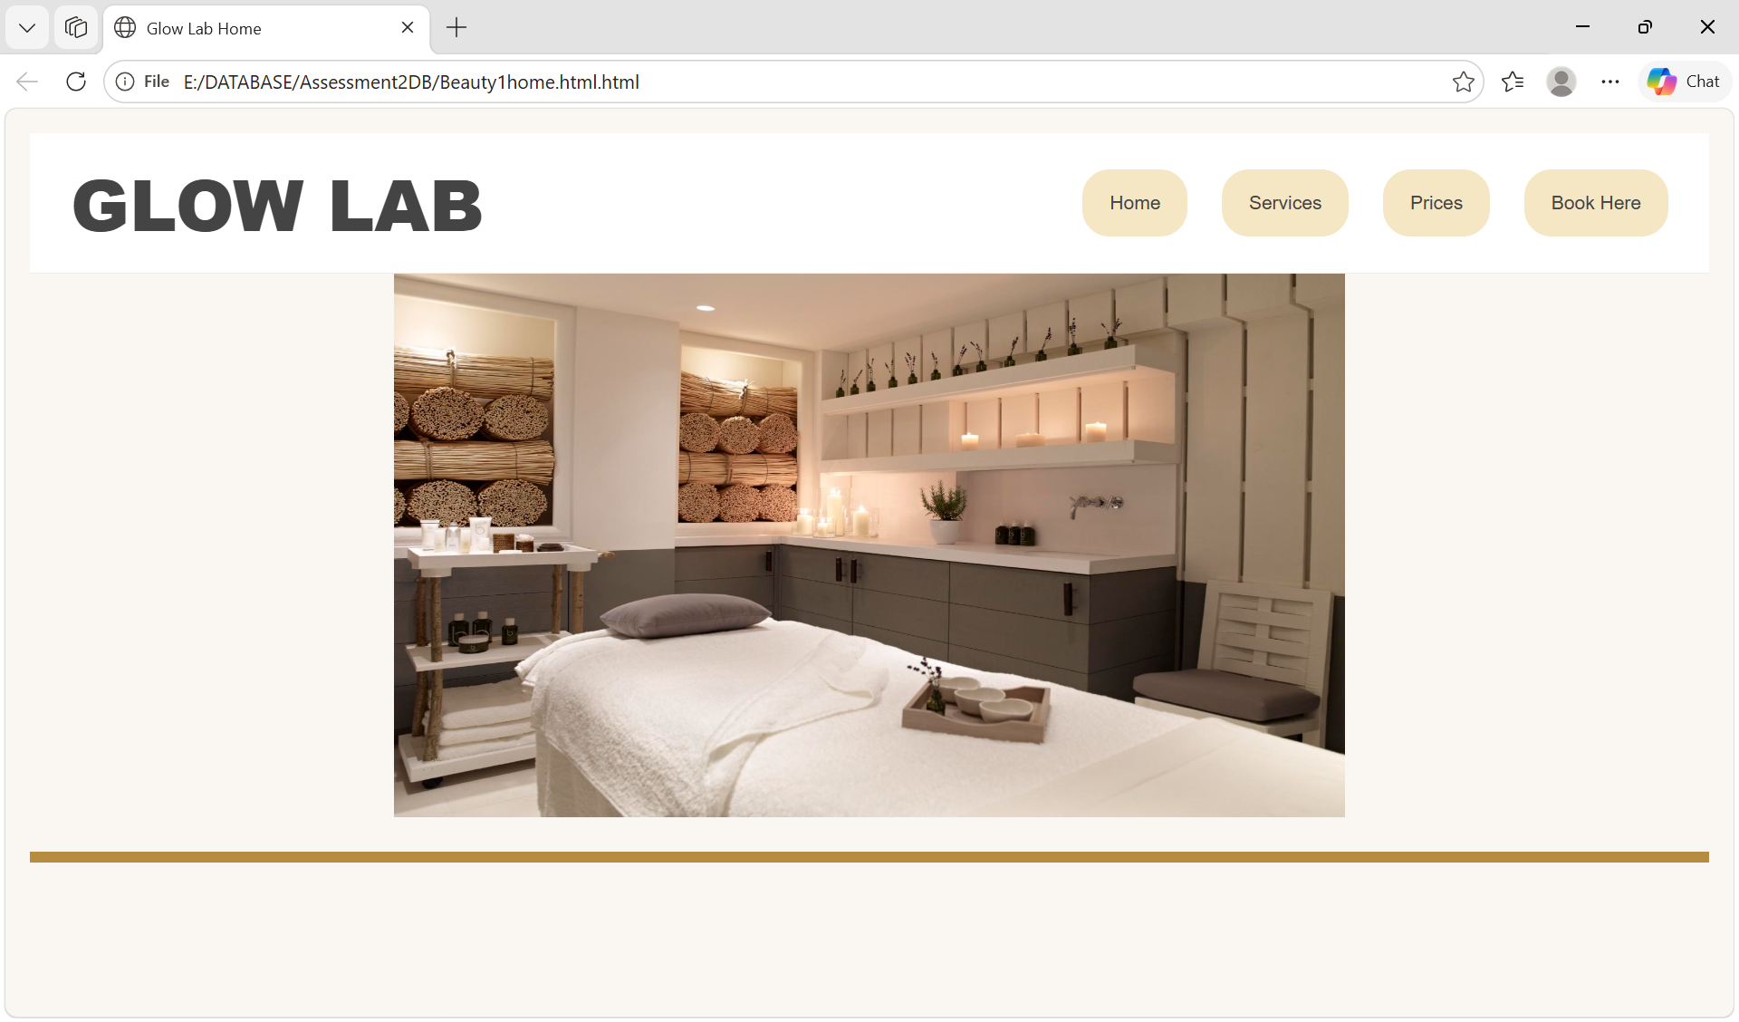
Figure1. Home page screenshot.

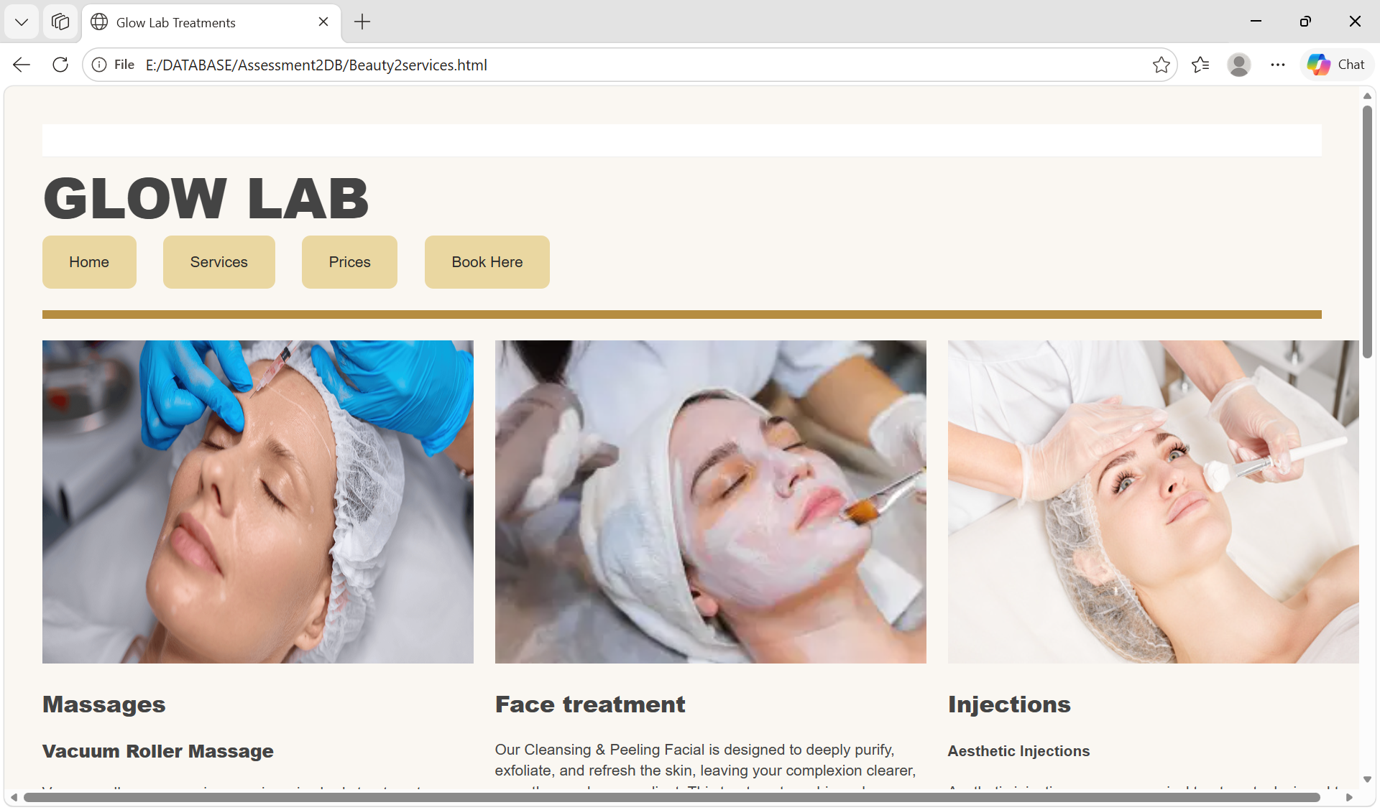
Figure 2. Services page screenshot.
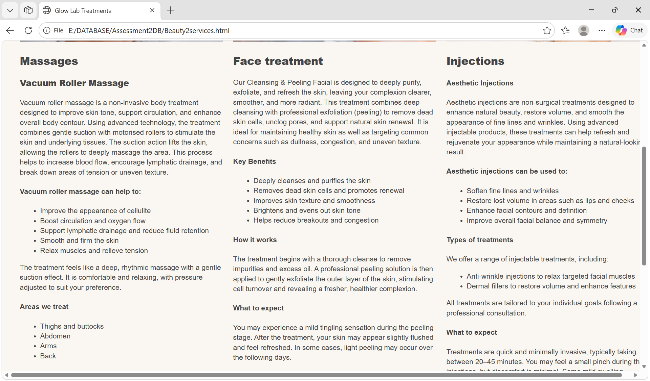
Figure 2a. Services page screenshot.

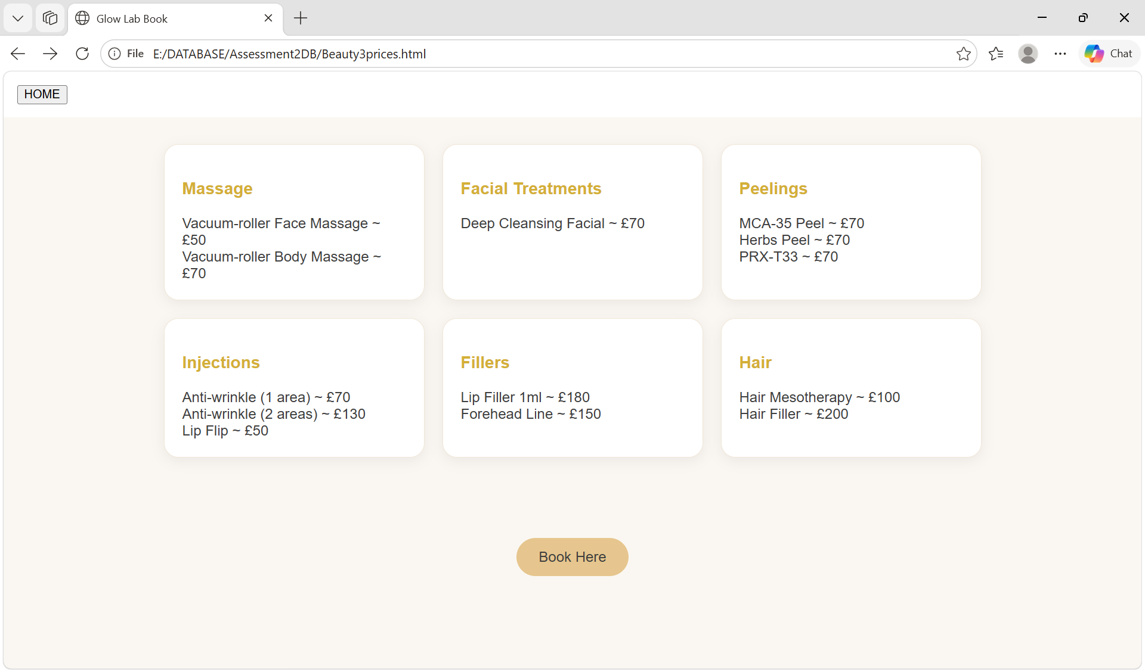
Figure 3. Prices page screenshot.
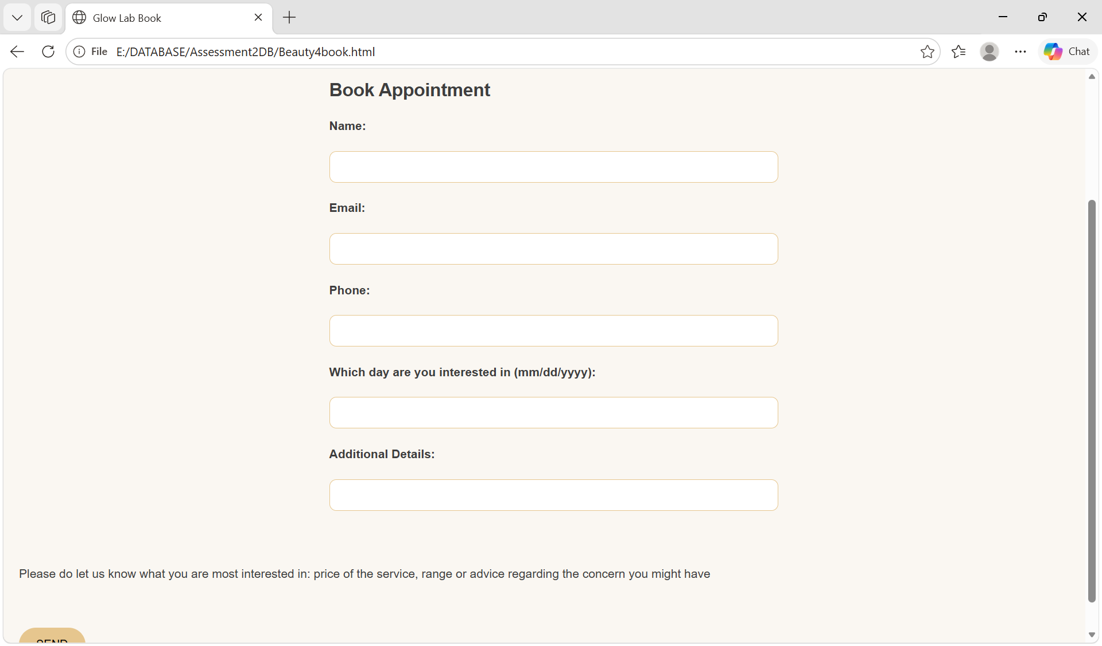
Figure 4. Book Appointment page screenshot.

Results (HTML & CSS)

The website code was tested by me. Most of the code was successfully. However, a few issues were identified during testing.

Incorrect HTML structure: some elements were incorrectly nested (e.g., headings inside paragraphs, multiple <header> tags); fix: restructured HTML to follow correct semantic rules; class naming inconsistency: CSS classes like Price-card and Prices were inconsistent with CSS selectors and fix - standardised naming to lowercase (price-card, prices); file path issues absolute file paths were used earlier, causing broken links after moving files and fix it - replaced with relative paths to ensure portability.

After applying fixes, the website became more structured, consistent, and compliant with web standards. The final version functions correctly across all pages and maintains a clean design and user-friendly experience.

4. Evaluation
a) Research:
Usability refers to how easy a website is to use and navigate. A usable website should be intuitive, consistent, and efficient for users. Good usability improves user satisfaction and reduces errors. According to [1], usability includes learnability, efficiency, and user satisfaction.
Accessibility ensures that websites can be used by people with disabilities. This includes features such as proper heading structure, alt text for images, and keyboard navigation. WCAG 2.1 guidelines define international standards for accessibility [2].
SEO (Search Engine Optimization) is the process of improving a website’s visibility in search engines. Key elements include meta tags, headings, keywords, and alt attributes. According to Google [3], well-structured HTML improves ranking and discoverability.
b) Website Evaluation:
Usability & Utility
The Glow Lab website has clear navigation and a simple layout. Users can easily move between pages (Home, Services, Prices, Book). The structure is consistent, which improves usability. The website provides useful information about services and pricing, fulfilling its purpose.
SEO Techniques Used
The website uses basic SEO techniques such as page titles for each HTML file; heading structure (h1, h3); clean HTML layout.
Accessibility (WCAG 2.1)
The website partially follows WCAG 2.1 guidelines: good color contrast between text and background; use of headings for structure; form inputs for user interaction.
c) Website Comparison
Usability
The Glow Lab website performs well in usability due to its simple navigation and clear structure. Compared to standard commercial websites, it is slightly less advanced but still user-friendly.
Accessibility
Accessibility is partially implemented. While basic structure exists, improvements are needed to fully comply with WCAG 2.1 standards (e.g., alt text, ARIA labels).
SEO
SEO is basic. The website includes titles and headings but lacks advanced optimisation such as meta tags, structured data, and keyword strategy.
Mobile Friendliness
The website is moderately mobile-friendly. Flexbox and grid layouts allow basic responsiveness, but additional media queries are needed for full optimisation on smaller devices.
Conclusion
Overall, the website is functional, visually consistent, and easy to use. However, improvements in accessibility, SEO, and responsive design would significantly enhance its quality and professional standard.

5. Conclusion
The Glow Lab website is a functional multi-page website designed to present beauty and aesthetic services in a clear and visually appealing way. It successfully includes key pages such as Home, Services, Prices, and Booking, allowing users to easily navigate and access important information.
The design follows a consistent soft aesthetic style using a neutral colour palette, which improves user experience and readability. The website demonstrates basic usability principles, with clear structure and simple navigation.
However, there are areas for improvement. Accessibility could be enhanced by adding alt text for images and improving semantic structure. SEO could also be strengthened through the use of meta descriptions, keywords, and better optimisation techniques. Additionally, mobile responsiveness could be improved using more advanced CSS media queries.
Overall, the website meets its main functional requirements and provides a good foundation for further development into a more professional and fully optimised web application.

6. References (IEEE Format)
[1] J. Nielsen, Usability Engineering, Academic Press, 1993.
[2] W3C, “Web Content Accessibility Guidelines (WCAG) 2.1,” 2018. [Online]. Available: https://www.w3.org/WAI/WCAG21/
[3] Google Developers, “Search Engine Optimization (SEO) Starter Guide,” 2023. [Online]. Available: https://developers.google.com/search/docs
[4] MDN Web Docs, “HTML: Hyper Text Markup Language,” Mozilla. [Online]. Available: https://developer.mozilla.org/
[5] W3Schools, “HTML Tutorial.” [Online]. Available: https://www.w3schools.com/html/

7. Appendices
Include full HTML and CSS code listings.

HTML
Beauty1home

<!DOCTYPE html>
<html>
<head>
<title>Glow Lab Home</title>
<link rel="stylesheet" href="GLstyle1.css"/>
</head>
<body>
<header>
<div class="topbar">
<div class="logo">GLOW LAB</div>
<div class="nav">
<a href="Beauty1home.html">Home</a>
<a href="Beauty2services.html">Services</a>
<a href="Beauty3prices.html">Prices</a>
<a href="Beauty4book.html">Book Here</a>
</div>
</div>
<header class="header">
<img src="4.jpg"style="width:700px;height:400px;class="avatar>
</header>
</body>
</html>

Beauty2services

<!DOCTYPE html>
<html>
<head>
<title>Glow Lab Treatments</title>
<link rel="stylesheet" href="GLstyle2.css"/>
</head>
<body>
<header>
<div class="topbar"></div>
<div class="logo">GLOW LAB</div>
<div class >
<div class="nav">
<a href="Beauty1home.html">Home</a>
<a href="Beauty2services.html">Services</a>
<a href="Beauty3prices.html">Prices</a>
<a href="Beauty4book.html">Book Here</a>
</div>
<div class="header"></div>
<div class="gallery">
<div class="item">
<img src="1.jpg"style="width:400px;height:300px;class="avatar>
<h2><b>Massages</h2></b>
<h3><b>Vacuum Roller Massage</b></h3>

Vacuum roller massage is a non-invasive body treatment designed to improve skin tone, support circulation, and enhance overall body contour. Using advanced technology, the treatment combines gentle suction with motorised rollers to stimulate the skin and underlying tissues.
The suction action lifts the skin, allowing the rollers to deeply massage the area. This process helps to increase blood flow, encourage lymphatic drainage, and break down areas of tension or uneven texture.
<h4>Vacuum roller massage can help to:</h4>
<ul>
<li>Improve the appearance of cellulite</li>
<li>Boost circulation and oxygen flow</li>
<li>Support lymphatic drainage and reduce fluid retention</li>
<li>Smooth and firm the skin</li>
<li>Relax muscles and relieve tension</li>
</ul>
The treatment feels like a deep, rhythmic massage with a gentle suction effect. It is comfortable and relaxing, with pressure adjusted to suit your preference.
<h4>Areas we treat</h4>
<ul>
<li>Thighs and buttocks</li>
<li>Abdomen</li>
<li>Arms</li>
<li>Back</li>
</ul>
<h4>Aftercare</h4>
To maximize results, we recommend drinking plenty of water after your treatment to help support the body’s natural detoxification process.
How many sessions will I need?
For best results, a course of treatments is recommended. Your therapist will create a personalized plan based on your goals.
</div>

<div class="item">
<img src="2.jpg" style="width:400px;height:300px; class="avatar">
<h2><b>Face treatment</b></h2>
Our Cleansing & Peeling Facial is designed to deeply purify, exfoliate, and refresh the skin, leaving your complexion clearer, smoother, and more radiant.
This treatment combines deep cleansing with professional exfoliation (peeling) to remove dead skin cells, unclog pores, and support natural skin renewal. It is ideal for maintaining healthy skin as well as targeting common concerns such as dullness, congestion, and uneven texture.
<h4>Key Benefits</h4>
<ul>
<li>Deeply cleanses and purifies the skin</li>
<li>Removes dead skin cells and promotes renewal</li>
<li>Improves skin texture and smoothness</li>
<li>Brightens and evens out skin tone</li>
<li>Helps reduce breakouts and congestion</li>
</ul>
<h4>How it works</h4>
The treatment begins with a thorough cleanse to remove impurities and excess oil. A professional peeling solution is then applied to gently exfoliate the outer layer of the skin, stimulating cell turnover and revealing a fresher, healthier complexion.
<h4>What to expect</h4>
You may experience a mild tingling sensation during the peeling stage. After the treatment, your skin may appear slightly flushed and feel refreshed. In some cases, light peeling may occur over the following days.
<h4>Who is it suitable for?</h4>
This facial is suitable for most skin types and is ideal for those who:
<ul> <li>Have dull or tired-looking skin</li>
<li>Experience clogged pores or breakouts</li>
<li>Are looking for regular skin maintenance</li>
</ul>
<h4>Aftercare</h4>
<ul> <li>Apply SPF daily to protect your skin</li>
<li>Keep skin hydrated with a gentle moisturiser</li>
<li>Avoid harsh or active products for a few days</li>
<li>Do not pick or peel the skin</li>
</ul>
<h4>Results</h4>
Skin appears instantly cleaner, smoother, and more radiant, with continued improvement as the skin renews itself. Regular treatments are recommended for optimal results.
</div>
<div class="item">
<img src="3.jpg" style="width:400px;height:300px; class="avatar">
<h2><b>Injections</b></h2>
<h4>Aesthetic Injections</h4>
Aesthetic injections are non-surgical treatments designed to enhance natural beauty, restore volume, and smooth the appearance of fine lines and wrinkles.
Using advanced injectable products, these treatments can help refresh and rejuvenate your appearance while maintaining a natural-looking result.
<h4>Aesthetic injections can be used to:</h4>
<ul> <li>Soften fine lines and wrinkles</li>
<li>Restore lost volume in areas such as lips and cheeks</li>
<li>Enhance facial contours and definition</li>
<li>Improve overall facial balance and symmetry</li>
</ul>
<h4>Types of treatments</h4>
We offer a range of injectable treatments, including:
<ul> <li>Anti-wrinkle injections to relax targeted facial muscles</li>
<li>Dermal fillers to restore volume and enhance features</li>
</ul>
All treatments are tailored to your individual goals following a professional consultation.
<h4>What to expect</h4>
Treatments are quick and minimally invasive, typically taking between 20–45 minutes. You may feel a small pinch during the injections, but discomfort is minimal.
Some mild swelling, redness, or bruising can occur after treatment, but this usually settles within a few days.
<h4>Results</h4>
Anti-wrinkle treatments: results typically appear within a few days, with full effect in up to 2 weeks
<br></br>
Dermal fillers: results are visible immediately, with continued improvement as the product settles
<h4>Aftercare</h4>
<ul> <li>Avoid touching or massaging the treated area</li>
<li>Avoid intense exercise, heat treatments, and alcohol for 24 hours</li>
<li>Follow all aftercare advice provided by your practitioner</li>
</ul>
<h4>Safety & Consultation</h4>
Your safety is our priority. All treatments are carried out by trained professionals, and a full consultation is required to ensure the treatment is suitable for you.
<br></br>
</div>
</div>
<form action="Beauty1home.html">
<input type="submit" value="HOME">
</form>
</html>

Beauty3prices

<!DOCTYPE html>
<html>
<head>
<title>Glow Lab Book</title>
<link rel="stylesheet" href="GLstyle3.css"/>
</head>
<body>
<div class="topbar">
<form action="Beauty1home.html">
<input type="submit" value="HOME">
</form>
</div>
<div class="prices">
<div class="price-card">
<h3>Massage</h3>
Vacuum-roller Face Massage ~ £50<br>
Vacuum-roller Body Massage ~ £70
</div>
<div class="price-card">
<h3>Facial Treatments</h3>
Deep Cleansing Facial ~ £70
</div>
<div class="price-card">
<h3>Peelings</h3>
MCA-35 Peel ~ £70<br>
Herbs Peel ~ £70<br>
PRX-T33 ~ £70
</div>
<div class="price-card">
<h3>Injections</h3>
Anti-wrinkle (1 area) ~ £70<br>
Anti-wrinkle (2 areas) ~ £130<br>
Lip Flip ~ £50
</div>
<div class="price-card">
<h3>Fillers</h3>
Lip Filler 1ml ~ £180<br>
Forehead Line ~ £150
</div>
<div class="price-card">
<h3>Hair</h3>
Hair Mesotherapy ~ £100<br>
Hair Filler ~ £200
</div>
</div>
<div class="book-section">
<a href="Beauty4book.html" class="book-btn">Book Here</a>
</div>
</body>
</html>

Beauty4book

<!DOCTYPE html>
<html>
<head>
<title>Glow Lab Book</title>
<link rel="stylesheet" href="GLstyle4.css"/>
</head>
<body>
<div class="header">
<header class="header">
<form action="Beauty1home.html">
<input type="submit" value="HOME">
</form>
</div>
<br></br>

<div class="section">
<h2>Book Appointment</h2>
<form action="/submit" method="post">
<label><b>Name:</b></label><br></br>
<input type="text" name="name"><br></br>
<label><b>Email:</b></label><br></br>
<input type="email" name="email"><br></br>
<label><b>Phone:</b></label><br></br>
<input type="tel" name="phone"><br></br>
<label><b>Which day are you interested in (mm/dd/yyyy):</b></label><br></br>
<input type="day" name="day"><br></br>
<label><b>Additional Details:</b></label><br></br>
<input type="det" name="details"><br></br>
</form>
</div>
<p>Please do let us know what you are most interested in: price of the service, range or advice regarding the concern you might have
</p>
<br></br>
<button type="SUBMIT">SEND</button>
</header>
</body>
</html>

CSS

Beauty1home

@page {
size: A4;
margin: 0.55in;

}
body {
font-family: Arial, Helvetica, sans-serif;
color: #444444;
background-color: #FAF7F2;
margin: 0;
padding: 18px;
line-height: 1.4;
font-size: 14px;
}
.topbar {
display: flex;
align-items: center;
padding: 15px 30px;
background-color: #FFFFFF;
border-bottom: 1px solid #eee;
}
.logo {
font-size: 52px;
font-weight: 800;
}
.nav {
margin-left: auto;
display: flex;
gap: 25px;
}
.nav a {
text-decoration: none;
padding: 15px 20px;
background: #F5E6C4;
color: #444;
border-radius: 20px;

}
.nav a:hover {
background: #E6C68E;
}
.home{
text-align: center;
border-bottom: 11px solid #B68D40;
padding-bottom: 14px;
margin-bottom: 18px;
}
.header {
font-size: 14px;
text-align: center;
border-bottom: 8px solid #B68D40;
padding-bottom: 20px;
margin-bottom: 20px;
}

Beauty2services

@page {
size: A4;
margin: 0.55in;
}
body {
font-family: Arial, Helvetica, sans-serif;
color: #444444;
background-color: #FAF7F2;
margin: 0;
padding: 35px;
line-height: 1.4;
font-size: 14px;
}
.topbar {
display: flex;
align-items: center;
padding: 15px 30px;
background-color: #FFFFFF;
border-bottom: 1px solid #eee;
}
.logo {
font-size: 52px;
font-weight: 800;
}
.gallery {
display: grid;
grid-template-columns: repeat(3, 1fr);
gap: 20px;
}
.item {
text-align: left;
}
.nav {
margin-left: auto;
display: flex;
gap: 25px;
}
.nav a {
text-decoration: none;
padding: 15px 25px;
background: #EAD7A1;
color: #2B2B2B;
border-radius: 8px;
transition: 0.3s;
}
.nav a:hover {
background: #D4AF37;
color: white;
}
.header {
font-size: 16px;
text-align: left;
border-bottom: 8px solid #B68D40;
padding-bottom: 20px;
margin-bottom: 20px;
}

Beauty3prices

body {
background-color: #FAF7F2;
font-family: Arial;
color: #3E3E3E;
margin: 0;
}
.topbar {
padding: 15px;
background: #fff;
}
.prices {
display: flex;
flex-wrap: wrap;
gap: 20px;
justify-content: center;
padding: 30px;
}
.price-card {
background: #fff;
width: 250px;
padding: 20px;
border-radius: 16px;
box-shadow: 0 4px 15px rgba(0,0,0,0.06);
border: 1px solid #F0E6D6;
}
.price-card h3 {
color: #D4AF37;
}
.book-btn {
display: inline-block;
margin-top: 30px;
padding: 12px 25px;
background: #E6C68E;
color: #3E3E3E;
text-decoration: none;
border-radius: 25px;
}
.book-btn:hover {
background: #D4AF37;
color: white;
}
.book-section {
text-align: center;
margin-top: 30px;
}

Beauty4book

body {
font-family: Arial, Helvetica, sans-serif;
color: #3E3E3E;
background-color: #FAF7F2;
margin: 0;
padding: 18px;
line-height: 1.4;
font-size: 14px;
}
.header {
padding: 15px;
background: white;
border-bottom: 1px solid #eee;
}
.section {
padding: 30px;
max-width: 500px;
margin: auto;
}
input, textarea {
width: 100%;
padding: 10px;
border-radius: 8px;
border: 1px solid #E6C68E;
}
button {
background: #E6C68E;
border: none;
padding: 12px 20px;
border-radius: 20px;
cursor: pointer;
}
button:hover {
background: #D4AF37;
color: white;
}

