HOW A SCHOOL DEVELOPS ONE ASPECT OF ITS SDP: A REPORT THAT CRITICALLY REFLECTS ON THE ACTIONS, IMPACT AND EVIDENCE BASE.

Module code: ECAD7003

Student number : 2309477

Table of Contents
Introduction 3
Literature review 3
Developing an action plan 7
Reflection and evaluation 10
Practical Suggestions for Improvement: 12
Conclusion 14

Introduction
The focus of this assignment is to explore the process of the school Development Plan (SDP), with a particular emphasis on the context of a school. The essay will identify different factors within the economics department and provide suitable improvement recommendations. The school is located in South Wales which caters for up to 1,800 students offering a variety of subjects. 23.3% of students use free school meals. The percentage of free school meals is above average of 17.4% within Wales, this is due to the fact the school is located within a deprived area. An Estyn report has identified the school as ‘Good’ with factors of improvement (Estyn2016). The school follows the curriculum for Wales encouraging the learns to be ambitious, capable learners, enterprising, creative contributors, ethical, informed citizens, healthy and confident individuals (Welsh Government 2022)

Literature review
According to TAHIRA,(2021), the vision and mission statements of a school serves as the initial scope which sets out a schools journey in the directions of achieving excellence and how the school can do that. The theoretical stage the schools mission statements is deeply rooted in educational philosophy, representing the philosophical foundations that form the identity and cause of the school. The vision and mission statements articulates the middle requirements which enables the heads to take actions within the school and their individual department (TAHIRA et al., 2021). The theoretical basis of those statements draws upon academic philosophy, a subject that explores the important nature and ambitions of education. It reflects a careful attention for the department heads role within the school, its dedication to fostering holistic improvements in school students, and its determination to educating a powerful and inclusive mastering environment. This theoretical grounding ensures that the vision and mission statements represent a real willpower to educational ideas and how these ideas are implemented within the school.
As per the view of Chan (2023), at the theoretical aspect of the school development approach lies the needs analysis, a strategic enterprise grounded in instructional research and records assessment. This system is not an insignificant administrative replacement but a deliberate and systematic investigation of the educational structure , a strong theoretical basis and the needs analysis is designed to pick out areas for improvement at some stage in numerous dimensions, alongside pupil learning results, team of workers development wishes, and average faculty typical overall performance. Educational research contributes theoretical insights to this method, ensuring that the dreams evaluation is aligned with proof-primarily based practices and present day pedagogical facts(Chan, et al., 2023). The need for analyses is supported by the curriculum for wales (welsh government2022) in which it is stated that the need for analyses is linked with the need to developing ambitious and capable learners that try their hardest.
Data assessment forms an understanding, allowing teachers to investigate quantitative and qualitative factorss that shows the particular strengths and areas of improvement. Theoretical frameworks guides the selection of assessment gear, methodologies, and requirements for assessment, making sure a complete understanding of the academic surroundings (willams&smith,2021)

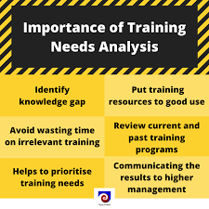
Figure: Importance of Need Analysis
(Source: nibusinessinfo)

Brien(2020) states that the curriculum improvement is essential of the school to develop. A theoretical framework that is like the curriculum theory, academic psychology and pedagogical studies. Educational philosophy and curriculum theory gives an insight in key goals, encouraging a curriculum which goes beyond teaching information developing critical thinking , creativity and holistic student development (brien et al.,2020. The view of Davies(2020) also highlights the curriculum for wales, underlining the importance of creating and creative curriculum, which offers the divers diverse learning and creative contributors
Munoz (2022), states the SDP is a strategic roadmap to decorate diverse sides of training. This analyses the movements, effectiveness, and proof base related with a selected issue of the SDP, providing an evaluation of its effectiveness. The SDP makes plans and deliberate actions are undertaken to gain present needs (Munoz et al., 2022). Munoz et al., 2022 assesses the implementation of these actions, inspecting the quantity to which they align with the overarching goals of the plan. The SDP explores results and adjustments discovered inside the school. The evidence base is a focus, drawing from resources together with exams, pupil performance facts, and comments mechanisms. This proof is measure for measuring the fulfillment of the SDP, offering valuable insights into the efficacy of the undertaken moves.
Mthembu (2021), state the implementation of key terms sheets in economics contributed extensively to the observable enhancement of school students economic vocabulary. By strategically incorporating those sheets sourced from AQA glossary booklets at KS4 and KS5 into the curriculum, students were provided with critical economic terms. This deliberate exposure no longer facilitates a steady studying level, however additionally reinforced the gaining of vocabulary through repetition and contextual expertise. Exams performed two instances termly served as reinforcement checkpoints, permitting school students to actively engage with and not forget key phrases. Additionally, the use of key terms in classroom-based assessments furnished realistic software program possibilities, encouraging students to articulate their knowledge in responses and exams (Mthembu et al., 2021). The growing impact of those pedagogical strategies in academic principles, created an immersive analysis to develop and keep a strong economics vocabulary among school students (Welsh government2022.CFW)
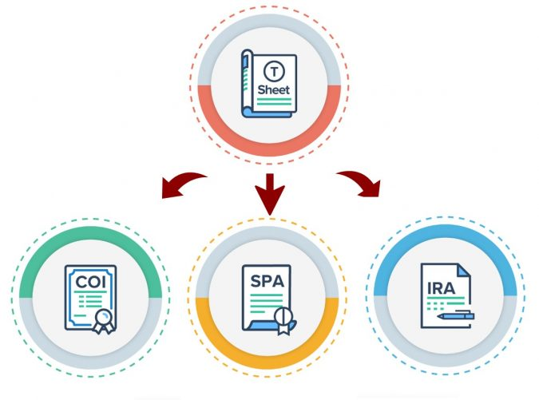
Figure: Implementation of key term sheets in economics
(Source: bridgeland-advisors, 2021)
According to Griaznova (2021), the training and delivery of GCSE subjects involves a multifaceted method aimed towards growing an appealing, student-targeted studying environment. Firstly, the non-stop replacement of booklets at a few stages within the year is important. By integrating real life information around the world, responsibilities tailored to students requirements, and incorporating selection-making activities, educators may want to make the content material more applicable and relatable to real life. This will enable ways of instructional theories emphasising the importance of contextual gaining knowledge.
Secondly, an academic approach contributes to development(Griaznova, et al., 2021). Encouraging students to mirror on their knowledge of subjects promotes metacognition and autonomy in gaining knowledge. This aligns with constructivist theories, emphasizing that researchers actively build their statistics through mirrored images. Additionally, including more choice making activities into the learning engages students in critical questioning, connecting theoretical principles to realistic scenarios. The shift in the course of a more student-focused, reflective, and completed learning method now aligns with educational theories however also complements the overall teaching of GCSE subjects by using a dynamic classroom experience.

Developing an action plan
The development of a proper action point within the prospect of a School Development Plan (SDP) is a very much critical process that mainly involves various stages, including self-evaluation, data analysis, stakeholder involvement, strategic planning, as well as impact measurement. (Bibi et al., 2021). This section will explores techniques, emphasising their importance in shaping a powerful movement point, at the same time as keeping a vital perspective.
The first step in making an action aspect is an intensive self-evaluation. This consists of an honest and whole evaluation of the strength, weaknesses, possibilities, and threats. In the context of the SDP, the school has identified a want to decorate studying of economics (Adams et al., 2022). This knowledge developed from a scientific evaluation of instructional normal performance and student engagement.
Data assessment plays a key position in figuring out developments, patterns, and areas for improvement(Steebet al., 2021). In the case of the SDP, the choice to decorate economics education have become supported by way of quantitative and qualitative information, at the side of exam effects, student ordinary performance metrics, and remarks from teachers and students.
Critical Reflection:
Its important to carefully check the information used within the school. And example of this can be the metrics mentioned by (Aggarwal et al.2022). as well as this any issues which come up from the data itself should be addressed. This will enable reasonable decisions to be put into place according to the issues which has come in order to tackle the issues and resolve it.
Once the school has accomplished an intensive self-assessment and identified the needs for improvements, the following vital step is concerning stakeholders inside the preference-making method(McSweeney et al., 2020). Stakeholders encompass teachers, students, parents, and the broader community. In the context of improving economics , teacher understandings into curriculum tests students views on the learning experience, and parents expectations for their child’s training are beneficial.
The school have to severely study the inclusivity of stakeholder involvement(Medici et al., 2021). Were many perspectives considered, or was there a bias closer to positive groups. Ensuring that all relevant voices are heard promotes an extra holistic proficiency of the difficulty and fosters a feel of ownership among stakeholders. It's critical to avoid tokenistic involvement and try for real collaboration.
School Economics development plan
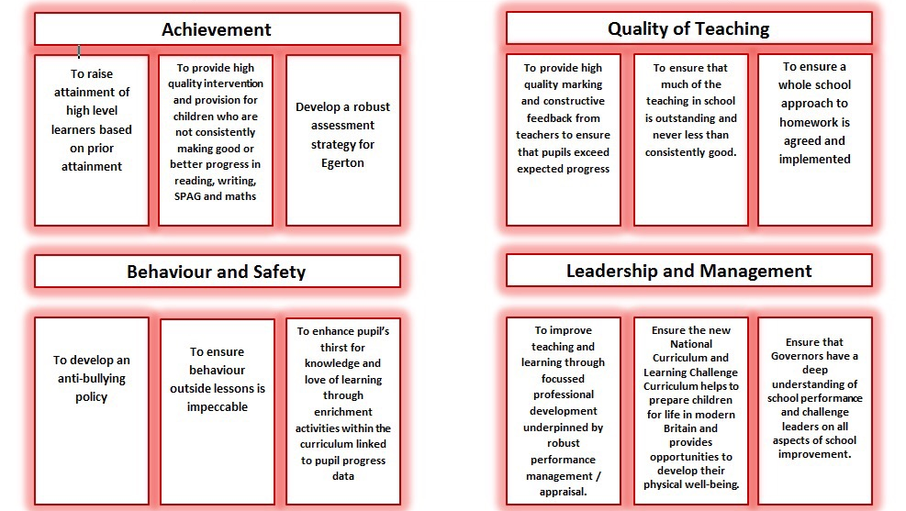
With clear knowledge of the problem identified, the faculty can maintain to strategic planning. This consists of formulating a roadmap that outlines specific actions, timelines, and useful resource allocating to deal with the issues (Wang et al., 2021). In the case of the SDP, strategies together with offering key time period sheets, updating academic materials, and incorporating selection making have been selected.
The school must seriously examine the possibility and appropriateness of the selected strategies(Setlhodi et al., 2022). Are the proposed movements sensible inside the given assets and timelines. A contingency plan in case of unexpected demanding conditions is very important in order to keep a focus on areas. A strategic plan enables the probability of a success implementation. However, it's important to live adaptably and open to changes as wanted.
Measuring the effect of carried out strategies is vital for assessing the fulfillment. In the SDP, success criteria in conjunction with students' superior vocabulary, increased independence, and reflective self-evaluation serve as signs of effect.
The school is required to take a look at the chosen success criteria(Gao et al., 2022).
- Are they without a doubt indicative of significant development?
- Is there a hazard of focusing on without difficulty measurable results on the charge of deeper, qualitative adjustments?
An understanding of effects ensures that the movement factors contributes to improvement in place of superficial adjustments. Therefore Developing a movement factor inside the SDP is complicated as that calls for a careful combination of self-assessment, data evaluation, stakeholder involvement, strategic making plans, and effective dimension. A important attitude in the course of those approaches is important to ensure that the motion point isn't always knowledgeable but also addresses the reasons of the recognised issues (Mariano et al., 2021). Success of the SDP centers on the schools capability to navigate these techniques with transparency, inclusivity, and a dedication to proper development.

Reflection and evaluation
The school's journey in the process of developing and implementing an action point within the SDP to improve the teaching and learning of economics has been a huge effort. Reflecting in this approach offers understandings into successes, difficult situations, and areas for improvement.
Successes:
The initial self-evaluation emerged as a foundation fulfillment in the schools journey inside the directions of economics education. The determination to conducting an intensive evaluation of strengths, weaknesses, opportunities, and threats showcased a thorough method to school improvement (Lowney et al., 2021). This systematic self-appraisal allowed the lead teachers to pinpoint a selected need in economics training, demonstrating a keen alignment with the principles of powerful school development. This fulfillment laid the inspiration for a focused and impactful movement factor in the School Development Plan. By accomplishing a self-assessment, the school not only identified the want for development but additionally set the degree for proof-based totally preference-making(Hardiansyahet al., 2020). The thorough exam of tutorial average performance, pupil engagement, and remarks mechanisms ensured that the identified want turned into fixed in a know-how of the school academic view. The inclusion of various stakeholders within the choice-making technique marked but each different commendable success. The lively involvement of teachers, students, and parents in shaping the motion factor contributed a wealth of particular perspectives(Ismail, et al., 2021). This inclusive method fostered a ownership amongst stakeholders, instilling a notion that their insights had been essential to the selection-making system. The ensuing movement factor, knowledgeable through many inputs, resonated with the broader school network, enhancing its relevance and capability for an implementation.
The chosen techniques, which includes providing key time period sheets and updating instructional materials, demonstrated a strategic alignment with the recognised need in economics education. This segment showcased the school potential for translating identified issues into concrete, actionable plans. The clarity in outlining specific actions, timelines, and resource allocations highlighted a properly-observation-out technique, contributing to the effectiveness of the general movement aspect.
By setting up clear signs, at the side of progressed vocabulary, increased independence, and reflective self-evaluation, the teachers examined a focus on effects(Mariano et al., 2021). This commitment to measurable success criteria grows to be vital for assessing the effectiveness of the action factor and furnished a basis for ongoing evaluation.
Challenges:
Therefore the school to properly enhance economics education via the SDP shows successes and also thoughtful strategies. (Muliati et al., 2021). A more whole interest of numerous records resources and perspectives all through self-evaluation must decorate the validity of the identified want. Integrating external evaluators can offer an independent lens, minimizing inner preconceptions and ensuring a more objective facts of the school’s dynamics.

Implementing everyday workshops or recognition schools could offer a better framework for students engagement. Ensuring examples from external sources and providing easy guidelines for full-size contributions would substitute an extra inclusive preference-making method.
Strategic making plans, should come upon challenges in encouragement sharing and possibility(Pearlstein et al., 2021). An interest of support constraints and potential difficulties at some stages in the planning segments have to decorate the practicality of the proposed strategies. Phased implementation techniques can be taken into consideration to control useful resource constraints effectively, deliberating a greater adaptive and sustainable technique. To further increase the effectiveness of the SDP and the associated factors, it is imperative to consider practical suggestions for development as these suggestion will improve the economics subject.

Self-evaluation is essential for the school’s changing aspects. Beyond inner tests, incorporating a variety of statistics assets will offer a full view. External assessments, consisting of standardised exams or outdoor evaluations, can provide an goal attitude, helping to limit internal biases (Raza et al., 2021). Additionally, implementing everyday pupil surveys and provoking reflective input from instructors will enhance the self-assessment procedure. Introducing outside evaluators, likely from educational institutions or professional corporations, can further objectivity and make sure a holistic knowledge of the faculty's strengths and regions for development.

Refining the engagement system can expand its outcomes(Ahmad et al., 2022). Structured mechanisms, such as normal workshops can offer a platform for systematic and in-depth discussions. Clear guidelines for participation want to be hooked up, making sure that each students corporation is represented proportionally. This inclusive method will foster a dynamic and collaborative selection-making method. It is important to create a surroundings in which all voices are heard, taking into account a extra equitable distribution of influence and input. These improves link to the curriculum for Wales as it aims to focus on developing ethical informed citizens who are ready to learn and be active participants (Welsh government,2022)

The success of any strategic plan closely is based on judicious aid allocation. Prioritising assistance considerations for the duration of the making plans section is crucial. A entire evaluation of modern-day resources, each individuals, need to be conducted(Kovacs et al., 2021).
It involves assessing teaching group of students, infrastructure, technology, and budgetary allocations. It is important to examine different challenges and put a plan in place to tackle these challenges (Chafouleaset al., 2021). Using different techniques to overcome challenges allows for a more practical and adaptable approach, especially when dealing with limited resources. This will ensure that the strategic plan is well thought out and feasible within the given boundaries. (Johnson et al.,2017)

Measuring the impact of implemented strategies have to encompass each quantitative and qualitative dimensions. While quantitative metrics offer numerical success, qualitative signs capture detailed changes in coaching and gaining knowledge of dynamics(Staricoff, et al., 2022). Adopting a more flexible technique to effect size carries the complex and complex nature of schooling. Regularly reviewing and adjusting success standards primarily based mostly on academic priorities guarantees that the impact length stays relevant and aligned with the school’s overarching goals. It encourages an extra responsive and adaptive method of education.

A continuous development framework is key for maintaining and improving the efficacy of the SDP. This framework must encompass based mechanisms for ordinary reviews and changes to the plan. Involving key stakeholders in reflective practices guarantees that several views contribute to the ongoing improvement technique(Kauret al., 2021). Establishing a cycle of assessment and adjustment, probable via periodic reviews or evaluation checkpoints, affords a dependent approach to continuous improvement. This adaptive framework ensures that the SDP stays dynamic, responsive, and aligned with growing educational traits and worrying situations.

Conclusion
In conclusion, the school's initiatives to enhance economics education via the School Development Plan exhibit notable successes as well as thoughtful strategies. The determination to a complete self-evaluation, complete student engagement, and nicely-accomplished strategic making plans underscore the school’s determination to development. Critical reflections have identified areas for improvement, which include the need for greater numerous statistics in self-assessment, dependent participants engagement, useful resource-focused strategic planning, flexible effect length, and a formalised ongoing development framework. Applying those sensible tips should guide the school's improvement methods, making sure a dynamic and adaptive technique to training. Overall, the school's journey displays a proactive measure, stakeholder collaboration, and a commitment to ongoing improvement, positioning it nicely for sustained instructional excellence.
Reference list
TAHIRA, M. and HAIDER, A.G., 2020. Role of head teacher in the whole school development. Turkish International Journal of Special Education and Guidance & Counselling ISSN: 1300-7432, 9(2), pp.50-65.

Chan, H.C., 2020. Exploring the Trajectories and Roles of External Change Agents in the Comprehensive School Improvement Process under a Self-Financing University-School Partnership Mechanism for Secondary Schools in Hong Kong (Doctoral dissertation, The Chinese University of Hong Kong (Hong Kong

O’Brien, S., 2022. Old Ribbons, New Bows: The Historical Development of Internal Improvement Processes in Irish Schools. In Education Policy in Ireland Since 1922 (pp. 175-217). Cham: Springer International Publishing.

Munoz Chereau, B. and Ehren, M., 2021. Inspection Across the UK: how the four nations intend to contribute to school improvement.

Mthembu, M.D.K. and Chummun, B.Z., 2022. Exploring school leadership challenges of ‘presencing’to the creation of societal value and nation building in South Africa. Gender and Behaviour, 20(3), pp.19620-19637.

Griaznova, J.A., 2020. The Dynamic Journey: Insights into the Challenges and Facilitators Encountered in Implementing the Dynamic Approach to School Improvement (Doctoral dissertation, University of Cambridge

Bibi, T. and Warris, S., 2021. An Exploration of the Key Indicators in Holistic Accountability at Public Sector Elementary Schools. Responsible Education, Learning and Teaching in Emerging Economies, 3(1), pp.37-45.

Steeb, D.R., Zeeman, J.M., Bush, A.A., Dascanio, S.A. and Persky, A.M., 2021. Exploring career development through a student-directed practicum to provide individualized learning experiences. Currents in Pharmacy Teaching and Learning, 13(5), pp.500-505.

Medici, F.V., 2022. What Potential Does an Individual Professional Development Plan (IPDP) Have in Addressing the Learning Needs of Educators in united kingdom?. Education, 3(2), pp.34-55.

Wang, Y., Chen, H., Long, R., Sun, Q., Jiang, S. and Liu, B., 2022. Has the sustainable development planning policy promoted the green transformation in China's resource-based cities?. Resources, Conservation and Recycling, 180, p.106181.

Mariano, S.R., 2021. IN-SERVICE PRINCIPALS’DEVELOPMENT IN BRAZIL: DISCONNECTION AND INSULATION FROM INTERNATIONAL CONTEMPORARY KNOWLEDGE IN EDUCATION ADMINISTRATION. Revista Pensamento Contemporâneo em Administração, 15(4), pp.37-54.

Lowney, N., 2021. INTERDEPENDENCE DAY! TEACHING THE SUSTAINABLE DEVELOPMENT GOALS THROUGH DRAMA FOR ALL AGES. A Development Education Review.

Ismail, O.A., AlRiyami, R.M. and Alhosani, M., 2023. The Art of Assuring Quality Education: Internal Approaches and Best Practices. In Restructuring Leadership for School Improvement and Reform (pp. 182-201). IGI Global.

Mariano, S.R., 2021. Formação de diretores de escolas no Brasil: Desconexão e isolamento da base de conhecimento internacional contemporânea em administração da educação. Revista Pensamento Contemporâneo em Administração, 15(4), pp.37-54.

Pearlstein, E., 2021. An Analysis of Self-Perceptions of Teacher Leader Success in Urban, Public High Schools Designated for Comprehensive School Improvement Support. Gwynedd Mercy University.

Raza, H., Ali, A., Rafiq, N., Xing, L., Asif, T. and Jing, C., 2023. Comparison of higher education in Pakistan and China: A sustainable development in student’s perspective. Sustainability, 15(5), p.4327.

Kovacs, M., 2020. The Development of Community Schools in Romania: Putting Policy Into Practice. Peabody Journal of Education, 95(1), pp.33-45.

Lin, S.C., Chang, H.K. and Chung, Y.F., 2022. Exploring the Impact of Different Port Governances on Smart Port Development Strategy in Taiwan and Spain. Sustainability, 14(15), p.9158.

Kaur, J., 2022. Performativity and Inadequacy in School Leadership Development: A Comparative Study of Primary Schools in Punjab (India) and Midlands (UK) (Doctoral dissertation, University of Huddersfield).

Adams, T., 2021. Catalyzing School Improvement Communities (Doctoral dissertation).

Aggarwal, V., Dash, S., Yadav, P.D. and Gupta, A.K., 2022, February. Role of ICT enabled Cloud Learning Management System tools in Fostering Entrepreneurship Amongst Youth. In 2022 2nd International Conference on Innovative Practices in Technology and Management (ICIPTM) (Vol. 2, pp. 508-515). IEEE.

McSweeney, M., Hayhurst, L., Wilson, B., Bandoles, E. and Leung, K., 2021. Colliding mandates of social enterprises: Exploring the financial strategies, environment, and social-market tensions of bicycles-for-development organizations. Sport Management Review, 24(5), pp.791-814.

Setlhodi, I.I., 2020. Collaboration practices between the two tiers of school leadership in eradicating underperformance. South African Journal of Education, 40(3).

Gao, X. and Hew, K.F., 2023. A flipped systematic debugging approach to enhance elementary students’ program debugging performance and optimize cognitive load. Journal of Educational Computing Research, p.07356331221133560.

Hardiansyah, F., 2022. The Implementation of School-Based Management in Improving Quality of Education in Primary School. Kelola: Jurnal Manajemen Pendidikan, 9(2), pp.148-162.

Makoelle, T.M., Makhalemele, T. and Du Plessis, P. eds., 2021. School Leadership for Democratic Education in South Africa: Perspectives, Achievements and Future Challenges Post-Apartheid. Routledge.

Muliati, A., Sihotang, W. and Octaviany, R.A., 2022. Effectiveness of school resources management in improving the quality of education. East Asian Journal of Multidisciplinary Research, 1(6), pp.901-916.

Ahmad, T., 2021. Vocational skill development through BRAC skill development program in Bangladesh: how this Is influencing socio-economic life of female training graduates (Doctoral dissertation, Brac University).

Chafouleas, S.M. and Iovino, E.A., 2021. Engaging a whole child, school, and community lens in positive education to advance equity in schools. Frontiers in Psychology, 12, p.5692.

Staricoff, M., 2020. The joy of not knowing: a philosophy of education transforming teaching, thinking, learning and leadership in schools. Routledge.

Williams, A. and Smith, J., 2021. The role of data and theory in needs assessment for school improvement. Journal of Educational Planning and Assessment, 34(2), pp.147-165.

Davies, L., 2019. Fostering Creativity Through Cross-Disciplinary Curriculum. Journal of Curriculum Innovation, 22(3), pp. 42-52.

Welsh government, (2022) Curriculum for Wales guidance

Johnson, L., Adams Becker, S., Cummins, M., Estrada, V., Freeman, A. and Hall, C. (2016) 'NMC Horizon Report: 2016 Higher Education Edition', The New Media Consortium, Austin, Texas.

