

University of Wales Trinity Saint David
School of Engineering

BEng Advanced Manufacturing and Operations

Factory Control – Box Sorting Conveyor System

Amy Evans
1909135
Module Code: ACMA6001

Contents
1. Introduction 4
2. Literature Review 5
2.1. PLC’s 5
2.2. Types of PLC’s 5
2.3. Brands 6
3. Factory Layout 7
3.1. Component’s list 7
4. Process Flow 8
5. Ladder Logic Program – Operation 9
5.1. Network 1 – PLC/HMI 9
5.2. Network 2 – Control Panel Operation 9
5.3. Network 3 – Conveyor Operation 9
5.4. Network 4 – Stack Light Control 10
5.5. Network 5 - Activate Large Box Pusher 12
5.6. Network 6 - Activate Small & Medium Box Pusher 13
5.7. Network 7 & 8 – Box Weighing Operation 14
5.8. Network 9 - Weight Payload Sorter 15
5.9. Network 10 to 14 – Box Counting 16
6. Ladder Logic Program – Warnings and Alarms 18
6.1. Network 11 & 15 – Large Box Errors 18
6.2. Network 16 & 17 – Small & Medium Box Errors 19
6.3. Network 18 & 19 – Warning & Alarm Flags / Master 20
6.4. Network 20 – Safety Door Open Alarm 20
7. HMI Control 21
7.1. Root Screen 21
7.1.1. Conveyor Operation 21
7.1.2. Box Count 22
7.1.3. Stack Lights 22
7.1.4. Errors 22
7.1.5. E-Stop Button 23
7.1.6. Reset All Counters 23
7.2. Warning & Alarm Screen 23
7.3. Engineering Screen 24
8. Works Cited 25

Table of Figures
Figure 1 - PLC Block Diagram 5
Figure 2 – Compact PLC 5
Figure 3 – Modular PLC 5
Figure 4 - Control Panel Operation 9
Figure 5 - Network 3 – Alarm Siren 9
Figure 6 - Conveyor Operation 10
Figure 7 - Stack Light Yellow 10
Figure 8 - Green Stack Light 11
Figure 9 - Red Stack Light 11
Figure 10 - Activate Large Box Pusher 12
Figure 11 - Box Pusher 0 and Large Box Sensor 12
Figure 12 - Activate Small & Medium Box Pusher 13
Figure 13 - Extra Small Box Line 13
Figure 14 - Box Conveyor Operation 14
Figure 15 - Conveyor Weight Scale & Digital Weight Display 14
Figure 16 - Weight Payload Sorter Operation 15
Figure 17 - Payload Sorter Right and Left 15
Figure 18 - Network 10 Total Box Count 16
Figure 19 - Loading Box Emitter and Total Box Count Sensor 16
Figure 20 - Total Box Count Sensors and Removers for all Box Sizes 17
Figure 21 - Network 12 to 14 Total Box Counting 17
Figure 22 - Large Box Counter 18
Figure 23 - Large Box Error Section 18
Figure 24 - Large Box Counter Warning & Alarm Logic 19
Figure 25 - Small & Medium Box Warning & Alarm Logic 19
Figure 26 - Warning & Alarm Flags / Master Logic 20
Figure 27 - Safety Doors Open Logic 20
Figure 28 - Root Screen 21
Figure 29 - Conveyor Operation Buttons 21
Figure 30 - Box Count Visual 22
Figure 31 - Stack Light Visual 22
Figure 32 - Error Visual 22
Figure 33 - E-Stop Button 23
Figure 34 - Reset Counters Button 23
Figure 35 - Warning & Alarm Screen 23
Figure 36 - Engineering Screen 24

Introduction
Companies are constantly looking for ways to increase production through automation. Object sorting is widely used in many industries to increase production rates. This project looks into an automation system that sorts four different sizes of boxes based on height and weight variations. During the process, the boxes will be transported using belt conveyors. Infrared (IR) sensors will be placed at strategic locations to detect and count the height of the boxes. To sort different box sizes down the correct work stream, pneumatic pushers, weight conveyor, and pusher wheel sorters will be used. The system will be controlled using a PLC and incorporate a HMI for operator interaction.

Literature Review

PLC’s
Programmable logic controllers (PLCs) were developed in the late 1960s in the automotive industry in the United States to replace relay logic systems (Parr, 1998). They are embedded systems that are used to control machines and processes. It stores instructions and functions such as on/off control and timing counting in programmable memory.
Intelligent I/O modules are used to transfer data between CPUs and communication networks. These communication modules communicate with other PLCs and computers located in a different location.
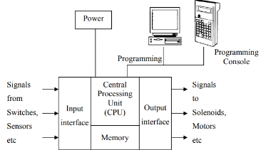

Figure 1 - PLC Block Diagram

Types of PLC’s
PLCs are classified into two types: compact/fixed (Figure 2) and modular (Figure 3). A compact PLC has a fixed number of I/O modules contained within a single case but lacks the capability to expand the modules. A modular PLC allows for module expansion and increases I/O components. Based on their output, PLCs are classified into three types: relay, transistor, and triac. The relay output is ideal for both AC and DC output devices. PLCs with transistor outputs are found inside microprocessors and use switching operations (Muthukrishnan, 2022).

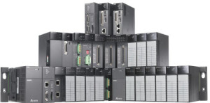
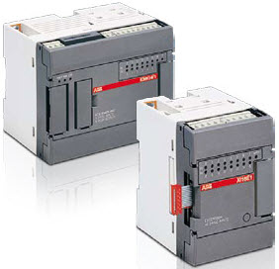

Figure 2 – Compact PLC
Figure 3 – Modular PLC

Brands
In industry, there are numerous brands and types of PLCs. Each PLC has its own set of advantages and disadvantages. Siemens and Allen Bradley are widely used in for automation purposes and could potentially be used for this project. Below is a comparison chart of each brand and model that could be selected.

Table 1 - Comparison Table Siemens Vs Allen-Bradley
Brand | Siemens | Allen-Bradley
Compact | Yes | Yes
Model | S7-1200 | MicroLogix 1200
Memory | 8192 bytes | 6144 bytes
Onboard Digital I/O | 14Inputs/10 Outputs | 40
Onboard Analog I/O | 2 inputs/2 outputs | Unknown
Mounted | Din Rail | Backplane
Approx. Cost | £500.00 | £780.00
Advantages | - Processing power and memory  - HMI and PLC can be programmed from the same software package  - Powered by any 24V DC power supply | - Processing power and memory  - User-friendly programming
Disadvantages | - Limited add on modules  - Difficult Programming | - Requires rack and AB power supply  - Price
References | - (Hardware Comparison: Allen-Bradley vs Siemens PLCS, 2022)  - (Siemens vs. Allen-Bradley PLCs: One Engineer’s Perspective, 2022)  - (Siemens, 2022) | - (Hardware Comparison: Allen-Bradley vs Siemens PLCS, 2022)  - (Siemens vs. Allen-Bradley PLCs: One Engineer’s Perspective, 2022)  - (Allen-Bradley, 2022)

Factory Layout
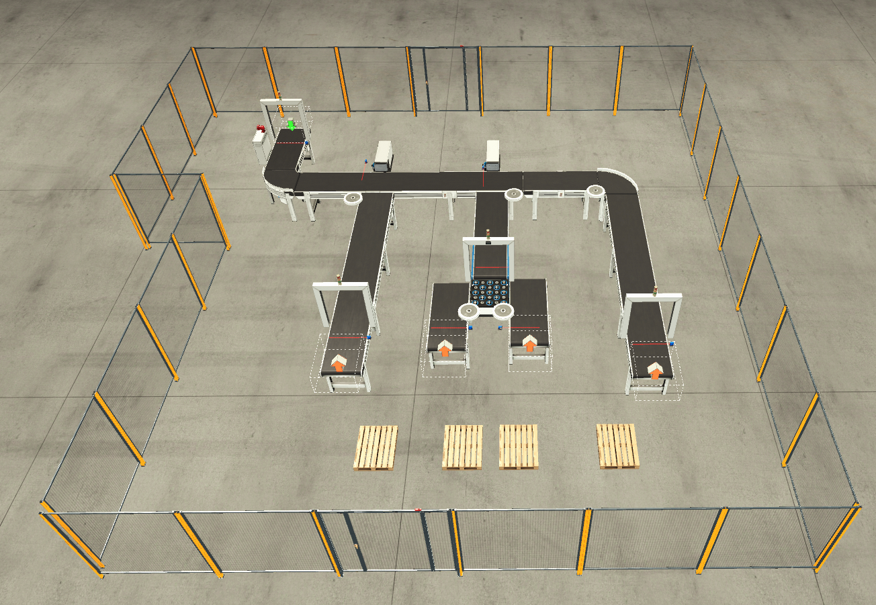

Component’s list
Component List | Quantity
2 Meter Conveyor | 5
6 Meter Conveyor | 3
Curved Conveyor | 2
Pneumatic Pusher | 2
InfraRed Sensor | 8
Weight Conveyor | 1
Pop-up Wheel Sorter | 1
Stack Light | 4
Box Emitter | 1
Box Remover | 4
Control Panel | 1
Siren | 1
E-Stop (HMI) | 1

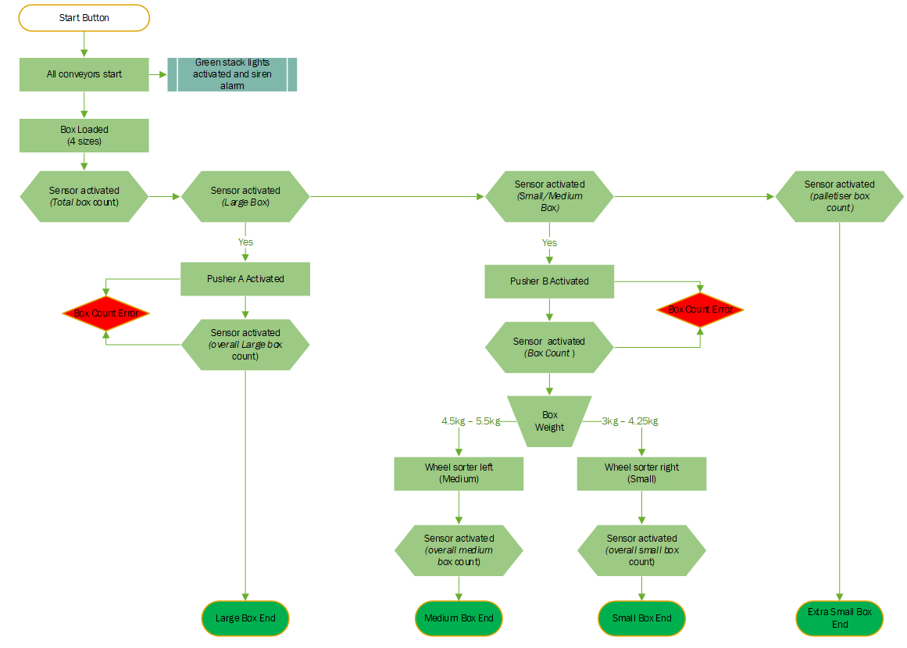
Process Flow

Ladder Logic Program – Operation

Network 1 – PLC/HMI
PLC connection.

Network 2 – Control Panel Operation
The control panel is located on the loading side of the conveyor and includes a start/stop button for the conveyor system as well as an emergency stop button. If the 'Start Button' and 'Stop Button' inputs (I) are both TRUE (1) and the 'Alarm Master' is FALSE (0), the output (Q) is 'Operation'. If the ‘Alarm Master’ is TRUE, the process will stop (Figure 4).
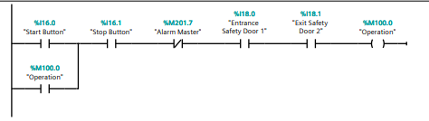
Figure 4 - Control Panel Operation

Network 3 – Conveyor Operation
The conveyor system will begin operation once the 'Operation' input is set to true (1). The TP and TON timers will be used for these operations. The TP (pulse timer) function is used to activate the siren, and when the result of the input (IN) changes from FALSE to TRUE, the programmed time (PT) begins. The accumulator timer accumulates time values over a period specified by the (PT) parameter. When the input changes from FALSE to TRUE, the duration PT begins, and the 'Alarm Siren' sounds for 2 seconds (Figure 5).
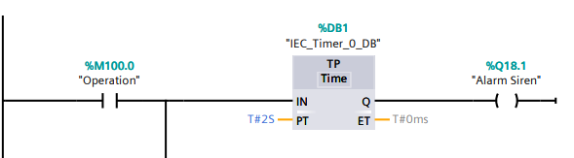
Figure 5 - Network 3 – Alarm Siren
To operate the conveyor system TON (delay timer) function is used, which will delay the Q output by the PT duration. This will start when the input changes to TRUE. For example, the ‘Belt Conveyor (2m) 0’ will start after the time delay of 2 seconds (Figure 6). The ET output is reset as soon as the signal state at the input changes to FALSE. The same applies to all other conveyors including weight conveyor and pop-up wheel sorter.
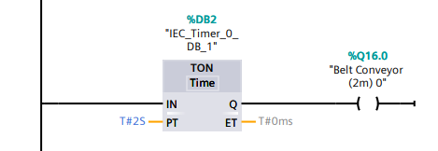
Figure 6 - Conveyor Operation

Network 4 – Stack Light Control
There are four stack lights located on the system, one at box loading and one at every box unloading station. When the ‘Alarm Siren’ is TRUE all four stack lights will turn Yellow (Figure 7). When ‘Loading Conveyor (2m) 1’ is TRUE all four stack lights will turn Green (Figure 8) or if 0 the stack lights will turn red (Figure 9).
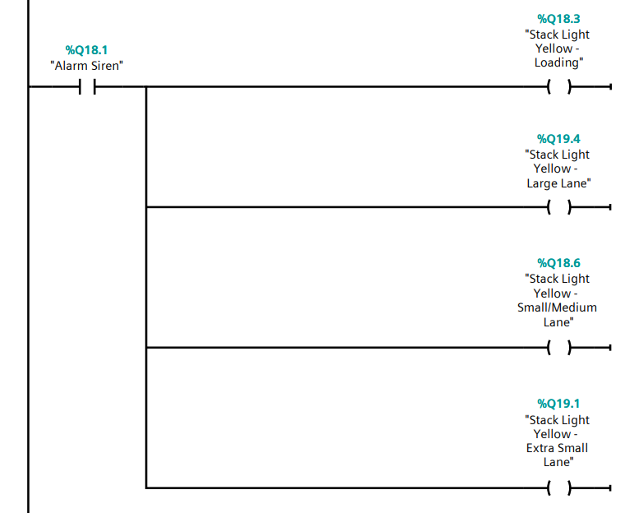
Figure 7 - Stack Light Yellow

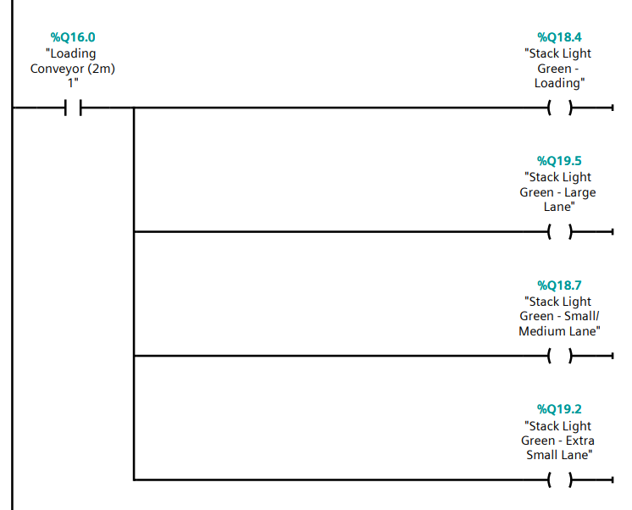
Figure 8 - Green Stack Light
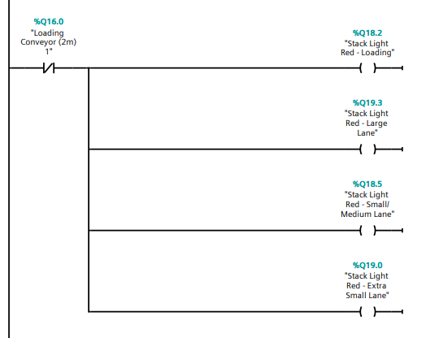
Figure 9 - Red Stack Light

Network 5 - Activate Large Box Pusher
This network is used to activate the first pusher on the conveyor system, which separates the large boxes (Figure 10). It is triggered by an infrared sensor set to the large box height (Figure 11). When the TON function is used with the 'Sensor - Large Size Sort' set to TRUE, there is a 500-millisecond delay (PT) to allow the box to align with the pusher, after which the pusher activates and large boxes progress down the large box line.
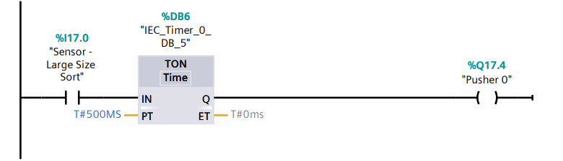
Figure 10 - Activate Large Box Pusher
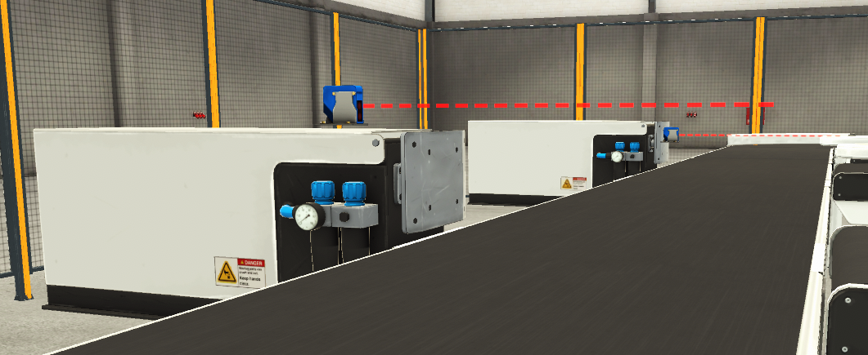
Figure 11 - Box Pusher 0 and Large Box Sensor

Network 6 - Activate Small & Medium Box Pusher
Network 6 performs the same functions as Network 5, but it activates the second pusher that separates the small and medium boxes. If the sensor is set to be activated by the small and medium box height, the pusher will activate, and the small and medium boxes will progress down the dedicated box line (Figure 12).
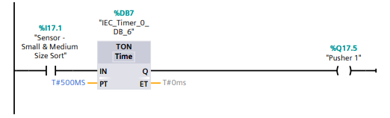
Figure 12 - Activate Small & Medium Box Pusher

The extra small boxes will continue to move down the conveyor after passing through both pusher sections without activating the sensors (Figure 13).
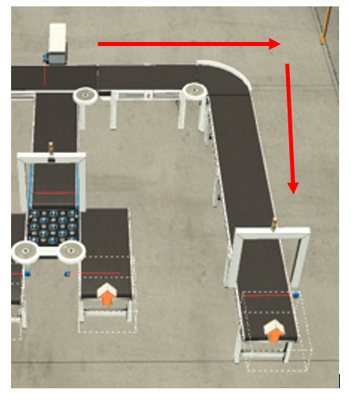
Figure 13 - Extra Small Box Line

Network 7 & 8 – Box Weighing Operation
A weight conveyor is used to distinguish between small and medium boxes. When the boxes pass down the small medium box line, the 'Sensor - Small & Medium Alarm Counter' is activated, and when TRUE using output (R) on 'Conveyor Scale (+),' the conveyor scale resets, and an off-timer delay of 500MS is added using the TOF function to allow the box to move to the centre of the scale, and the conveyor scale is set (S) for 420ms using the TON function. After that, the TON, TP, and MOVE functions are used to output to the 'Digital Weight Display' for 400ms, after which the 'Ready' tag is set (S) (Figure 14 & Figure 15).

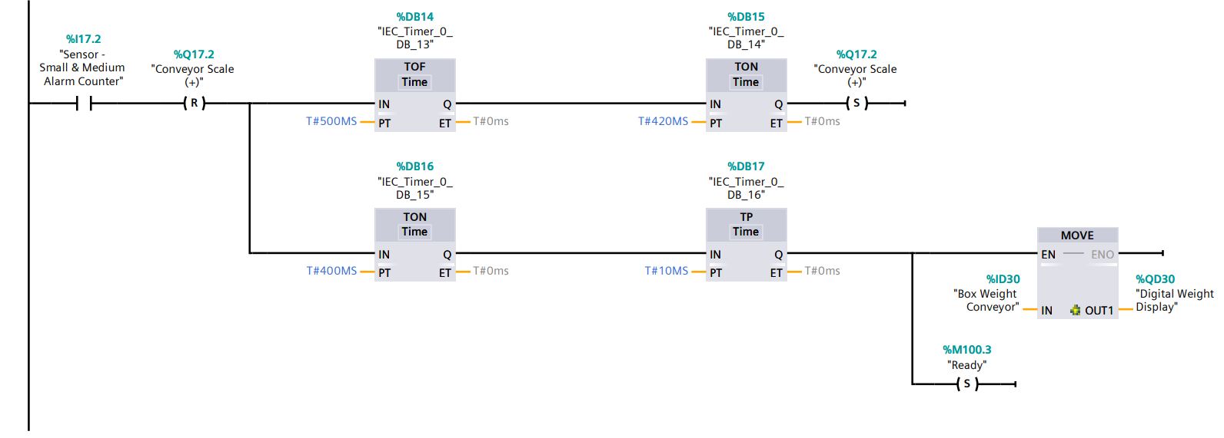
Figure 14 - Box Conveyor Operation

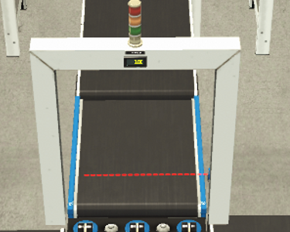
Figure 15 - Conveyor Weight Scale & Digital Weight Display

Network 9 - Weight Payload Sorter
The payload wheel sorter sorts the boxes by weight output, determining whether the box is small or medium using the 'Ready' tag. If the box weighs between MIN 3kg and MAX 4.25kg, the 'Pop Up Wheel Sorter (Left)' will be set (S) and the 'Pop Up Wheel Sorter (Right)' will be reset (R), indicating that all small boxes will be moved to the left conveyor. If the box weighs between 4.5kg and 5.5kg, the 'Pop Up Wheel Sorter (Right)' will be set (S) and the 'Pop Up Wheel Sorter (Left)' will be reset (R), indicating that all medium boxes will be moved to the right conveyor (Figure 16 & Figure 17).
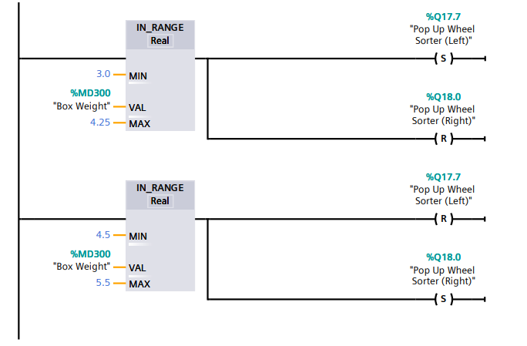
Figure 16 - Weight Payload Sorter Operation
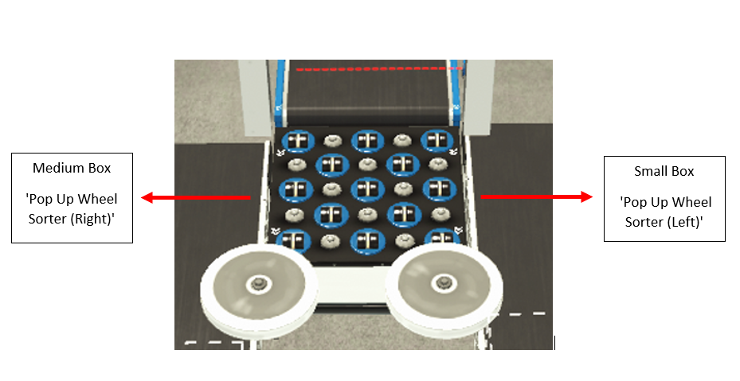
Figure 17 - Payload Sorter Right and Left

Network 10 to 14 – Box Counting
The logic for the box counting operation is covered in Networks 10 to 14. Network 10 is used to count the total number of boxes loaded through the emitter (Figure 18). Using the ‘CTU’ function when ‘Sensor-Loading Counter’ is TRUE the ‘Total Box Count’ (CV) will increment by one each time the logic is set to TRUE. To reset this counter, the ‘Reset All Counters’ tag will be used with the function (R) (Figure 19).
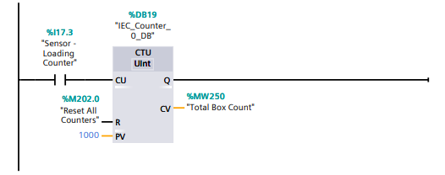
Figure 18 - Network 10 Total Box Count
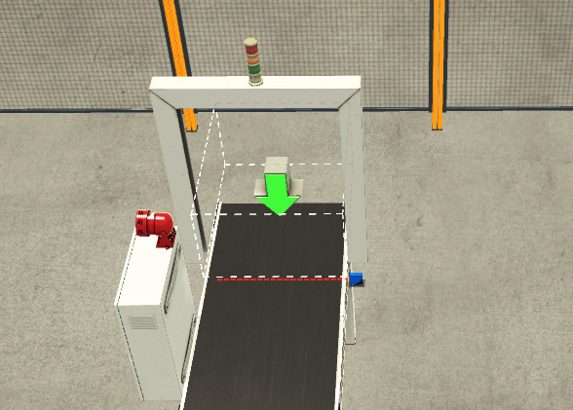
Figure 19 - Loading Box Emitter and Total Box Count Sensor

The same logic is used in networks 12-14 to count the total count for each box size by using the sensor located before each box remover at each box line (Figure 20 & Figure 21).
Network 11 large box counter also covers the logic for the large box conveyor error, which is covered in section 6.1.

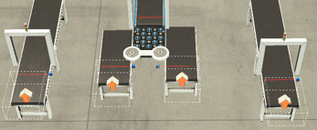
Figure 20 - Total Box Count Sensors and Removers for all Box Sizes

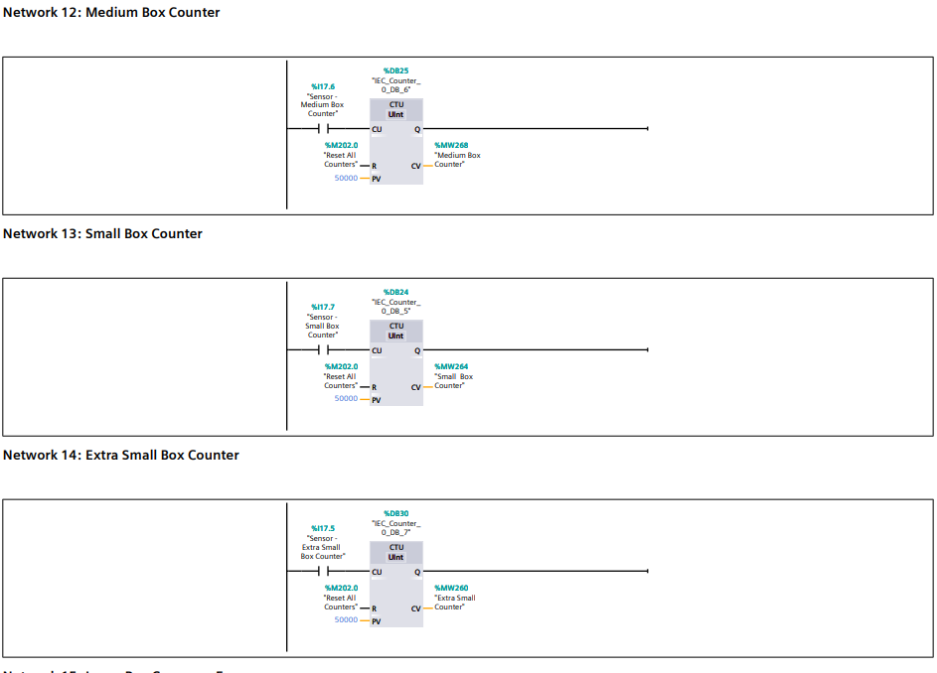
Figure 21 - Network 12 to 14 Total Box Counting

Ladder Logic Program – Warnings and Alarms
As there is a possibility of conveyor failures, such as boxes becoming stuck or falling off the conveyer, these potential occurrences have been factored into the logic.

Network 11 & 15 – Large Box Errors
Network 11 is responsible for highlighting all large box errors between the first pusher and the large box remover (Figure 23) using the 'CTUD' function in line 1 and the 'CTU' function in line 2. The 'CTUD' function counts up and down, so when 'Pusher 0' is TRUE, the function counts up (CU), then counts down using the 'Sensor - Large Box counter' tag. If the counters do not align by the maximum count number determined by the operator (see HMI section 7.3), the output (CV) tag is 'Large Box Errors’ (Figure 22).
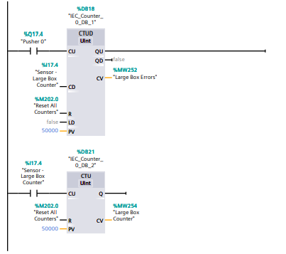
Figure 22 - Large Box Counter
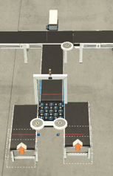
Figure 23 - Large Box Error Section
If there are any large box errors, Network 15 is set to generate a warning or alarm. If the 'Large Box Errors' equal or exceed the 'Large Box Warning set' (set by the operator), the output is 'Warning 1'. Line 2 applies the same principle, but at a higher value, and output an alarm labelled 'Alarm 1' (Figure 24).
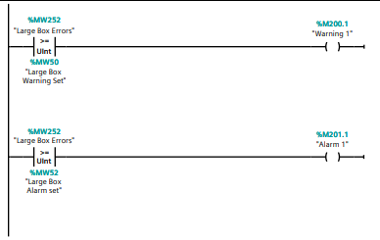
Figure 24 - Large Box Counter Warning & Alarm Logic

Network 16 & 17 – Small & Medium Box Errors
The small and medium box errors are programmed the same as the large boxes using the second pusher and the sensor prior to the weight conveyor outputting ‘Warning 2’ and ‘Alarm 2’ tags (Figure 25).
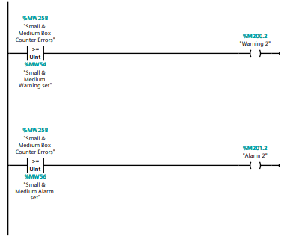
Figure 25 - Small & Medium Box Warning & Alarm Logic

Network 18 & 19 – Warning & Alarm Flags / Master
In order to initiate a warnings and alarms on the HMI but also an ‘Alarm Master’ tag has been created. If the system goes into Alarm mode, the ‘Alarm Master’ will be triggered, and the conveyor system will stop (Figure 26).
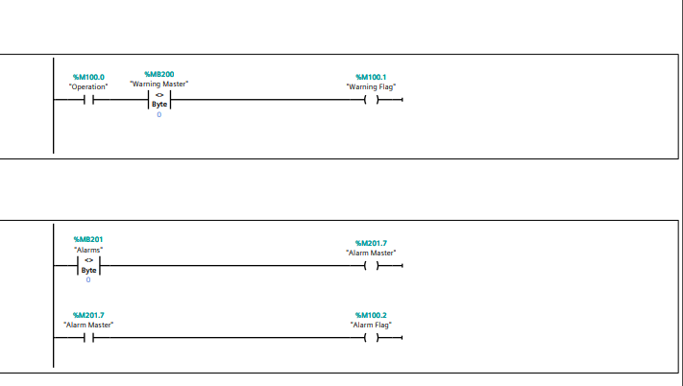
Figure 26 - Warning & Alarm Flags / Master Logic

Network 20 – Safety Door Open Alarm
Safety fencing and doors are placed around the conveyor system. Network 20 is programmed that if the either the entrance or exit door is open it will trigger an ‘Alarm 3’ or ‘Alarm 4’ tag and will be displayed on the HMI (Figure 27).
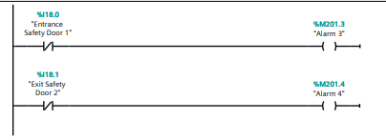
Figure 27 - Safety Doors Open Logic

HMI Control
Human machine interfaces (HMIs) are used as an operator control panel to PLCs. It allows the operator to start and stop processes, adjust settings, and other functions required to monitor and interact with a process. The HMI for this process consists of 3 screens, Root Screen, Engineering Screen and Warning and Alarm Screen. The HMI screens are set up within the TIA 16 software system and buttons/icons are linked to tags within the program logic. This section looks at the screens and the tags used from the logic.

Root Screen
The root screen acts as the main overview screen for the operator. The operator can start and stop the process, monitor total box counts, box errors, and stop the process in the event of an emergency (Figure 28).
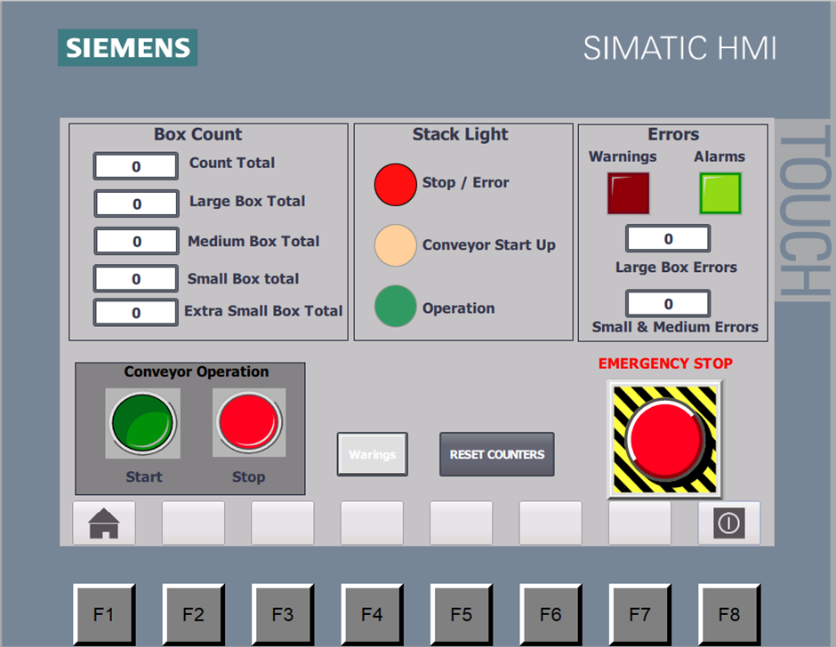
Figure 28 - Root Screen

Conveyor Operation
The start and stop buttons on the HMI will allow the operator to start and stop the process using logic from Network 2 (Figure 29).
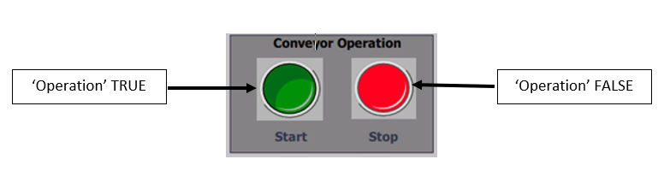
Figure 29 - Conveyor Operation Buttons

Box Count
This displays the box count totals taken from the box count tags in networks 10 to 14 for each size using (Figure 30).
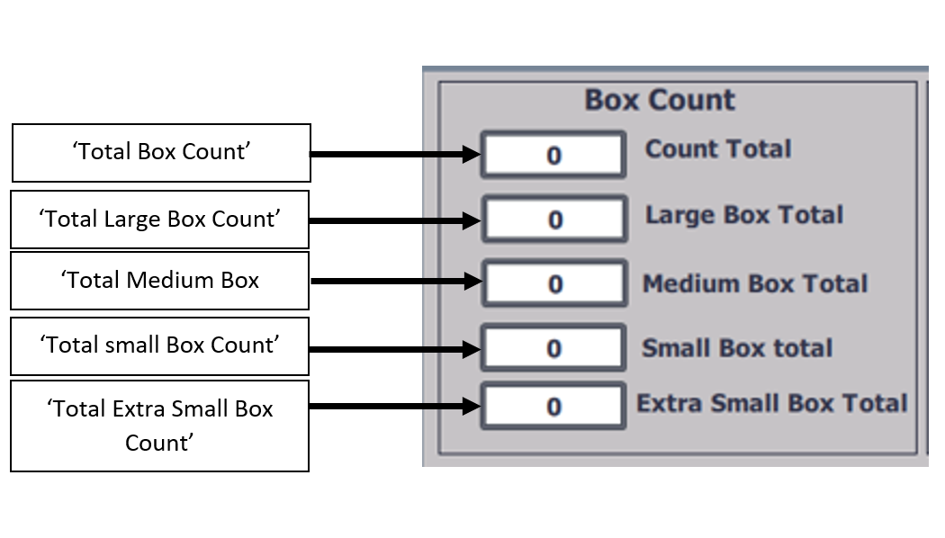
Figure 30 - Box Count Visual

Stack Lights
This mirrors the stack lights that are located on the conveyor system. Three HMI tags were created and linked to the loading stack lights in Network 4 (Figure 31).
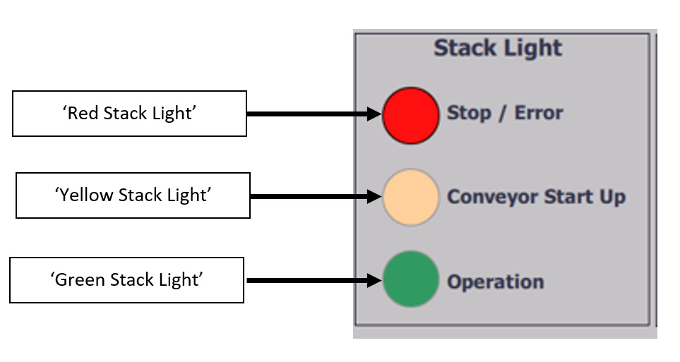
Figure 31 - Stack Light Visual

Errors
The warning and alarm indicators are used to notify the operator of a system error using tags created in network 19. When in warning mode, the conveyor will continue to run, but if an alarm is triggered, it will stop. The box errors display’s the number of box errors created in networks 11 through 17 (Figure 32)
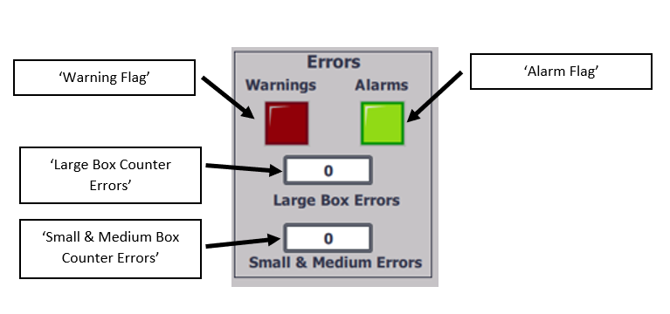
Figure 32 - Error Visual

E-Stop Button
The E-Stop button is there for the operator to stop the conveyor in an emergency (Figure 33).

Figure 33 - E-Stop Button

Reset All Counters
The reset all counter button will reset all counters within in the box counting networks 11-14 using the ‘Reset All Counters’ tag (Figure 34).
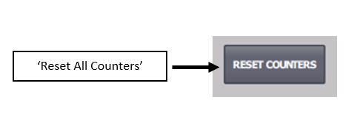
Figure 34 - Reset Counters Button

Warning & Alarm Screen
The warning and alarm screen (Figure 35) shows the operator if there are any warnings or alarms initiated on the system by turning red. The warning and alarm tags have been created within HMI tags and used within the logic as outputs.
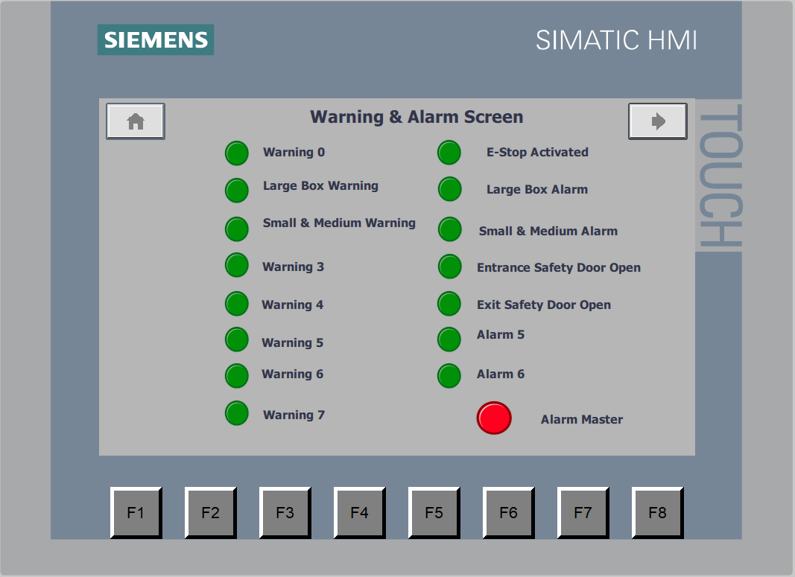
Figure 35 - Warning & Alarm Screen

Engineering Screen
The engineering settings screen (Figure 36) allows the operator to insert the warning and alarm limits for box errors programmed in networks 15 and 17. Using the 'Large Box Warning Set' and 'Small & Medium Warning Set' tags, if any of the limits equals or exceeds the number entered, warning and alarm lights will be highlighted on both the root and warning and alarm screens. A reset all counters and a master reset button were also included on this screen.
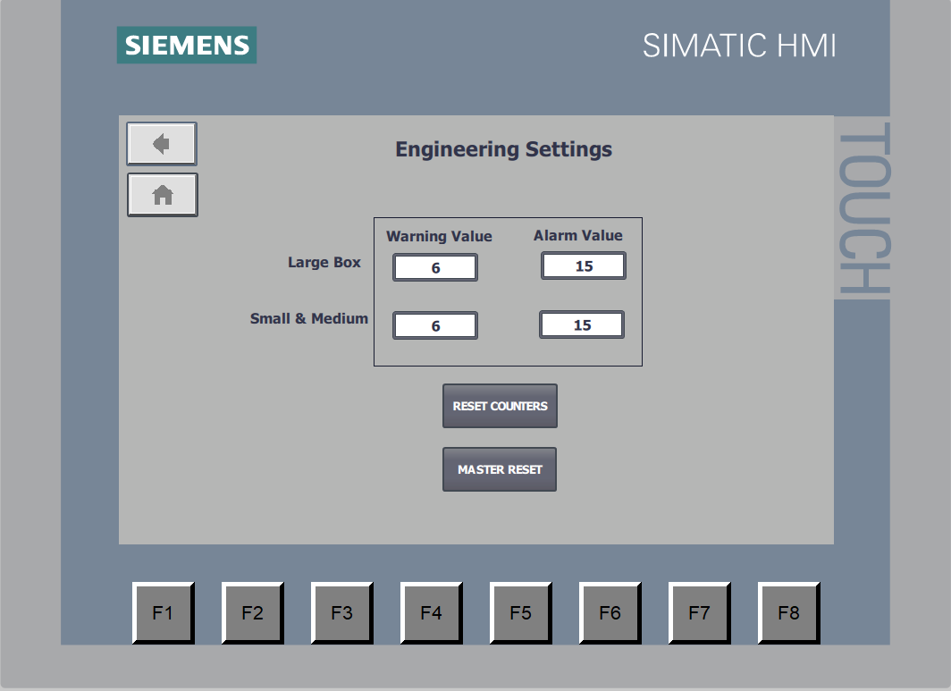
Figure 36 - Engineering Screen

Works Cited
Allen-Bradley. (2022, July 17). MicroLogix 1200 Programmable Controller - User Manual. Retrieved from Rockwell Automation: https://literature.rockwellautomation.com/idc/groups/literature/documents/um/1762-um001_-en-p.pdf
Hardware Comparison: Allen-Bradley vs Siemens PLCS. (2022, July 148). Retrieved from Do Supply INC: https://www.dosupply.com/tech/2020/10/16/hardware-comparison-allen-bradley-vs-siemens-plcs/
Muthukrishnan, V. (2022, July 28). Programmable Logic Controllers (PLCs): Basics, Types & Applications. Retrieved from Electrical4U: https://www.electrical4u.com/programmable-logic-controllers/#:~:text=PLC%20are%20divided%20into%20three,output%2C%20and%20Triac%20Output%20PLC.
Parr, E. A. (1998). Industrial Control Handbook. Industrial Press.
Siemens. (2022, July 17). SIMATIC S7 S7-1200 Programmable controller - Technical Specifications. Retrieved from Siemens: https://support.industry.siemens.com/cs/mdm/109759862?c=94829908363&lc=en-GB
Siemens vs. Allen-Bradley PLCs: One Engineer’s Perspective. (2022, Jul 18). Retrieved from The Automation Blog: https://theautomationblog.com/siemens-vs-allen-bradley-plcs-one-engineers-perspective/

