Design of distributed database based on abertware art center case
Shengqing Pei

Abstract

With the advent of the Internet era, most enterprises have made great changes in the management of data. From the beginning of the text entity records to the records of an object-oriented database system, the management mode of most enterprises has changed, from the complex and huge amount of data to the quick and convenient search, addition and deletion, reducing a lot of human and material resources, This paper takes the data management of a theater in Swansea as an example to show the fast and convenient data management model brought by SQL Server data-base., performance management system designed for distributed client / server computing. It realizes the organic combination with Windows NT and provides a transaction based enterprise information management system. Its dominating features are as follows: high performance design, can get the utmost out of the advantages of Windows NT. Senior management management, support Windows graphical management tools, support local and distant management of system management and configuration. Strong transaction processing function, using various methods to ensure the integrity of data. It props up symmetric multiprocessor architecture, stockpile procedure, and has autocephalous SQL language. SQL server furnish an outstanding database platform to user, developers and system with its built-in data replication function, formidable management tools, close integration with Internet and open system structure.

Catalogue
Chapter one SQL database and NoSQL database
1.1 SQL database
1.1.1 Preponderance of SQLdatabase...............................................................
1.1.2 Faultiness of SQL database ...................................................................
1.1.3 Storage procedure of SQL database ....................................................
1.2 NoSQL database
1.2.1 Preponderance of NOSQLdatabase........................................................
Chapter TWO Distributed Database Design
2.1 System definition
2.2 Key Features
2.2.1 Independence and transparency...............................................................
2.2.2 Replication transparency.........................................................................
2.2.3 Easy to expand........................................................................................
Chapter TTREE Design of distributed database based on abertware art center case
3.1 Table design
3.2 Design of constraints
3.3 Data of input
3.4 Data query verification
Chapter Four Summary
4.1 Project summary

Chapter one SQL database and NOSQL database

1.1 SQL database

SQL is an ANSI touchstone computer tongue, used to access and operate database system. SQL statements are used to stockpile and renewal data in the database. SQL can work with database item, such as MS Access , MS, Oracle, SYBASE and other database systems.Unfortunately, there are many different versions of SQL, but in order to be compatible with the ANSI standard, they must support some key index term (such as elect, revocation, insert, etc.) in a similar way.
    - Preponderance of SQL database

Advantages of relational database: 1. Keep the consistency of data (transaction processing) 2. Because of the premise of normalize,at the expense of data update is very small (there is basically only one same field) 3. It can carry out complex queries such as join. The biggest advantage of relational database is to keep the consistency of data. 4.SQL is easy to learn. Sentences are all made up of highly descriptive English words, and the number of these words is small. 5.Although SQL looks very easy, it is actually a strong language, flexible use of its language elements, can be very intricacy and progressive database operations.
    - Faultiness of SQL database

Disadvantages of relational database: not good at processing. 1. Write a large number of data processing. 2. Make index or schema changes for tables with data updates. 3. When the field is not fixed. 4. The simple query needs to return the result quickly.
    - Storage Procedure of SQL database

The mainly obtain information from system table, complete the management of the database server, provide help for the system administrator, and provide convenience for the user to view the database objects. The system stored procedure is located in the database server, and uses sp_ At the beginning, the system is defined in system defined and user-defined database, and it is not necessary to add the database qualified name before the stored procedure when calling. For example: SP_ Rename system stored procedure can modify the name of the user created object in the current database stored procedure can display the text information of rules, default values or views. A lot of management work in SQL server is completed by executing system stored procedure, and a lot of system information can also be obtained by executing system stored procedure.Some system stored procedures can only be used by system administrators, while some system stored procedures can be used by other users through authorization.Custom stored procedure means that users use t_ SQL statement, in order to achieve a specific business needs, t_ SQL statement collection, CLR stored procedures refer to references Microsoft.NET Method stored procedures of framework common language can accept and return parameters provided by users. They are implemented as public static methods of classes in. Net framework assembly.

NOSQL database
    - Preponderance of NOSQL database
1. Flexible data model : only need to add more columns without data migration.
2. Automatic slicing : Because the relational database stores structured data, it usually adopts vertical expansion, The solution to this problem is horizontal expansion, that is, adding servers instead of expanding the processing capacitywithout additional operations on the application.
3. Auto copy : NOSQL database supports automatic replication. Therefore, when multiple users access the same data, user requests can be distributed to multiple servers. At the same time, when a server fails, the data of other servers can be backed up, that is, the distributed cluster of NOSQL database has the ability of high availability and disaster recovery.

Chapter two Distributed Database Design

2.1 System definition

Distributed database system is developed on the basis of centralized database system. It is the combination of computer technology and network technology. The distributed database system is suitable for the departments with scattered units. It allows each department to store its commonly used data locally and use them locally

2.2 Key Features

2.2.1 Independence and transparency
Data independence is one of the main goals of database methods. Distributed transparency means that users do not have to be anxious about the reasonable partition of data, the particulars of data real position distribution, the consistency of duplicate copies (redundant data), and the data model supported by the database on local sites. user's application program is written as if the data is not distributed. When the data is moved from one site to another, it is not necessary to rewrite the application program. When the duplicate copies of some data are added, it is not necessary to rewrite the application program.
2.2.2 Replication transparency
Users do not need to care about the replication of the database in each node of the network, and the update of the copied data is automatically completed by the system. In the distributed database system, the data of one site can be copied to other sites for storage, and the application program can use the data copied to the local to complete the distributed operation locally, so as to avoid data transmission query efficiency update operation replicated , it is necessary to involve the update of all replicated data.

2.2.3 Easy to expand
In most mesh surroundings, a sole database server not meet the needs of users. As the server software supports transparent horizontal expansion, manifold servers can be habituated to further distribute data and share conducting tasks.

Chapter TTREE Design of distributed database based on ABERTWARE art center case
In the model of this case study, 10 tables will be used to jointly reserve the venue of the theater, hold amateur and professional level drama, performance and dance competitions, arrange performance and marketing, sell tickets they like to interested customers, and reserve seats for future performances. The tickets will be distinguished according to the difference between professional and non professional, and the specifications of the theater will also be determined The manager of the company can get the booking information, booking information and ticket information from the database.
In the era of big data, if the database can achieve a good integration, especially the integration of macro data and micro data, then the use of big data technology for a series of analysis of these data is effective, and the advantages of the era of big data will be fully utilized. Through data analysis, we can draw a variety of reasonable conclusions, so that the behavior of each department is beneficial to both sides It is advantageous. The integration of macro database and micro database can also further mine the nature of data, delimit the scope of application according to the nature of data, and improve the correct understanding of data. If the macro data and micro data can not be integrated, there will be data mismatch. The conclusion drawn from the macro data analysis and the conclusion drawn from the micro data analysis will eventually be inconsistent, which will make the macro department and micro department behavior can not achieve the maximum utility, and there will be contradictions between various decisions. The decision-making of the state sector is not conducive to the enterprise sector, and the decision-making of the enterprise sector can not cater to the preferences of the resident sector. All kinds of decisions that seem to be obtained through strict data and empirical analysis may eventually lead to inefficient or even ineffective resource allocation. At present, many industries in our country still have the problem of "information island", such as the credit industry and some other "data island". Data fusion and sharing can solve these problems and bring opportunities for the development of the industry

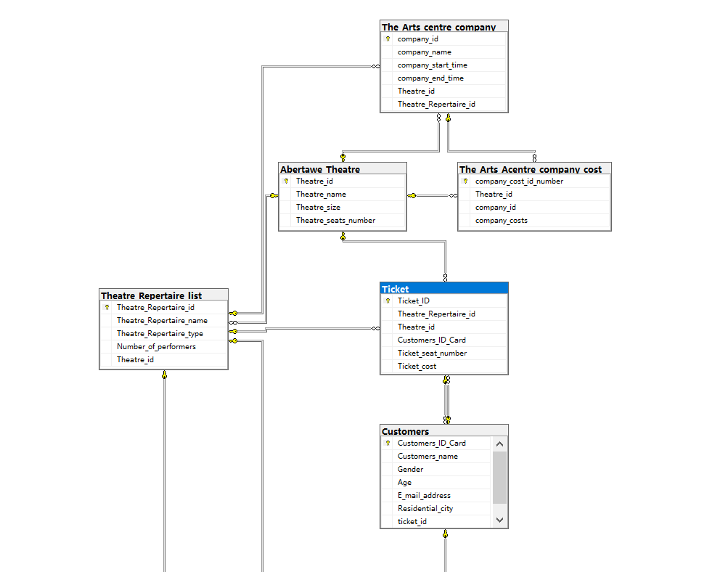

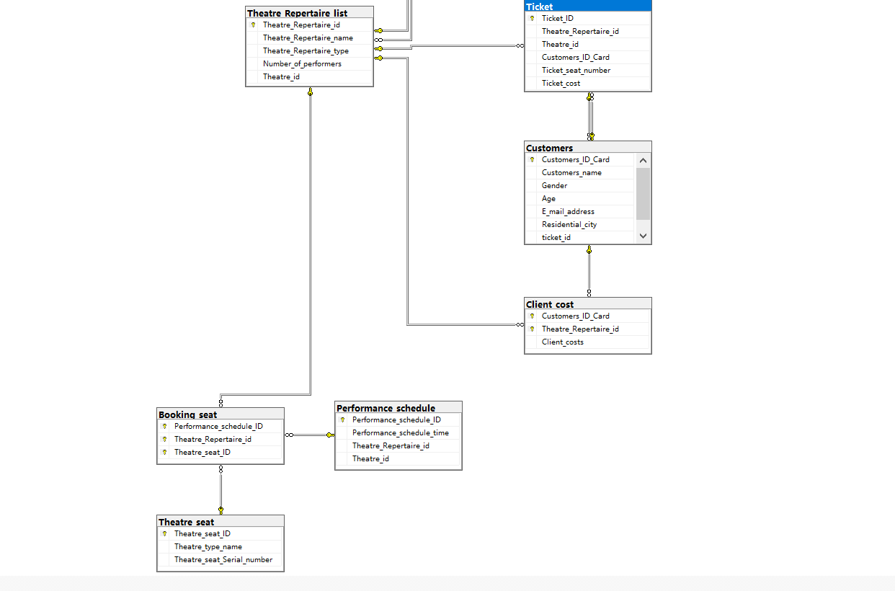

3.1 Tabulation design

In order to come across the demand of the theater, the database will create 10 data tables, including 9 primary keys, three groups of joint primary keys, and multiple foreign key constraints. Foreign key constraints affect the worth of each data in the form. In order to come across the demand of the database be normalized to 3NF, customers can book tickets that are not registered as activities.
Part of the code is shown below:
CREATE TABLE Booking_seat
(Performance_schedule_ID int,
Theatre_Repertaire_id int,
Theatre_seat_ID int,
primary key(Performance_schedule_ID ,Theatre_Repertaire_id ,Theatre_seat_ID)
)
CREATE TABLE Theatre_Repertaire_list
(Theatre_Repertaire_id int primary key,
Theatre_Repertaire_name varchar(120),
Theatre_Repertaire_type varchar(30),
Number_of_performers int,
Theatre_id int
)
CREATE TABLE Customers
(Customers_ID_Card int primary key,
Customers_name varchar(60),
Gender varchar(60),
Age varchar(20),
E_mail_address varchar(100),
Residential_city varchar(80),
ticket_id int
)
CREATE TABLE Performance_schedule
(Performance_schedule_ID int primary key,
Performance_schedule_time datetime,
Theatre_Repertaire_id int,
Theatre_id int
)
CREATE TABLE Theatre_seat
(Theatre_seat_ID int primary key,
Theatre_type_name varchar(60),
Theatre_seat_Serial_number varchar(60)
)
CREATE TABLE The_Arts_Acentre_company_cost
(company_cost_id_number int primary key,
Theatre_id int,
company_id int,
company_costs int
)
--Abertawe Theatre
CREATE TABLE Abertawe_Theatre
(Theatre_id int primary key,
Theatre_name varchar(40),
Theatre_size varchar(40),
Theatre_seats_number int
)

3.2 Data of input

insert into Abertawe_Theatre values('1001', 'The main auditorium ', 'big', '550')
insert into Abertawe_Theatre values('1002', 'Dylan 1 ', 'small', '60')
insert into Abertawe_Theatre values('1003', 'Burton 2 ', 'small', '160')
insert into Customers values('34082', 'JACK ', 'Male', '20','1010616058@qq.com','Edinburgh','2001')
insert into Customers values('52642', 'Charlie ', 'Male', '19','2050615808@qq.com','Belfast','2002')
insert into Customers values('45821', 'James ', 'Female', '26','3650565008@qq.com','Birmingham','2003')
insert into Customers values('14524', 'William ', 'Male', '30','1234623508@qq.com','London','2004')
insert into Customers values('14554', 'Edward Adam Davis ', 'Male', '26','8532523508@qq.com','Cardiff','2005')

3.2 Design of constraints

There are six constraint types: 1. Primary key; 2. Foreign key; 3. Unique; 4. Not null; 5. Check; 6. Default. At the request of abertware Art Center, most of the constraints are used to constrain the data in the database, as shown in the following code:
alter table The_Arts_Acentre_company_cost
add constraint FK_Bcompany_id foreign key(company_id)
references The_Arts_centre_company(company_id)
alter table The_Arts_Acentre_company_cost
add constraint FK_ATheatres_id foreign key(Theatre_id)
references Abertawe_Theatre(Theatre_id)
alter table Booking_seat
add constraint FKPerformance_schedule_ID foreign key(Performance_schedule_ID)
references Performance_schedule(Performance_schedule_ID)
alter table Booking_seat
add constraint FKGTheatre_Repertaire_id foreign key(Theatre_Repertaire_id)
references Theatre_Repertaire_list(Theatre_Repertaire_id)
alter table Booking_seat
add constraint FKTheatre_seat_ID foreign key(Theatre_seat_ID)
references Theatre_seat(Theatre_seat_ID)

3.2 Data query verification

Step 1: the application sends the query SQL statement to the server for execution
When we execute SQL statements in the data layer, the application will connect to the corresponding database server and send the SQL statements to the server for processing.
Step 2: the server parses the SQL statement of the request
1. SQL plan cache. Friends who often use query analyzer probably know the fact that it takes a very long time for a query statement to run for the first time, but if you run the same statement immediately or within a certain period of time, you will return the query results in a very short time.
2. After the syntax is consistent, it starts to verify whether its semantics are correct, for example, whether the database objects such as table name, column name, stored procedure and so on really exist. If it is found that there is one that does not exist, it will report an error to the application and end the query at the same time.
3. The next step is to obtain the parsing lock of the object. When we query a table, the server will first lock the object, which is to ensure the data consistency. If the lock is not added, there will be data insertion at this time. However, because there is no lock, the query has read the record, and some inserts will be rolled back due to the failure of the transaction, which will lead to dirty reading.
Step 3: statement execution
After the SQL statement is parsed by the server, the server will know what the statement represents, and then the SQL statement will be executed.
There are two situations
If the data line contained in the query statement has been read to the data buffer, the server will directly read the data from the data buffer and return it to the application, which avoids reading from the physical file and improves the query speed.
If the data row is not in the data buffer, the record will be read from the physical file and returned to the application, and the data row will be written to the data buffer for next use.
As shown in the figure below:

1.select * from Abertawe_Theatre:
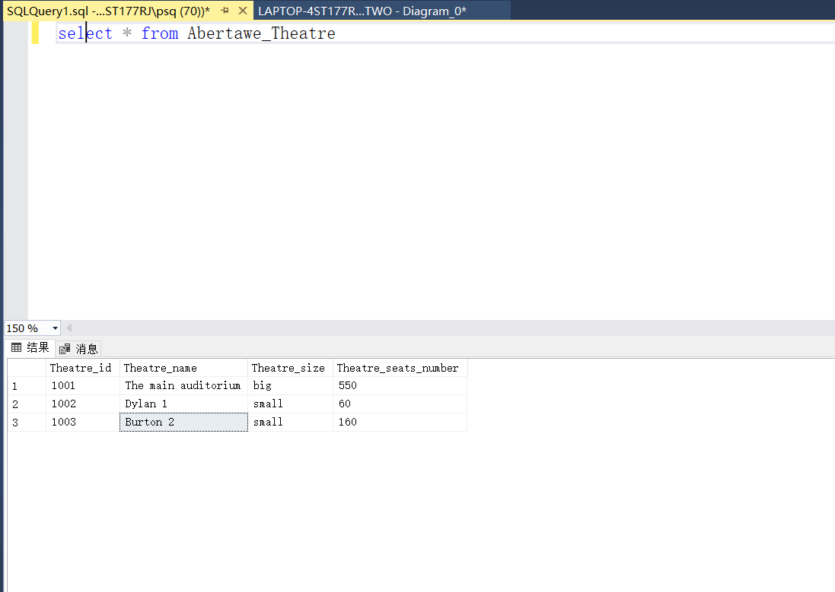

2.select Theatre_Repertaire_name, Theatre_Repertaire_type
from Theatre_Repertaire_list
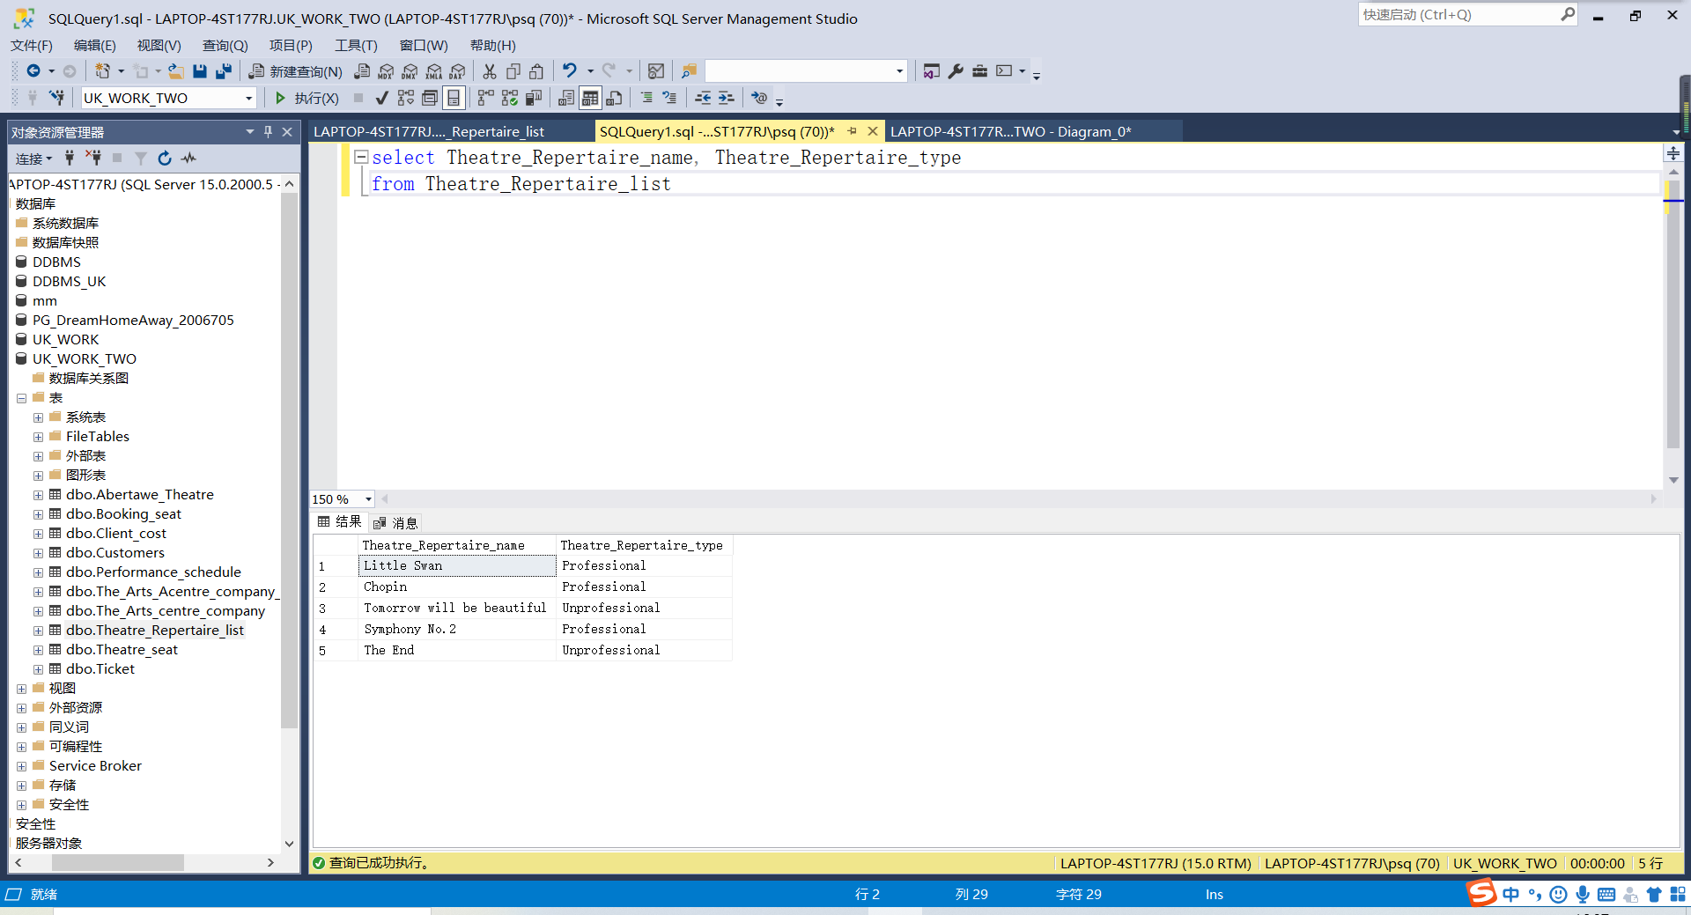

3.select *
from Theatre_seat
where Theatre_type_name like 'The main auditorium '

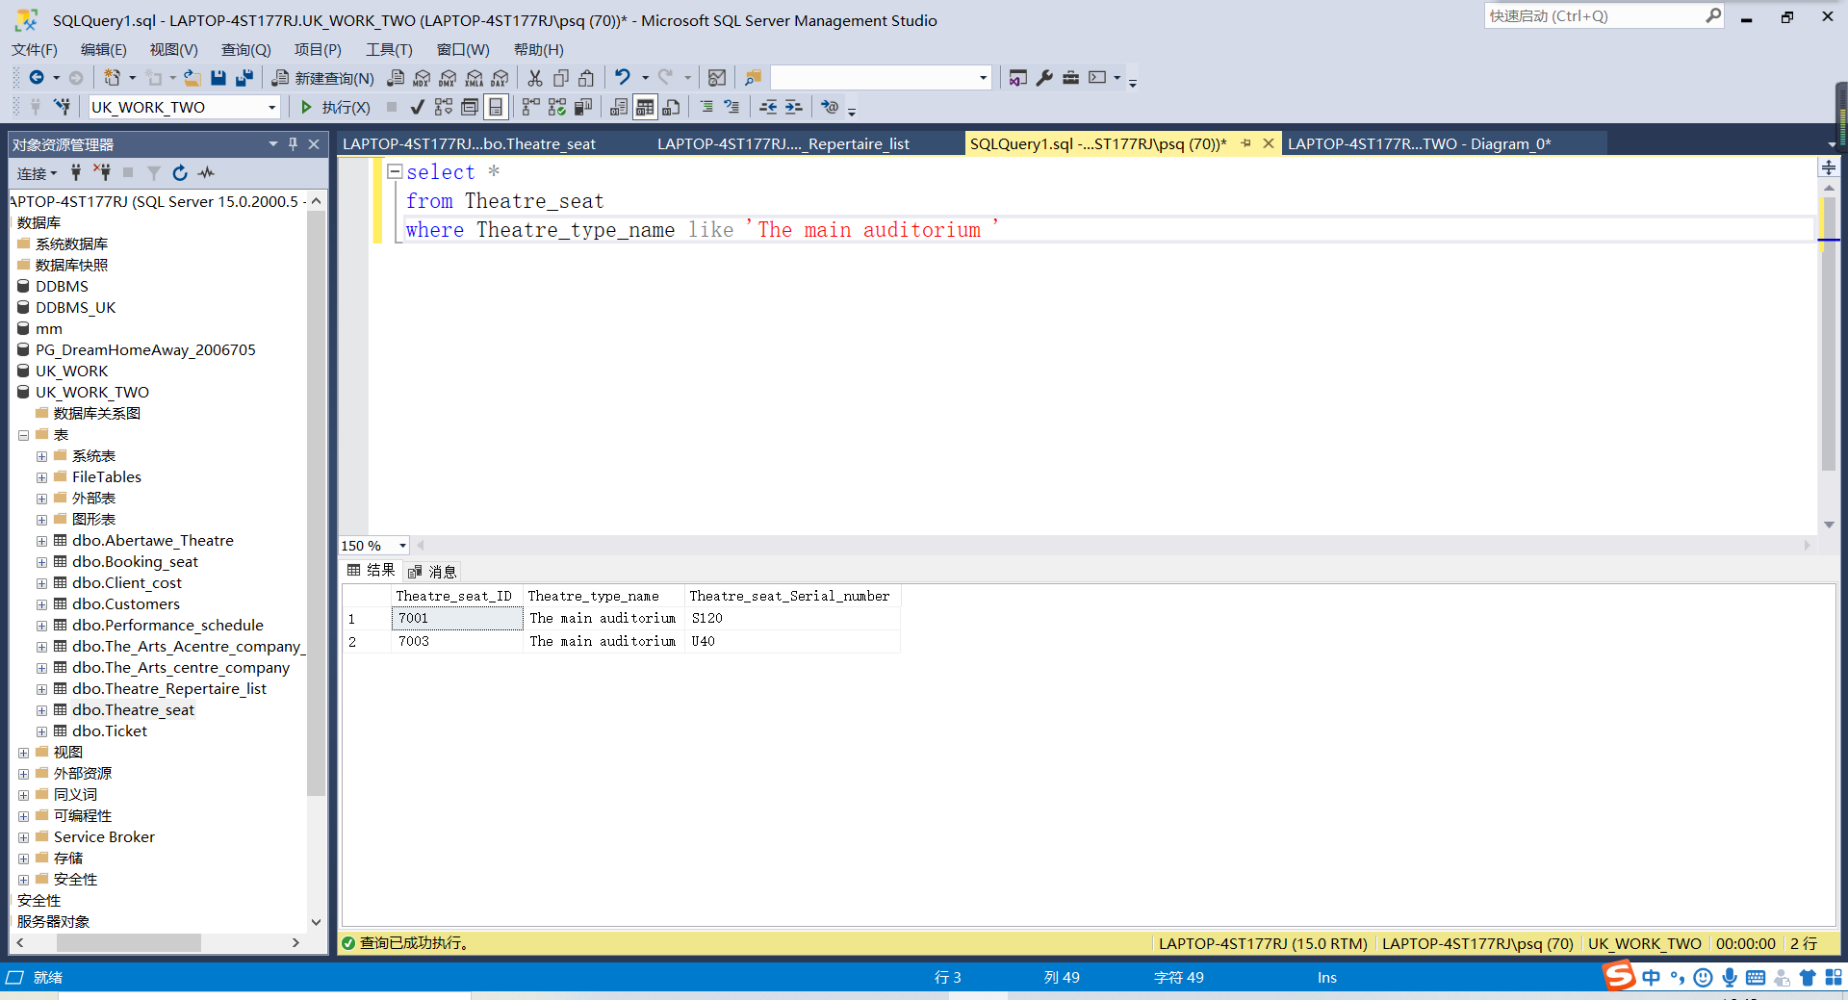

4.select *
from Abertawe_Theatre
where Theatre_seats_number between '0' and '200':
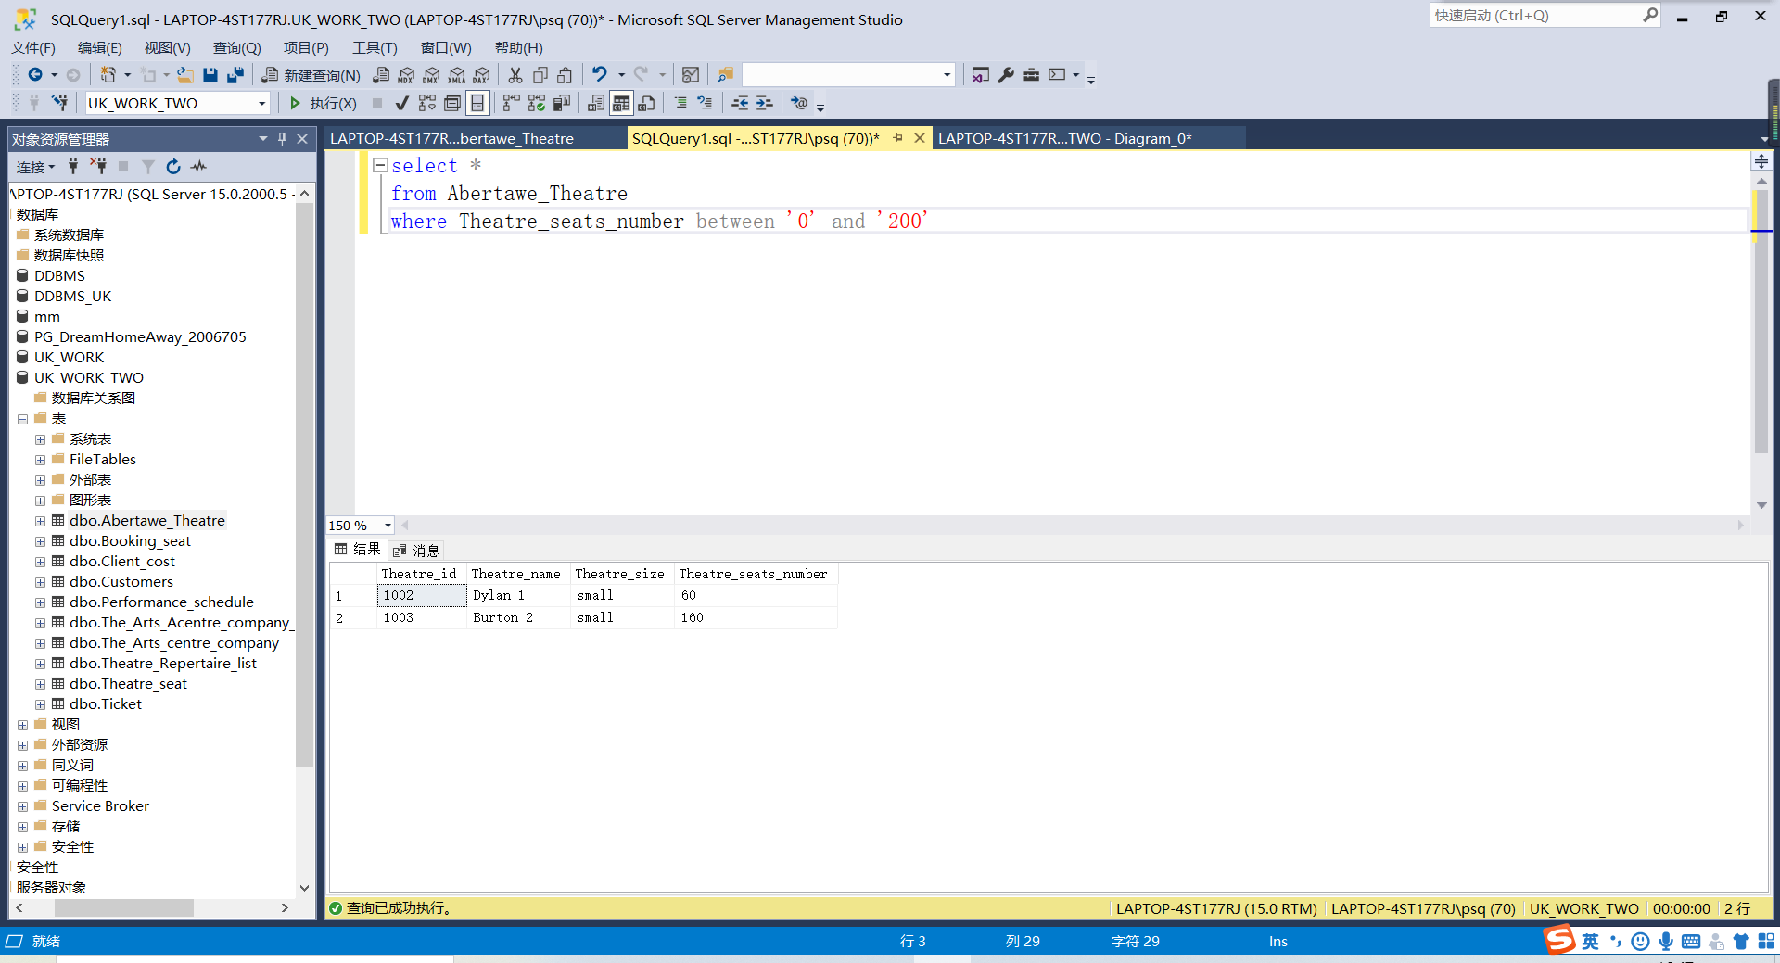

Chapter Four Summary

4.1 Project summary

The database has basically completed the requirements and ideas put forward by abertware Arts Centre, and generally completed the task requirements put forward by abertware Arts Centre. We hope that the database system can fully complete the tasks faced in the future, and the database has indeed brought convenient and safe data services to many companies.At the same time, the emergence of new technologies such as distributed technology also puts forward new requirements for database technology, so more and more non relational databases are used This kind of database is very different from the traditional relational database in design and data structure.In the history of database development, it has experienced three aspects of dWith the advent of the era of big data, the amount of information data is growing rapidly, the use of data is more and more frequent, and data analysis is becoming more and more important. Through data analysis, we can get insight into the macro policies of the country, the profitability of enterprises, and various personal preferences in daily life, which are closely linked and interact with each other. If the analysis of these data is accurate and effective, then all kinds of decisions from the national level to the individual level can be integrated with each other. Not only the enterprise department can maximize profits, but also the resident department can maximize welfare. From the perspective of the whole national level, it can achieve the optimal allocation of resources and maximize the utility of each department. However, on the other hand, it has high requirements for data, the accuracy of data and the matching between data play a very important role. including hierarchical database, online database and relational database, as well as the rapid development of database technology in various aspects.

References
- Yang Tao, Zhang Kuo, Zhao shumeng, et al. Discussion on the concept of "far" and "near" in the combination of far and near acupoints: determining the distance and near by Qi Street [J]. Liaoning Journal of traditional Chinese medicine, 2018,45 (8): 1618-1619
- Jiang Hui, Chen Yunfeng. Data mining and an association rule algorithm [J]. Computer and digital engineering, 2011,39 (6): 32-35
[3] Weiliang. Financial credit data sharing: Realistic Dilemma and future prospect. Credit information, 2019 (6): 14-19
[4] Luo Jianxiong, Feng Yulian. Thinking on the development and security of China's credit information industry in the era of big data [J]. Credit information, 2019 (6): 27-33
[5]Liu ziye. Introduction and Enlightenment of major domestic micro databases 〔 J 〕. China Statistics, 2018 (7): 35-37

