developing innovation and creativity for business advantage(bMSW6102_SWAN)
Bitabrata Chowdhury
1713201

Table of Contents

1.0 Introduction 2
2.0 - Main Finding 3
2.1 internal and external factor of the swot parallel to the organisation – 3
2.2 Types of Innovation 3
2.3 Models of innovation 4
2.3.1 open and close innovation 5
2.3.2 The innovation process 5
2.3.3 4P’s of innovation 6
2.4 Assessments of the Effectiveness – 6
2.4.1 Barriers and risk 6
3.0 Conclusion 7
4.0 Recommendation 7
5.0 Appendices 8
6.0 References 11

.

EXECUTIVE SUMMARY

This report is a study of how important innovation and creativity for business is prospective. How innovation and creativity can turn the entire project into a successful venture. Throughout the report, different types of tools for improving creativity and innovation will be discussed. The researcher will also bring an academic as well as a practical model to relate to the report.

In this context, the researcher will go through the number of research materials through which the skills that are needed to be a successful investor or a creative person can also be discussed.

Lots of different skills and academic material will be nurtured during the whole report which will help to understand the real target of what this report is trying to achieve. There will be some interesting learning for the research materials which will emphasise the importance of this report. While concluding the report the researcher will leave a substantial recommendation for the further development or innovative growth of the organisation

1.0 Introduction
While talking about an organisation that could be seen as a creative and innovative company, one organisation that stands out is Veolia, which is not only innovative in the sense that they are truly creative. Never been the environmental concern is so high as it is now, it is a concern that how we are losing to keep an ecological balance day by day, Veolia is a big name in the waste management control organisation which is trying to make the right ecological transformation day in day out.
The main purpose of Veolia is a mission which states to resourcing the whole world through the environmental service, they tend to do it through fighting the climate changes, treating the dangerous pollution, and optimizing resources. it’s a company that probably brought the ultimate creativity or innovation trying to bring out a product that can be used after waste management, energy management, and water management.
Veolia is first started in 1853 which is established on December 14 by imperial decree with two separate goal irrigation and water supply to the French town and cities, the major success came when CGE did sign a contract outside of France and it did reach another agreement for the wastewater treatment in 1884 in Reims. (The history of Veolia,2021)

2.0 - Main Finding

To start the discussion SWOT needs to be analysis and through swot the innovative opportunities of the organisation in this case “Veolia” can be discussed. To define SWOT which can be seen as a purposeful tool that is in given situation analysis to gather all the strategic basics from all different kinds of the channel. SWOT tries to find out the strength, weaknesses with the kind of opportunities and detecting the threats to create the alternatives strategically. (Pahl and Richter, 2007)

To start the main research about the Strength of Veolia is its financial recourses, how they collaborate with the suppliers, advance knowledge of waste management, they are unique in the sense that it is not only continuing human development by continuing to address the issue of economic, social and environmental but also dealing them as an individual whole issue. to critically evaluate SWOT, the purpose of the discussed organisation has to be taken into account. The creativity and innovation come from the transformation of the three factors and how it is handling. the strength lies in adopting the climate changes, sobriety in creating ways how to create a new product that will be useful to mother nature and can be successful in transforming the need of human beings. (Veolia Purpose,2021). Some of the main strength of the organisation is its creativity in the ways it is treating the pollution also, fighting the air pollution, water pollution, plastic pollution, decontaminating the soil and making unique ways to mold this situation to positivity, which will be helpful for human being well-being. The details of the SWOT analysis of Veolia could be found in the Appendices.

2.1 internal and external factor of the swot parallel to the organisation –

To discuss the internal and external factors of SWOT in the perspective of Veolia it can be seen as the outside factor that is responsible for the strength weakness, opportunities, and threats considered as the external factor and simultaneous the changes that affect those factors internally can be classed as an internal factor. Swot analysis can combine externally and internally to get a total effect of business as it can be suggested like there can be a choice for a huge enthusiastic worker or a unique product, which could be the strength, alternatively, it could be limited finance or non-exciting client, the threat could be a rival competition or a bigger budget banner, opportunities like an interested shareholder or an investor. (External and internal analysis for your marketing plan | nibusinessinfo.co.uk, 2021). In terms of the external factor Veolia environment, they are creatively trying to change the climate by reducing CO2 emissions, digital technologies that transform the cities, dealing externally with local authorities, handling the crisis management well organized. Ecological transformation is the key external factor as far as the external factor is concerned. internally also as a company, they are trying to manage the finance so that the risk-taking factor is less, and the money can be used in other places for further innovation. (Veolia homepage,2021).

2.2 Types of Innovation

According to Tim Berners lee, Innovation is serendipity, it is all about practicality. it is all about realistic creativity and how that is being used to do progress, all about making some creative new ideas useful which will be fruitfully in the future (Mckeown,2014) to define an innovation matrix it can be easily said that innovation Matrix is a way or process of visualizing how the different kind of process of innovation can be detected, which completely rely on what kind of aim is needed to obtain certain paraphilia. (Innovation matrix, Toolshare,2021)
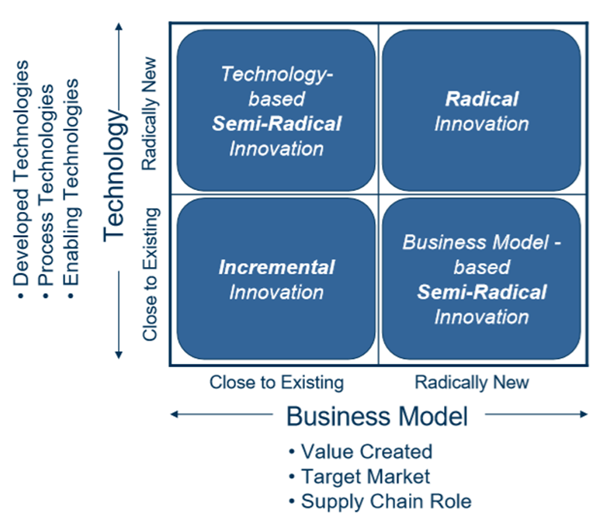

In the case of the innovation matrix and if it has to be used to pinpoint the innovation that has been taking places in Veolia it should be the technological innovation, it is a kind of innovation where a new kind of innovation or a much more improved product is developed through the process it can be looked like a process innovation or creation (Callegaro, 2021). In terms of the actual innovation, the latest innovation of Veolia is the. Air control covid, this is the latest ventilation monitor which controls the risk of spreading the Covid -19. This is undoubtedly the latest achievement in terms of the innovation of Veolia (Air control, Covid,2021). besides the applied matrix of innovation, Veolia is also nicely channelising the wastewater management, reusing the wastewater which is the lifeline for a lot of other water type resources. The type of innovation

Which is only possible by innovation and creativity? One of the major creativities is decontaminating the soil, which becomes bad and gets polluted, and brings a substantial danger to the human race and to the environment which in terms pollutes the entire population. Veolia gives the client treated soil and prevents them, smaller environmental footprint, excavating the contaminated soil and not reusing them again. (Soil remediation: a second life, 2021).

2.3 Models of innovation
To define the different kind of innovation process, it needs to be understood that hat will be critical discussed as the key element is the product which have to be emphasised properly here. Let’s first discussed about the open and close innovation

2.3.1 open and close innovation

Open innovation can be defined as the purposeful flows of knowledge both out and in to enhance the inside innovation and then expand the entire open market for the use of external innovation. it can be looked at the phase when knowledge is excepted for internal innovation to expand, open to any kind of open creativity. So basically, open innovation has two aspects one is “inside out “which is not very popular organisation wise, where unitised idea of the organisation is allowed to be used with other outside ideas, the other half which is the popular one “outside-in”- where brilliant ideas and technologies are brought inside the organisation for further innovation. (Chesbrough, 2011).

Close innovation can be described as the innovation, which is developed from years and years of practical and non-practical ideas inside the organisation, ideas which are gained by experiment over development and marketing, this is purely inside the organisation innovation process. the companies normally invest a large amount for the research and development to get to the know-how, which led to the internal innovation product and solutions within the organisation (Zapel ,2018)

Likewise in Veolia some of the innovation like getting the recycling process from the collection of garbage and transforming them into the ecological project by applying new improved technology is a complete close door affaire, Veolia spent lots of research and development to reach the point to bring up the changes in the environment which in turns does helping the human race ultimate to keep the ecological balance intact.

2.3.2 The innovation process

The innovation process is the path or the route through which the remaining or the existing knowledge changes into a marketable gamer changer or reasonable solution. The companies who are quite ahead of the market competition do get themselves with lots of research with upmarket innovation to keep ahead. (Francis, Bessant ,2006)

According to Tidd and Bassant the innovation process can be considered in four stages, as it goes, recognising the opportunities, finding the recourses then going on to develop the idea, and finally capturing the value. It can be simplified or critically emphasises as -

The first stage is observing the problem, why the problem arises, what is the cause, is this common in the market and how the problem can be made easier, like in the concerned organisation the biggest challenges is to make the community aware of the issues which are making the environment worsen day after day through various kind of pollution, that is the biggest challenges to make people aware and then proving them how to make waste management work, either it soil, water, plastic or any biodegradable produce and make the paradigm shift

The second stage – Making the solution or developing the solution, as in the case of Veolia searching for the right way to bring the ecological system back once the problem has been detected then doing the right things by making an innovative attempt to transform the waste material to a reusable product, that’s true needs, lots of research, technical hard work to bring out the creativity that works.

The third stage – It goes through lots of processes in Veolia to try out the innovation that has been thought or being developed have to be tried up. The solution which has been chosen to have to be tested out is the third stage to be practiced. Few innovative ideas that were tested out before it goes to be used in the market

The fourth stage – this stage can be termed as the implementation stage, as the product that is developed after a lot of research and development, ’s the time to implement the product in the market. like the Air control Covid ventilator monitor which is a tested out (Four-Step Innovation Process, 2021)

2.3.3 4P’s of innovation
The 4 p’s of innovation model was invented by John Bessant and Joe Tidd. Through this model, it clarifies how comprehensive the innovation is. the model itself focuses mainly on four major categories.
The product or service – what the organisation is offering the whole world.
The process – the way the product is being created and then it is delivered.
The position – to whom the product or the service is being rendered and what kind of explanation is being given to make it looks better.
The paradigm – sometimes the Paradigm is being called the business model. It is the thinking about the organisation. (Flixabout.com,2021)
The remarkable thing about the model is, it is a continuous process. It at times forces people to discuss the innovation and how much it is being innovated. it can also be learned while using the model where particularly the innovation focus has to be placed.
Likewise in the chosen organisation Veolia which generally offer recycling product to the consumers. it is one of its kind of organisation which is working on the improvement of the mother nature. Veolia is a company where innovation is used to the topmost ability to create something new which will be healthy to use. for example, the Via by Veolia is itself a group open program. The program has two main objectives, first is the innovative technical solutions that can do a world of good to the operating system what it is working on and the second one is all related to the growth of the business and what the organisation is interested to offer the customers. (VIA ,2021).

2.4 Assessments of the Effectiveness –
During challenging times like decision-making time, identifying the opportunities, detecting if the move is correct or not, or the given proposal or the chosen path will be right or not, it is not always choosing the pros or cons or the right or not. Force field analysis is a technique that can be taken to detect the risk is worth taking or not. The reason why this technique is a much better option than thinking about right or wrong is the point which it makes the ultimate decision by given points to each point with proper reasoning and hence its easy to choose the right action. (Mindtool.com,2021)

2.4.1 Barriers and risk
While refereeing to the force field analysis some of the barriers and risk that the concern organisation should be aware of when implementing the innovative opportunities which have been already been discussed are
• Lack of leadership as leading the innovation is the key to the success
• Thinking something for very short term which is not good for the organisation growth
• Collaboration is the key, lacking collaboration is a major set back
• Lacking in the focus, which is necessary to focus on the goal
• Lack of time – absolutely crucial to calculate the time while doing an innovative project
• Have to overcome the fear factor, if not the project will be underachieved.
• Focus on innovative ideas that should be delivered to the market.
• Confidence should be high, not to be overconfidence, but the work which is approach should be done with full confidence, so the research and development behind that innovation should be ready beforehand. (Proo V,2021)
On the contrary, if the barriers or risk is seen from the employee side some of the main barriers which come out can be categorised are Resources, Thoughtful leadership style, the age barrier or the age gap, difference in communication, narrow thinking, or closed mind, tradition and the last but the most important is the Money (Hall,2013)
This are some of the barriers that can be looked upon during thinking of innovation opportunities

3.0 Conclusion

At the end to conclude the report it can be said that innovation and creativity are needed to the full potential for the growth of any organisation in today’s world. Throughout the report, it had been seen that the different kind of tools that are needed to understand how to innovate and become creative so that the real goal can be achieved. Starting from understanding and demonstrating the types of innovations, going through the innovation process, siting up the close and the open innovation, getting into the 4p’s innovation, and going through nicely with the force field analysis, it is understood that innovation and creativity is the key to the growth of any concern. Though it is not very easy to innovate or create anything without any barrier or risk, it will be there, but it had to be overcome to get to the goal.

4.0 Recommendation
As an innovative chef few recommendations can be mentioned to get more innovation in the work culture of Veolia. The company itself is doing a remarkable job by taking special care of mother nature so that the ecological balance is maintained. It is already growing concerned about the rubber plantation as the rubber plant is not being treated in the right way, hence Veolia can look at a project to recycle the tire to get the ecological balance right so that natural balance is maintained. workplace safety is a growing concern nowadays so a lot of can be invented to improve workplace safety and Veolia can create some products from recycling products which would be helpful. ECO driving system and innovation of saving the fuel and the Co2 gas emission reduction.

5.0 Appendices

SWOT ANALYSIS OF VEOLIA

STRENGTH  Supplier collaboration  Unique innovative ideas  Demand increasing day after day for recycling product  Ecological balance maintains | WEEKNESS  Negative in ROI in social issue  The company growth depends on supplier
OPERTUNITIES  Lots of sector is open for recycling market  Change for new marketing massage  Local recycle product development | THREAT  Low customers switching cost  High risk in sustainability  Ethically issue sometime

Technological innovation

The Innovation Process
This process can be illustrated as shown below, and according to Tidd & Bassant (2018) are the key areas that require attention if innovation is to be management well
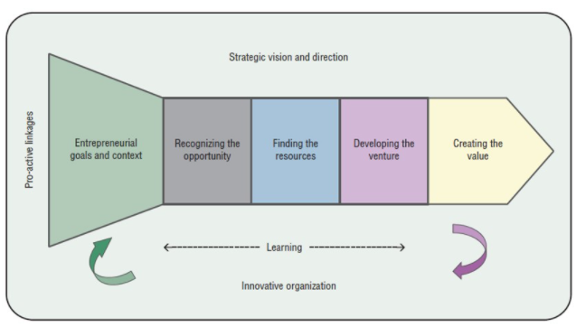

Open and Closed Innovation

Closed Innovation is developed in a self-contained company environment

Open Innovation incorporates external knowledge.

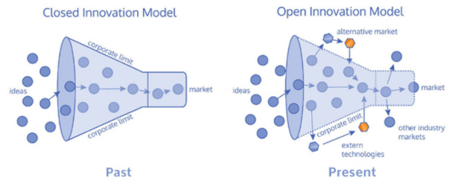

4P’s to Innovation (Innovation Mix)
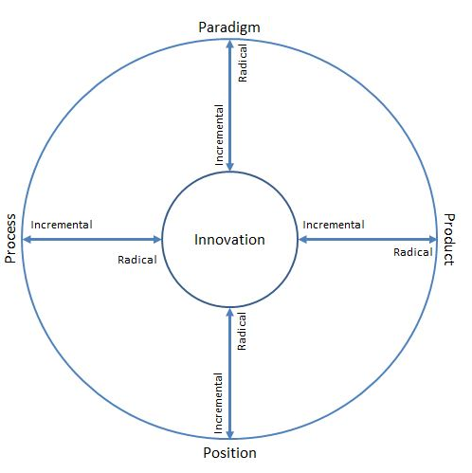
- Product innovation is the things first things that the organisation offers at the very beginning, this comes in the point while talking about innovation
- Process innovation is referring to changes in the particular manner the things are created and delivered.
- Position innovation is the change in the context about which the new story is going on in which the products/services are introduced
- Paradigm innovation, this is the change in the mental outlook which relates what the organisation does or in another way how the company frames what it does.

FORCE FIELD ANALYSIS

FORCE FOR CHANGE | SCORE | CHANGE PROPOSAL | FORCE AGAINST CHANGE | SCORE
Demand in new product | 4 | Veolia new Germany incubator programs called u start | New product means extra work for staff could be barriers | 3
Recycling product will be used, ecological balance maintains | 4 |  | Staff hard work on planning fear of new changes | 2
Demand will be high | 4 |  | Disruption | 4
Cost effective | 4 |  | Cost per product | 2
TOTAL 16 TOTAL 11

6.0 References

Callegaro, A., 2021. Why innovation and technology aren't the same. - UNHCR Innovation. (online) UNHCR Innovation. Available at: <https://www.unhcr.org/innovation/innovation-technology-arent-the-same/ > (Accessed 17 April 2021).

Chesbrough, H., 2011. Everything You Need to Know About Open Innovation. (online) Forbes. Available at: <https://www.forbes.com/sites/henrychesbrough/2011/03/21/everything-you-need-to-know-about-open-innovation/> (Accessed 18 April 2021).

Francis, D. and J. Bessant (2006), Targeting innovation and implications for capability development. Technovation 25: 171–183.
Free Management Books. 2021. Four-Step Innovation Process. (online)Available at: <http://www.free-management-ebooks.com/news/four-step-innovation-process/> (Accessed 18 April 2021).
Flixabout.com. 2021. The 4 P's innovation of Space | FlixAbout.com. (online)Available at: <http://flixabout.com/4-ps-innovation-space > (Accessed 22 April 2021).
Hall, J., 2013. 10 Barriers to Employee Innovation. [online] Forbes. Available at: <https://www.forbes.com/sites/johnhall/2013/04/29/10-barriers-to-employee-innovation/?sh=5de89868117d > (Accessed 19 April 2021)
Mckeown, M., 2014. The Innovation Book. Pearson: London, p.3.

Mindtools.com. 2021. Force Field Analysis: Analysing the Pressures for and Against Change. [online] Available at: < https://www.mindtools.com/pages/article/newTED_06.htm > [Accessed 19 April 2021].

Pahl, N. and Richter, A., 2007. Swot Analysis - Idea, Methodology and a Practical Approach. (online) Google Books. Available at: <https://www.google.co.uk/books/edition/Swot_Analysis_Idea_Methodology_and_a_Pra/JJEBWvvG73YC?hl=en&gbpv=1&dq=definition+of+swot+analysis&printsec=frontcover > (Accessed 14 April 2021).

ProoV. 2021. The 5 Biggest Barriers to Innovation and How to Overcome Them | prooV. (online) Available at: < https://proov.io/blog/5-biggest-barriers-innovation-overcome /> (Accessed 19 April 2021).

Swot 15 Writers. 2021. SWOT Business Analysis Example Paper | 15 Writers. (online)Available at: <https://15writers.com/swot-analysis-example/> (Accessed 23 April 2021).

Toolshero. 2021. Innovation Matrix, a powerful innovation tool explained | toolshero. (online)Available at: <https://www.toolshero.com/innovation/innovation-matrix/ > (Accessed 17 April 2021).

Veolia. 2021. The history of Veolia: 1853-1900. (online) Available at: <https://www.veolia.com/en/veolia-group/profile/history/1853-1900 > (Accessed 14 April 2021)
Veolia. 2021. Our Purpose. (online)Available at: <https://www.veolia.com/en/veolia-group/purpose/our-purpose > (Accessed 17 April 2021).

Veolia. 2021. homepage. (online) Available at: <https://www.veolia.com/en > (Accessed 18 April 2021).

Veolia. 2021. AIR Control COVID: with Veolia, monitor ventilation and limit the risk of Covid-19 spreading. (online)Available at: <https://www.veolia.com/en/our-media/news/air-control-covid-veolia-monitor-ventilation-and-limit-risk-covid-19-spreading >(Accessed 17 April 2021).

Veolia. 2021. Soil remediation: a second life. (online) Available at: <https://www.veolia.com/en/solutions/remediation-rehabilitation-soil-industry-cities-tertiary-sector > (Accessed 18 April 2021)

Veolia. 2021. VIA by Veolia's calls for Solutions. (online) Available at: <https://www.veolia.com/en/veolia-group/innovation/VIA-by-veolias-calls-solutions> (Accessed 19 April 2021).

ZAPFL, D., 2018. Open Innovation vs. Closed Innovation. (online) Lead-innovation.com. Available at: <https://www.lead-innovation.com/english-blog/open-innovation-vs.-closed-innovation > (Accessed 18 April 2021)

