Digital Signal Processing

Contents
Abstract 3
Introduction 3
Simulation Models 5
Results 7
Discussion 8
Conclusion 9
References 10
Appendices 11

Abstract
The purpose of this experiment was to investigate how robust different digital modulation schemes were against Additive White Gaussian Noise (AWGN). The modulation schemes tested were Amplitude Shift Keying (ASK), Binary Phase Shift Keying (BPSK), Quadrature Phase Shift Keying (QPSK) and Quadrature Amplitude Modulation (QAM), more specifically 16-QAM. The modulation schemes were simulated in Simulink [1] where the modems were designed using basic Simulink components. Results were obtained by collecting an average Bit Error Rate (BER) over 5 measurements over a multitude of Signal to Noise Ratios (SNRs). A failure BER of 25% was adopted to show when too much noise was present in the signal. The effectiveness of each modulation scheme was tested around this figure. For the purposes of this experiment the scheme with the lowest SNR under 25% would be considered the most robust. The results from this experiment show that ASK is the most robust whereas QAM is the least. However, BPSK shows a better gathering of data which looks more reliable than the ASK data set which may have be too affected from outlying measurements to get an accurate representation.

Introduction
Digital modulation schemes are essential for modern day communications as these modulated signals are required to propagate digital signals Over the Air (OTA). These signals are used in communication protocols such 4G/5G, Wi-Fi, Bluetooth and in the case of ASK, used for sensors [2]. 16-QAM, QPSK and BPSK are commonly used modulations used in 4G and 5G [3]. In this task digital modems (modulator- demodulator) were designed in Simulink separated by an AWGN channel to depict different Radio Frequency (RF) environments.
ASK is the simplest modem and simply combines a binary square wave to a carrier wave. The product is the modulated wave where the carrier wave’s amplitude varies depending on that of the changing message (binary) signal.
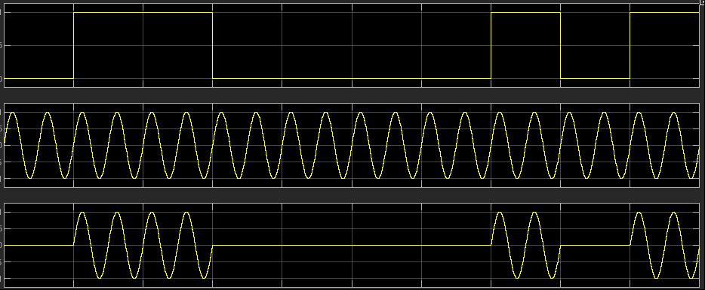
Figure 1: ASK Modulation: Top: Message Signal, Middle: Carrier Signal, Bottom: Modulated Signal.

Phase Shift Keying (PSK) or BPSK adopts a similar technique to ASK however, instead of alternating amplitude with respect to the message signal, the modulated signal changes in phase instead. This characteristic in theory makes the signal less susceptible to noise [4]. BPSK is generated by combining the message signal with one of two carrier signals which are 90 degrees out of phase from one another. The phase change denotes a binary 1 or 0 and is configured with a switch with a threshold value, in the case of the simulation it was 0.5 (see Fig 2A).

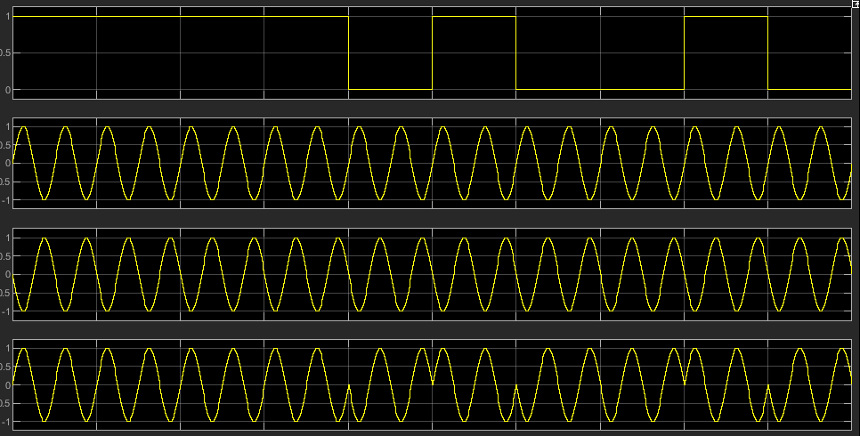
Figure 2: 1st: Message Signal, 2nd: Carrier, 3rd: Carrier + pi, 4th: Modulated Signal

QPSK is less robust against noise than BPSK however it is able to encode more data in the modulated signal and therefore have a higher bit-rates. In QPSK two carrier signals are used which have phase difference of 45 degrees. These are referred to as the I and Q waves. The data from the message signal is split into two streams and has 0.5 subtracted from the binary figure (1 or 0). This signal is manipulated to output 1 or -1 depending if the input was positive or negative. This signal is then combined with one of the carrier waves (I or Q) depending on the stream. These two modulated waves are then summed together to create QPSK which has a phase change of 45 degrees in denote symbol change instead of 90 degrees in BPSK.
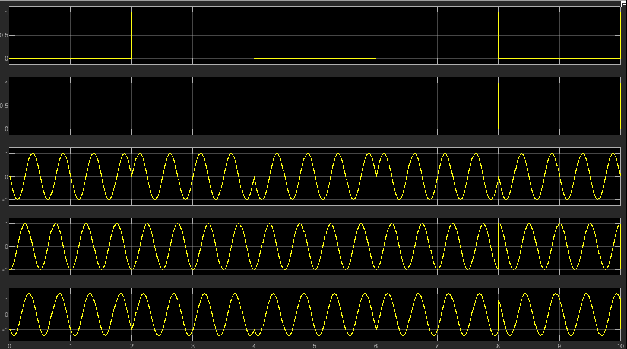
Figure 3: Top two show both binary streams, the second two shows the modulated I & Q waves, the bottom shows QPSK modulated wave.

QAM combines ASK and QPSK to be able to encode 4-bit data. QAM is more susceptible to noise than QPSK but has higher data rates.
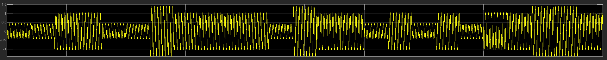
Figure 4: QAM Modulation

Simulation Models
As previously stated all of the digital modulation schemes were designed in Simulink [1] using basic components. In the simulation a modem was designed where a random bit stream would be generated from ‘Bernoulli Binary’ block to act as the message signal. Then dependent on the modulation scheme this message signal would be combined with a carrier wave/s and be modulated. On the other side a demodulator was designed to demodulate the signal again and detect any BER. The demodulators would vary depending on the modulation but all consisted of combining the wave again with the carrier to get rid of it and then pass the rest of the signal through a low-pass filter block any high frequencies that may remain.
The modulator and demodulator were separated by an AWGN channel to simulated EMEs with different SNRs. Another branch was added which compared the signal at the output of the Bernoulli Binary generator and the end demodulated message signal via a ‘Error Rate Calculation’ Block which would calculate the BER and be able to measure the robustness of that channel against AWGN noise.

AWGN channel is common channel used to simulate line of sight (LOS) conditions where multipath is not present. AWGN adds white noise which is noise that has the same power distribution across all frequencies of the channel. The noise is random in nature and the Gaussian model to calculate probability of events [5].
All models were run over the same runtime (1000 seconds) with the same carrier frequency of 12.66Hz (2*pi*2). Wherever possible the same blocks were used i.e. filter blocks, BER blocks and Sine-Wave source blocks. This was done to control as many variables as possible so that the only thing changing was the noise channel. Each SNR value of the noise channel was tested five times after which a mean Bit Error Rate (BER) was calculated along with the standard deviation (SD) to understand how dispersed each measurement was from the mean. A low SD show that the measurements are located near the mean value which makes the total result more reliable [6].
The ASK model is the simplest combining the binary message signal to a carrier wave and then removing that carrier and low-pass filtering the signal to get the message signal on the receiver end. The filter used was the ‘Digital Filter Design’ block with and Fpass of 1.23Hz and a Fstop of 4Hz with a sample rate if 1KHz. The output of this filter would then be passed to a switch to with a threshold of 0.25dB any amplitude below this threshold will have a value of zero any value above will be denoted 1 hence regaining the original square wave message signal. (see fig 1A).
As previously stated BPSK assigns one of two carrier waves (90 degrees out of phase) depending on whether the binary digit is a 1 or 0. This is then transmitted through the AWGN channel. At the receiver end two streams are generated to subtract the carrier away from each component of the carrier wave. One stream is then taken away from another to produce an unfiltered message signal.
The signal is then passed through the digital filter block which is acting as a low pass ‘Direct-Form FIR’ filter with 76 orders and a pass frequency of 1 and a frequency stop 2.5Hz. This is enough to filter out any remaining carrier wave signal and noise left on the message signal. The output of the filter is inputted into a switch similar to the ASK switch however the threshold changes as the amplitude values are now between 1 and -1 so a threshold of 0.1 was chosen to divide those amplitudes into ones and zeros to then generate the original square wave bit-stream (see Fig A2).
QPSK has a more complicated Modem than BPSK as the modulated has been encoded with more data (2 bit instead of BPSK’s 1bit). In order to do this the binary data stream has to be split into to two streams and then in each stream have that value subtracted from a constant, in this case it was 0.5. Depending if the input to this subtraction was 1 or 0 would determine if the output was negative or positive. This output would then be passed to a ‘Sign’ block which takes a value and depending whether it was positive negative or zero would output 1, -1 and 0 respectively. In this case the outputs would only be 1 or -1 due to the constant subtraction beforehand. These values are then multiplied with a carrier I or Q waves. Both modulated streams are then summed to create the QPSK modulated signal.
On the receiver end the streams are split again and multiplied with the carriers once again to remove them from the message. The output is then passed through a digital low-pass filter with an Fpass of 0.75Hz and an Fstop of 2.25Hz. The filter is once again a Direct-Form FIR with 76 orders. Next both streams are passed through a switch like in BPSK to square off the wave and create a bit stream which is then combined back into one stream via a mux to produce the original bit stream signal albeit a bit delayed from processing.

Results
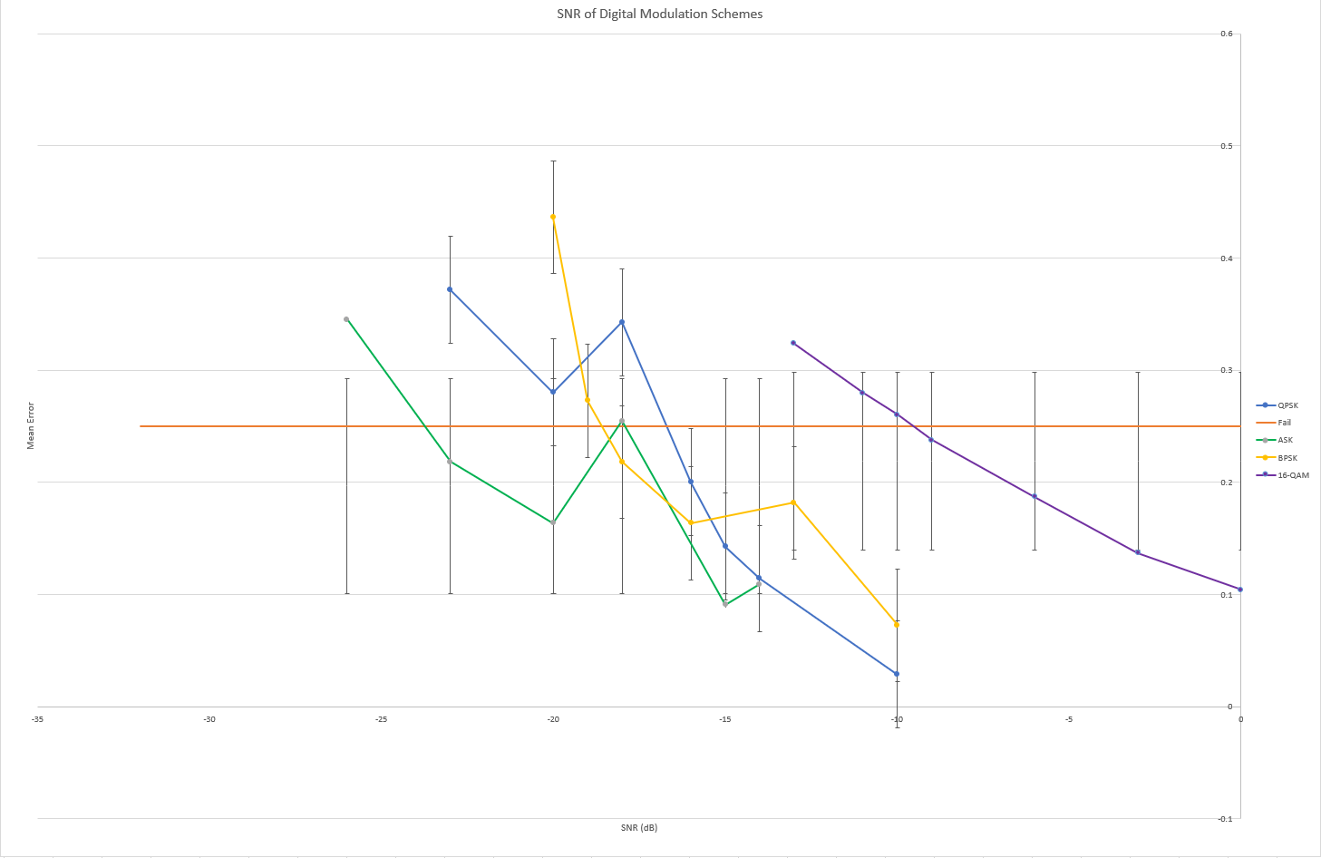
Figure 5: Table of Combined Results.
The graph above has the SNRs plotted on the X-axis with mean error (BER) being plotted on the Y-axis. The coloured lines plotted represent all the different modulation schemes tested except the horizontal orange line which represents the fail/pass line of 25% BER. In real-life 10% is usually a used to determine when the BER is too great for the messages to be successfully decoded by the receiver however, for this experiment 25% error was chosen in order to understand the drop off of the signal in noisy environments to see if some modulations have a greater drop off than others. The results also have error bars attached in the Y-direction to represent the SD at each noise level. Anything below the orange line represents a pass (below 25% error) and everything on or above is a fail.
The results show that QAM is the least robust modulation scheme against noise and the ASK is the best. QAM crosses the fail-line around -9dB whereas ASK initially crosses around -18dB before ducking back under and not failing again until around -24dB. BPSK appears to be the next robust modulation scheme failing at around -19dB, lower than ASK, but never recovers. However, BPSK has smaller error bars than ASK showing smaller SD. Finally, QPSK is the 3rd most robust crossing the fail-line at around -17dB and never recovering. Like BPSK, QPSK seems to have narrow error bars indicating little spread of measurements around the mean.
Out of all the four schemes QAM looks to have the most gradual rise looking almost linear where as BPSK seems to decay and error rapidly rise to an error rate of almost 50% at -20dB (far higher than the surrounding signals of QPSK and ASK). The last result also looks like it would intersect with QAM if this scheme carried on rising at the same rate. Both ASK and QPSK seem to fail the most initially -18dB, with ASK error rate at 0.25 and QPSK at 0.35 before both recovering slightly at -20dB (however QPSK not as much to cross back below the fail-line). ASK later crosses the fail-line again at -24dB.

Discussion
Of all the results ASK is the only one that appears to misplaced. In theory BPSK should perform better in nosier environments as the wave carries two waves out of phase by 90 degrees, whereas ASK is just the switching on/off a signal via a switch depending on whether it’s a 1 or 0. When plotted on a constellation diagram it means the data point on BPSK are further away than with ASK. As EMEs get nosier the bits tend to become less localised around the bit point. Hence the further away two points are theoretically the more robust to noise the modulation will be.
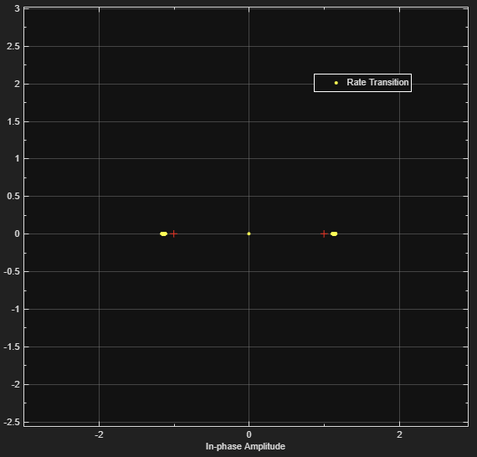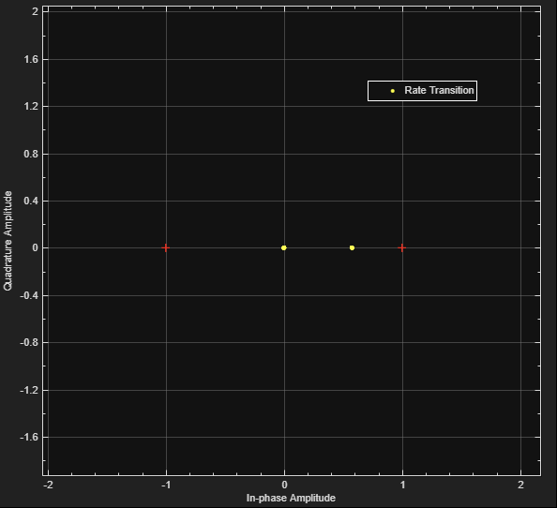
Figure 6&7: Constellation Diagram, Left BPSK, Right ASK.
However, in this case ASK seemed to cross the fail-line (after bounce back) with lower SNR than BPSK. Reasons for this could be that the data set use was relatively small (only 5 measurements taken per SNR value) and therefore it is only in this rare case that ASK out performs BPSK. This can be further shown as the standard deviation of ASK is much greater than BPSK with the only time that they are similar is at SNR -18dB where BPSK out performs ASK. It is also worth mentioning that this point for ASK seems to be anomalous as it seems to not follow the trend of the rest of the data. On the other-hand ASK error bars are so wide that even up at -14dB the extremities are crossing failure point of 25% whereas BPSK’s only starts to cross this point at -18dB.
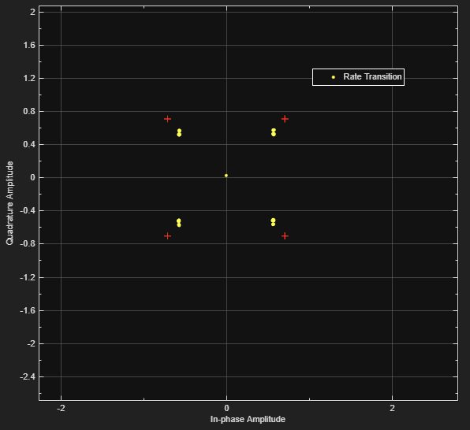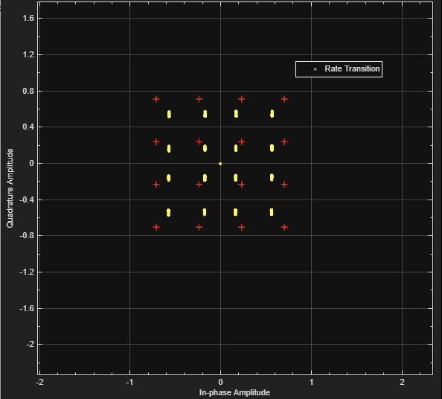
Figure 7&8: Constellation Diagram, Left: QPSK, Right, 16-QAM
As stated previously both QPSK and QAM are more susceptible to noise than the other two schemes as they are higher bit rate and therefore to achieve this each wave has to be encoded with more data (2-bit in QPSK and 4-bit in QAM). This means on constellation diagrams there are more points that are closer together and therefore in noisy environments there is a higher likelihood of interfering with other data points, more so in case of QAM. It seems at -20dB QPSK outperforms BPSK however as this point is not really of interest as both points are way above the failure point and is once again most likely due to lack of data as both error bars do cross at the higher and lower extremities.

Conclusion
In this experiment it has been determined that ASK is the most robust modulation scheme and that QAM is the most vulnerable to noise. This is unexpected as in theory BPSK is the most robust scheme and the reasons for this result is likely due to a small data set. When paying attention to the error bars BPSK has smaller error bars than which cross the failure point of 25% BER later much later on than ASK. The main reason for this wide spread of data and unexpected result for ASK was the small number of measurements. Only taking 5 measurements for each SNR could mean outlying data will have more effected on the average and SD therefore, adjusting the result to a greater extent. To get more accurate results in the future, acquiring more measurements per SNR (i.e. 20) should hopefully get a more accurate mean and smaller error bars. This in turn should therefore give results more synonymous with the theory. Another reason the results are not as expected could be due to the simulation software Simulink however as this is well renowned tool to simulate real-life environments the likelihoods of this having a major effect is very low.
Both QPSK and QAM follow the theory and show what is expected both in plots and error bars.

References

[1] | Mathsworks, Simulink, Mathsworks, 1984.
[2] | RF Wirelss World, "ASK vs FSK vs PSK | Difference between ASK, FSK, PSK modulation," RF Wirelss World, 2012. [Online]. Available: https://www.rfwireless-world.com/Terminology/ASK-vs-FSK-vs-PSK.html. [Accessed 28 October 2023].
[3] | C. Johnson, Long Term Evolution IN BULLETS 2nd Edition, Northampton: Amazon, 2012, p. 592.
[4] | B. L. J.-H. L. Y.-C. K. Julius Ssimbwa, "A Survey on Robust Modulation Requirements for the Next Generation Personal Satellite Communications," 17th May 2022. [Online]. Available: https://www.frontiersin.org/articles/10.3389/frcmn.2022.850781/full. [Accessed 28 October 2023].
[5] | Data Science, "Additve White Guassian Noise," Science Direct, 2021. [Online]. Available: https://www.sciencedirect.com/topics/engineering/additive-white-gaussian-noise. [Accessed 25 October 2023].
[6] | T. bmj, "Mean and Standard Deviation," The bmj, [Online]. Available: https://www.bmj.com/about-bmj/resources-readers/publications/statistics-square-one/2-mean-and-standard-deviation. [Accessed 31 October 2023].

Appendices

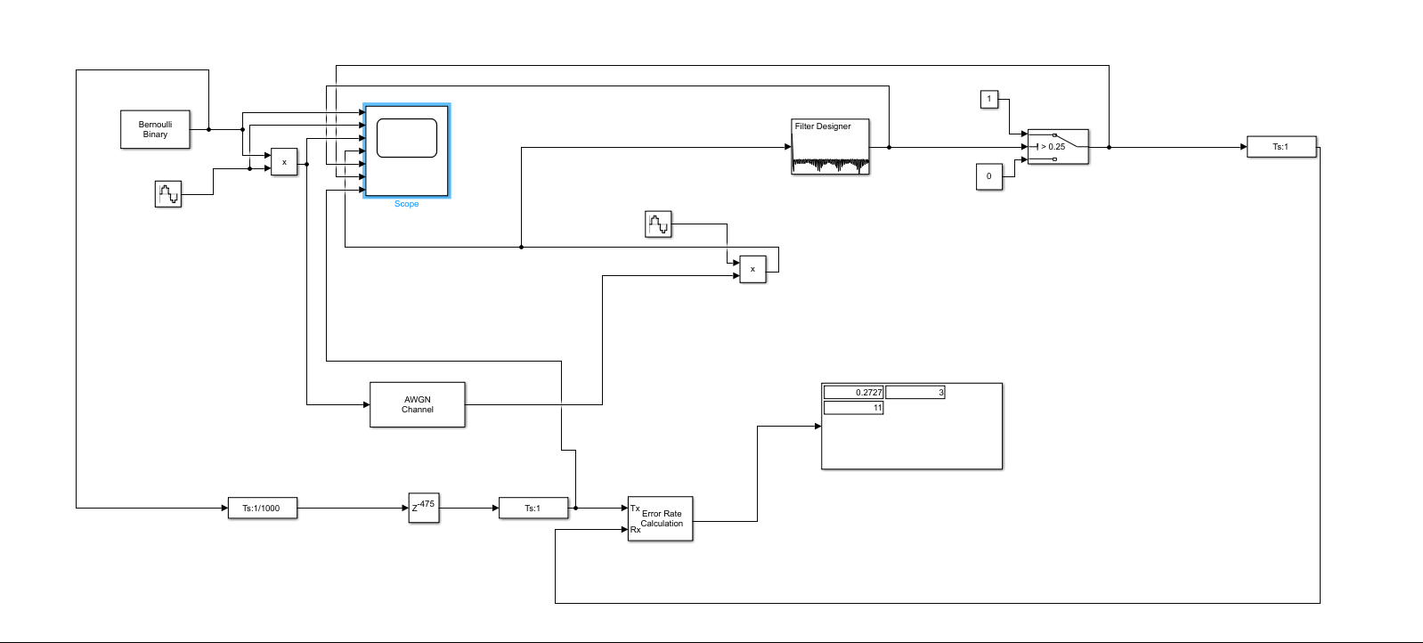

Fig A1: ASK Modem

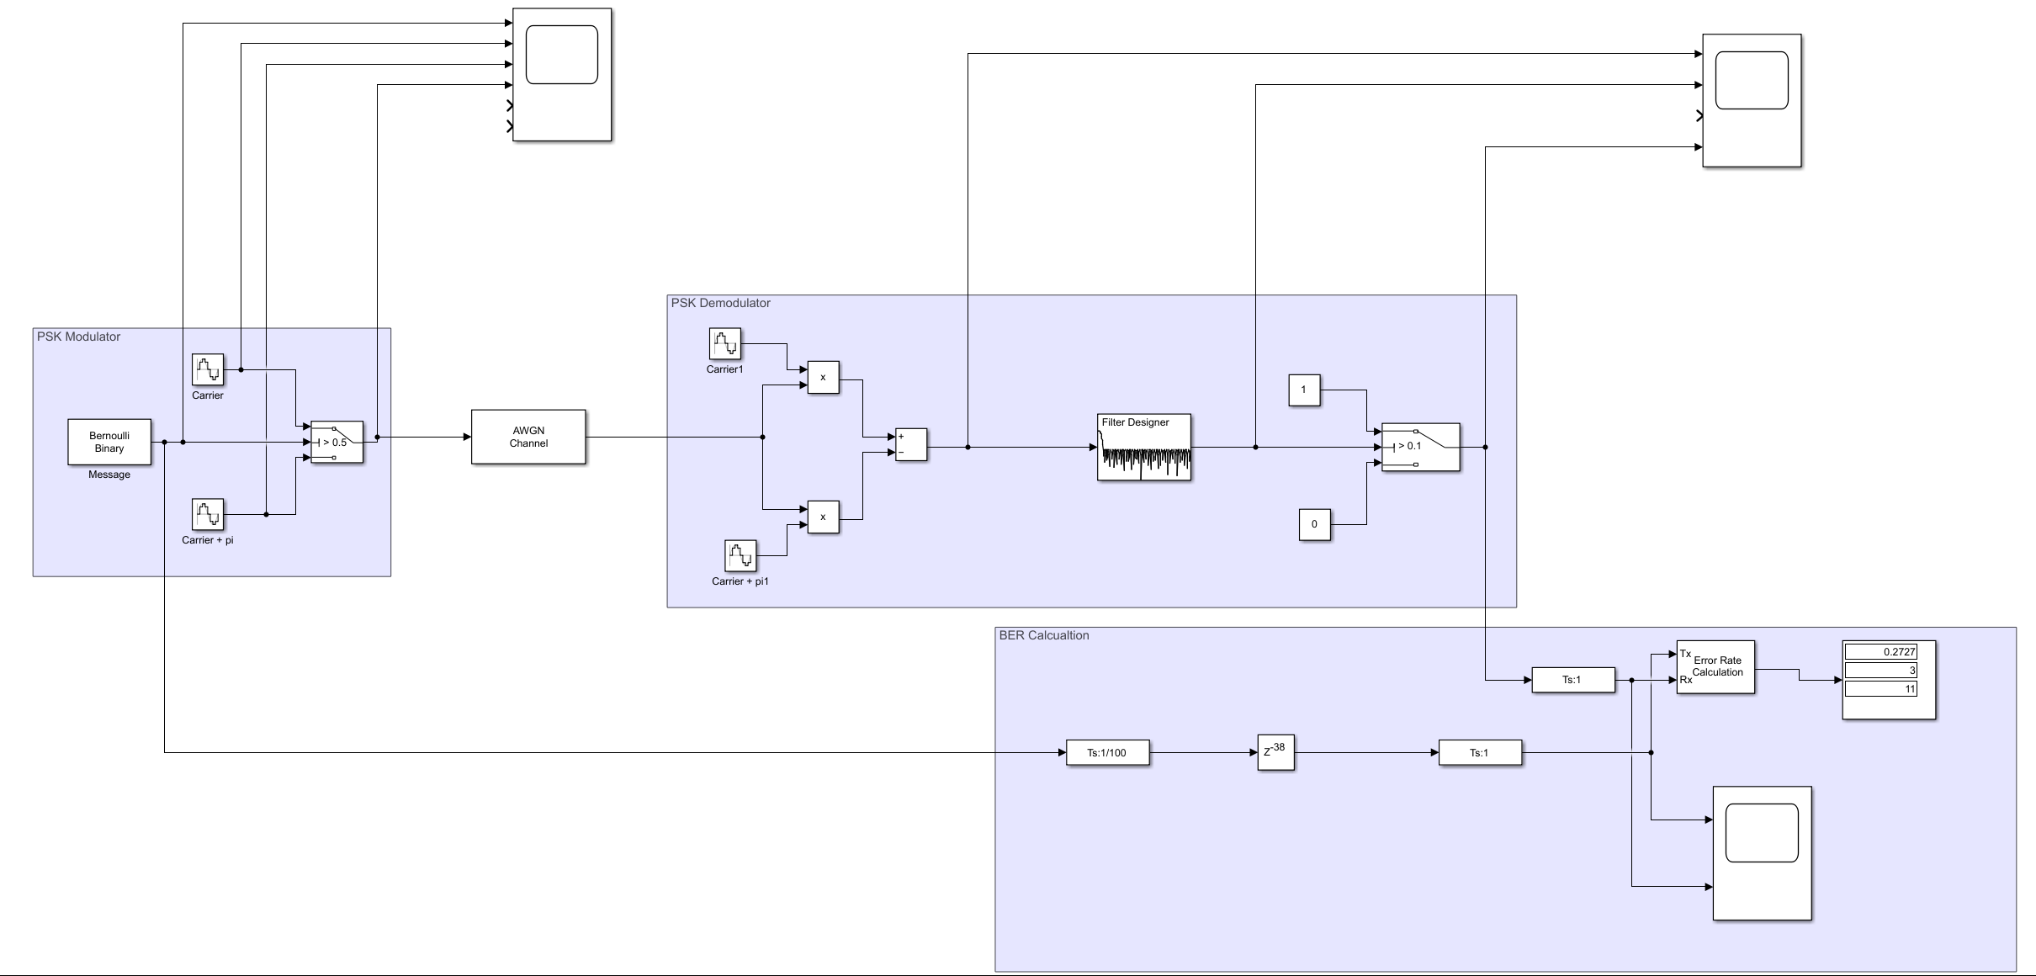
Fig A2: BPSK Modem
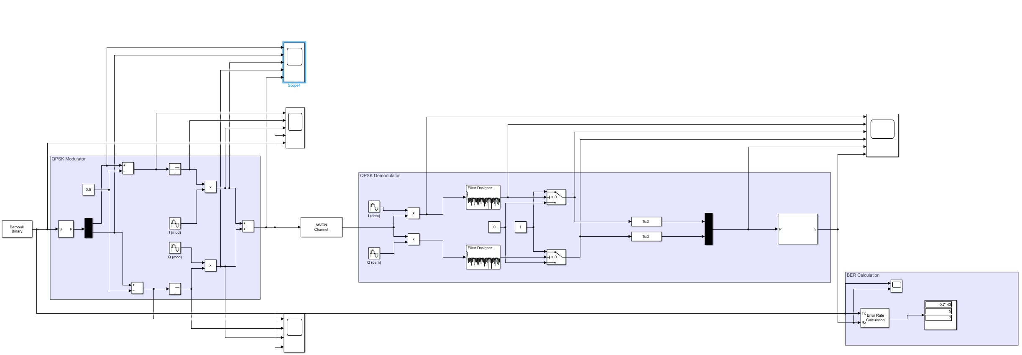
Fig A3: QPSK Modem

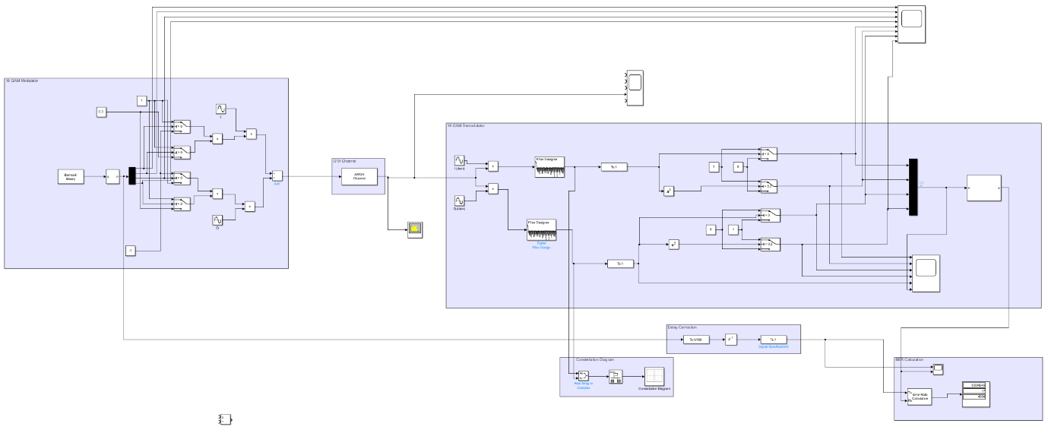
Fig A4: 16 QAM Modem

Fig A5: Table of Combined Results

