Assignment Title: Computer System Component Specification

(Part 1 and Part 2)

Student name: Anamaria-Cristina Finta
Student ID number:2326510

Module:
Computer Systems Fundamentals (ACCA4028)

Tutor: Dr Redhwan Al-amri
List of Contents
Introduction 2
Task 1: Specification for Low-Cost Desktop PC 2
1.1 CPU and Motherboard 2
1.2 RAM 2
1.3 Non-Volatile Storage 3
1.4 Input/Output Features and Ports 3
1.5 Graphics Card Features 3
1.6 Case and Power Supply 3
1.7 Monitor 4
1.8 Network Connectivity 4
1.9 Software Requirements 4
1.10 Shopping List and Pricing 4
Task 2: Analysis of Current Computer 8
2.1 Primary Uses 8
2.2 Detailed Specifications 8
2.3 Performance Analysis 8
2.4 Benchmark Results 9
Conclusion 11
References 12

Introduction
This report focuses on two different tasks, which will be presented here. The first task is designing a budget-friendly desktop PC for an elderly relative. The second task is analysing the existing system configuration of the machine that is currently in use. Therefore, the report will focus on analysing the required essential functionalities for the elderly. It will then provide suggestions that will enable the creation of a machine that can be used. Every requirement such as word processing, internet browsing and video calls will be considered. On the other hand, the analysis of the current machine will delve into the system's intricacies. Then the report will conclude with an analysis of Task 2, which will go through in detail.

Task 1: Specification for Low-Cost Desktop PC

1.1 CPU and Motherboard
CPU: The CPU chosen for this task is the Intel Core i3-14100F. It is a great choice because of its simplicity and cost-effectiveness. This processor offers sufficient performance for everyday tasks. On the other hand, it has a TDP of 58W, which prevents unnecessary power consumption [1].
Motherboard: The ASRock B760M-HDV DDR4 Version is compatible with the chosen CPU [2]. It provides all of the essential features required for this. This includes multiple USB ports and integrated audio. Hence, it is suitable for basic computing needs.

1.2 RAM
An 8GB DDR4 RAM from CORSAIR Vengeance is recommended to ensure smooth multitasking [4]. In this scenario, 8GB RAM should be enough to cover most of the tasks. However, there is an important decision for not choosing a RAM with a lower size due to it not suiting the motherboard. Therefore, this will ensure efficient performance during activities such as web browsing and video calls. This capacity is adequate for the specified use case and keeps the costs down.

1.3 Non-Volatile Storage
A 256GB Solid State Drive (SSD) is suggested for this build. SSDs offer faster boot times and quicker application launches. This is in comparison to the traditional HDD (Hard Disk Drives). Hence, it enhances the overall user experience [5]. Here, the trade is speed to size. The HDDs offer more storage at a cheaper price. However, the user here will not require that much storage. However, the speed will be beneficial for the person using it. Hence, in terms of having a reliable speed, the SSDs are beneficial for the elderly relative.

1.4 Input/Output Features and Ports
The selected motherboard is equipped with a range of essential I/O (Input/Output) ports. The motherboard includes multiple USB 3.0 and 2.0 ports for connecting peripherals [6]. These include the ones such as keyboard and mouse, which are some of the most important peripherals for a machine. On the other hand, the HDMI and DVI ports are present for versatile monitor connectivity. The standard 3.5mm audio jacks for headphones or speakers are present, which should be enough for most of the tasks. There is also an Ethernet port for reliable wired internet connectivity. The entire port array the motherboard has ensures stable connectivity throughout.

1.5 Graphics Card Features
Integrated graphics provided by the Intel Core i3-14100F are sufficient for tasks such as video streaming and video calls. The GPU requirements in this computer are much smaller and therefore, it should be enough for the elderly relative to use the integrated GPUs, as the dedicated ones are too costly and unnecessary. The integrated graphics in this processor are strong enough to withstand any type of task they will use [7]. Hence, the elderly do not require a dedicated graphics card. This can be assessed from the requirements of the tasks that they will do. Therefore, it is a great idea to reduce both cost and power consumption.

1.6 Case and Power Supply
A MicroATX mini tower case Zalman T3 Compact is recommended for its compact size. This fits well in limited spaces with a proper heat flow [8]. It also is vital, as the machine does not have any GPU. Hence, it leads to the form factor of the model being much cheaper to work with. This also allows for storing all of the selected components. On the other hand, a 300W power supply unit (PSU) SilverStone SST-TX300 is suitable for this build. This is because the 300W supply will be enough to provide sufficient power without excessive energy use. Therefore, it is beneficial for the entire configuration.

1.7 Monitor
A 24-inch Full HD (1920x1080) monitor is ideal. Here, the recommendation is BenQ GW2283 21.5" Full HD monitor. This monitor size is big enough for such an old person. It offers clear visuals and a comfortable viewing size. For the elderly, this is ideal without costing too much. It also has great eyesight considerations. Hence, the configuration along with the blue light filter enhances its usability for this case [9].

1.8 Network Connectivity
The motherboard's built-in Ethernet port offers reliable wired internet access. This is enough for most purposes and hence, in this case, it is suitable for the machine’s composition.

1.9 Software Requirements
The system requires Microsoft Windows 11 Home as the operating system. This OS (Operating System) offers a user-friendly interface and compatibility with intended applications. The Microsoft Office Home & Student Edition 2021 is a great choice [10]. This package includes essential tools like Word and Excel. These are necessary. The reliable antivirus program, Norton is chosen for secure browsing and virus protection.

1.10 Shopping List and Pricing
Component | Model | Price | Product Image
CPU | Intel Core i3-14100F | $222 | 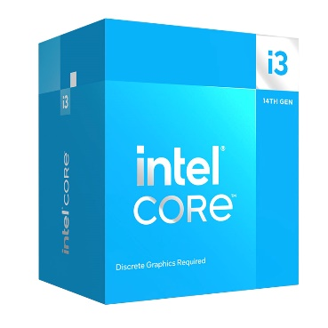
Motherboard | ASRock B760M-HDV (DDR4 Version) | $89 | 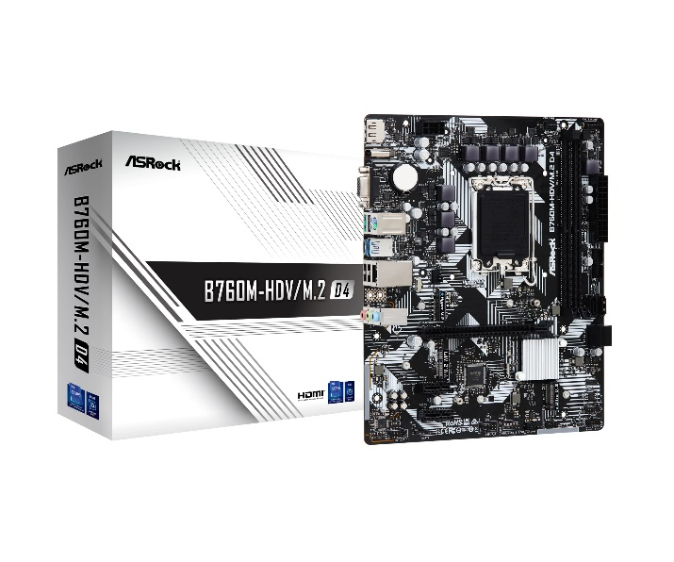
RAM | CORSAIR 8GB Vengeance LPX DDR4 PC4-19200 2400MHz Desktop Memory | $20 | 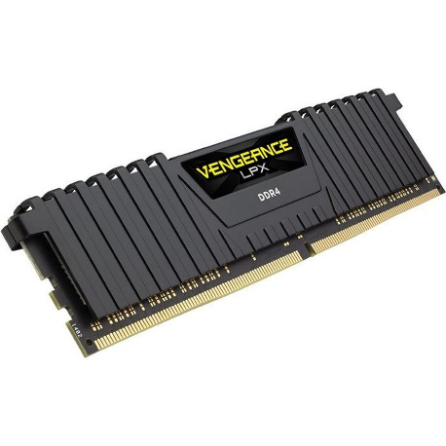
Storage | KingSpec SSD 256GB Internal Solid-State Drive 2.5 Inch SATA III NAND Flash Data Storage | $19 | 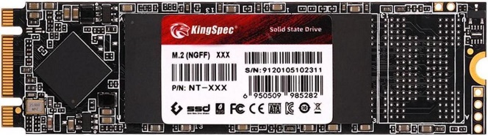
Case | Zalman T3 Compact Desktop PC Case, mATX Mini Tower, | $37 | 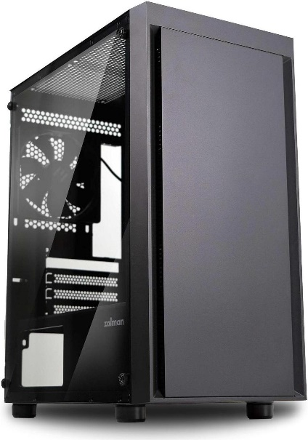
Power Supply | SilverStone SST-TX300 300 W TFX (Compatible with ATX12V v2.4) 80 PLUS BRONZE Certified Active PFC Power Supply | $68 | 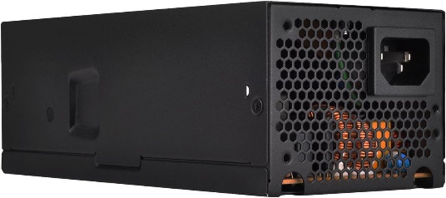
Monitor | BenQ GW2283 21.5" Full HD 1920 x 1080 VGA HDMI Flicker-Free Technology Built-in Speakers Slim Bezel Design IPS Eye-care Monitor | $84 | 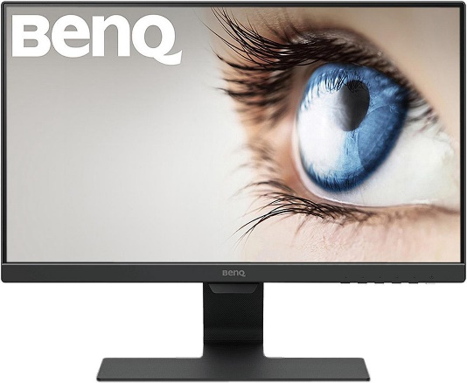
Operating System | Microsoft Windows 11 Home | $139 | 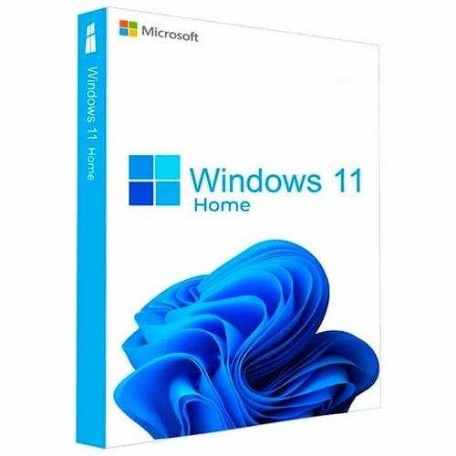
Productivity Suite | Microsoft Office Home & Student Edition 2021 | $149 | 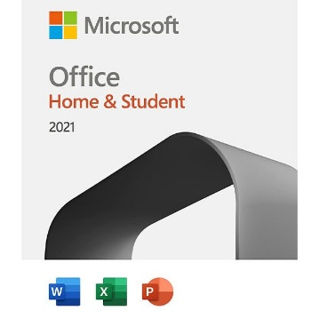
Antivirus Software | Norton Antivirus (1-year subscription) | $29 | 
Table 1: Price table of the components with images
The entire cost of this setup is $859, which is reasonable considering a low budget yet an extensive PC covering the use of professional software and securities.

Task 2: Analysis of Current Computer

2.1 Primary Uses
The Dell Inspiron 15 3000 is primarily used for various tasks. These tasks include word processing, making spreadsheets and presentations using Microsoft Office [11]. On the other hand, the computer is used to do video calls using Zoom and Teams. The computer also has a strong ability to do web browsing and emails. These are some of the most important tasks, which are performed using device. Other uses include basic photo editing using inbuilt tools.

2.2 Detailed Specifications
Below are the detailed specifications of the Dell Inspiron 15 3000. Firstly, the model has an Intel Core i3-1115G4 CPU (Central Processing Unit). It contains 2 cores, 4 threads, and a 3.0 GHz base clock speed. This is highly useful for this case. The model has 8GB DDR4 RAM (Random Access Memory) at a clock speed of 2666 MHz [11]. The next part is storage. The model has 256GB NVMe SSD storage. Then the GPU is the Integrated Intel UHD Graphics. This is a dedicated GPU, which performs well in most average tasks. The screen is 15.6-inch Full HD (1920x1080). It is an anti-glare screen, which prevents any type of issues with vision.
The I/O devices are great with 2 x USB 3.2 Gen 1, and 1 x USB 2.0. These are valuable, as they allow the model to connect with various devices all at the same time. These ports also allow for much more compatible modern devices to be integrated here. Then it also has 1 HDMI 1.4 port. This is a very standard port allowing other displays to be connected with it, making it much more usable in the process. The model has a 3.5mm combo jack, which is an added benefit to it [3]. There is also an SD Card Reader with a dedicated slot. This allows the machine to attach more memory to the model. The OS in use is Windows 11 Home. This is a very useful OS, which covers most of the tasks. The applications installed here are of a wide range from Microsoft Office Suite, and Zoom, to Google Chrome, and VLC Media Player. These specifications make the laptop a highly usable one in terms of everyday tasks.

2.3 Performance Analysis
The Dell Inspiron 15 3000 delivers satisfactory performance for everyday work. These are the daily tasks of the laptop. Hence, it is essential that the performance have to be analysed from all sides. The laptop has quick boot times. This is due to the use of its NVMe SSD [12]. The time averaged 12 seconds from power-on. This is a standard boot time for most laptops and therefore, the laptop performs satisfactorily. However, a better boot time can be expected from other laptops in this range. Therefore, this laptop efficiently handles moderate multitasking such as running multiple browser tabs alongside Microsoft Word [3]. This machine is capable of handling basic tasks at the multitasking level. However, it experiences performance limitations when dealing with intensive workloads. These are in the times of rendering large images or editing videos. However, for simple tasks, this is a great choice.

2.4 Benchmark Results
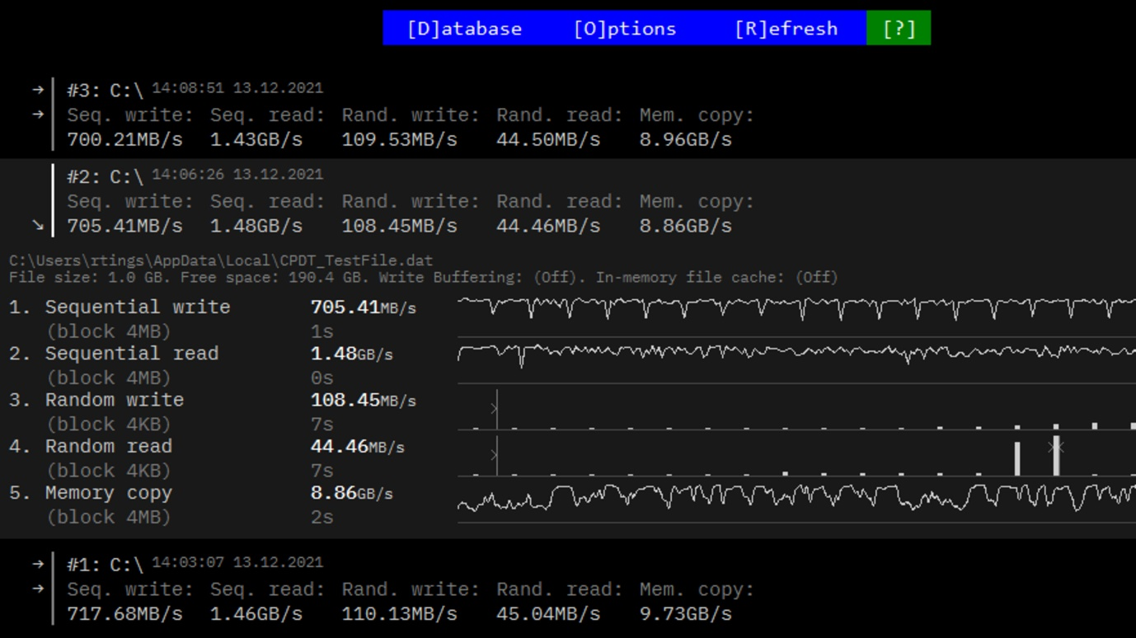
Figure 1: Read and Write Speed Benchmark
(Source: [3])
The read and write speeds are good as found from the benchmarks. The model achieves a sequential write speed of 705 MB/s. On the other hand, it attains the read at over 1.48 GB/s. This shows the capabilities of the SSD in the model (Fig. 1). The battery lasts for around 7.8 hours for web browsing and 5.3 hours for video watching. These are standard timings for the battery. However, it may feel less compared to some other models. Hence, the performance of the battery is comparatively a bit on the lower end. Specifically for the video playback one. However, it is to be noted that the laptops do not usually have a higher battery life.
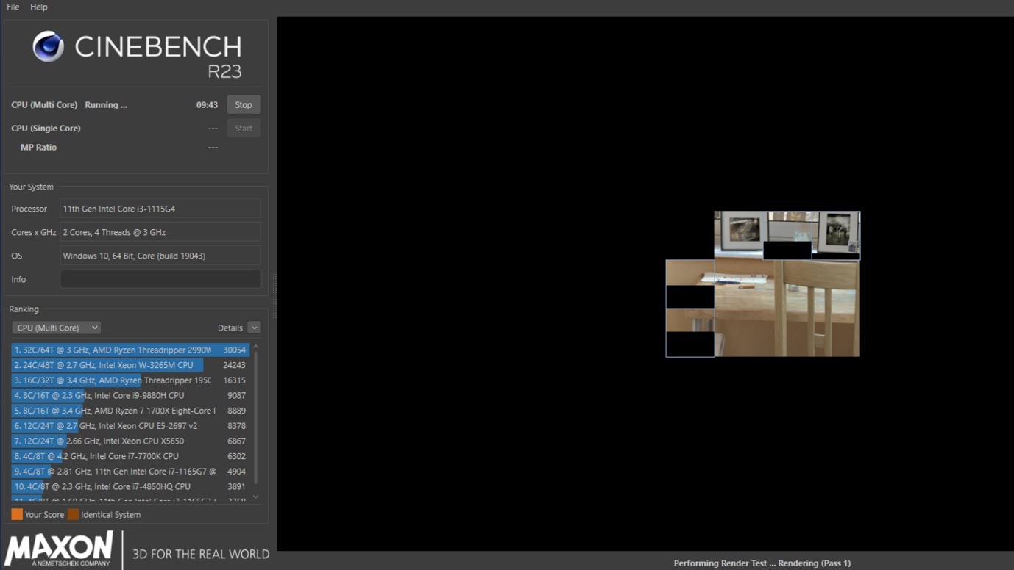
Figure 2: CineBench R23 Benchmark
(Source: [3])
The Cinebench R23 benchmark suite shows a single thread performance of 1316 points, while in the multithread case, it is 2859 points (Fig. 2). The performance, therefore, is well in the single thread and moderate in the multithread. Its performance makes it a good player in this market segment.
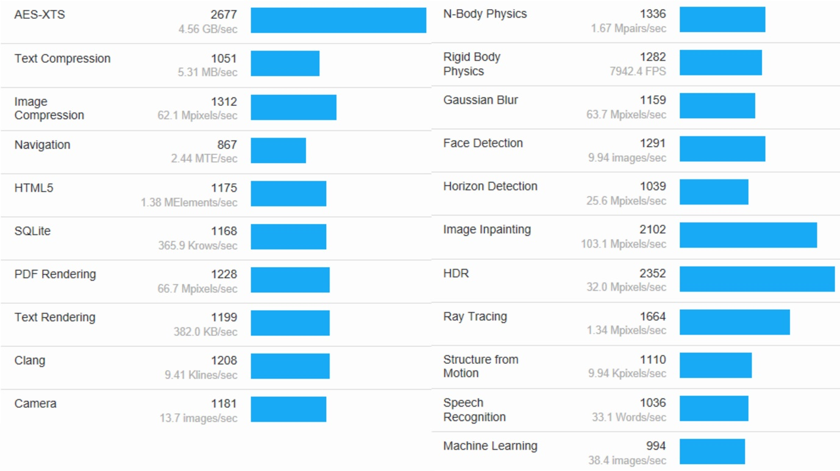
Figure 3: GeekBench Benchmark
(Source: [3])
The GeekBench shows the CPU to have a performance of 1279 points and at multi-threat a performance of 2536 points (Fig. 3). Hence, it is evident that the single thread performance is excellent in this model. However, the GPU performance lags in this model, as the GPU is much weaker compared to the standard dedicated GPUs and hence, the high-performance games suffer due to high frame rate drops. Most of the standard games fall below 30 FPS (Frames per Second) in this model, which is expected.

Conclusion
In this report, it was noted that the machine required for the elderly has to be minimal yet capable. It was found that the created machine in task 1 costs around $849. It was observed that the machine covers the necessary workloads that will be given to it while being highly usable for such a person. The report provided justification for the choice of each item and found that in certain cases, the in-built systems such as GPUs are enough for this. In task 2, the existing machine was analysed for performance and benchmarking. It was found that the machine is capable of most of the tasks; however, it faces challenges in terms of performance for heavy tasks. It was noted that the laptop covers a wide array of tasks and has software to do so. The benchmarks of the machine showed important results highlighting the usability of such a machine.

References
[1] Intel, “Intel® CoreTM i3 processor 14100F (12M Cache, up to 4.70 GHz) - Product Specifications,” Intel, Dec. 19, 2024. https://www.intel.com/content/www/us/en/products/sku/236786/intel-core-i3-processor-14100f-12m-cache-up-to-4-70-ghz/specifications.html
[2] ASRock, “ASRock B760M-HDV/M.2 D4,” Asrock.com, Dec. 19, 2024. https://www.asrock.com/mb/Intel/B760M-HDVM.2%20D4/index.asp (accessed Dec. 19, 2024).
[3] A. Tozzi, R. Lim, and J. Peroramas, “Dell Inspiron 15 3000 (2020) Review,” RTINGS.com, Aug. 23, 2024. https://www.rtings.com/laptop/reviews/dell/inspiron-15-3000-2020 (accessed Dec. 19, 2024).
[4] D. Hawthorne, M. Kapralos, R. W. Blaine, and S. J. Matthews, "Evaluating cryptographic performance of Raspberry Pi clusters," in 2020 IEEE High Performance Extreme Computing Conference (HPEC), 2020, pp. 1–9. Available at: http://dx.doi.org/10.1109/HPEC43674.2020.9286247
[5] H. Riggs, S. Tufail, I. Parvez, and A. Sarwat, "Survey of solid state drives, characteristics, technology, and applications," in 2020 SoutheastCon, Mar. 2020, pp. 1–6. Available at: https://doi.org/10.1109/SoutheastCon44009.2020.9249760
[6] K. A. Koffi, C. Smiliotopoulos, C. Kolias, and G. Kambourakis, "To (US) Be or Not to (US) Be: Discovering Malicious USB Peripherals through Neural Network-Driven Power Analysis," Electronics, vol. 13, no. 11, p. 2117, 2024. Available at: https://doi.org/10.3390/electronics13112117
[7] S. Ananthakrishnan, S. Abedin, V. Cavé, F. Checconi, K. Du Bois, S. Eyerman, J. B. Fryman, W. Heirman, J. Howard, I. Hur, and S. Jain, "The Intel programmable and integrated unified memory architecture graph analytics processor," IEEE Micro, vol. 43, no. 5, pp. 78–87, 2023. Available at: https://doi.org/10.1109/MM.2023.3295848
[8] N. A. C. Sidik and G. C. Qiang, "Heat flow in computer casing," Journal of Advanced Research Design, vol. 74, no. 1, pp. 1–14, 2020. Available at: https://www.akademiabaru.com/submit/index.php/ard/article/download/5187/4034
[9] A. J. Munsamy, M. Moodley, Z. Khan, K. Govender, M. Nkwanyana, S. Cele, and M. Radebe, "Evidence on the effects of digital blue light on the eye: A scoping review," African Vision and Eye Health, vol. 81, no. 1, p. 685, 2022. Available at: https://hdl.handle.net/10520/ejc-aveh_v81_i1_a685
[10] Microsoft, “Office Home 2024,” Microsoft Store, 2024. https://www.microsoft.com/en-in/microsoft-365/p/office-home-2024/cfq7ttc0pqvj (accessed Dec. 19, 2024).
[11] Dell, “Inspiron 15 inch 3000 Laptop with the latest processors | Dell Hong Kong,” Dell, Dec. 19, 2024. https://www.dell.com/en-hk/shop/laptops-and-ultrabooks/inspiron-15-3583/spd/inspiron-15-3583-laptop (accessed Dec. 19, 2024).
[12] V. Leis, "LeanStore: A high-performance storage engine for NVMe SSDs," Proc. VLDB Endowment, vol. 17, no. 12, pp. 4536–4545, 2024. Available at: https://doi.org/10.14778/3685800.3685915

