Harry Byrne

P133366

Software Development ACCA4017

Programs in C and Documentation Part C

Brief

This program was to make a card matching game where two cards are selected out of an array to see if they were matching figures, if the cards didn’t match, the cards were to be turned and not seen in next selection.

Pseudocode

Set array;
Set integers;
Shuffle array;
Ask user to pick first ‘card’;
Save number into memory;
Ask user to pick second ‘card’;
Save number to memory;
Compare numbers to see if they match;
If matched congratulate user and take those 2 cards out of the game, while loop to allow next selection of pairs;
Else if not matched tell user, then loop to allow another selection of pairs;
Count attempts to make matches;
When all pairs are made, show user the amount of attempts taken.

Annotated Code

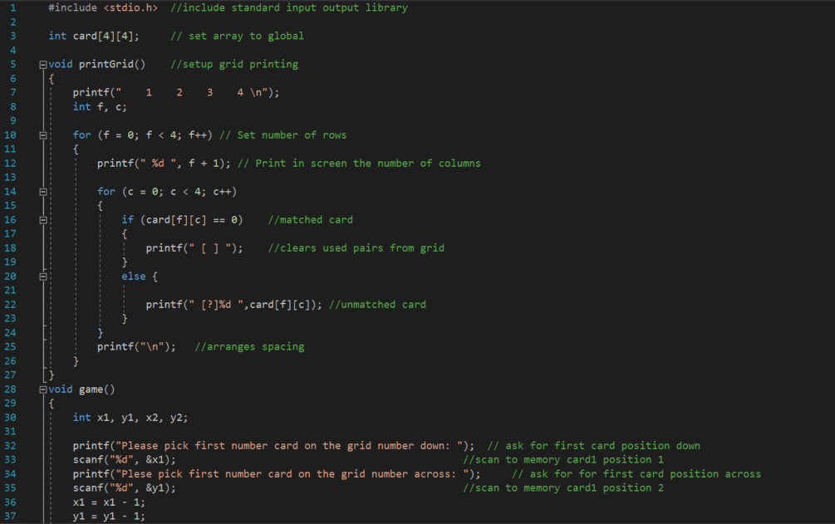

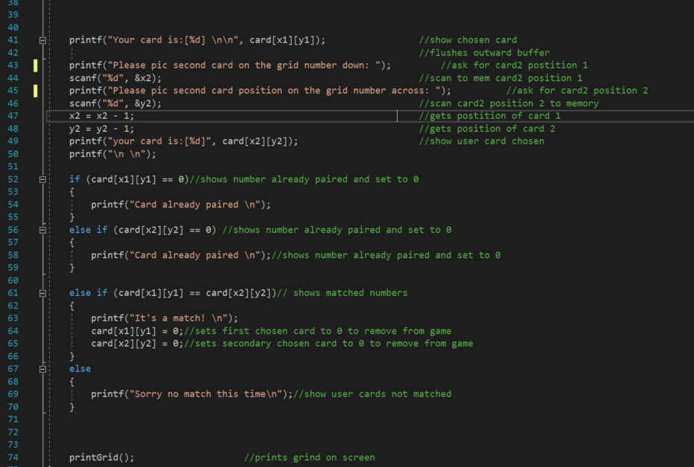

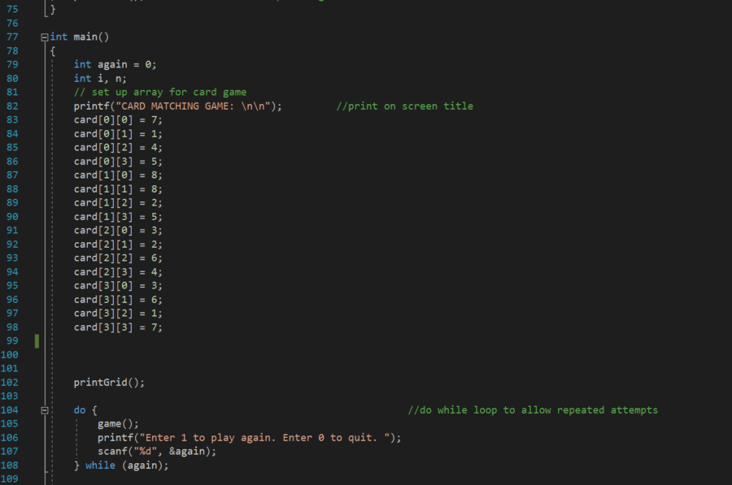

Testing

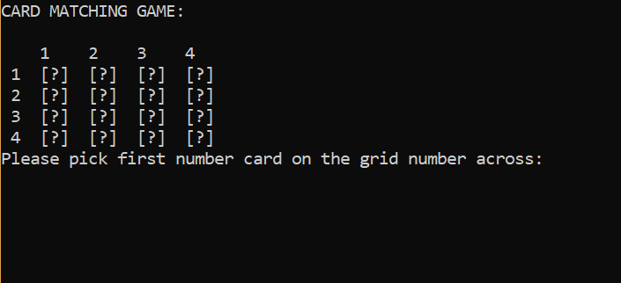

The above screenshot shows the program setup before first input from user.

The code had a minor change to show the cards for ease of testing.
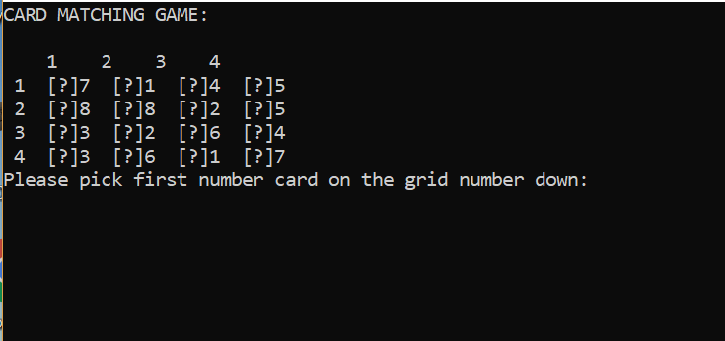

The screenshot below shows a non matched pair. Program ran as expected.

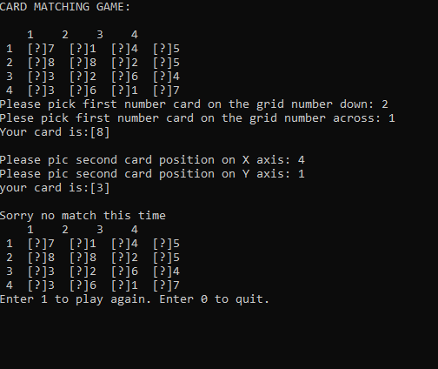

The below screenshot shows a matched pair. As can be seen the [?] on the array has been cleared of the matched numbers to show the user that they should not be picked again. Program ran as expected.

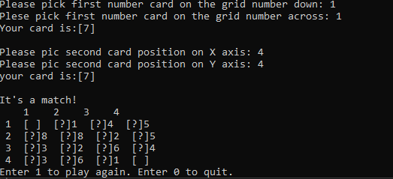

As can be seen below as the program progresses the pairs matched continue to be removed from the game board.
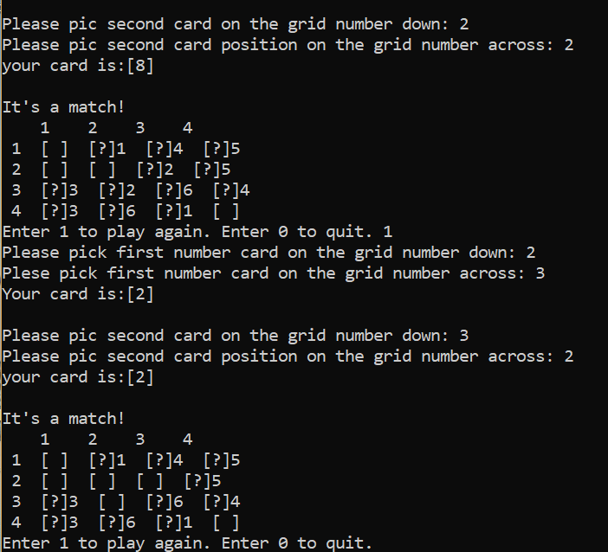

If user tries to select used pairs, program te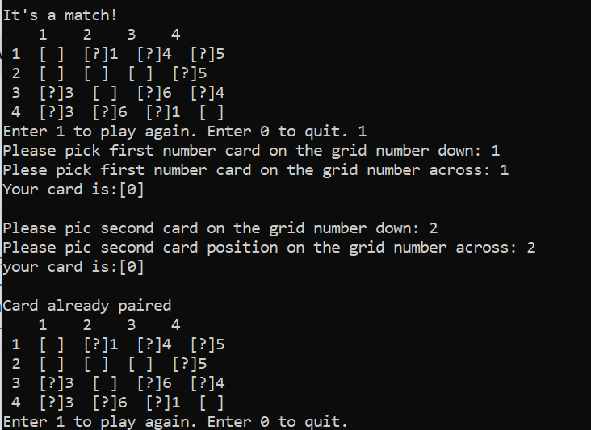lls them that they are already paired.

Numbers out or range are inputted below, the program fails.

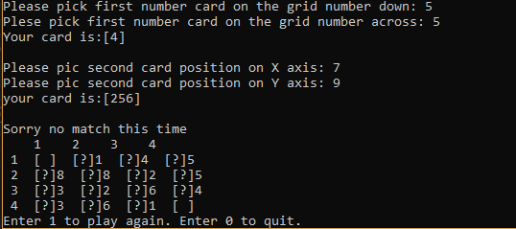

When a character is entered the program goes into a loop and fails. The screenshot below shows the fail.

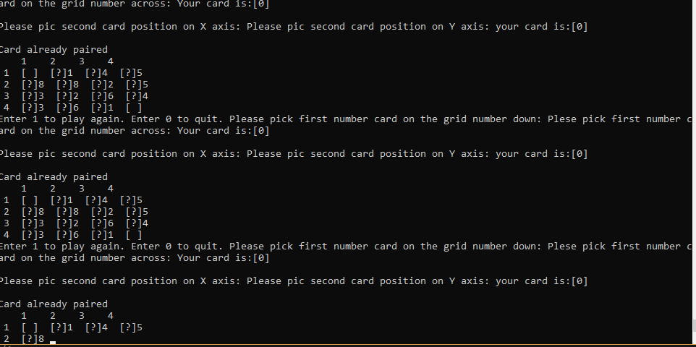

Software improvements

To better the program it would be best for user interest to put a shuffle into the program. This could be done in a for loop where numbers for the array are moved into temporary array and shuffled. The program would also benefit a counter to show the user how many turns are used to complete the puzzle.

