

Application of Machine Learning

ACCA7025

Image classification using Artificial Neural Networks

Student: Jure Jurcevic
Student number: 2212275
Date: 10/11/2025

Contents
Abstract 3
Introduction 4
Related Work 5
Methodology 6
Results 8
Discussion 12
Conclusion 14
References 15
Appendix 17

Abstract
Convolutional Neural Networks (CNNs) are widely used for image classification due to their ability to learn spatial features from raw images. This report focuses on classifying the CIFAR-10 dataset, which contains 60,000 32×32 colour images across 10 categories, using a deep CNN enhanced with data augmentation, dropout, and batch normalization. Recurrent Neural Networks (RNNs) are not considered, as they are better suited for sequential data. Related research is reviewed to support the use of CNNs and optimization techniques such as dropout, batch normalization, and hyperparameter tuning. The methodology outlines the dataset and CNN architecture. Results include accuracy metrics, training curves, and confusion matrices. The baseline CNN achieved 75 - 76% test accuracy, outperforming alternative models with lower learning rates or higher regularization. Findings highlight the impact of tuning and justify architectural choices. A full code walkthrough is included in the Appendix.

Introduction
Image classification assigns labels to input images and is a central task in computer vision [1]. Convolutional Neural Networks (CNNs) have significantly advanced this area, notably with the 2012 breakthrough on the ImageNet benchmark [2]. CNNs extract spatial features through convolutional filters, making them ideal for image data, while Recurrent Neural Networks (RNNs) are better suited for sequential tasks like language or time series analysis [3].
This report applies a CNN to classify images from the CIFAR-10 dataset, which contains 60,000 low-resolution colour images across 10 classes, including animals and vehicles. Each class is balanced with 6,000 images, making the task challenging due to diverse object types and backgrounds. The CNN architecture is enhanced using dropout to reduce overfitting, batch normalization for training stability, and basic hyperparameter tuning to improve performance [4].
The report covers related work on CNNs, RNNs, and optimization techniques, followed by the methodology, including dataset details and model structure. Results include performance metrics, training curves, and confusion matrices.

Related Work
CNNs first gained attention in the 1990s with LeNet-5 for digit recognition but became widely adopted after Krizhevsky introduced AlexNet, a deep CNN that outperformed previous methods on the ImageNet challenge [5]. AlexNet’s use of multiple convolutional layers, ReLU activations, and dropout set the stage for further advances like VGG and ResNet, establishing CNNs as the standard for image classification [6].
RNNs are designed for sequential data, making them suitable for tasks like language modelling or speech recognition [7]. Unlike CNNs, which process 2D spatial structures, RNNs handle 1D sequences and are less effective for static image classification. Flattening images into sequences for RNNs discards spatial relationships, leading to poorer performance. CNNs remain the preferred model for image tasks such as CIFAR-10 classification [8].
To reduce overfitting, dropout randomly disables a fraction of neurons during training, encouraging redundancy and improving generalization. Originally introduced by Srivastava, dropout is commonly applied after dense or convolutional layers, with typical rates around 40 - 50% [9].
Batch Normalization (BN), introduced by Ioffe and Szegedy, standardizes layer inputs to maintain consistent distributions during training [10]. This reduces internal covariate shift, enables higher learning rates, and speeds up convergence. BN also has a mild regularization effect and can reduce reliance on dropout. In this model, BN is applied after each convolution layer to improve training stability.
Hyperparameter tuning is essential for improving CNN performance. Key hyperparameters, such as learning rate, batch size, epochs, and dropout rate, must be set manually and can greatly influence accuracy. Research by Bergstra and Bengio found that random search often outperforms grid search, while Bayesian optimization has shown further gains, reducing CIFAR-10 error rates from 18% to 15% without data augmentation [11].
This project explores two basic variations: reducing the learning rate and increasing regularization through higher dropout and larger batch size. These tests highlight how different settings affect training dynamics and model performance.
Modern high performing image classifiers typically rely on a combination of strong CNN architectures, regularization techniques like dropout and batch normalization, and careful hyperparameter tuning, all reflected in this work.

Methodology
The CIFAR-10 dataset contains 60,000 colour images (32×32 pixels) across 10 balanced classes, including vehicles and animals. It provides 50,000 training images and 10,000 test images [12]. Due to varied content and low resolution, it remains a challenging benchmark. For model development, 10% of the training set is used for validation. Images are normalized to the [0,1] range, and class labels are one hot encoded for multi class classification (Figure 1).
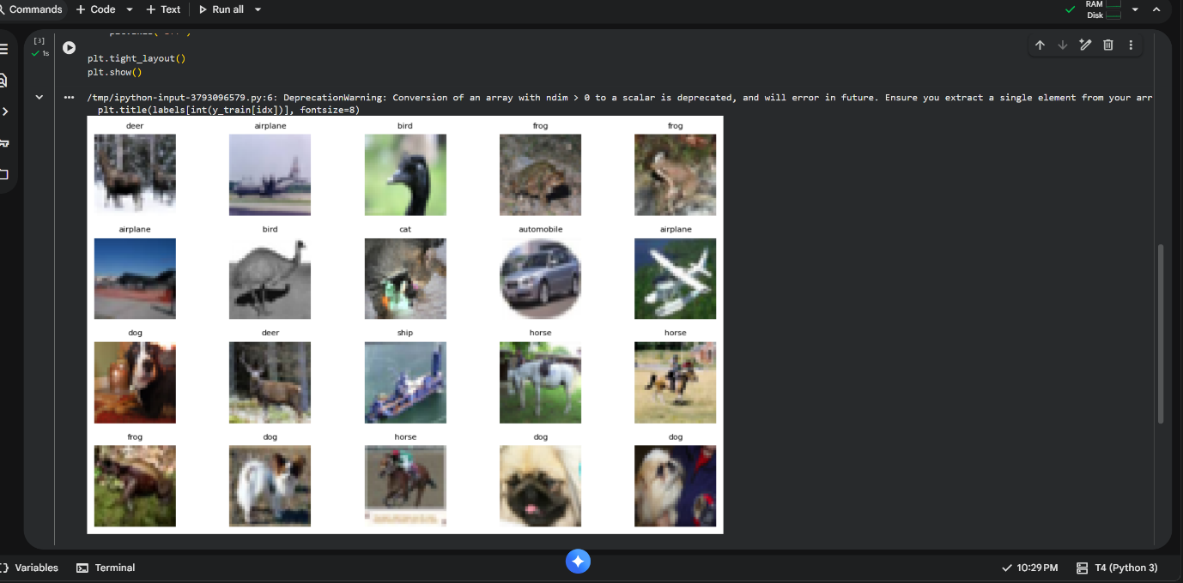
Figure 1 Samples from the CIFAR-10 dataset (random selection of 20 images with their class labels). Each image is 32×32 pixels. The dataset includes a diverse set of objects such as animals and vehicles, as shown above.
The custom CNN model, named “simple_cifar10_cnn,” was built using TensorFlow/Keras for CIFAR-10 classification. It begins with a data augmentation layer that randomly flips, rotates, and translates images to improve generalization. The network consists of three convolutional blocks followed by a dense classification head. Each of the first two blocks contains two 3×3 Conv2D layers with ReLU activation, batch normalization, max pooling, and 40% dropout. The third block includes a single Conv2D layer with 128 filters, followed by batch normalization, ReLU, pooling, and dropout [13]. After flattening the features, a dense layer with 256 units is used, followed by batch normalization, ReLU, and 50% dropout. The final layer uses softmax activation to output class probabilities [14]. The architecture contains about 668,000 trainable parameters. A CNN is preferred over an RNN due to its ability to capture spatial features, weight sharing, and efficiency. While deeper networks could achieve higher accuracy, this model balances simplicity and performance, effectively demonstrating key CNN components.
The model was compiled using the Adam optimizer with an initial learning rate of 0.001 and categorical cross entropy loss, suitable for multi class classification [15]. Accuracy was used as the main evaluation metric. Two callbacks were added: EarlyStopping to halt training if validation loss stopped improving for 8 epochs, and ReduceLROnPlateau to lower the learning rate by half after 4 stagnant epochs, supporting better convergence [16].
Training was conducted over 30 epochs with a batch size of 64, using 90% of the training data and 10% for validation. Metrics such as accuracy and loss were tracked at each epoch. Evaluation on the 10,000-image test set provided final performance metrics, including test accuracy, loss, a classification report (precision, recall, F1-score), and a confusion matrix showing class prediction patterns.
Two additional training configurations were tested. Experiment B used a reduced learning rate (0.0005) to examine its effect on accuracy and convergence speed. Experiment C applied heavier regularization with a 0.6 dropout rate and a larger batch size of 128 to explore generalization effects. All models shared the same architecture and were trained for 20 epochs. Results from these runs were compared to assess the impact of different hyperparameter choices on CIFAR-10 performance.

Results
The baseline CNN was trained for up to 30 epochs. Early in training, the model’s accuracy increased quickly. Figure 2 displays the training and validation curves across epochs. Training loss steadily declined, accompanied by a rise in training accuracy. Validation accuracy began at approximately 44% in epoch 1 and improved to about 76% by epoch 30, while validation loss decreased and eventually plateaued. The ReduceLROnPlateau callback was triggered twice, at epochs 21 and 26, when validation loss flattened, leading to a reduced learning rate each time. These adjustments contributed to slight improvements in validation performance near the end of training.
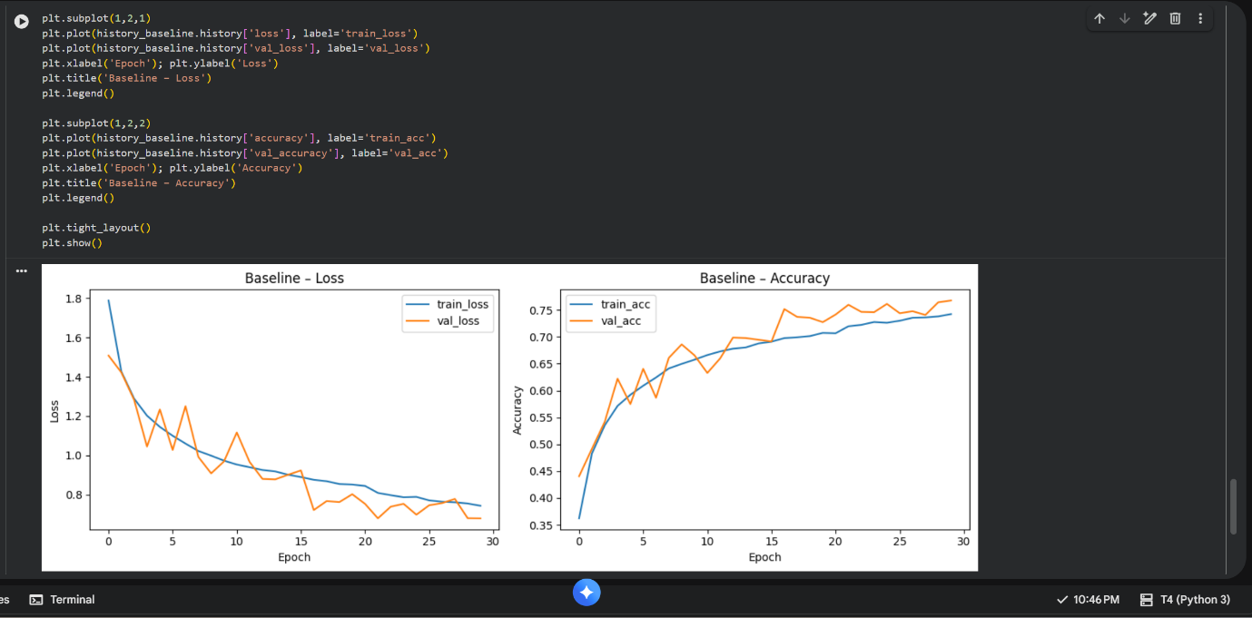
Figure 2 Baseline model training history. Left: Loss vs. epoch (blue = training loss, orange = validation loss). Right: Accuracy vs. epoch (blue = training accuracy, orange = validation accuracy).
After training, the baseline CNN was evaluated on the 10,000 image test set. The model achieved a test accuracy of 76.18% and a test loss of approximately 0.7076, correctly classifying about 7,618 test images. This result aligns with the validation performance, where the final validation accuracy reached 76.78%. The close match between validation and test accuracy indicates good generalization and minimal overfitting.
A classification report and confusion matrix were generated to assess class wise performance. The overall test accuracy was 76.2%. Precision and recall for most classes ranged from 70% to 90%, with notable variations. The model performed best on the automobile and ship classes, achieving both precision and recall between 88% and 93%, demonstrating strong recognition for these categories.
In contrast, bird and cat classes showed weaker performance. Recall for birds was 0.51, and for cats, 0.48, indicating many actual instances of these classes were missed. Precision for birds was high at 0.86, suggesting many false positives were labelled as birds, possibly due to confusion with airplanes or other animals. Cats had a precision of around 0.73, also showing a tendency for misclassification with visually similar classes.
An interesting case was the frog class, where recall was very high at 0.96, but precision was low at 0.51. This means the model correctly identified nearly all frogs but also incorrectly labelled many non-frog images, particularly deer or birds, as frogs. This behaviour may result from visual similarities such as shared green or brown tones, indicating a model bias in ambiguous cases.
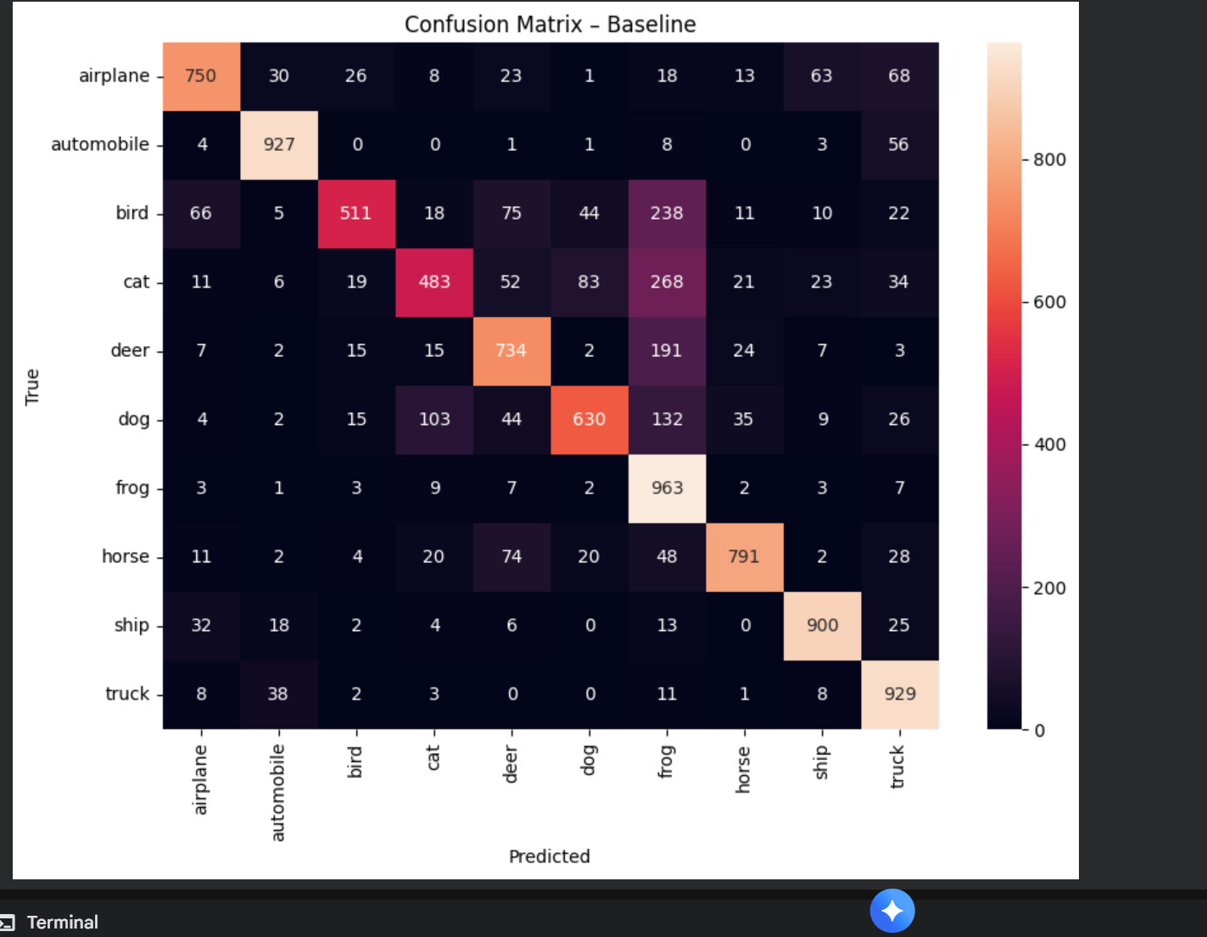
Figure 3 Confusion matrix for the baseline CNN on CIFAR-10 test set. Rows indicate true class and columns predicted class (each row sums to 1000 since there are 1000 test images per class). The diagonal cells (highlighted) show correct predictions per class.
Overall, the baseline CNN’s performance (~76% accuracy) is respectable for a relatively simple model without extensive hyperparameter tuning. Common misclassifications aligned with intuitive confusions: e.g., cats vs. dogs (both are pets with somewhat similar appearance at low resolution), or birds vs. airplanes (small flying objects in the sky). The model was very confident on vehicles (cars, trucks, ships) likely because their shapes and colours differ markedly from animals.
Three training configurations were tested for comparison. Configuration A used 30 epochs, a learning rate of 0.001, dropout of 0.4, and a batch size of 64. Configuration B used 20 epochs, a lower learning rate of 0.0005, the same dropout rate of 0.4, and a batch size of 64. Configuration C also used 20 epochs but increased dropout to 0.6 and doubled the batch size to 128 while keeping the learning rate at 0.0005.
For a fair comparison, performance after 20 epochs was examined. Figure 4 shows that configuration A reached the highest validation accuracy, reaching roughly 73% by epoch 20. Configuration B followed a similar pattern but reached about 68% by epoch 20, improving more slowly due to the reduced learning rate and likely requiring additional epochs to match A’s performance.
Configuration C performed significantly worse. Its validation accuracy plateaued around 40 - 45%, indicating strong underfitting. The combination of a high dropout rate and a large batch size limited the model’s ability to learn meaningful patterns. The large batch size also reduced the beneficial noise of stochastic gradient descent, which can lead to poorer convergence. As a result, configuration C failed to approach the performance levels of A or B.
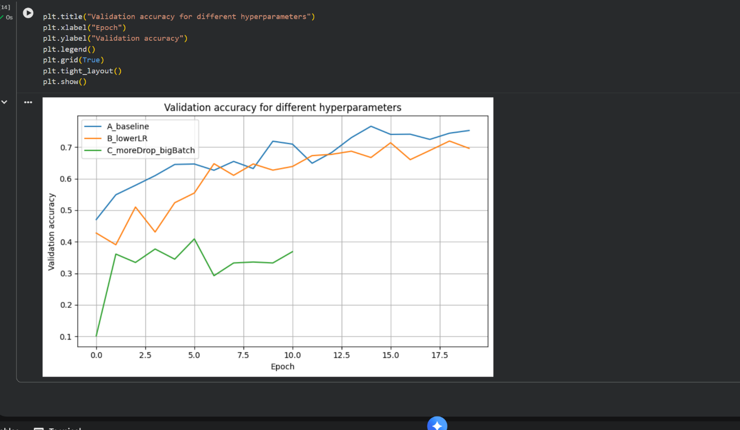
Figure 4 Validation accuracy during training for the three configurations: A_baseline (blue), B_lowerLR (orange), C_moreDrop_bigBatch (green). Baseline (A) achieves the highest validation accuracy by epoch 20 (~73%).
After training, each model was evaluated on the test set using the weights from the epoch with the best validation performance. Figure 5 shows the resulting test accuracies. The baseline model (A) reached approximately 74.7% test accuracy, slightly below the 76.2% achieved when trained for the full 30 epochs, since only the first 20 epochs are considered for comparison. Model B, which used a lower learning rate, achieved 70.6% accuracy. This reduction is expected, as a smaller learning rate often requires more epochs to reach the same level of convergence. Despite this, the result indicates that the model still had the potential to improve with longer training.
Model C performed significantly worse, achieving only 40.6% accuracy, barely above random chance for a 10-class problem. The combination of high dropout and a large batch size caused severe underfitting, limiting the model’s ability to learn meaningful features. This outcome highlights the need for balanced hyperparameter choices, as excessive regularization or overly large batches can greatly restrict model performance.
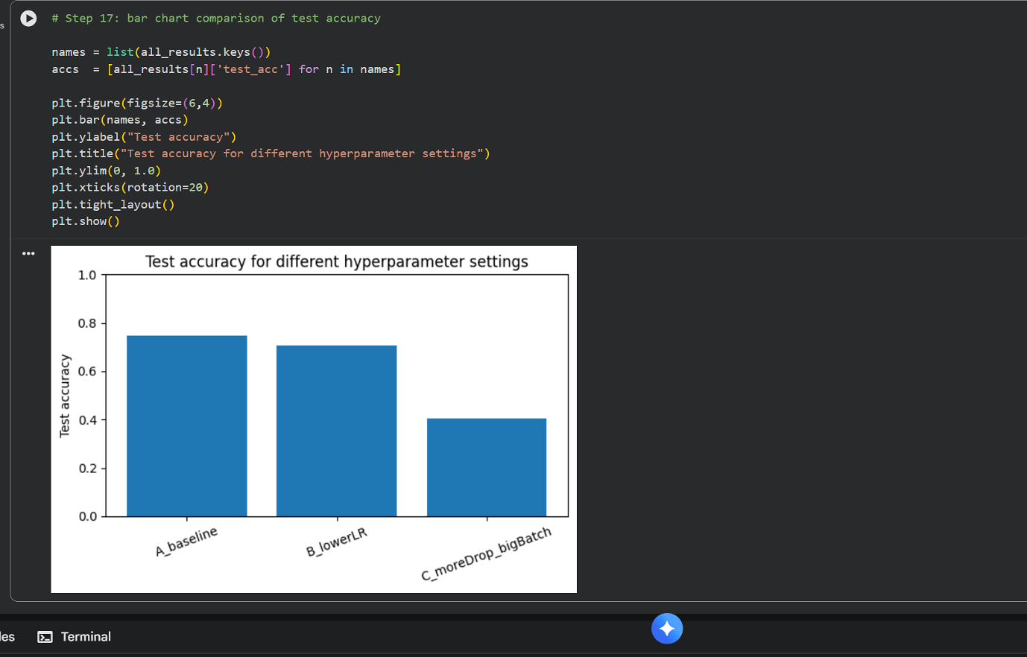
Figure 5 Test accuracies of the different models (A: baseline, B: lower learning rate, C: high dropout & big batch). The baseline (A) achieved ~74.7% test accuracy. The lower learning rate model (B) reached ~70.6%.

Discussion
The experiments highlight the importance of selecting balanced hyperparameters and appropriate regularization strength for CNN training [17]. The baseline CNN (A), using a moderate learning rate of 0.001, dropout of 0.4, and a batch size of 64, delivered the strongest results on CIFAR-10, reaching roughly 75% test accuracy after 20 epochs and about 76% when extended to 30 epochs. The model learned meaningful features, shown by solid precision and recall across most classes. The confusion matrix (Figure 3) indicates strong performance on vehicle classes, while certain animal classes remain more challenging due to the low resolution and visual similarity typical of CIFAR-10.
A comparison between Model B and the baseline highlights differences in training dynamics. With a learning rate reduced by half, Model B improved more slowly, which is expected because smaller gradient updates require more epochs to reach optimal values. By epoch 20, it had not matched the baseline’s accuracy, though validation accuracy continued increasing without plateauing, suggesting that additional training time could allow it to reach or exceed the baseline. After epoch 20, the learning rate scheduler reduced the baseline model’s learning rate to 0.0005, effectively adopting Model B’s setting for fine tuning. This combination of fast early learning and slower later refinement helps explain why the baseline achieved slightly higher accuracy within the same total epoch count.
Model C demonstrates the downside of excessive regularization. A dropout rate of 0.6 removes more than half the neurons on each update, which prevented the network from learning enough signal. Its training loss remained high and accuracy low, showing clear underfitting. The large batch size of 128 likely contributed as well; very large batches reduce gradient noise, which can harm generalization and lead to conservative updates. This combination caused Model C to remain under 50% accuracy. The results suggest that the chosen values overshot the optimal regularization range. Dropout levels around 0.3 - 0.5 are more typical for CIFAR-10, making the baseline’s 0.4 more suitable. Extremely large batch sizes also tend to require learning rate adjustments, which were not applied here.
Model capacity also plays a role in the final performance. The architecture used is intentionally simple, with three convolutional blocks and roughly 668,000 parameters. High performing modern architectures such as DenseNet or EfficientNet, which often exceed 90% accuracy on CIFAR-10, rely on many more layers, more parameters, and advanced techniques such as aggressive data augmentation or learning-rate scheduling [18]. A simpler model naturally reaches performance saturation sooner, which explains the plateau around the mid 70% range. Gains beyond this point typically require additional depth, more complex designs, or systematic hyperparameter optimization.
Batch normalization contributed to training stability across all configurations. Its ability to maintain stable activation distributions likely helped the baseline model train effectively even with a relatively high initial learning rate [19]. BN can also introduce a mild regularizing effect by adding noise during training. Although BN could not compensate for the extreme regularization in Model C, it likely prevented further instability or divergence. Its stabilizing influence made the learning rate adjustments and dropout variations more manageable throughout the experiments.
Overall, the baseline configuration proved to be the most effective for this architecture on CIFAR-10. The reduced learning rate model illustrated the trade-off between training speed and final accuracy, while the over-regularized model showed that excessive dropout and large batch sizes can severely limit learning. These outcomes align with established deep learning practice: begin with balanced defaults, adjust hyperparameters cautiously, and use techniques such as early stopping and learning rate scheduling to refine performance [20]. Further improvements could come from intermediate settings, such as moderate dropout or batch sizes, or from exploring deeper or more advanced architectures.

Conclusion
In this report, a Convolutional Neural Network was implemented to classify images in the CIFAR-10 dataset, alongside an examination of strategies aimed at improving model performance. CNNs were selected instead of RNNs due to the spatial structure of image data, a choice strongly supported by existing literature and practical evidence showing that CNNs are far more effective for visual tasks, while RNNs are designed for sequential information. The resulting model, consisting of approximately 668,000 parameters and three convolutional blocks, achieved around 75 - 76% accuracy on the CIFAR-10 test set. Several key techniques were applied, including dropout regularization to reduce overfitting by randomly disabling neurons, and batch normalization to stabilize and accelerate training by normalizing intermediate activations. Data augmentation broadened the variety of training examples, and callbacks such as early stopping and learning rate scheduling further optimized the training process.
Comparative experiments demonstrated that the baseline hyperparameter configuration was well balanced. A lower learning rate slowed training progress without delivering immediate accuracy benefits, while excessive dropout caused underfitting and significantly reduced performance. These outcomes highlight the importance of thoughtful hyperparameter tuning: moderate adjustments can yield improvements, whereas extreme values may hinder learning. Although only manual tuning was performed here, more advanced approaches such as automated hyperparameter optimization or systematic search methods could offer additional gains. Even so, the experiments conducted in this report provide valuable insight into how different settings affect training dynamics and final accuracy.
Overall, a properly designed and tuned CNN can classify CIFAR-10 images with solid accuracy. This project illustrates the complete workflow behind such a model, from dataset preparation and architectural design to training, evaluation, and iterative refinement through hyperparameter adjustments. The Appendix offers a thorough walkthrough of the full codebase to ensure reproducibility and to clarify the function of each component, including data loading, model construction, training loops, and evaluation procedures. Future developments could involve deeper architectures or more advanced techniques such as learning rate decay, alternative optimizers, or additional regularization methods like weight decay to further increase accuracy. Even so, the work presented here establishes a strong foundation for understanding how CNNs operate in image classification and how their performance can be enhanced through modern deep learning methods.

References
[1] M. M. Taye, “Theoretical Understanding of Convolutional Neural Network: Concepts, Architectures, Applications, Future Directions,” Computation, vol. 11, no. 3, p. 52, 2023, doi: 10.3390/computation11030052.
[2] A. Krizhevsky, I. Sutskever, and G. E. Hinton, “ImageNet Classification with Deep Convolutional Neural Networks,” Communications of the ACM, vol. 60, no. 6, pp. 84–90, May 2012.
‌[3] R. Ghosh and A. Kumar, “A hybrid deep learning model by combining convolutional neural network and recurrent neural network to detect forest fire,” Multimedia tools and applications, vol. 81, no. 27, pp. 38643–38660, 2022, doi: 10.1007/s11042-022-13068-8.
[4] S. Lee and C. Lee, “Revisiting spatial dropout for regularizing convolutional neural networks,” Multimedia tools and applications, vol. 79, no. 45–46, pp. 34195–34207, 2020, doi: 10.1007/s11042-020-09054-7.
[5] G. S. Nugraha, M. I. Darmawan, and R. Dwiyansaputra, “Comparison of CNN’s Architecture GoogleNet, AlexNet, VGG-16, Lenet -5, Resnet-50 in Arabic Handwriting Pattern Recognition,” Kinetik: Game Technology, Information System, Computer Network, Computing, Electronics, and Control, May 2023, doi: https://doi.org/10.22219/kinetik.v8i2.1667.
‌[6] M. Z. Alom et al., “The History Began from AlexNet: A Comprehensive Survey on Deep Learning Approaches,” arXiv:1803.01164 [cs], Sep. 2018, Available: https://arxiv.org/abs/1803.01164
‌[7] I. D. Mienye, T. G. Swart, and G. Obaido, “Recurrent Neural Networks: A Comprehensive Review of Architectures, Variants, and Applications,” Information (Basel), vol. 15, no. 9, p. 517, 2024, doi: 10.3390/info15090517.
[8] S. Divya, B. Adepu, and P. Kamakshi, “Image Enhancement and Classification of CIFAR-10 Using Convolutional Neural Networks,” in 2022 4th International Conference on Smart Systems and Inventive Technology (ICSSIT), IEEE, 2022, pp. 1–7. doi: 10.1109/ICSSIT53264.2022.9716555.
[9] N. Srivastava, “Improving Neural Networks with Dropout,” 2013. Available: http://www.cs.toronto.edu/~nitish/msc_thesis.pdf
[10] Sergey Ioffe and C. Szegedy, “Batch Normalization: Accelerating Deep Network Training by Reducing Internal Covariate Shift,” PMLR, pp. 448–456, Jun. 2015, Available: http://proceedings.mlr.press/v37/ioffe15.html
‌[11] J. Bergstra and Y. Bengio, “Random search for hyper-parameter optimization,” Journal of Machine Learning Research, Feb. 2012, doi: https://doi.org/10.5555/2188385.2188395.
[12] B. Kumar, K. Bavisetti, A. Vinay, S. Battula, K. Reddy, and A. Kumar Varma, “Performance Investigation on Image Classification Methods for CIFAR-10,” in 2024 Asian Conference on Intelligent Technologies (ACOIT), IEEE, 2024, pp. 1–6. doi: 10.1109/ACOIT62457.2024.10939672.
[13] “Comparative Analysis of CNN Architectures for Eight-Class Facial Expression Recognition: A Performance and Error Pattern Study,” Tehnicki vjesnik - Technical Gazette, vol. 32, no. 3, Jun. 2025, doi: https://doi.org/10.17559/tv-20240914001990.
[14] B. Asadi and H. Jiang, “On Approximation Capabilities of ReLU Activation and Softmax Output Layer in Neural Networks,” arXiv.org, 2020. https://arxiv.org/abs/2002.04060 (accessed Nov. 14, 2025).
[15] U. M. Khaire and R. Dhanalakshmi, “High-dimensional microarray dataset classification using an improved adam optimizer (iAdam),” Journal of Ambient Intelligence and Humanized Computing, vol. 11, no. 11, pp. 5187–5204, Mar. 2020, doi: https://doi.org/10.1007/s12652-020-01832-3.
[16] M. T. R et al., “Transformative Breast Cancer Diagnosis using CNNs with Optimized ReduceLROnPlateau and Early Stopping Enhancements,” The International journal of computational intelligence systems/International journal of computational intelligence systems, vol. 17, no. 1, Jan. 2024, doi: https://doi.org/10.1007/s44196-023-00397-1.
[17] S. Iqbal, A. N. Qureshi, A. Ullah, J. Li, and T. Mahmood, “Improving the Robustness and Quality of Biomedical CNN Models through Adaptive Hyperparameter Tuning,” Applied sciences, vol. 12, no. 22, p. 11870, 2022, doi: 10.3390/app122211870.
[18] C. Zhang et al., “ResNet or DenseNet? Introducing Dense Shortcuts to ResNet,” in Proceedings / IEEE Workshop on Applications of Computer Vision, IEEE, 2021, pp. 3549–3558. doi: 10.1109/WACV48630.2021.00359.
[19] S. Wang, X. Zhang, D. Liu, and Junchi Yan, “Unified Batch Normalization: Identifying and Alleviating the Feature Condensation in Batch Normalization and a Unified Framework,” arXiv.org, 2024.
[20] T. Yu and H. Zhu, “Hyper-Parameter Optimization: A Review of Algorithms and Applications,” arXiv:2003.05689 [cs, stat], Mar. 2020, Available: https://arxiv.org/abs/2003.05689

Appendix
Cell 1 Check TensorFlow & GPU
import tensorflow as tf

print("TensorFlow version:", tf.__version__)
print("GPU available:", tf.config.list_physical_devices("GPU"))
Cell 2 Imports & CIFAR-10 Load
import numpy as np
import matplotlib.pyplot as plt
import seaborn as sns

from tensorflow.keras.datasets import cifar10
from tensorflow.keras.utils import to_categorical
from tensorflow.keras import layers, models

from sklearn.metrics import classification_report, confusion_matrix

(x_train, y_train), (x_test, y_test) = cifar10.load_data()

labels = ["airplane","automobile","bird","cat","deer",
"dog","frog","horse","ship","truck"]

print("Training images:", x_train.shape)
print("Test images:", x_test.shape)
Cell 3 Show Sample Images
plt.figure(figsize=(10,4))
for i in range(20):
idx = np.random.randint(0, len(x_train))
plt.subplot(4,5,i+1)
plt.imshow(x_train[idx])
plt.title(labels[y_train[idx][0]])
plt.axis("off")
plt.tight_layout()
plt.show()
Cell 4 Preprocessing
x_train = x_train.astype("float32") / 255.0
x_test = x_test.astype("float32") / 255.0

y_train_cat = to_categorical(y_train, 10)
y_test_cat = to_categorical(y_test, 10)

print("x_train min/max:", x_train.min(), x_train.max())
print("y_train_cat shape:", y_train_cat.shape)
Cell 5 Data Augmentation Layer
data_augment = tf.keras.Sequential(
[
layers.RandomFlip("horizontal"),
layers.RandomRotation(0.08),
layers.RandomTranslation(0.08, 0.08)
],
name="data_augment"
)
Cell 6 Build CNN Model
def build_model(input_shape=(32,32,3), num_classes=10, dropout_rate=0.4):

inp = layers.Input(shape=input_shape)
x = data_augment(inp)

# Block 1
x = layers.Conv2D(32, (3,3), padding="same")(x)
x = layers.BatchNormalization()(x)
x = layers.ReLU()(x)
x = layers.Conv2D(32, (3,3), padding="same")(x)
x = layers.BatchNormalization()(x)
x = layers.ReLU()(x)
x = layers.MaxPooling2D((2,2))(x)
x = layers.Dropout(dropout_rate)(x)

# Block 2
x = layers.Conv2D(64, (3,3), padding="same")(x)
x = layers.BatchNormalization()(x)
x = layers.ReLU()(x)
x = layers.Conv2D(64, (3,3), padding="same")(x)
x = layers.BatchNormalization()(x)
x = layers.ReLU()(x)
x = layers.MaxPooling2D((2,2))(x)
x = layers.Dropout(dropout_rate)(x)

# Block 3
x = layers.Conv2D(128, (3,3), padding="same")(x)
x = layers.BatchNormalization()(x)
x = layers.ReLU()(x)
x = layers.MaxPooling2D((2,2))(x)
x = layers.Dropout(dropout_rate)(x)

# Dense head
x = layers.Flatten()(x)
x = layers.Dense(256)(x)
x = layers.BatchNormalization()(x)
x = layers.ReLU()(x)
x = layers.Dropout(0.5)(x)

out = layers.Dense(num_classes, activation="softmax")(x)

return models.Model(inputs=inp, outputs=out, name="simple_cifar10_cnn")
Cell 7 Compile Model
baseline_lr = 1e-3

model = build_model(dropout_rate=0.4)
model.compile(
optimizer=tf.keras.optimizers.Adam(learning_rate=baseline_lr),
loss="categorical_crossentropy",
metrics=["accuracy"]
)

earlystop = tf.keras.callbacks.EarlyStopping(
monitor="val_loss", patience=8, restore_best_weights=True
)

reduce_lr = tf.keras.callbacks.ReduceLROnPlateau(
monitor="val_loss", factor=0.5, patience=4, verbose=1
)

print(model.summary())
Cell 8 Train Baseline Model
history_baseline = model.fit(
x_train, y_train_cat,
epochs=30,
batch_size=64,
validation_split=0.1,
callbacks=[earlystop, reduce_lr],
verbose=2
)
Cell 9 Plot Training Curves
plt.figure(figsize=(12,4))

plt.subplot(1,2,1)
plt.plot(history_baseline.history["loss"], label="train_loss")
plt.plot(history_baseline.history["val_loss"], label="val_loss")
plt.title("Loss Curves")
plt.legend()

plt.subplot(1,2,2)
plt.plot(history_baseline.history["accuracy"], label="train_acc")
plt.plot(history_baseline.history["val_accuracy"], label="val_acc")
plt.title("Accuracy Curves")
plt.legend()

plt.show()
Cell 10 Evaluate on Test Set
test_loss, test_acc = model.evaluate(x_test, y_test_cat, verbose=2)
print("Baseline test loss:", test_loss)
print("Baseline test accuracy:", test_acc)
Cell 11 Classification Report & Confusion Matrix
y_pred_probs = model.predict(x_test)
y_pred = np.argmax(y_pred_probs, axis=1)
y_true = y_test.flatten()

print(classification_report(y_true, y_pred, target_names=labels))

cm = confusion_matrix(y_true, y_pred)

plt.figure(figsize=(10,8))
sns.heatmap(cm, annot=True, fmt="d", cmap="Blues",
xticklabels=labels, yticklabels=labels)
plt.ylabel("True Label")
plt.xlabel("Predicted Label")
plt.title("Confusion Matrix")
plt.show()
Cell 12 Hyperparameter Sets
hyperparameter_sets = {
"A_baseline": {"learning_rate": 0.001, "dropout_rate": 0.4, "batch_size": 64, "epochs": 20},
"B_lowerLR": {"learning_rate": 0.0005, "dropout_rate": 0.4, "batch_size": 64, "epochs": 20},
"C_moreDrop_bigBatch": {"learning_rate": 0.0005, "dropout_rate": 0.6, "batch_size": 128, "epochs": 20},
}

hyperparameter_sets
Cell 13 Helper Function
def train_one_config(name, cfg):

print("\nTraining config:", name, cfg)

model_cfg = build_model(dropout_rate=cfg["dropout_rate"])
model_cfg.compile(
optimizer=tf.keras.optimizers.Adam(cfg["learning_rate"]),
loss="categorical_crossentropy",
metrics=["accuracy"]
)

es = tf.keras.callbacks.EarlyStopping(
monitor="val_loss", patience=5, restore_best_weights=True
)
rlr = tf.keras.callbacks.ReduceLROnPlateau(
monitor="val_loss", factor=0.5, patience=3, verbose=1
)

history = model_cfg.fit(
x_train, y_train_cat,
epochs=cfg["epochs"],
batch_size=cfg["batch_size"],
validation_split=0.1,
callbacks=[es, rlr],
verbose=2
)

test_loss, test_acc = model_cfg.evaluate(x_test, y_test_cat, verbose=0)

return model_cfg, history, {"test_loss": test_loss, "test_acc": test_acc}
Cell 14 Run All Configurations
all_models = {}
all_histories = {}
all_results = {}

for name, cfg in hyperparameter_sets.items():
m, h, r = train_one_config(name, cfg)
all_models[name] = m
all_histories[name] = h
all_results[name] = r

all_results
Cell 15 Validation Accuracy Comparison Plot
plt.figure(figsize=(10,5))

for name, hist in all_histories.items():
plt.plot(hist.history["val_accuracy"], label=name)

plt.legend()
plt.title("Validation Accuracy Across Hyperparameter Configurations")
plt.show()
Cell 16 Test Accuracy Bar Chart
names = list(all_results.keys())
accs = [all_results[n]["test_acc"] for n in names]

plt.figure(figsize=(7,5))
plt.bar(names, accs)
plt.ylim(0,1)
plt.title("Test Accuracy Comparison")
plt.ylabel("Accuracy")
plt.show()
Cell 17 Best Model Identification & Evaluation
best_name = max(all_results, key=lambda n: all_results[n]["test_acc"])
best_model = all_models[best_name]

print("Best configuration:", best_name, all_results[best_name])

# Detailed evaluation
y_pred_probs = best_model.predict(x_test)
y_pred = np.argmax(y_pred_probs, axis=1)
y_true = y_test.flatten()

print(classification_report(y_true, y_pred, target_names=labels))

cm = confusion_matrix(y_true, y_pred)

plt.figure(figsize=(10,8))
sns.heatmap(cm, annot=True, fmt="d",
xticklabels=labels, yticklabels=labels)
plt.title(f"Confusion Matrix – Best Model ({best_name})")
plt.show()

