

Individual Report
Innocent Drinks – A Mission-Driven Business

Programme: BA (Hons) Leadership and Management Skills for the Workplace

Module: Strategic Management for Business

Module code: LCLM 6001
Student name: Diana Maria Boboc

Student id: 2324060

Executive Summary
The strategic position of Innocent Drinks, a UK-based business well-known for its smoothies, juices, and plant-based drinks, is examined in this paper. Through environmental pledges, ethical branding, and a unique marketing strategy, the company has established a solid reputation. Ethical branding and responsible marketing practices have become increasingly important for companies operating in the food and beverage sector, as consumers are becoming more aware of environmental and social issues (Frings, 2016). Innocent Drinks has successfully positioned itself as a brand associated with healthy lifestyles and ethical business values.
However, the company operates in a highly competitive beverage market where firms must continuously innovate in order to remain competitive. Marketing strategy plays an important role in determining how organisations position their products, attract customers and sustain competitive advantage (Stone, 2007). In addition, companies must effectively manage the marketing mix, including product, price, place and promotion, to meet changing consumer expectations and market conditions (McCarthy, 1960).
This report evaluates Innocent Drinks’ current market situation by analysing both internal and external environments using strategic tools such as SWOT analysis, PESTEL analysis and Porter’s Five Forces. These frameworks help organisations understand competitive pressures and identify opportunities for strategic development (Drummond and Ensor, 2005).
Based on this analysis, the report proposes a strategic growth option focused on expanding Innocent’s plant-based product portfolio and strengthening its sustainable packaging initiatives. Such strategies are important for maintaining brand growth and differentiation in competitive markets (Edwards et al., 2005). The proposed strategy aligns with Innocent’s mission of producing natural and healthy products while reinforcing its sustainability commitments.
Overall, the report concludes that the recommended strategy can support Innocent Drinks’ long-term growth, strengthen its competitive position and maintain its ethical brand identity in the global beverage market.

Table of Contents
Executive Summary 2
1 Introduction 4
2 Market Situation Analysis 5
2.1 SWOT Analysis 5
2.2 PESTEL Analysis 6
2.3 Porter’s Five Forces 7
3 Strategic Growth Options 8
3.1 Ansoff Matrix 8
3.2 Porter’s Generic Strategies 9
4 Recommended Strategy 9
5 Strategy Evaluation (SFA Framework) 10
5.1 Suitability 10
5.2 Feasibility 10
5.3 Acceptability 11
5.4 Conclusion of Strategy Evaluation 11
6 Stakeholder Analysis 12
7 Implementation and Monitoring 13
7.1 Objectives 14
7.2 Actions 14
7.3 Monitoring and KPIs 14
8 Conclusion 15
9 References: 16

1 Introduction
Founded in 1999, Innocent Drinks is a UK-based beverage company that focuses in plant-based drinks, juices, and smoothies. The company has developed a strong reputation for combining healthy products with a responsible business philosophy. Innocent’s mission is “to make natural, delicious food and drink that helps people and the planet live well and die old,” reflecting its commitment to both consumer health and environmental sustainability (B Corporation, 2026). This mission positions the organisation as a purpose-driven brand that integrates ethical values with commercial success.
The company’s vision is closely linked to sustainability and responsible business practices. Innocent aims to operate in a way that benefits people, communities and the environment while continuing to grow its presence in the global beverage market. As a certified B Corporation, the company seeks to demonstrate that businesses can create economic value while also generating positive social and environmental impact (Innocent Drinks, 2026). Sustainability-oriented strategies have increasingly become an important source of competitive advantage in modern organisations, particularly in the food and beverage sector (Liczmańska-Kopcewicz, 2019).
The values of Innocent Drinks emphasise responsible sourcing, environmental protection and ethical behaviour within the organisation. These values guide decision-making across the company and influence how it interacts with customers, suppliers and wider society (Innocent Drinks, 2026). Research also highlights that companies adopting sustainability-oriented strategies are more likely to generate long-term value and stronger stakeholder relationships (Sustainability Journal, 2019; Sustainability Journal, 2021). Consequently, Innocent’s mission, vision and values form the foundation of its strategic direction and brand identity.

2 Market Situation Analysis
To understand the strategic position of Innocent Drinks, it is necessary to analyse both the internal and external environment in which the company operates. Strategic management frameworks such as SWOT analysis, PESTEL analysis and Porter’s Five Forces are widely used to evaluate organisational performance and the competitive environment (Johnson, Scholes and Whittington, 2008). These analytical tools help organisations identify key internal strengths and weaknesses while also evaluating external opportunities and threats that may influence strategic decision-making.

2.1 SWOT Analysis
SWOT analysis is a strategic tool used to assess an organisation’s internal capabilities and external market conditions (Johnson, Scholes and Whittington, 2008). Innocent Drinks has several strengths that contribute to its strong market position. The company has built a powerful brand identity associated with healthy lifestyles, sustainability and ethical values. In addition, Innocent benefits from strong brand recognition and customer loyalty in the healthy beverage market.
However, Innocent also faces several weaknesses. The company operates in a highly competitive beverage market where large multinational corporations dominate market share. In addition, maintaining sustainable production and environmentally friendly packaging can increase operational costs. Nevertheless, opportunities exist due to the increasing consumer demand for healthy beverages and sustainable products (Geissdoerfer et al., 2018).

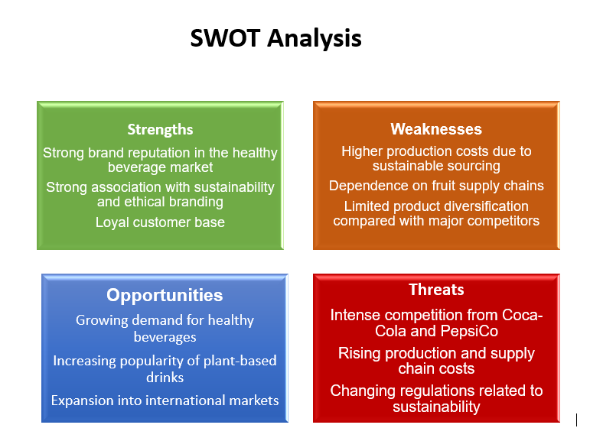
Figure 1: SWOT analysis

2.2 PESTEL Analysis
PESTEL analysis examines the broader macro-environmental factors that may influence an organisation’s strategy, including political, economic, social, technological, environmental and legal factors (Johnson, Scholes and Whittington, 2008). Political and regulatory pressures related to environmental protection and food safety increasingly influence the beverage industry. Governments and regulators are encouraging companies to reduce environmental impacts and improve sustainability practices.
Economic factors such as inflation, production costs and global supply chain disruptions may also affect beverage companies. Social factors are particularly important for Innocent Drinks because consumer preferences are shifting towards healthier and more environmentally responsible products. Research shows that sustainability and circular economy strategies are becoming increasingly important for modern businesses seeking long-term growth (Geissdoerfer et al., 2018).
Technological developments also provide opportunities for innovation in packaging, production and distribution systems. Environmental concerns such as climate change and waste reduction further encourage companies to adopt sustainable business models (Stubbs and Cocklin, 2008).
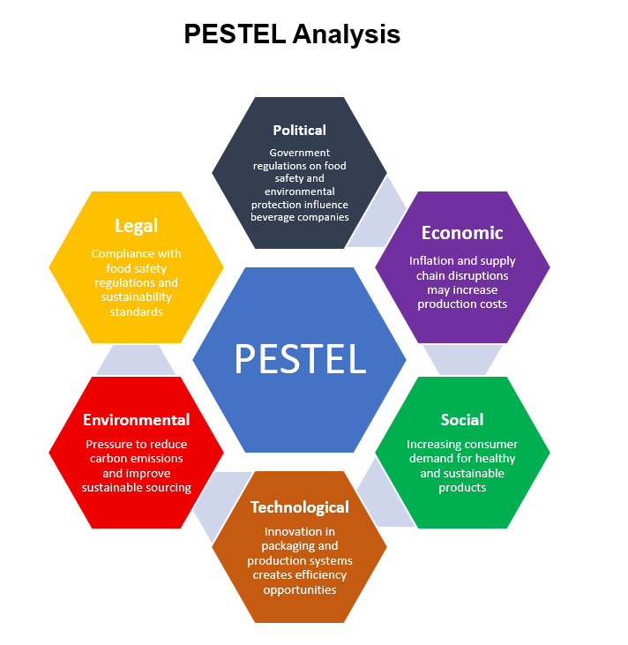
Figure 2: Pestle analysis

2.3 Porter’s Five Forces
Porter’s Five Forces framework is widely used to analyse the level of competition within an industry and identify factors affecting profitability (Porter, 2008). The beverage industry is characterised by intense competitive rivalry due to the presence of global companies such as Coca-Cola and PepsiCo. These large organisations have significant financial resources, strong distribution networks and powerful brand recognition.
The bargaining power of buyers is also relatively high because consumers have access to a wide range of alternative beverage products. The threat of substitutes is significant as customers can easily switch to other healthy drinks such as flavoured water, plant-based beverages or functional drinks.
At the same time, suppliers may have moderate bargaining power depending on the availability of raw materials such as fruit and natural ingredients. Sustainable sourcing requirements can also influence supplier relationships. Overall, the competitive forces within the beverage industry require companies such as Innocent Drinks to continuously innovate and maintain strong brand differentiation in order to sustain their competitive advantage (Geissdoerfer et al., 2018; Stubbs and Cocklin, 2008).

3 Strategic Growth Options
Identifying effective growth strategies is essential for organisations seeking to maintain competitive advantage in dynamic markets. Strategic frameworks such as the Ansoff Matrix and Porter’s Generic Strategies are widely used to evaluate alternative growth opportunities and determine the most suitable strategic direction for organisations. These models help firms align their internal capabilities with market opportunities and external environmental conditions (Johnson et al., 2008; Mintzberg et al., 2003).

3.1 Ansoff Matrix
The Ansoff Matrix is a strategic planning framework that identifies four potential growth strategies based on the relationship between products and markets: market penetration, product development, market development and diversification. The model helps organisations assess potential growth opportunities and the level of risk associated with each strategic option (Johnson et al., 2008).
For Innocent Drinks, several strategic growth options can be identified using this framework. The first option is market penetration, which focuses on increasing market share within existing markets through improved marketing strategies, distribution channels or promotional activities. However, the beverage market in the United Kingdom is already highly competitive, meaning that growth through market penetration alone may be limited.
A second option is product development, which involves introducing new products to existing markets. This strategy appears particularly suitable for Innocent Drinks because consumer demand for healthy beverages, plant-based products and functional drinks continues to increase. Companies operating in competitive industries often rely on product innovation to maintain their market position and respond to changing consumer preferences (Johnson et al., 2013).
Another potential strategy is market development, which involves introducing existing products into new geographical markets. Expanding into new regions or emerging markets may allow Innocent Drinks to increase its global presence and reach new customer segments.
Finally, diversification involves introducing new products into new markets and is considered the most risky growth strategy because organisations operate outside their existing capabilities and knowledge. While diversification may generate new opportunities, it also requires significant investment and organisational resources (Mintzberg et al., 2003).

3.2 Porter’s Generic Strategies
Porter’s Generic Strategies framework provides another important approach for analysing how organisations achieve competitive advantage. According to Porter, companies can gain competitive advantage through three main strategies: cost leadership, differentiation and focus (Mintzberg et al., 2003).
Cost leadership focuses on becoming the lowest-cost producer in an industry. However, this strategy may be difficult for Innocent Drinks because the company emphasises high-quality natural ingredients and sustainable production processes, which may increase operational costs.
Differentiation, on the other hand, involves creating unique value for customers through product quality, brand identity or innovation. Innocent Drinks has already developed a strong brand reputation associated with healthy lifestyles, ethical values and sustainability. Differentiation strategies enable organisations to distinguish themselves from competitors and create stronger customer loyalty (Johnson et al., 2008).
The focus strategy targets a specific market segment or niche group of consumers. In the case of Innocent Drinks, this could involve targeting health-conscious consumers or environmentally aware customers who value natural ingredients and sustainable business practices.

4 Recommended Strategy
Based on the analysis above, the most appropriate growth strategy for Innocent Drinks is a combination of product development (Ansoff Matrix) and differentiation strategy (Porter). Developing new healthy beverages, plant-based drinks and sustainable packaging innovations would allow Innocent Drinks to strengthen its brand identity while responding to changing consumer preferences.
This strategy aligns with the company’s mission and sustainability commitments while supporting long-term growth and competitive advantage within the global beverage market.

5 Strategy Evaluation (SFA Framework)
Evaluating strategic options is a crucial stage of the strategic management process because it helps organisations determine whether a proposed strategy is appropriate and achievable. The Suitability, Feasibility and Acceptability (SFA) framework is widely used to evaluate strategic decisions and assess whether a strategy can effectively support organisational objectives and long-term performance (Zolfani et al., 2022). The framework examines whether a strategy responds to environmental challenges, whether the organisation possesses the necessary resources to implement it and whether stakeholders are likely to support the proposed strategic direction.

5.1 Suitability
Suitability refers to the extent to which a strategy addresses the organisation’s strategic position and external environment. A suitable strategy should respond to opportunities and threats identified during strategic analysis and support the organisation’s long-term objectives (Lee et al., 2000). Research suggests that strategic evaluation models are particularly useful when organisations must align internal capabilities with external market conditions (Zolfani et al., 2022).
In the case of Innocent Drinks, the proposed strategy of product development and differentiation through sustainable and plant-based beverages can be considered suitable because it responds directly to changing consumer preferences. Increasing demand for environmentally responsible products and sustainable business practices is transforming many industries, particularly the food and beverage sector (Geissdoerfer et al., 2017). Companies that successfully adapt to these trends are more likely to maintain long-term competitive advantage and market relevance (Geissdoerfer et al., 2017).

5.2 Feasibility
Feasibility evaluates whether an organisation has the financial, technological and organisational resources required to implement a strategy successfully. Even if a strategy is attractive from a market perspective, it may fail if the organisation lacks the necessary capabilities or infrastructure to support implementation (Zolfani et al., 2022). Strategic frameworks emphasise that feasibility analysis is essential because organisational resources determine whether a proposed strategy can realistically be achieved (Lee et al., 2000).
For Innocent Drinks, the proposed strategy appears feasible because the company already has strong brand recognition, established supply chains and experience in producing healthy beverages. Furthermore, organisations that integrate sustainability principles into their business models often improve their innovation capacity and operational efficiency, making the implementation of sustainability-oriented strategies more achievable (Stubbs and Cocklin, 2008).

5.3 Acceptability
Acceptability refers to how stakeholders perceive a strategy and whether they are willing to support its implementation. This dimension evaluates potential returns, risks and the overall impact of a strategy on stakeholders such as customers, employees and investors (Zolfani et al., 2022). A strategy is considered acceptable if it generates positive outcomes while maintaining an acceptable level of risk.
Innocent Drinks’ proposed strategy is likely to be acceptable because it aligns with the company’s core values and sustainability commitments. Consumers increasingly support organisations that demonstrate environmental responsibility and ethical business practices (Geissdoerfer et al., 2017). Similarly, sustainable business models can strengthen stakeholder relationships and enhance long-term value creation (Stubbs and Cocklin, 2008).

5.4 Conclusion of Strategy Evaluation
Overall, the SFA analysis suggests that the proposed strategy is suitable, feasible and acceptable for Innocent Drinks. The strategy addresses changing consumer preferences, can be supported by the company’s existing resources and aligns with stakeholder expectations regarding sustainability and ethical business practices. Therefore, implementing a product development strategy combined with differentiation could help Innocent Drinks maintain its competitive advantage and support long-term growth in the beverage market.

6 Stakeholder Analysis
Stakeholder analysis is an essential component of strategic management because organisations must consider the interests and expectations of different stakeholder groups when implementing strategic decisions. Stakeholder theory argues that organisations operate within a network of relationships involving individuals and groups that can influence or be influenced by organisational activities (Freeman, 1984). According to this perspective, long-term organisational success depends on balancing the interests of multiple stakeholders rather than focusing solely on shareholders (Child and Marcoux, 1999). Stakeholder management therefore plays a critical role in organisational strategy and decision-making (Mainardes, Alves and Raposo, 2011).
To identify and prioritise stakeholders effectively, organisations often use the Mendelow Matrix, which classifies stakeholders according to their level of power and interest in organisational decisions. This framework helps managers determine which stakeholders require closer attention and engagement (Friedman and Miles, 2006). Stakeholders with high power and high interest should be closely managed, while those with lower levels of influence require less direct involvement but still need to be monitored.
In the case of Innocent Drinks, several key stakeholders can be identified. High power and high interest stakeholders include investors, senior management and major retail partners such as supermarkets. These stakeholders significantly influence the company’s strategic decisions and overall performance, and therefore must be closely engaged during strategy implementation.
High power but low interest stakeholders include government regulators and policy makers who influence regulations related to food safety and environmental sustainability. Their policies can significantly affect the beverage industry and therefore must be carefully monitored.
Low power but high interest stakeholders include customers and environmental organisations. These groups are particularly important for Innocent Drinks because the company promotes sustainability and healthy lifestyles as part of its brand identity. Research suggests that stakeholder engagement and responsible business practices strengthen organisational legitimacy and stakeholder trust (Greenwood, 2007).
Finally, low power and low interest stakeholders include the general public and media organisations. Although they have limited direct influence on strategic decisions, they may still affect public perception and corporate reputation.
Overall, stakeholder analysis demonstrates that Innocent Drinks must carefully balance the expectations of different stakeholder groups while maintaining its sustainability commitments and long-term strategic objectives.
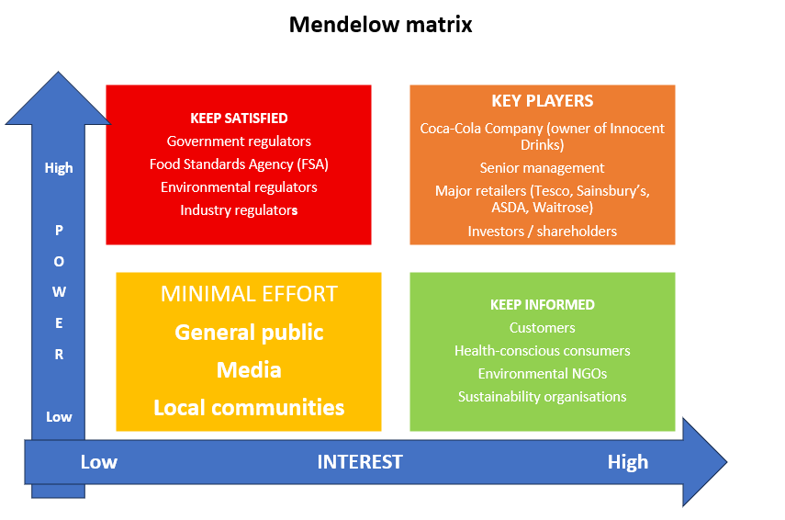

Figure 3: Stakeholder analysis

7 Implementation and Monitoring
Effective strategy implementation is essential for ensuring that strategic plans translate into organisational performance and competitive advantage. Research highlights that even well-designed strategies cannot deliver results unless they are implemented effectively through coordinated managerial actions, organisational resources and monitoring systems (Tawse and Tabesh, 2021). Strategy implementation therefore involves translating strategic objectives into operational actions and aligning organisational resources to support the execution process.

7.1 Objectives
The primary objective of the proposed strategy for Innocent Drinks is to expand the company’s plant-based product portfolio and strengthen its sustainability initiatives. Strategic objectives should be clearly defined because organisations that establish measurable goals are more likely to achieve successful strategy implementation and improved performance (Wang et al., 2020). In this context, Innocent Drinks aims to increase market share within the healthy beverage sector while also reinforcing its reputation as a sustainable and ethically responsible brand.

7.2 Actions
To achieve these objectives, several key actions are required. First, the company should invest in research and development in order to introduce new plant-based beverages and healthier product options. Second, Innocent Drinks should strengthen partnerships with sustainable suppliers to ensure responsible sourcing of ingredients and environmentally friendly packaging. Third, marketing campaigns should highlight the company’s sustainability commitments and health benefits in order to attract environmentally conscious consumers. Research suggests that successful strategy implementation depends on managerial actions, organisational capabilities and alignment between strategic goals and operational activities (Tawse and Tabesh, 2021).

7.3 Monitoring and KPIs
Monitoring performance is essential to ensure that the strategy is delivering the expected results. Organisations commonly use Key Performance Indicators (KPIs) to measure progress and evaluate organisational performance. KPIs provide quantifiable metrics that allow managers to monitor whether strategic objectives are being achieved (Setiawan and Purba, 2020). Examples of relevant KPIs for Innocent Drinks include increasing plant-based product sales, improving market share within the healthy beverage sector and reducing carbon emissions in production processes.
Furthermore, research indicates that performance measurement systems aligned with strategic objectives help organisations improve decision-making and organisational performance (Wang et al., 2020). Continuous monitoring also allows managers to identify potential challenges during implementation and adjust strategies when necessary. As a result, combining clearly defined objectives, coordinated actions and performance monitoring systems can significantly improve the effectiveness of strategy implementation (Tawse and Tabesh, 2021).
Overall, implementing the proposed strategy requires a structured implementation plan supported by clear objectives, operational actions and measurable KPIs. Through effective monitoring and performance evaluation, Innocent Drinks can ensure that its sustainability-focused growth strategy contributes to long-term organisational success.
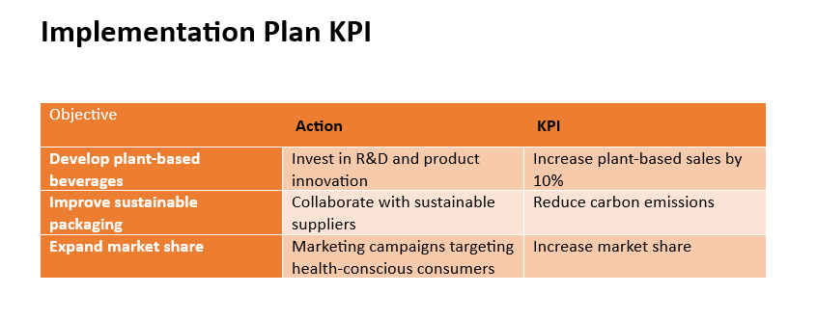

8 Conclusion
In order to help Innocent Drinks' long-term development in the cutthroat beverage market, this analysis looked at the company's strategic position and suggested growth plans. Innocent operates in a dynamic sector marked by fierce rivalry, shifting customer tastes, and rising sustainability demands, according to a review of the internal and external environment utilising strategic frameworks including SWOT, PESTEL, and Porter's Five Forces. Despite these obstacles, the business gains from a strong brand identification, moral principles, and an increasing market for sustainable and healthful drinks..
Based on this analysis, the report recommended a growth strategy focused on product development and differentiation, particularly through the expansion of plant-based beverages and sustainable product innovations. The strategy was evaluated using the SFA framework, which confirmed that it is suitable for current market trends, feasible considering Innocent’s capabilities and acceptable to key stakeholders.
Overall, the proposed strategy can strengthen Innocent Drinks’ competitive advantage while supporting its sustainability commitments. By implementing this strategy effectively and monitoring performance through appropriate KPIs, the company can enhance its market position and achieve sustainable long-term growth in the global beverage industry.

9 References:

- B Corporation (2026) Innocent Drinks – Certified B Corporation. Available at: https://www.bcorporation.net/en-us/find-a-b-corp/company/innocent-drinks/ (Accessed: 9 March 2026).
- Bonoma, T.V. (2004) Making your marketing strategy work. Available at: https://www.sciencedirect.com/science/article/abs/pii/S0007681304001016 (Accessed: 9 March 2026).
- Child, J.W. and Marcoux, A.M. (1999) Freeman and Evan: Stakeholder theory in the original position. Business Ethics Quarterly. Available at:
https://www.cambridge.org/core/journals/business-ethics-quarterly/article/abs/freeman-and-evan-stakeholder-theory-in-the-original-position/775B05AA9072EA207D8DFA485F07C909 (Accessed: 9 March 2026).
- Drummond, G. and Ensor, J. (2005) Introduction to Marketing Concepts. Oxford: Butterworth-Heinemann. Available at:
https://repo.darmajaya.ac.id/4299/1/Graeme%20Drummond%2C%20John%20Ensor%20-%20Introduction%20to%20Marketing%20Concepts%20%282005%29.pdf (Accessed: 9 March 2026).
- Drummond, G. and Ensor, J. (2005) Introduction to Marketing Concepts. London: Routledge. Available at:
https://books.google.co.uk/books/about/Introduction_to_Marketing_Concepts.html?id=k-unP_bEKFMC (Accessed: 9 March 2026).
- Freeman, R.E. (1984) Strategic Management: A Stakeholder Approach. Boston: Pitman.
- Friedman, A. and Miles, S. (2006) Stakeholders: Theory and Practice. Available at:
https://onlinelibrary.wiley.com/doi/abs/10.1002/9781405164771.ch1 (Accessed: 9 March 2026).
- Frings, L. (2015) The Marketing Strategy of Innocent Drinks. Munich: GRIN Verlag. Available at:
https://www.hausarbeiten.de/document/368133 (Accessed: 9 March 2026).
- Frings, L. (2016) The Marketing Strategy of Innocent Drinks. Available at:
https://dolgozattar.uni-bge.hu/53097/ (Accessed: 9 March 2026).
- Frings, L. (2016) The Marketing Strategy of Innocent Drinks. Available at:
https://www.researchgate.net/publication/317350919_The_Marketing_Strategy_of_Innocent_Drinks (Accessed: 9 March 2026).
- Greenwood, M. (2007) Stakeholder engagement: Beyond the myth of corporate responsibility. Journal of Business Ethics. Available at:
https://link.springer.com/article/10.1007/s10551-012-1276-8 (Accessed: 9 March 2026).
- Huff, A.S. and Reger, R.K. (1982) Strategic management research. Strategic Management Journal. Available at: https://sms.onlinelibrary.wiley.com/doi/abs/10.1002/smj.4250030306 (Accessed: 9 March 2026).
- Innocent Drinks (2026) A bit about us. Available at: https://www.innocentdrinks.co.uk/a-bit-about-us (Accessed: 9 March 2026).
- Innocent Drinks (2026) Our values. Available at: https://www.innocentdrinks.co.uk/fancy-a-job/our-values (Accessed: 9 March 2026).
- Karaarslan, E. and colleagues (2021) Strategic evaluation and performance measurement. Available at:
https://www.tandfonline.com/doi/full/10.1080/14942119.2021.1914809 (Accessed: 9 March 2026).

- Liczmańska-Kopcewicz, K. (2019) Corporate social responsibility and sustainable enterprise development. Sustainability. Available at: https://www.mdpi.com/2071-1050/11/20/5808 (Accessed: 9 March 2026).
- Mainardes, E., Alves, H. and Raposo, M. (2011) Stakeholder theory: Issues to resolve. Available at:
https://www.emerald.com/cg/article-abstract/19/1/44/51007/Stakeholder-management-a-systematic-literature (Accessed: 9 March 2026).
- Okumus, F. (2001) Towards a strategy implementation framework. International Journal of Contemporary Hospitality Management. Available at: https://www.emerald.com/ijchm/article-abstract/13/7/327/123082/Towards-a-strategy-implementation-framework (Accessed: 9 March 2026).
- Setiawan, I. and Purba, H. (2020) A systematic literature review of key performance indicators implementation. Available at: https://www.sciencedirect.com (Accessed: 9 March 2026).
- SSRN (2018) Strategic management and competitive advantage. Available at:
https://papers.ssrn.com/sol3/papers.cfm?abstract_id=3130530 (Accessed: 9 March 2026).
- Sustainability Journal (2021) Sustainable business strategies and value creation. Available at: https://www.mdpi.com/2071-1050/13/5/2508 (Accessed: 9 March 2026).
- Tandfonline (2001) Strategic management and business strategy frameworks. Available at:
https://www.tandfonline.com/doi/abs/10.1080/13921525.2001.10531717 (Accessed: 9 March 2026).
- Tawse, A. and Tabesh, P. (2021) Strategy implementation: A review and an introductory framework. European Management Journal. Available at: https://www.sciencedirect.com/science/article/abs/pii/S0263237320301316 (Accessed: 9 March 2026).
- Wang, X. et al. (2020) Conceptual framework for strategic management and organisational performance. Available at: https://onlinelibrary.wiley.com/doi/full/10.1155/2020/6253013 (Accessed: 9 March 2026).
- Wang, X. et al. (2022) Strategic modelling approaches for decision making. Available at:
https://www.mdpi.com/2227-7390/10/14/2401 (Accessed: 9 March 2026).
- World Scientific (2018) Strategic management perspectives. Available at:
https://www.worldscientific.com/doi/abs/10.1142/S1363919618500391 (Accessed: 9 March 2026).
- Zolfani, S.H., Bazrafshan, R., Yazdani, M. and Ecer, F. (2022) Combining the Suitability-Feasibility-Acceptability (SFA) strategy with multi-criteria decision making. Available at:
https://casopisi.junis.ni.ac.rs/index.php/FUMechEng/article/view/8001 (Accessed: 9 March 2026).

