Coursework: Written Report

Module: International Financial Management

Module Code: LCBB6002

Lecturer: Dr. Thomas Adeyemi

Assessment 1

Student: Lachezar Dimitrov

Student Number: 1915922
Table of Contents
Introduction 3
Understanding Foreign Exchange Risks 3
Evaluation of FX Risk Management Strategies 5
Analysis 7
Conclusion 8
References 8

Strategies for Managing Foreign Exchange Risks: A Comprehensive Evaluation

Introduction
The in realm of international financial management, the MNC organization faces several challenges in managing their finances. For an MNC organization, there are several challenges they face at the time of performing foreign exchanges. In this report, we will perform an crtcial analysis of the diverse strategies adopted to perform foreign exchanges, identify the challenges, mitigate all those risks, gain insights from IFM theories. The foreign exchange has been gained by making volatility on exchange rate, profound impact on cash flow at MNC, manage profits and gain competitive positioning. The adoption of foreign exchange risks might causes volatility in managing exchange rates. It is necessary to analyze the IFM theories to evaluate the risk management strategies. The analysis of foreign exchange risks might cause several volatility in exchange rate and cash flow that are performed internally on the organization. The MNC operates under variety of approaches in foreign exchanges, there are several management approaches are involved including transaction, tradition and economic risks. To perform the border transaction, there are more urgent exposed in managing exchange rates and adopt FX risks. This report will provide comprehensive analysis of strategies for managing foreign exchange risks and provide broad understanding on FX risk management. By understanding complexities in FX, MNC can able to provide actionable insights in proceeding international finance on market effectively.

Understanding Foreign Exchange Risks
For the multinational organizations, it is essential to understand the foreign exchange risks that might takes place. While operating in a global market, there are several fundamental risks that an multinational corporation is facing. The adoption of foreign exchange cause several risk due to fluctuation in exchange risks. Due to the exchange rates, there are several negative impacts and uncertainties are taken place including MNC cash flow, profitability and competitiveness.
Based on the analysis, the three financial risks that MNC were facing are
- Transaction risks
- Translation risks
- Economic risks
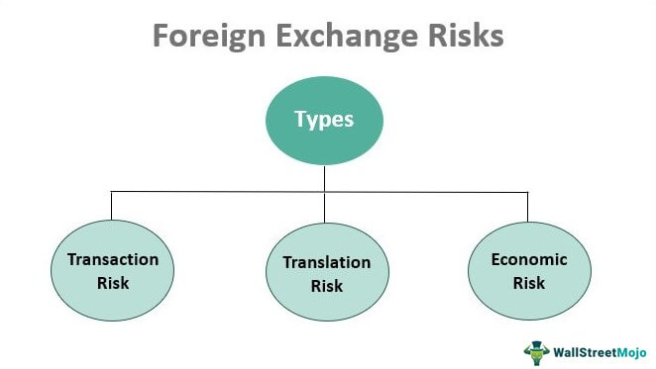
Figure 1 Foreign Exchange rates
The transactional risk is one of the primary risks that every MNC might face at the time of making transaction with foreign countries. The transactional risks is caused due to additional contractual cash flows. Due to the adoption of cash flows, there are huge dominance in exchanging foreign currency with other countries.
Similarly, the translation risks occurs on organization due to utilization of same financial statement. In this, there are several foreign subsidiaries are taken place to manage their reporting. There are several risks occurred in exchange rates that affect the asset valuation, liability, revenue calculation and spent expenses. In overall these kind of variation on assets and liabilities affect overall financial performance and net worth.
At the same time, the economic risks is one of the fundamental risk that occurs on operating exposure. These kind of fluctuation affect their entire cash flows and competitive position. To address this, the team is required to address the modification on demand and pricing strategies. The economic issues might take place were addressing cash flows to manage additional demands. The risks needs to be addressed based on changes in demand, cost structure, pricing strategies and market shifts. All these are occurring at the changes in exchange rates based on competitive pricing models
To manage the risks occurs on exchange rates for MNC, there are several strategies are adopted including forward contracts, operational issues. The strategies includes contract forwarding, operational, adjustments, geographical diversification and match with additional revenues. By adopting all these approaches, the international organization can adopt natural hedging, matching revenue and support with strategic management as a part of long term contracts in managing operational functions.
The better understanding on the implication of foreign exchange risks, the MNC should adopt appropriate management strategies. The adoption of these strategies are supportive to enhance financial performance and foster a resilience of volatile global economic conditions.

Evaluation of FX Risk Management Strategies
The foreign exchange risk management is one of the essential step that should be adopted in MNC for addressing barriers. To manage the risks effectively, the team should navigate additional complexities occurs on financial market. Based on the evaluation, the foreign exchange risk management strategies are evaluated and some of the strategies were identified. The common FX risk management strategies were discussed in the following.
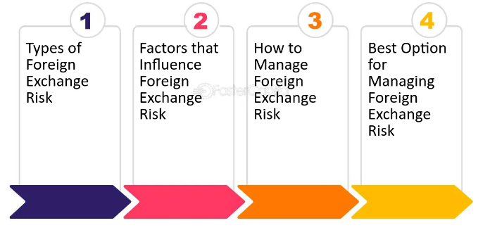
Figure 2 Common Evaluation steps
- Financial Hedging Techniques
Most of the multinational corporation were using forward contracts to performing their transaction. These kind of process utilized in future exchange rates has been blocks. According ti the research conducted, the author have status that forward contracts are quite complex and it is not so effective in performing deviations. This even cause several deviation and does not ale to cover the interest rate parity effectively.
They have also recommended to adopt some option for multination corporate to adopt Provide flexibility but come with costs and imperfect correlation risks.
- Operational Strategies
Currently the organization are involving in presenting invoices to manage their home currency. By keeping the currency stable, they can able to reduce their overall exposure rate. These kind of operation in local market affect the competitiveness. In future, the geographical diversification on operation might affect the MNC gain and one region gets non beneficial and other one is highly beneficial.
At that time, the geographical diversification on operations for MNC is supportive. There are more empirical studies shows that Geographical diversification can offset FX losses but yields mixed results.
- Natural Hedging
This is about matching of revenue and costs to manage their overall revenue stream. There are more expenses are taken place due to translation and transaction risks. By adopting all those risks, there are several perfective risks are involved that might gets affected due to market dynamics. There are more MNC are adopted. The leading and lagging of performance causes delay in payment. It is highly effective to mitigate from foreign exchange risks. The adoption of that approach will able to create an effective workplace and to manage their regulatory compliance in treating cash flows.
- Strategic Management
Long-term Contracts is an effective strategy that grows stability but may face renegotiation challenges. These kind of model will helpful in stabilizing revenue and costs on a workplace but it will reduce the foreign exchanges and causes complexities in contracts. Centralized Treasury Management is essential to streamlines FX risk management but decentralized operations offer local market responsiveness.
In overall, there are several FX risk management strategies are adopted that will address both challenges and limitation on enhancing effectiveness of specific circumstances to involve in financial transaction. This is more essential to address additional risks and to tailor with risk exposure. The MNC is recommended to integrate with multiple strategies for mitigating additional foreign exchange risks. The continuous monitoring and evaluation of all these risks and uncertainty at the time of foreign exchange is essential. This will helpful in adopting continuous monitoring techniques for remaining organization objective and to meet evolving market conditions.

Analysis
Based on the analysis of complexity of foreign exchange risk management, the MNC should adopt an holistic and dynamic approaches. Based on the careful evaluation, the common strategies are addressed and focuses on competitiveness to mitigate from foreign exchange risks, fluctuation and uncertainties. The analysis of FX risk management’s strategies are essential
- The financial hedging technique support forward contact and enhance flexibility on implementing these strategies.
- The currency invoicing model, the team should strike a balance between risk mitigation and market penetration.
- There are several leading and lagging strategies are adopted to meet operational realities and achieve perfect heading to enhance feasibility and effectiveness.
- The long term contact will enhance control and adapt to overall changing market conditions.
In addition to that the long term viability, contextual consideration, importance of monitoring and implementation of multiple strategies will supports to optimize risk management outcomes. In addition to that they can able to tailor with approaches and enhance control on local dynamics for treating risk management outcomes. The adoption of these strategies will meet resilience and competitiveness in FX risks.

Conclusion
Thus the report have presented comprehensive analysis on the management of foreign exchange risks that taken place in MNC. It is adopted with multifaceted approach that is informed by international finance management theories on managing their overall budgeting option. The analysis presented variety of management techniques and supported with adjustments. The strategies that I discussed in this report were financial hedging techniques, operational adjustment, strategic management and natural hedging that are discussed to mitigate the risks occurs on foreign exchanges. There are several hedging strategies are adopted t manage their risks effectively. This report have presented with holistic and adaptive approaches for managing uncertainties occurs on foreign exchange market. There are several continuous monitoring approach has been undertaken to enhance their FX risk management practices. This helps to align with evolving market condition and managing FX risks and manage organization goals. This report acts an guideline to maintain agility in response to changing circumstances. In overall, the analysis is more supportive for MNC in enhancing their resilience and competitiveness on global marketplace.

References
Astuti, D. D., Fadah, I., Sukarno, H., & Nurhayati, .. (2018). Determinants of capital structure and its impact on firm value on manufacturing companies at Indonesia stock exchange (IDX) and Thailand stock exchange (SET). Proceedings of the Journal of Contemporary Accounting and Economics Symposium 2018 on Special Session for Indonesian Study. https://doi.org/10.5220/0007017204810491
Avutswa, N. O., Oluoch, O., & Olweny, T. (2018). Effect of contemporaneous exchange rate changes on value of multinational Nonfinancial companies listed at Nairobi securities exchange. International Journal of Scientific Research and Management (IJSRM), 6(07). https://doi.org/10.18535/ijsrm/v6i7.em06
Bartram, S. M. (2021). What lies beneath: Foreign exchange rate exposure, hedging and cash flows. SSRN Electronic Journal, 123-144. https://doi.org/10.2139/ssrn.905087
Berghöfer, B., & Lucey, B. (2019). Fuel hedging, operational hedging and risk exposure — Evidence from the global airline industry. International Review of Financial Analysis, 34, 124-139. https://doi.org/10.1016/j.irfa.2014.02.007
Ihrig, J. E. (2018). Exchange-rate exposure of multinationals: Focusing on exchange- Rate issues. SSRN Electronic Journal, 10(4), 140-154. https://doi.org/10.2139/ssrn.282569
Jain, A. (2021). Exchange rate and its determinants in India. SSRN Electronic Journal, 123-144. https://doi.org/10.2139/ssrn.2177284
Lookman, A. A. (2019). Does hedging increase firm value? Comparing premia for hedging 'Big' versus 'Small' risks. SSRN Electronic Journal. https://doi.org/10.2139/ssrn.501182
O'Brien, T. J. (1998). Accounting versus economic exposure to currency risk. SSRN Electronic Journal. https://doi.org/10.2139/ssrn.53363
Ozerturk, S. (2003). Costly managerial hedging, market liquidity and firm value. SSRN Electronic Journal, 20(3), 140-154. https://doi.org/10.2139/ssrn.431400
Sero, J. E., & Prior, D. M. (2023). The effect of exchange rate fluctuations on multinationals' returns. SSRN Electronic Journal. https://doi.org/10.2139/ssrn.460600

