Ransomware Report
Contents
1. Introduction 1
2. Ransomware 1
2.1 What is ransomware? 1
2.1.1 Why they are dangerous 2
2.1.2 How they are spread 2
2.2 How it could affect you. 2
3. Cryptowall 2
3.1 What is Cryptowall? 2
3.1.1 Who was it aimed at? 2
3.1.2 How it infects computers 2
3.1.3 Types of files it encrypted 2
3.2 How was it removed? 2
3.2.1 Payment 2
3.2.2 File Recovery Software 2
3.2.3 Backup Solutions 2
4. Pre-emptive measures 2
4.1 Backup Solutions 2
4.1.1 On Prem solutions 2
4.1.2 Cloud solutions 2
4.2 Antivirus Software 2
5. References 2

Introduction
This report will cover various topics regarding a type of malware called Ransomware. It will cover what is ransomware, why it is dangerous and who it can affect, a well-known ransomware called Cryptowall and how it impacted businesses and individuals, as well as finally covering how to prevent and protect yourself against any and all forms of malware.

Ransomware

What is ransomware?
Ransomware is a type of computer virus (malware) that locks access to your computer and/or data and requests a sum to unlock it and return it to you, within a set time. If the sum is not paid, then your data is deleted and unrecoverable. [1]
A recent notable example of a ransomware attack would be the 2017 WannaCry Attack on the NHS in the UK, which was caused due to a security exploit that existed on older versions on Windows. [2]

Why they are dangerous
Ransomware is unique when compared to other malware, as its sole purpose is to extort the end user for money, or to steal their information and sometimes both, which could impact business heavily. [3]
Antivirus Organisation Sophos reported that in 2023 66% of respondents stated that they faced a ransomware attack, with the more value the company is worth, the higher likelihood they faced an attack. [4]
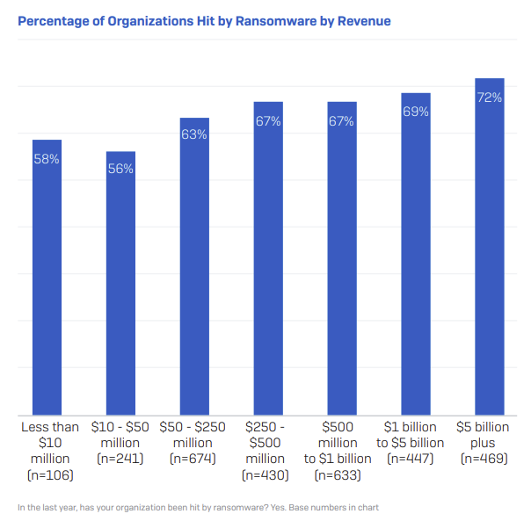 [4]

How they are spread
This type of malware is typically spread by infecting normal looking documents and links, a common example would be via a phishing link, which works by the user clicking on it and downloading a seemingly safe document to your computer, which is infected with the ransomware. [5]
As computers within a company or organization are often linked to one another via domains, or a shared network drive, it is also easier to spread the malware and encrypt other documents. [5]

How it could affect you.
Forbes has stated that this type of malware targets organisations due to more data and higher valued data available to be stolen, as the average person may not have any important files, thus making the ransom worthless. [6]
Furthermore, they target companies as the data stolen can be sold for a higher price which in turn allows for a larger ransom to be demanded, as well as the “damaged reputation from a security breach.” [6]

Cryptowall

What is Cryptowall?
Cryptowall is a type of ransomware that was released in 2014 and has gone through various iterations to decrease the likelihood of detection and making it harder to remove via various methods. [7]
Cryptowall has gone through various iterations, starting with version 1.0 and now at 5.0. These versions all aimed to improve the ability to root itself within the device and make recovery less possible, and to further coerce the user into paying the ransom. [8] [7]

Who was it aimed at?
It did not have any specific target, it infected as many people as possible, which made it particularly dangerous as it affected businesses and individuals. The FBI [9] released a statement about the rise of Cryptowall, who it was aimed at and and how it “impacts victims beyond the ransom fee itself”.

How it infects computers
This type of malware is spread by clicking infected links, opening attachments and phishing emails, as it embeds itself within these. [9] [7]
Newer versions of Cryptowall have enhanced infection capabilities, Michael Buckbee [7] states that it roots itself in the operating system, while deleting all shadow volumes in case the user tries to restore the encrypted files.
The Cyber Threat Alliance [10] provides an infographic on how it spreads, as seen below.
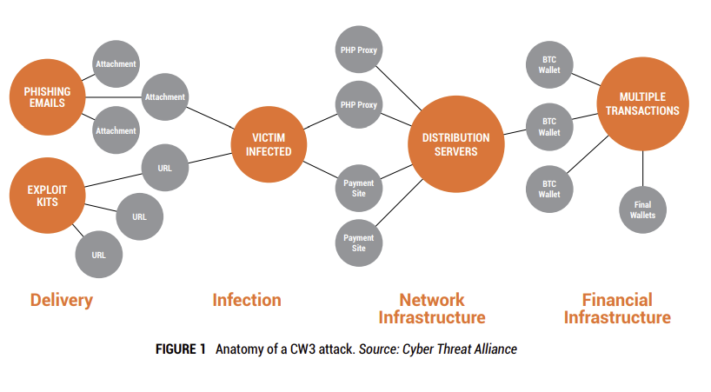 [10]

Types of files it encrypted and how
Michael Buckbee [7] states that it can infect a large variety of file extensions, as seen below.
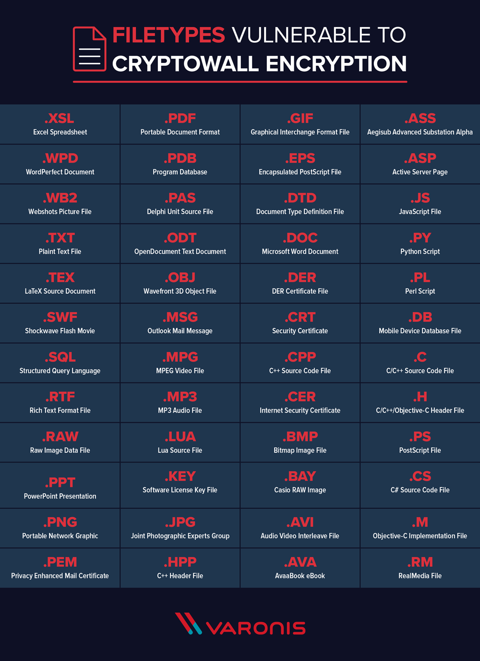 [7]
Newer variants of Cryptowall have been stated to use AES encryption, whereas in previous versions it would use RSA encryption to lock files [8] [7]. It would encrypt both the file name and file extension, so that the user could not attempt to find it via name and restore a backup [8] [7].
It also encrypted any removable drives, shared drives and even cloud services that were linked to file explorer, such as OneDrive. [11]

What happens to an infected computer?
Once the infection has happened and files have been encrypted, it would display a message explaining how to pay the ransom and get the decryption key [8]. Newer versions of Cryptowall display an updated message that belittles the user and makes them believe that paying the ransom is the only way to get their data back. [12]
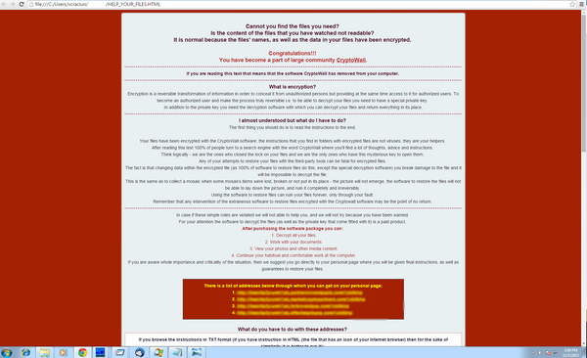 [12]

How was it removed?
Cryptowall has a variety of ways it could be either decrypted or removed, however the best method of removal is prevention.

Payment
The first option was to simply pay the fee, which would allow you to obtain the decryption key and get access to your computer, however this is not suggested as according to Michael Buckbee [7] only 19% of users get access to their files back.
Furthermore, if they do release your files, the malware can still be on your system embedded in the OS, recording and selling your private information online and leaving you vulnerable to an attack again in the future. [3]

File Recovery Software
While file recovery software is a better option than paying the ransom, the trouble is that the malware often removes any file recovery solutions, such as deleting shadow volume copies [8] and disabling windows services [7].
It also encrypts not only the data, but the file names as well, therefore trying to find a file and restore it based on name is also near impossible [7] [13].

Backup Solutions
This is the best way to remove Cryptowall, as any backups of data, including anything from a full disk copy to important documents on an external drive, such as a NAS, allows you to keep the files without any risk of residual infection. In this case, it would be best to completely reset the device, to fully get rid of any trace of the virus and import the documents onto a fresh system [3, p. 6] [5].

Preventative measures
When dealing with Malware, there are many preventative measures that we can apply beforehand to deal with a potential attack in the future, these range from various backup solutions to antivirus software.
It is highly recommended to use both solutions listed below in tandem, to create a secure backup solution that can work effectively, even if one is unavailable at that time.

Backup Solutions
A backup solutions main purpose can be split into two sub-categories, the first is to recover data after it is lost and the second is to recover data from previous version, however both are ultimately archiving data [14]. Two examples of this might be to retrieve an accidentally deleted file and to retrieve data from a document that might have been overwritten.

On Prem solutions
An on-premises solution refers to having the backup readily available in person, in this case these are usually in the forms of backup to a NAS (Network Attached Storage) or another external storage device. [15]
This is a good method of prevention as in the case of any data loss or theft, it can immediately be retrieved internally with minimal downtime and you have direct control over your data, which makes it very secure. [15] [16].
However, the downside to this is that these backups need to be taken manually, which involves human error and checked manually in case of corruption. There is also the initial cost, as these require physical implementations which can be too costly for some [15] [16].

Cloud solutions
Cloud solutions refer to backups being taken and stored by a third party, which are accessible over the internet, popular solutions of this include Dropbox, OneDrive and GDrive [15].
The benefits of Cloud Solutions are that they are cost-effective, being relatively cheap per terabyte of storage, and they do not require any maintenance by the user. [15] [16]
The downside of Cloud Solutions are that they are usually only accessible via the internet, which in times where the internet is unavailable or blocked will be useless, and that the data stored is managed by a third party, in the case of an attack on their side your data may be unretrievable, making it less secure. [15] [16]

Antivirus Software
Antivirus software is a good preventative measure as it will actively scan any downloaded documents, all emails and attachments if you use a desktop client and can stop any potential malware from infecting your device, it is important to choose a reputable and reliable antivirus as to best protect yourself. [17]
There are both paid and free antivirus software, Windows and Macs now both have built-in antivirus software on all supported versions, but it is recommended to get a paid version.

What else to do
Other paths you can take to defend yourself are to make sure your computer is up to date at all times, as this means you are less susceptible to security vulnerabilities, keeping your antivirus up to date and finally to not click any suspicious links or attachments [5].

References

[1] | M. P and S. F, “National Cyber Security Centre,” NCSC Publications, 11 09 2023. [Online]. Available: https://www.ncsc.gov.uk/blog-post/ransomware-cyber-crime-ecosystem. [Accessed 08 11 2023].
[2] | NHS, “National Health Service England,” 21 04 2023. [Online]. Available: https://www.england.nhs.uk/long-read/case-study-wannacry-attack/. [Accessed 08 11 2023].
[3] | HM Treasury Office of Financial Sanctions Implementation, “Ransomware and Sanctions,” 02 2023. [Online]. Available: https://assets.publishing.service.gov.uk/media/63e4f0c58fa8f50507f59c16/Ransomware___Sanctions_guidance__Feb_2023_.pdf. [Accessed 08 11 2023].
[4] | Sophos, “The State of Ransomware 2023,” 17 05 2023. [Online]. Available: https://www.sophos.com/en-us/content/state-of-ransomware. [Accessed 08 11 02023].
[5] | M. Albin, “Malware and Ransomware,” 9 10 2021. [Online]. Available: https://ciso.uw.edu/education/risk-advisories/malware-and-ransomware/. [Accessed 08 11 2023].
[6] | T. Moore, “Forbes,” 23 06 2022. [Online]. Available: https://www.forbes.com/sites/forbestechcouncil/2022/06/23/ransomware-attacks-are-earning-big-by-staying-under-the-radar/. [Accessed 08 11 2023].
[7] | M. Buckbee, “The State of CryptoWall in 2018,” 09 05 2022. [Online]. Available: https://www.varonis.com/blog/cryptowall. [Accessed 11 08 2023].
[8] | Sophos, “The current state of ransomware: CryptoWall,” 17 12 2015. [Online]. Available: https://news.sophos.com/en-us/2015/12/17/the-current-state-of-ransomware-cryptowall/. [Accessed 10 11 2023].
[9] | Federal Buerau of Invesitgation (FBI), “FBI Warns Public of Cryptowall Ransomware Schemes,” FBI San Diego, 25 06 2015. [Online]. Available: https://www.fbi.gov/contact-us/field-offices/sandiego/news/press-releases/fbi-warns-public-of-cryptowall-ransomware-schemes. [Accessed 10 11 2023].
[10] | Cyber Threat Alliance, “Lucrative Ransomware Attacks: Analysis of the CryptoWall Version 3 Threat,” Cyber Threat Alliance, 2015.
[11] | D. S. C. T. U. T. Intelligence, “Secureworks,” 27 08 2014. [Online]. Available: https://www.secureworks.com/research/cryptowall-ransomware. [Accessed 10 11 2023].
[12] | A. Gheorghe, “Bitdefender,” 05 11 2015. [Online]. Available: https://www.bitdefender.co.uk/blog/hotforsecurity/cryptowall-4-0-returns-to-the-wild-posing-as-good-guy/. [Accessed 10 11 2023].
[13] | A. Zaharia, “Everything You Need To Know About CryptoWall,” 14 02 2022. [Online]. Available: https://heimdalsecurity.com/blog/cryptowall-ransomware/. [Accessed 10 11 2023].
[14] | D. Ince, Backup, Oxford: Oxford University Press, 2019.
[15] | S. Heiney, “Impero,” Impero Solutions Ltd, 05 05 2021. [Online]. Available: https://www.imperosoftware.com/blog/on-premise-vs-cloud-solutions-whats-the-difference/#:~:text=the%20internet%20to%E2%80%A6-,On%2Dpremise%20IT%20solutions%20are%20those%20in%20which%20data%2C%20applications,via%20the%20so%2Dcalled%20cloud.. [Accessed 10 11 2023].
[16] | N. Hazdun, “Cloud Versus On Premises: Advantages And Disadvantages Of Both Models,” 27 03 2023. [Online]. Available: https://www.forbes.com/sites/forbestechcouncil/2023/03/27/cloud-versus-on-premises-advantages-and-disadvantages-of-both-models/. [Accessed 10 11 2023].
[17] | NCSC, “What is an antivirus product? Do I need one?,” National Cyber Security Centre, 21 01 2019. [Online]. Available: https://www.ncsc.gov.uk/guidance/what-is-an-antivirus-product#:~:text=Antivirus%20products%20work%20by%20detecting,and%20other%20types%20of%20malware.. [Accessed 10 11 2023].

