Carlie Hughes – 1703030
BA Photojournalism and Documentary Photography
Contextual Studies: Ways of Perceiving
M4X01559

Within todays society we face a major problem with drug and alcohol abuse, leading to many individuals being treated for various addictions. It is thought that in the UK around 1 in 12 adults aged 16-59, have taken illegal drugs within the last year; this means that around 2.7 million individuals pose the risk of needing treatment through the NHS, due to addiction linked mental health issues (NHS, 2018).
The NHS deal with daily hospital admissions with a primary diagnosis of drug related mental or behavioural disorders. Within the last year there have been 8,621 hospital admissions by individuals that require treatment due to taking illegal substances, with 15,074 hospital admissions being presented as poisoning due to the illegal drugs. These figures show that drug related mental health problems are on the rise, presenting at 6% higher than 2015/16, with over a 50% increase from 2005/6 (NHS, 2018).
These addiction problems are creating a major strain on the NHS that is already struggling with staffing and funding. Photographers that document real life photographs of addiction circumstances, can be a way of portraying the devastating consequences of taking illegal substances to the wider public, which could act as a deterrent through eliciting fear.

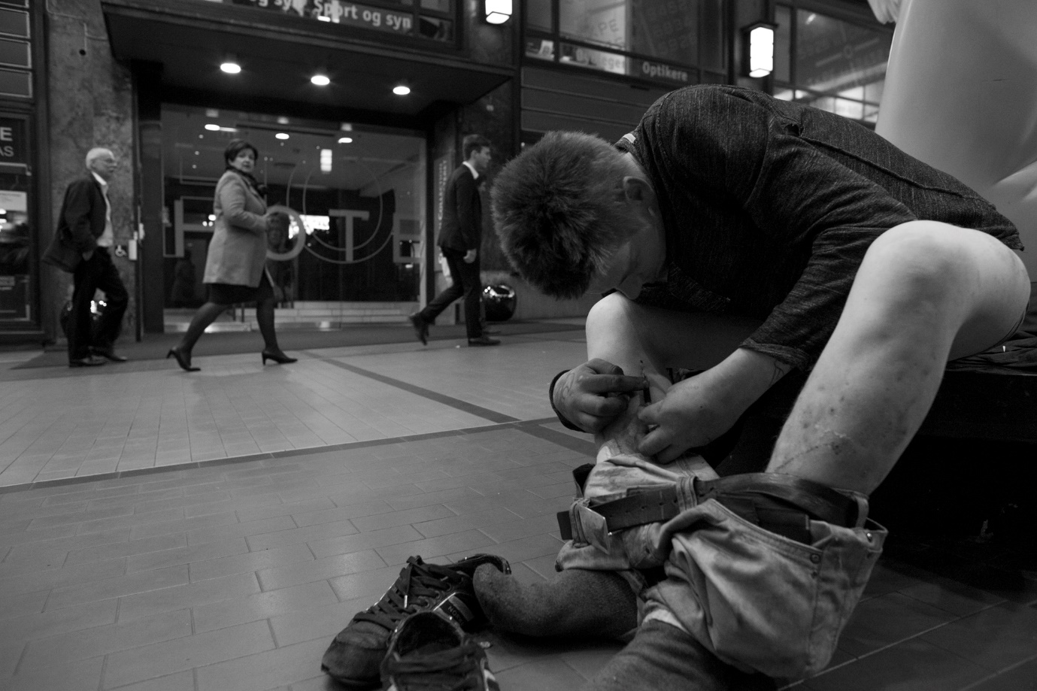Figure 1 – ‘Drug Addicts’ By Warren Richardson
The real life of a drug addict is rarely seen by those that dabble with different illegal substances. It is a common thought that ‘I won’t get addicted’ or ‘I only do it socially’, but no one ever thinks ‘I’m going to get addicted to this stuff’.
Warren Richardson is an Australian photographer, that currently works in Eastern Europe capturing important human and environmental issues, such as addiction. Richardson has been incredibly influential in the field of documentary photography when capturing addictions, as his photographs are incredibly real and shocking to the everyday person. The photograph above portrays the reality of life behind addiction and the severity of the need for more substance. The image is very controversial as it presents a man injecting himself in the middle of a busy town centre, as well as the disapproving looks from passers-by (Richardson, 2018).

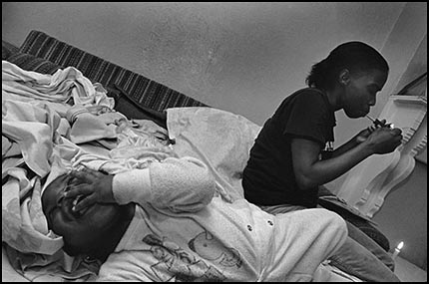
Figure 2 – ‘Cocaine True, Cocaine Blue’ By Eugene Richards

Eugene Richards is an activist photographer who works in the USA on different civil rights issues. He has worked alongside many different medias and governments, as well as publishing several books and films. The photograph above comes from ‘Cocaine True, Cocaine Blue’ one of Richards many books. The book focuses on the life of an addict and the surrounding environment that they live.
The photograph above evokes a lot of emotion from the viewers as it is quite startling. It portrays how much one’s priorities change when being an addict. It shows that even with family responsibilities, the user’s main objective is to get his fix. As a crying baby is present within the image, it brings out a lot of anger and hatred towards the user. This image could be used as a deterrent for drugs, as it really does portray the reality of life as an addict (Hempenstall, 2009).

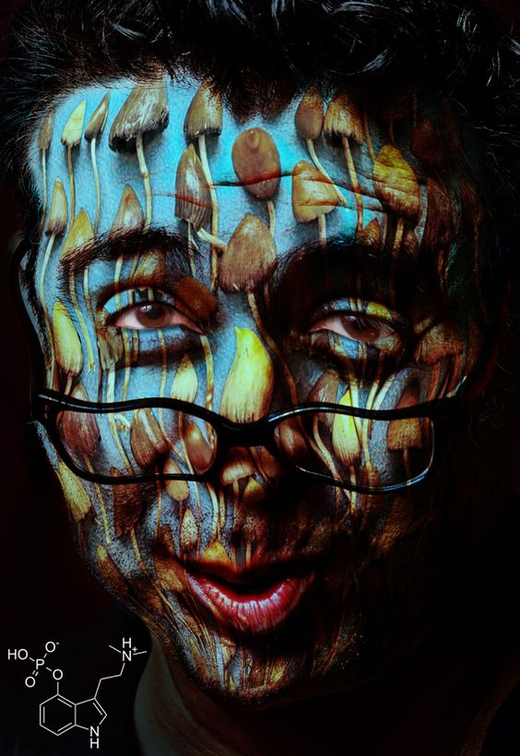
Figure 3 – ‘No Matter What You Think’ By Les Baker
Les Baker is a New Mexico based photographer that takes photographs of people peaking on different drugs, presenting the diverse effects of each individual drug. Les Baker’s INEBRI-NATION project portrays a powerful message about drug abuse. “The individuals featured in this series showcase the diversity of those who use mind-altering substances, they include students, servers, doctors, soldiers, layers, Politian’s, mothers, fathers, artists, teachers, police officers, fire fighters and judges”.
Baker initially materialized this idea while bartending. After working in many different types of bar work, he began to notice side effects of other substances. His aim was to try and capture some of the experiences that he witnessed during his time working in bars and clubs, as well as present that drug abuse is not only limited to those on the streets, it consumes all walks of life (Marks, 2016).

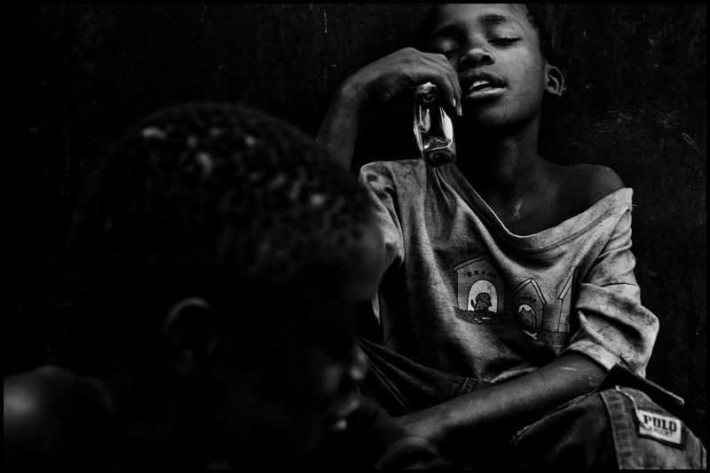
Figure 4 – Child Drug Addicts, By Zoriah Miller
Zoriah Miller is an American Photojournalist that focuses on capturing images of child drug abuse in 3rd world countries. Zoriah thinks that it is important to see that drug abuse is happening all around the world, and even worse within third world countries. Just because it is less published it does not mean that it does not happen.
During his last trip to Uganda, Zoriah spent a large amount of time in the slums photographing the lives of children that live amongst poverty. Within this area, drug addiction has a whole different meaning to that in the western world. While away Zoriah realised that there were hundred of thousands of young children reliant on drugs to get by. Out in Africa the drug of choice is glue as it is cheap… one of the main reasons that children get addicted to the substance is that it is often cheaper than food and takes away the feeling of hunger (Blakeney, 2011).
This photograph evokes many different emotions as it portays young children being addicted to harmful substances. A natural human instinct is to feel sorry for the child having to go through such trauma at such a young age. This is why Zoriah is so well regarded for his photographs as he pushes the boundaries of photojournalism.
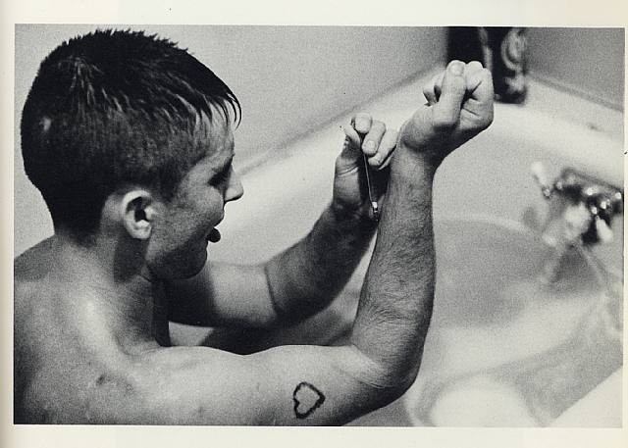
Figure 5 – Tulsa, By Larry Clark
Larry Clark is a photographer from Oklahoma, who started photographing his self addiction while he was injecting different substances during his younger years. The photograph series ‘records his secret teenage life’. Clarks photography is particularly disturbing for viewers today as it depicts the ease of access to such substances and weapons, as well as the reality of suburban America (O'Hagan, 2014).
This photograph is very startling to the viewer as the black and white effect emphasises the brutal reality of drug addiction. Knowing the background of the photograph and knowing that he was capturing his own battle with addiction, enhances the effects of the image.

All the photographs above present the reality of drug addiction, each image shows different effects of drug addiction and the prevalence of them within todays society. If these photographs were more established within today’s society, maybe individuals would contemplate the consequences of drug taking before they become addicted to the substances. Using such images in a way that could deter individuals from addiction means that there could be less of a burden on the NHS as less individuals would be entering A&E or being referred to the hospital for treatment.

References

Blakeney, A. (2011, 07 07). Child Drug Addicts. Retrieved from Zoriah: http://www.zoriah.net/blog/2011/07/child-drug-addicts-drug-abuse-among-children.html
Hempenstall, D. (2009, 10 19). Eugene Richards. Retrieved from Journal: http://journal.davidhempenstall.com/?p=598
Marks, A. (2016, March 18). The Photographer Capturing People on Drugs. Retrieved from Creators: https://www.google.co.uk/amp/s/creators.vice.com/amp/en_uk/article/jpvny4/drug-portrait-photographer
NHS. (2018). Statistics of Drug Misuse. Retrieved from NHS: https://digital.nhs.uk/data-and-information/publications/statistical/statistics-on-drug-misuse/statistics-on-drugs-misuse-england-2017
O'Hagan, S. (2014, 06 05). Larry Clark's Photographs; "Once the Needle goes in, It Never comes out". Retrieved from The Guardian: https://www.google.com/amp/s/amp.theguardian.com/artanddesign/2014/june/05/larry-clark-tolsa-teenage-lust-photography-controversy
Richardson, W. (2018). Norwegian Drug Addicts. Retrieved from Warren Richardson: https://www.warrenrichardson.com/drug-addicts

