Game Design and History
Ashanti Taylor / 2304545

Ryse: Son of Rome [1] was released on November 22, 2013, developed by a German studio called Crytek and published by Microsoft Studios as an Xbox One exclusive. Crytek is also known for their other titles, Farcry, Crysis and The Climb being the most recognisable to consumers. ESRB rated Ryse M for Mature, so its primary target audience was 18–25-year-old males. The 6-hour action-adventure game was initially intended to be an Xbox 360 Kinect release but was later altered to be the Xbox One’s flagship title. Ryse offers QTE-infused combat and cinematic cutscenes. QTEs in Ryse have little incentive to follow through, executions can become repetitive and be exploited as temporary invincibility, however. Both historical and fantastical elements are interwoven in its storyline. Set in Ancient Imperial Rome, in the age of Nero (the fifth and final empire of Rome’s first dynasty), we can assume the date to be around AD 54. Its historical background feels respectful, but also unique—it takes liberties with non-fiction historical figures and occurrences to make it feel fresh to Roman history enthusiasts, simultaneously making it more user-friendly overall since the player does not need to know Roman history to understand the story Ryse tells. The understanding and digestibility of the story a game is trying to tell can elevate the game experience overall. We play as Marius Titus, whose family was slain early on by the game’s portrayed enemies- the Barbarians. As Marius, we then travel with the Roman army to Britannia to seek revenge. As a player, we may feel emotionally invested in this story and/or relate to Marius. We are instantaneously encouraged to defeat and brutally execute the Barbarians in defence-like settings. At first, we are fighting against an invasion of Rome, using various methods such as throwing pilas(also dubbed pilums or javelins, which are accurate to the Roman Empire’s history, as the Roman army would commonly use these), utilising shields (aiding in Ryse’s ‘parry’ system) and short swords (‘gladius hispaniensis’, a ubiquitous weapon amongst Roman legionaries, generals, and emperors[2]). The usage of weapons carries on throughout the game, with the addition of how the player will be encouraged at many points during the game to use canons. The Barbarians however are differentiated from the Roman army, Heavy Barbarians in specific using axes, clubs, and bows and arrows.
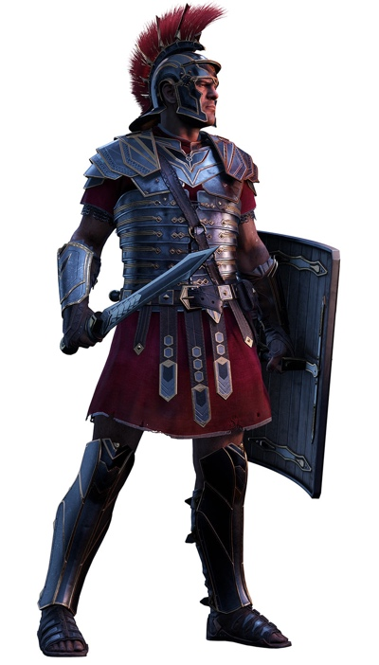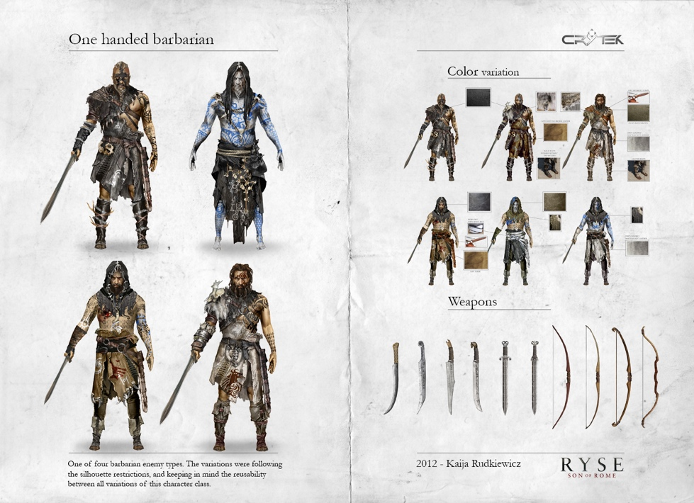
(Marius Titus screencap, One-Handed Barbarian Concept Art by Kaija Rudkiewicz)

Its visual style is gritty and gory, yet realistic. The graphics from Ryse are outstanding for a 2013 release and still hold up very well in the current day. Where Ryse finds much success, is in its environments. The environments the player is led through are all believable in accordance with its time setting and are beautifully crafted. Good environment design is integral to games, Ryse being no different. It allows the player to feel thoroughly immersed in the game, as though it is its own universe worthy of protection (a main theme in Ryse). It plays a crucial role in setting the mood in Ryse, the first sections of the game being Rome in peril. Fires, smoke, and debris all litter the streets; yet, we see glimpses of normality still, seen near the food market the player runs through in one of the traversal-intermission sections. Ryse also takes advantage of lighting and shadows to set moods, allowing the player to feel even more engaged in the world of Ryse. The Xbox Hub covers this, stating that “Lighting and shadows are powerful [themes] game environment artists use to enhance immersion. The interplay of light and shadow adds depth, realism, and atmosphere to the game world. It can evoke different moods, from the warmth of a sunrise to the eerie ambiance of a dimly lit dungeon.” [3] Crytek as a studio have created fully immersive, gorgeous worlds, especially seen in The Climb, a Virtual Reality (VR) release. As the player traverses as Marius, they can feel the weight of his armour, the strength of his attacks, and the knock-back if Marius is hit. The screen will shudder, a partial greyscale overlay (to emulate blood and/or bleeding) will appear, and Marius will stumble as visual cues.
(Displaying the penalty of getting hit, ending the player’s streak/combo).

(Displaying Ryse: Son of Rome environment design. Screenshots taken in-game and from a video playthrough [4].)

Character design is where Ryse both succeeds and lacks in. The Barbarians as designs are dark, grungy, and wild, representing exactly what this opposing force stands for and has been through. The Heavy Barbarian, for example, wears a bear’s skin for warmth, but the player can also infer this as a trophy— perhaps the Heavy Barbarian had slain this bear in a perilous battle previously, and uses it as an intimidation tactic. Materials we most commonly see on The Barbarians are leather, animal fur, and rope, whilst the colours are blacks, browns, tans and blues. Good character design can tell stories visually, we can tell a lot about a character without any dialogue needed, and that is exactly what occurs with The Barbarians in Ryse. The Roman army has been designed to juxtapose The Barbarians; utilising clean, yet battle-damaged metals such as iron or bronze. Colour themes we see within the Roman Army are bright reds, silver, golds, and browns. Kyle Deguzman, a blogger who has a Bachelours of Science in Television, Film, and New Media, states that for character designs, the goal is to give them personalities and details that make them iconic and serve as a vehicle of a story [5]. However, the biggest challenge in Ryse is in the number of enemies(hordes), so the player will often see duplicates of the same character. This saves money and time for the developers but offers little interest from the player's side- we aren’t invested in their storylines anymore. When the player must fight against numerous Barbarians wearing bear skins, they start to simply become obstacles, rather than substantial characters with stories to tell.

(The player can see the difference between The Barbarians and The Roman Army based on their silhouettes alone, since The Barbarians have sharper, messier shapes whilst The Roman Army has very sleek and simplistic silhouettes.[6])
On its original platform, the Xbox One, haptic feedback from the controller is also a cue of impact for the player. For immersive, engaging feedback systems in games, sound and visual effects are essential tools for game designers. In Ryse, its expert use of visual and audio feedback makes the game much more exciting. Hearing the clashing of swords, the booms of canons in the distance, and the shouts of our enemies and comrades—it is all very thrilling for the player to experience. MadVFX, a community that aids in the improvement of gameplay VFX, states that audiovisual effects can let the player know what caused an event or result in-game. It reminds users of the link connecting their actions and results each time they occur—thus, when a conflict becomes more intense, the players will likely remember what to input to get the result they want [7]. The risk factor in Ryse is balanced and simplistic; if you are hit, the combo the player builds up from dodging, parrying, and hitting enemies is disrupted, and Marius takes damage, thus his health is decreased. However, a unique aspect of Ryse is how you can alter the payout of finishing an enemy mid-fight. The player can scroll between refilling focus (focus in Ryse is used to temporarily slow down time, so it is easier for the player to execute enemies), and a time-limited damage output increase, health regeneration, or an immediate boost in experience points (EXP) earned.
(In-game screenshot demonstrating the incentive for players to continue. More valor and more EXP, means more brutal executions, health upgrades, focus and more).

Ryse: Son of Rome has a ‘hordes of enemies’ system, which in typical fashion, can let the player be as creative as possible with their execution methods and how to get rid of as many enemies at once. However, Ryse only offers a singular method of taking out enemies— QTE executions. They are brutal, and gruesome in their animations, but Ryse expects the player to feel satisfied despite so many limitations in place- which it fails at. Chris Crawford suggests that intense conflict necessitates a short game [8], Ryse adheres to this, but the sour lack of freedom Ryse gives its players affects the experience and makes it feel less interactive and more repetitive. The game flow is also simplistic, from a battle to a cutscene, rinse and repeat. It makes Ryse feel like an interactive movie since it is so linear. It does include minor choices at specific points throughout the game, for example, the player has a choice to “TARGET THE SIEGE TOWERS” so fewer enemies pile through, but you will have randomised projectiles and AOEs. On the other hand, you can “TARGET THE SIEGE ENGINES” where you won’t have those projectiles and AOE-based attacks, but you will have a lot more enemies. S. Björk and J. Holopainen state “For a game to be a game at all, the players have to be able to make what they feel are interesting choices. This means that the choices must have seemingly different effects that are meaningful. If these conditions are met, players can feel that they have freedom of choice within the game system.” [9] Ultimately, these immediate choices do not affect the story whatsoever, but give the illusion of such to a first-time player. Thanks to its short, linear story and lack of options to spice up combat, its replay value is very little. The exception to this is how the player unlocks ‘Legendary’ difficulty once beating the game, this is the hardest difficulty level since the amount of damage Marius takes is amplified. Matched with the hordes of enemies and managing combat bonuses and combos, it makes for much more of a challenge.

When talking about Ryse’s game-flow, typically during a period of high stimulation is not the best time to convey information, yet Ryse integrates heavy story cutscenes in between engaging combat segments. Players may find the difference jarring—people who prefer story-driven games and are immersed in the story of Ryse will find the combat sections to be boring, whilst people who prefer combat will find the story to drag. Ryse does not strike a medium between the two, shrinking the target demographic to only people who enjoy both story and combat. Sean Baron states “Whilst the player can handle a lot of audiovisual information at one time, they have their limitations. Once their attention has been divided, critical processing restrictions occur. When task-relevant information has been presented too quickly or when multiple sources of stimulation are competing for our attention.” [10], it may be a struggle for players to give their full attention to both, especially since the storyline is so stimulating. Traversal between combat is not very interactive, the player does not have a manual jump option, and essentially run around looking for highlighted aspects of the environment, or blue drapery to lead you where to walk nearby. The player might find themselves getting lost simply because of how little they are permitted to wander from the main path. Movement feels clunky at times and the camera is hardly at the most optimal angle. Occasionally, Marius’ body covers the execution, not allowing the player to see which colour the enemy is highlighted which is integral to the player’s combat combo and game-flow overall. It is essential for the player to feel a sense of progression to aid in the game’s flow, but Ryse misses this, limiting the player in various ways, such as melee weapon choices, styles of combat and little exploration.

Overall, Ryse: Son of Rome is a game full of brutal executions, gorgeous environments, stunning character designs, poorly matched with a lacklustre combat system, and little incentive to play and replay. All of this adds up to the mediocre title of Ryse: Son of Rome. If the average consumer is looking for the one game to prove the power of their Xbox One, it's absolutely, positively Ryse, however. The game is a visual feast, but what may have let Ryse down is its lack of timelessness in theme and the lost sensation of progress. What the player learns in the tutorial is what they will be doing all the way through the end of the game, taking away that sense of accomplishment and progress, that ultimately led to Ryse’s downfall.

Reference List / Bibliography

[1] Ryse: Son of Rome. [Software], Redmond, Washington: Microscoft Studios, 2013.

[2] C. J. Campbell, “The weapons of the Roman Legionary: An in-depth guide,” TheCollector, https://www.thecollector.com/weapons-roman-legionary/ (accessed Nov. 1, 2023).

[3] TXH, “The importance of Game Environment Design for Video Games,” TheXboxHub, https://www.thexboxhub.com/the-importance-of-game-environment-design-for-video-games/ (accessed Oct. 30, 2023).

[4] Gamer’s Little Playground, “RYSE: SON OF ROME Gameplay Full Walkthrough / No Commentary 【FULL GAME】4K HDR” YouTube, https://www.youtube.com/watch?v=wBekMcc5aJk&ab_channel=Gamer%27sLittlePlayground (accessed Oct. 17, 2023)

[5] K. DeGuzman, “What is Character Design - tips on creating iconic characters,” StudioBinder, https://www.studiobinder.com/blog/what-is-character-design-definition/ (accessed Nov. 1, 2023).

[6] K. Rudkiewicz, “Ryse: Son of Rome Character Concept Art by Kaija Rudkiewicz,” Concept Art World, https://conceptartworld.com/news/ryse-son-of-rome-character-concept-art-by-kaija-rudkiewicz/ (accessed Nov. 1, 2023).

[7] “Gameplay Visual Effects in Games,” MadVFX, https://mad-vfx.com/vfx-in-gameplay/ (accessed Nov. 1, 2023).

[8] C. Crawford, Chris Crawford on Game Design. Indianapolis, In. New Riders, 2003.

[9] S. Björk and J. Holopainen, Patterns in Game Design. Boston, Mass: Charles River Media, 2006.

[10] 2012 Sean Baron, “Cognitive Flow: The Psychology of Great Game Design,” Game Developer, https://www.gamedeveloper.com/design/cognitive-flow-the-psychology-of-great-game-design (accessed Nov. 1, 2023).

