Student Name: Francine Jones
Student Number: 1701891
Programme of Study: Fine Art
Module: M4X01559

Curation, commentaries and composition
For my exhibition I would like to hold it at mission gallery based in Swansea as it a small local gallery which is extremely perfect for the feeling I am attempting to portray as I would like a personal, deeply intimate and small viewing experience for the audience to be able to fully understand and analyse the artwork in the curated space. Exploring the idea of feminist, strong women artists work was definitely the direction I wanted to go. I looked at the idea of women’s bodies and the sexualisation behind them, also the suggestion of women doing what they want to do and not letting anyone lead their life is an area I find extremely interesting and powerful. For placement I wanted to space out the pieces to create their own impact without being closely situated together as I feel the viewer will be able to appreciate the art more as there are no distractions when admiring the pieces. All of the four artists I chose to exhibit play with the idea of pushing art further to become a powerful statement rather than a pretty image, They explore the sexualisation of women and their bodies and the impact that has in society. Feel the idea of feminism is such an important topic due to the fact that there are still people out there that do not understand the topic of feminism this is within the same idea as the Artist Suzanne Lacy when she quoted “the goal of Feminist art was to influence cultural attitudes and transform stereotypes." (The Art Story, 2018) Before feminism, the majority of women artists were invisible to the public eye. (The Art Story, 2018).
For my curation I chose four artists that I find represent feminist art in a way I found crucial, they all build on the broad idea of the woman body but convey it all in different ways. I am curating the work of Elly Smallwood, Yapci Ramos, Marilyn minter and Hannah Wilke.In this curation space there is a curved wall area which I feel is the main focus of the room therefore I wanted to place my most interesting piece in this spot as it will more than likely be the first thing you see, For this I decided on placing the Elly Smallwood figurative oil painting there as it it’s a conversation piece. Due to the wall being curved I would like to hang this painting from the ceiling I also feel this would bend the idea of fragility when it comes to women which contrasts to the idea of strength that I want to portray. I wanted to place both Yapci Ramos Rosi y Mari from the Perras y Putas series and Marilyn Minter’s thigh gap pieces opposite each due to them sort of connecting with a similar aspect of an idea. The image Rosi y Mari is from a series called Perras y Putas which is a collection of photographs that are living portraits of the women behind the word prostitute although more commonly applied to them as “putas” (Perras y Putas, 2018). Marilyn Minter’s thigh gap painting displays a blurred image of a woman’s private area I feel it links to the work of Yapci Ramos due to its qualities. The last image I’ve decided to curate is Hannah Wilke’s Beware of Fascist Feminism for this piece I decided to place it by the entrance doors as I feel it’s an opening piece of work as it was done in the wake of negative critical responses from feminists to her Starification series (The Art Story, 2018).
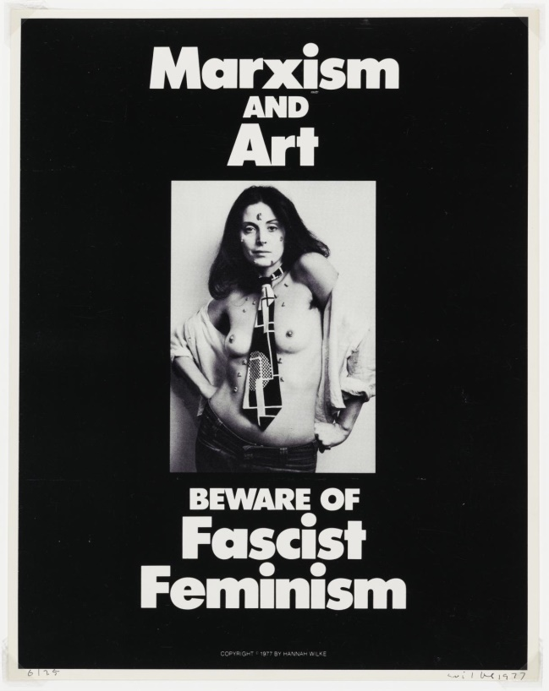

Hannah Wilke, Marxism and Art: Beware of Fascist Feminism, 1977

This piece was made at the start of getting negative critical responses from feminists after one of her series. At a time when Feminist art was in its infancy theoretically many feminists were uncomfortable with Wilke's use of her own body, especially because it was conventionally beautiful (The Art Story, 2018).In her response to the critics she exposes the feminists who would critic her on how she uses her own body (as men had always policed women's bodies) by referring to these critics as fascists. It was only by taking control of her own representation that she was able to draw attention to the objectification of women. (The Art Story, 2018).

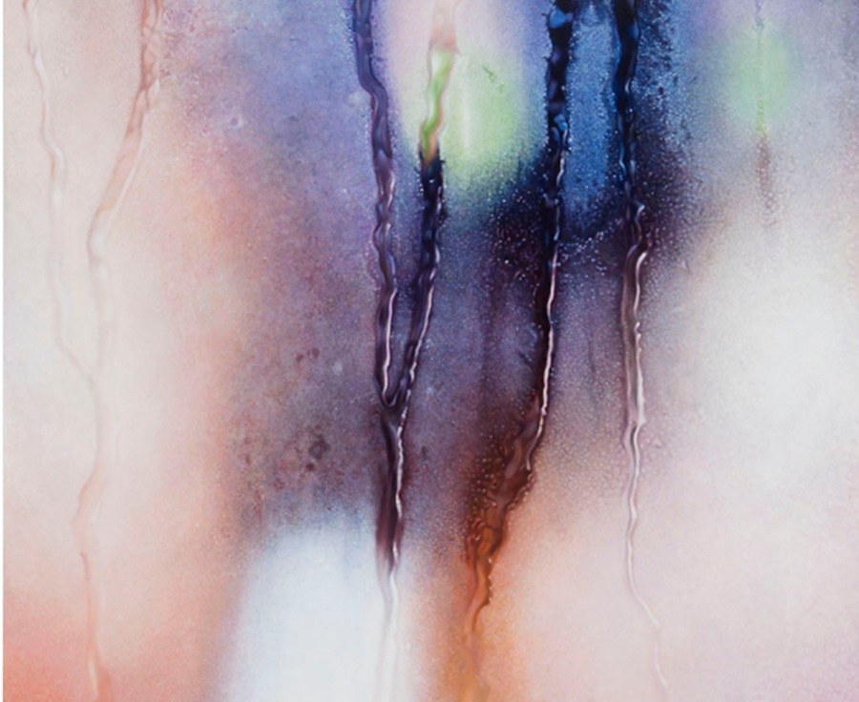

Marilyn Minter, thigh gap, 2016
This unique enamel on metal piece explores a different outtake on a woman’s genitals by blurring the area it creates the idea of the area being very personal and not for others to see. I feel it plays on the thought of owning your body while others sexualising a woman’s body therefore It goes extremely well with the other pieces in the curation.
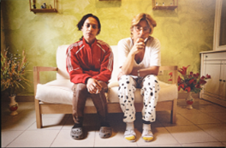

Yapci Ramos, Rosi y Mari, 2010 Perras y putas, 2015, New York
In the exhibition I am going to show this piece by Artist Yapci Ramos Rosi y Mari it is one of the photographs from her series focusing on Putas. She has dedicated her art career to turning her lens on social justice, by documenting the lives of prostitutes around the world. These collections of photographs illustrate the emotional world for these women (Art Nerd New York, 2018).It explores the idea of doing what you want to do with your body and not caring about others opinions.
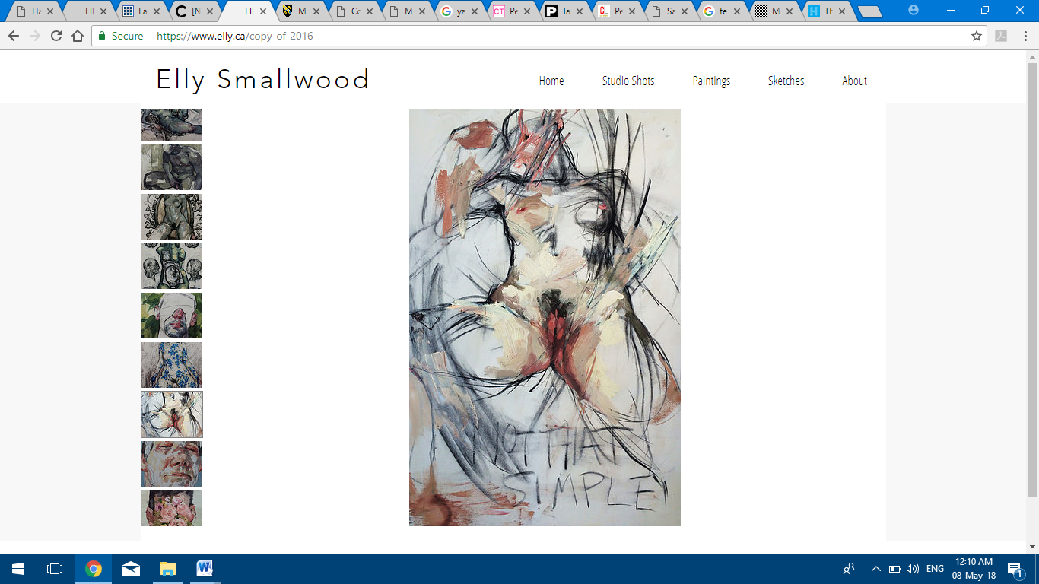

Elly Smallwood, Figurative, 2016
The final piece of work within this exhibition would be by the artist Elly Smallwood, who created the piece figurative (2016).This piece explores the idea of femininity and sense of a woman that is physically and emotionally in touch with herself. In capturing people at their most vulnerable and raw, she creates pieces that are both aesthetically and emotionally layered. In each piece of her work the viewer may see a state of mind that feels like déjà vu, like those private moments we've kept to ourselves (Creators, 2018). The painterly brush strokes give a sense of meaning and almost an aura to the oil painting which conveys a personal feeling to the viewer, the use of bold words such as “not that simple” give off the sense of personal possession, that it’s your own body and as a woman even if the outlook is suggestive you’re not easy to “get”. One of the reasons I want this piece within the exhibition is the bold qualities and All the artists I chose play with the idea of pushing art further to become a powerful statement rather than a pretty image which is something I really want to be portrayed in this curation.

Map of the Exhibition

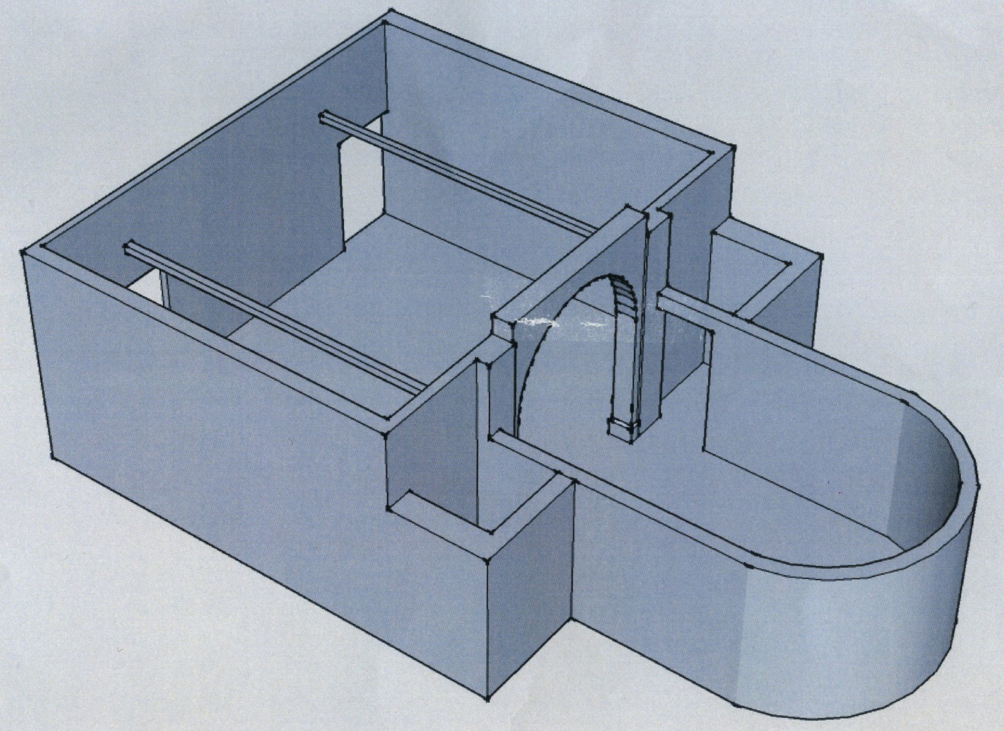
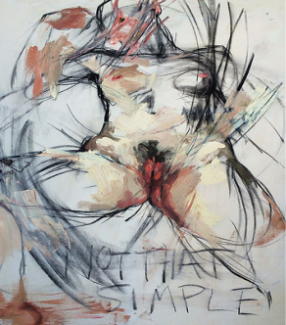
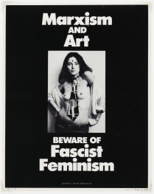
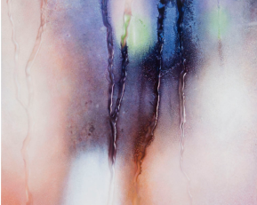
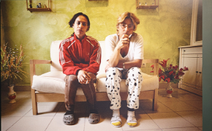
Marilyn Minter, thigh gap, 2016
Hannah Wilke, Marxism and Art: Beware of Fascist Feminism, 1977
Elly Smallwood, Figurative, 2016

: Feminist views within art

Bibliography
(Creators, 2018) [NSFW] Mythical Paintings of Our Most Intimate Moments - Creators. [ONLINE]
Available at: https://creators.vice.com/en_au/article/ezwedw/elly-smallwood-mythical-paintings-of-our-most-intimate-moments.
[Accessed 07 May 2018].

(The Art Story, 2018) Feminist Art Movement, Artists and Major Works The Art Story. [ONLINE]
Available at: http://www.theartstory.org/movement-feminist-art.htm.
[Accessed 07 May 2018].

(Perras y Putas, 2018) Perras y Putas. [ONLINE]
Available at: http://www.catincatabacaru.com/exhibitions/perras-y-putas#pressrelease.
[Accessed 07 May 2018].

(Thigh Gap, 2018) Thigh Gap. [ONLINE]
Available at: http://www.marilynminter.net/painting/thigh-gap/
[Accessed 07 May 2018].

(The Art Story, 2018) Hannah Wilke Most Important Art | The Art Story. [ONLINE]
Available at: http://www.theartstory.org/artist-wilke-hannah-artworks.htm.
[Accessed 07 May 2018].

(Art Nerd New York, 2018) Perras y Putas, Yapci Ramos’ socially charged portraits | Art Nerd New York. [ONLINE]
Available at: http://art-nerd.com/newyork/perras-y-putas-yapci-ramos-socially-charged-portraits/.
[Accessed 07 May 2018].

