Student name: Kayani Amjad Ghulam
Student ID: 1807441
Module Code: BMSW5104
Module Title: Project planning and Management in workplace
Lecturer’s name: Paul Ranson

Table of contents:
Introduction: page 3
The project organisation: page 3
Critical risks assessment of the project: page 5
Project management tools and techniques: page 5
Communication among stakeholders during the project: page 8
Personnel reflection and future recommendations: page 8
References: page 9

Introduction:
This report consists of a case study, where I will be acting as a project manager to plan the transition a family run business from a shop to a warehouse. The Vintner antique is a family run business that has been running for three generations and the family needs to move from the Shirley shop to a warehouse. They sold the shop to Tesco local and want to take the business into a different direction. During this report, technical language will be used to elaborate this transition and mitigate any potential issues. This project management report will describe the organisation and the potential breakdown of the team that will make the decision regarding the outcome of the project. During this exercise, risk assessment associated with this project as well project management tools and techniques will be highlighted. Furthermore, the communication with the stakeholders during this project, as well as personnel reflection with future recommendations and personnel development plan will be described in this report.
The project organisation:
Now, Vintner antique is run by a team that consists of Doreen Vintner, Denis Vintner, Suha Madani and Omar King. Doreen and Dennis are the two siblings and Doreen looks after the finance while Dennis oversees the finding of antiques. Suha Madani and Omar King are the employees and Suha handles the customer services, while Omar works on the shop floor. For any project to be successful, it is important to have a structure to the team and everyone need to know their roles and responsibilities in that team. According to Senior (1997, p.242)” people are often chosen to be members of a team on the basis of their functional roles, these being considered most appropriate to the task(s) which the team has to perform”. But the structure of the team is not decided by the project manager and the members of the Vintner Antique will need to come up with a structure that will suit best their project. From a project point of view, couple of structure can be effective going forward with this project. This both structures made of project sponsor and steering group can be effective, but eventually one structure must be put forward by the organisation. Every member of the team will contribute towards the project depending on their role and expertise. However, the project manager must make sure that the team members must adhere to their role and their expertise.

Fig1: one example of Vintner Antique team structure

Fig 2: 2nd example of Vintner Antique team structure
 Dennis Vintner  Doreen Vintner  Suha madani  Omar King

Critical risks assessment of the project:
Zeng & Smith (2007, p.589) argue that “in many circumstances, it may be extremely difficult to assess the risks associated with a project due to great uncertainty involved”. However, according to Neeto-Morote & Ruis-Villa (20011, p.1)” risk is inherent in all project undertakings, as such it can never be fully eliminated, although can be effectively managed to mitigate the impacts to the achievement of project’s goals”. In this project, one of the main risks is that it is a family business and often in a family business, people tend to get involved in every aspect of the business. Sometime, this can lead to anarchy and arguments. Furthermore, it can be a challenge to manage people and create an order that will help achieve the goals of the project. Even with a structured team, it can be difficult to keep people in their role of expertise and to stop them from becoming expert in every subject. At times, the team may give solutions instead of describing the problems during the user story stage. Giving solutions can lead to problems as people may not have the necessary expertise to be able to give the best solutions to the problems identified. Furthermore, the team can come up with a lot of stories during the user story and it may not be feasible to accommodate all of them in the project. Hence it is necessary to do a “triage” by using the chevron technique to select the most important stories going forward. The chevron technique allows the team to select the problems identified during the user story into three categories such as the musts, the wants and nice to have. Moreover, like many projects, customers may change their mind during a project, and this could affect the length and the cost of the project. This is known as the iron triangle, where money, scope and time are linked and if one factor is changed, it will affect the other(s). According to Mokoena (2013, p.814)” The concept of the Iron Triangle is an effective way of communicating the interrelationships between these central success criteria. It is typically depicted as a triangle with the criteria on the vertices. Movement of one criteria, for example in response to client demands or resource limitations, can put pressure on the other criteria. Failure in one constraint will likely lead to negative pressure on one or both of the other two”. Finally, failure to monitor could lead to problems at some stage of the project and this could have serious consequences on the outcome of the project. Each day a report needs to be done about the progress of the project to keep a data and to monitor the progress.
Project management tools and techniques used:
Techniques used during the project:
Stakeholder map:
For the success of a project, it is important to have structure of the stakeholders involved in the task for communication to be effective. Knowing people role and responsibilities in a project will facilitate conversation and improve the efficiency of the project. For this task, we have a project sponsor, a finance specialist, a user specialist, a development specialist, and a project manager.
User story:
The user story is an important part in defining a project and its goals. Done at the beginning of a project, it allows the project sponsor and the steering group to come up with the problems that will need to be resolve during the project. This technique allows a collaboration between the stakeholders and if managed correctly can create a good team togetherness.
Chevron Technique:
This technique plays an important part in selecting the stories in term of importance to the outcome of the project. The stakeholders must collaborate to select the importance of the stories for the project. Through this triage, the stories will be assigned to three categories such as the musts, the wants and the nice to have.
Iron Triangle:
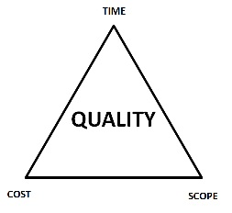
Fig1: Iron Triangle by Jake Sorofman
The iron triangle allows to communicate with the stakeholders about the outcome of the project if one or more parameters change during the project. For example, if the scope changes then it may affect the cost or the time of the project and sometimes it will affect both to achieve the quality required.
Time and cost estimation:
Roberts (2011, p.111) argues that” when developing a plan, it is helpful to understand the relationship between products and tasks”. The idea is to split the estimate into two dimensions such as the complexity of the tasks and the size of the product. This is known as the products project technique and it allows to identify tasks in term of difficulty like low, medium, and high. Furthermore, this technique also allows to identify the project in term of size such as small, medium, and large. Estimation will be done by the specialists by describing the difficulty of the task and the size of the project in terms of numbers and according to these numbers, an estimation will be given. But to have a better accuracy, the use of Delphi technique can be combined with Roberts technique. Asking as many team members as possible the same question can increase accuracy of the estimation and create a team togetherness.
Tools used during the project:

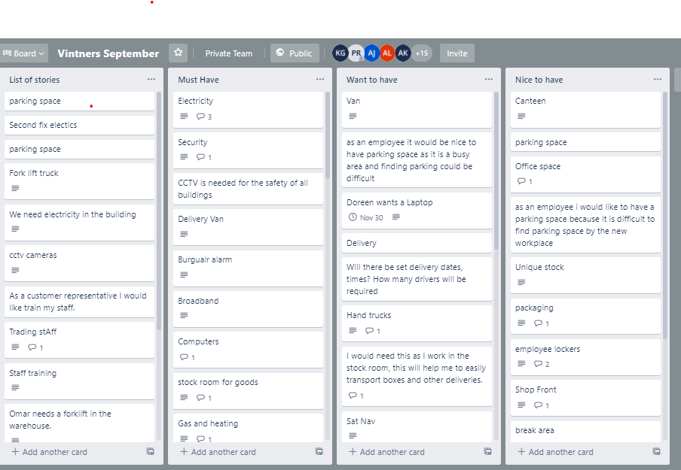
Fig 2: Vintner Trello board
Trello is a tool to replace the white board that is used normally in the development of user stories. This tool has become important due to the current health crisis to allow stakeholders to participate without been present in a same room. With this tool, stakeholders can collaborate to define the problems and use the Chevron technique to select the most appropriate stories as shown in the figure above.
Gantt chart:
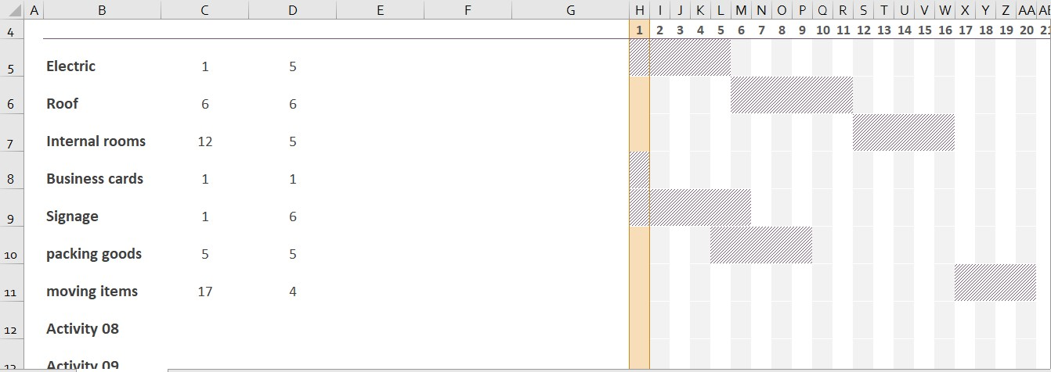
Fig 3: Gantt Chart
Gantt Chart helps to plan a project into steps that will need to be taken to complete the project. It shows all the stories that will need to be done during the project. Some of the stories are dependent and others are independent. Dependent stories are stories that rely on each other during a project, for example from this chart, electric will need to be completed before the roof can be done. While independent stories do not rely on others such as business cards can be done at any time during the project regardless of any other story.
Communication among stakeholders during the project:
Communication plays an important part in any walk of live but during a project it becomes even more important. Upstream, downstream, and horizontally, communication is necessary for the success of a project. According to Stanciu et al (2016, p.2) “communication is essential for achieving the objectives of an organization successfully, including those related to quality”. During this project, a stand-up meeting will take place every morning for about 10 minutes to allow different stakeholders to communicate with each other and to create a good understanding and teamwork. Through this meeting, the team members will understand other team members actions and will adjust accordingly (Stray et al, 2017). Along with the standup meeting, Gantt Chart will be used to communicate with all stakeholders regarding the progress of the project. Along the similar lines, Caughron & Mumford (2008) acknowledged that Gantt chart is used for communication and coordination. Thus, this Gantt chart can be adjusted according to the progress of the project and will be used to communicate horizontally as well as vertically during the project.
Personnel reflection and future recommendation:
With this case study and the last ten weeks of studying project management, I have managed to gain an understanding about project management and the importance of planning. Like many people, I have been involved over the years with some projects but without having a proper structure or plan. This topic has allowed me to understand better the waterfall model and how it can be used during a project. This sequential model describes the steps required to achieve a project. This case study has allowed me to have taste of project management and going forward I am looking to pursuit a carrier in this field. Unfortunately, this knowledge gained may not be enough and I doubt that I can secure a job without certain qualifications. Looking to do a Prince 2 qualification soon as well as the agile project management qualification. Although these two qualifications will have be done separately of this degree, I am sure that it will give me a better chance in the job market. With these qualifications, I will be able to carry out plan- based project with the help of prince 2 and unpredictable project with the help of Agile project management. along with the qualifications, I am also looking to apply the knowledge gained during this term to practice on some personnel project and to help family and friends with any projects available.

References:
Caughron, J.J. and Mumford, M.D., 2008. Project planning: The effects of using formal planning techniques on creative problem‐solving. Creativity and Innovation Management, 17(3), pp.204-215.
Mokoena, T., Pretorios, J. and Van Wyngaard, C. 2013. “Triple Constrain Considerations in the Management of Construction Projects”. Proceedings of the 2013 IEEE International Conference on Industrial Engineering and Engineering Management, IEEE Conference Publications: 813-817.
Nieto-Morote, A. and Ruz-Vila, F., 2011. A fuzzy approach to construction project risk assessment. International Journal of Project Management, 29(2), pp.220-231.
Roberts, P., 2011. Effective project management: Identify and manage risks plan and budget keep projects under control. Kogan Page Publishers.
Stray, V., Moe, N.B. and Bergersen, G.R., 2017, May. Are daily stand-up meetings valuable? A survey of developers in software teams. In International Conference on Agile Software Development (pp. 274-281). Springer, Cham.
Senior, B., 1997. Team roles and team performance: is there ‘really’a link?. Journal of occupational and organizational psychology, 70(3), pp.241-258.
Stanciu, A.C., Condrea, E. and Zamfir, C., 2016. The importance of communication in quality management. Ovidius University Annals, Economic Sciences Series, 16(2), pp.393-396.
Zeng, J., An, M. and Smith, N.J., 2007. Application of a fuzzy based decision making methodology to construction project risk assessment. International journal of project management, 25(6), pp.589-600.

