MARRIOTT INTERNATIONAL

Name: Syed Hussain Ahmed

Student ID number: 2120133

Marketing Essentials BMIH4005

Lecturer

Christopher Wilkin
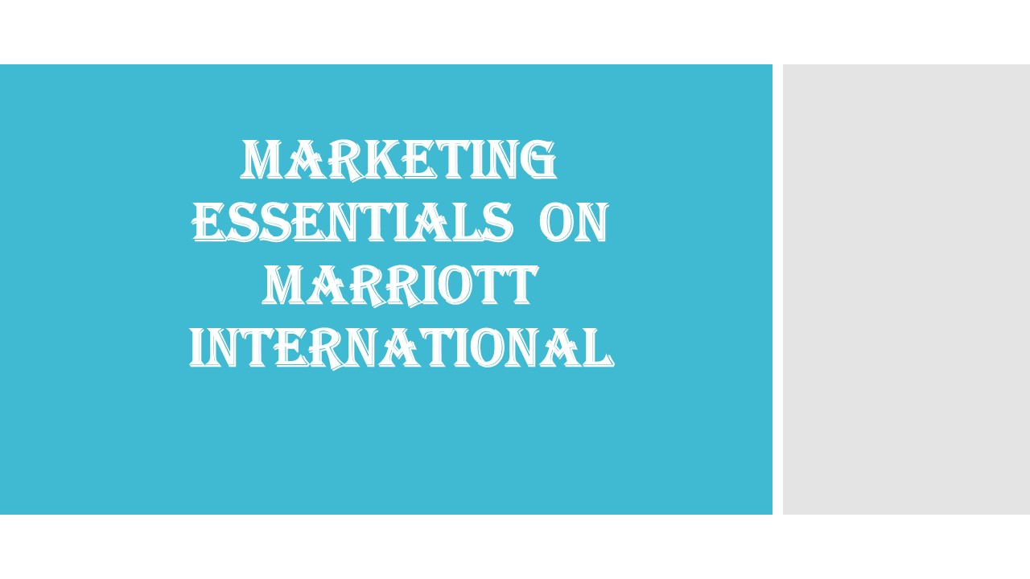

Table of Contents
Introduction 3
Marketing Mix 4
The Marketing Environment - Micro 5
The Marketing Environment – Macro 6
Creating Customer Value and Engagement 7
Effective Use of Digital Marketing 8
Conclusion 9
References 10

Introduction
The concept of this report is to make a marketing plan for the hotel industry to lure in new customers and make the best of the activities that may be termed necessary in this regard. The chosen hotel for this assignment is MARRIOTT hotel group. The geographical location of the hotel industry is the current business plan in London as this has been one of the topmost situations to look for the new customers in the hotel industry. The purpose of this marketing plan is to attract new customers and make the best use off the resources to make the MARRIOTT hotel into one of the successful ones.

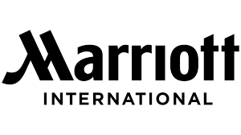
Figure: Logo of Marriott International (Armstrong, M., 2009)
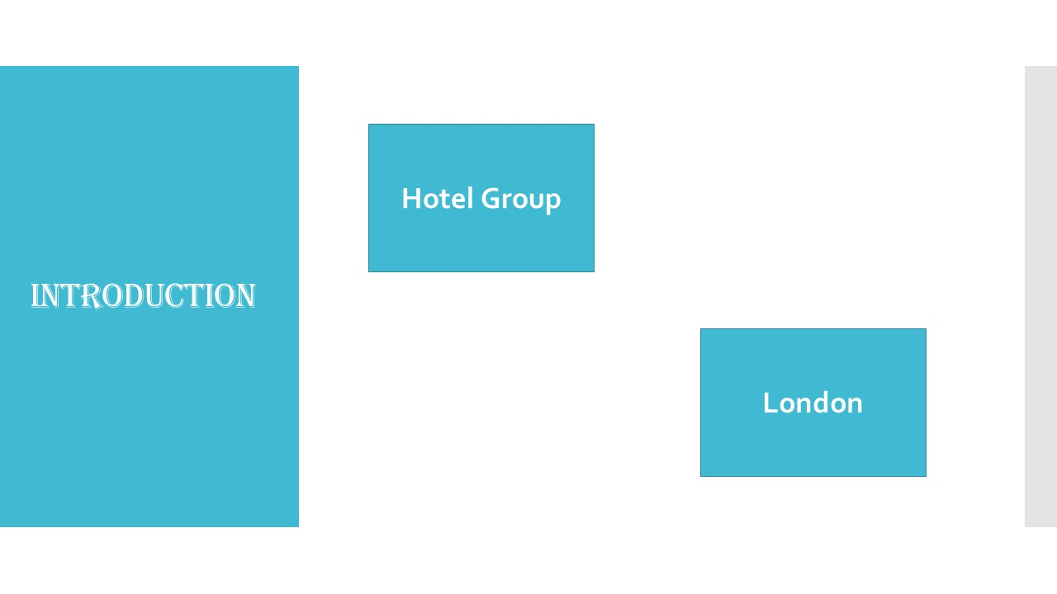

Marketing Mix
The concept of the marketing mix has been a huge factor in the hotel industry as this is widely regarded as one of the largest situations to take after. The condition in the different platform of MARRIOTT hotel has been to learn the various techniques and gather the new and available plans to make the best of the situation (Bernstein, F., & De Vearicourt, F, 2018).
Product – The product in the hotel business is the hotel itself. In this case the product is the MARRIOTT hotel chain, and their services are termed as the necessity to bring towards the people who are targeted in the marketing plan (Cousins et al. , 2011).
Price – The price of the rooms at MARRIOTT hotel is to be within the ranges of the people as they are targeted, and it needs to be budget friendly as well.
Place – The place for the business of MARRIOTT is selected London and there are different variations that needs to be followed up accordingly to meet the requirements (Brown, D. R., TotalBoox and TBX , 2013).
Promotion – Different promotional activities are to be carried out to make the best of the situation of the hotel industry for MARRIOTT hotel chain. This is likely to help and understand different parts of the business venture that needs to be developed.
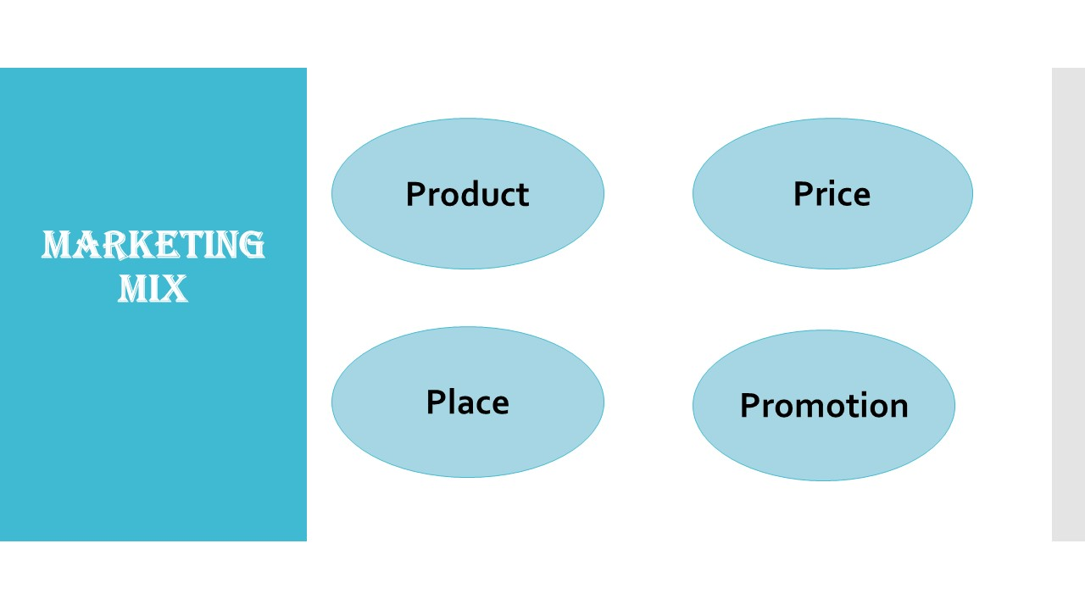

The Marketing Environment - Micro
The micro marketing environment is to be taken care of to make the rightful decisions at the most suitable time. This has been the definition of the cases which will make the best of the services that needs to be taken for the beneficial part in the overall business. The environment surrounding the hotel industries must be selected to make and maintain the positivity which is to be looked for the optimistic situation under the main theme. In order to make the rightful decisions the best suited platform has been to make the right decisions to bring the best of the people and also gather the knowledge which has been fruitful under the main event. This is likely because of the situation to look for the responses that the marketing management has been totally connected towards the main situation for the business of MARRIOTT hotel chain. The business that is set to make different categories in the right path has been towards the consecutive changes in the marketing plan and it needs to be fully developed under the phrase to maintain and select on the positive approach which will help to understand and make the different situations towards the next achievement.
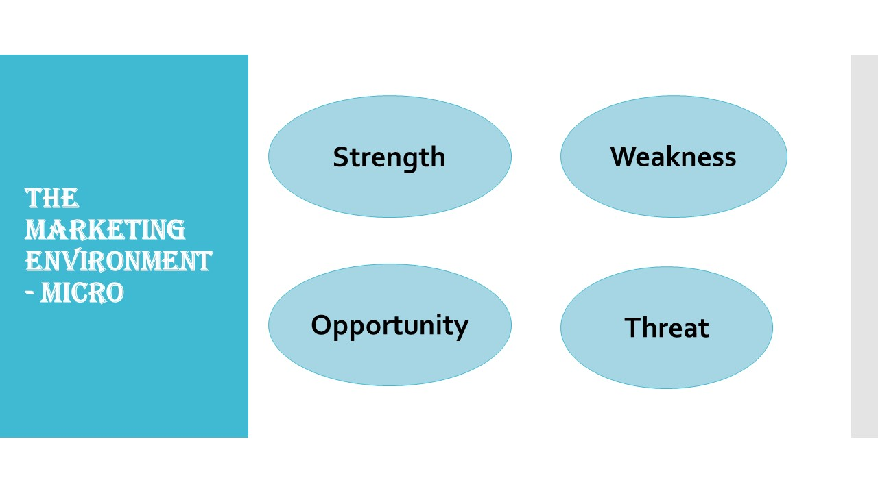

The Marketing Environment – Macro
The macro environment factor is the output of the PESTEL analysis. In every business venture it is important to have a different approach and make the different situations fully understandable under the feature to maintain and grow towards the successful venture of macro environment factors (worthington I., 2018). It is very important to know about the PESTEL analysis and make the arrangements in a proper way that it will help to make the progressive parts to understand and select the different opinions on the macro environment factors (Cousins et al. , 2011). This has been widely known to be considered as one of the leading platforms in the hotel chain business and MARRIOTT is a valuable approach in the hotel industry as this helps to mark the changes toward the successful venture to meet and greet towards the achievements on a different platform to select the ventures of the business of MARRIOTT hotel chain. Some of the macro environment factors are fully depended on the outcome to maintain the changes in the business of MARRIOTT and therefore make the adjustments to understand and issue the different ventures of the business on the same level of marketing approaches. It has been widely known to understand and categorize the ventures to investigate the positive matters from the macro environment factors (Torrington.D, Hall.L, Atkinson.C and Taylor.S, 2016).
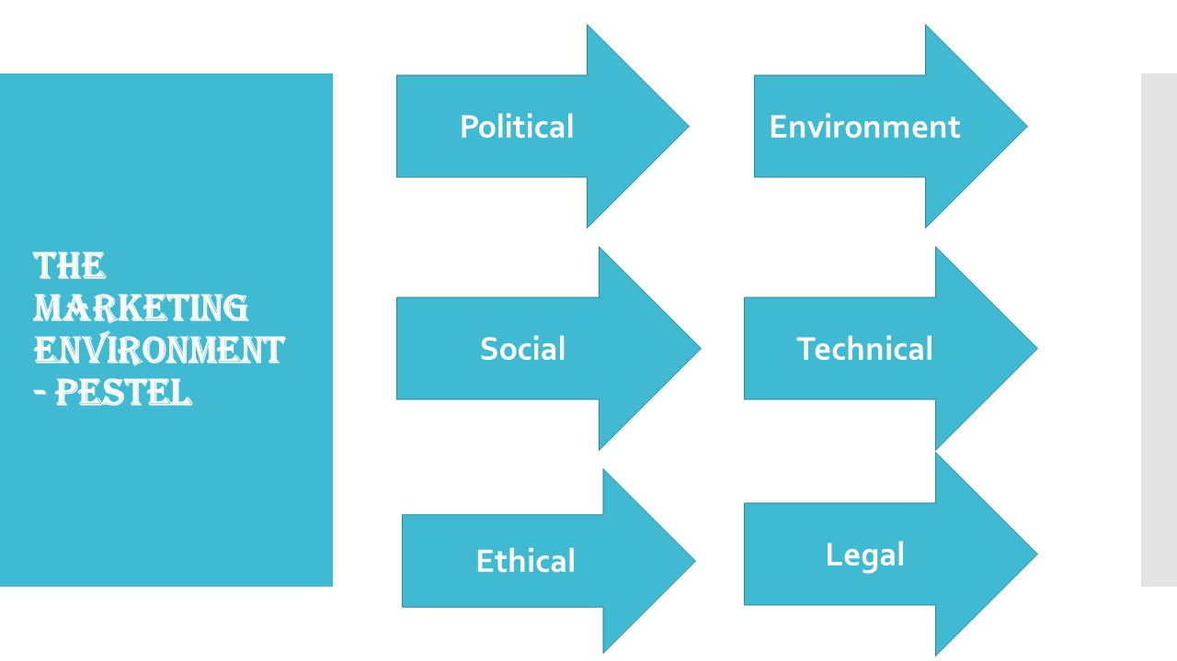

Creating Customer Value and Engagement
In the hotel business the most important thing is to know about the customers. For the business of MARRIOTT to grow in London it is required to set up a survey that will be conducted on the people who are living in London and therefor understand them, read them, and make proper use of the people (Larson, P. D., & Rogers, D. S., 2012). This is likely to help and understand about the different situation that is based in the premises of London. Some of the beneficial parts have been known to be attractive in creating the proper customer value. By making a survey based on the physical approach and using the online media it is quite easy to understand and maintain the changes that will be available in the end of the research conditions. The result of such survey will help to motivate the situation for the understatement of MARRIOTT hotel to look for as this is for the betterment on different connections to be given the proper set up (Williams, S., 2008). The survey carried out on the people who are living in London has been considered as they are likely to make the right approaches in the overall survey situation that has been primarily selected in such approaches of hotel business.
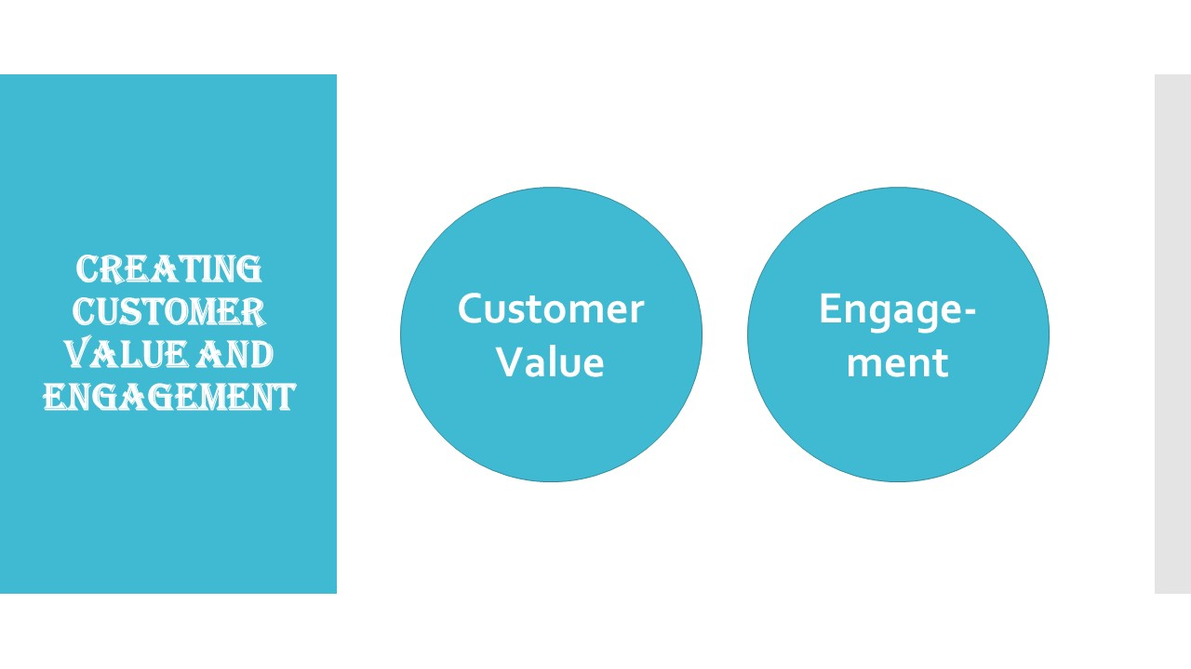

Effective Use of Digital Marketing
To quick up the process of the use of social media is a must as this is directly linked to the satisfaction level of the customers in different ways. The business of MARRIOTT hotel has been growing in other nations and to keep the business fully developed it is needed to have a wide range of availability in the hotel business to sum up the whole process as this will help to motivate the new customers to come to the hotel (Ghauri, P N, 2014). A website will be designed in this process to gather up new people as this is also one of the easiest methods to attract new and potential customers in the market. A loyal set of customers are very crucial to arrange and attend the different possibilities which has been made possible to gather the knowledge in the overall progressiveness towards the connection to be made. Some of the mentioned social values have been widely known to be precise in the connection that has been recorded for the attraction of new customers that will help to attract the situation and make proper evaluation at the end of the phrases (Blackwell, E, 2011).
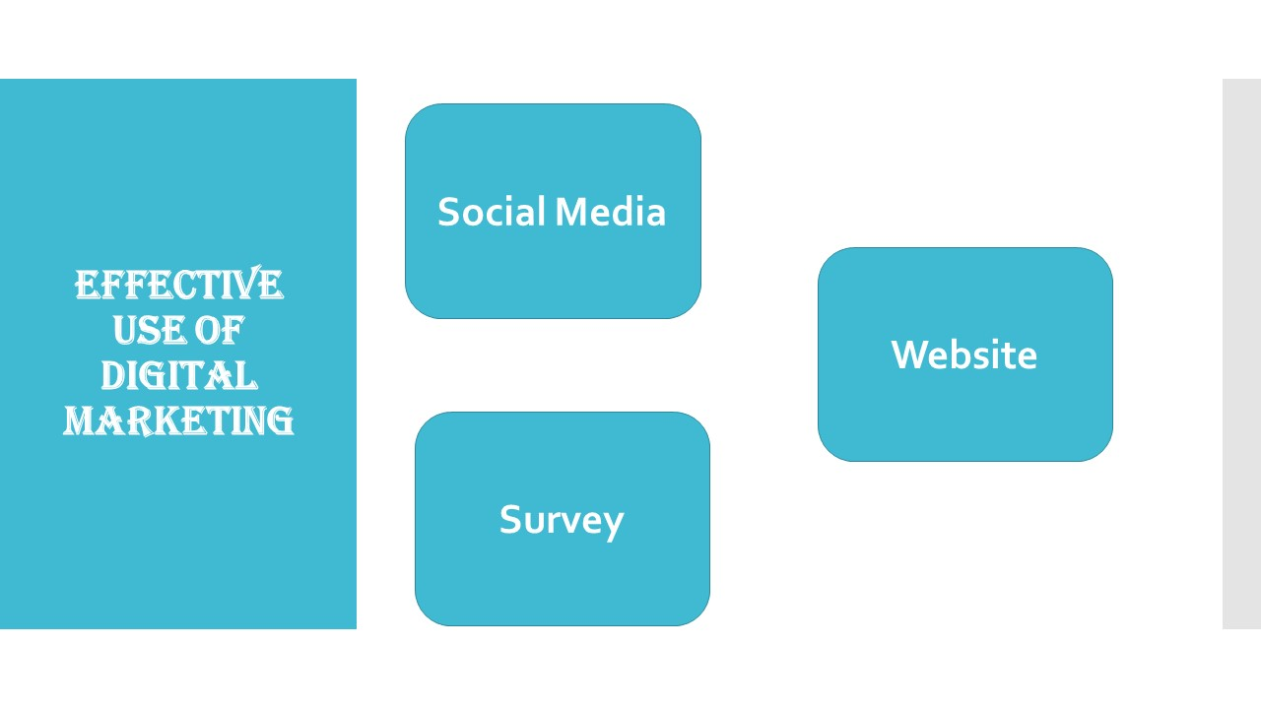

Conclusion
The success and failure of any business venture depends on the condition of the marketing plan. If the marketing plan is a good one, then the success rate increases but if the marketing plan is a failure, then the overall changes will be the opposite to which have been thought of. This is likely to make different respective nature to keep the track as this is likely to be understood on a variation towards the successful venture and to improve the situation of the marketing plan for MARRIOTT in different hotel and business-related natures. The optimistic situation has been promoted to understand and categorise the changes to bring the best in such marketing related connections.
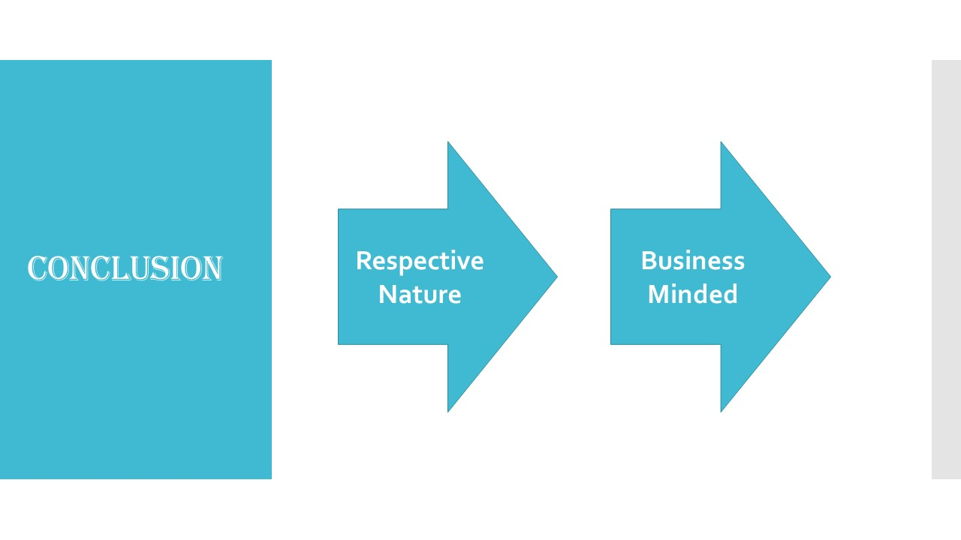

References
Armstrong, M., 2009. Armstrong's Handbook of Human Resource Management Practice. 11 ed. London: Kogan.
Bernstein, F., & De Vearicourt, F, 2018. Competition for procurement contracts with service guarantees. Operations Research, pp. 562-575.
Blackwell, E, 2011. How to Prepare a Business Plan: Planning for Successful Start-up and Expansion, (5th Ed). s.l.:s.n.
Brown, D. R., TotalBoox and TBX , 2013. The Restaurant Manager’s Handbook : How to Set Up, Operate, and Manage a Financially Successful Food Service Operation. 4th ed. s.l.:Atlantic Publishing Group.
Churchill, G.A, 2015. : Marketing Research Methodological Foundation, Sixth edition, Harcourt Brace College.
Cousins et al. , 2011. Food and beverage management: For the hospitality, tourism and event industries. 3rd ed. Oxford: Goodfellow.
Ghauri, P N, 2014. International Marketing, 4th Ed, McGraw Hill, London. s.l.:s.n.
Larson, P. D., & Rogers, D. S., 2012. Supply chain management:. Journal of Marketing Theory, pp. 1-5.
The World Travel & Tourism Council - wttc.org, n.d. In: s.l.:s.n.
Torrington.D, Hall.L, Atkinson.C and Taylor.S, 2016. Human Resource Management. 10th ed. s.l.:s.n.
Williams, S., 2008. FT Guide to Business Start Up 2009: The only annually updated guide for entrepreneurs, 4th. s.l.:s.n.
worthington I., 2018. Business Environment: A global perspective. s.l.:s.n.



