CLASS: SKILLS FOR THE WORKPLACE

PROFESSIONAL CAREER DEVELOPMENT
CLASS BMSW 4005

ASSIGNMENT – TASK 2
ROLE PLAY, PERSONAL CAREER DEVELOPMENT
REFLECTIVE REPORT

STUDENT: YORDANKA GEORGIEVA
STUDENT No 1906944

LECTURER: CHARLES OHAM

TABLE OF CONTENTS

INTRODUCTION 3
ROLE PLAY MOTIVATION 3
SELF-EVALUATION REVIEW – SELF-LEARNING STYLES 4
PERSONAL DEVELOPMENT PLAN, SWOT ANALYSIS, SMART OBJECTIVES, JOHARY WINDOW 5
WORLD OF EMPLOYMENT 6
CAREER AMBITIONS AND ASPIRATIONS 7
CONCLUSION 8
APENDIXES: 9
REFERENCE LIST: 11

INTRODUCTION

Career planning is a tool that helps to evaluate personal professional development career aspiration going through identifying the gaps in skills, knowledge and experience and organised progressive plan for career goals achievement.
Professional career development plan and personal development plan are beneficial for disclosure of personal strengths and development areas, opportunities, improvement of effective work and work up for future career growth.
Life line is a personal reflection that helps me to grip my own story, to explore where am I today, what I went through to get there and to realize where I wish to be in the future. (Cohen and Rabin, 2008)
This report reflects Role Play – Task 1(I used Gibbs reflective cycle (1988) to describe my role, following the model steps) as well as self-motivation, learning styles, Personal Development Plan (attached), SWOT Analysis (attached), SMART objectives (attached), understanding and expectations of employment’s world and career ambitions.

ROLE PLAY

The third term of my University training I was assigned a task involving a Role Play - preparing and performing a job interview both as interviewer and interviewed.
The job interview is a process of gathering information from an applicant to find out if they fit to the advertised job they applied. It involves coordinator of the conversation, called interviewer who ask questions and interviewee responding to these questions. (Morgan, 2017)
In the role of interviewer I was required to do a brief presentation of myself and my position in the organization, to prepare appropriate job description of advertised job and questions to ask the applicant, designed around the job role that would reveal my competence to be interviewer.
Good questions design help interviewer to separate potential fit for the position candidate from those who do not able to fit in. (Morgan, 2017)
In the interviewee’s role I had to answer the similar questions that my team pair classmate was prepared for me. In this process I included carefully considering job specifications, answers based on my experience I might be ask, widely research of organization’s goals and work requirements, any specific answers I might be ask for more awareness. I realized spending time writing down some possible answers including my skills, qualifications and experience helps me to be better prepared. (Doyle, A. 2019)
At the interview day I was very nervous, as I am very shy and public speaking is not my strength. My first public presentation was complete disaster and I had to take measures to deal with this condition. Even though I was practicing meditation and often walking in nature to calm my nerves down it doesn’t help me at first. When the interview started I was shaking, and I could barely remember the questions that I had to ask my partner. Then I took a deep breath and realized that if I failed because of this plague I would fail my classmate as well. This helped me to calm down and to understand that professional development and career progress required to believe in myself. After first question I was completely calm and confident. The interview went well, and I am grateful that I was finally able to control this condition, which prevent me in developing my abilities. I am feeling now much more self-assured to speak in front of people.
Action plan: In future I am going to continue to practice meditation and to walk often in nature, but I need to practice more relaxing exercises for example Yoga and to listen soothing music to be more concentrated and calm next time.

SELF-EVALUATION REVIEW – SELF-MOTIVATION, LEARNING STYLES

Career progression relates to self-assessment which is ability to test person to discover how much progress they made. It also helps individuals to display their own abilities and to determine gaps in their knowledge, finding out what their weaknesses and strengths are, identifying rudiments that can sophisticated their self-motivation to achieve goals into career development. (Cleverism, 2020)
Self-motivation is a skill that gives person force to move forward in pursuing the set goals supporting by commitment, initiative, optimism and personal aspiration. (SKILLSYOUNEED, 2011-2020)
There are several learning styles helping in self-awareness and self-motivation. Learning style is an individual preference of thinking and learning, depending of personal habits, behaviour and strategies.
Honey Mumford Learning style helps me to analyse my own orientation and to discover what learner am I.
Developed by Peter Honey and Alan Mumford in 1986 they elaborated their own Learning Styles Questionnaire, that research individuals’ general behavioural tendencies and groups people under four learning styles: Activist, Reflector, Theorist and Pragmatic.
Activist prefers to have an experience, Reflector reviews the experience, Theorist concludes from the experience and Pragmatic plan the next steps.
Knowledge of which learning style person belongs help in perfecting learning skills and awareness, making smart decisions and experience expansion. (Swailes, C.&Senior, B., 2002)
Honey and Mumford Learning styles questionnaire revealed my Pragmatic learning style. At first my impression was that there is something wrong. I was kind of surprised, because I always considered myself as Activist because I rather prefer to do the things and to learn from my experience, than to plan them. Reading full description of Pragmatic learning style I realized that it pointed actions inherent in my style. Putting ideas, theories and technics into practice, searching new ideas and experiment, acting quickly and confidently, getting straight to the point and impatience with endless described me quite correctly and gave me an indication how to learn. Discovering my learning style I also evaluated the opportunities that it gives me in my self-motivation and achieving important goals in my professional and personal life.

PERSONAL DEVELOPMENT PLAN, SWOT ANALYSIS, SMART OBJECTIVES, JOHARY WINDOW

Personal development plan is effective tool in achieving futured goals, related to student or professional development identifying the necessary knowledge and skills steps. This personal progress guide helps me to determine my goals, knowledge, resources, responsibilities and deadlines for achieving a certain short, middle or long-term goal.
SMART objectives supported my work in creating specific, motivational, achievable, realistic and time bound goals and helped me to identify my priorities, to focus on what is important, to make a SMART objective and to monitor progress. (BusinessDictionary, 2020)
My Personal development plan relates to three years goals and reveals beside this what knowledge, needs, support, resources, success measure and adhere deadlines need to achieve these goals. It helped me to plan my future career providing an opportunity to see the picture of my development for a certain of time period.
SWOT Analysis is a process of understanding individuals in a better manner, measuring person’s strengths, weaknesses, opportunities and threats. It helps in evaluating yourself in different life areas such as career and skill development. (Cussons, A. 2019)
Strengths and weaknesses are internal factor which is variable and subject to change, strengths can be developed, and weaknesses can be improved.
The second step consider external factors such as economic, environment, market and much more, and involving opportunities and threats.
Johari window is a self-awareness improving technique. It is a psychological tool created by Joseph Luft and Harry Ingham in 1955 and is useful in self-help, training, personal development, communications improvement, making right quality decisions, and increasing the chance of success. (SelfAwareness, 2013)
SWOT Analysis and Johari Window perfectly completed my Personal development plan and supported my self-awareness. Discovering my strengths and opportunities and finding out my weaknesses and treats gave me an advantage and opportunity in controlling and improving them.
My PDP, SWOT Analysis and Personal objectives are attached as an Appendix.

WORLD OF EMPLOYMENT

In today’s globalisation era academy study, work approaches and employment are directly connected. (Lansbury, R. 2018)
Perception of the nature of this relation is beneficial for me as the basic cognition of employment world and would lead me in my future career. The knowledge I gained from my training involves job search ways and features, recruitment and selection process, going through job interview specific requirements and employment legislation.
Understanding of job search process which goal is to find employment that matches person’ skills, abilities, predilections, is advantageous and important for my eventually future development and growth in career. I also learned that different ways in finding job are registration at recruitment agency, searching on company’ websites, following social media sites, talking with job advisors or friends.
Recruitment and selection aim are to define and plan recruitment and to attract and select candidates using certain policy, specifications and suitable methods. (ACAS, 2010)
Job interview is discovering applicant’s skills, experience, qualifications and personal values through a conversation including interviewer and interviewee. The essence of interview process is to find the right candidate suits to employers’ objectives and requirements going through specific questions which reveal applicants’ abilities and readiness to meet the conditions of the advertised job. (McNamara, 1999)
Employment legislation is set of workplace rules and Parliament’ Acts which are adopted by law. The aims of the Acts are to protect employees’ rights and obligations and to determine employers’ requirements. (Lansbury, 2018)
Considering the information of employment’ world I can conclude that dept understanding and accepting culture of work, valued, beliefs and choices would lead me through professional and personal development to achieve my career ambitions goals.

CAREER AMBITIONS AND ASPIRATIONS

Inspired career involves motivation and professional progress. Career means also experience, responsibility, qualifications, attitude and following long term goals.
My ambitions are focusing over the aim to set my own business in the field of nutrition.
My career aspirations include earning a University degree, improving my professional, personal and networking skills, taking the leadership position, following by Manager position, and starting my own business. For me the most important part of career success is enjoyment of what I am doing and being proud from achievements. The measure of my success is people’s satisfaction. (Gentle, 2018)
I believe that my career progress relies on my professional development and striving to be always the best of what I am doing or achieving. It is beneficial not only for me, but it makes the others to do their best encouraging of what they see believing in their potential. (Walton, 2017) That motivates me to achieve as many short and middle term goals as I can and to go boldly towards my ultimate goal.

CONCLUSION

Evaluating Personal Career Development task I was able to figure out unclear vision about my future career and the path that would lead me to achieve my ultimate goal, how would use the tools and strategies needed to support my development and growth, requirements and rules that I would meet in employment world.
Important experience for me was Task 1 - Job interview as I found it useful for my future career.
Also, I realised that if I am enjoying of what I am doing I will be on the top of success much faster than I expect.

APENDIXES:

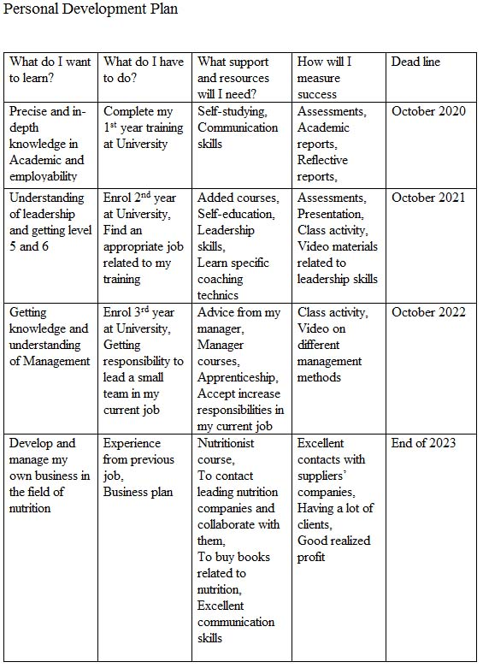
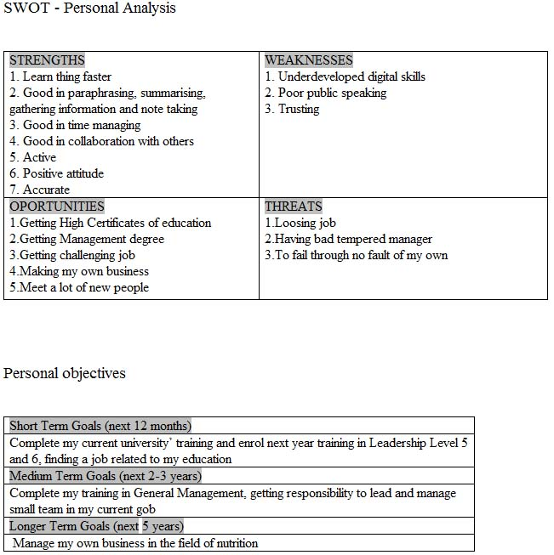

REFERENCE LIST:

ACAS. (2010) Recruitment and induction. [online:] Available from: https://www.acas.org.uk Assessed: 7 July 2020

Ackerman, C.(2020) Positive Psychology. What is Self-Awareness and Why is It Important? [5 Ways to Increase It] [online:] Available from: https://positivepsychology.com/self-awareness-matters-how-you-can-be-more-aware/ Assessed: 1 July 2020

Birdi, K.,Alan, C.,&Warr, P.(1997) Correlates and outcomes of four types of employee development activity. Journal of Applied Psychology, 82 (6), 845-857

BusinessDictionary, (2020) SMART objectives. [online:] Available from: https://www.businessdictionary.com/definition/smart-objectives.html, Assessed 4 July 2020

CLEVERISM, (2020) Self-Assessment. [online:] Available from: https://www.cleverism.com/skills-and-tools/self-assessment, Assessed: 4 July 2020

Cussons, A. (2019) Action COACH. S.W.O.T Analysis For Personal Development [online] Available from: https://andrewcussons.actioncoach.co.uk/s-w-o-t-analysis-for-personal-development Assessed: 1 July 2020

Doyle, A.(2019) The Balance Careers. Behavioural based job interview questions. [online:] Available from: https://www.thebalancecareer.com/behavioural-job-interview-questions-2059620 Accesses: 2 July 2020

Gentle, S. (2018) Onrec. Brits reveal job satisfaction is far more important than salary. [online:] Available from: https://www.onrec.com/news/statistics-and-trends/brits-reveal-job-satisfaction-is-far-more-important-than-salary, Assessed: 9 July 2020

Jobs.ac.uk, (1998-2019) Career Advice. How to Create a Professional Development Plan. [online:], Available from: https://career-advice.jobs.ac.uk/academic/how-to-create-a-professional-development -plan/, Assessed: 30 June 2020

Lansbury, R. (2018) Tylor&Francis Online. Labour and industry: a journal of social and economic relation of work. The changing world of work and employment relation: a multi-level institutional perspective of the future. [online:] Available from: https://www.tandfonline.com/doi/abs/10.1080/10301763.2018.1427425 Assessed 5 July 2020

Maund, A., Schriek, M., and Tinkler, P.(2017) Certificate in Higher Education: Skills for the Workplace Student Yearbook, London: SAGE, pp. 279-310

McNamara, C. (1999) General Guidelines for Conducting Interviews. [online:] Available from https://www.managementhelp.org/businessresearch/interviews.org, Assessed: 2 July 2020

Morgan, P.(2017) THE BUSINESS STUDENT GUIDE TO STUDY AND EMPLOYABILITY, London: SAGE, pp. 366-390

SelfAwareness (2013) Understanding the Johari Window model. [online:] Available from: https://www.selfawareness.org.uk/news/understanding-the-johari-window-model, Assessed: 4 July 2020

SKILLSYOUNEED, (2011-2020) Self-Motivation. [online:] Available from: https://www.skillsyouneed.com/ps/self-motivation.htm, Assessed: 4 July 2020

Swailes,S.&Senior,B. (2002) International Journal of Selection and Assessment. The Dimensionality of Honey and Mumford’s Learning Styles Questionnaire. [online:] Available from: https://onlinelibrary.com/doi/abs/10.1111/1468-2389.00099, Assessed: 4 July 2020

Walton, B.(2017) FORS MATSH GROUP. Importance of Career development in Organizational Success. [online:] Available from: https://www.forsmarshgroup.com/knowledge/news-blog/previous-years/january/importance-of-career-development-in-organizational-success, Assessed: 2 July 2020

