

Postgraduate/Distance Learning
Assignment coversheet & feedback form

THIS SHEET MUST BE THE FIRST PAGE OF THE ASSIGNMENT YOU ARE SUBMITTING (DO NOT SEND AS A SEPARATE FILE)

For completion by the student:
Student Name: Octavia Sheepshanks

Student University Email: 1604414@student.uwtsd.ac.uk
Module code: HPCA7002  Module title: Researching Contemporary Cosmologies | Student ID number:  1604414 |  |  | Educational support needs:  Yes
Assignment title: An investigation into the present day culture of Instagram astrology meme creators

Assignment due date: Monday, 20th May 2019
This assignment is for the 1st ☐ 2nd ☐ 3rd ☐ 4th ☐ 5th ☐ 6th ☒ module of the degree
I confirm that this is my original work and that I have adhered to the University policy on plagiarism.
Signed ……….Octavia Rose Sheepshanks……………………………………………………
Email submission:if you are submitting this form via email, please tick this box □
(as a substitute for your signature) to confirm that you agree to the above declaration.
Assignment Mark
1st Marker’s Provisional mark
2nd Marker’s/Moderator’s provisional mark
External Examiner’s mark (if relevant)
Final Mark

NB. All marks are provisional until confirmed by the Final Examination Board.

For completion by Marker 1 :
Comments:

Marker’s signature: |  |  | Date:
For completion by Marker 2/Moderator:

Comments:

Marker’s Signature: |  | Date:
External Examiner’s comments (if relevant)

External Examiner’s Signature: |  | Date:

An investigation into the present day culture of Instagram astrology meme creators

[ ]

Introduction to research themes

The intention of this project was to investigate the beliefs about astrology among Instagram astrology meme creators. Astrology memes are simple visual ‘jokes’ that play on astrological stereotypes or experiences in order to amuse and possibly educate the observer. They almost always take the format of an image or video with added text, and their meaning is limited to what can actually be seen in the meme. For example, if an image of an famous figure is used in a ‘Capricorn’ meme , the label ‘Capricorn’ is not making any claim about the sun sign of that person, nor is it criticising that person; it is solely being used to lambast a Capricornian archetype.

Nicholas Campion acknowledges that there is evidently a form of ‘New Age astrology which is millennial in origin and which has had a wide impact on the discipline as a whole’. Unpacking the term ‘millennial’ Campion discusses a Platonic emphasis on education, the Christian tradition of predicting a coming crisis, ‘nostalgia for a lost golden age in the past, concern over social and moral decay in the present, and the utopian anticipation of an imminent future crisis, to be followed by the restoration of paradise.’ Aware of the preponderance of Instagram astrology memes – a search for the hashtag ‘#astrology’ returns over 3,000,000 posts on Instagram – I wondered if there was another kind of ‘millennial’ astrology. Millennials are a label for the generation born between 1979 and 1994 and primary users of Instagram. Other evidence for the popularity of astrology in digital youth culture is the fact that the startup astrology application for iPhone, Co-star, currently the 12th most popular iPhone ‘Lifestyle’ app, has recently raised 5 million dollars from investors to launch an app on Android.

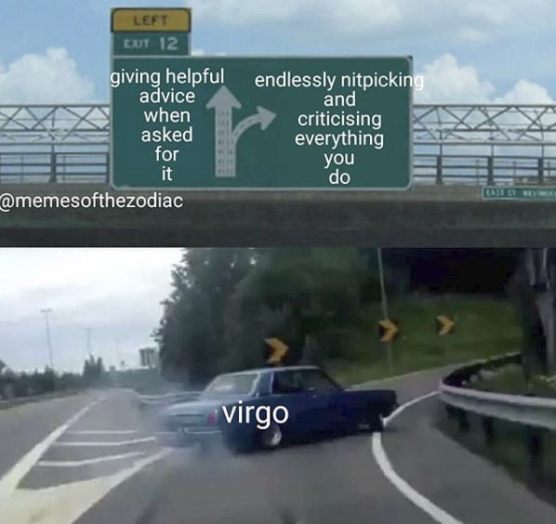

Figure 1, @memesofthezodiac, 2018. Image: Instagram

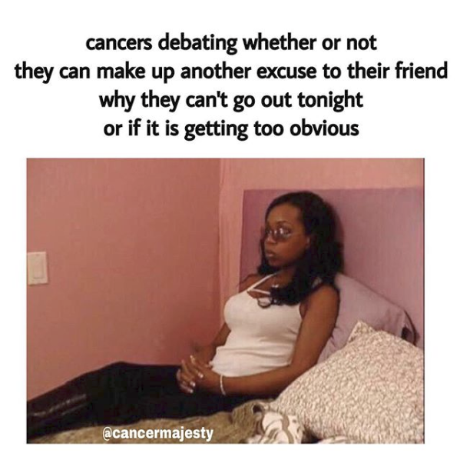
Figure 2, @cancermajesty, 2018. Image: Instagram

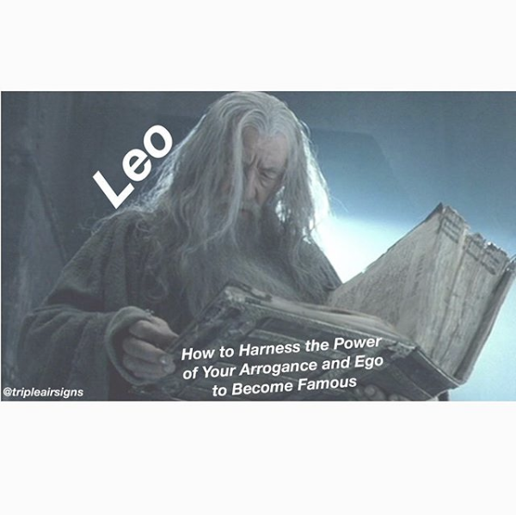
Figure 3, @tripleairsigns, 2018. Image: Instagram

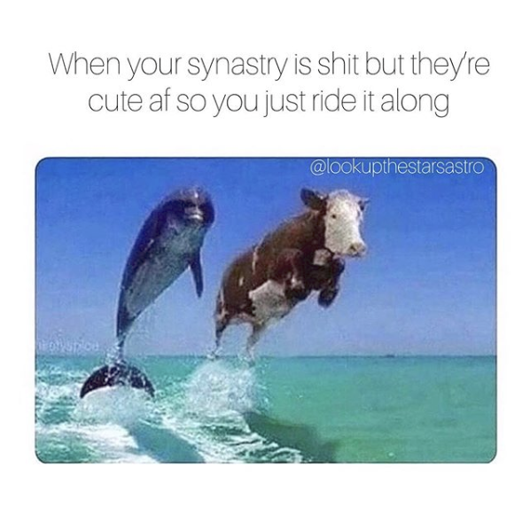
Figure 4, @lookupthestarsastro, 2018. Image: Instagram

Literature Review

Frances Clynes has suggested that the lack of research into the use of the Internet for astrology suggests ‘a lack of understanding of the implications of Internet use for astrology’. What triggered my project was the suspicion that there was a lack of understanding of the implications of Instagram astrology memes. They were seen as trivial; indeed, only through studying them did I realise how meaningful and significant their culture is. In the year 2000, Garry Phillipson wrote Astrology in the Year Zero, a presentation and discussion of 33 interviews with astrologers in an attempt to show ‘what astrologers do, and why they do it, in their own words’. Though relatively recent, the study was pre-iPhone, pre-Instagram, and pre memes in the visual sense. I wanted to research the experiences of these digital astrologers and hope to learn more about their motivations, methods, and whether (and if so, how) astrology plays a part in their everyday life aside from Instagram. The concept of an Internet meme has been described by Lynne McNeill as ‘a form of folklore created by and relevant to digital settlers and immigrants’. By studying these digital natives, settlers and immigrants of Instagram, I hoped to learn more about their culture. In 2012 Nicholas Campion published ‘Astrology and Popular Religion in the Modern West’, and observed, referring to Phillipson’s work, that ‘there is just one published volume of interviews with astrologers’. Campion perceived a ‘lack of interest in what astrologers themselves actually say.’ Therefore the topic to be studied was a subculture within a culture – contemporary astrology – around which there is already a lack of research.

Participant recruitment

Recruiting participants initially seemed an easy task. Instagram has a direct messaging service through which any user can message another, no matter how many followers the latter has. I contacted 50 meme accounts with a varied following, from 1,000-400,000 followers. Most who read the message replied; I had 20 responses. All said they were interested and I then asked for an email address where I could send further information. 6 failed to do so, and I then had 14 participants to email. I asked for a simple yes or no response confirming whether they were still interested, and only had 3 replies to this. In hindsight, I think I created too many hoops for participants to jump through and could simply have sent them the questionnaire directly with an information sheet and ethics briefing. In the end, after some time with only 3 responses to my questionnaire from those who had replied ‘yes’ and thus been sent the questionnaire, I sent out the questionnaire, ethics and info sheets to all those who had sent me their email address. I had also made the mistake of failing to give a deadline, as I wanted to give participants as much of a chance as possible to respond. Eventually I implemented a 12-hour call, and received one more response. I wonder whether with an anonymous method of recruiting, there is little accountability and therefore potential participants were more comfortable replying that they were interested, and had no issue with failing to let me know when they were no longer interested in participating.

Ethical considerations

Participants were informed of their anonymity. However, given that some of them were already anonymous; i.e. their Instagram account is public but their identity is private, I was aware that they might feel comfortable with the anonymity offered by their account, and permit the interviewer (me) to use their Instagram handle when writing up the report. This emerged to be the case in the three anonymous accounts, and the public account (i.e. where the account is publicly linked to a real identity) requested for her anonymity to be waived. I obtained written permission in all four cases for the Instagram handle to be used, which meant I could, for example, include memes in the report and discuss follower counts. Other ethical considerations included the possibility that some content could, unbeknownst to the interviewer, be particularly emotionally triggering to the interviewee. For example, a question regarding when the interviewee became interested in the activity being studied [astrology] could feasibly trigger emotions regarding other life events at the time. To mediate this I made participants aware that they could withdraw at any time, choose to limit their responses to any questions as they wished, and/ or decline questions entirely. I also pledged to cease the interview if the interviewee appeared in any difficulty whatsoever.

Methodology

I consulted using questionnaires and interviews in order to better understand the culture of astrological Instagram memes and the Instagram astrology community. The astrologers who originally expressed an interest in taking part had from 1000 - 400,000 followers each on Instagram and hence had a wide reach. I used open-ended questionnaires in all four cases, and followed these up in two out of four participants, with one Instagram interview and one Facebook interview, communication mediums that had been requested by the respective participants. I had already observed that in keeping with the study of Instagram culture, live written interviews could be conducted using Instagram chat, which would perhaps in some ways be the most natural way to communicate about the topic. People can feel self-conscious about their own voice when talking to strangers whereas for millennials (primary analysis suggests the average Instagram meme creator is under the age of 25), chat is the most common method of communication apart from real life contact. As chat happens live, it retains some of the organic nature of voice conversations, as replies are mostly spontaneous. Which method(s) of interview is/are used was determined and tailored following the initial questionnaire. Hennink, Hutter and Bailey observe that qualitative research ‘allows you to identify issues from the perspective of your study participants’. Since my goal was to learn about how the culture of Instagram memes feels for the creators themselves, a qualitative approach was taken using the methods detailed above. Bryman has discussed how use of a ‘prior theoretical framework’, in particular one which shapes the research strategy, can lead to misconstruction of data. I do not know what it is like to be a meme creator, but since I was a semi-insider, with an Instagram account myself that I use to follow astrology meme accounts and share memes with friends, I felt I was at risk of constructing or projecting a prior framework onto my research. I consequently made a conscious effort to detach myself from preconceptions. In keeping with this aim, I used the questionnaires - the first mode of study - not only to obtain research data but to tailor the interview questions to what the questionnaires suggest.

Findings

(i) Participant data

Since I only had four responses to my questionnaire and therefore four participants, they became more like case studies. I was aware that I could no longer even attempt to generalise my findings, but knew that the richness of the data generated would mean they were valuable for their own sake. Because I had recruited blindly, in that I had no idea of the background of the accounts when I asked them if they wanted to participate, my first real findings consisted of the backgrounds and demographics of my participants. All four were women. They were, respectively, 19, 20, 27 and 33 in age. They were from four different countries: England, Germany, Canada, and the US.

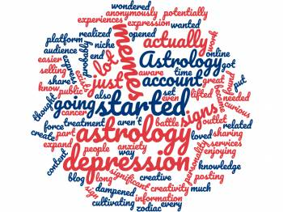

Figure 5, Word cloud created from answers to the question, ‘What is the primary reason you set up your [Instagram meme] account?’, 2019. Image: Wordclouds

My primary research goal was to find out what my participants, all Internet meme astrologers, actually thought about astrology. My findings, however, branched away from this; the most notable findings were in response to a different question: the motivation behind each account, more specifically why the meme artists had started the accounts, and why they continued to post today. I had not expected to learn so much about the motivations and surprising benefits of the meme accounts, and I found that the accounts served a depth of purpose I had not anticipated. Primary themes that emerged as motivation, which would all benefit from further study, were: anonymous expression, community, learning, teaching, financial gain, as a creative outlet, and as a boost to mental health.

One very noticeable factor, evident in all the questionnaires was that the motivation participants had for launching their Instagram meme account, was often not the reason they continued. Participants began their meme account for one reason and continued it for another, and there was extensive further variation between the reasons they gave. For example, @memesofthezodiac told me, ‘I was curious about cultivating an online audience to potentially end up selling astrology related services to, and then once I started I found myself just enjoying sharing information and experiences’. @cancermajesty, on the other hand, wrote ‘I wanted to force myself to expand my astrology knowledge’ and described how the content of her own memes expanded as she learnt, through private study and by engaging with meme culture in general. When asked if this was why she continued, she wrote ‘No, today it's not that much about learning anymore. I just enjoy creating memes and seeing people laugh about them. It brings me so much joy to read how people enjoy my memes, that's really my main motivation.’

(ii) Expansion on core motivations: anonymous expression, community, financial gain, learning, teaching, a creative outlet, mental health

Anonymous expression

@tripleairsigns and @memesofthezodiac both spontaneously mentioned anonymity in their questionnaires. When I interviewed @memesofthezodiac I asked more about this. For @tripleairsigns, being anonymous is an integral part of participating in the online culture. She told me that she loves having an ‘anonymous Instagram account’ and expanded on why; it appears that the anonymous aspect is key. Writing in answer to whether she spends time looking at other astro-memes’, she responded: ‘One of the things I love about having an anonymous instagram account is that I can interact with people and I can see people tag their friends in posts. It’s like I am influencing a bit of how people see themselves, hopefully in a fun way, and that helps foster connection with others. I find that part really fascinating and love to see what people think of my memes, even if they find them obnoxious or offensive. Lol!’ For @memesofthezodiac, retaining anonymity is essential. When asked how she would prefer to be interviewed, she responded by saying ‘Insta chat is probably easiest due to the fact the people I live with don’t know about my interest in astrology and it’s not ideal for me to tell them anytime soon’. During our Instagram chat interview, I asked if she was willing to expand on this. I learned that she lived with her parents, who were strict Christians, and any form of astrology is a big no-go area. The anonymity offered by Instagram means she has a platform to express herself freely and experience a community centred around something she enjoys and must keep hidden in her real-life, domestic environment.

Financial gain

An astrology meme account as a means to income was a marginal factor compared to others, although it was mentioned in two out of four interviews. @memesofthezodiac ‘was curious about cultivating an online audience to potentially end up selling astrology related services to’ but soon shelved this idea in favour of simply enjoying the experience of sharing memes. Both @cancermajesty and @tripleairsigns stated that there was no commercial aspect to their accounts, however @tripleairsigns meditated on the concept and wondered if perhaps she should start offering readings after all. She had not posted on her account in several months, stating lack of time and money as restrictions on her free time and ability to work on her meme account. Perhaps if there was a way to monetise it she might be able to continue. The only account in the study belonging to a professional astrologer was @lookupthestarsastro, whose Instagram account was started in connection with her blog and is linked to her astrology services, but is also a way to share her ideas. Originally, ‘I started my account because I had just started an astrology blog and thought I needed a platform to share my work. As I started my account I wondered what content I could put out there, and I realized that I loved memes, and Astrology, and that there was probably a public for niche Astrology memes.’ Now, on the other hand, ‘it’s just part of who I am and I love the idea that I’m participating in building awareness of Astrology by using bite size humor.’

Community

The concept of an astrology meme community was one I already had in mind before beginning the study. As a semi-insider, one who had followed meme accounts for over a year, but never created my own, I had the sense of a community culture, but didn’t want to pre-suppose this in my study. One question I asked in the questionnaire was ‘Do you get many messages from your followers? If so, do you typically respond to them?

Learning

Creative outlet

Mental Health

I set up my account after going through a significant battle with depression and
anxiety, actually. After going through a lot of treatment, once my depression lifted,
I opened myself to a lot more creativity- it was dampened for a long time during
my depression. My memes became a great outlet for creative expression

Teaching

> ASTROLOGY FINANCIAL SERVICES
One participant set up their account with a possible view to this, but motivation changed
One participant set up their account associated with a blog associated with professional astrology services

> TO LEARN
By posting memes wanted to force self to learn about other signs

>ANONYMOUS EXPRESSION

>OUTLET FOR CREATIVE EXPRESSION

>MENTAL HEALTH

4. What is the primary reason you set up your account? Other reasons also welcome!

I was curious about cultivating an online audience to potentially end up selling astrology related
services to and then once I started I found myself just enjoying sharing information and
experiences

I wanted to force myself to expand my astrology knowledge, which I did. I actually started out only posting cancer memes because I did not know that much about all the other signs. But the more I got into astrology and all the zodiac signs, the easier it was for me to create memes for every sign.

I started my account because I had just started an astrology blog and thought I needed a
platform to share my work. As I started my account I wondered what content I could put
out there, and I realized that I loved memes, and Astrology, and that there was probably a
public for niche Astrology memes.

I set up my account after going through a significant battle with depression and
anxiety, actually. After going through a lot of treatment, once my depression lifted,
I opened myself to a lot more creativity- it was dampened for a long time during
my depression. My memes became a great outlet for creative expression and also
a way to anonymously express a part of my personality that some people aren’t
even aware exists!

5. Is this the same reason you continue creating memes today?

No I definitely continue because I enjoy the sense of community rather than as part of a
potential business plan

No, today it's not that much about learning anymore. I just enjoy creating memes and seeing people laugh about them. It brings me so much joy to read how people enjoy my memes, that's really my main motivation.

Well now it’s different. When I started it was such a baby movement. Under the hashtag
astrologymemes there was less than 10 000 posts total. Now it’s just part of who I am
and I love the idea that I’m participating in building awareness of Astrology by using bite
size humor.

No, but if I were to start again, then it absolutely would be. It’s a fun distraction from the
mundane aspects of life and the pressures of parenting and work.

Conclusions

This paper has discussed some of the findings from a study conducted among Instagram astrology meme artists in April 2019. Four astrology meme artists were recruited through Instagram and responded to an extended questionnaire, and two of those were interviewed, one through Facebook and one through Instagram. Though a face to face interview might have been preferable, the digital contact did feel particularly appropriate given the topic of study. So much rich data was generated that this particular paper has focused on the element of motivation and reason for holding the Instagram account. In conclusion, there were a range of motivations and benefits that emerged from the questionnaires and discussion. Motivations included: promotion of astrological services, creative expression and fun, learning about astrology by being part of the online community. Benefits were: a sense of community, deriving enjoyment from sharing information with others (teaching), opportunity for free creative expression through anonymity, a new lease of life after a struggle with depression. This primary study demonstrates an arena ripe for further study, where an expanding astrological community is thriving, and enriched, rather than alienated, by the presence of anonymity.

Bibliography

Bryman, Alan, Quantity and Quality in Social Research (London: Routledge, 2001)

Campion, Nicholas, Astrology and Popular Religion in the Modern West (London and New York: Routledge, 2016 [2012])

Clynes, Frances, 'An Examination of the Impact of the Internet on Modern Western Astrology', PhD Thesis, University of Wales Trinity Saint David, 2015

Hennink, Monique, Inge Hutter and Ajay Bailey, Qualitative Research Methods (London: Sage, 2011)

Myers, Karen K., and Kamyab Sadaghiani, ‘Millennials in the Workplace: A Communication Perspective on Millennials' Organizational Relationships and Performance’. Journal of Business and Psychology, Vol. 25, No. 2 (2010), pp. 225–238

McNeill, Lynne S., ‘The End of the Internet: A Folk Response to the Provision of Infinite Choice’, Folklore and the Internet: Vernacular Expression in a Digital World, ed. Trevor J. Blank, University Press of Colorado, 2009, pp. 80-97

Phillipson, Garry, Astrology in the Year Zero (London: Flare Publications, 2000)

Willis Roy, and Patrick Curry, Astrology, Science and Culture: Pulling Down the Moon (Oxford and New York: Berg, 2004)

APPENDIX I: PARTICIPANT INFORMATION SHEET



Octavia Sheepshanks
Student of the MA in Cultural Astronomy and Astrology
Faculty of Humanities and the Performing Arts
University of Wales Trinity Saint David, Ceredigion
Wales, SA48 7ED, UK.

PARTICIPANT INFORMATION SHEET

Ethics information

You can withdraw from the study at any time, by letting the researcher (me) know. This is possible even after you have submitted the questionnaire, or given an interview, by requesting that your responses are not used in the study after all. You can also choose not to answer a question if for any reason you do not wish to do so; this applies to both the questionnaire and interview. Your answers will be kept anonymous, and any personal data provided will be kept secure and destroyed in at least three years. Regarding anonymity, since I am specifically studying largely already anonymous Instagram accounts, I will ask you if you would permit your Instagram handle to be used in the study, as well as other factors that would make your account identifiable but not you personally. For example, this would allow me to use pictures of memes in my research write-up. I could also discuss factors such as number of followers. In the case of your Instagram handle being used, this would be discussed and you would need to email me your consent. I realise that some of you can be identified from your accounts, in which case the same would apply regarding a request to waive anonymity and requirement of written consent.

Research information

I am researching the culture of astrological Instagram memes. Specifically I am interested in the experiences of meme creators (you!), such as motivations, methods, whether astrology plays a part in your everyday life aside from Instagram, and if so, how. In the year 2000, Garry Phillipson wrote Astrology in the Year Zero, a presentation and discussion of 33 interviews with astrologers in an attempt to show ‘what astrologers do, and why they do it, in their own words’. Though relatively recent, the study was pre-iPhone, pre-Instagram, and pre memes in the visual sense. I wish to use a similar approach in studying the astrology of Instagram. The concept of an Internet meme has been described by Lynne McNeill as ‘a form of folklore created by and relevant to digital settlers and immigrants’. Whether you feel like a digital settler, immigrant or a native, if you are taking part in this study, you are a key player in the culture of Instagram astrology folklore, and as a researcher I am interested in what you think and feel.

APPENDIX II: QUESTIONNAIRE

Octavia Sheepshanks
Student of the MA in Cultural Astronomy and Astrology
Faculty of Humanities and the Performing Arts
University of Wales Trinity Saint David, Ceredigion
Wales, SA48 7ED, UK.

QUESTIONNAIRE

Hello and welcome! Thank you so much for agreeing to take part in the study, which is summarised below. This may not look like a short questionnaire, but the questions are designed so you can give as long or short an answer as you like, and it is completely fine to give a short answer! For example, question B5 is ‘Have you experienced any rivalry with other accounts?’. You can just write yes or no, or you can write a longer answer e.g. giving an anecdote or saying more about how you feel. More info is always welcome and will enrich the study, but it’s not at all expected. And of course you can give short answers to some and then expand if you particularly want to on one question.

Firstly, please read the following statements and confirm you have read them. (You can right click and change the box to a tick, or just write Y).

I can withdraw from the study at any time, by letting the researcher know.

I can withdraw even after I have submitted the questionnaire by requesting that my responses are not used in the study. I can also choose not to answer any question.

I consent for my answers to the questionnaire to be used in the study (provided I do not withdraw).

I understand that my answers will be kept anonymous and that any personal data provided will be kept secure and destroyed within three years. Any exception to this (for example including an identifiable Instagram image in the report) would be arranged by prior agreement and a consent form signed.

~~~~~~~~~~~~~~~~~~~~~~~~~~~~~~~~~~~~

What is the study about?

Broadly speaking, I am researching the culture of astrological Instagram memes. Specifically I am interested in the experiences of meme creators (you!), such as motivations, methods, whether astrology plays a part in your everyday life aside from Instagram, and if so, how. In the year 2000, Garry Phillipson wrote Astrology in the Year Zero, a presentation and discussion of 33 interviews with astrologers in an attempt to show ‘what astrologers do, and why they do it, in their own words’. Though relatively recent, the study was pre-iPhone, pre-Instagram, and pre memes in the visual sense. I wish to use a similar approach in studying the astrology of Instagram. The concept of an Internet meme has been described by Lynne McNeill as ‘a form of folklore created by and relevant to digital settlers and immigrants’. Whether you feel like a digital settler, immigrant or a native, if you are taking part in this study, you are a key player in the culture of Instagram astrology folklore, and as a researcher I am interested in what you think and feel.

About you

The answers to these questions will only be used in a context such as ‘60 percent of questionnaire respondents live in the US’ or ‘70 percent are under 25’ etc.

What is your instagram handle? This is for my personal identification of the questionnaire only; you will be asked at the end of the questionnaire if you are happy for this to be mentioned in the write-up. If it is mentioned, it won’t be linked with any of the personal data in this section.

Where do you live (country/state)?

How old are you?

What is your preferred gender description?

What is your email address?
I know I already have this, it’s just to make totally sure I have my records straight.

Questions: Section A

In a multiple choice question, if no option is quite right, feel free to give a more relevant response. (E.g. just write ‘Other:’ and write what you feel is more accurate)

1. What date did you first make an Instagram account of any kind? If you don’t know, please give the month and year, or just the year.

2. If different, what date did you create your first astrology meme Instagram account? If you don’t know, please give the month and year, or just the year.

3. Did you follow other astrology meme accounts before creating your own and if so how long for? Please check one box (replace with tick, or put a Y).

- Yes, for a year or more
- Yes, for 6-12 months
- Yes, for 1-6 months
- Yes, for 1-4 weeks
- I created my account straight away

4. Did you already have an interest in astrology before encountering astrology meme culture?

- No; astrology memes were my first real introduction to astrology.
- Somewhat; I was interested before but astrology memes enhanced my knowledge and interest.
- Yes; I was already interested in astrology before I followed astrology meme accounts or set up my own; I consider most of my knowledge to come from outside Instagram.

5. Do you spend time reading, writing or studying anything astrological outside of Instagram?

- Yes, memes are an expression of my astrology interests that exist primarily outside meme culture itself.
- No or not much; engaging in meme culture is my primary way of engaging with astrology.
- Other: please expand below.

6. Do you think there is objective truth in astrology? I.e. whatever debates there may be over sign attributes etc, do you think there is a real connection in some way between the movement of the planets and individual lives?

7. Can you read a natal chart? If yes, could you before you discovered astrology memes?

Section B

1. How long do you usually spend over the course of a week creating your memes?

2. Do you spend time looking at other astro-memes?

3. Do you get many messages from your followers? If so, do you typically respond to them?

4. Have you made friends with other astro meme artists?

5. Have you experienced any rivalry with other accounts?

6. Do you see your memes posted elsewhere without credit to you? If so how does this make you feel?

Section C

1. Do you make any money from astrology? Please note: even if you allow your anonymity to be waived, this response will still be kept secure. Eg. it will only be used in the context of “50% of respondents have made money from astrology”. You can still choose not to answer!

2. Do you actively use your meme account to share information about astrology services, if you offer them?

3. Do you do astrology readings for friends and family? (i.e. informal, usually without a fee)

4. What is the primary reason you set up your account? Other reasons also welcome!

5. Is this the same reason you continue creating memes today?

Section D : Expanded answers!

If you have time, I would love to hear a bit more on any of the questions above, or just if there is anything you would like to share with me about what it is like being an astro meme artist, what you think about astrology, friendships you’ve made through astrology on or off line, etc! Write away… To get you started, I love hearing about how people discovered astrology.

Closing section

If there is anything you would like to let me know regarding the questionnaire, or the study, please write it here. For example if there is a particular question you want your answer to be kept private to, even if you are happy for your account handle to be mentioned, you can say so here.

Would you be happy to be interviewed in some way?

If so, how would you prefer this interview to take place? For example, Skype, skype voice call, instagram chat (i.e. typed but live so we would pick a time to chat, meaning the responses would still be relatively intuitive).

Would you be happy for me to use your instagram handle in the write up, and a picture of a meme from your account? If so I will send you a permission email and you will just need to write your name and send it back. I will also let you know which meme(s) I plan to include later on, and you can approve/veto.

Thank you so much for taking part! Your contribution to the anthropology of astrology is invaluable!

Nicholas Campion, Astrology and Popular Religion in the Modern West, (London and New York: Routledge, 2016 [2012]), p14
Source: Instagram, 20th May 2019, 4.31pm
Karen K. Myers and Kamyab Sadaghiani, ‘Millennials in the Workplace: A Communication Perspective on Millennials' Organizational Relationships and Performance’. Journal of Business and Psychology, Vol. 25, No. 2 (2010), p. 225
Promotional email received from Co-star, 16th April 2019, 18:05
Frances Clynes, 'An Examination of the Impact of the Internet on Modern Western Astrology', PhD Thesis, University of Wales Trinity Saint David, 2015, p. 3
Garry Phillipson, Astrology in the Year Zero (London: Flare Publications, 2000), p. 9
Lynne S. McNeill, ‘The End of the Internet: A Folk Response to the Provision of Infinite Choice’, Folklore and the Internet: Vernacular Expression in a Digital World, ed. Trevor J. Blank, University Press of Colorado, 2009, p. 95
Nicholas Campion, Astrology and Popular Religion in the Modern West, (London and New York: Routledge, 2016 [2012]), p. 187
Monique Hennink, Inge Hutter and Ajay Bailey, Qualitative Research Methods (London: Sage, 2011), p. 45
Alan Bryman, Quantity and Quality in Social Research (London: Routledge, 2001), p. 91
Garry Phillipson, Astrology in the Year Zero (London: Flare Publications, 2000), p. 9
Lynne S. McNeill, ‘The End of the Internet: A Folk Response to the Provision of Infinite Choice.’, Folklore and the Internet: Vernacular Expression in a Digital World, ed. Trevor J. Blank, University Press of Colorado, 2009, p. 95
Garry Phillipson, Astrology in the Year Zero (London: Flare Publications, 2000), p. 9
Lynne S. McNeill, ‘The End of the Internet: A Folk Response to the Provision of Infinite Choice.’, Folklore and the Internet: Vernacular Expression in a Digital World, ed. Trevor J. Blank, University Press of Colorado, 2009, p. 95

