Managing Enterprise in the 21st Century

Executive Summary
The major aim of the report is to demonstrate the managing enterprise in the 21st century. For demonstration, a new business plan is discussed in the report which will be named “Bella Napoli” and it will be a restaurant. It is an Italian and seafood’s restaurant that will be concreted on serving as the consumers as a guest of the house. Firstly, the products of the organization have been discussed in the report. Besides, two market analytical tools including SWOT analysis, PESTEL analysis have been demonstrated in the report.
For preparing this report, secondary resources have been used for collecting data compiling books, journals, websites, and newspapers, and the hypothetical data are used in the financial analysis.

Table of Contents
Introduction 4
Overview of the organisation 5
Aims and objectives of Bella Napoli 5
Mission and Vision of the company 5
Marketing mix of the company 6
SWOT analysis of the company 7
PESTEL analysis of the company 8
Business Operations 9
Management and organisation of the company 10
Financial management process 10
Conclusion 12
References 13
Appendix 14

Introduction
To make a new business plan and imply it successfully requires a lot of evaluation and effort. Several tasks are required to execute it properly. A new business plan to start a restaurant in London has been demonstrated in the report. Bella Napoli is an Italian and seafood’s restaurant which will be situated in London in the United Kingdom. Firstly, the aim and objectives of the organization have been discussed. The mission and vision of the organization have been discussed. Legal compliance has been discussed. Besides, the marketing mix, SWOT analysis, and PESTEL analysis have been discussed. Moreover, the business operations and financial management of the organization also have been discussed in the report.

Overview of the organization
Bella Napoli is a restaurant which will be situated in London in the United Kingdom. It is an Italian and seafood restaurant that will be concreted on serving as the consumers as a guest of the house. The market offerings of Bella Napoli’s are Italian and seafood items that are affordable and available in the market of England with different flavors. Various drinks and dessert items will be also offered by the organization. The price of the product of Bella Napoli’s will be lower than the other Italian restaurants in England and it will be a positive point of the organization and it will serve high quality of the products. Bella Napoli’s will locate at the core place of England with a rooftop location. The organization will also start its restaurants in various places in the United Kingdom as well as different countries. Promotional strategy to segment the market set target market and promotional activities. Bella Napoli’s will segment its market according to demographic characteristics and promote its restaurant through social media and advertising.

Aims and objectives of Bella Napoli
To concentrate on the point which is essential for achieving the final goal of the organization, the aims and objectives play a crucial role and help the restaurant (Cavusoglu, 2019). The major aims and objectives of Bell Napoli are discussed below:
- Be a consumer-oriented restaurant.
- Serve the best Italian foods in England.
- Maintain the quality of service.
- Develop the quality of the foods over time.
- Serve consumers cordially.

Mission and Vision of the company
A business organization has been helped by the mission and vision to create a profitable and sustainable organization.
The mission of Bella Napoli- “Treating consumers as a patron”.
The vision of Bella Napoli- “Being the best Italian food server in England”.

Marketing mix of the company
According to Amofah (2016), the method or set of activities that are maintained and followed by a business enterprise for positioning the market offer of the business enterprise effectively is known as the marketing mix. The most general marketing mix 4Ps which followed by Bella Napoli that refers to product, price, place, and promotion. The marketing mix of Bella Napoli is explained below:
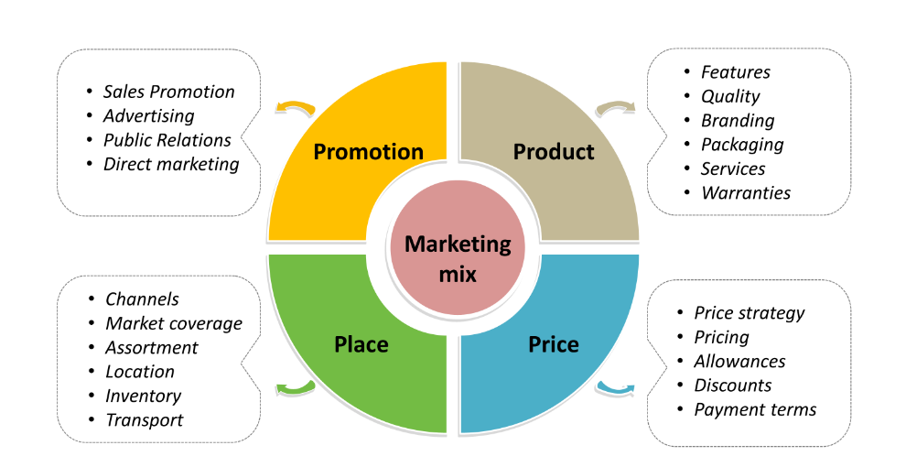
Figure-01: Marketing mix (Seturi, 2017)
- Product: First of all, an organization has to decide and define the market offering or product/ service that will serve the consumers (De Silva, 2013). It can be a tangible thing that is produced by the organization. The market offerings of Bella Napoli’s are Italian and sea foods items that are affordable and available in the market of England with different flavors. Various drinks and dessert items will be also offered by the organization.
- Price: Another important element of the marketing mix is price and an organization has to define the price of the product that it will offer in the market after determining the product (Hemingway, 2016). The price of the product of Bella Napoli’s will be lower than the other Italian restaurants in England and it will be a positive point of the organization and it will serve high quality of the products.
- Place: In this step, the organization will determine the place where it will operate its business activities. Bella Napoli’s will locate at the core place of England with a rooftop. The organization will also start its restaurants in various places in the United Kingdom as well as different countries.
- Promotion: At the least, the organization will build a promotional strategy to segment the market, set the target market, and promote activities. Bella Napoli will segment its market according to demographic characteristics and promote its restaurant through social media and advertising (Hemingway, 2016).

SWOT analysis of the company
SWOT analysis is an analytical model that is utilized by an organization to identify the strengths, weaknesses, opportunities, and threats by evaluating the external and internal environment of the company. The SWOT analysis of Bella Napoli is shown below:
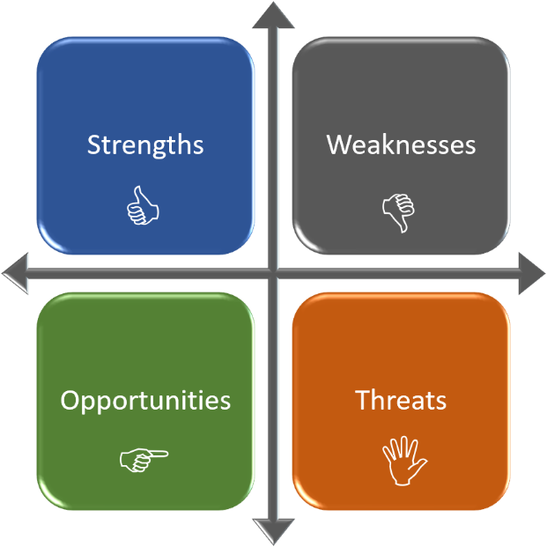
Figure-02: Diagram of SWOT (Seturi, 2017)
- Strengths: Bella Napoli will serve Italian and sea food in London in the United Kingdom that is quite popular and the price of the foods are also high. It is a strength of the company to serve popular Italian and sea foods at minimum cost. Besides, the company will endeavor to serve foods that contain unique tastes and the location of the restaurants is also attractive. These are the crucial strengths of the company.
- Weaknesses: All companies have some drivers that become weaknesses of the company in the future run. Bella Napoli is a new idea to start a business in the United Kingdom. As it is a new business plan, the lack of experience is one of the weaknesses of the company. Besides, lack of resources is another weakness of the company.
- Opportunities: Various external drivers that may provide some crucial extra value to the performance of the company are considered as the opportunities of the organization. A lot f restaurants in the United Kingdom that only offer Italian or sea foods. But few offer both foods. It is an opportunity for the company to offer both foods and attract more consumers.
- Threats: Various external drivers that may create some hindrances to the performance of the company are considered as threats. Of the organization. As a lot of successful restaurants are situated in the United Kingdom, Bella Napoli has to face some competition. Tough rivalry is one of the major threats for the company (Hemingway, 2016).

PESTEL analysis of the company
The macro environment has a great impact on the business organization which includes various external factors compiling political factors, economic factors, environmental factors, and so on. To analyze the macro environment, a popular analytical model has been used by the organization which is named PESTEL analysis. The Pestle analysis of the organization is-

Figure-03: PESTEL analysis (De Silva, 2013)
- Political factors: Political factors are important macro-environmental factors that have a great impact on the business organization and it compiles government, rules, and effect on the performance of the enterprise. Due to Brexit, Bella Napoli has to face an unstable political situation (Seturi, 2017). Moreover, a stable political situation exists in the United Kingdom that will help the organization to grow.
- Economic factors: It is also an important factor that includes the interest rate, tax, inflation rate, and so on and these will impact the performance of the organization that needs to manage by Bella Napoli (Phadermrod, 2019).
- Social factors: It includes cultural and traditional factors where an enterprise will conduct its business. As Bella Napoli is going to serve Italian and sea foods in the United Kingdom, the organization has to face some difficulties as they are out of culture.
- Technological factors: Advanced technology has a great impact on the performance of an organization. Using touch screen Point of Sale, QR code for ordering and paying, payment methods that are contactless, kitchen displays screens that will improve the performance of Bella Napoli.
- Environmental factors: “These are the factors related to the environment where a business organization performs its activities. Bella Napoli has to pay attention to keeping the environment cool and safe by not contaminating different components of the environment like air, water, soil, and so on” (Tan, 2020).

Legal factors: Different types of laws and regulations are included by the legal factors that have a great impact on the performance of an organization. Employment legislation and corporate social responsibilities need to be maintained by Bella Napoli.

Business Operations
Business operations can be defined as the activities that organizations engage in day to day to enhance the value of the organisation and earn a profit (Matovic, 2020). For establishing a successful organisation, it is very important to operate business activities properly. The business operations of Bella Napoli are discussed below:
- Preparing food: As Bella Napoli is a sea and Italian food restaurant, the main business operation of the organisation is preparing food. Good food will help to attract customers.
- Providing customer service: Another important operation of the business is providing good customer service. Consumer satisfaction is very important for a restaurant.
- Cleaning: To maintain cleaning in the restaurant is very important. It will help the organisation to create a strong image.
- Buying raw materials: For preparing foods, the organisation has to buy raw materials like spices, vegetables, meat, fish, and so on. For operating a business properly, it has to buy raw materials on time (Phadermrod, 2019).
- Accounting: Accounting is another important business operation that will help the organisation to maintain its daily activities.
- Reporting: Reporting will help the organisation to track its progress and decide future steps.

Management and organisation of the company
Management and organisation both are very important functions of the company. They help an organisation to optimum use of resources through significant planning and maintaining the workplace (Matovic, 2020). The management and organisation of the company are discussed below:
- Combining day to day operations
- Determining roles and duties
- Aligning tasks and responsibilities
- Overseeing activities.
- Creating a strong bottom line for long term growth
- Being consistent and proactively management
- Maintaining inventory and marketing activities

Financial management process
Another most crucial function of an organisation is financial function. The summarized profit and loss account, cash flow statement, and balance sheet of Bella Napoli have been presented below:
Profit Loss Statement
Details | Amount | Amount
Sales revenue  Other revenues  Total revenue  Total expenses  Profit | 85000  5000 | 89000  52000  37000

Cashflow Statement
Details | Amount
Cashflow from operations  Net earnings  Addition to cash  Subtraction from cash  Net cash from operations  Cashflow from investment  Equipment  Cash flow from financing  Notes payable  Net cash | 37000  5500  (4000)  37500  (8000)  2000  31500

Balance Sheet
Details | Amount | Amount
Assets  Total current assets  Total fixed assets  Total assets  Liabilities and equity of owners’  Total liabilities  Shareholders’ equity  Total liabilities and owners’ equity | 200000  350000  90000  460000 | 550000  550000

Conclusion
Bella Napoli is an Italian and seafoods restaurant which will be situated in London in the United Kingdom. It is an Italian and seafood restaurant that will be concreted on serving as the consumers as a guest of the house. The concrete aim and objectives will help the company to successfully establish itself. Besides, several tasks that will help to successfully execute the idea have been discussed. Different market analytical tools have been applied to the organisation. Moreover, business operations, management, and financial activities have been discussed.

References
Amofah, O., Gyamfi, I. and Tutu, C.O., 2016. The influence of service marketing mix on customer choice of repeat purchase of restaurant in Kumasi, Ghana. European Journal of Business and Management, 8(11), pp.102-112.
Cavusoglu, M., 2019. An analysis of technology applications in the restaurant industry. Journal of Hospitality and Tourism Technology.
De Silva, D.G., Elliott, C. and Simmons, R., 2013. Restaurant wars: spatial competition in UK restaurants. Univ. Management School.
Heminway, J.M., 2016. The Role of Business Counsel as Compliance Gatekeepers: Toward Understanding and Combatting Reckless Disregard for Legal and Ethical Compliance in Business Entities. Wayne L. Rev., 62, p.7.
Ikechi, A., Chinenye, E.P. and Chiyem, O., 2017. Marketing Mix Concept: Blending the Variables to Suit the Contemporary Marketers. International Academic Journal of Management and Marketing, 9(1), pp.55-65.
Matovic, I.M., 2020. PESTEL Analysis of External Environment as a Success Factor of Startup Business. ConScienS, p.96.
Nguyen, L.T., 2017. RESTAURANT STARTUP MARKETING MIX: Case study Mad Wok and Helmi restaurant-success and failure in marketing.
Pan, W., Chen, L. and Zhan, W., 2019. PESTEL analysis of construction productivity enhancement strategies: A case study of three economies. Journal of Management in Engineering, 35(1), p.05018013.
Phadermrod, B., Crowder, R.M. and Wills, G.B., 2019. Importance-performance analysis based SWOT analysis. International Journal of Information Management, 44, pp.194-203.
Satori, M. and Urotadze, E., 2017. About Marketing Process Model and Relationship Marketing. In Proceedings of International Workshop „Model-Based Governance for Smart Organizational Future (pp. 169-171).
Tan, T.F. and Netessine, S., 2020. At your service on the table: Impact of tabletop technology on restaurant performance. Management Science, 66(10), pp.4496-4515.

Appendix
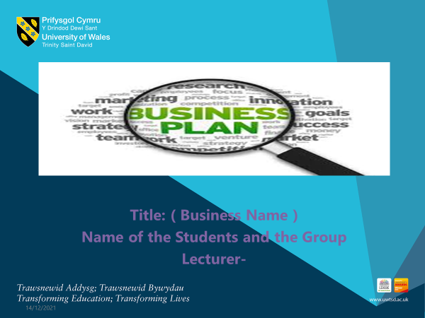
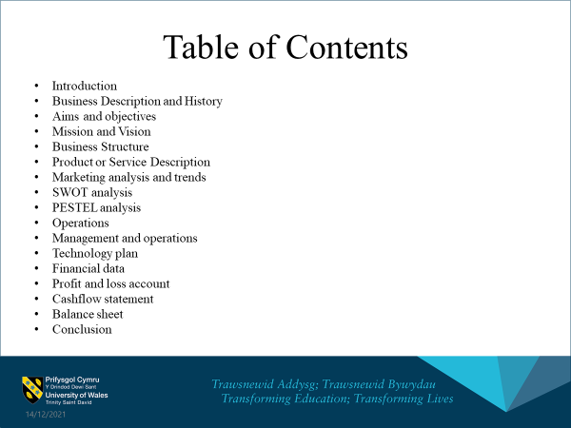

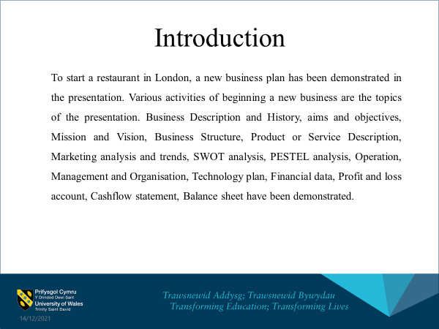
Note: To start a restaurant in London, a new business plan has been demonstrated in the presentation. Various activities of beginning a new business are the topics of the presentation. Business Description and History aims and objectives, Mission and Vision, Business Structure, Product or Service Description, Marketing analysis, and trends, SWOT analysis, PESTEL analysis, Operation, Management and Organisation, Technology plan, Financial data, Profit and loss account, Cashflow statement, Balance sheet have been demonstrated

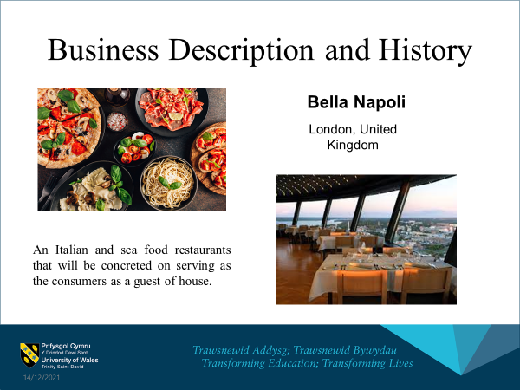
Note: The name of the organisation is Bella Napoli which will be situated in London in the United Kingdom. It is an Italian and seafood restaurant that will be concreted on serving as the consumers as a guest of the house.
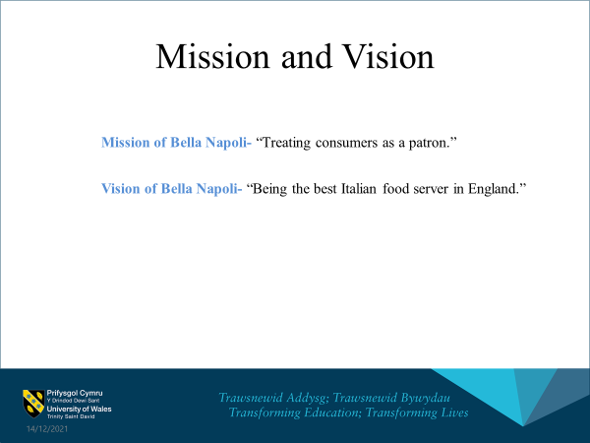
Note: The mission and vision of the organisation are-
The Mission of Bella Napoli- “Treating consumers as a patron.”
The Vision of Bella Napoli- “Being the best Italian food server in England.”
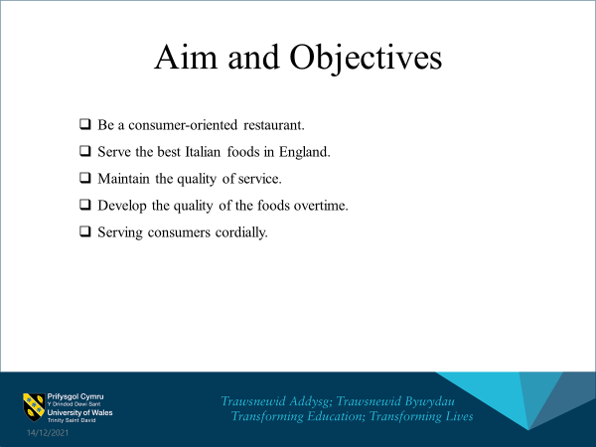
The aim and objectives of Bella Napoli are being e a consumer-oriented restaurant, serving the best Italian foods in England and maintaining the quality of service (Cavusoglu, 2019). Developing the quality of the foods over time and serving consumers cordially are also the objectives of the company.
The mission and vision of the organisation are-
The Mission of Bella Napoli- “Treating consumers as a patron.”
The Vision of Bella Napoli- “Being the best Italian food server in England.”
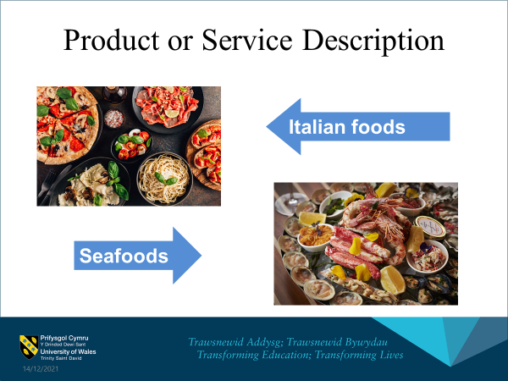
“The major product of Bella Napoli will be different kinds of seafood and Italian foods. These foods will offer something extra than other restaurants in the market. Some unique flavors and tastes will be added to these dishes”.
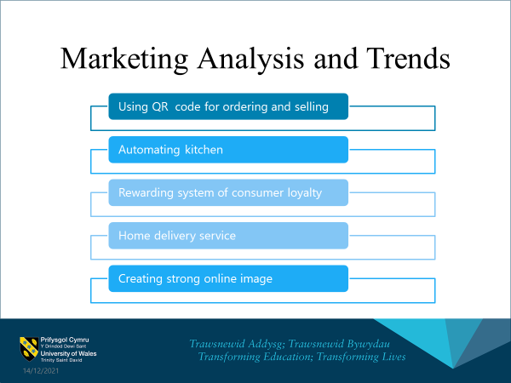
The marketing analysis and trends are using QR codes for ordering and selling, and automating kitchen. Rewarding the system of consumer loyalty is another trend. The other trends are home delivery service and creating a strong online image.
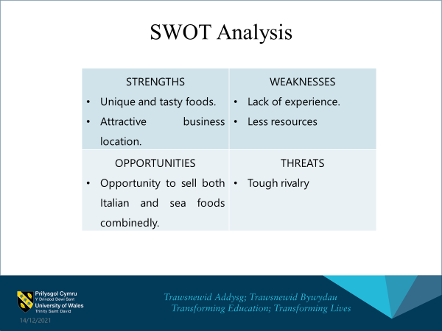
The SWOT analysis of the organisation is-
STRENGTHS: Unique and tasty foods and Attractive business location.
Weakness: Lack of experiences and resources
Opportunities: Opportunity to sell both Italian and sea foods combinedly
Threats: Tough rivalry
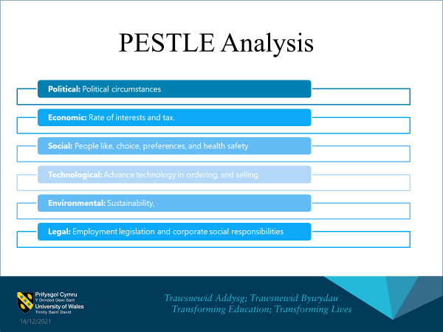
The Pestle analysis of the organisation is-
Political: Political circumstances
Economic: Rate of interests and tax (De Silva, 2013).
Social: People like, choice, preferences, and health safety
Technological: Advance technology in order, and selling
Environmental: Sustainability,
Legal: Employment legislation and corporate social responsibilities
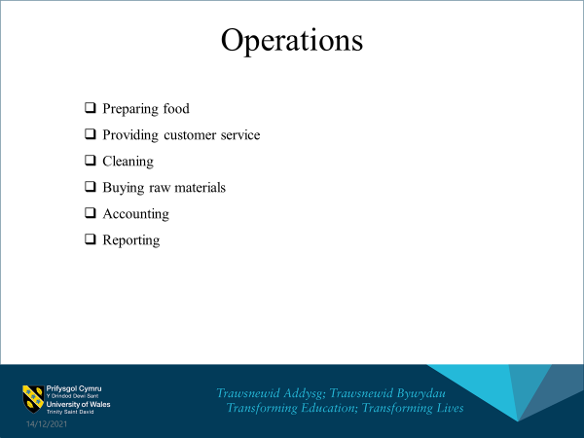
The operations of the organisation are-
- Preparing food
- Providing customer service
- Cleaning
- Buying raw materials
- Accounting
- Reporting
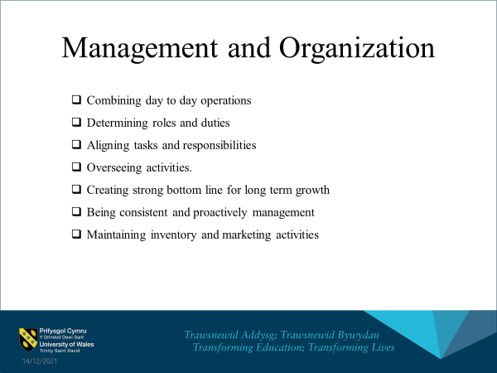
The managing and organizing activities of Bella Napoli are combining day to day operations, determining roles and duties, aligning tasks and responsibilities, overseeing activities, creating a strong bottom line for long term growth, being consistent and proactively managing and maintaining inventory and marketing activities (Ikechi, 2017)
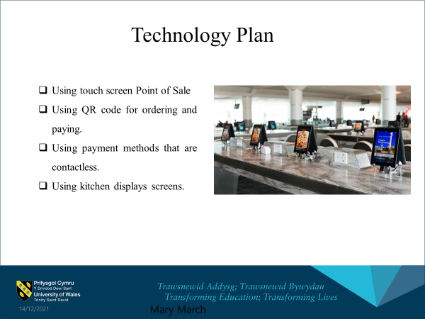
The technological plan of the organisation is-
- Using touch screen Point of Sale
- Using QR codes for ordering and paying (Amofah, 2016)
- Using payment methods that are contactless.
- Using kitchen displays screens
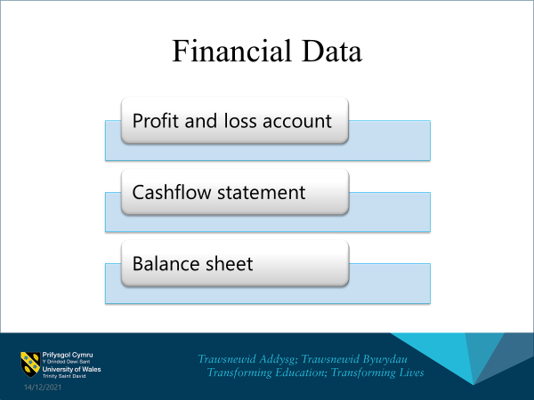
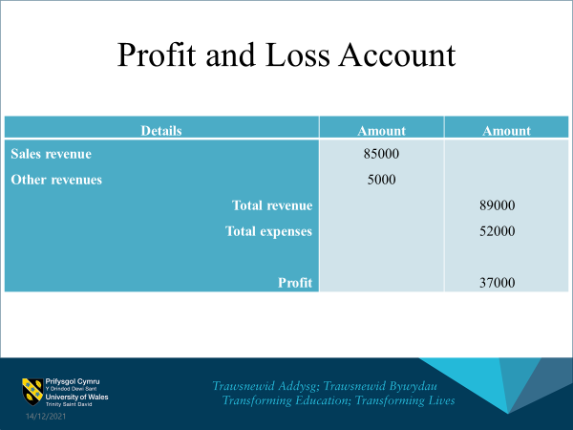
The estimate net income of the company is £37000
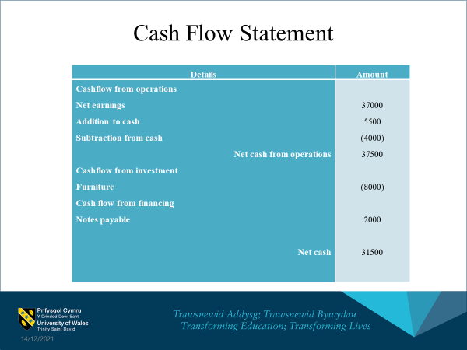
The estimated net cashflow is 31500
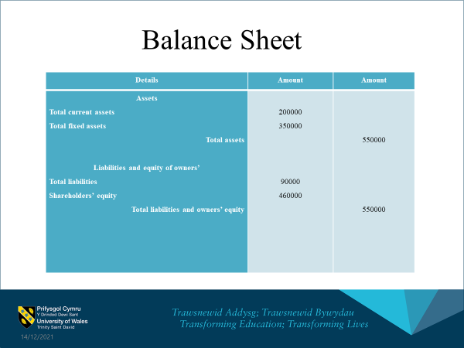
The total of the assets and total of the liabilities and owner’s equity is 550000
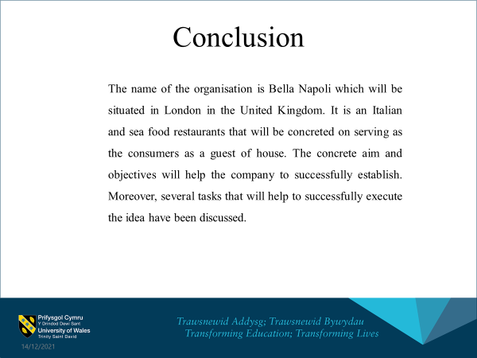
The name of the organisation is Bella Napoli which will be situated in London in the United Kingdom. It is an Italian and sea food restaurant that will be concreted on serving as the consumers as a guest of house. The concrete aim and objectives will help the company to successfully establish. Moreover, several tasks that will help to successfully execute the idea have been discussed.



