Word Count: 2034

Introduction to Public Health

Assignment 2

By Sheikh Redaaur Rahman
Student ID: 2115197

Table of Contents
Introduction 3
Public health 3
Data collection 3
Herd immunity 4
Communicable disease 4
Discussion 4
Trends 5
Public health campaigns and approaches 6
Recommendations 6
Non-communicable disease 7
Discussion 7
Trends 8
Public health campaigns and approaches 8
Recommendations 9
Conclusion 9
Reference List- 10

Introduction
Public health protects and promotes the health of the communities where they live, work, and learn. This study explains the role of various agencies that are engaged in collecting data related to health and diseases. Along with that, it defines how the World Health organisation, Public Health Wales and other agencies collect data. In addition, this study explains one communicational disease and one non-communicable disease which is widespread in the United Kingdom. Therefore, the communicable disease is tuberculosis which will be explained in this study along with its signs, symptoms, campaign, and approaches. On the other hand, this study defines the non-communicable disease Asthma including its trends, signs, symptoms, treatment, and approaches. In addition, this study also mentions the current lifestyle choices' impact and recommendations for healthy development.

Public Health
Public health is important to improving and protecting the health of the common people and communities. As mentioned by Allington et al. (2021), the work of public health is defined by achieving the healthy lifestyle of communities, injury prevention, researching various diseases and preventing infectious diseases. Public health aims to prevent problems in the communities by recommending policies, conducting research, and administering services. The practices of public health play a great role in medical sciences and philosophy along with controlling and manipulating the environment of the common people. In recent times, various public health agencies come to establish, monitor, and control disease within societies on both the international and national levels.

Data Collection
Many agencies in the United Kingdom conduct campaigns often and take the record of the diseases. For example, the Health Resources and Service administration is one of the popular agencies that conduct health campaigns and collect data regarding the health of the communities. On the other hand, many hospitals connect with various agencies so that they can help them to collect important data.

Herd Immunity
Herd immunity occurs when a considerable section of society acquires resistance to a disease, disease transmission from person to person becomes rare. Consequently, the entire community not just individuals who are immune are protected. As mentioned by Stellefson et al. (2020), illnesses are likely to coexist in a person, although they may go unnoticed for a long time until issues arise. Due to the obvious severity of the consequences, it is critical for public health departments in many countries throughout the world to adopt systematic screening for the diseases if the world is to avoid them.

Communicable Disease
A communicable disease is mainly caused by bacteria or viruses that can be spread by one another person through contaminated contact. As opined by Ortega and Orsini (2020), this type of disease is mainly the growth and presence of pathogenic biological agents in single persons. Transmission of this disease can be done in various ways, and it can redirect physical contact, consuming contaminated beverages and foods with an infectious human being. In addition, a lot of people in the UK are affected by tuberculosis disease and over the last 20 years, it is increasing slowly. In addition, communicable diseases can also be spread if a person receives a bite from an animal carrying the biological pathogen. As mentioned by Tang et al. (2020), the pathogen of the communicable disease can replicate after entering a new body and it is harmful to the person. However, this type of disease is mild, and the person can get the symptoms after a few days of receiving the pathogen.

Discussion
A person who is suffering from tuberculosis disease can have different noticeable signs and symptoms.
- Signs and Symptoms- The most vital symptom of this disease is having a cough for three and more weeks. In addition, a person with this disease must cough with blood and mucus along with chest pain and breathing problems. On the other hand, other symptoms of this disease are sudden weight loss, fatigue, loss of appetite, fever, and night sweats. The tuberculosis disease can also affect other parts of the human body including the brain, spine, or kidneys.
- Implications- The mode of the transmission of the disease is air and so it does not spread by surface contact. As observed by Brouard et al. (2020), a person with this disease should take care of their lifestyle and continue with the instruction of the experts. Along with that, they must visit the doctor often and take all the medicines prescribed by the doctor.

Trends
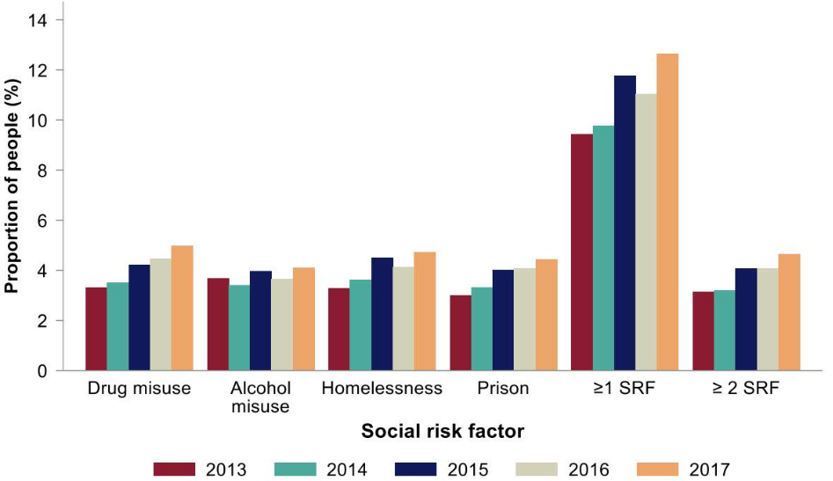
Figure 1: Prevalence and Spread of TB in the UK
(Source: Phillips et al. 2019)
In the United Kingdom, tuberculosis is one of the notifiable diseases and over the last 20 years, it is increasing slowly. Along with that, a total of 1.5million people died from tuberculosis in 2020 globally and it is a serious issue. In addition, research of various health care sectors states that 44% fall in recent diagnosis from 2011 to 2018. As mentioned by Phillips et al. (2019), the people of the UK are not concerned about this disease, and they have to be more aware of the disease. In addition, they should attend more campaigns about the disease so that they can know about it. In the first few months of 2021, 995 people in England were affected by this disease. In the last year, the rate of death in tuberculosis was the highest at any time in history and it was approximately 8000 per day.

Public health campaigns and approaches
The public health campaign aims to prevent the spread of harmful health risks and it is an integral communication in recent times. This type of campaign engages a broad set of medical activities and strategies so that the specialist can approach various guidelines to the people. As per the proposal given by Nugent et al. (2018), it is important to conduct public health campaigns often to guide the people effectively. For example- radically boost awareness campaign of tuberculosis is often held and specialists of this disease suggest to the infectious people what to do in this situation. However, these types of campaigns are also helpful for the common people as it promotes healthy life and how to lead it. Therefore, the purpose of the public health campaign is to increase the public consciousness about vital health problems by teaching specific teams. For example, the UK Health Security agency conducts public health campaigns often related to various diseases.

Recommendations
Patients with this infection should follow some rules and restrictions to cure the disease soon.
The family of the patient should also have to place them in airborne precautions.
It is also important to wear safety and a surgical mask when a person enters the room of the infected person as it is an air transmitted pathogen.
- Patients with the infection should always follow the guidelines of the doctors and visit the doctor regularly
- They should take medicines as per the suggestion of the experts at a time or else they can suffer serious problems
- It is mandatory to maintain hygiene along with covering the nose and mouth with a mask at the time of coughing or sneezing as it can reduce the spread of the infection.
- The spread of this disease can be reduced by the ventilation system, use of medical masks and keeping the patients separately from others

Non-communicable Disease
Non-communicable diseases are those that cannot be passed from one person to the next person. The four primary groups of non-communicable diseases are such as diabetes; chronic respiratory disease such as asthma; coronary artery diseases such as congestive heart failure and Cardiovascular illness such as hypertension. Non-communicable diseases have become the primary cause of death worldwide therefore non-communicable diseases account for more than 63.1 % of yearly mortality. Around 37 million people worldwide die each year from non-communicable diseases, with 81 % of them coming from low-income as well as middle-income nations. However, before even the age of 60, over 9.1 million people die from non-communicable diseases (Brown, 2018). Females, as well as males, are equally affected by non-communicable diseases, with minimal difference in cancer, hypertension, asthma, and diabetes. Although lifestyle is the leading cause of non-communicable diseases, a simple change in lifestyle can play an important role in their treatment.

Discussion
Asthma is a disorder that causes a person’s airways to constrict as well as thicken and create excess mucus. It can cause breathing problems, resulting in coughing, screeching (gasping for breath) on exhalation, as well as shortness of breath. Asthma is a mild annoyance for some people.
- Signs and Symptoms: Asthma can cause breathing problems, chest discomfort, coughing, and congestion whereas symptoms may flare up from time to time. Asthma has a variety of symptoms which includes tightness in the chest, breathing problems, coughing on a regular basis especially at night. Apart from this, suffocation, as well as feeling short of breath, are also signs of asthma (Seutloali et al. 2018).
- Implications: Asthma is often treated with rescue inhalers that relieve symptoms as well as regulatory nasal sprays which avoid them. Longer-acting sprays which keep the lungs healthy, and inhalant steroids, may be required in severe instances. Quitting smoking will reduce the frequency of asthma symptoms one experiences, improve the asthma symptoms daily, as well as it treats the healing of the lungs.

Trends
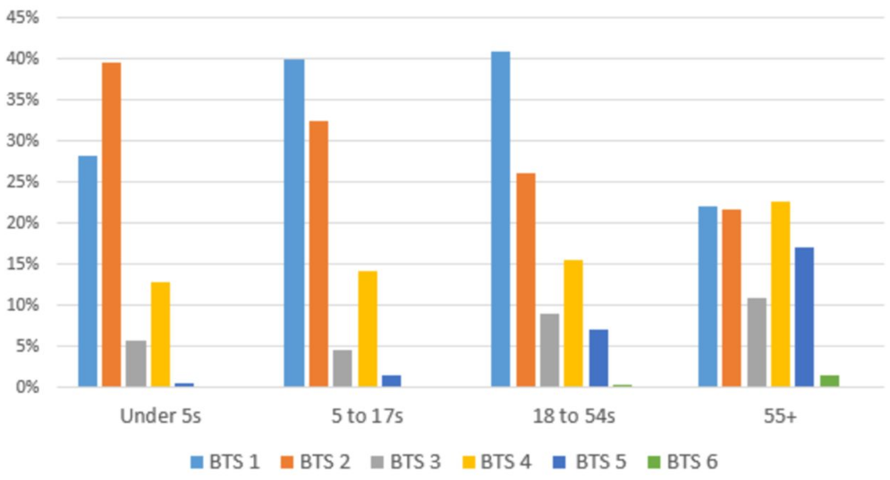
Figure 2: Risk and Characterization of the UK’s Asthma Population
(Source: Koh et al. 2021)
Non-communicable diseases are frequently linked to possible causes that are nearly identical. Air pollution, overweight, family background of illnesses, high levels of reduced lipoprotein in the body, tobacco, and alcohol addiction as well as lack of physical activity are only a few of the risk factors. In 2010, about 43.1 million children under the age of five and 1.6 billion adults were estimated to be overweight, indicating that more individuals may acquire non-communicable diseases in the future. On the other hand, tobacco kills about 6.3 million people per year in the world, with the figure expected to rise to 7.6 million in the upcoming time (Koh et al. 2021). The treatment of the two disorders requires early identification. Individuals must also take responsibility for their own health by engaging in regular exercise, eating good foods, quitting smoking, and maintaining a healthy weight to aid in their prevention.

Public health campaigns and approaches
The goal of a public health campaign is to avoid the spread of dangerous health implications, and it has become an important part of current communication. It is critical to run public health campaigns on a regular basis to successfully guide the public. This sort of campaign entails a diverse range of medical actions and techniques, allowing specialists to present numerous suggestions to the public. In addition, campaigns are frequently performed, with experts in the illness advising infected individuals on what to do in such a case. On the other hand, these sorts of advertisements are beneficial to the public since they promote a healthy lifestyle and how to live it. However, the goal of the public health campaign is to raise public awareness about critical health issues by training particular teams. For example, national programmer for prevention and control of cancer is routinely held, with specialists in the disease instructing afflicted people on what to do in such a situation. The public health campaign's purpose is to raise public awareness of essential health concerns through training certain teams (Jones, 2019).

Recommendations
Patients with these non-communicable diseases should adhere to a set of rules and limits to recover quickly which are as follows:
- They must take medicines as prescribed by professionals on a timely basis, or they may experience devastating results.
- Patients with infections should constantly follow their physicians' instructions and see them on a frequent basis.
- Implement as well as develop effective legal frameworks (Lee et al. 2018).
- Reduce significant modifiable risk factors include cigarette use, hazardous alcohol consumption, poor diets, as well as lack of physical exercises.
- Highlight the impact of non-communicable diseases through worldwide collaboration as well as advocacy.

Conclusion
From the above study, it can be concluded that public health is concerned with the protection and promotion of the health of the communities in which people live, work, and study. To examine this, the study provides the roles of several agencies involved in the collection of data on health and disease. Apart from this, the study describes communicable diseases as well as non-communicable diseases including their signs and symptoms as well as the implications.

Reference List
Allington, D., Duffy, B., Wessely, S., Dhavan, N. and Rubin, J., 2021. Health-protective behaviour, social media usage and conspiracy belief during the COVID-19 public health emergency. Psychological medicine, 51(10), pp.1763-1769.
Brouard, S., Vasilopoulos, P. and Becher, M., 2020. Sociodemographic and psychological correlates of compliance with the Covid-19 public health measures in France. Canadian Journal of Political Science/Revue canadienne de science politique, 53(2), pp.253-258.
Brown, R.C., 2018. Resisting moralisation in health promotion. Ethical Theory and Moral Practice, 21(4), pp.997-1011.
Jones, R., 2019. Climate change and Indigenous health promotion. Global health promotion, 26(3_suppl), pp.73-81.
Koh, A., Swanepoel, D.W., Ling, A., Ho, B.L., Tan, S.Y. and Lim, J., 2021. Digital health promotion: promise and peril. Health Promotion International, 36(Supplement_1), pp.i70-i80.
Lee, M., Lee, H., Kim, Y., Kim, J., Cho, M., Jang, J. and Jang, H., 2018. Mobile app-based health promotion programs: a systematic review of the literature. International journal of environmental research and public health, 15(12), p.2838.
Nugent, R., Bertram, M.Y., Jan, S., Niessen, L.W., Sassi, F., Jamison, D.T., Pier, E.G. and Beaglehole, R., 2018. Investing in non-communicable disease prevention and management to advance the Sustainable Development Goals. The Lancet, 391(10134), pp.2029-2035.
Ortega, F. and Orsini, M., 2020. Governing COVID-19 without government in Brazil: Ignorance, neoliberal authoritarianism, and the collapse of public health leadership. Global public health, 15(9), pp.1257-1277.
Phillips, C.M., Chen, L.W., Heude, B., Bernard, J.Y., Harvey, N.C., Duijts, L., Mensink-Bout, S.M., Polanska, K., Mancano, G., Suderman, M. and Shivappa, N., 2019. Dietary inflammatory index and non-communicable disease risk: a narrative review. Nutrients, 11(8), p.1873.
Seutloali, T., Napoles, L. and Bam, N., 2018. Community health workers in Lesotho: Experiences of health promotion activities. African Journal of Primary Health Care and Family Medicine, 10(1), pp.1-8.
Stellefson, M., Paige, S.R., Chaney, B.H. and Chaney, J.D., 2020. Evolving role of social media in health promotion: Updated responsibilities for health education specialists. International journal of environmental research and public health, 17(4), p.1153.
Tang, B., Wang, X., Li, Q., Bragazzi, N.L., Tang, S., Xiao, Y. and Wu, J., 2020. Estimation of the transmission risk of the 2019-nCoV and its implication for public health interventions. Journal of clinical medicine, 9(2), p.462.

