Research in Data Security and Compliance – Physical Security
Wayne Howell
Student University of Wales Trinity St David, Swansea, Wales
2207408@student.uwtsd.ac.uk

Abstract - Physical security is a crucial component of data compliance and security, concentrating on safeguarding physical assets and facilities from unauthorised access and potential threats. This paper explores various aspects of physical security, including frameworks, challenges, and the implementation of security measures. It critically evaluates existing literature and methodologies, with comparative analyses, and theoretical frameworks, to demonstrate why organisations need to create environments that protect, detect, react, and safeguard applications using their IT systems and infrastructure. By analysing these elements, the paper provides comprehensive insights into how organisations can enhance their security to ensure data protection and compliance.
- Physical Security Overview
Physical Security is the protection of personnel, hardware, software, networks, and data from physical actions and events that have the potential to cause substantial loss or harm to an organisation, agency, or educational establishment. This includes security against terrorism, burglary, theft, vandalism, and natural catastrophes, as well as fire, flood, and natural disasters [1].
In the modern era, where digital and physical realms are increasingly intertwined, the importance of physical security for data cannot be overstated. Physical and information security are naturally linked. Without robust physical security, information security measures can be easily bypassed.
Physical threats to data can come in various forms which can result in severe consequences to organisations and potential irreversible damage to their reputation. For example, unauthorised access to server rooms or data centres can lead to data breaches, hardware theft, or destruction. This can result in legal and financial repercussions, a loss of customer trust and a reluctancy for further business.
Many organisations are subject to regulatory requirements regarding data protection. For example, the General Data Protection Regulation (GDPR) mandate the implementation of physical security to protect sensitive data. This relies on a coordinated effort within an organisation, specifically staff in information technology (IT), security and general management roles.
- Frameworks and Challenges
Parker’s seven major sources of physical loss continues to provide a valuable framework for organisations to understand and mitigate physical security risks [2]. It provides a comprehensive foundation. However, Parkers framework does not address modern threats. For instance, the advancement of technology, such as Internet of Things (IoT) and advanced cyber-attacks means organisations must continuously adapt their strategies to address both traditional and emerging threats. New challenges such as global warning and climate change can introduce more frequent temperature changes which can complicate temperature management. Potentially this can be negated by the introduction of advanced control systems to reduce the impact of extreme temperatures. New air quality monitoring systems can improve detection and mitigate gaseous treats. The Covid-19 pandemic highlighted the need for comprehensive health and safety protocols, all of which are not addressed in Parker’s original framework.
Treat | Description
Temperature | extreme heat of cold
Gases | war gases, commercial vapours, humid or dry air, suspended particles
Liquids | water, chemicals
Living Organisms | viruses, bacteria, people, animals, insects
Projectiles | tangible objects in motion, powered objects
Movement | collapse, shearing, shaking, vibration, liquefaction, flow waves, separation, slide
Energy | electrical surge or failure, magnetism, static electricity, aging circuitry; radiation: sound, light, radio, microwave, electromagnetic, atomic
Table 1: Donn B. Parker’s seven major sources of physical loss
To address the evolving threats, organisations must be adaptable by implementing viable security measures that are consistent with the most recent frameworks. This policy will feed a more robust risk management strategy, fit for today’s world.
In conjunction with Parkers framework, organization's can utilise the National Protective Security Authority (NPSA) websites [3,4]. It provides up-to-date guidance on how organisations can meet the challenges ahead. It focuses on critical threats and practical measures with the goal of achieving effective physical security through multilayer procedures. It addresses several key areas, with links to numerous bespoke components of physical security, including a welcomed focus on Cyber Assurance and Physical Security Systems (CAPSS). The primary objective of CAPSS is to establish a mechanism that enables a prominent level of confidence in effective cyber mitigations, thus supporting organisations with updated strategies [4].
The NPSA's insights provide practical recommendations that expand upon the theoretical frameworks and challenges previously discussed. Organisations will be able to employ these concepts in real-world scenarios, adapting when necessary to ensure a solid physical security strategy.
- Implementation of Physical Security Measures
Physical security is a complex subject which involves the use of a wide variety of methods and technologies, each of which is specialised to handle particular security issues. When combined, these tools produce a comprehensive protective system that is applicable to a wide range of environments [5].
Fennelly’s, Effective Physical Security [6], is an excellent source and guide on how to apply physical security measures. The book provides a thorough overview of all aspects of physical security, ranging from basic concepts to advance strategies and tackles modern security concerns more directly. Environmental design, security surveys, locks, lighting, and CCTV provide a broad understanding of creating a secure environment. This is enhanced by expert contributors to provide a variety of perspectives and proficiency. It contains the latest International Organisation of Standardisation (ISO) for risk assessment and management, a significant strength that aligns the book with global recognised practices and benchmarks.
Currently on its 5th edition, it has the latest advancements in security technology, which is crucial to an ever-evolving field.
- Physical Security Measures
There are several protective measures that organisations can implement to ensure physical security.
- Physical Security Controls
- Access Controls
The location of the organisation’s buildings can deter unauthorised access and minimise the risk of attacks from physical threats. These facilities often utilise natural terrain, local traffic flow, and surrounding development. The strategic placement of buildings can significantly enhance security by using physical geography to create obstacles to alleviate access. For example, placing a facility on high ground can make it hard for intruders to approach undetected. Additional protection mechanisms such as fences, gates, walls, guards, and alarms, creates multiple layers of security. All are used for controlling and governing the movement of people within facilities and controlling their access to company resources​. However, implementing and maintaining extensive security measures can be costly. Maintenance costs can be a significant burden, especially for smaller organisations. The physical nature of these controls may result in scalability issues when an organisation experiences growth and change. Adapting these security measures can be challenging and expensive. The National Institute of Standards and Technology (NIST) Special publication 800-12 [7] provides a thorough discussion of physical and environmental security measures. As a reputable and credible source, it breaks down complex topics and explains the importance of each security measure and provides practical examples and offers guidance on implementation. Though, it could benefit with an updated version considering new modern technologies and latest security threats and potentially tailor its information to specific industries.

- Security Controls
Security controls are essential to provide the necessary measures to protect assets, ensure safety and maintain the integrity of an organisation.
There are several security controls an organisation can implement inside and outside its facilities.

Each security control has both advantages and disadvantages some of which are outlined below:

- Walls, fencing, and gates provide a visible deterrent and limit access points, but they are immobile and easily overcome.
- Guards provide versatility and fast response, but they are expensive and susceptible to distraction.
- Dogs excel at sensory detection and intimidation, but they require training and care.
- ID cards and badges provide effective authentication and tracking, yet they are prone to modification, cloning and loss.
- Locks and keys are simple and trustworthy, yet they are susceptible to picking and mechanical failure.
- Mantraps provide excellent security but can be extremely expensive and inconvenient.
- Electronic monitoring provides continuous observation and evidence recording, but it creates privacy problems and requires regular maintenance.
- Alarms give immediate notifications and deterrence, but they can cause false alarms and require a prompt reaction.
- Computer rooms protect important infrastructure, yet they are costly and have the potential to be single points of failure.
- Walls and doors provide separation and fire protection, although they are expensive to build and can be evaded if not professionally installed.

NIST SP 800-53 Revision 5 [8], is credible source that extensively discusses security controls to ensure privacy and information systems in organisations are protected. It emphasizes the importance of developing layers of protection as a security principle. It is wide range of security controls make it applicable to the many types of organisations, and it stresses the need for organisations to tailor their needs as a best practice. It highlights specific security considerations that organisations should consider when implementing controls. Accompanied by the latest technologies such as smart cameras, AI and Machine learning, facial recognition, drones, and robotics to patrol large areas, it provides valuable insights for organisations to enhance the effectiveness of security measures and the importance of aligning with regulations.

- Fire Safety and Response
- Fire Security and Safety
Ensuring the safety of people within an organisation is paramount. Fires pose a signification threat to not just individuals but to physical assets, including servers, data storage devices and critical infrastructure. This makes fire safety a top priority in physical security planning.

The implication of not having a solid fire security and safety plan is disastrous. Injuries or fatalities caused by fires can have profound legal, ethical, and operational implications for an organisation.

The Regulatory Reform (Fire Safety) Order 2005 (FSO) [8], is the central legislation covering fire safety in non-domestic premises in England and Wales. It consolidates various safety laws in a single piece of legislation, providing a streamlined legal framework, delivering consistency, efficiency, and clarity to organisations. Its key aspects include.

- Responsibility – designates who is accountable for fire safety i.e. employer or building owner.
- Fire Risk Assessment – requires regular assessments and appropriate measures to mitigate risks.
- Precautions – mandates adequate fire detection, alarms, fire exits and fire equipment.
- Training and information – Ensure staff receive up-to-date fire training and information.

Organisations must follow the legislation to offer fire safety for its employees and physical assets, and it is a crucial component in any fire safety plan.

- Fire Detection, Suppression Systems and Response
Fire detection and response involve systems and protocols designed to identify and react to fires quickly and effectively. These systems are critical in mitigating fire hazards, protecting lives, and minimizing property damage. Fire detection systems can be manual, relying on human intervention, or automatic, utilising sensors to detect heat, smoke, or flames. Response mechanisms include various suppression systems, such as portable extinguishers, sprinkler systems, and gas-based solutions, tailored to control and extinguish fires while minimizing harm to people and property.

Fire detection systems provide comprehensive coverage via manual and automatic routes to ensure robust fire safety measures. Utilising diverse detection types such as thermal, smoke, and flame detection to cater for a variety of scenarios. Plus, modern advanced suppression systems like water mist and clean agents like Halon can minimise damage. However manual systems can cause false alarms, leading to unnecessary disruptions.

The Fire Industry Association (FIA) guide [9], provides comprehensive insights into fire detection and alarm systems. Its strengths lay in best practices, regulatory requirements, and technological advancements in fire safety.

The document offers thorough explanations of different advanced fire detection systems and stresses adherence to UK fire safety regulations, ensuring legal compliance to safeguard comprehensive detections and responses are in place. However, the more advanced systems can be costly to install, so the document also provides alternatives.
- Facilities Maintenance and Safety
- Heat Ventilation and Air Conditioning
Heat, ventilation and Air Conditioning (HVAC) systems are critical infrastructure within an organisation. There are four principal areas of concern that can cause damage to information systems: temperature, filtration, humidity, and static electricity. All of which can severely impact loss of data and staff.

Modern HVAC systems have automated environment controls to reduce the risk of human error and include integrated monitoring systems and backup systems for rapid response. However, organisations find challenges in integration with IT security to provide adequate protection against cyber-attacks and threats to life. Their maintenance can also be expensive, so sufficient funding is needed, not only for systems but for professional IT technicians.

Thakur’s, Intelligent HVAC Control Systems for Smart Infrastructures [10] highlights the need for intelligent HVAC systems to combat modern day issues. It discusses the concepts of HVAC systems in different regions like Europe, Asia, and North America with the importance of tailored solutions for each area. It explores the use of IoT and AI-enhanced HVAC systems listing benefits such as optimizing environmental conditions and reducing the risk of data loss. It can aid organisations to determine their best course of action going forward to tackle emerging threats.

- Structural Collapse
Maintaining the structure of buildings in an organisation is necessary. Regular assessments are needed by qualified civil engineers to highlight potentially dangerous conditions. Examples include natural disasters such as earthquakes and flooding, corrosion, poor design, substandard materials, overloading, and maintenance neglect.

The Construction (Design and Management) Regulations 2015 [11], covers all aspects of construction project management, health and safety, and legal requirements that an organisation can use when constructing or updating new facilities. The document clearly outlines roles and responsibilities ensuring accountability at every stage. Providing training to all stakeholders to understand and implement the regulations will keep organisations at the forefront of conformity. Implementing software to track progress and responsibly will enhance safety and management practices.
Creating a disaster plan to prepare for such events can help organisation recover far quicker and safeguards the business.

- Conclusion
Physical security is an essential component of an organisation's total security. It needs to ensure the safety of individuals, hardware, software, networks, and data against physical attacks. This paper examined the critical frameworks, problems, and safeguards required to protect against these threats. It emphasizes the significance of constantly monitoring and updating physical security measures to combat emerging technology and developing threats.
Failure to maintain strong physical security can have serious effects, such as data breaches, legal and financial ramifications, and irreversible harm to an organisation's brand. Integrating physical and IT security, with advanced technologies, adhering to legal standards, and implementing comprehensive security controls are critical for establishing a secure environment.
Organisations must acknowledge the importance of adapting to new issues and emerging threats by being proactive and not reactive. Implementing updated frameworks and policies with scheduled reviews, organisations can build and maintain effective physical security. This practical strategy ensures not only compliance but also the protection of vital assets and infrastructure, which contributes to the broader aim of improving physical security.

Task 2: Case Scenario

Table of Contents
Table of Contents 5
2.1 List of Figures/Tables 6
2.2 List of Acronyms 7
2.3 Introduction 8
2.4 Research 9
2.4.1 CIA Triangle 9
2.4.2 The McCumber Cube 9
2.4.3 System Development Life Cycle (SDLC) 10
2.4.4 Bottom-Up Approach v Top-Down Approach 11
2.4.5 Security Models 11
2.5 Design Approach 13
2.5.1 Organisation Structure/Chart 13
2.5.2 Policies and Procedures 16
2.5.3 Data Protection and Compliance 18
2.5.4 Security Standards 18
2.5.5 Contingencies Planning 19
2.5.6 Governance and Strategic Planning for Security 21
2.5.7 Risk Management 21
2.7 Conclusion 23
2.8 References 24

2.1 List of Figures/Tables

Figure/Table | Description
Figure 1 | Components of the CIA Triad
Figure 2 | CNNS Security Model (The McCumber Cube)
Figure 3 | SDLC Waterfall Model
Figure 4 | Organisation Chart of Proposed Information Security Unit
Figure 5 | The relationship between practices, policies, standards, guidelines and procedures
Figure 6 | Components of Contingency Planning
Table 1 | Bottom-Up Approach v Top-Down Approach
Table 2 | Strengths - ISO 27000 Series v NIST Security Models
Table 3 | Comparative Analysis of ISO 27000 Series v NIST Security Models
Table 4 | Proposed Security Polices

2.2 List of Acronyms

Acronym | Description
BCP | Business Continuity Plan
BIA | Business Impact Analysis
CCFP | Certified Cyber Forensics Professional
CIA | Confidentiality, Integrity, and Availability
CIO | Chief Information Office
CISM | Certified Information Systems Manager
CISO | Chief Information Security Officer
CISSP | Certified Information Systems Security Professional
DPIA | Data Protection Impact Assessment
DRP | Disaster Recovery Plan
EISP | Enterprise Information Security Policies
GDPR | General Data Protection Regulations
HIPAA | Health Insurance Portability and Accountability Act
IPP | Incidence Response Planning
ISO | Information Standards Organisation
ISSP | Issue-Specific Security Policies
ISU | Information Security Unit
IT | Information Technology
NIST | National Institute of Standards and Technology
PCI-DSS | Payment Card Industry Data Security Standard
SDLC | System Development Life Cycle
SysSP | System-Specific Security Policies
VPN | Virtual Private Network

2.3 Introduction
This report aims to provide a comprehensive overview of a strategic approach to create a new Information Security Unit within an organisation. The new unit is critical to protect the organisation’s data assets, ensure compliance with relevant data protection legislation, and safeguard against increasing cyber threats.
An extensive review of related work and research was undertaken to inform the design approach, where several key factors critical to the successful implementation are addressed. The detailed approach highlights the need for organisation structure, policies and procedures, data protection compliance, security standards, contingency planning, governance, and risk management.
Finally, the report presents an analysis of the proposed approach, offering insights and justifications for the decisions made, alongside suggestions for future improvements.

2.4 Research
The design approach is driven by research in security principles and frameworks for information security. The findings in this research will be applied to a variety of areas in the new Information Security Unit (ISU).

2.4.1 CIA Triangle
The C.I.A. triangle is a foundational model in information security that has been considered the industry standard since the development of the mainframe. It focuses on three core principles: Confidentiality, Integrity, and Availability [12].
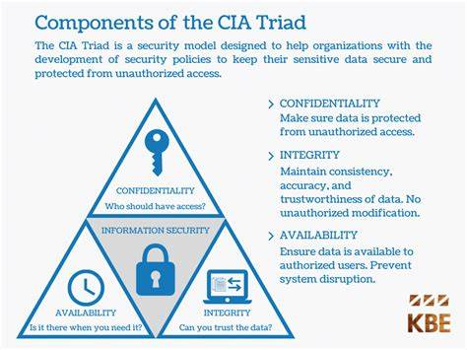
Figure 1: Components of the CIA Triad [13]
Over time, the C.I.A. triangle has expanded into a more comprehensive list of critical characteristics of information. These additional characteristics address the evolving landscape of information security and include authentication, authorisation, non-repudiation, and accountability.
ISU Relevant Areas: Policies and Procedures, Security Standards, Risk Management.

2.4.2 The McCumber Cube
The McCumber Cube, or CNSS Security Model, is a comprehensive information security framework. This model ensures all security aspects are considered and implemented. Using this model requires addressing all 27 cells during security.
The McCumber Cube considers three dimensions for Information security:
Information States: The states in which information exists.
Security Measures: The types of protection applied to information.
Security Services: The goals of these protections.
These three dimensions are combined to form a cube with 27 cells, representing various aspects of information security that need to be addressed.
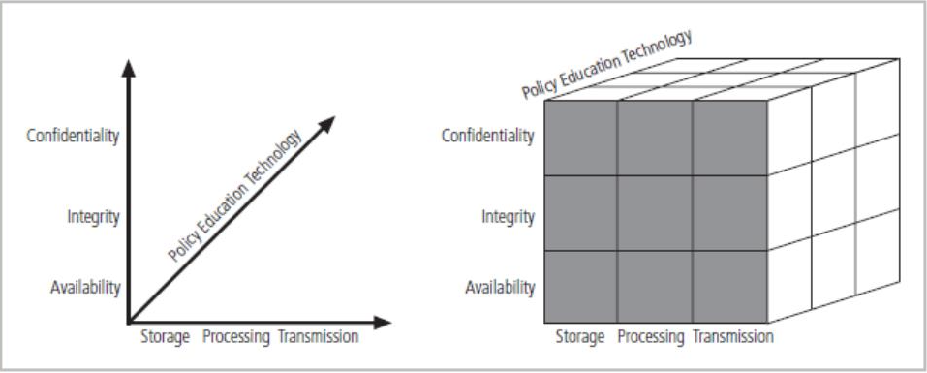
Figure 2: CNNS Security Model (The McCumber Cube)
ISU Relevant Areas: Policies and Procedures, Security Standards, Governance and Strategic Planning.

2.4.3 System Development Life Cycle (SDLC)
The Systems Development Life Cycle (SDLC) is a structured methodology used for the design, development, and implementation of information systems within an organisation. It provides a systematic approach to creating systems that meet business requirements and user needs while ensuring quality and efficiency throughout the development process [14].
The traditional SDLC consists of six phases knows as the waterfall model, shown in Figure 3.

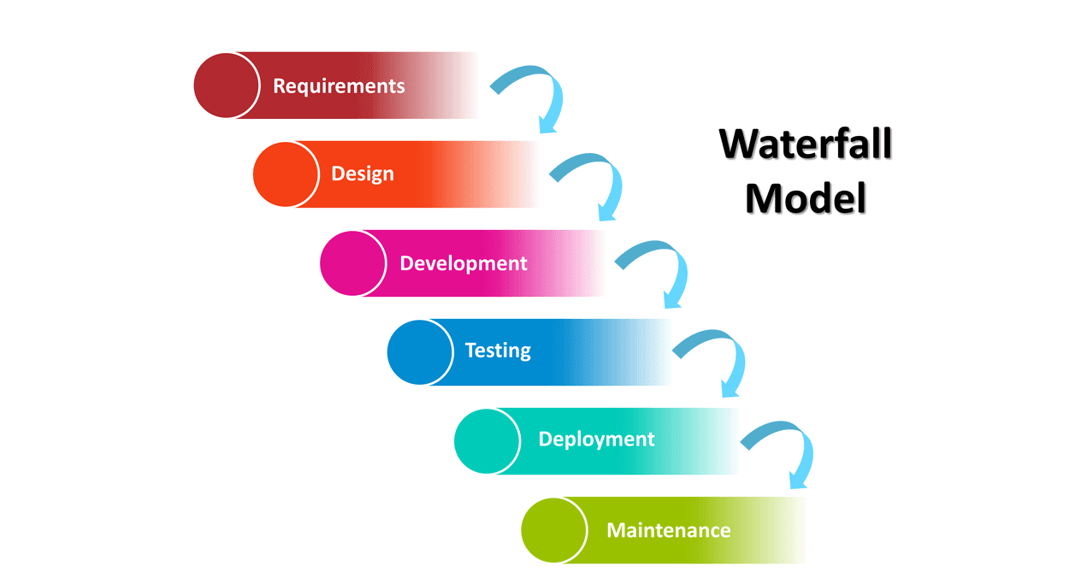
Figure 3: SDLC Waterfall Model [15]

SLDC security is stressed in NIST Special Publication 800-64, rev. 2 [16]. It organises security integration and addresses security issues thoroughly. Organisations can create secure, compliant, and cost-effective systems by following the guidelines.
ISU Relevant Areas: Policies and Procedures, Security Standards, Contingency Planning.

2.4.4 Bottom-Up Approach v Top-Down Approach
The top-down approach to management involves senior managers making company-wide decisions. The bottom-up approach to security involves system administrators and technical staff taking the initiative to secure their systems [17].
Below is a table comparing the two approaches.
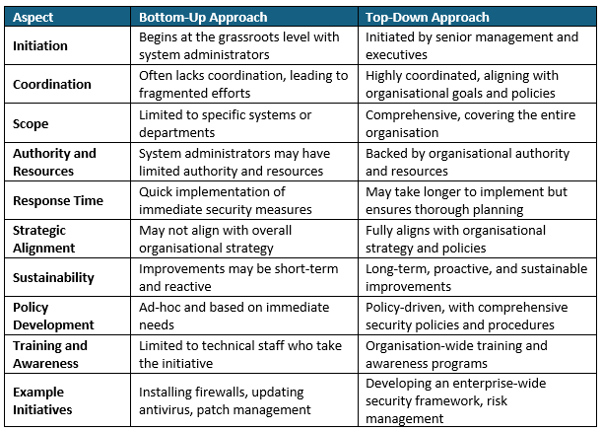
Table 1: Bottom-Up Approach v Top-Down Approach
ISU Relevant Areas: Organisation Structure/Chart, Policies and Procedures, Governance and Strategic Planning, Data Protection Compliance.
Recommendations: The top-down approach - by aligning with organisational strategy, providing sufficient resources, and implementing comprehensive policies, it offers a higher probability of sustained and effective security.

2.4.5 Security Models
The two most recognised are the ISO 27000 series and the NIST security models.
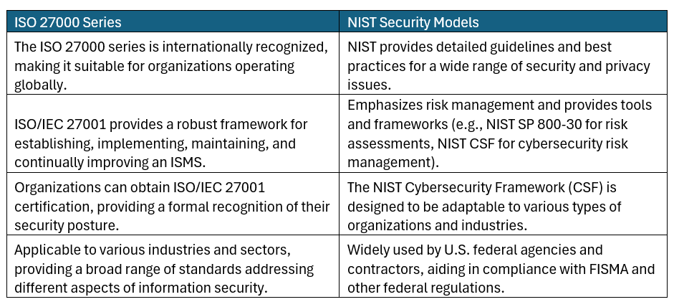
Table 2: Strengths- ISO 27000 Series v NIST Security Models
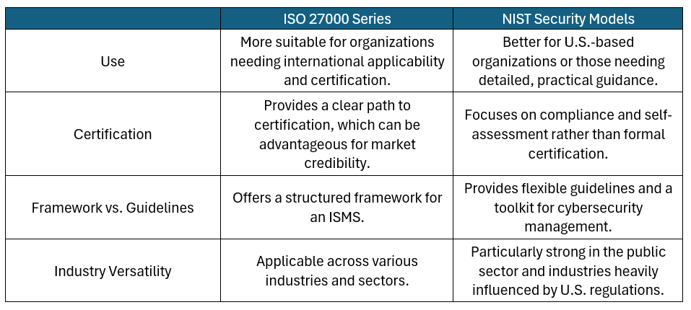
Table 3: Comparative Analysis of ISO 27000 Series v NIST Security Models
ISU Relevant Areas: All Areas
Recommendations: A blended approach to benefit from integrating aspects of both frameworks to create a robust and comprehensive security stance.

2.5 Design Approach
Information security is complex due to the need to protect against an extensive variety of threats. Regulatory requirements, data protection challenges, technical complexity, and human factors all contribute to the intricate nature of information security.
The design approach aims to significantly enhance security of information assets with the creation of a new Information Security Unit to position the organisation to handle future security threats and regulatory requirements.

2.5.1 Organisation Structure/Chart
The organisation chart below (Figure 4) has been designed to provide a clear chain of command, embedding the top-down approach, and defining roles and responsibilities. The aim is to provide a well-structured approach to ensure all aspects of information security are addressed comprehensively and effectively to support the ISU’s overall security strategy.
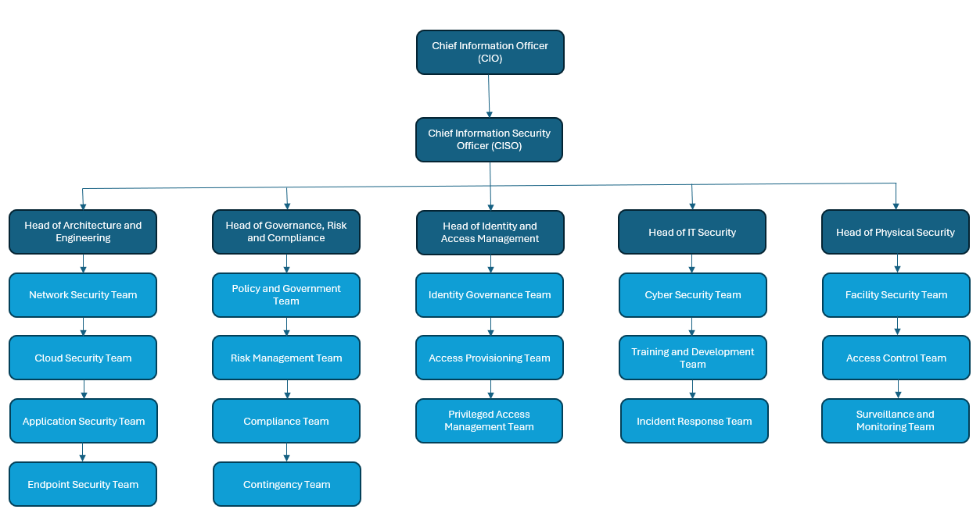Figure 4: Organisation Chart of Proposed Information Security Unit.
Roles and Responsibilities
CIO: The Chief Information Officer oversees the entire ISU, aligning security strategies with business objectives and ensuring overall governance of IT systems.
CISO: The CISO is responsible for the development and implementation of the information security strategy, managing all security-related functions, and ensuring the organisation’s information assets are protected.

Head of Architecture and Engineering
This role focuses on the design and implementation of secure IT infrastructure and systems, ensuring that security is integrated into the technology architecture from the ground up.
Network Team: Secures the ISU network structure, implementing/managing firewalls, intrusion detection/prevention systems and Virtual Private Networks (VPN).
Cloud Team: Secures cloud based services, implements policies, and monitor and responds to cloud security incidents.
Application Team: Secures applications, conducts code reviews and vulnerability assessments, and implements security measures.
Endpoint Team: Protects endpoint devices e.g., desktops, laptops, mobile devices, and other internet-connected devices, from security threats to ensure compliance with security policies

Head of Governance, Risk and Compliance
Responsible for ensuring the organisation adheres to regulatory requirements and manages risk effectively. This role involves creating policies, performing risk assessments, and ensuring compliance with laws and standards.
Policy and Governance: Develop and maintain security policies and procedures, ensuring alignment with legal and regulatory requirements, and conduct security awareness and training programs.
Risk Management: Identify, assess, and mitigate risks. Conduct regular risk assessments and audits. Develop and implement risk management strategies.
Compliance: Ensure compliance with laws and regulations to industry standards.
Contingency: Develops, implements, and maintains plans for incident response, disaster recovery, and business continuity to ensure operational readiness and minimise disruption impacts.

Head of Identity and Access Management
This role focuses on managing user identities and access permissions to ensure that only authorised individuals have access to sensitive systems and data.
Identity Governance: Manage the identity of staff regarding passes, badges, and security clearance data. Conduct regular reviews of user access and entitlements.
Access Provisioning: Handle user access requests in a timely manner. Maintain access controls systems and technologies
Privilege Access Management: Manage and secure privileged accounts, implement solutions and conduct regular reviews.

Head of IT Security
Oversees all operational aspects of IT security, including incident response, training, and day-to-day security operations.
Cyber Security: Protect the ISU from cyber threats. Monitor and respond to cyber security incidents. Conduct penetration testing and vulnerability assessments.
Training and Development: Develop and deliver training programs for employees. Promote security awareness and best practices to ensure compliance with policies.
Incident Response: Detect, respond to, and mitigate security incidents. Conduct investigations and root cause. Develop incident response plans.

Head of Physical Security
Oversee the organisation's physical security operations and implements and manages physical security measures and controls, while coordinating with IT security to ensure a cohesive security strategy. The importance of which are outlined in task 1, “Research in Data Security and Compliance – Physical Security.”
Facility Security: Ensure the security of physical buildings and facilities. Conduct regular security audits and inspections. Implement physical security measures such as barriers, locks, and alarms.
Access Control – Manage physical access and security control systems. Conduct regular reviews of access logs and investigate anomalies.
Surveillance and Monitoring – operate and monitor surveillance system to ensure real-time monitoring and response to incidents. Responsible for maintaining and testing equipment.

Benefits
- The structure splits areas of information security into several departments, each managed by experts with deep, relevant knowledge and skillsets, incorporating the top-down approach.
- Each department can focus on its specific area of responsibility, enhancing management.
- Clear departmental boundaries improve communication channels and reduce misunderstandings.
- Resources can be allocated more effectively based on departmental needs and priorities.
- The structure supports growth and adaptation to new security challenges or emerging technologies.

2.5.2 Policies and Procedures
This section outlines a comprehensive framework for developing, implementing, and maintaining these policies and procedures, the relationships of which are depicted in Figure 5.
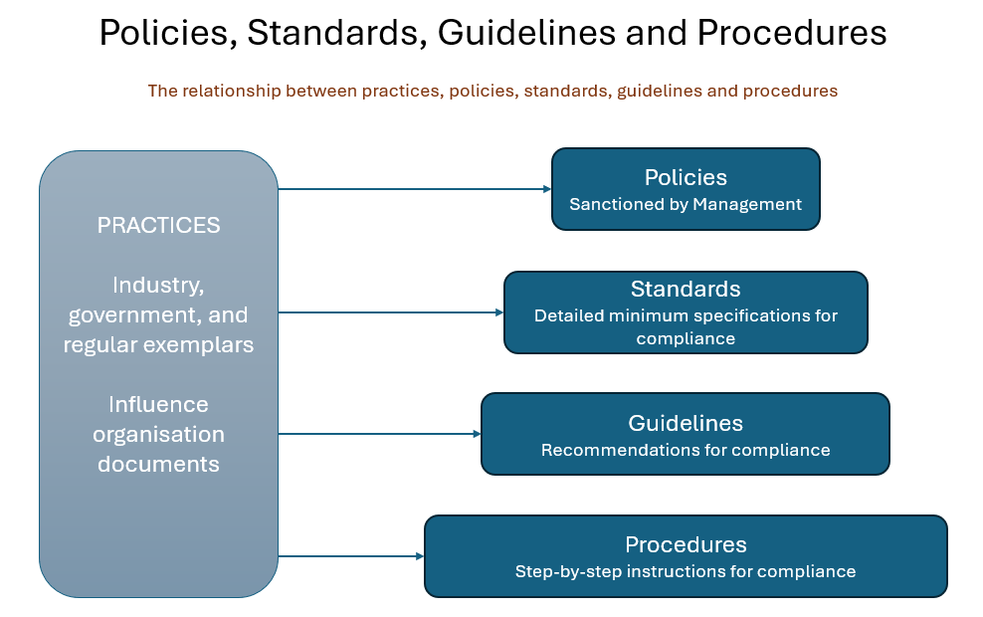
Figure 5: The relationship between practices, policies, standards, guidelines, and procedures
Policy Creation/Review
The Governance, Risk, and Compliance department would create, review, and update ISU security policies. GAP analyses should review all policies, procedures, and controls to identify vulnerabilities and improvements, while documenting findings and comparing policies to industry standards and regulations.
Policies
The ISU will need several policies across all departments which include:
- Enterprise Information Security Policies (EISP) – provides the ISU’s security framework and direction, guiding information security governance and strategic alignment with business goals.
- Issue-Specific Security Policies (ISSP) – addresses specific ISU issues including acceptable use, email security, and internet usage with detailed policies and guidelines.
- System-Specific Security Policies (SysSP) - Ensures individual systems and applications are securely configured and managed according to the ISU’s security standards and practices.
Utilising the ISO/IEC 27001 literature aids the creation of widespread security policies. Table 2 summarizes the roles in which EISP, ISSP and SysSP will be deployed.
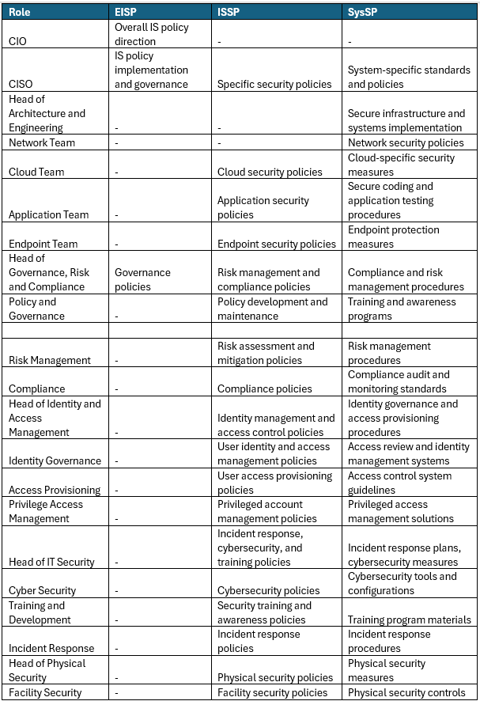
Table 4: Proposed Security Polices
Procedures
Implementing policies requires detailed procedures. Engagement with key stakeholders will make these feasible. ISU procedures will be tailored to roles and responsibilities while incorporating all 27 McCumber Cube aspects.

Management
Policies and procedures must be reviewed and revised regularly, using checklists and criteria based on the McCumber Cube's dimensions, regulations, modifications, and ISU needs. Management will document policies, version control, note changes, and allocate ownership.

2.5.3 Data Protection and Compliance
Incorporating robust data protection and compliance practices is essential for safeguarding sensitive information, meeting regulatory requirements, and maintaining trust. Below is an approach to integrating these practices effectively within the Governance, Risk and Compliance department.
Identify Relevant Data Protection Regulations
Conduct a regulatory assessment to identify applicable data protection regulations pertinent to the ISU. The main regulations being:
- General Data Protection Regulations (GDPR) [19]
- Health Insurance Portability and Accountability Act (HIPAA)
- Payment Card Industry Data Security Standard (PCI-DSS) [20]
Conduct an Impact Assessment
To identify ISU departments, systems, and processes that must comply with personal data regulations. Find customer and employee data collection, processing, and storage areas. Compare cloud and third-party data storage and transfer. Scan databases, servers, and networks for security and compliance.
Create Data Protection Impact Assessments (DPIAs)
A DPIA helps you assess, identify, and reduce data protection risks. It is essential to accountability under the UK GDPR and helps analyse and demonstrate data protection compliance [21].
Identify and implement necessary measures to mitigate these risks. Arrange regular reviews to update DPIA’s to reflect changes in work processes, regularity requirements, or emerging risks.
Implement Data Protection Controls and Procedures
Guard sensitive data by restricting access to authorised personnel. Protect data at rest and in transit with encryption. Data should be kept only as long as needed and safely destroyed.
Training and Awareness Programs
Train staff on data protection, compliance, and incident response regularly. Periodically remind employees of data protection policies through awareness programs.
Schedule Regular Audits and Review
Perform internal audits to assess compliance with data protection policies and procedures. Adjust polies and procedures based on findings and evolving best practices.

2.5.4 Security Standards
Th approach below ensures that security standards are met by utilising the NIST security models and the ISO 27000 series.
Planning
Develop a foundational security policy using NIST SP 800-14 and ISO 27001 [22,18] to define organisational security policies. Conduct a risk assessment and create detailed security requirements based on ISO 27002 [23] controls that are cost-effective and meet the ISU’s goals.
Design
Integrate security as an integral part of the overall system design, as recommended by NIST SP 800-14, and clearly define physical and logical security boundaries following ISO 27001 guidelines. Implementing layered security to ensure no single point of vulnerability, employing defence-in-depth strategies to protect information assets. Tailor the security controls to meet ISU security goals and regularity requirements.
Development
Ensure security is embedded in all processes and code by adopting secure coding practices, training developers as per NIST SP 800-53 [24], and regularly reviewing and testing code for security vulnerabilities. Access controls are enforced to authenticate users and processes, adhering to NIST SP 800-12 [25], and we apply the principle of least privilege to limit access to sensitive information. Additionally, robust encryption methods are used to protect information in transit and at rest, in line with ISO 27002 standards.
Testing
Conduct regular security testing, including penetration testing and vulnerability assessments, and perform regular security audits to ensure compliance. Implement User Acceptance Testing (UAT) to verify user access and data protection mechanisms, ensuring that all identified security issues are resolved before deployment.
Implementation
Create a secure deployment checklist to ensure all security controls are in place, including monitoring mechanisms to detect and respond to security incidents. Comprehensive training to be provided, aligning them with relevant certifications such as Certified Information Systems Security Professional (CISSP), Certified Information Systems Manager (CISM), and Certified Cyber Forensics Professional (CCFP).
Maintenance
Continuous monitoring to detect and respond to new threats, and regularly update security controls to address emerging vulnerabilities. Periodic reviews of security measures and policies as advised by NIST SP 800-14. An incident response plan to be provided to address security breaches.

2.5.5 Contingencies Planning
Contingencies in an ISU are crucial for ensuring operational continuity during unexpected disruptions, protecting critical data and systems, and minimising financial and reputational damage. Contingency plans are critical to provide structured responses to incidents and disasters, enabling swift recovery and maintaining the ISU’s resilience.
Contingency Team
The Contingency Team will manage the overall response to the crisis, support personnel, determine the impact on business operations, and communicate with stakeholders. Its key areas are to ensure the well-being of employees and their families and keep an updated headcount of personnel and ensure the availability of emergency contact information.
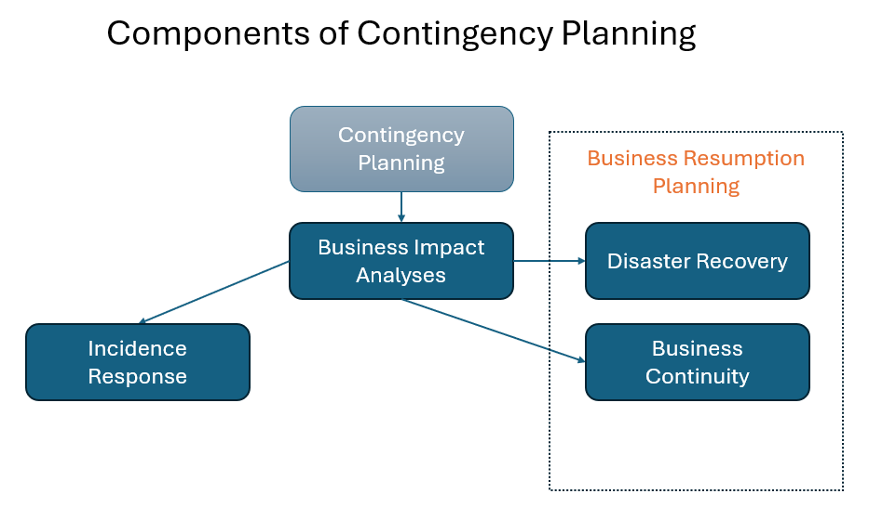
Figure 6: Components of Contingency Planning
Contingency Plan Creation
The steps to undertake are outlined below and are aligned to the SDLC research findings.
- Develop a Contingency Planning Policy Statement that expresses the ISU’s commitment to maintaining operations and outlines the purpose, objectives, and scope of the contingency plan.
- Conduct Business Impact Analysis (BIA) to Identify and evaluate critical business processes and their impact on operations if disrupted.
- Identify preventative controls to mitigate the risk of disruptions
- Create contingency strategies such as Incidence Response Planning (IRP), Disaster Recovery Planning (DRP) and Business Continuity Planning (BCP).
- Consolidate all strategies into a comprehensive contingency plan that includes the IRP, DRP, and BCP. Ensure the plan covers response actions, recovery procedures, and continuity strategies.
- Schedule testing, training, and exercise to ensure its effectiveness and update as needed.
Accessibility and Reviews
The contingency plan is to be stored electronically of easy access, and hard copies made available if necessary. Periodic reviews will be implemented to ensure the plan remains relevant and effective.

2.5.6 Governance and Strategic Planning for Security
Governance and strategic planning are essential for managing cybersecurity risks, complying with regulations, and protecting information assets. Using ISO/IEC 27001 standards [18], the CISO and the Governance, Risk, and Compliance department can integrate these practices effectively.
Identify Relevant ISO/IEC 27001 Requirements
Assess and apply relevant ISO/IEC 27001 requirements such as Context of the Organisation, Leadership, Planning, Support, Operation, Performance, Evaluation, and Improvement
Conduct a Governance Assessment
Review organisational structure and information flow and identify key stakeholders and their governance roles. Perform gap analyses against ISO/IEC 27001 requirements.
Establish Information Security Governance Objectives
- Align security strategies with business objectives.
- Develop a risk management framework to identify, assess, and mitigate risks.
- Allocate resources effectively to support security initiatives.
- Develop KPIs and metrics to measure security performance.
- Ensure security investments deliver measurable benefits.
Create Polices
Create the relevant policies in all areas of the ISU.
Monitoring and Reporting
Implement security monitoring tools and generate reports which are regularly reviewed to identify areas for improvement.
Training Programs
Device regular training and awareness and prioritise security as a core organisational value.
Regular Reviews
Create an executive board comprising all senior management with scheduled meetings to review, update and improve policies, procedures, and controls.

2.5.7 Risk Management
Risk management involves identifying, assessing, and controlling threats to the ISU’s assets and operations. Effective risk management ensures that potential risks are mitigated to safeguard the ISU's objectives.
Risk Identification
Conduct sessions with stakeholders to identify potential risks and review historical data to identify recurring risks. Undertake SWOT analysis to identify internal and external risks. Document in a risk register, including detailed descriptions of each risk, potential impacts, proposed mitigation strategies, and assign risk owners. Additionally, define risk trigger-events that might activate the identified risks.

Risk Assessment
Implement a detailed risk assessment to understand the potential impact and likelihood of each risk. Create a risk matrix based on impact versus likelihood to help visualise the risk levels. Benchmark these risk ratings against industry standards or historical data. Use predefined scales (e.g., low, medium, high) for assessing the impact and likelihood of each risk.
Risk Prioritisation
Rank the risks according to their ratings to identify those that need immediate focus. Allocate resources effectively to manage the most critical risks. Use prioritisation criteria such as business impact, regulatory requirements, and stakeholder concerns to guide the process.
Risk Control and Mitigation
Develop and implement strategies to manage the identified risks. Key strategies include
- Avoidance - which involves changing project plans to eliminate risks
- Mitigation - which reduces the impact or likelihood of risks through proactive measures
- Transfer - which shifts risks to third parties such as through insurance or outsourcing
- Acceptance - which acknowledges the risk and prepares to manage its impact if it occurs.
For each control strategy, develop detailed action plans that include specific actions, timelines for implementing mitigation measures, assigned responsibilities, and contingency plans in case primary strategies fail.
Risk Monitoring and Review
Regularly assess risks and control effectiveness. Reevaluate risks and update the risk register regularly. Risk incidents should be reported and addressed quickly. Keep the risk register and documents current. Integrate ISU risk management to business processes to better understand and mitigate threats. Keep stakeholders informed about risk management with ongoing training and awareness programs. Measure risk management effectiveness and report to senior management regularly.
Enhanced Risk Control Strategies
To reduce risks, use security protocols, quality control, and compliance checks. To identify risks early, use audits, monitoring, and performance reviews. To mitigate risks, create disaster recovery and incident response plans.

2.7 Conclusion
The design approach is both comprehensive and strategic, addressing all critical areas essential for robust information security. The proposed solutions leverage well-recognised frameworks and standards, such as the CIA Triad, McCumber Cube, ISO 27000 series, and NIST security models. This ensures that the ISU is built on a solid foundation of industry best practices, enhancing its ability to protect the organisation’s data assets, ensure compliance with regulations, and mitigate cyber threats.
To improve the Information Security Unit (ISU) in the future, it is recommended to integrate advanced technologies like Artificial Intelligence (AI) and Machine Learning (ML) for proactive threat detection and response. Establishing continuous feedback loops from incidents and audits will help refine policies and controls. Increasing the focus on user awareness through interactive training and simulations is crucial. Adopting a Zero Trust security model, which involves strict identity verification and continuous monitoring, will enhance security. Regularly benchmarking against industry best practices and investing in advanced incident response tools will further improve the ISU’s effectiveness.

2.8 References

[1] M. Cobb, “What is physical security?,” SearchSecurity, Apr. 01, 2021. https://www.techtarget.com/searchsecurity/definition/physical-security#:~:text=Physical%20security%20is%20the%20protection%20of%20personnel%2C%20hardware%2C (accessed Jul. 13, 2024).
[2] D. B. Parker, Fighting Computer Crime. Wiley, 1998.
[3] “Physical Security Advice | NPSA,” www.npsa.gov.uk, Jan. 29, 2021. https://www.npsa.gov.uk/physical-security (accessed Jul. 20, 2024).
[4] “Cyber Assurance of Physical Security Systems | NPSA,” www.npsa.gov.uk, Feb. 05, 2024. https://www.npsa.gov.uk/cyber-assurance-physical-security-systems-capss (accessed Jul. 20, 2024).
[5] S. Burge, “What is Physical Security & Why is it Needed?,” internationalsecurityjournal.com, Dec. 01, 2023. https://internationalsecurityjournal.com/what-is-physical-security/ (accessed Jul. 13, 2024).
[6] L. J. Fennelly, Effective physical security, Fifth edition. Oxford, United Kingdom: Butterworth-Heinemann, 2017.
[7] NIST, “NIST SP 800-12: Chapter 15 - Physical and Environmental Security,” csrc.nist.rip, Jul. 28, 2014. https://csrc.nist.rip/publications/nistpubs/800-12/800-12-html/chapter15.html (accessed Jul. 13, 2024).
[8] gov.uk, “The Regulatory Reform (Fire Safety) Order 2005,” Legislation.gov.uk, 2021. https://www.legislation.gov.uk/uksi/2005/1541/introduction (accessed Jul. 23, 2024).
[9] Fire Industry Association, “Best Practice Guide to Fire Safety 2 | BEST PRACTICE GUIDE TO FIRE SAFETY,” May 2018. Accessed: Jul. 23, 2024. [Online]. Available: https://www.fia.uk.com/static/uploaded/1a8193bf-30f9-42db-9c7dfda0eec72e8d.pdf
[10] A. Thakur, "Intelligent HVAC Control Systems for Smart Infrastructures," Advances in Finance, Accounting, and Economics Book Series, pp. 216-227, 2024, doi: 10.4018/979-8-3693-2750-0.ch011
[11] Health and Safety Executive, “Construction (Design and Management) Regulations 2015 - Legal requirements: A summary,” www.hse.gov.uk, 2015. https://www.hse.gov.uk/construction/cdm/2015/legal.htm (accessed Jul. 24, 2024).
[12] Fortinet, “What is the CIA Triad and Why is it important?,” Fortinet, 2024. https://www.fortinet.com/resources/cyberglossary/cia-triad
[13] KBE, “Security Design,” KBE Information Security. https://kbeintelligence.ca/cyber-evolution-services/security-design/ (accessed Jul. 26, 2024).
[14] A. Gillis, “What Is Systems Development Life Cycle? - Definition from WhatIs.com,” Search Software Quality, Jun. 2019. https://www.techtarget.com/searchsoftwarequality/definition/systems-development-life-cycle (accessed Jul. 26, 2024).
[15] Trace Dynamics, “SDLC (Software Development Life Cycle) - A Comprehensive Guide,” TraceDynamics, Feb. 27, 2021. Accessed: Jul. 26, 2024. [Online]. Available: https://www.tracedynamics.com/sdlc/
[16] NIST, “NIST Special Publication 800-64 Revision 2,” 2019. Accessed: Jul. 26, 2024. [Online]. Available: https://nvlpubs.nist.gov/nistpubs/Legacy/SP/nistspecialpublication800-64r2.pdf
[17] Team Asana, “Top-Down Approach vs. Bottom-Up Approach: What is the Difference? • Asana,” Asana, Feb. 24, 2024. https://asana.com/resources/top-down-approach (accessed Jul. 26, 2024).
[18] ISO, “ISO/IEC 27001 standard – information security management systems,” ISO, Oct. 2022. https://www.iso.org/standard/27001 (accessed Jul. 27, 2024).
[19] GDPR, “General data protection regulation (GDPR),” General Data Protection Regulation (GDPR), 2024. https://gdpr-info.eu/ (accessed Jul. 27, 2024).
[20] PCI Security Standards Council, “PCI DSS v4.0,” www.pcisecuritystandards.org, 2022. https://docs-prv.pcisecuritystandards.org/PCI%20DSS/Supporting%20Document/PCI-DSS-v4-0-At-A-Glance.pdf (accessed Jul. 27, 2024).
[21] ICO, “What is a DPIA?,” ico.org.uk, May 19, 2023. https://ico.org.uk/for-organisations/uk-gdpr-guidance-and-resources/accountability-and-governance/data-protection-impact-assessments-dpias/what-is-a-dpia/ (accessed Jul. 27, 2024).
[22] NIST, “Archived NIST Technical Series Publication Archived Publication Series/Number: Title: Publication Date(s): Withdrawal Date: Superseding Publication(s),” 1996. Accessed: Jul. 28, 2024. [Online]. Available: https://nvlpubs.nist.gov/nistpubs/Legacy/SP/nistspecialpublication800-14.pdf
[23] ISO, “ISO/IEC 27002:2022,” ISO, Feb. 2022. https://www.iso.org/standard/75652.html (accessed Jul. 28, 2024).
[24] NIST, “Security and privacy controls for information systems and organizations,” Security and Privacy Controls for Information Systems and Organizations, vol. 5, no. 5, Sep. 2020, doi: https://doi.org/10.6028/nist.sp.800-53r5.
[25] M. Nieles, K. Dempsey, and V. Y. Pillitteri, “An introduction to information security,” An Introduction to Information Security, vol. 1, no. 1, Jun. 2017, doi: https://doi.org/10.6028/nist.sp.800-12r1.

