Iwan Williams (1901752)
Vehicle Technology (M4X00394)
Examination answers
Examination date: 14/5/2020
Start time: 13:00

Question 2
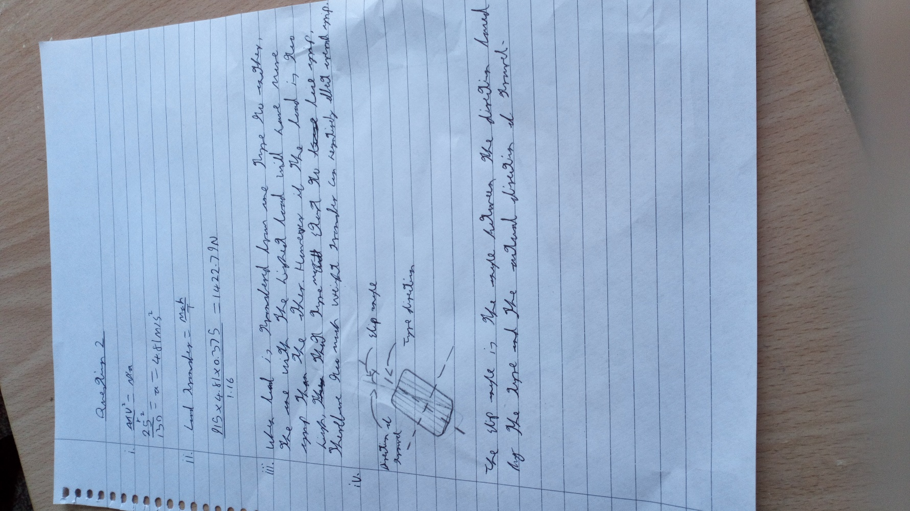

Question 3
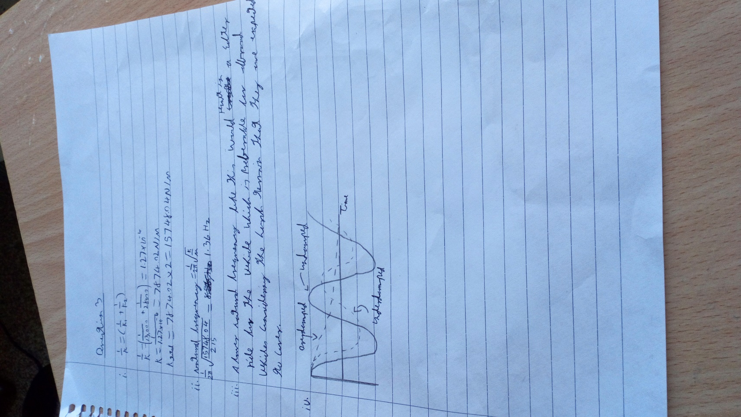

Question 4
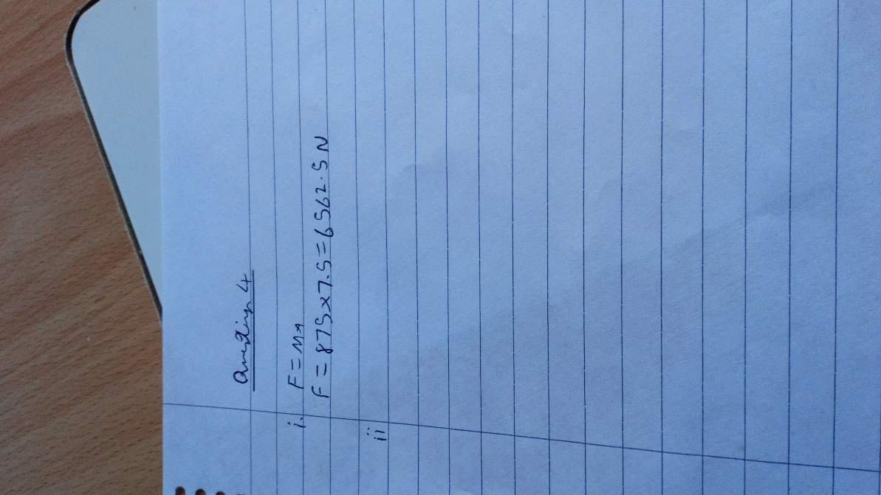

Question 5


