21/03/2025
Zakriya Fathi 2003845

Academic and Employability Skills Development
Reflective Report

Contents
1. Introduction 2
2. Application of Fundamental Learning Techniques 2
2.1 Understanding Learning Styles 2
2.2 Setting Motivation and Goals 2
2.3 Positive Engagement in Studies 3
3. Self-Management Techniques 3
3.1 Time Management 3
3.2 Creating a Conducive Learning Environment 4
4. Problem-Solving Techniques 4
4.1 Action Plans 4
4.2 Creative Thinking 5
5. Research Methods and Academic Skills 6
5.1 Research Methods 6
5.2 Referencing Techniques 6
5.3 Academic Writing 6
5.4 Presentation Skills 7
6. Employability and Professional Skills 7
6.1 Teamworking Skills 7
7. Reflection and Lifelong Learning 8
Appendix 9
Reflection feedback from lectures 9
Web concept report Feedback 9
Presentation Feedback 9
Skills Audit 9

1. Introduction
This report will document my experience learning and implementing academic and professional skills throughout the year as part of the Academic and Employability module. These abilities have helped me improve my academic achievement and employment. I now understand how this will benefit my future learning and professional growth.
I will demonstrate how these abilities have benefited me in the first year by delving into crucial topics such as research approaches, team working, time management, and professional writing. I will explain their relevance to my professional objectives and give evidence from my assignment to support this claim.

2. Application of Fundamental Learning Techniques

2.1 Understanding Learning Styles
As part of my academic and employability skills module, I completed a questionnaire to identify my learning styles. The VAK (Visual, Auditory, and Kinesthetic) questionnaire helped me understand how to learn. The findings revealed that I am kinesthetic learner, meaning I like acquiring specialised knowledge via hands-on experiences, practical exercises, and real-world applications rather than just reading or hearing.
This makes our practice programming mock simpler. I found it a lot simpler to come up with answers after physically laying out ideas with my group. Working together and debating various techniques improved my understanding over merely going through notes. This experience demonstrated the need for actively interacting with the content rather than passively receiving knowledge.
Now that I understand my learning style, I can use it to improve my study habits and work on tasks. I want to include more hands-on activities into my learning skill, such as web coding tasks, generating diagrams, and engaging in group discussions. This will make learning more straightforward, understandable, and pleasant, mainly when working in groups during workshops. This experience will help me build essential employability skills, including collaboration, problem-solving, and task management.

2.2 Setting Motivation and Goals
Staying motivated has been crucial, allowing me to stay focused and manage my workload throughout the year. Achieving these objectives has given me a clear sense of where to begin and stop, making it easy to keep on course, even when confronted with new problems. Dividing the assigned duties into smaller, more manageable goals has helped me keep steady consistent progress and prevent feeling pressured.
For example, when working on my Web Concepts project for the Introduction to Web and Database Concepts module, I set a short-term goal of doing and finishing research in two days. This deadline helped me stay organised and gave me enough time to write, correct a few typos, and explain my work. Maintaining these little goals has given me a feeling of accomplishment, encouraging me to continue striving towards larger academic goals.
In addition to goal planning, my values, such as honesty and thoroughness, have significantly contributed to my motivation. I constantly strive to create high-quality work and accept responsibility for ensuring that my assignments meet academic requirements. An excellent example of this is ensuring that all of my sources are correctly cited, demonstrating respect for intellectual property and academic integrity.
In the future, I want to create both short-term and long-term goals to remain motivated and improve my academic performance. Understanding these objectives will encourage me to stay on track with my education and drive me to accomplish even more in my future job.

2.3 Positive Engagement in Studies
Participating in my classes has helped me become more focused and driven while studying. Instead of just listening to lectures or reading assigned materials such as PowerPoint slides, participating, asking questions, and using what I know practically makes learning more productive. Techniques such as active listening and hands-on exercises have helped me remember knowledge and feel more engaged in learning.
I increased my involvement by actively engaging in class discussions and workshops. Rather than just sitting back and collecting notes, I contribute by expressing ideas and collaborating with others to seek alternative perspectives. This has improved my ability to interact and work with other pupils.
An example of this occurred during a presenting methods session. I gave a simulated presentation titled Understanding the Parts of a Computer, outlining several components and their functions. This practice reinforced my knowledge while increasing my confidence in presenting to a prospective audience. Understanding how to layer my presentations better and explain my thoughts was a valuable experience that will benefit me in future projects and professional settings.
By concentrating on my academics, I've developed a better learning attitude that allows me to engage in academic events. In the future, I want to use these plans to build my comprehension of new subjects, strengthen my talents, and maximise the value of my future education.

3. Self-Management Techniques

3.1 Time Management
Time management is one of the most essential talents I've developed throughout my course. I found it difficult to manage many duties and deadlines, and I often felt pressured to complete projects at the last minute. This caused frustration, which damaged the quality of my work. However, I learnt how to manage my time better and remain stress-free. I could effectively and efficiently arrange practical activities or deadlines, significantly increasing my productivity.
Google Calendar is a fantastic tool for me to stay organised. It has helped me construct a clear strategy for each week's studies by dividing down tasks and adding reminders, ensuring that I don't leave things to the last minute. It has also given me a better understanding of what work has to be done and when which has helped me reduce stress and stay on schedule.
For example, I constructed a timetable with specified phases for each activity when I began working on my Web Concepts assignment. I broke it down into reasonable chunks, such as online research, revising class notes, and practicing Notepad++ HTML site code. This helped me feel more in control, and I could do the project without being startled by what I had been handed. By keeping to this timetable, I could submit the project on time.
Time management has helped me remain on track with my academics and lessen my stress. In the future, I want to hone these abilities by using tools such as calendars and planners to help me manage my job. These approaches will help me remain organised and prepared for future academic and career difficulties.
Below is a screenshot of my Google Calendar covering what I need to do, such as research, rewrite notes from what I learnt on the day, and practicing web coding
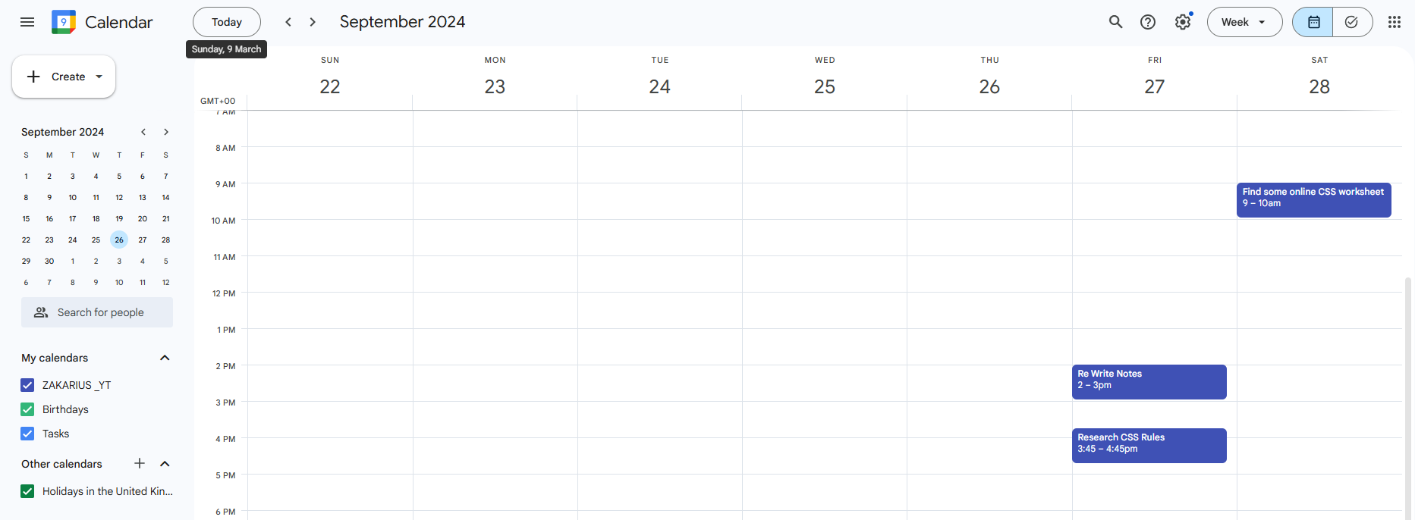

3.2 Creating a Conducive Learning Environment
I've discovered that having an organised study space is critical to staying focused. Initially, I would study in various rooms of my house, but this was not ideal due to the distractions surrounding me. Setting up a study space really improved my ability to accomplish my tasks.
Having a quiet environment in my room is critical to maintaining concentration. I must avoid distractions such as the television and other people to concentrate on my studies. I began studying in various locations around my home, but I soon realised this was not optimal due to the distractions surrounding me. Having a consistent study environment has helped me complete my work.
When working on assignments or preparing presentations, such as Microsoft Word or PowerPoint slides, I ensured my study space had everything I needed, including textbooks, a functional laptop, and any module-specific resources. These fundamentals enabled me to keep focused without spending time looking for items or dealing with technological challenges.
Creating this ordered location, keeping to a schedule, and taking frequent breaks have helped me concentrate. This has shown me the importance of having an area where you can focus and develop a productive attitude. I'll keep this configuration in the future since it has significantly impacted my academic performance.

4. Problem-Solving Techniques

4.1 Action Plans
While working on the Web Concepts assignment for the Introduction to Web and Database Concepts module, I recognised that doing everything simultaneously would be too difficult. I started breaking down the task into smaller pieces to make it more doable and less stressful. This helped me keep focused and organised throughout the procedure.
I began by defining the task's main components, such as completing research, writing the material, and working on the code. Instead of treating the task as a single large report, I separated the brief into distinct parts for each. For example, I want to do research in the first two days, write the content in the next three days, and code and test in the remaining time.
Breaking things down into smaller manageable portions has allowed me to concentrate on one activity at a time and avoid being overwhelmed. This will enable me to keep track of my work, remain motivated, and avoid last-minute tasks.
Following the action plan has allowed me to complete the work on time and without stress. This experience showed me the need for planning when dealing with complex projects. Moving forward, I divide major responsibilities into smaller, more achievable chores to stay organised and reduce stress.
Below is a screenshot of the action plan I made for my Web Concept assignment
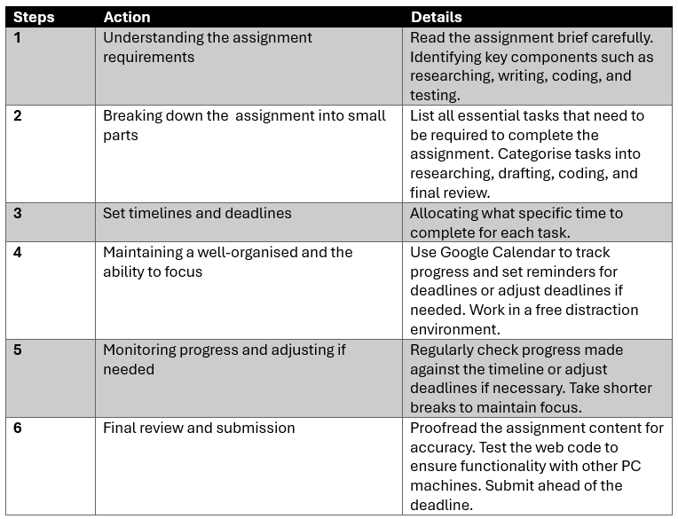

4.2 Creative Thinking
For the Web Concept assignment, we were supposed to create a website based on our selected subject. I chose to focus on Swansea Tourism and create an HTML/CSS website to display the many areas for visitors who want to visit Swansea rather than just promoting the most well-known sites.
I built the site to highlight renowned tourist destinations such as Waterfront City and Mumbles. I want to offer new travellers who have never seen or heard of Swansea a place to explore.
While my approach varied from that of other tourist websites, which mainly concentrated on well-known spots, the response I got commended the inventiveness and diversity of the locations available.
The work taught me the importance of thinking creatively and researching other tourist websites for ideas when approaching a subject. I added a unique touch to make my website more fun and valuable.
In future assignments, I want to continue using creative thinking and seeking fresh and innovative approaches to challenges to make my work stand out and have a more significant effect.

5. Research Methods and Academic Skills

5.1 Research Methods
In this module, I realised how crucial it is to research and use credible sources while writing tasks. At first, I wasn't aware of all the numerous research tools available to me, but I gradually became more comfortable with them. For example, I found Google Scholar to be beneficial.
For example, while researching the Website Usability assignment, I collected various materials to support my findings. I also looked to scholarly papers to learn about user experience, web design, and usability concepts. This guaranteed I could better comprehend the subject while working on the task.
To remain structured, I started a reading log to keep track of my research. I jotted down each source's title, author, publication date, and significant observations.
This experience showed me the value of being structured and keeping track of my sources while researching. I want to continue utilising tools such as academic resources and reading logs to expedite the research process and deliver high-quality results.

5.2 Referencing Techniques
Initially, I found it challenging to use IEEE referencing. There were various items to remember, including the proper sequence of author names, publication dates, and article titles. However, by practicing in my leisure time, I eventually became comfortable with it.
Referencing correctly is critical since it acknowledges the original writers and materials I utilised in my Web Concept project. It demonstrates that my work is based on reliable evidence supporting my report. In my Swansea Tourism report, for example, appropriately attributing papers and publications supported my views, giving my analysis more weight and credibility. Without adequate citations, my ideas would have been less compelling and lacked the credibility required to be taken seriously.
As I became more familiar with referencing, I saw its importance for academic honesty. It guarantees that I give credit to the appropriate persons and adds professionalism and dependability to my projects. To preserve the quality of my work in the future, I want to continue honing my reference abilities and ensuring that I accurately credit diverse sources of information.

5.3 Academic Writing
Throughout the year, I've improved in terms of assignment structuring. At first, I found it difficult to order my ideas and ensure that my reports were clear. However, I soon understood that organising and arranging my writing before beginning the actual work was critical to improving the flow of my assignment.
Before I began writing, I outlined the topics I needed to address. These outlines assisted me in organising my thoughts into more manageable chunks. With a concise, organised report, I could concentrate on extending my ideas without becoming lost. The format helped me keep on target, making the writing process much more efficient.
For example, in my Web Concepts assignment, I utilised proper headers and subheadings to divide the content into sections like introduction, research, analysis, and conclusion. I also added a table of contents and page numbers to help readers navigate the report. This made it much simpler for the reader to comprehend my ideas and the report's structure.
The habit of arranging my assignments with clear headers and outlines made my work more straightforward and professional. This enhanced the flow of my work and allowed me to remain focused. I've learnt that arranging my work efficiently from the beginning significantly impacts the overall quality of my projects, and I'll continue to apply this strategy in the future.

5.4 Presentation Skills
During this module, I focused on improving my presenting abilities since I understood how crucial it is to express ideas academically and professionally. Initially, speaking in front of people was intimidating, but with practice and the correct tools, I got more comfortable and confident in giving my presentations efficiently.
Using PowerPoint was a valuable tool in my efforts to improve. I learnt how to create concise, visually appealing presentations that only include vital information. Instead of bombarding the audience with words, I highlighted essential points and utilised visuals such as images and tables to emphasise my views. This made the slides simpler to understand and more entertaining for the audience.
For example, during my presentation on Understanding the Parts of a Computer, I practiced speaking in front of a mirror to become more conscious of my body language, gestures, and tone of voice. This allowed me to focus on conveying my message with confidence. My professor also provided suggestions that helped me develop my approach. They pointed out ways I might improve, such as changing my tempo and tone to keep the audience interested. This criticism helped me continue developing and honing my presenting approach.
Learning and utilising these tactics gave me confidence in presenting and conveying my message. My ability to properly outline my thoughts, effectively use graphics, and practise my delivery has greatly improved my presentation. This experience has helped me develop my presenting abilities, which will be helpful for future academic assignments and career prospects.

6. Employability and Professional Skills

6.1 Teamworking Skills
Teamwork was vital for me throughout the course and greatly influenced my learning. One of my most important team experiences was during a programming module when we collaborated on a mock exercise to better comprehend and apply the programming languages we were learning.
To begin with, we understood that each team member has unique abilities. Some were skilled coders, while others excelled at presenting complex concepts or troubleshooting. We recognised the applications of the various talents by allocating tasks correctly. This enabled us to focus on areas where we could most readily contribute to the task.
Throughout the session, we discussed and shared our progress while addressing problems. This helped us to tackle difficulties collectively and find answers more quickly. For example, if someone struggled to code, others in the group may provide guidance or an alternative method.
We also learnt to appreciate one another's opinions. Working as a team requires flexibility and support. It wasn't only about performing individual tasks; the primary goal was to achieve the goals. We could operate more efficiently and provide excellent outcomes.
This event underlined the need for collaboration. It highlighted how a group achieves better outcomes when everyone contributes and supports one another. It also helped me enhance critical abilities like communication, problem-solving, and adaptability, which will be helpful in both academic and professional settings.

7. Reflection and Lifelong Learning
Reflecting on my journey through this module, I am happy with my progress. I've realised how important skills like time management, research, and cooperation are in my academic and professional life. These abilities have helped me excel in my classes, tasks, and life while tackling new challenges. Looking back, I see how much I've learnt, encouraging me to keep going.
I've improved in one area time management. Balancing many deadlines was tough initially, but using tools like Google Calendars helped me stay on track. I've learned to focus on my responsibilities better and be prepared, which has helped me lessen stress. I am now confident in my ability to manage academic and personal duties.
I have also increased my research abilities. I've become more comfortable utilising many sources, such as Google Scholar, to access and obtain material to support my work. This has given my employment more credibility, and these research skills will be helpful in my future academic and professional endeavours.
Teamwork has also been beneficial in my growth. Collaborating with others on tasks has encouraged me to communicate and comprehend diverse points of view and combine my abilities to get better outcomes. Working in groups has shown me how valuable it is in any professional setting.
Looking forward, I want to continue learning throughout my life. While I have made progress, I know that growth will be penalised. I want to attend seminars, receive criticism, and be open to new talents in the future.
Overall, this program provided a reasonable basis for my future. The skills I've learnt have inspired me to excel not just in my education but also in my future job. I'm thrilled to keep growing and learning while aiming for success.

Appendix

Reflection feedback from lectures
Feedback on my Web Concept assignment and presentations has helped me discover my strengths and areas for improvement.

Web concept report Feedback
The assessment from my Introduction to Web and Database Concepts program indicated that my work was well-structured and included all necessary components. However, essential features like appropriate referencing and a bibliography were absent. This suggests that I must enhance my academic writing by adequately citing all sources I utilised and including a bibliography to back up my study. In addition, I will need to be more cautious when referring to the report's IEEE method.
Another important consideration was the technological component of my selected website. I utilised suitable HTML, CSS, and Bootstrap, however I did not integrate JavaScript to enhance the user experience and functionality. Furthermore, I did not call my site "index," which is standard web construction procedure. This was a tiny error, but it is an essential element that I will rectify in the future.
Testing was another area for improvement. My website functioned great however, it did not completely adjust to all devices. More testing would have enabled me to detect and resolve these problems. In the future, I want to test my websites across numerous screen sizes.

Presentation Feedback
My lecture said my presentation was well-organised but had technological concerns, such as missing graphics and out-of-date material. In addition, I read too much from the slide notes rather than presenting confidently as the topic expert. To overcome this problem, I plan to practise more before my presentations and ensure I know what I will say without depending on notes.
The criticism also said that my presentation speed was too quick and that I should calm down to guarantee clarity. Practising in front of an audience, in a mirror, or with a timer will help me improve my timing and confidence. Furthermore, I will need to thoroughly reread my slides and remove any extraneous components, such as the white backdrop and table in one of them.

Skills Audit
Skill Area | Current Skill Level (1-5) | Strengths | Area for Improvement | Actions to Improve
Researching Skills | 4 | The use of Google Scholar | Expand various sources and improve efficiency in research | Practice evaluating sources
Time Management Skills | 5 | Use of Google Calendar to plan tasks | Avoid last minute work | Will continue using planners and set clear priorities
Teamworking Skills | 3 | Effective collaboration in programming exercises | Handling conflicts improving with the team | Engage more in group tasks and seek feedback on teamwork
Presentation Skills | 2 | Improve confidence use of PowerPoint effectively | Managing my tone and pace, audience engagement | Practice in front of peers, and get feedback from lectures or other people
Problem-Solving Skills | 5 | Breaking tasks into smaller parts, creating action plans | Develop a alternate solutions | Participate in problem-solving activates
Academic Writing Skills | 5 | Using structured outlines and organise ideas effectively | Improve the clarity and argument development | Continue practicing academic writing support if needed
Referencing Skills | 2 | Understanding the IEEE referencing system | Rembereing all details correctly | Use referencing tools, keep reference guide
Professional Writing Skills | 5 | Structuring reports well and using subheadings | Refining writing style for professional settings | Review academic reports, practicing summarising information
Self-Management Skills | 5 | Creating well organised study environment to limit distractions | Stay constantly focused | Maintain a well-structured routine, take scheduled breaks
Creativity Skills | 5 | Unique approach to website design in Web Concept assignment | Expand creative thinking with different module | Explore creative problem-solving techniques, look at examples if needed

