Excerpt 1: Source: Success in Academic Writing 6th Edition, by Trevor Day, Bloomsbury Publishing, 2023-09-07. ProQuest.EbookCentral, online http://ebookcentral.proquest.com/lib/trinity/detail.action?docID=7249341.
Created from Trinity on 2025-08-26 13:44:37.
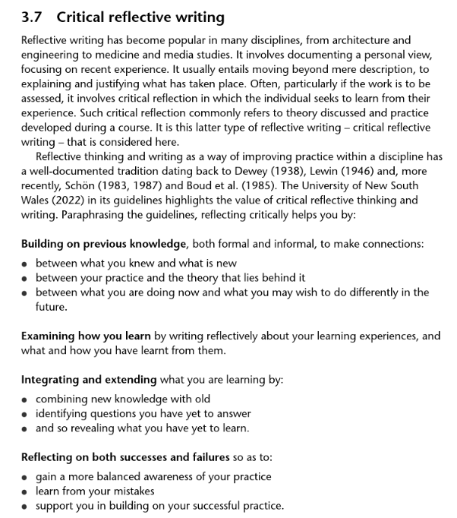

Excerpt 2:

Source: Page 65. The Mature student’s study guide- essential skills for those returning to school or distant learning. by Dr Catherine Dawson. Published in Oxford by How to books. 2007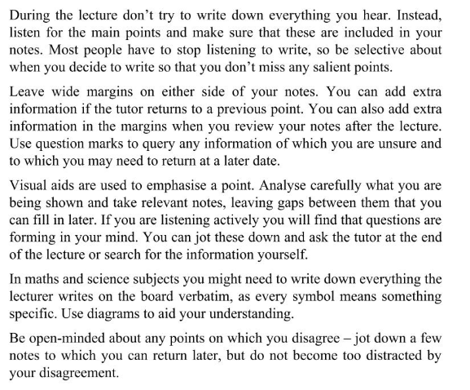

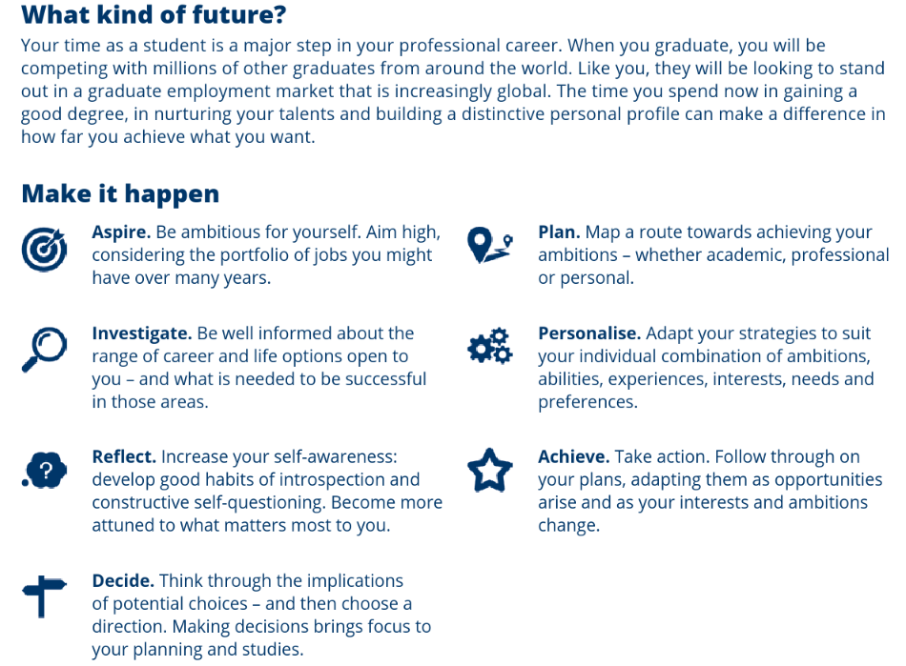
Excerpt 3:
Source: Skills for Success : Personal Development and Employability By Stella Cotrell. Published in 2021 by Macmillan Education UK. ProQuest Ebook Central, Page 3. https://ebookcentral.proquest.com/lib/trinity/detail.action?docID=6577749.

