Student Name: Dumitru Nicolae Silviu  Student ID: 2235616  Module Title: Foreign Languages & Cultural Awareness  Module Code: BMIH5003  Lecturer: Heidi Prosser  Date: 06-02-2024 | 
ASSIGNMENT 1: PORTFOLIO
(4 Components)

Component 1: Professional Reflection

Weighting: 25%
Cultural misunderstanding is a challenge in the case of the F&B industry. As an employee in a similar industry, I have faced such issues while working. I can remember an incident where a Chinese couple came to the hotel for the purpose of stay. However, the couple was proficient in speaking English although Chinese was their native language. In this scenario, the main challenge occurred when the Chinese couple came for the breakfast buffet on the very next day. All the items were presented over there along with their names written on them. The names of the items were written in English and the ingredients were also written in English. The Chinese couple was capable of speaking English however, they were not aware of written English hence; they were incapable of understanding the ingredients of items. The couple was vegan hence; they wanted vegan food options over there.
The issue was resolved when the couple asked for guidance from the employees. I was present there and helped the couple to understand the ingredients of the item. I have provided them with information related to the menu of the breakfast buffet. Vegan items were served to the couple in accordance with their preference. This incident has created a bit of frustration among the Chinese couple. They felt like their culture was not included in the hotel as the hotel was providing all the information in British English. Cultural misunderstanding due to language has been reflected in this situation. After the incident, the manager has decided that all of the food items must have vegan, vegetarian or non-vegetarian signage from now on. So that, all of the guests can feel included. Customer satisfaction can also be achieved with the help of the utilisation of signage in the food items to understand the ingredients.
The manager of the organisation has decided to include more employees from different cultures so that they can meet the needs of the guests from different countries. In addition to that, the manager initiated cultural training for all of the employees present in the organisation so that they could learn about the different cultures. Strong cultural knowledge among individuals can be developed based on cultural training. Respect towards different culture can also be improved in cultural training (Kim, 2020).
In accordance with the incident, I have understood that I need to improve my foreign language skills so that it can help me in my career in the hospitality industry. Learning a foreign language can help to improve communication with guests (Jhaiyanuntana and Nomnian, 2020). I will be capable of communicating with the guest in their native language. Utilisation of the native language is responsible for providing the guests a welcoming feeling. Besides that, the linguistic needs of international customers in the hotel industry can easily be achieved by learning of foreign language (Harrison et al., 2020). International guests also appreciate their language hence positive environment for the guest can be developed. Up-selling and cross-selling are possible in accordance with the utilisation of different languages. Explaining the menu and ingredients to the guests will be possible based on foreign language. Besides that, it is also helpful to earth the creation of a positive environment for employees coming from different cultural backgrounds.

References:
Harrison, R., Walton, M., Chitkara, U., Manias, E., Chauhan, A., Latanik, M. and Leone, D., 2020. Beyond translation: engaging with culturally and linguistically diverse consumers. Health Expectations, 23(1), pp.159-168.
Jhaiyanuntana, A. and Nomnian, S., 2020. Intercultural communication challenges and strategies for the Thai undergraduate hotel interns. PASAA: Journal of Language Teaching and Learning in Thailand, 59, pp.204-235.
Kim, D., 2020. Learning language, learning culture: Teaching language to the whole student. ECNU Review of Education, 3(3), pp.519-541.

Component 2: Training Plan

Weighting: 25%

Identified cultural misunderstanding (in a few words) :
Cultural misunderstanding refers to the situation where two or more individuals speak same language however; they are unable to get the same meaning. This is reflected due to the variations in the culture of individuals (Aririguzoh, 2022).
Training plan (Why/What//Who/Where/When):
Why: The training can be helpful to minimise the cultural misunderstanding between the guests and staff in hospitality industry.
What: Training will be provided to improve the knowledge of the employees regarding cultural awareness.
Who: Staffs of Britannia International Hotel will receive the training.
Where: The location will be the hotel premises.
When: It will be conducted in the month of March.
Training objectives
In accordance with the above situation, I think that a cultural awareness training plan is required for the improvement of the knowledge among staff. The training objective will be to improve the understanding of cultural diversity. Common cultural traditions and norms of international guests must be explored in this training. The hotel can provide basic training for the key languages that are spoken by the client base of the hotel (Ushakov et al., 2020). Common and essential phrases can be included in the training for the improvement of the communication of staff in the hotel. In addition to that, cultural sensitivity training must be provided in this situation. This can be responsible towards the eradication of cultural misunderstanding as well as stereotypes. Improvement of customer service skills can be reflected in accordance with the adaptation of this training. Language barriers between the guests and the staff in the hotel can be minimised in this scenario (Ma et al., 2020). Interpersonal skills among the staff of the hotel can be developed in this scenario. Besides that, it will also be responsible towards the improvement of team building.
Training methods
Workshops and seminars can be conducted for the improvement of cultural awareness. Language skills can be improved through the help of the offering of different language courses. The hotel can also provide online resources to employees so that they can learn about the commonly spoken language in the hotel. Besides that, language exchange programs can also be initiated in the hotel for the improvement of different knowledge among them. It can also adopt role-playing exercises for real-life situations just like the above. Improvement in communication skills of employees can be possible through the help of role-playing exercises. Online quizzes and assessments can be used in this scenario to improve cultural competency among employees. The hotel can also initiate cultural events and celebrations. This can provide sufficient knowledge to staff related to different cultures.
Training strategies
A training strategy that can be utilised is culturally sensitive communication. All the staff must be engaged in effective communication which can manage diversity. Understanding global culture is also required hence, staff can be provided with different language knowledge. Promotion of good manners among staff in the organisation is required during the training session. Respectful behaviour towards the guest can also help them to achieve satisfaction during their stay in the hotel (Dmitrieva et al., 2020). Traditional holidays of foreign clients and colleagues can be celebrated in the hotel for the improvement of cultural awareness. This can help the guests to feel included in the hotel. For example, I have started to gain knowledge about the ethnicity of guests staying in the hotel and include their traditional menu in the breakfast buffet. This can help to eradicate language barriers and cultural differences.
Evaluation and feedback
Feedback on the improvement of cultural awareness among staff can be understood through the help of surveys and feedback forms. In this scenario, guests can be provided with feedback forms related to the language proficiency and cultural efficiency of employees in the hotel. Thereafter, they can provide relevant information about the areas of improvement that is needed among staff. Assessments and observations are also required for the understanding of the improvement of knowledge among employees in the organisation.
References:
Aririguzoh, S., 2022. Communication competencies, culture and SDGs: effective processes to cross-cultural communication. Humanities and Social Sciences Communications, 9(1), pp.1-11.
Dmitrieva, M., Fernandes, P.O. and Nunes, A., 2020. Guests’ Satisfaction: Application of the Importance-Performance Analysis. In ICTR 2019 2nd International Conference on Tourism Research.
Ma, C., Ren, L., Chen, P. and Hu, R.X., 2020. Institute–hotel coordinating barriers to early career management—hoteliers’ accounts. Journal of China Tourism Research, 16(2), pp.297-317.
Ushakov, R.N., Kryukova, E.M., Khetagurova, V.S., Mukhomorova, I.V. and Zelenov, V.V., 2020. Efficiency of hotel management. Training of specialists in hotel industry field. Journal of Environmental Management & Tourism, 11(2 (42)), pp.388-395.

Component 3: Student Self-Reflection

Weighting: 25%
I can use Kolb’s reflective model to evaluate the understanding of the importance of cultural awareness in the hospitality industry. There are four stages in Kolb’s reflective model and they can be regarded as concrete experience, reflective observation, abstract conceptualization and active experimentation (Morris, 2020). In accordance with my concrete experience, I have faced several challenges over the years in this industry due to language barriers. I have worked as a kitchen porter, laser centre, and linen porter as well as C&E assistant and team leader along with HSK supervisor over the last 5 years. This has provided me with several opportunities to interact with International guests on a daily basis. Language barrier has become a main issue in case of communication with them. I have realised over the years that it is also a bit disrespectful to the guest as I was unable to understand their situation.
In the case of reflective observation, I have realised that I could understand basic words of different languages. However, I was unable to understand a complete sentence of the guests. Better practice in language was required in this situation. At first, I thought that understanding a foreign language was important to communicate with the guest. With the passing of time, I have realised that learning a foreign language is not only important for communication but also required for showing respect to the guests. It can make them feel comfortable and customer satisfaction can be achieved. Besides that, I have also realised that knowledge of foreign languages is as important as the knowledge of the culture of different guests.
With the Abstract conceptualization stage, I have improved my knowledge regarding the importance of cultural awareness. This is important towards the enhancement of the customer service. Personalised services can be provided to the guest in accordance with their cultural backgrounds (Lam et al., 2022). Meeting the needs and preferences of guests is possible through the help of understanding their culture. Positive guest experience can be provided in this scenario. This is also helpful towards the minimising of cultural misunderstanding. The language barrier between the guest and the employee can be eradicated with the help of the development of cultural awareness. Better communication among them can be initiated in this situation. Employees can develop cultural sensitivity knowledge.
I have learnt that avoiding cultural mishaps is possible in accordance with the knowledge of different ethnicities and cultures. In sensitive behaviour among employees can be eradicated in the scenario. Cultural taboos and Customs can also be understood in case of improvement of cultural awareness (Irwin, 2020). This is helpful towards building trust with the guests from different backgrounds. It is helpful for increasing the loyalty among guests and repeat business in the organisation. A positive workplace can also be developed with the help of cultural awareness training among staff.
In accordance with active experimentation, I have used my knowledge to create a better experience for guests in the hotel. For example, we have arranged the La Tomatina festival for Spanish guests. Nearly 20 Spanish people were visiting our hotel and we have arranged this festival for them to celebrate. All the staffs in the organisation have also participated so that the guests can feel included.

References:
Irwin, H., 2020. Communicating with Asia: Understanding people and customs. Routledge.
Lam, R., Cheung, C. and Lugosi, P., 2022. The impacts of cultural intelligence and emotional labor on the job satisfaction of luxury hotel employees. International Journal of Hospitality Management, 100, p.103084.
Morris, T.H., 2020. Experiential learning–a systematic review and revision of Kolb’s model. Interactive learning environments, 28(8), pp.1064-1077.

Component 4:Training Presentation

Weighting: 25%
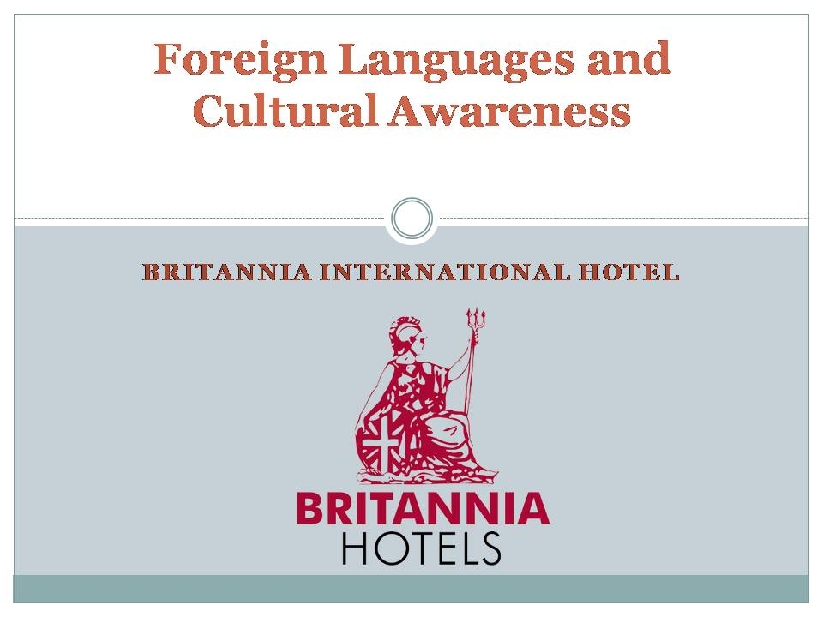
[Content Slide 1]
[Content Slide 2]
[Content Slide 3]

[Content Slide 4]

[Content Slide 5]

[Content Slide 6]

References (no screenshots):
Grodzka, K. 2023. Excelling in business communication in Germany - Focus, Focus Language Audit. Available at: https://focusaudits.eu/excelling-in-business-communication-in-germany-a-guide-to-cultural-appropriateness/ (Accessed: 28 January 2024).
Källkvist, M. and Hult, F.M., 2020. Multilingualism as problem or resource? Negotiating space for languages other than Swedish and English in university language planning. Language perceptions and practices in multilingual universities, pp.57-84.
Prima, S., 2022. A study of perception of the importance of English language skills among Indonesian hotel employees. J-SHMIC: Journal of English for Academic, 9(1), pp.73-86.
Sariah, S., Widiastuti, R., Mulyanah, A., Kurniati, A., Riani, R. and Budihastuti, E., 2023. Language, identity, and modernity: A case of hotel images in Karawang City, Indonesia. International Journal of Society, Culture & Language, 11(2 (Themed Issue on Language, Discourse, and Society)), pp.103-118.
Suebwongsuwan, W. and Nomnian, S., 2020. Thai hotel undergraduate interns’ awareness and attitudes towards English as a lingua franca. Indonesian Journal of Applied Linguistics, 9(3), pp.704-716.

